2024 • Volume • • Electronic publication date:

Tracking trends in the Top End: clindamycin and erythromycin resistance in Group A *Streptococcus* in the Northern Territory, 2012–2023

Joanne Nixon, Jann Hennessey, Rob Baird

# Abstract

This retrospective study reviewed the macrolide resistance rates of Group A *Streptococcus* (GAS) isolates in the Northern Territory from 2012 to 2023. Clindamycin and erythromycin resistance rates peaked in 2021, at 6.0% and 12.2% respectively, and then returned to near baseline at 1–2% in 2023. Increased resistance rates were identified in the Top End of Australia from mid-2020, followed 15 months later by high rates in central Australia in 2022. Factors associated with resistant isolates were living in a rural region and of age 18 years and older. Possible explanations include a transient clonal introduction of a resistant GAS strain to the Northern Territory from 2020 to 2022. Ongoing surveillance is required to monitor regional trends and identify temporal variations in resistant isolates.

Keywords: Group A streptococcus; *Streptococcus pyogenes*; clindamycin; erythromycin; resistance; Northern Territory

# Introduction

*Streptococcus pyogenes*, or Group A *Streptococcus* (GAS), is a significant cause of morbidity and mortality in the Northern Territory;1 of concern, there are increasing clindamycin resistance rates observed in many countries.2 Although universally GAS remains susceptible to penicillin, clindamycin is often used as primary therapy in patients with skin disease or penicillin allergies, or as an adjunctive agent to inhibit exotoxin production.3 Studies have shown high rates of GAS in the Northern Territory, with a median population prevalence of impetigo of 44.5% among children living in remote Indigenous communities in northern Australia.4 In this study, we review the clindamycin and erythromycin resistance of GAS isolates in patients in the Northern Territory.

Antimicrobial resistance has rapidly become a global problem. Despite this, and despite increasing rates of GAS infection and of penicillin use, GAS isolates have remained exquisitely susceptible to penicillin antibiotics.5,6 Concerningly, increasing clindamycin and erythromycin resistance is emerging. Several mechanisms underlie macrolide and lincosamide resistance, with resistance conferred by ribosomal modifications such as methylation from encoded *ermA*, *ermB* or *ermTR* genes with several genomic clusters noted worldwide.7,8 M phenotypes carry the *mefA* gene which causes efflux of antibiotics.8

A retrospective analysis of GAS isolates in the United States of America (USA), from 2015–2017 and 2018–2019, confirmed increasing clindamycin resistance from 17% to 24% due to rapidly expanding genomic subclones.7 Recent research in West Virginia, USA, analysed 76 invasive GAS isolates and identified 76% with simultaneous clindamycin and erythromycin resistance.9 Within the European Union, GAS resistance varies across countries. A study conducted in Greece, during 2016–2021, identified 18.8% clindamycin resistance rates of GAS.10 In comparison, a ‘Surveillance Program for Invasive Group A *Streptococcus*’ in Spain during 2007–2020 confirmed 3.9% clindamycin-resistant isolates.11 In China, macrolide resistance in GAS appears to be the highest documented: a study of isolates in the paediatric population, during 2010–2017, identified 66 cases of invasive GAS, of which 88.9% tested resistant to clindamycin.12

Clindamycin resistance rates of GAS are not well described in Australia. We have conducted a study of GAS resistance in the Northern Territory of Australia to determine the rates of clindamycin and erythromycin resistance in GAS isolates from 2012 to 2023. This study will help guide whether current guidelines and empirical antimicrobial practices should be amended.

# Methods

Over an 11-year period from January 2012 to June 2023, non-invasive GAS susceptibility results were recovered from the laboratory information system (Labtrak, Intersystems USA), as routine susceptibility testing included clindamycin and erythromycin. Specimen types were predominantly skin swabs (> 90%) and all were non sterile site specimens. Invasive GAS (iGAS) bacterial isolates were excluded, as macrolide and lincosamide susceptibilities are not performed on these isolates. Isolates of iGAS represent fewer than 1% of the GAS isolates obtained in the Northern Territory. The data was collected from the six public laboratories in the Northern Territory, and a large number of isolates were reviewed. There are no private microbiology laboratories, as remote collection centres move specimens interstate. We believe this is a representative sample, due to the wide geographic diversity of specimen locations and the large number of isolates reviewed.

Results were recorded for a three-month snapshot for each year across January 2012 to June 2023, and within each quarter for the years 2020–2022. Resistance testing was performed as per Clinical and Laboratory Standards Institute (CLSI, Pennsylvania USA) guidelines. Data was stored in a Microsoft excel database. Inducible clindamycin resistance (ICR) testing was performed on all isolates. Reporting of erythromycin resistance testing results is not always recommended, but mixed skin infections with *Staphylococcus aureus* bacteria are common and resistance rates have been historically low.

Electronic medical records were reviewed to obtain demographic data including age, sex and geographical patient location. Patients were categorised into urban or rural regions based on the suburb listed on each patient’s electronic medical record. Urban areas included Darwin, Palmerston and Alice Springs. Rural areas included Katherine, Gove, Tennant Creek and remote communities. Demographic data was sourced from the Australian Bureau of Statistics (ABS).13 The Northern Territory is geographically divided into two distinct climatically diverse areas, the Top End and Central Australia. Geographically, the Top End is an area of 245,000 km2 encompassing the northernmost section of the Northern Territory. It runs along the northern coast from Darwin in the west, to Kakadu National Park, and onto Arnhem Land in the east. The climate is tropical monsoon with ‘wet’ and ‘dry’ seasons (wet: October–March; dry: April–September). Central Australia describes the geographical centre of Australia surrounding the town Alice Springs. The climate is drier and more temperate.

This retrospective analysis was approved by the Human Research and Ethics Committee of Northern Territory Department of Health and Menzies School of Health Research (Northern Territory HREC Reference Number 2023-4684).

# Results

A total of 33,519 isolates positive for GAS were identified from 1 January 2012 to 30 June 2023. From 2012 to early 2020, resistance rates of clindamycin and erythromycin across the entire Northern Territory remained low, within the range 1–2% (Figure 1). However, from early 2020 there was a notable increase in both clindamycin and erythromycin resistance rates, with peaks of 6.0% and 12.2%, respectively in 2021. By early 2023, clindamycin- and erythromycin-resistant isolates had returned almost to the baseline of 1–2%.

Figure 1: Clindamycin and erythromycin resistance rates in Group A streptococcus isolates in the Northern Territory, Australia, by year, 2012–2023

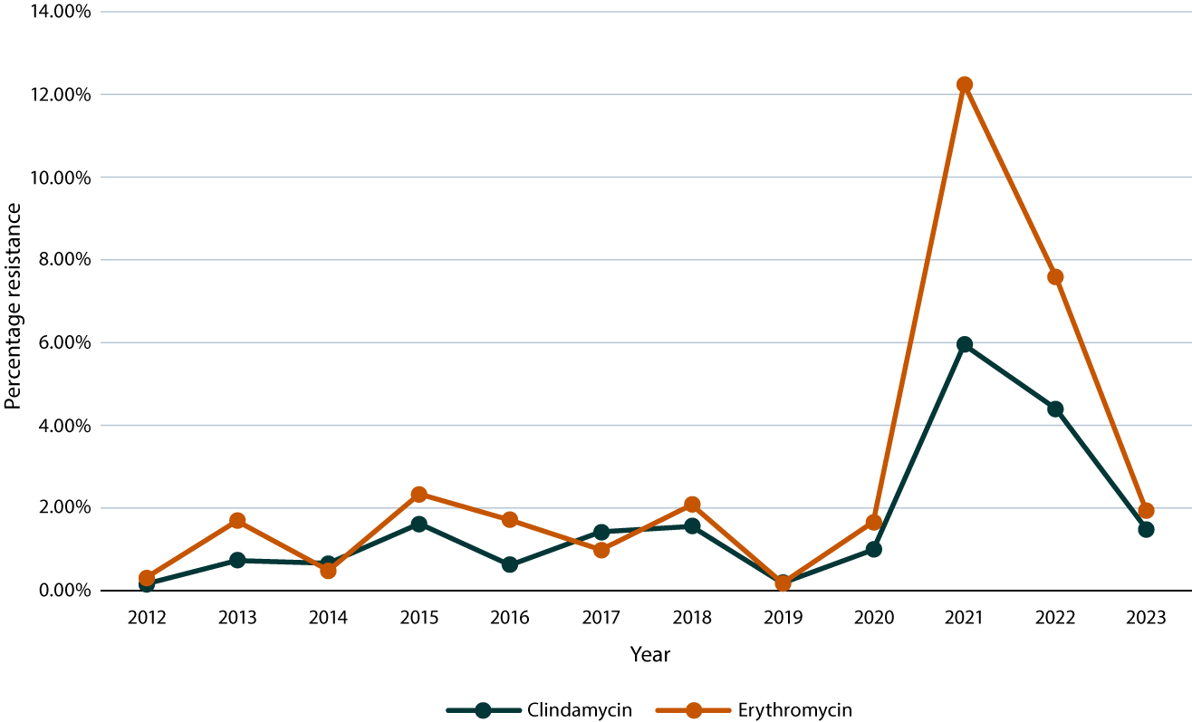

We analysed this spike in clindamycin-resistant GAS isolates in more detail, by looking at quarterly resistance rates over the 2020 to 2022 period. There was a steady increase in prevalence from the third quarter of 2020 to the first quarter of 2021, then a steady decline until the fourth quarter of 2022 (Figure 2). There was a difference in prevalence by season, with more clindamycin-resistant isolates obtained during the wet season (October–March). The proportion of clindamycin-resistant isolates varied temporally by region, with the peak in isolates obtained from the Top End in the first quarter of 2021 (9.0%) and the peak in isolates obtained from Central Australia in the second quarter of 2022 (5.6%) (Figure 3).

Figure 2: Clindamycin and erythromycin resistance rates in Group A streptococcus isolates in the Northern Territory, Australia, by quarter, January 2020 – December 2022

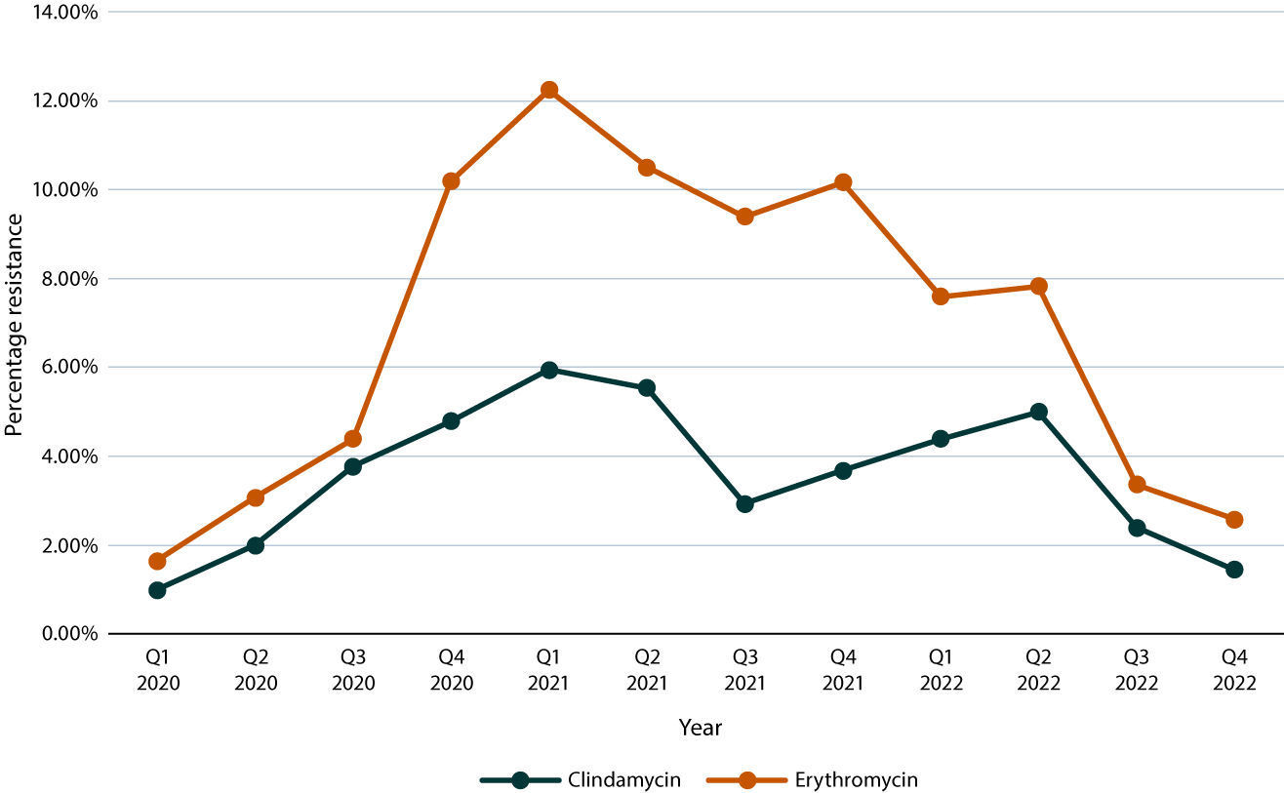

Figure 3: Clindamycin resistance rates in Group A streptococcus isolates in the Northern Territory, Australia, by quarter and region, January 2020 – December 2022

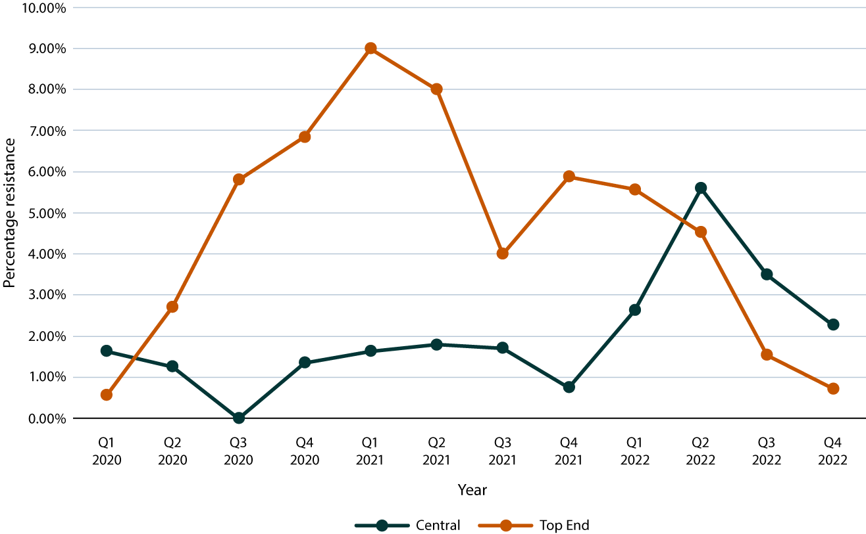

There was some variation of resistant isolates by age, gender and location (Table 1). The proportion of clindamycin-resistant isolates was higher in persons aged 18 years and over. However, 74% of the Northern Territory is above the age of 18 years.13 Resistant isolates occurred more frequently in males in 2020 and 2021 (54% and 57% respectively), but in females (60%) in 2022. ABS data reveals that 53% of the Northern Territory is male.13 The proportion of clindamycin-resistant isolates in rural regions in 2020 mirrored the ABS data on the proportion of the NT’s population resident in such regions (24%);13 much higher proportions of resistant isolates were obtained in rural regions in 2021 (59%) and 2022 (60%).

Table 1: Demographics of Northern Territory patients with clindamycin-resistant GAS isolates 2020 to 2022

| Category | Value | 2020 | | 2021 | | 2022 | |
| --- | --- | --- | --- | --- | --- | --- | --- |
| Number | %a | Number | %a | Number | %a |
| Total number of GAS isolates identified |  | 2,885 |  | 2,965 |  | 3,408 |  |
| Number of clindamycin-resistant GAS isolates |  | 78 | 100 | 132 | 100 | 96 | 100 |
| Age (years) | < 18 | 14 | 18 | 19 | 14 | 16 | 17 |
| 18+ | 64 | 82 | 113 | 86 | 80 | 83 |
| Sex | Male | 42 | 54 | 75 | 57 | 39 | 40 |
| Female | 36 | 46 | 57 | 43 | 57 | 60 |
| Locationb | Urban | 58 | 74 | 53 | 40 | 37 | 39 |
| Rural | 20 | 26 | 78 | 59 | 58 | 60 |
| No fixed address | 0 | 0 | 1 | 1 | 1 | 1 |
| Region | Top End | 67 | 86 | 114 | 86 | 56 | 58 |
| Central Australia | 11 | 14 | 18 | 14 | 40 | 42 |

a Percentage among clindamycin-resistant isolates for the indicated year.

b Urban: Darwin, Alice Springs, Palmerston; rural: Tennant, Gove, Katherine, all other towns and communities.

# Discussion

The striking finding in this study is the recent rise and fall in the Northern Territory GAS isolates’ resistance to clindamycin and erythromycin from mid 2020 to 2022, from a low baseline level of 1–2% in the preceding decade. Interestingly, by early 2023 resistance rates had almost declined to baseline. Analysis of the resistance isolates’ temporal trend revealed that Top End resistance peaked in the first quarter of 2021, followed by a similar rise and fall in Central Australia fifteen months later. The higher rates of resistance in 2021 and 2022 occurred more commonly in rural locations, suggesting Aboriginal and Torres Strait Island people were disproportionately affected.

Clindamycin is a semi-synthetic lincosamide and erythromycin is a macrolide antibiotic; both target the 50S subunit of the ribosome.14 Resistance to these antibiotics is mostly due to target site modification or efflux pumps.14 Target sites are modified through ribosomal methylation due to methylases encoded by the *erm* genes.15 Our data revealed that most GAS isolates resistant to clindamycin were also resistant to erythromycin, suggesting that an *erm* genotype mutation was most likely involved in promulgating resistance.

One possible explanation for the rise and fall in macrolide resistance in the Northern Territory is a clonal introduction of a resistant GAS type(s) to the Northern Territory, initially in the Top End and then spreading to Central Australia. The resistant GAS isolates were not stored, so are not available for genetic analysis. However, as invasive GAS (iGAS) is notifiable in the Northern Territory, these iGAS isolates are stored, and were available for analysis. However, invasive isolates represent only ~1% of all microbiologically confirmed GAS isolates in the Northern Territory. The rate of macrolide resistance inferred from *erm* gene analysis of these iGAS isolates revealed a 3% resistance rate, which had not changed.[1]

Several studies in the Northern Territory have previously demonstrated highly variable GAS *emm* types circulating.16 Data collected between 1987 and 2008 identified 1,819 GAS isolates encompassing 101 *emm* types.17 A further surveillance study supported this evidence, screening 49 households across three communities in the Northern Territory and identifying 43 different *emm* types appearing within the screened households.18 There were no *emm* types found to be associated with severe or invasive disease.18 There is a lack of published data on molecular typing of resistant isolates to identify *emm* clusters in the region.

As detailed in Table 2, international rates of clindamycin resistance vary by country. Similar results to our study were observed in a study conducted in Finland in 2014, where the proportions of clindamycin-resistant isolates were significantly higher in 2012 and 2013 compared with prior years.8 In this study, certain *emm* types transiently harboured *ermTR* genes, with the *emm33* isolates resistant to both clindamycin and erythromycin.8 A study in the USA demonstrated an increase in erythromycin-resistant GAS isolates in 2018 and 2019 belonging to six different *emm* types.7

Table 2: Reported international rates of clindamycin and erythromycin resistance

| Category | Reference | Years | Resistance | |
| --- | --- | --- | --- | --- |
| Clindamycin | Erythromycin |
| United States of America | 6 | 2006–2017 | 14.6% | 14.5% |
| Finland | 8 | 2010–2011 | 3% | N/Aa |
| 2012 | 23% | N/Aa |
| 2013 | 17% | N/Aa |
| Spain | 11 | 2007–2020 | 3.9% | 8.7% |
| Greece | 10 | 2016–2021 | 18.8% | 20.4% |
| China | 12 | 2010–2017 | 81.4% | 88.9% |

a N/A: not available.

Our study has several limitations. As this is a retrospective study, resistant non-invasive GAS isolates were not available for specific *emm* typing and resistance gene analysis. This limits the ability to identify *emm* types associated with resistance. As our study has only been conducted in the Northern Territory, the results do not reflect the overall national rates of clindamycin- and erythromycin-resistant GAS isolates. A nationwide study would be required to clarify rates of macrolide resistance and to identify epidemiology, risk factors, and genotypic and phenotypic features of resistant and susceptible GAS isolates. The role of the coronavirus disease 2019 (COVID-19) pandemic in relation to the findings was not assessed. Finally, we were unable to identify Indigenous status of patients, as this information is not available from hospitals’ electronic medical records.

Antimicrobial resistance is a major global health concern. While GAS remains susceptible to penicillin, the emergence of clindamycin resistance poses a threat to health care for patients with β-lactam allergies, or those with severe invasive GAS infections requiring toxin inhibition or better tissue penetration. Over the study period, clindamycin and erythromycin resistance in GAS isolated was found to peak from 2021 to 2022 in the Top End of the Northern Territory, then to migrate to Central Australia, followed by a decline in rates to near baseline 1–2% in 2023. These rates are low and we have not changed current antimicrobial practices. Our study highlights the need to expand genomic surveillance to include invasive and non-invasive GAS isolates to enable monitoring of regional trends and identification of temporal variations in resistant isolates. GAS transmission dynamics are complex and can vary between skin, throat and iGAS streptococcal populations.

# Acknowledgments

Microbiology staff, Territory Pathology, Royal Darwin Hospital.

Dr Ouli Xie, Dr Mark Davies and Dr Steve Tong, University of Melbourne.

# Author details

Dr Joanne C Nixon,1,2,3

Ms Jann Hennessy,2,3

A/Prof. Rob W Baird.2,4

1. Advanced Trainee Infectious Diseases and Acute and General Care Medicine.
2. Territory Pathology, Royal Darwin Hospital, Rocklands Drive TIWI NT 0810 Australia.
3. Department of Microbiology, Royal Darwin Hospital, Rocklands Drive TIWI NT 0810 Australia.
4. Clinical Microbiologist and Director of Pathology, Territory Pathology, Royal Darwin Hospital, Rocklands Drive TIWI NT 0810 Australia.

Corresponding author

Dr Joanne C Nixon

Address: Royal Darwin Hospital, Rocklands Drive, TIWI NT 0810 Australia.

Phone: +61 433 633 846

Email: joanne.nixon@nt.gov.au

# References

1. Birrell JM, Boyd R, Currie BJ, Anstey NM, Abeyaratne A, Majoni SW et al. Invasive group A streptococcal disease in the Northern Territory and the impact of melioidosis antibiotic prophylaxis. *Med J Aust*. 2022;217(10):544–5. doi: https://doi.org/10.5694/mja2.51739.
2. White BP, Siegrist EA. Increasing clindamycin resistance in group A streptococcus. *Lancet Infect Dis*. 2021;21(9):1208–9. doi: https://doi.org/10.1016/S1473-3099(21)00456-4.
3. Cortés-Penfield N, Ryder JH. Should linezolid replace clindamycin as the adjunctive antimicrobial of choice in group A streptococcal necrotizing soft tissue infection and toxic shock syndrome? A focused debate. *Clin Infect Dis*. 2023;76(2):346–50. doi: https://doi.org/10.1093/cid/ciac720.
4. Bowen AC, Mahé A, Hay RJ, Andrews RM, Steer AC, Tong SY et al. The global epidemiology of impetigo: a systematic review of the population prevalence of impetigo and pyoderma. *PLoS One*. 2015;10(8):e0136789. doi: https://doi.org/10.1371/journal.pone.0136789.
5. Yu D, Guo D, Zheng Y, Yang Y. A review of penicillin binding protein and group A Streptococcus with reduced-β-lactam susceptibility. *Front Cell Infect Microbiol*. 2023;13:1117160. doi: https://doi.org/10.3389/fcimb.2023.1117160.
6. Fay K. Onukwube J, Chochua S, Schaffner W, Ciesak P, Lynfield R et al. Patterns of antibiotic nonsusceptibility among invasive group A *Streptococcus* infections – United States, 2006–2017. *Clin Infect Dis*. 2021;73(11):1957–64. doi: https://doi.org/10.1093/cid/ciab575.
7. Li Y, Rivers J, Mathis S, Li Z, McGee L, Chochua S et al. Continued increase of erythromycin nonsusceptibility and clindamycin nonsusceptibility among invasive group A streptococci driven by genomic clusters, United States, 2018–2019. *Clin Infect Dis*. 2023;76(3):e1266–9. doi: https://doi.org/10.1093/cid/ciac468.
8. Pesola AK, Sihvonen R, Lindholm L, Pätäri-Sampo A. Clindamycin resistant *emm33* *Streptococcus* *pyogenes* emerged among invasive infections in Helsinki metropolitan area, Finland, 2012 to 2013. *Euro Surveill*. 2015;20(18):21117. doi: https://doi.org/10.2807/1560-7917.es2015.20.18.21117.
9. Powell LM, Choi SJ, Chipman CE, Grund ME, LaSala PR, Lukomski S. Emergence of erythromycin-resistant invasive group A *Streptococcus*, West Virginia, USA, 2020–2021. *Emerg Infect Dis*. 2023;29(5):898–908. doi: https://doi.org/10.3201/eid2905.221421.
10. Meletis G, Soulopoulos Ketikidis AL, Floropoulou N, Tychala A, Kagkalou G, Vasilaki O et al. Antimicrobial resistance rates of *Streptococcus pyogenes* in a Greek tertiary care hospital: 6-year data and literature review. *New Microbiol*. 2023;46(1):37–42.
11. Villalón P, Bárcena M, Medina-Pascual MJ, Garrido N, Pino-Rosa S, Carrasco G et al. National surveillance of tetracycline, erythromycin, and clindamycin resistance in invasive *Streptococcus pyogenes*: a retrospective study of the situation in Spain, 2007–2020. *Antibiotics (Basel)*. 2023;12(1):99. doi: https://doi.org/10.3390/antibiotics12010099.
12. Hua CZ, Yu H, Xu HM, Yang LH, Lin AW, Lyu Q et al. A multi-center clinical investigation on invasive Streptococcus pyogenes infection in China, 2010–2017. *BMC Pediatr*. 2019;19(1):181. doi: https://doi.org/10.1186/s12887-019-1536-1.
13. Australian Bureau of Statistics. Snapshot of Northern Territory: high level summary data for Northern Territory in 2021. [Webpage.] Canberra: Australian Bureau of Statistics; 28 June 2022. Available from: https://www.abs.gov.au/articles/snapshot-nt-2021.
14. Spízek J, Rezanka T. Lincomycin, clindamycin and their applications. *Appl. Microbiol. Biotechnol*. 2004;64(4):455–64. doi: https://doi.org/10.1007/s00253-003-1545-7.
15. Johnson AF, LaRock CN. Antibiotic treatment, mechanisms for failure, and adjunctive therapies for infections by group A streptococcus. *Front Microbiol*. 2021;12:760255. doi: https://doi.org/10.3389/fmicb.2021.760255.
16. Holt D, Giffard P. *Staphylococcus aureus* and *Streptococcus pyogenes* in the north: distinctively different. *Microbiol Aust*. 2022;43(3):104–7. doi: https://doi.org/10.1071/MA22034.
17. Giffard PM, Tong SYC, Holt DC, Ralph AP, Currie BJ. Concerns for efficacy of a 30-valent M-protein-based *Streptococcus pyogenes* vaccine in regions with high rates of rheumatic heart disease. *PLoS Negl Trop Dis*. 2019;13(7):e0007511. doi: https://doi.org/10.1371/journal.pntd.0007511.
18. Meumann EM, Krause VL, Baird R, Currie BJ. Using genomics to understand the epidemiology of infectious diseases in the Northern Territory of Australia. *Trop Med Infect Dis*. 2022;7(8):181. doi: https://doi.org/10.3390/tropicalmed7080181.

About Communicable Diseases Intelligence

Communicable Diseases Intelligence (CDI) is a peer-reviewed scientific journal published by the Health Protection Policy & Surveillance Division, Department of Health and Aged Care. The journal aims to disseminate information on the epidemiology, surveillance, prevention and control of communicable diseases of relevance to Australia.

© Commonwealth of Australia as represented by the Department of Health and Aged Care

ISSN: 2209-6051 Online

This journal is indexed by Index Medicus and Medline.

This publication is licensed under a Creative Commons Attribution-NonCommercial-NoDerivatives 4.0 International Licence (CC BY-NC-ND) available from https://creativecommons.org/licenses/by-nc-nd/4.0/legalcode (Licence). You must read and understand the Licence before using any material from this publication.

Restrictions

The Licence does not cover, and there is no permission given for, use of any of the following material found in this publication (if any):

* the Commonwealth Coat of Arms (by way of information, the terms under which the Coat of Arms may be used can be found at www.pmc.gov.au/resources/commonwealth-coat-arms-information-and-guidelines);
* any logos (including the Department of Health and Aged Care’s logo) and trademarks;
* any photographs and images;
* any signatures; and
* any material belonging to third parties.

Disclaimer

Opinions expressed in *Communicable Diseases Intelligence* are those of the authors and not necessarily those of the Australian Government Department of Health and Aged Care or the Communicable Diseases Network Australia. Data may be subject to revision.

Enquiries

Enquiries regarding any other use of this publication should be addressed to the CDI Editor at: [cdi.editor@health.gov.au](mailto:cdi.editor@health.gov.au)

Communicable Diseases Network Australia

Communicable Diseases Intelligence contributes to the work of the Communicable Diseases Network Australia. www.health.gov.au/cdna

**Editor**: Christina Bareja • **Deputy Editor**: Simon Petrie • **Design and Production**: Lisa Thompson

**Editorial Advisory Board**: David Durrheim, Mark Ferson, Clare Huppatz, John Kaldor, Martyn Kirk, Meru Sheel and Stephanie Williams

Contacts

CDI is produced by:

Health Protection Policy & Surveillance Division, Australian Government Department of Health and Aged Care,  
GPO Box 9848, (MDP 6) CANBERRA ACT 2601

Website: [www.health.gov.au/cdi](http://www.health.gov.au/cdi)

Email: [cdi.editor@health.gov.au](mailto:cdi.editor@health.gov.au)

Submit an Article

You are invited to submit your next communicable disease related article to the *Communicable Diseases Intelligence* (CDI) for consideration. More information regarding CDI can be found at: www.health.gov.au/cdi.

Further enquiries should be directed to: [cdi.editor@health.gov.au](mailto:cdi.editor@health.gov.au)

1. Personal communication, Dr Ouli Xie.