• Volume 48 • https://doi.org/10.33321/cdi.2024.48.26 • Electronic publication date: 17/07/2024

The effect of COVID-19 public health measures on nationally notifiable diseases in Australia during 2020 and 2021

Anna C Rafferty, Anna Glynn-Robinson, Dharshi Thangarajah, Ben Polkinghorne

# Abstract

The novel coronavirus disease 2019 (COVID-19) pandemic prompted Australia to implement large-scale domestic lockdowns and halted international travel. However, the impact of these measures on national notifiable diseases is yet to been fully examined. In this paper, we expand on a preliminary analysis conducted in 2020, and conducted a retrospective, observational study using nationally notifiable disease surveillance system (NNDSS) data to examine if the changes identified in the first half of 2020 continued in Australia through wide-scale public health measures.

We found that there was an overall reduction in most of Australia’s nationally notifiable diseases over the two pandemic years during which wide-scale public health measures remained in operation, particularly for 23 social and imported diseases. We observed an increase in notifications for psittacosis, leptospirosis and legionellosis during these years. The public health measures implemented in 2020 and 2021 (including lockdowns, mask mandates, and increased hand and respiratory hygiene) may have contributed to the observed notification reductions. The outcomes of these measures’ implementation provide insights into broader communicable disease control for mass outbreaks and pandemic responses.

Keywords: Australia; communicable disease; COVID-19; surveillance

# Introduction

In response to the novel coronavirus disease 2019 (COVID-19) pandemic and its rapid international spread, Australia implemented large-scale domestic lockdowns and halted international travel in mid-March 2020.1 At the national and jurisdictional levels, significant public health measures were implemented over different periods in 2020 and 2021 and included domestic border closures, curfews, mask mandates, and lockdown zones.

A preliminary report reviewed the impact that these public health restrictions had on other notifiable diseases in Australia for the first half of 2020.1 This analysis found there were reductions in notifications reported for several notifiable diseases in Australia, most notable in imported diseases, social diseases, and foodborne diseases. The analysis also identified small increases in diseases frequently seen in Australia, such as environmental exposure-related diseases (legionellosis) or vector-borne diseases (Ross River virus).1 Similar analyses have been conducted internationally, with global trends showing reductions in respiratory, gastrointestinal, and vaccine-preventable illnesses across several countries, attributed in part to physical distancing and improved hygiene.2–7

The longer-term impact of these measures on notifiable diseases in Australia has not been fully explored. In this paper, we expand on the preliminary analysis conducted in 2020, examining changes in nationally notifiable diseases in Australia during periods of wide-scale public health measures. The purpose of this analysis is to help inform future public health responses and to understand how the COVID-19 pandemic impacted communicable disease epidemiology in Australia.

# Methods

Excluding COVID-19, all notifiable disease notifications with a diagnosis date from 1 January 2015 to 31 December 2021 were extracted from the National Notifiable Diseases Surveillance System (NNDSS) on 22 February 2022. Diagnosis date represents the true onset date of disease; in the absence of a true onset date, the earliest of the following dates was used: specimen collection date, notification date, or notification received date.

We calculated percentage changes between the first two years of the COVID-19 pandemic (2020 and 2021, hereafter identified as ‘the pandemic years’) and 2019 for all diseases reported to the NNDSS, and between the pandemic years and a static five-year pre-pandemic mean (2015–2019) for all diseases except rotavirus, which had been only nationally notifiable for three years at the time of analysis. Notification rates were calculated for diseases where more than ten notifications were reported in each pandemic year (2020 and 2021) using national annual mid-year population estimates from the Australian Bureau of Statistics.8

We used univariate negative binomial regression to calculate notification rate ratios (NRRs) and their associated 95% confidence intervals (CI) and *p* values. Statistical analysis was conducted in STATA 17.9

We categorised notifiable diseases based on transmission dynamics, in line with the categories used in the preliminary analysis.1 These included: ‘social diseases’ requiring person-to-person contact; ‘imported diseases’ acquired overseas; and ‘foodborne diseases’ potentially associated with food consumption. We categorised additional diseases that did not meet the above criteria as ‘other diseases’ for the purpose of this analysis. Due to the different transmission routes of the two major Legionella species in Australia, *L. longbeachae* and *L. pneumophila*, we analysed these species separately.10 The Australian National University provided ethics approval for this study (HREC Protocol 2022/273).

# Results

We present notification counts and percentage changes (Table 1) and calculated NRRs and significance values (Table 2) for notifiable diseases in Australia. Decreases were observed across the majority of notifiable diseases. Increases in notifications were observed for psittacosis, leptospirosis, and legionellosis.

Overall, there was a 57% reduction in notifications reported to the NNDSS in 2020 compared with 2019, and a 39% reduction compared with the static five-year mean (2015–2019). In 2021, there were 62% and 47% fewer notifications compared with 2019 and the static five-year (2015–2019) mean, respectively. We present in detail the epidemiology of notifiable diseases where there was an observed increase or decrease when compared with 2019 and the static five-year mean.

Table 1: Nationally notifiable diseases notification numbers by disease group,a year and static five-year mean, 1 January to 31 December, 2015–2021, Australia

| Disease group | Disease | Notifications (1 January – 31 December) | | | | Percent difference (2020) | | Percent difference (2021) | |
| --- | --- | --- | --- | --- | --- | --- | --- | --- | --- |
| 2019 | 5-year mean 2015–2019 | 2020 | 2021 | vs. 2019 | vs. 5-year mean | vs. 2019 | vs. 5-year mean |
| Bloodborne diseases | Hepatitis B (newly acquired) | 164 | 154 | 122 | 79 | -26% | -21% | -52% | -49% |
| Hepatitis B (unspecified) | 5,636 | 5,921 | 4,976 | 4,917 | -12% | -16% | -13% | -17% |
| Hepatitis C (newly acquired) | 793 | 717 | 676 | 726 | -15% | -6% | -8% | 1% |
| Hepatitis C (unspecified) | 8,390 | 9,799 | 7,331 | 6,917 | -13% | -25% | -18% | -29% |
| Hepatitis D | 68 | 66 | 70 | 85 | 3% | 5% | 25% | 28% |
| Gastrointestinal diseases | Botulism | 2 | 1 | 1 | 5 | -50% | -29% | 150% | 257% |
| Campylobacteriosisb | 36,132 | 28,953 | 31,957 | 37,467 | -12% | 10% | 4% | 29% |
| Cholera | 2 | 1 | 0 | 1 | -100% | -100% | -50% | -29% |
| Cryptosporidiosis | 2,677 | 3,973 | 2,443 | 1,836 | -9% | -39% | -31% | -54% |
| Haemolytic uraemic syndrome (HUS) | 19 | 16 | 14 | 7 | -26% | -13% | -63% | -56% |
| Hepatitis A | 246 | 244 | 85 | 24 | -65% | -65% | -90% | -90% |
| Hepatitis E | 55 | 45 | 31 | 10 | -44% | -32% | -82% | -78% |
| Listeriosis | 52 | 70 | 44 | 44 | -15% | -37% | -15% | -37% |
| Paratyphoid | 116 | 84 | 38 | 5 | -67% | -55% | -96% | -94% |
| Salmonellosis | 14,693 | 16,016 | 12,040 | 10,730 | -18% | -25% | -27% | -33% |
| Shigellosisc | 3,154 | 1,971 | 1,602 | 475 | -49% | -19% | -85% | -76% |
|  | Shiga toxin-producing *E. coli* (STEC) | 655 | 439 | 570 | 621 | -13% | 30% | -5% | 42% |
| Typhoid fever | 202 | 148 | 88 | 16 | -56% | -41% | -92% | -89% |
| Other bacterial diseases | Legionellosis | 440 | 401 | 527 | 574 | 20% | 31% | 30% | 43% |
| Leprosy | 10 | 12 | 6 | 13 | -40% | -50% | 30% | 8% |
| Meningococcal disease (invasive) | 207 | 260 | 90 | 74 | -57% | -65% | -64% | -72% |
| Tuberculosis | 1,511 | 1,400 | 1,612 | 1,452 | 7% | 15% | -4% | 4% |
| Sexually transmissible infections | Chlamydial infection | 107,143 | 98,797 | 91,285 | 85,932 | -15% | -8% | -20% | -13% |
| Gonococcal infection | 34,749 | 27,254 | 29,846 | 26,811 | -14% | 10% | -23% | -2% |
| Syphilis < 2 years | 5,925 | 4,355 | 5,372 | 5,604 | -9% | 23% | -5% | 29% |
| Syphilis > 2 years or unspecified duration | 2,508 | 2,116 | 2,074 | 1,888 | -17% | -2% | -25% | -11% |
| Infectious syphilis | 8,433 | 6,472 | 7,446 | 7,492 | -12% | 15% | -11% | 16% |
| Syphilis congenital | 4 | 5 | 17 | 15 | 325% | 227% | 275% | 188% |
| Vectorborne diseases | Barmah Forest virus infection | 241 | 395 | 731 | 383 | 203% | 85% | 59% | -3% |
| Chikungunya virus infection | 84 | 90 | 33 | 2 | -61% | -63% | -98% | -98% |
| Dengue virus infection | 1,465 | 1,497 | 224 | 10 | -85% | -85% | -99% | -99% |
| Flavivirus infection (unspecified) | 10 | 32 | 13 | 3 | 30% | -60% | -70% | -91% |
| Japanese encephalitis virus infection | 3 | 2 | 1 | 1 | -67% | -43% | -67% | -43% |
| Malaria | 379 | 338 | 158 | 56 | -58% | -53% | -85% | -83% |
| Murray Valley encephalitis virus infection | 0 | 1 | 0 | 1 | — | — | — | — |
|  | Ross River virus infection | 2,965 | 5,255 | 6,309 | 3,085 | 113% | 20% | 4% | -41% |
| West Nile/Kunjin virus infection | 1 | 1 | 0 | 0 | -100% | -100% | -100% | -100% |
| Vaccine preventable diseases | Diphtheria | 7 | 7 | 9 | 6 | 29% | 25% | -14% | -17% |
| *Haemophilus influenzae* type b | 22 | 18 | 19 | 18 | -14% | 7% | -18% | 1% |
| Influenza (laboratory confirmed) | 313,447 | 163,007 | 21,362 | 754 | -93% | -87% | -99.9% | -99.9% |
| Measles | 284 | 128 | 25 | 0 | -91% | -80% | -100% | -100% |
| Mumps | 172 | 613 | 151 | 20 | -12% | -75% | -88% | -97% |
| Pertussis | 12,026 | 15,906 | 3,458 | 555 | -71% | -78% | -95% | -97% |
| Pneumococcal disease (invasive) | 2,134 | 1,876 | 1,116 | 1,341 | -48% | -40% | -37% | -29% |
| Rotavirusd | 6,200 | — | 1,707 | 2,581 | -72% | — | -58% | — |
| Rubella | 20 | 15 | 3 | 3 | -85% | -79% | -85% | -79% |
| Tetanus | 3 | 4 | 7 | 3 | 133% | 84% | 0% | -21% |
| Varicella zoster (chickenpox) | 4,432 | 3,545 | 2,894 | 1,990 | -35% | -18% | -55% | -44% |
| Varicella zoster (shingles) | 15,215 | 10,495 | 16,088 | 10,628 | 6% | 53% | -30% | 1% |
| Varicella zoster (unspecified) | 13,130 | 14,145 | 12,447 | 20,504 | -5% | -12% | 56% | 45% |
| Zoonotic diseases | Brucellosis | 9 | 19 | 18 | 16 | 100% | -4% | 78% | -15% |
| Creutzfeld-Jakob disease | 41 | 40 | 31 | 25 | -24% | -22% | -39% | -37% |
| Leptospirosis | 82 | 114 | 97 | 247 | 18% | -15% | 201% | 116% |
| Pscittacosis | 23 | 19 | 64 | 35 | 178% | 244% | 52% | 88% |
|  | Q fever | 567 | 545 | 452 | 484 | -20% | -17% | -15% | -11% |
| Tularaemia | 0 | 0 | 2 | 0 | — | — | — | — |

a COVID-19 and diseases with no notifications during the study period are excluded.

b New South Wales commenced reporting of campylobacteriosis in April 2017.

c Case definition for shigellosis was changed in July 2018.

d Rotavirus became nationally notifiable in 2017.

Table 2: Notification rate ratios (NRR) of selected diseases in 2020 and 2021, compared with pre-pandemic years 2015–2019

| Disease group | Disease | Mean notification rate per 100,000 population | | | | NRR compared with 2019a | | | | NRR compared with 5-year meana,b | | | |
| --- | --- | --- | --- | --- | --- | --- | --- | --- | --- | --- | --- | --- | --- |
| 2020 | | 2021 | | 2020 | | 2021 | |
| 2019 | 5-year meanb | 2020 | 2021 | NRR | 95% CI | NRR | 95% CI | NRR | 95% CI | NRR | 95% CI |
| Bloodborne diseases | Hepatitis B (newly acquired) | 0.64 | 0.62 | 0.48 | 0.31 | 0.74 | 0.59–0.94 | 0.48 | 0.37–0.63 | 0.77 | 0.63–0.93 | 0.50 | 0.39–0.62 |
| Hepatitis B (unspecified) | 19 | 24 | 19 | 19 | 0.88 | 0.80–0.96 | 0.87 | 0.79–0.95 | 0.81 | 0.73–0.90 | 0.80 | 0.72–0.88 |
| Hepatitis C (newly acquired) | 3.10 | 2.90 | 2.63 | 2.82 | 0.85 | 0.64–1.13 | 0.91 | 0.68–1.21 | 0.91 | 0.72–1.15 | 0.97 | 0.77–1.23 |
| Hepatitis C (unspecified) | 33 | 40 | 29 | 27 | 0.87 | 0.75–1.01 | 0.82 | 0.70–0.96 | 0.72 | 0.59–0.88 | 0.68 | 0.55–0.83 |
| Hepatitis D | 0.27 | 0.27 | 0.27 | 0.33 | 1.02 | 0.73–1.43 | 1.24 | 0.90–1.71 | 1.02 | 0.79–1.32 | 1.23 | 0.97–1.56 |
| Gastrointestinal diseases | Campylobacteriosisc | 141 | 116 | 124 | 146 | 0.88 | 0.67–1.16 | 1.03 | 0.78–1.36 | 1.07 | 0.80–1.42 | 1.25 | 0.94–1.66 |
| Cryptosporidiosis | 10 | 16 | 9.51 | 7.13 | 0.91 | 0.57–1.45 | 0.68 | 0.43–1.09 | 0.59 | 0.36–0.98 | 0.44 | 0.27–0.73 |
| Hepatitis A | 0.96 | 0.98 | 0.33 | 0.09 | 0.34 | 0.14–0.84 | 0.10 | 0.04–0.25 | 0.34 | 0.17–0.68 | 0.09 | 0.04–0.21 |
| Hepatitis E | 0.22 | 0.18 | 0.12 | 0.04 | 0.56 | 0.36–0.87 | 0.18 | 0.09–0.35 | 0.66 | 0.45–0.96 | 0.21 | 0.11–0.40 |
| Listeriosis | 0.20 | 0.28 | 0.17 | 0.17 | 0.84 | 0.56–1.26 | 0.84 | 0.56–1.26 | 0.60 | 0.42–0.87 | 0.60 | 0.42–0.87 |
| Salmonellosis | 57 | 65 | 47 | 42 | 0.82 | 0.66–1.01 | 0.73 | 0.59–0.90 | 0.72 | 0.59–0.88 | 0.64 | 0.53–0.78 |
| Shigellosisd | 12 | 7.89 | 6.24 | 1.85 | 0.51 | 0.27–0.95 | 0.15 | 0.08–0.28 | 0.79 | 0.40–1.54 | 0.23 | 0.12–0.46 |
| Shiga toxin-producing *E. coli* (STEC) | 2.56 | 1.75 | 2.22 | 2.41 | 0.87 | 0.31–2.39 | 0.94 | 0.34–2.59 | 1.26 | 0.53–3.02 | 1.37 | 0.58–3.28 |
| Typhoid fever | 0.79 | 0.59 | 0.34 | 0.06 | 0.43 | 0.28–0.67 | 0.08 | 0.04–0.15 | 0.58 | 0.37–0.91 | 0.10 | 0.06–0.20 |
| Other diseases | Legionellosis | 1.72 | 1.62 | 2.05 | 2.23 | 1.19 | 1.05–1.35 | 1.30 | 1.14–1.47 | 1.27 | 1.14–1.42 | 1.38 | 1.24–1.53 |
| *L. longbeachae* | 0.76 | 0.67 | 1.05 | 1.10 | 1.37 | 1.14–1.65 | 1.45 | 1.21–1.74 | 1.57 | 1.36–1.81 | 1.65 | 1.43–1.90 |
| *L. pneumophila* | 0.90 | 0.90 | 0.91 | 1.01 | 1.01 | 0.84–1.21 | 1.11 | 0.93–1.33 | 1.01 | 0.88–1.17 | 1.12 | 0.98–1.28 |
|  | Meningococcal disease (invasive) | 0.81 | 1.05 | 0.35 | 0.29 | 0.43 | 0.24–0.77 | 0.35 | 0.20–0.63 | 0.33 | 0.20–0.55 | 0.27 | 0.16–0.46 |
|  | Tuberculosis | 5.91 | 5.64 | 6.28 | 5.64 | 1.06 | 0.98–1.15 | 0.95 | 0.88–1.03 | 1.11 | 1.03–1.20 | 1.00 | 0.93–1.08 |
| Sexually transmissible infections | Chlamydial infection | 419 | 398 | 355 | 334 | 0.85 | 0.75–0.95 | 0.80 | 0.71–0.89 | 0.89 | 0.81–0.99 | 0.84 | 0.76–0.93 |
| Gonococcal infection | 136 | 110 | 116 | 104 | 0.85 | 0.59–1.23 | 0.77 | 0.53–1.11 | 1.06 | 0.75–1.51 | 0.95 | 0.67–1.35 |
| Syphilis < 2 years | 23 | 17 | 21 | 22 | 0.90 | 0.59–1.37 | 0.94 | 0.62–1.43 | 1.20 | 0.78–1.83 | 1.24 | 0.81–1.91 |
| Syphilis > 2 years or unspecified duration | 9.81 | 8.53 | 8.08 | 7.34 | 0.82 | 0.73–0.92 | 0.75 | 0.67–0.84 | 0.95 | 0.81–1.11 | 0.86 | 0.73–1.01 |
| Infectious syphilis | 33 | 26 | 29 | 29 | 0.88 | 0.65–1.19 | 0.88 | 0.65–1.20 | 1.11 | 0.80–1.55 | 1.12 | 0.80–1.56 |
| Vectorborne diseases | Barmah Forest virus infection | 0.94 | 1.60 | 2.85 | 1.49 | 3.02 | 1.65–5.51 | 1.58 | 0.86–2.89 | 1.77 | 0.95–3.31 | 0.93 | 0.50–1.74 |
| Dengue virus infection | 5.73 | 6.07 | 0.87 | 0.04 | 0.15 | 0.07–0.33 | 0.01 | 0.00–0.02 | 0.14 | 0.08–0.27 | 0.01 | 0.00–0.02 |
| Malaria | 1.48 | 1.36 | 0.62 | 0.22 | 0.41 | 0.27–0.63 | 0.15 | 0.09–0.24 | 0.45 | 0.32–0.64 | 0.16 | 0.11–0.24 |
| Ross River virus infection | 12 | 21 | 25 | 12 | 2.12 | 0.80–5.58 | 1.03 | 0.39–2.72 | 1.15 | 0.47–2.79 | 0.56 | 0.23–1.36 |
| Vaccine preventable diseases | *Haemophilus influenzae* type b | 0.09 | 0.07 | 0.07 | 0.07 | 0.86 | 0.47–1.59 | 0.81 | 0.44–1.51 | 1.03 | 0.63–1.69 | 0.97 | 0.59–1.62 |
| Influenza (laboratory confirmed) | 1226 | 653 | 83 | 2.93 | 0.07 | 0.02–0.21 | 0.002 | 0.00–0.01 | 0.13 | 0.04–0.38 | 0.004 | 0.00–0.01 |
| Mumps | 0.67 | 2.49 | 0.59 | 0.08 | 0.87 | 0.62–1.23 | 0.12 | 0.07–0.20 | 0.24 | 0.09–0.61 | 0.03 | 0.01–0.09 |
| Pertussis | 47 | 65 | 13 | 2.16 | 0.29 | 0.16–0.52 | 0.05 | 0.02–0.08 | 0.21 | 0.12–0.36 | 0.03 | 0.02–0.06 |
| Pneumococcal disease (invasive) | 8.35 | 7.55 | 4.35 | 5.21 | 0.52 | 0.41–0.66 | 0.62 | 0.49–0.79 | 0.58 | 0.47–0.71 | 0.69 | 0.56–0.85 |
| Rotaviruse | 24 | 19 | 6.65 | 10 | 0.27 | 0.12–0.61 | 0.41 | 0.19–0.92 |  |  |  |  |
| Varicella zoster (chickenpox) | 17 | 14 | 11 | 7.73 | 0.65 | 0.42–1.01 | 0.45 | 0.29–0.69 | 0.79 | 0.54–1.16 | 0.54 | 0.37–0.80 |
|  | Varicella zoster (shingles) | 60 | 42 | 63 | 41 | 1.05 | 0.58–1.92 | 0.69 | 0.38–1.26 | 1.49 | 0.84–2.65 | 0.98 | 0.55–1.75 |
|  | Varicella zoster (unspecified) | 51 | 57 | 48 | 80 | 0.94 | 0.78–1.14 | 1.55 | 1.28–1.88 | 0.85 | 0.71–1.01 | 1.39 | 1.17–1.66 |
|  | All varicella | 128 | 113 | 122 | 129 | 0.95 | 0.76–1.20 | 1.00 | 0.80–1.26 | 1.08 | 0.87–1.33 | 1.13 | 0.92–1.40 |
| Zoonotic diseases | Brucellosis | 0.04 | 0.08 | 0.07 | 0.06 | 1.99 | 0.89–4.43 | 1.77 | 0.78–3.99 | 0.92 | 0.50–1.72 | 0.82 | 0.43–1.55 |
| Creutzfeld-Jakob disease | 0.16 | 0.16 | 0.12 | 0.10 | 0.75 | 0.47–1.20 | 0.61 | 0.37–1.00 | 0.76 | 0.52–1.10 | 0.61 | 0.40–0.92 |
| Leptospirosis | 0.32 | 0.46 | 0.38 | 0.96 | 1.18 | 0.68–2.03 | 2.99 | 1.77–5.05 | 0.82 | 0.49–1.37 | 2.08 | 1.27–3.40 |
| Pscittacosis | 0.09 | 0.08 | 0.25 | 0.14 | 2.77 | 1.72–4.46 | 1.51 | 0.89–2.56 | 3.32 | 2.41–4.56 | 1.81 | 1.23–2.67 |
| Q fever | 2.22 | 2.20 | 1.76 | 1.88 | 0.79 | 0.64–0.99 | 0.85 | 0.68–1.05 | 0.80 | 0.67–0.95 | 0.85 | 0.72–1.01 |

a Statistically significant decreases in NRR, for either pandemic year relative to pre-pandemic years, are shown in blue; statistically significant increases in the same metric are shown in orange.

b Static five-year mean (2015–2019).

c New South Wales commenced reporting of campylobacteriosis in April 2017.

d The case definition for shigellosis was changed in July 2018.

e Rotavirus became notifiable in 2017.

## Social diseases

### Chlamydia

In 2020, there were 91,285 chlamydia notifications, 15% lower than in 2019 (n = 107,143), and 8% lower than the static five-year mean (n = 98,797) (Table 1, Figure 1). In 2021, there were 85,932 chlamydia notifications, which was 20% lower than 2019 and 13% lower than the static five-year mean (Table 1, Figure 1).

In 2020, the notification rate for chlamydia was 355 per 100,000 population, lower than the rate of 419 per 100,000 population in 2019 (NRR = 0.85; 95% CI: 0.75–0.95), and 398 per 100,000 population per year for the static five-year pre-pandemic mean (NRR = 0.89; 95% CI: 0.81–0.99). In 2021 the rate decreased to 334 per 100,000 population and was significantly lower than in 2019 (NRR = 0.80; 95% CI: 0.71–0.89) and when compared to the static five-year pre-pandemic mean notification rate (NRR = 0.84; 95% CI: 0.76-0.93) (Table 2).

Figure 1: Chlamydia notifications by year and month of diagnosis, 1 January 2020 to 31 December 2021, and static five-year mean (2015–2019), Australia

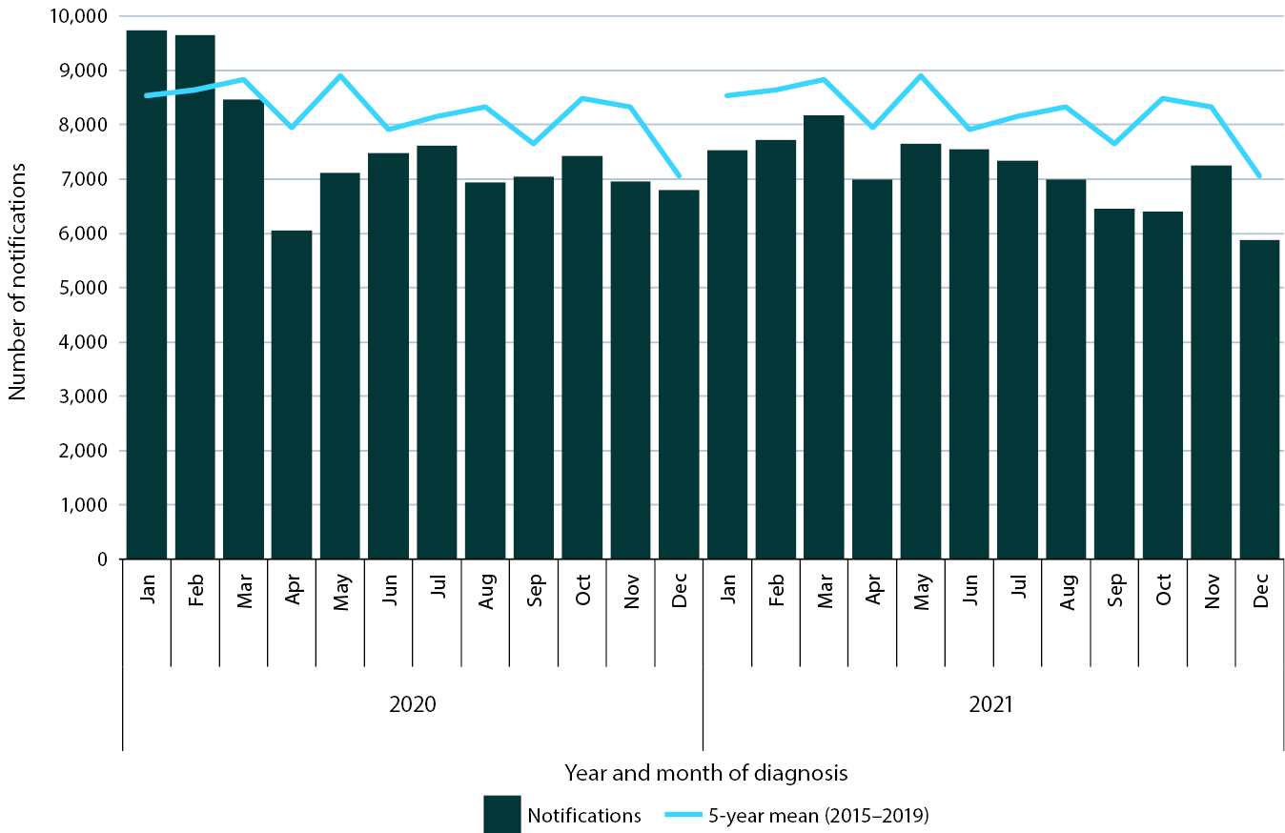

### Laboratory-confirmed influenza

There were 93% fewer cases of laboratory-confirmed influenza reported to the NNDSS in 2020 (n = 21,362) and 99.9% (n = 754) in 2021, than in 2019 (n = 313,447) (Figure 2). A decrease was also observed against the pre-pandemic static five-year mean (n = 163,007), with 87% fewer cases reported in 2020, and 99.9% fewer in 2021 (Table 1).

This corresponded to a statistically significant decrease in the notification rates of laboratory-confirmed influenza. In 2020, the notification rate was 83 per 100,000 population, compared with 1,226 per 100,000 population in 2019 (NRR = 0.07; 95% CI: 0.02–0.21), and 653 per 100,000 population per year for the static five-year pre-pandemic mean (NRR = 0.13; 95% CI: 0.04–0.38). In 2021, the notification rate was 3 per 100,000 population, which was significantly lower than in 2019 (NRR = 0.002; 95% CI: 0.00–0.01) and compared to the static five-year pre-pandemic notification rate (NRR = 0.004; 95% CI: 0.00–0.01) (Table 2).

Figure 2: Laboratory-confirmed influenza notifications by year and month of diagnosis, 1 January 2020 to 31 December 2021, and static five-year mean (2015–2019), Australia

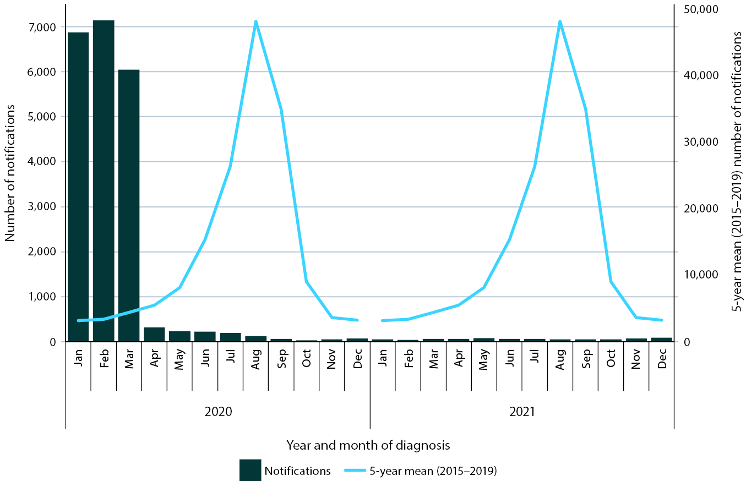

### Rotavirus

Compared with notifications in 2019 (n = 6,200), there were 72% fewer cases of rotavirus reported to the NNDSS in 2020 (n = 1,707) and 58% fewer (n = 2,581) in 2021 (Table 1). Rotavirus notifications were below baseline levels throughout the majority of 2020 and 2021, with notifications increasing from September 2021 (Figure 3).

This corresponded to a statistically significant decrease in the notification rates of rotavirus. In 2020, the notification rate of rotavirus was 7 per 100,000 population, compared with 24 per 100,000 population in 2019 (NRR = 0.27; 95% CI: 0.12–0.61). In 2021 the notification rate remained lower than 2019, with 10 notifications per 100,000 population (NRR = 0.41; 95% CI: 0.19–0.92) (Table 2).

Figure 3: Rotavirus notifications by year and month of diagnosis, 1 January 2020 to 31 December 2021, Australia

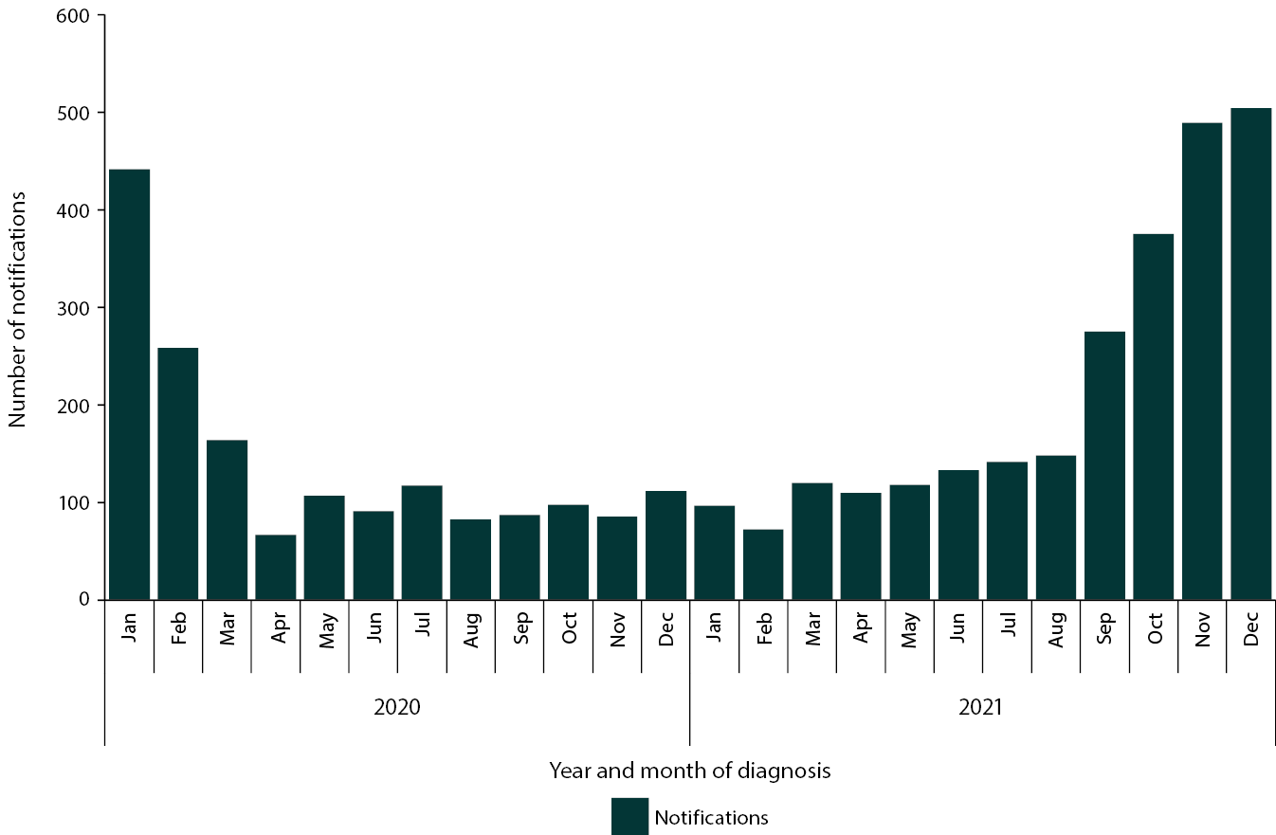

### Invasive meningococcal disease (IMD)

In 2020, there were 57% fewer cases of IMD reported to the NNDSS (n = 90), and 64% fewer (n = 74) in 2021, than in 2019 (n = 207). There were 65% fewer cases reported in 2020 and 72% fewer in 2021 compared with the pre-pandemic static five-year mean (n = 260) (Table 1). This is consistent with a statistically significant decrease in the notification rates of IMD per 100,000 population in 2020 and 2021 when compared with the 2019 and the static five-year mean (Table 2).

### Shigellosis

In 2020, there were 1,602 shigellosis notifications reported, 49% fewer than in with 2019 (n = 3,154) and 19% lower than the static five-year mean (n = 1,971) (Figure 4, Table 1). In 2021, there were 475 shigellosis notifications reported, 85% lower than in 2019 and 76% lower than the static five-year mean (Table 1).

These decreases in total notifications corresponded to a statistically significant decrease in the notification rates of shigellosis per 100,000 population in 2020 when compared with 2019 only. The decrease in 2021 was significant compared with both the 2019 and the static five-year mean (Table 2).

Figure 4: Shigellosis notifications by year and month of diagnosis, 1 January 2020 to 31 December 2021, and static five-year mean (2015–2019), Australia

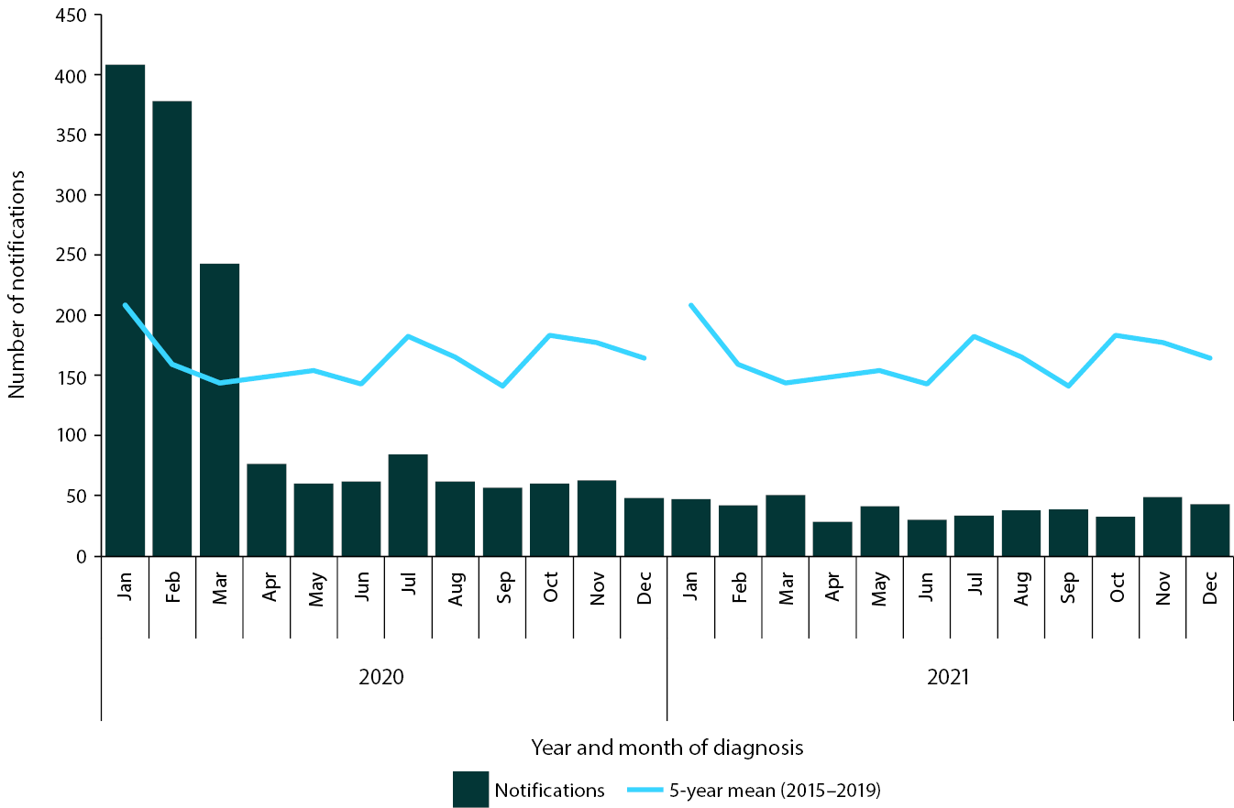

## Foodborne diseases

### Salmonellosis

In 2020, there were 12,040 salmonellosis notifications reported, 18% lower than in 2019 (n = 14,693) and 25% lower than the static five-year mean (n = 16,016) (Table 1). In 2021, there were 10,730 salmonellosis notifications reported, 27% lower than in 2019 and 33% lower than the static five-year mean (Table 1). Notifications continued to follow the known seasonal patterns in 2020 and 2021 (Figure 5).

Decreases in total salmonellosis notifications corresponded to statistically significant decreases in the notification rates in 2020 compared with the static five-year mean. The decrease in 2021 was significant compared to both the 2019 and the static five-year mean (Table 2).

Figure 5: Salmonellosis notifications by year and month of diagnosis, 1 January 2020 to 31 December 2021, and static five-year mean (2015–2019), Australia

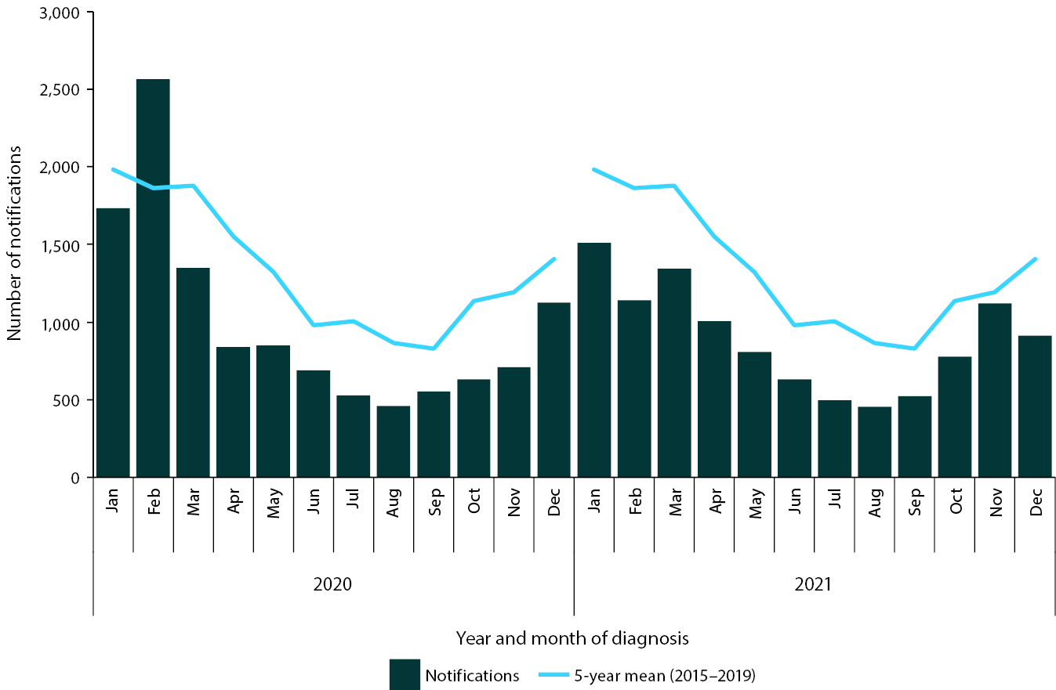

## Imported diseases

Overall, notifications of imported diseases including chikungunya virus infection, cholera, dengue virus infection, malaria, measles, paratyphoid fever, and typhoid fever were all below their respective static five-year monthly means at the beginning of 2020, with further decreases in notifications observed from April 2020 onwards when Australia closed its international borders. Only a small number of notifications of selected imported diseases (dengue virus infection, malaria, paratyphoid fever, and typhoid fever) were reported in the remainder of 2020 and throughout 2021. There was a slight increase in December 2021 in notifications of malaria, typhoid fever, and dengue virus infection (Figure 6).

Figure 6: Imported disease notifications by disease, year and month of diagnosis, 1 January 2020 to 31 December 2021, Australia

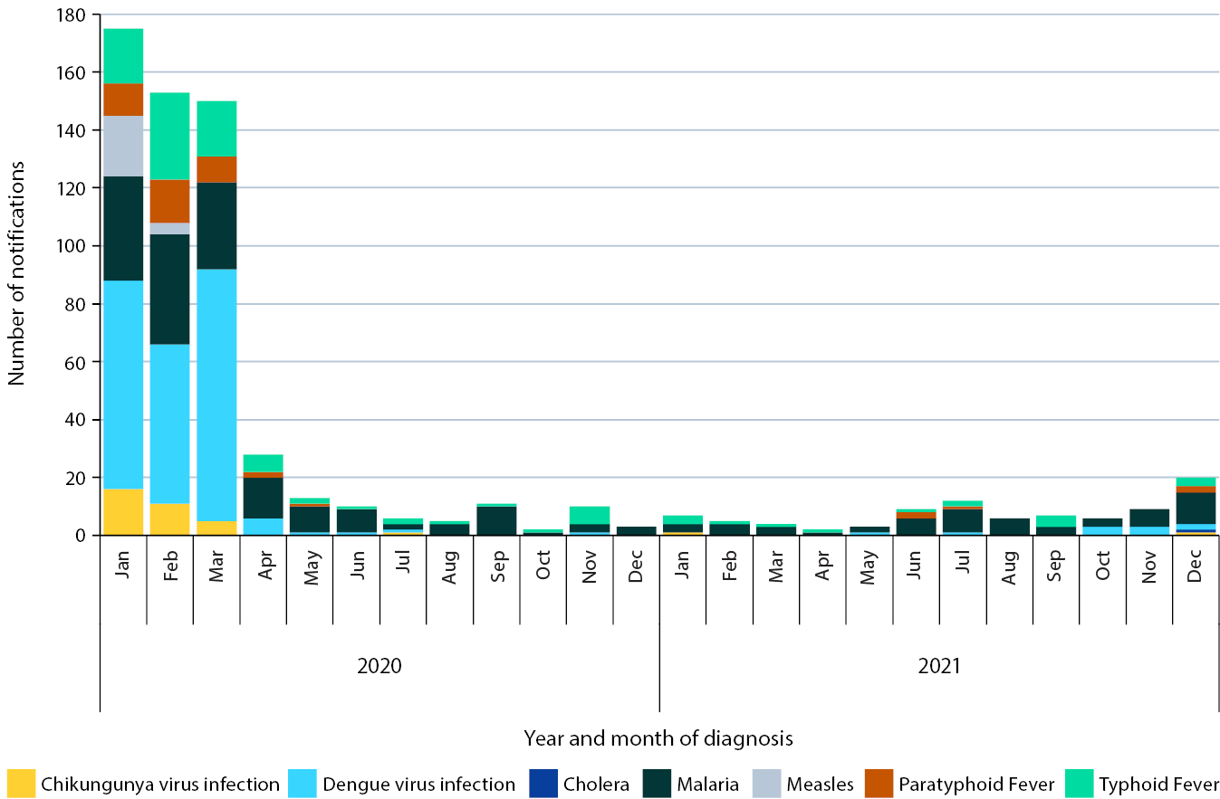

## Other diseases

### Psittacosis

For the majority of 2020 and 2021, psittacosis notifications were higher than the static five-year mean. In 2020, from the initial national lockdowns in March, notifications remained above the static five-year mean (Figure 7), with 64 notifications reported. This was almost three times the number of notifications reported in 2019 (n = 23) and more than three times as high as the static five-year mean (n = 19) (Table 1).

In the first four months of 2021, notifications initially reduced but then increased and remained above the static five-year mean from May 2021 to the end of the study period (Figure 7). In 2021, there were 35 psittacosis notifications reported, one and a half times the number of notifications reported in 2019 and almost double the static five-year mean (Table 1).

This increase in the 2020 rate of psittacosis corresponded to statistically significant increases when compared with 2019 and the static five-year mean. The increase in 2021 was only significant compared with the static five-year mean (Table 2).

Figure 7: Psittacosis notifications by year and month of diagnosis, 1 January 2020 to 31 December 2021, and static five-year mean (2015–2019), Australia

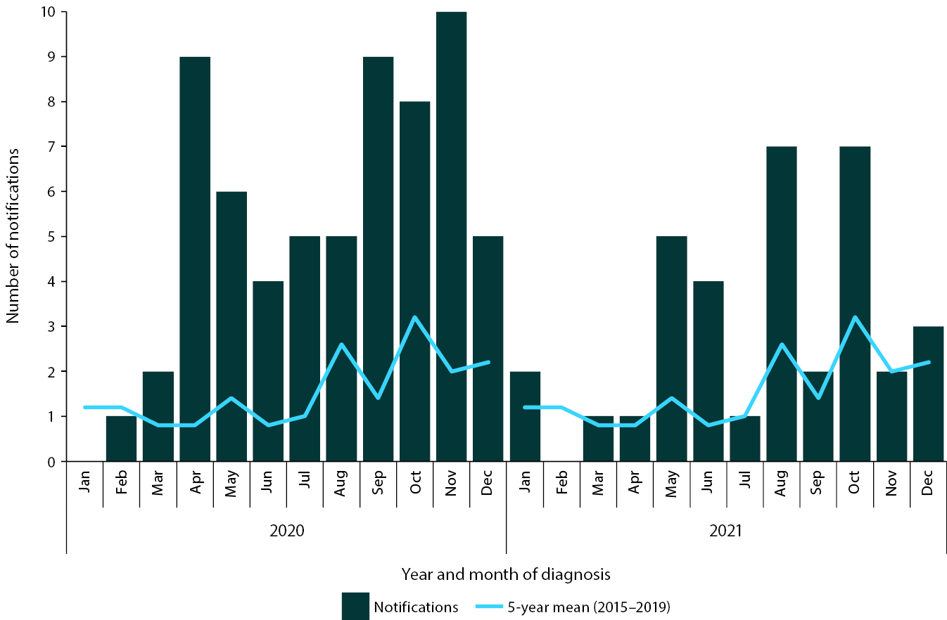

### Leptospirosis

Leptospirosis notifications remained stable during 2020. There was an increase in the first half of 2021, with notifications more than double the static five-year mean in March, April, and May 2021 (Figure 8). In 2020, there were 97 leptospirosis notifications reported, 18% higher than in 2019 (n = 82) but 15% lower than the static five-year mean (n = 114) (Table 1). In 2021, there were 247 leptospirosis notifications reported, almost three times the number of notifications reported in 2019 and just over double the static five-year mean (Table 1).

There was no statistically significant change to the notification rates of leptospirosis in 2020 compared with 2019 or the static five-year mean. However, in 2021, the observed increase corresponded to a significant increase compared to 2019 (NRR = 2.99; 95% CI: 1.77–5.05) and to the static five-year mean (NRR = 2.08; 95% CI: 1.27–3.4) (Table 2).

Figure 8: Leptospirosis notifications by year and month of diagnosis, 1 January 2020 to 31 December 2021, and static five-year mean (2015–2019), Australia

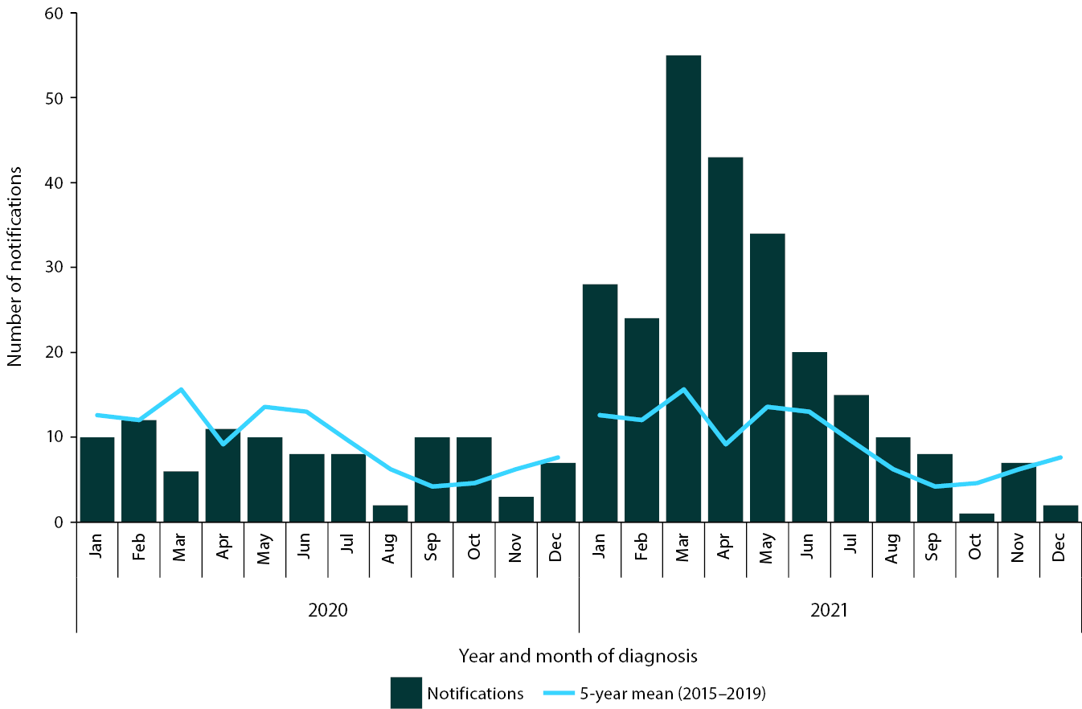

### Legionellosis

In 2020, there were 527 legionellosis notifications reported, which was 20% higher than in 2019 (n = 440) and 31% higher than the static five-year mean (n = 401) (Table 1). In 2021, there were 574 legionellosis notifications reported, 30% higher than 2019 and 43% higher than the static five-year mean (Table 1).

These increases corresponded to a statistically significant increase in the notification rates of legionellosis per 100,000 population in 2020 and 2021 when compared with both 2019 and the static five-year mean (Table 2). When analysed by species, the observed increase in notification rates was significant for notifications of *L. longbeachae* but not *L. pneumophila* (Table 2).

Notifications of *L. pneumophila* showed increases prior to the expected seasonal peaks, with 2020 and 2021 notifications both peaking in March, compared with the static five-year mean peak occurring in May (Figure 9). Notifications of *L. longbeachae* were elevated for most of the study period but remained seasonal (Figure 10).

In 2020, the notification rate of *L. longbeachae* was 1.0 per 100,000 population, compared with 0.8 per 100,000 population in 2019 (NRR = 1.37; 95% CI: 1.14–1.65), and 0.7 per 100,000 population per year in the static five-year pre-pandemic mean (NRR = 1.57; 95% CI: 1.36–1.81).

In 2021, the notification rate of *L. longbeachae* was considerably higher than in 2019 (NRR = 1.45; 95% CI: 1.21–1.74) and compared to the static five-year mean (NRR = 1.65; 95% CI: 1.43–1.90) (Table 2).

Figure 9: *Legionella pneumophila* notifications by year and month of diagnosis, 1 January 2020 to 31 December 2021, and static five-year mean (2015–2019), Australia

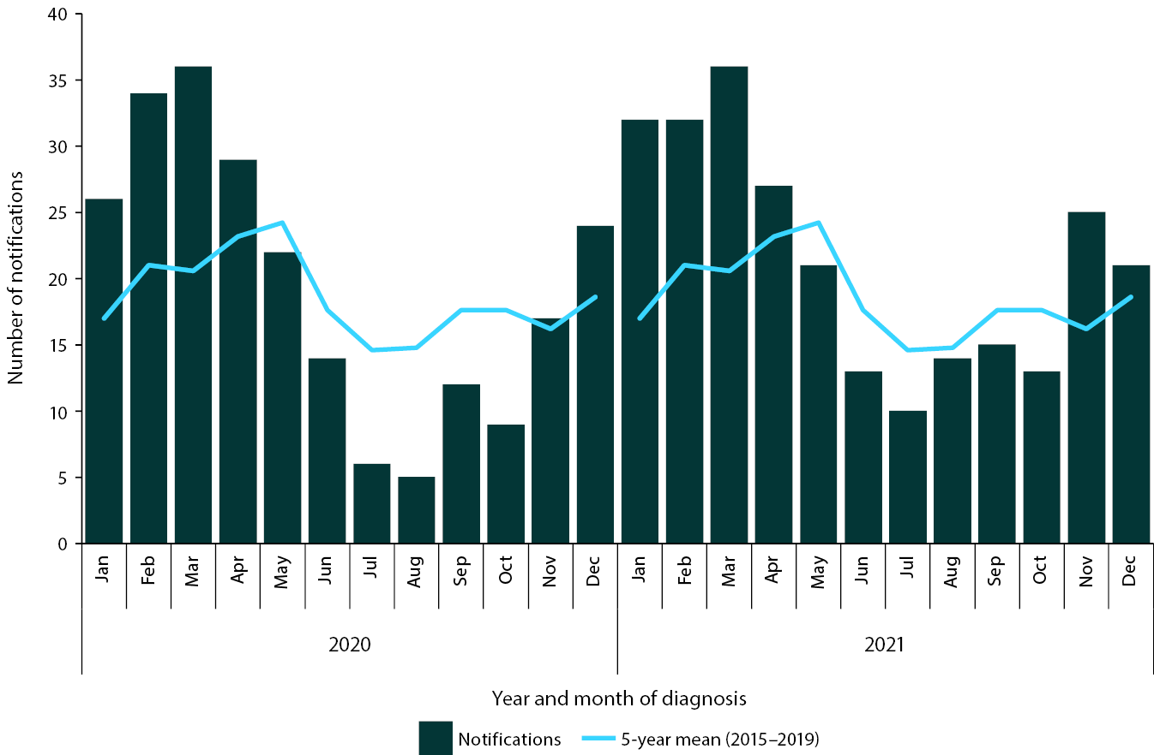

Figure 10: *Legionella longbeachae* notifications by year and month of diagnosis, 1 January 2020 to 31 December 2021, and static five-year mean (2015–2019), Australia

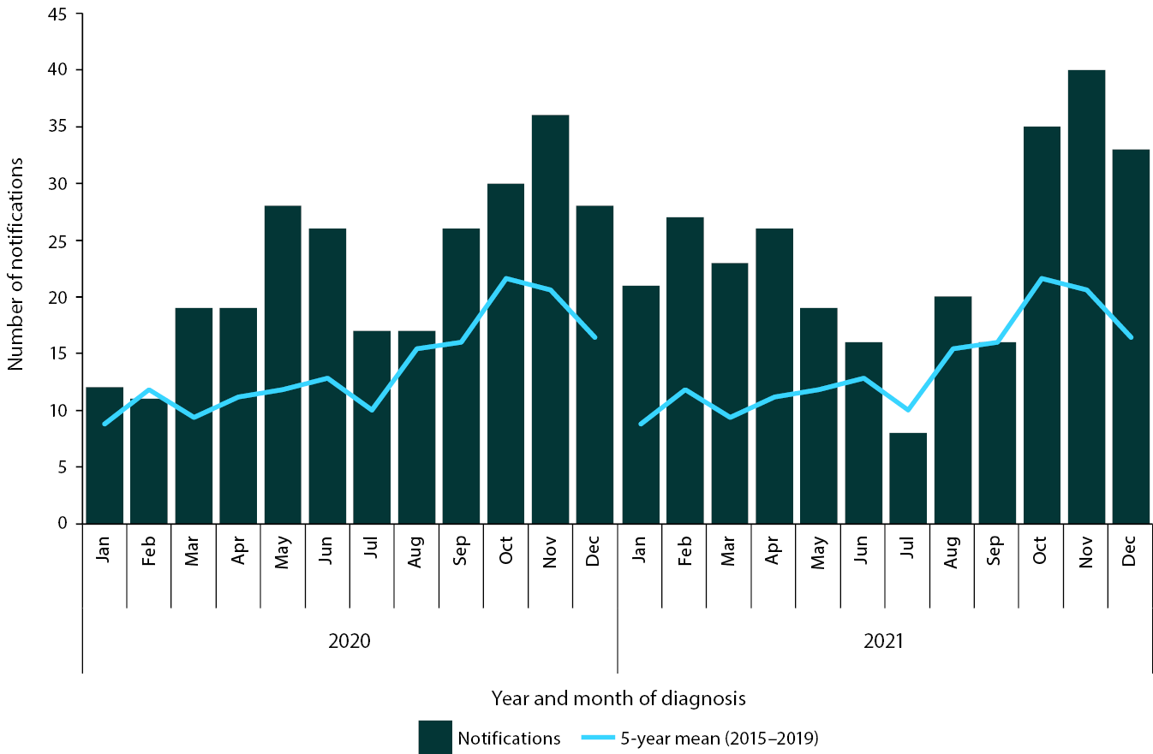

# Discussion

We have identified that public health measures implemented in 2020 and 2021 and behavioural changes (such as increase hand hygiene, voluntary mask wearing, and health seeking behaviour) in response to the COVID-19 pandemic, coincided with changes in notifications for nationally notifiable diseases in Australia. Similar to the findings from the preliminary analysis conducted by Bright et al.1 in 2020, we found that during the pandemic years of 2020 and 2021, notifications for many diseases decreased. However, our analysis also identified several diseases where increases were observed.

The public health measures implemented to slow the transmission of COVID-19 appear to have been associated with reductions in nearly all diseases categorised as ‘social’ in Australia, with lockdowns, mask mandates, and increased hand and improved respiratory hygiene most likely contributing.11 However, a proportion of the reductions seen in non-respiratory diseases may be attributable to changes in individual health-seeking behaviour and reductions in the availability of infectious disease screening programs and routine testing, that were put on hold during the pandemic years rather than entirely reflecting actual decreases in incidence.12

As discussed by the Doherty Institute, there were considerable decreases in chlamydia and gonorrhoea screening during 2020. These decreases resulted in 90,000 fewer people being screened for chlamydia, contributing to the observed reduction in notification rates.13

We observed an increase in rotavirus notifications at the end of 2021, largely driven by increased notifications in the Northern Territory, South Australia, and Western Australia, which at the time did not have active COVID-19 public health measures for their resident populations.14 Overall, during 2020 and 2021, rotavirus notifications decreased, consistent with notification trends seen in other social diseases.

For gastrointestinal diseases, decreases were seen in typhoid fever, cryptosporidium, hepatitis A, hepatitis E, and shigellosis, all of which are diseases primarily transmitted via the faecal-oral route.15 Whilst these decreases could be partially attributed to social distancing measures and increased hand hygiene during the pandemic, it is important to note that typhoid fever, hepatitis A, and hepatitis E are only rarely locally acquired in Australia, and are most often notified in returned travellers having acquired their infection overseas.16 While shigellosis is endemic in Australia, the rapid decline in notifications observed during the period of international border closures indicates that a large proportion of shigellosis cases may be overseas-acquired infections. Therefore, the observed decrease in shigellosis notifications is more likely to be attributed to decreased international travel, with 2020 and 2021 notification rates most likely representing endemic transmission of this disease in Australia. It is possible that these reductions may also be overestimated due to reduced pathology testing that occurred during the pandemic years.

Reductions observed in foodborne gastrointestinal disease notifications are likely to be attributable to decreased attendance at food establishments during lockdown periods and to a reduction in health-seeking behaviour or testing, as hypothesised by Bright et al.1 A study of gastrointestinal outbreaks in the United Kingdom during the pandemic years supports this, showing there were reduced odds of a food establishment being implicated in a gastrointestinal outbreak during periods of public health measures.17

Diseases where the source of infection occurs more commonly overseas, such a paratyphoid, typhoid, and measles, decreased substantially in Australia when international borders were closed in March 2020. Similar trends have also observed internationally, and specifically measles incidence across Europe.5,7,18

Our study demonstrated that notifications of some vector-borne and zoonotic diseases, endemic in Australia, increased during 2020 and 2021, a trend also observed internationally and attributed to the combination of changes in population movements, working from home and increased outdoor exercise.6,7,19

Increases in psittacosis observed in 2020 may have been associated with increased levels of avian illness during the same period,20 and by increases in people undertaking outdoor exercise, or being outdoors during lockdowns with potential exposure to wild birds. Enhanced testing for respiratory illness’ during the same period may have also driven this observed increase further.21,22 Increases in psittacosis notifications were not observed in 2021.

The increase in leptospirosis notifications in 2021 aligned with major flooding events that occurred in Australia, due to extreme rainfall along the Australian east coast in the first half of 2021. Flooding events are commonly associated with leptospirosis outbreaks due to exposure to turbid water.23 Additionally, a rise in rodent activity on the east coast of Australia was also observed in the same period, with leptospirosis infection known to be associated with exposure to infected rodent urine.15,24

There was a significant increase in *L. longbeachae* notifications during the pandemic years, likely driven by an increase in exposure through recreational gardening during lockdowns,25,26 paired with periods of flooding along the east coast of Australia, increasing soil proliferation of *L. longbeachae*.15,27 In addition, due to the similar symptomology of legionellosis and COVID-19, it is possible that these observed increases may have been partially due to improved case ascertainment, as differential testing for cases presenting with COVID-19-like symptoms resulted in confirmation of cases as Pontiac fever.28

Whilst we found no significant change in the annual notification rates of *L. pneumophila*, there were increases in notifications for this species occurring in the warmer months in Australia (November through to February) in the pandemic years, in contrast to the previously observed seasonal trend of late Summer and Autumn (January to May).29 Internationally, there was a reported increase in positive environmental samples of *L. pneumophila* detected in stagnant water cooling towers and hospitals following COVID-19 lockdowns.30,31 It is likely that the rise in observed in *L. pneumophila* notifications in Australia reflects this, but this has not been confirmed.

## Limitations

A limitation of this study is that this analysis is based on notification data and likely underestimates the true incidence of infectious diseases in Australia. As notifications are required to meet defined case definitions, which generally require laboratory testing, only cases that prompt medical attention, testing, and follow-through of testing are likely to be notified. This results in under-reporting, which may result in unintended censoring of seasonal patterns. A major limitation of this study is the lack of testing data and medical consultation rates available for the majority of notifiable diseases, reducing the ability to ascertain the true magnitude of observed changes.

Additionally, for a range of diseases, there have been changes in case definitions throughout the study period, which may have influenced case numbers, and subsequent notification rates. Furthermore, the epidemiology of communicable diseases in Australia can vary by jurisdiction due to the vast range of climates and environments in Australia. Although it was not conducted as part of our study, an analysis of notification trends at the jurisdictional level accounting for differences in these factors could be explored further.

# Conclusion

In 2020 and 2021, there was an overall reduction in the majority of Australia’s nationally notifiable diseases, particularly those classified as social or imported diseases. While factors such as decreased testing and changes to health-seeking behaviours have likely contributed to instances of increased or decreased notifications for some diseases, it is clear that the public health impact of the COVID-19 response is far-reaching. The observed changes we have identified impact our current understanding of notifiable diseases in Australia and provide context to the possible anomalies that are likely to be observed with upcoming five-year trends that include 2020 and 2021 data.

Further research should be directed at diseases without clear indications of why notifications and rates changed, such as legionellosis, to further understand the disease ecology and epidemiology. The impact of COVID-19 during 2020 and 2021 is a unique opportunity to explore additional factors that impact notifications and the likely incidence of communicable diseases in Australia.

# Acknowledgments

Anna Rafferty was supported by the Australian National University Master of Philosophy (Applied Epidemiology) Scholarship.

National Notifiable Diseases Surveillance System data were provided by the Health Protection Policy and Surveillance Division, Department of Health and Aged Care, on behalf of Communicable Diseases Network Australia.

The authors would like to acknowledge Rose Wright, Amy Bright and Stacey Kane for their review of the manuscript and Paul Collins for providing NNDSS data.

# Author details

Anna C Rafferty,1,2

Anna Glynn-Robinson,1

Dharshi Thangarajah,2

Ben Polkinghorne2

1. National Centre for Epidemiology and Population Health, Australian National University, Acton, ACT, Australia
2. Health Protection Policy and Surveillance Division, Australian Government Department of Health and Aged Care, Australia

Corresponding author

Anna C Rafferty

National Centre for Epidemiology and Population Health, Australian National University, Acton, ACT

Email: Anna.Rafferty@anu.edu.au

# References

1. Bright A, Glynn-Robinson AJ, Kane S, Wright R, Saul N. The effect of COVID-19 public health measures on nationally notifiable diseases in Australia: preliminary analysis. *Commun Dis Intell (2018)*. 2020;44. doi: https://doi.org/10.33321/cdi.2020.44.85.
2. Fischer FB, Mäusezahl D, Wymann MN. Temporal trends in legionellosis national notification data and the effect of COVID-19, Switzerland, 2000–2020. *Int J Hyg Environ Health*. 2023; 247:113970. doi: https://doi.org/10.1016/j.ijheh.2022.113970.
3. Geng MJ, Zhang HY, Yu LJ, Lv CL, Wang T, Che TL et al. Changes in notifiable infectious disease incidence in China during the COVID-19 pandemic. *Nat Commun*. 2021;12(1):6923. doi: https://doi.org/10.1038/s41467-021-27292-7.
4. Huh K, Jung J, Hong J, Kim M, Ahn JG, Kim JH et al. Impact of nonpharmaceutical interventions on the incidence of respiratory infections during the coronavirus disease 2019 (COVID-19) outbreak in Korea: a nationwide surveillance study. *Clin Infect Dis*. 2021;72(7):e184–91. doi: https://doi.org/10.1093/cid/ciaa1682.
5. Lai CC, Chen SY, Yen MY, Lee PI, Ko WC, Hsueh PR. The impact of the coronavirus disease 2019 epidemic on notifiable infectious diseases in Taiwan: a database analysis. *Travel Med Infect Dis*. 2021;40:101997. doi: https://doi.org/10.1016/j.tmaid.2021.101997.
6. Lai CC, Chen SY, Yen MY, Lee PI, Ko WC, Hsueh PR. The impact of the coronavirus disease 2019 epidemic on notifiable infectious diseases in Taiwan: a database analysis. *Travel Med Infect Dis*. 2021;40:101997. doi: https://doi.org/10.1016/j.tmaid.2021.101997.
7. Ullrich A, Schranz M, Rexroth U, Hamouda O, Schaade L, Diercke M et al. Impact of the COVID-19 pandemic and associated non-pharmaceutical interventions on other notifiable infectious diseases in Germany: an analysis of national surveillance data during week 1-2016 – week 32-2020. *Lancet Reg Health Eur*. 2021;6:100103. doi: https://doi.org/10.1016/j.lanepe.2021.100103.
8. Australian Bureau of Statistics. National, state and territory population: reference period September 2021. [Webpage.] Canberra: Australian Bureau of Statistics; 17 March 2022. Available from: https://www.abs.gov.au/statistics/people/population/national-state-and-territory-population/sep-2021.
9. StataCorp LLC. STATA statistical software: release 17. [Software.] College Station: StataCorp LLC; 2021. Available from: https://www.stata.com/company/.
10. Australian Government Department of Health and Aged Care. *Legionella and legionellosis SoNG Factsheet*. Canberra: Australian Government Department of Health and Aged Care, Communicable Diseases Network Australia; 2017. Available from: https://www.health.gov.au/sites/default/files/documents/2020/02/legionellosis-cdna-national-guidelines-for-public-health-units-legionella-and-legionellosis-cdna-fact-sheet.pdf.
11. Olsen SJ, Winn AK, Budd AP, Prill MM, Steel J, Midgley CM et al. Changes in influenza and other respiratory virus activity during the COVID-19 pandemic – United States, 2020–2021. *MMWR Morb Mortal Wkly Rep*. 2021;70(29):1013–9. doi: https://doi.org/10.15585/mmwr.mm7029a1.
12. Ferraro CF, Findlater L, Morbey R, Hughes HE, Harcourt S, Hughes TC et al. Describing the indirect impact of COVID-19 on healthcare utilisation using syndromic surveillance systems. *BMC Public Health*. 2021;21(1):2019. doi: https://doi.org/10.1186/s12889-021-12117-5.
13. WHO Collaborating Centre for Viral Hepatitis (WHO CC Viral Hepatitis). *Impacts of COVID-19 on BBVSTI testing, care and treatment: Medicare data analysis*. Melbourne: WHO CC Viral Hepatitis, The Peter Doherty Institute for Infection and Immunity; March 2021. Available from: https://www.doherty.edu.au/uploads/content_doc/COVID-19_impacts_-_BBVSTI_treatment_and_care_(data_to_January2021)_FINAL.pdf.
14. Australian Bureau of Statistics. Impact of lockdowns on household consumption - insights from alternative data sources. [Webpage.] Canberra: Australian Bureau of Statistics; 1 December 2021. Available from: https://www.abs.gov.au/articles/impact-lockdowns-household-consumption-insights-alternative-data-sources.
15. Heymann DL, ed. *Control of Communicable Diseases Manual: an official report of the American Public Health Association*. 20th ed. Fort Worth: APHA Press, 2015.
16. Yapa CM, Furlong C, Rosewell A, Ward KA, Adamson S, Shadbolt C et al. First reported outbreak of locally acquired hepatitis E virus infection in Australia. *Med J Aust*. 2016;204(7):274. doi: https://doi.org/10.5694/mja15.00955.
17. Love NK, Elliot AJ, Chalmers RM, Douglas A, Gharbia S, McCormick J et al. Impact of the COVID-19 pandemic on gastrointestinal infection trends in England, February–July 2020. *BMJ Open*. 2022;12(3):e050469. doi: https://doi.org/10.1136/bmjopen-2021-050469.
18. Nicolay N, Mirinaviciute G, Mollet T, Celentano LP, Bacci S. Epidemiology of measles during the COVID-19 pandemic, a description of the surveillance data, 29 EU/EEA countries and the United Kingdom, January to May 2020. *Euro Surveill*. 2020;25(31):2001390.   
    doi: https://doi.org/10.2807/1560-7917.ES.2020.25.31.2001390.
19. Liyanage P, Rocklöv J, Tissera HA. The impact of COVID-19 lockdown on dengue transmission in Sri Lanka; a natural experiment for understanding the influence of human mobility. *PLOS Negl Trop Dis*. 2021;15(6):e0009420. doi: https://doi.org/10.1371/journal.pntd.0009420.
20. Cox-Witton K, Grillo T, Ban S. Wildlife Health Australia. *Anim Health Surveill Q*. 2020;25(2):10–5. Available from: https://www.sciquest.org.nz/browse/publications/article/165245.
21. Victoria State Government Department of Health. Health warning on increase in psittacosis in Victorian Alpine region. [Internet.] Melbourne: Victoria State Government Department of Health; 16 December 2020. Available from: https://www.health.vic.gov.au/health-advisories/health-warning-on-increase-in-psittacosis-in-victorian-alpine-region.
22. New South Wales Government Department of Health (NSW Health), Nepean Blue Mountains Local Health District. ‘Parrot Fever’ alert in Blue Mountains and Lithgow. [Internet.] Sydney: NSW Health; 7 May 2020. Available from: https://www.nbmlhd.health.nsw.gov.au/nbmlhd-news/from-the-expert/parrot-fever-alert-in-blue-mountains-and-lithgow.
23. Smith JKG, Young MM, Wilson KL, Craig SB. Leptospirosis following a major flood in Central Queensland, Australia. *Epidemiol Infect*. 2013;141(3):585–90. doi: https://doi.org/10.1017/S0950268812001021.
24. Commonwealth Scientific and Industrial Research Organisation (CSIRO). *Monitoring mice in Australia – August 2021*. Canberra: CSIRO; August 2021. Available from: https://research.csiro.au/rm/wp-content/uploads/sites/422/2021/12/Mouse-Monitoring-project-Update-25-Aug-2021.pdf.
25. Egerer M, Lin B, Kingsley J, Marsh P, Diekmann L, Ossola A. Gardening can relieve human stress and boost nature connection during the COVID-19 pandemic. *Urban For Urban Green*. 2022;68:127483. doi: https://doi.org/10.1016/j.ufug.2022.127483.
26. Carter JS. Australians bought more plants than ever in 2020 with COVID-19 lockdowns fuelling sales. [Online.] Canberra: Australian Broadcasting Corporation, ABC News; 31 March 2021. Available from: https://www.abc.net.au/news/rural/2021-03-31/australians-bought-more-plants-than-ever-in-2020/100040258.
27. NSW Health, Hunter New England Local Health District. *Legionnaires’ cases prompt gardening* warning. [Media release.] Sydney: NSW Health; 2 June 2020. Available from: https://www.hnehealth.nsw.gov.au/__data/assets/pdf_file/0019/421507/MR_020620.pdf.
28. Cassell K, Davis JL, Berkelman R. Legionnaires’ disease in the time of COVID-19. *Pneumonia (Nathan)*. 2021;13(1):2. doi: https://doi.org/10.1186/s41479-020-00080-5.
29. NNDSS Annual Report Working Group. Australia’s notifiable disease status, 2016: annual report of the National Notifiable Diseases Surveillance System. *Commun Dis Intell (2018)*. 2021;45. doi: https://doi.org/10.33321/cdi.2021.45.28.
30. De Giglio O, Diella G, Lopuzzo M, Triggiano F, Calia C, Pousis C et al. Impact of lockdown on the microbiological status of the hospital water network during COVID-19 pandemic. *Environ Res*. 2020;191:110231. doi: https://doi.org/10.1016/j.envres.2020.110231.
31. Liang J, Swanson CS, Wang L, He Q. Impact of building closures during the COVID-19 pandemic on *Legionella* infection risks. *Am J Infect Control*. 2021;49(12):1564–6. doi: https://doi.org/10.1016/j.ajic.2021.09.008.

About Communicable Diseases Intelligence

Communicable Diseases Intelligence (CDI) is a peer-reviewed scientific journal published by the Health Protection Policy & Surveillance Division, Department of Health and Aged Care. The journal aims to disseminate information on the epidemiology, surveillance, prevention and control of communicable diseases of relevance to Australia.

© 2024 Commonwealth of Australia as represented by the Department of Health and Aged Care

ISSN: 2209-6051 Online

This journal is indexed by Index Medicus and Medline.

This publication is licensed under a Creative Commons Attribution-NonCommercial-NoDerivatives 4.0 International Licence (CC BY-NC-ND) available from https://creativecommons.org/licenses/by-nc-nd/4.0/legalcode (Licence). You must read and understand the Licence before using any material from this publication.

Restrictions

The Licence does not cover, and there is no permission given for, use of any of the following material found in this publication (if any):

* the Commonwealth Coat of Arms (by way of information, the terms under which the Coat of Arms may be used can be found at www.pmc.gov.au/resources/commonwealth-coat-arms-information-and-guidelines);
* any logos (including the Department of Health and Aged Care’s logo) and trademarks;
* any photographs and images;
* any signatures; and
* any material belonging to third parties.

Disclaimer

Opinions expressed in *Communicable Diseases Intelligence* are those of the authors and not necessarily those of the Australian Government Department of Health and Aged Care or the Communicable Diseases Network Australia. Data may be subject to revision.

Enquiries

Enquiries regarding any other use of this publication should be addressed to the CDI Editor at: [cdi.editor@health.gov.au](mailto:cdi.editor@health.gov.au)

Communicable Diseases Network Australia

Communicable Diseases Intelligence contributes to the work of the Communicable Diseases Network Australia. www.health.gov.au/cdna

**Editor**: Christina Bareja • **Deputy Editor**: Simon Petrie • **Design and Production**: Lisa Thompson/Kasra Yousefi

**Editorial Advisory Board**: David Durrheim, Mark Ferson, Clare Huppatz, John Kaldor, Martyn Kirk, Meru Sheel and Stephanie Williams

Contacts

CDI is produced by:

Health Protection Policy & Surveillance Division, Australian Government Department of Health and Aged Care,  
GPO Box 9848, (MDP 6) CANBERRA ACT 2601

Website: [www.health.gov.au/cdi](http://www.health.gov.au/cdi)

Email: [cdi.editor@health.gov.au](mailto:cdi.editor@health.gov.au)

Submit an Article

You are invited to submit your next communicable disease related article to the *Communicable Diseases Intelligence* (CDI) for consideration. More information regarding CDI can be found at: www.health.gov.au/cdi.

Further enquiries should be directed to: [cdi.editor@health.gov.au](mailto:cdi.editor@health.gov.au)