COVID-19 Australia: Epidemiology Report 31
Fortnightly reporting period ending 6 December 2020
COVID-19 National Incident Room Surveillance Team

Summary
Nationally, COVID-19 notifications remained at low levels this fortnight. Testing rates also decreased during the surveillance period. The daily average number of cases was eight compared to an average of 11 cases for the previous fortnight. There were 109 cases of COVID-19 and no deaths this fortnight, bringing the cumulative case count to 28,049 including 908 deaths. New South Wales reported the highest proportion of cases again this fortnight (54%; 59/109), with all except one acquired overseas (98%; 58/59). Locally-acquired cases accounted for 5% (5/109) of all cases reported this fortnight, with one of these from an unknown source. FluTracking data indicated that 47% of people in the community with ‘fever and cough’ and 19% of those with ‘runny nose and sore throat’ were tested for SARS-CoV-2, which was a decrease from the previous reporting period. Testing rates decreased to 9.3 tests per 1,000 population per week during this reporting period, representing a 29% decrease in fortnightly tests conducted compared to the last reporting period. The overall positivity rate for the reporting period remains at 0.03%.
Keywords: SARS-CoV-2; novel coronavirus; 2019-nCoV; coronavirus disease 2019; COVID-19; acute respiratory disease; epidemiology; Australia

Introduction
Coronavirus disease 19 (COVID-19), caused by the novel severe acute respiratory syndrome coronavirus 2 (SARS-CoV-2), was first identified in humans in Wuhan, China, in December 2019. The disease subsequently spread rapidly, leading to a global pandemic.¹ The predominant modes of transmission for COVID-19 are through direct or close contact with an infected person via respiratory droplets, or indirectly via contact with contaminated fomites.² The median incubation period of COVID-19 is 5–6 days, ranging from 1 to 14 days.^{3,4} The infectious period remains uncertain; however, it is estimated to be from 48 hours before symptoms develop until two weeks after symptom onset.^{3,5} The predominant symptoms reported in COVID-19 cases are cough, sore throat, fatigue, runny nose and fever.⁶ The majority of cases recover from the disease without clinical intervention; however, approximately 20% of global cases result in more severe outcomes, such as shortness of breath and pneumonia, necessitating hospitalisation and the requirement of additional oxygen or ventilation.^{7,8} Severe or fatal outcomes are generally more common among elderly cases or those with comorbid conditions.⁸ A visual depiction of the severity spectrum of COVID-19, and of the data sources that we use in this report to measure aspects of severity, is provided in Figure 1.

Figure 1: Severity spectrum of COVID-19 cases and data sources used to measure severity in Australia
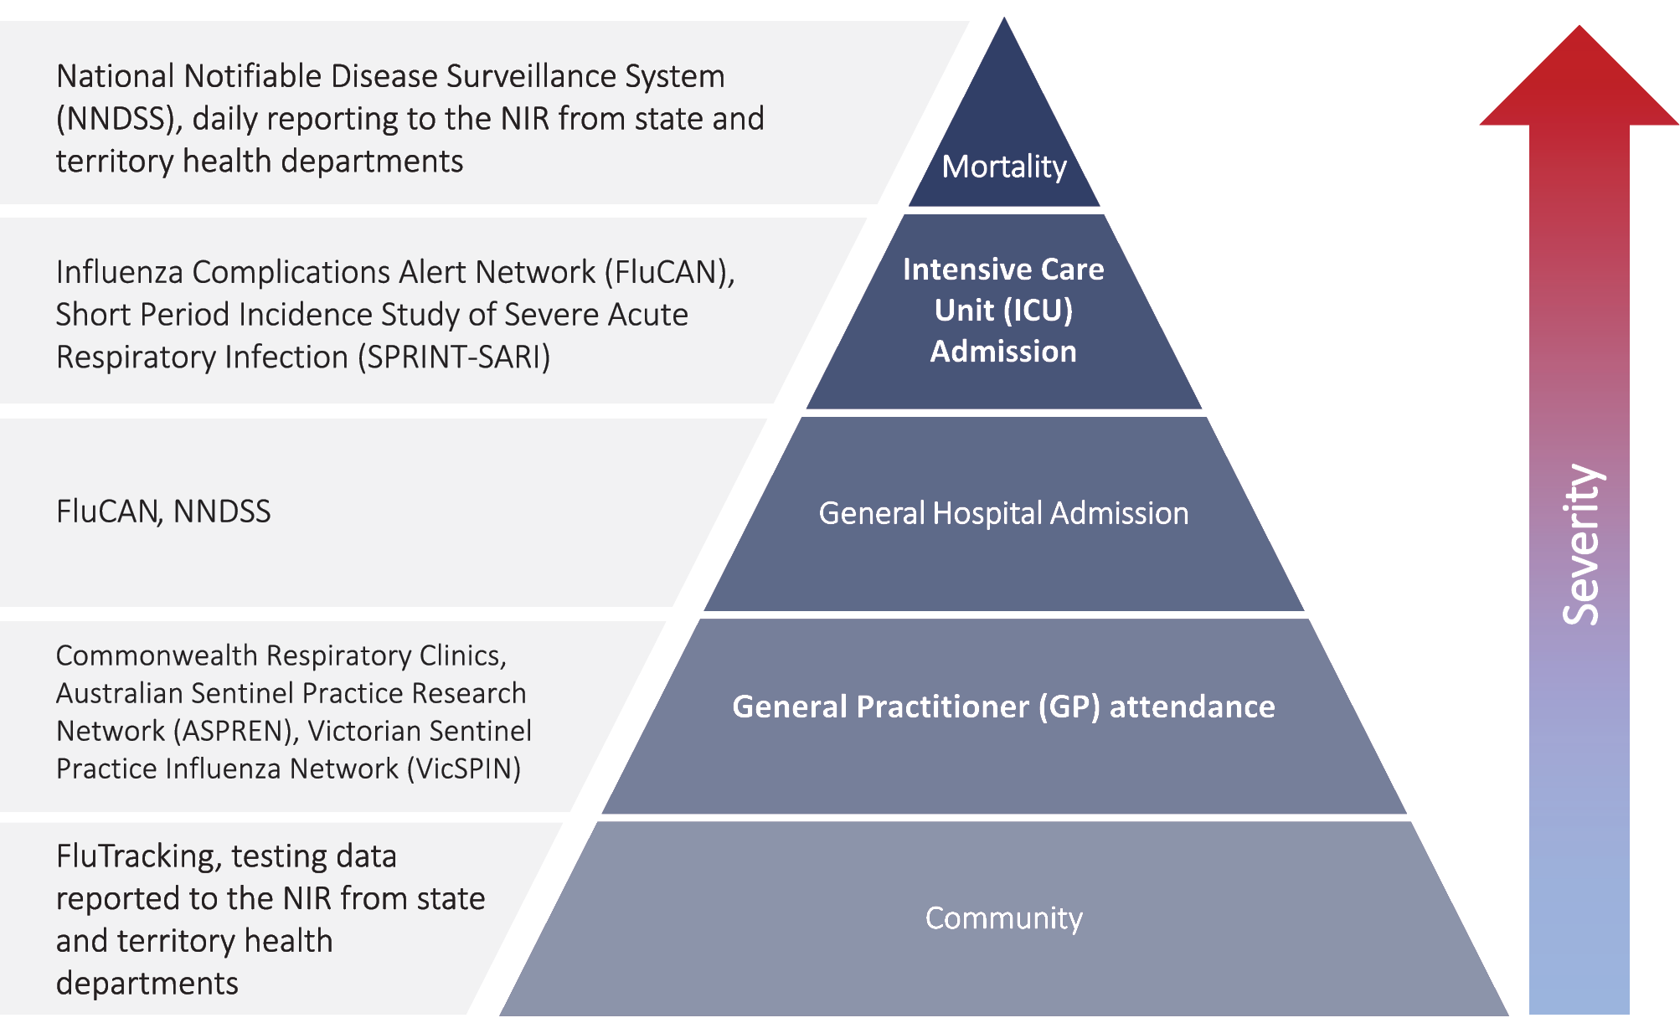
The epidemiology of COVID-19 in Australia has continued to evolve since cases were first detected in the country in late January 2020. This report provides an overview of the Australian COVID-19 epidemic, and compiles data from a variety of sources to describe cases and clusters, testing patterns, disease severity, public health response measures and the international situation. The report addresses indicators listed in the Australian National Disease Surveillance Plan for COVID-19,⁴ which describes a national approach for disease surveillance for COVID-19 and its causative agent, SARS-CoV-2.

Data sources

Notifications to health departments
The majority of data presented in this report were derived from the National Notifiable Diseases Surveillance System (NNDSS). COVID-19 is a notifiable disease under public health legislation in all states and territories and is listed on the National Notifiable Diseases List under the National Health Security Act (2007). Accordingly, all jurisdictions report confirmed and probable cases of COVID-19 through the NNDSS. The national case definition for surveillance is available in the COVID-19 Series of National Guidelines.⁹ Due to the dynamic nature of the NNDSS, numbers presented in this report may be subject to revision and may vary from numbers previously reported and from case notifications released by states and territories. Case numbers for the most recent dates of illness onset may be subject to revision, due to reporting delays. Data for the current report were extracted from the NNDSS on 8 December 2020 for notifications received up to 6 December 2020. Data for COVID-19 deaths notified in this reporting period were extracted from daily notifications from state and territory health departments to the National Incident Room (NIR), received up to 6 December 2020.

Acute respiratory illness
We report data from surveillance systems that monitor trends in the number of people reporting symptoms of mild respiratory illnesses in the community and in primary care settings. These systems gathered information from across Australia and include the online FluTracking syndromic surveillance system,¹⁰ the Commonwealth General Practice (GP) Respiratory Clinics, and the Australian Sentinel Practice Research Network (ASPREN) and Victorian Sentinel Practice Influenza Network (VicSPIN) GP sentinel surveillance systems. These systems capture data on any respiratory illness experienced by participants, including pathogens such as SARS-CoV-2.

Hospitalisations
To report on COVID-19 disease severity, we draw on hospitalisations and intensive care unit (ICU) admissions data provided from two sentinel surveillance systems: the Influenza Complications Alert Network (FluCAN)¹¹ and the Short Period Incidence Study of Severe Acute Respiratory Infection Study (SPRINT-SARI).¹² FluCAN is a real-time hospital sentinel surveillance system for acute respiratory disease requiring hospitalisation. Established to monitor for seasonal influenza, FluCAN has been modified to include surveillance for COVID-19. Participating sites collect detailed clinical and laboratory information from all hospitalised patients with a confirmed diagnosis of COVID-19. SPRINT-SARI is a sentinel system that collects detailed data on the characteristics and outcomes of and interventions for patients admitted to ICUs or High Dependency Units (HDUs) with COVID-19 at participating sites across Australia. Data presented from both sentinel surveillance systems may be subject to retrospective adjustments following publication. Data on severity is presented in the report each four weeks, rather than on a fortnightly basis.

Viral genomics
The Global Initiative on Sharing All Influenza Data (GISAID) is an international virus sequence database that provides open access to SARS-CoV-2 genomic data.¹³ Phylogenetic analyses are publicly available through the Nextstrain platform, which uses virus sequence data from GISAID to track the global evolution and spread of SARS-CoV-2.¹⁴

Testing data
Aggregated testing data were reported daily to the NIR by jurisdictions. Testing data by demographic breakdown were also reported on a weekly basis by jurisdictions.

Denominators
We used population data from the Australian Bureau of Statistics (ABS) Estimated Resident Population (as at 30 December 2019) to estimate rates of infection by jurisdiction, age group, sex and Indigenous status.

International
All data reported in the international section were extracted from the World Health Organization (WHO) Dashboard on 6 December 2020 unless otherwise specified.¹⁵

Activity

Acute respiratory illness

(FluTracking and Commonwealth Respiratory Clinics)
Based on self-reported FluTracking data, prevalence of fever and cough in the community remains low (Figure 2). Runny nose and sore throat symptoms in the community was stable during this reporting period and the prevalence in the community remained around 0.5%.

Table 1: COVID-19 notifications by jurisdiction and source of acquisition, Australia, 6 December 2020
Source | NSW | Vic. | Qld | WA | SA | Tas. | NT | ACT | Australia
Overseas | 58 | 0 | 16 | 16 | 0 | 0 | 12 | 1 | 103
Local — source known | 0 | 0 | 0 | 0 | 4 | 0 | 0 | 0 | 4
Local — source unknown | 1 | 0 | 0 | 0 | 0 | 0 | 0 | 0 | 1
Under investigation | 0 | 0 | 1 | 0 | 0 | 0 | 0 | 0 | 1
Total | 59 | 0 | 17 | 16 | 4 | 0 | 12 | 1 | 109
Table 2: Locally-acquired COVID-19 case numbers and rates per 100,000 population by jurisdiction and reporting period, Australia, 6 December 2020
Jurisdiction | Reporting period | Reporting period | Cumulative cases
 | 9–22 November | 23 November – 6 December
 | Number of cases | Number of cases | Number of cases | Rates per 100,000 population
NSW | 0 | 1 | 1,977 | 24.5
Vic. | 0 | 0 | 19,360 | 293.6
Qld | 0 | 0 | 302 | 5.9
WA | 0 | 0 | 101 | 3.9
SAª | 28 | 4 | 184 | 10.5
Tas. | 0 | 0 | 152 | 28.4
NT | 0 | 0 | 6 | 2.4
ACT | 0 | 0 | 28 | 6.6
Australia | 28 | 5 | 22,110 | 87.2

a South Australia's total for the two reporting periods includes one locally-acquired interstate case. Whilst it is known there were a total of 33 cases associated with the Parafield cluster, at the time of reporting only 31 of these had been notified to NNDSS.

Figure 2: Weekly trends in respiratory illness amongst FluTracking survey participants (age-standardised) compared to the average of the previous five years, Australia, 1 March – 6 December 2020ª
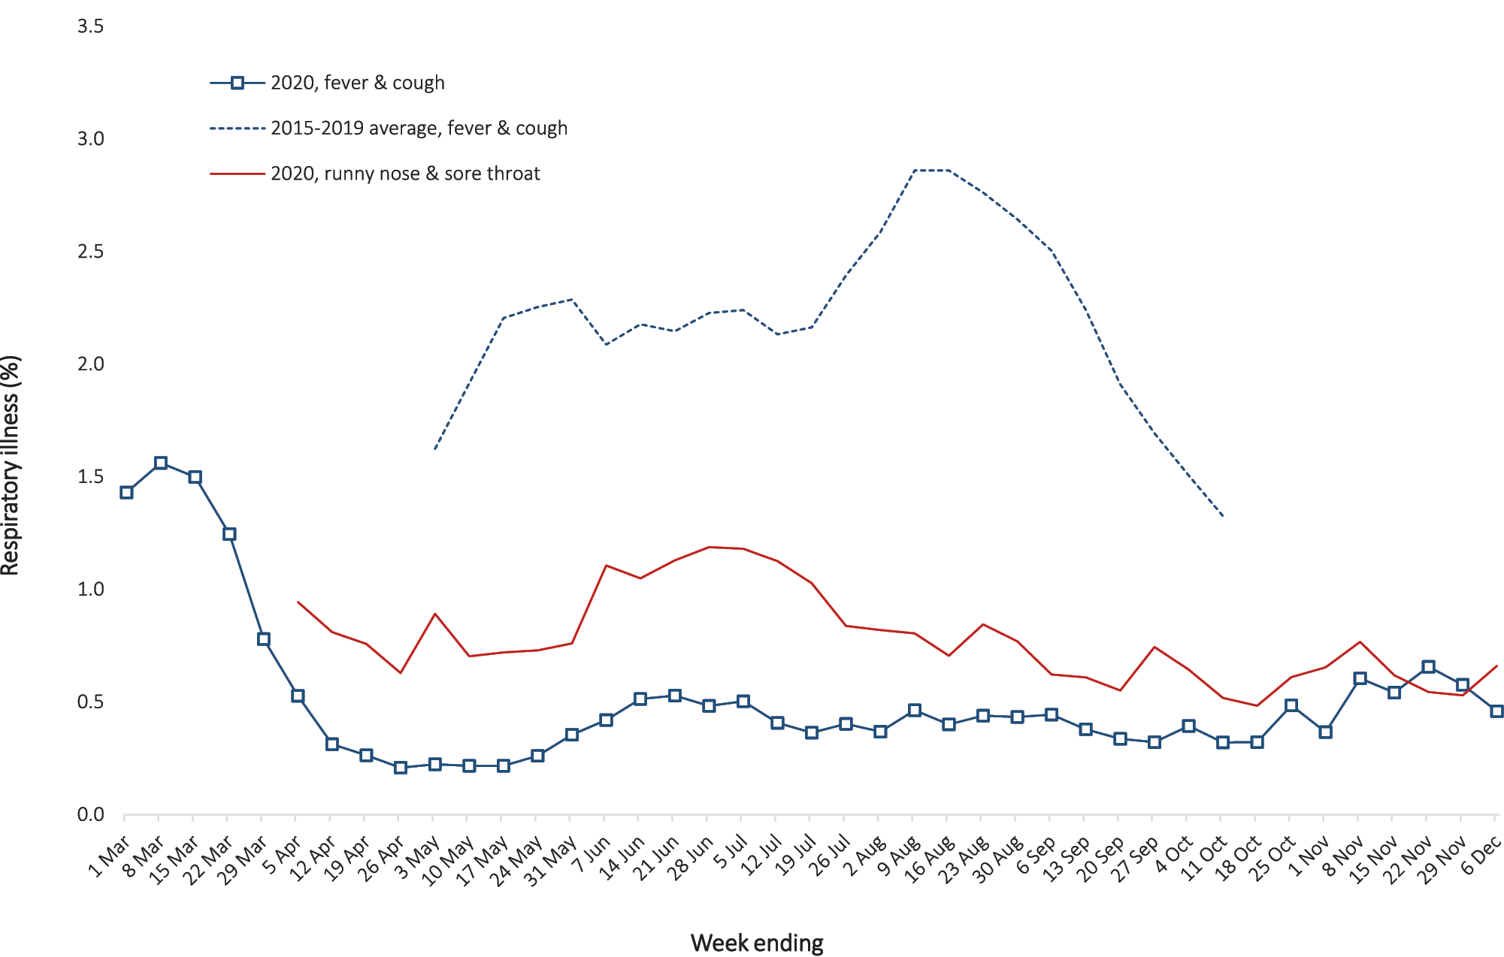
a In previous years, FluTracking was activated during the main Influenza season from May to October. A historical average beyond the week ending 11 October is therefore not available. In 2020, FluTracking commenced 10 weeks early to capture data for COVID-19. Data on runny nose and sore throat were only collected systematically after 29 March 2020, therefore a historical average for this symptom profile is unavailable.
In this reporting period, acute respiratory illness was highest in those aged 0–9, 10–19 and 30–39 years old, based on both self-reported FluTracking data and presentations to Commonwealth Respiratory Clinics. Females reported respiratory illness more frequently than males. Rates of fever and cough by jurisdiction ranged from 1.9/1,000 FluTracking participants in Tasmania to 8.0/1,000 participants in Western Australia.
FluTracking data indicate that 47% of those in the community with ‘fever and cough’ and 19% of those with ‘runny nose and sore throat’ were tested for SARS-CoV-2. This represents a decrease from the last reporting period. Testing rates varied by jurisdiction, being lowest in Western Australia and Queensland, and highest in South Australia and Victoria. It is important to acknowledge that there may be legitimate reasons why people did not get tested, including barriers to accessing testing. Symptoms reported to Flutracking were not specific to COVID-19 and may also be due to chronic diseases.
During this reporting period, there were 27,189 assessments at Commonwealth Respiratory Clinics with 94% tested for SARS-CoV-2. The positivity rate for SARS-CoV-2 at these Clinics was < 0.01% for this reporting period.
In patients experiencing influenza-like illness in this reporting period who were tested through the ASPREN and VicSPIN GP sentinel surveillance systems, the most frequent respiratory viruses detected were rhinoviruses and respiratory syncytial virus (RSV).
Based on FluTracking data, the rate of self-reported fever and cough among Aboriginal and Torres Strait Islander people and health care workers during the reporting period was similar to that observed for all other participants based on FluTracking data.
Based on all presentations to Commonwealth Respiratory Clinics to date, the principal symptoms reported in COVID-19 cases were cough, sore throat, tiredness, runny nose, and fever.

Transmission trends of confirmed COVID-19

(NNDSS and jurisdictional reporting to NIR)
As at 6 December 2020, there were 28,049 COVID-19 cases including 908 deaths reported nationally, with two distinct peaks in March and July (Figure 3). In this reporting period, there were 109 cases and no deaths reported. On average, eight cases were notified each day over this reporting period, a decrease from the average of 11 cases reported per day over the previous reporting period. The largest number of cases diagnosed this fortnight was from New South Wales (54%; 59/109), followed by Queensland (16%; 17/109), Western Australia (15%; 16/109) and the Northern Territory (11%; 12/109). Small numbers of cases were reported in South Australia (4) and the Australian Capital Territory (1). No new cases were reported in Tasmania and Victoria.
Figure 3: COVID-19 notified cases by source of acquisition and diagnosis date, Australia, week ending 6 December 2020ª
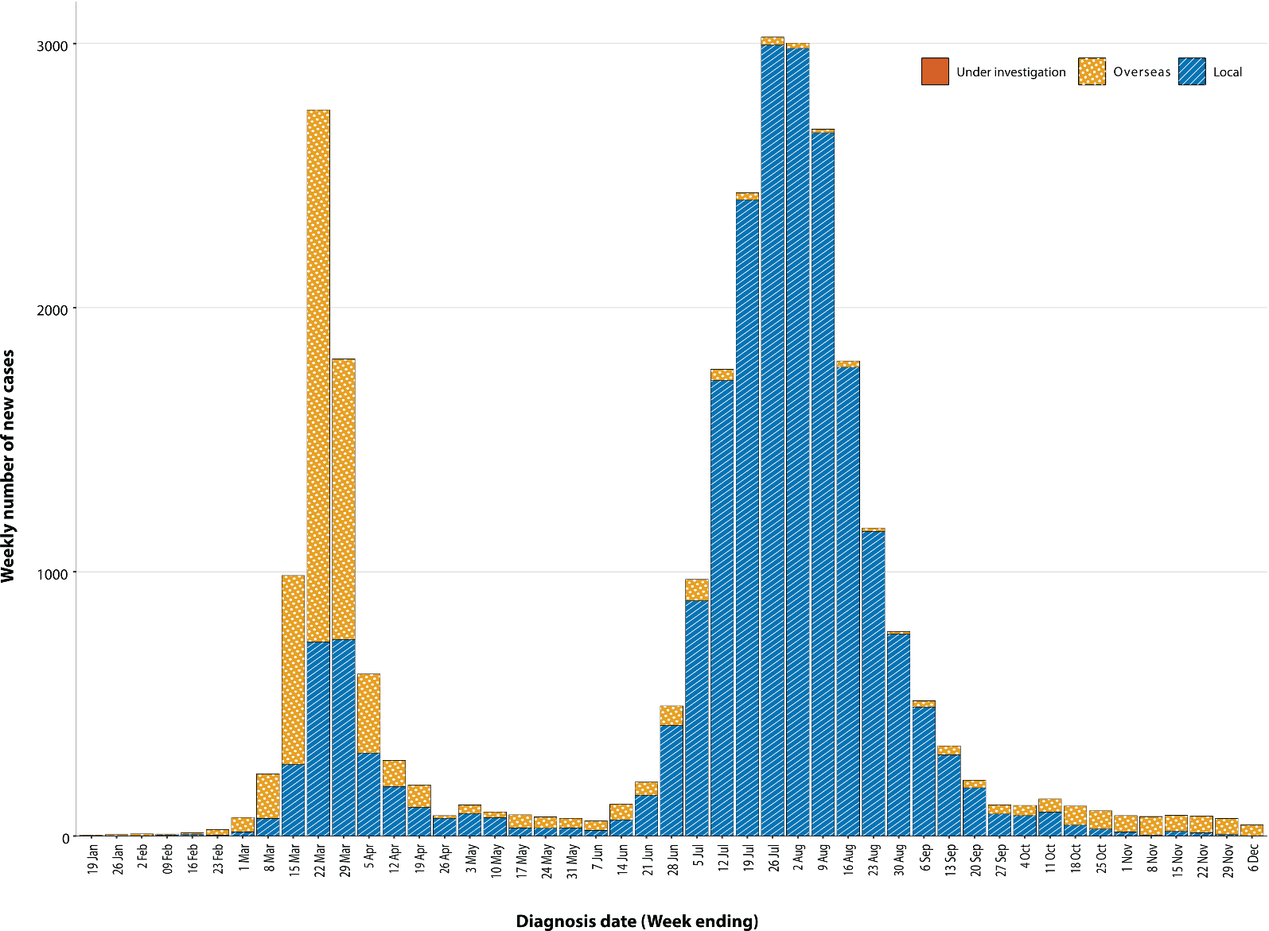
a Source: NNDSS.

Source of acquisition (NNDSS)
In this reporting period, 94% (103/109) of cases were reported as overseas acquired. Locally-acquired cases accounted for 5% (5/109) of cases, and the contact was not identified in one of these cases. Investigations continue into the source of infection for this case in NSW. The strain of the virus appears to be of US origin and NSW Health is progressing in examining potential links to international aircrew who were self-isolating in the hotel at the time. In total, 1% (1/109) of cases reported this fortnight were under investigation at the time of reporting (Table 1).
In this reporting period, the largest number of overseas-acquired cases was reported in New South Wales (57%; 58/102), followed by Queensland (16%; 16/102), Western Australia (16%; 16/102) and the Northern Territory (12%; 12/102). The higher number of overseas-acquired cases reported in New South Wales likely reflects the number of returned travellers managed there, as well as the origin of flights being from countries with a high incidence of disease.
In the past fortnight, the largest numbers of overseas-acquired cases were from the United States of America (25%; 25/102) followed by India (9%; 9/102) and the United Kingdom (8%; 8/102), which is similar to the previous reporting period. The number of cases by country is influenced by travel patterns of returning Australians as well as by the prevalence of COVID-19 in the country the person is arriving from.
Cumulatively, the infection rate to date for all locally-acquired cases was highest in Victoria with 293.6 infections per 100,000 population (Table 2). The rate of infection in Tasmania was 28.4 infections per 100,000 population, largely as a result of an outbreak in North West Tasmanian hospitals in April 2020, which represents half of all their cases.
Nationally, the most recent locally-acquired case of unknown source was notified by New South Wales on 2 December 2020.
Table 3: Days since last locally-acquired COVID-19 case (source known and source unknown), by jurisdiction, reported by notification received date, 6 December 2020
Jurisdiction | Locally acquired — source unknown |  | Locally acquired — source known
 | Date of last case | Days since last case | Date of last case | Days since last case
NSW | 2 December 2020 | 4 | 17 November 2020 | 19
Vic. | 29 October 2020 | 38 | 29 October 2020 | 38
Qld | 26 August 2020 | 102 | 15 September 2020 | 82
WA | 23 July 2020 | 136 | 15 August 2020 | 113
SA | 15 April 2020 | 235 | 29 November 2020 | 7
Tas. | 1 September 2020 | 96 | 1 September 2020 | 96
NTª | NA | NA | 4 April 2020 | 246
ACT | 28 March 2020 | 253 | 9 July 2020 | 150
a The Northern Territory has not reported any locally-acquired cases with an unknown source of infection.

Demographic features

(NNDSS)
In this reporting period, the largest number of cases occurred in those aged 30 to 39 years (36/109 cases). For all notifications to date, the highest rate of infection was in those aged over 90 years old with a rate of 386.8 per 100,000 population (Appendix A, Table A.1). Children aged under 10 years old had the lowest rate of infection (45.3 cases per 100,000 population), despite comparable testing rates to other age groups.
Cumulatively, the male-to-female rate ratio of cases was approximately 1:1 in most age groups. Notification rates were higher among females than among males in the 20–29 years age group and those aged ≥ 80 years old, and higher among males than among females in the 70–79 years age group (Figure 4). The largest difference in cumulative rates was in the 90+ years age group, where the cumulative rate among males was 333.7 cases per 100,000 population and among females 413.3 cases per 100,000 population (Appendix A, Table A.1).
Figure 4: Cumulative COVID-19 rate, by age group and sex, Australia, 23 January 2020 to 6 December 2020
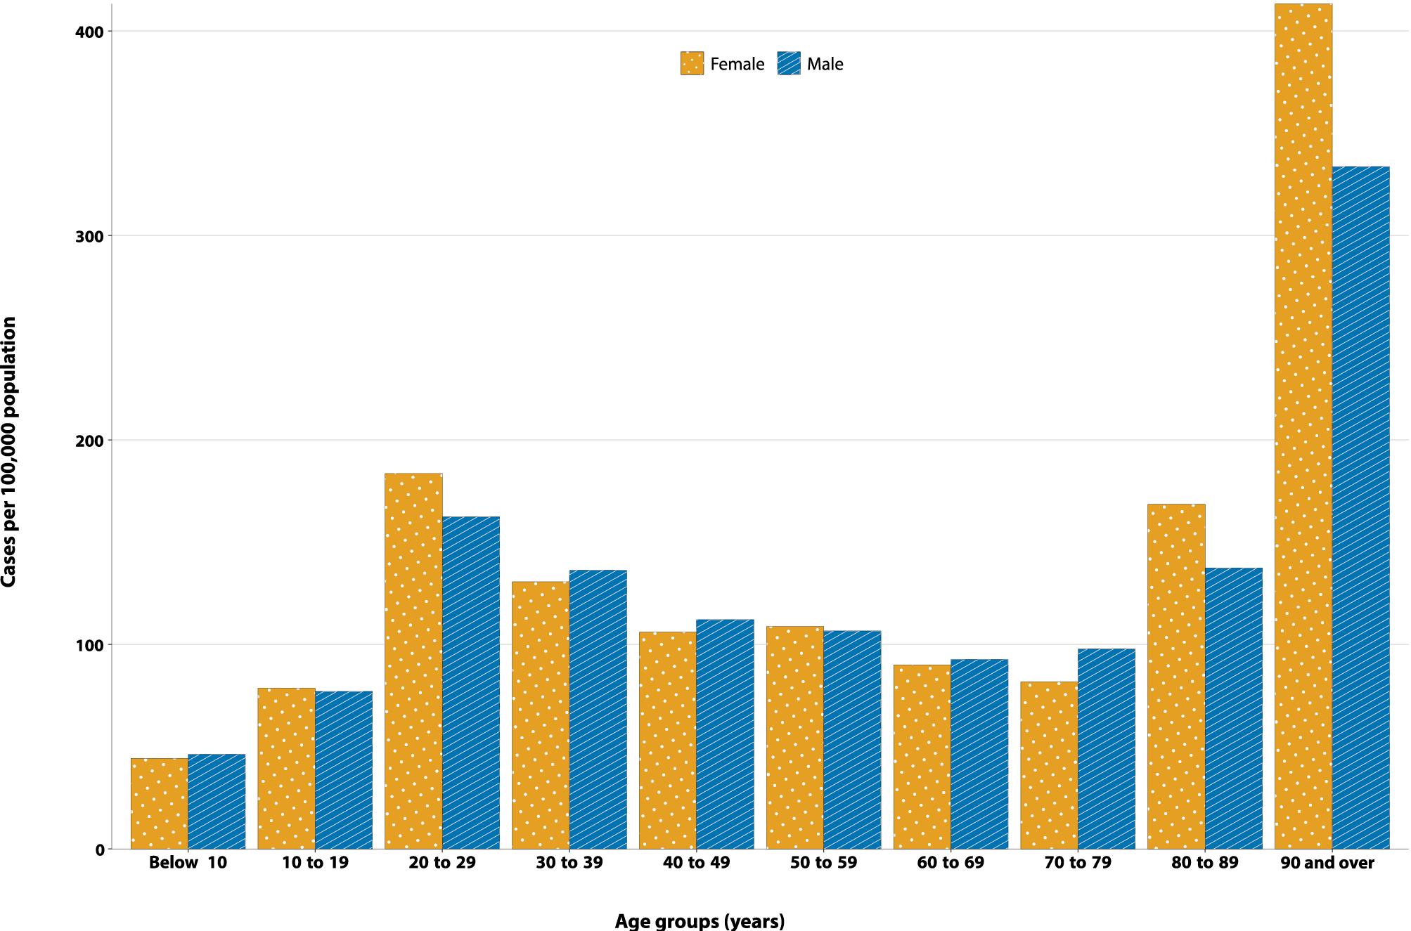
Since the beginning of the epidemic in Australia, the median age of all cases was 37 years old (interquartile range, IQR: 25–56) which has not changed since the beginning of August. Prior to 1 June 2020, COVID-19 cases were slightly older, with a median age of 46 years old (IQR: 29–62), associated with a high proportion of cases having a recent travel history or acquisition on a cruise ship. In cases reported after 1 June 2020, the median age was 34 years old (IQR: 23–53) reflecting transmission in the community and across a range of settings, especially in Victoria. The median age of cases in this reporting fortnight was 36 years old (IQR: 29–47).

Aboriginal and Torres Strait Islander people

(NNDSS)
There have been 147 confirmed cases of COVID-19 notified in Aboriginal and Torres Strait Islander people since the beginning of the epidemic. This represents approximately 0.5% of all confirmed cases. Table 4 compares the remoteness of cases in Aboriginal and Torres Strait Islander people with those in the Non-Indigenous population. No new overseas-acquired cases have been reported among Aboriginal and Torres Strait Islander people since the end of August and the last locally-acquired case was reported at the start of September.
Table 4: COVID-19 notifications by Aboriginal and Torres Strait Islander status by jurisdiction, source of acquisition and remoteness classification, Australia, 6 December 2020
 | Locally acquired |  |  |  | Interstate acquired | Overseas acquired | Unknownª | Total
 | Major Cities of Australia | Inner Regional Australia | Outer Regional Australia | Remote / Very Remote Australia
Aboriginal and  Torres Strait Islander^{b} | 90 | 15 | 6 | 1 | 4 | 31 | 0 | 147
Non-Indigenous | 20,464 | 914 | 223 | 20 | 151 | 5,898 | 203 | 27,900
a Includes 28 Non-Indigenous cases classified as overseas residents who were diagnosed in Australia and 175 Non-Indigenous cases with an unknown remoteness classification.
b Excludes one probable Aboriginal and Torres Strait Islander case.
The median age of COVID-19 cases in Aboriginal and Torres Strait Islander people was 31 years old (IQR: 21–49), which was younger than for Non-Indigenous cases where the median age was 37 years old (IQR: 25–56).
The notification rate across all age groups was higher in Non-Indigenous people than in Aboriginal and Torres Strait Islander people (Figure 5). The age-standardised Aboriginal and Torres Strait Islander:Non-Indigenous notification rate ratio was 0.2, indicating that the Aboriginal and Torres Strait Islander population had a lower COVID-19 case rate than the Non-Indigenous population after accounting for differences in age structure. Amongst Aboriginal and Torres Strait Islander cases, the highest notification rate was in those aged 70–79 years (36.0 cases per 100,000 population), followed by the 60–69 years age group (34.4 cases per 100,000 population). Similar to Non-Indigenous cases, children aged 0–9 years had the lowest notification rate among Aboriginal and Torres Strait Islander cases (6.9 cases per 100,000 population).
Figure 5: National COVID-19 notification rate per 100,000 population by age group, Aboriginal and Torres Strait Islander people and Non-Indigenous people, Australia, 23 January – 6 December 2020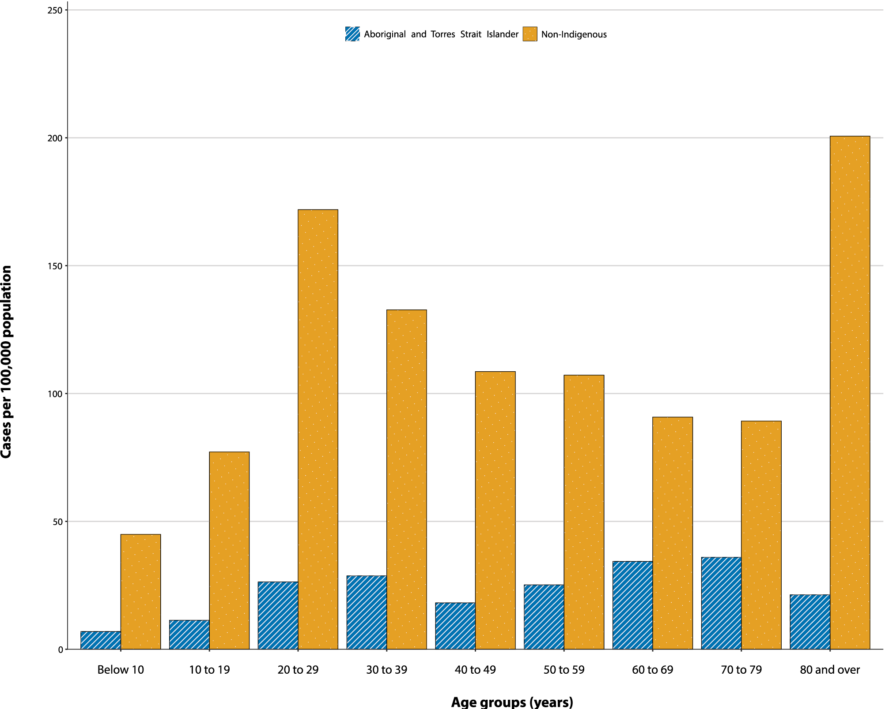

Clusters and outbreaks

(State and territory reporting)
For the fortnight ending 6 December 2020, there was a total of four open outbreaks associated with 26 cases. These outbreaks were all in South Australia as associated with the ‘Parafield cluster’. Outbreaks were reported in the following settings: quarantine facility (1), extended family setting (1); workplace (1); and education facility (1).
Nationally, since the beginning of the epidemic, there have been 830 outbreaks associated with 13,238 cases; 2,007 hospitalisations; and 799 deaths. Consistent with the national epidemic case trend, the first peak in outbreaks occurred in mid-March (Figure 6), which was followed by a rapid increase in outbreaks beginning in early July, corresponding with community transmission in Victoria.
Figure 6: Number of outbreaks throughout the course of the pandemic, Australia, 6 December 2020
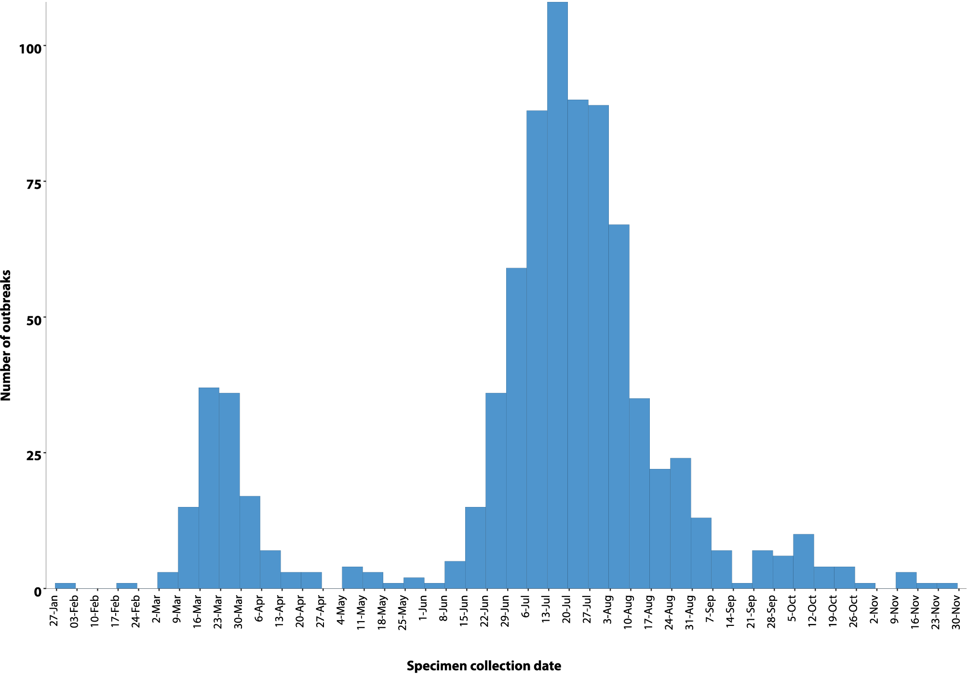
The median number of cases in each outbreak was six (range 2–331). Thirty-nine percent (326/830) of outbreaks had 6–24 cases, and almost a third (32%, 268/830) had only 3–5 cases (Figure 7). The number of cases associated with outbreaks was consistent across the two peaks in mid-March and July. The largest single jurisdictional outbreak occurred in a residential aged care facility and was associated with 260 cases.

Figure 7: Number of outbreaks by size, Australia, 6 December 2020
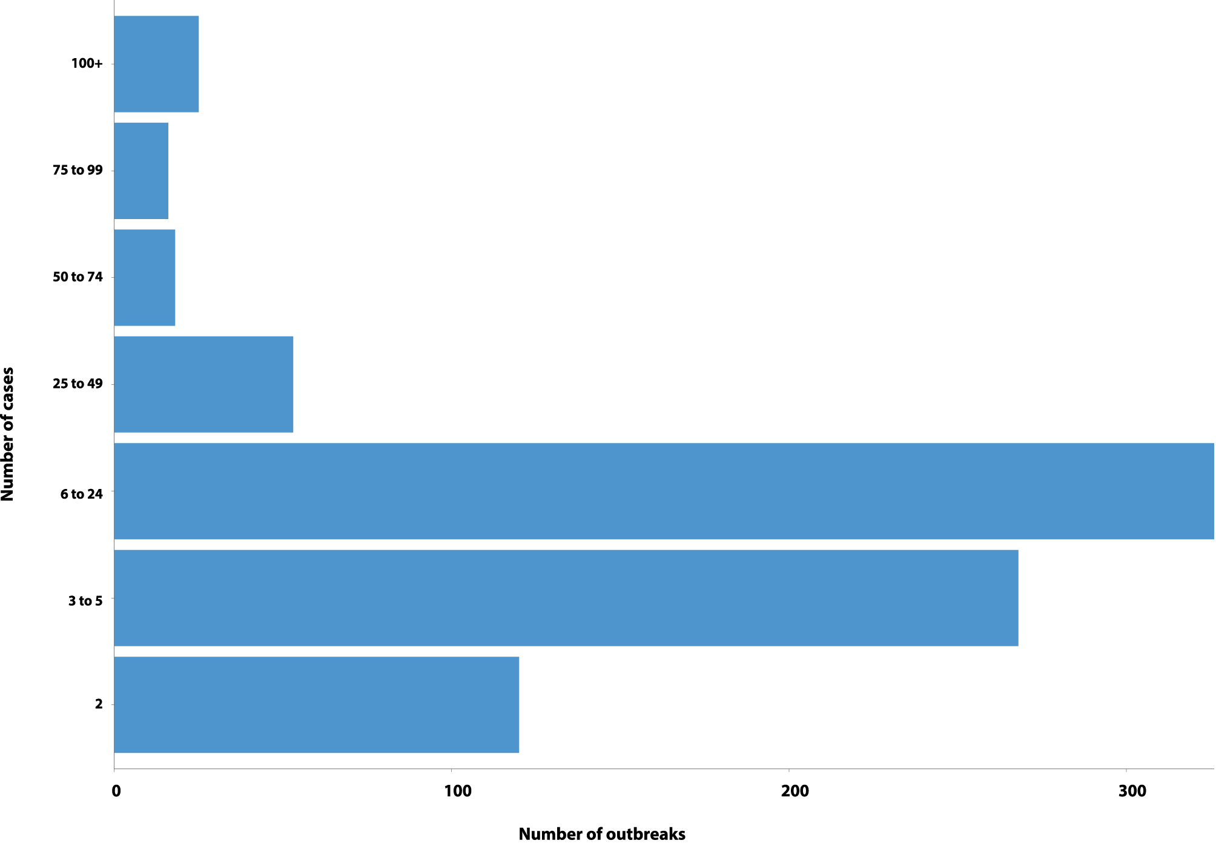
Residents of aged care facilities are at increased risk of COVID-19 infection due to the environment of communal living facilities and are more vulnerable to serious complications if they do become infected. As at 6 December 2020, there were 4,298 cases of COVID-19 associated with 219 residential aged care facilities, with 3,613 recoveries and 685 deaths. Of these cases, 2,049 occurred in aged care residents, with the remaining 2,249 cases occurring in care staff. The Commonwealth is actively supporting services with reported incidents and outbreaks of COVID-19 providing access to personal protective equipment and additional staffing resources where required. Advice and guidelines have been provided to aged care services, including the release of an outbreak management guide.^{16,17}

Virology

(GISAID)
At the time of this report, there were 16,282 SARS-CoV-2 genome sequences available from Australian cases on the global sequence repository, GISAID.¹³ These sequences were dispersed throughout the global lineages, reflecting multiple concurrent introductions into Australia.^{1,18,19} In the last fortnight, there has been one new Australian sequence uploaded to GISAID. Recent Australian SARS-CoV-2 sequences from the last month include 12 from New South Wales and 15 from South Australia. In the past month there have been six different sequences, reflecting the recent shift from locally-acquired to overseas-acquired cases in Australia.

Public health response measures
Since COVID-19 first emerged internationally, Australia has implemented public health measures informed by the disease’s epidemiology (Figure 8). On 8 May, the Australian Government announced a three-step framework for easing COVID-19 restrictions. Building on this framework, on 13 November National Cabinet (except for Western Australia) agreed to a ‘Framework for National Reopening’ which aims to achieve a COVID Normal Australia by Christmas 2020 wherever it is safe to do so.²⁰ States and territories have decision making authority in relation to public health measures and have eased restrictions at their own pace, depending on the local public health and epidemiological situation (Table 5).²¹

Table 5: State and territory changes to COVID-19 restrictions, Australia, 23 November to 6 December 2020
Jurisdiction | Summary of changes to COVID-19 restrictions
New South Wales | No further easing of restrictions during this reporting period.²²
Victoria | From 6 December Victoria moved to ‘COVIDSafe Summer’ restrictions, with the following restrictions eased:23  - Face masks only mandatory in select indoor circumstances (public transport, shopping centres)  - Up to 30 permitted at private gatherings  - Up to 100 permitted at outdoor public gatherings  - Density restrictions for indoor venues reduced to one person per 2m2 (including weddings, funerals and religious gatherings)
Queensland | From 1 December the following restrictions were eased:²⁴  - Up to 50 permitted at private gatherings and 100 permitted in public gatherings  - Density restrictions for indoor venues reduced to one person per 2m2  - Seated, ticketed venues and open air stadiums permitted 100% capacity
Western Australia | No further easing of restrictions during this reporting period.²⁵
South Australia | From 1 December businesses required to have customers sign in on SA GOV app.26
Tasmania | From 1 December the following changes to restrictions:²⁷  - Up to 250 permitted to stand and drink outdoors in licensed premises (within current density restrictions)  - An Events Framework released to support larger events  - ‘Check in Tas App’ available to assist business collecting contact information
Australian Capital Territory | From 2 December the following restrictions were eased:²⁸  - Up to 500 permitted at all gatherings  - Density restrictions for indoor venues reduced to one person per 2m2 if the Check In CBR app is used  - Cinemas permitted up to 65% capacity (up to 500 people) if the Check in CBR app is used  - Large indoor venues permitted up to 65% capacity (up to 1500 people) with Check in CBR app
Northern Territory | From 30 November the following changes to restrictions:²⁹  - The Territory Check In app available for all members of the public and businesses, with some businesses required to use it  - COVID Safety Plans required to be reviewed every six months

Figure 8: COVID-19 notifications in Australia by week of diagnosis and jurisdiction to 6 December with timing of key public health measures
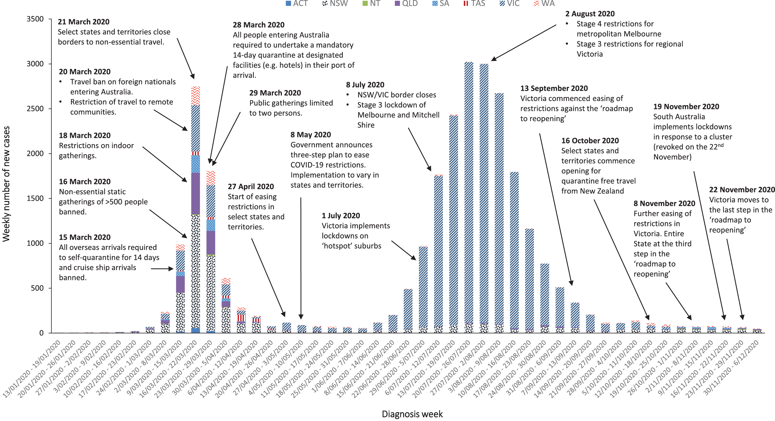

Testing

(State and territory reporting)
As at 6 December 2020, a cumulative total of 10,181,797 tests were conducted in Australia. The cumulative nationwide proportion of positive tests remained low at 0.27% (Table 6). With the exception of Victoria, the cumulative testing positivity in individual jurisdictions was < 0.2%.
Table 6: Diagnostic tests performed, by jurisdiction, Australia, 6 December 2020
Jurisdiction | Tests performed 9–22 November |  |  | Tests performed 23 November – 6 December |  |  | Cumulative tests performed to 6 December
 | n | Positivity (%) | Per 100,000 populationª | n | Positivity (%) | Per 100,000 populationª | n | Positivity (%) | Per 100,000 populationª
NSW | 216,291 | 0.04 | 2,675.06 | 155,300 | 0.05 | 1,920.73 | 3,538,908 | 0.13 | 43,768.72
Vic | 198,310 | 0.00 | 3,007.48 | 130,634 | 0.00 | 1,981.14 | 3,628,246 | 0.56 | 55,024.41
Qld | 58,622 | 0.03 | 1,151.14 | 49,576 | 0.04 | 973.51 | 1,373,765 | 0.09 | 26,976.10
WA | 28,352 | 0.08 | 1,081.38 | 33,977 | 0.09 | 1,295.92 | 563,757 | 0.15 | 21,502.37
SA | 90,157 | 0.04 | 5,144.99 | 87,058 | 0.01 | 4,968.14 | 749,833 | 0.08 | 42,790.73
Tas | 6,044 | 0.00 | 1,130.57 | 5,060 | 0.00 | 946.50 | 131,396 | 0.18 | 24,578.42
NT | 6,714 | 0.10 | 2,728.13 | 5,358 | 0.24 | 2,177.14 | 73,321 | 0.08 | 29,792.81
ACT | 6,886 | 0.01 | 1,615.87 | 5,644 | 0.04 | 1,324.42 | 122,571 | 0.10 | 28,762.48
Australia | 611,376 | 0.03 | 2,411.02 | 472,607 | 0.03 | 1,863.77 | 10,181,797 | 0.27 | 40,152.92
a Population data based on Australian Bureau of Statistics (ABS) Estimated Resident Population (ERP) as at 30 December 2019.
During this reporting period, 472,607 tests were conducted nationally, with a positivity rate of 0.03%. This represented a 29% decrease in fortnightly tests conducted compared to the last reporting period. Testing rates decreased to 9.3 tests per 1,000 population per week during this reporting period, significantly lower than the peak of 19.4 tests per 1,000 population per week in early August. Jurisdictional testing rates are driven by both current case numbers and numbers of people experiencing symptoms. All states except the Northern Territory reported a positivity rate of < 0.10% in this reporting period. The Northern Territory reported a positivity rate of 0.24%, which is an increase from the previous reporting period (0.10%), and was associated with an increased number of overseas-acquired cases linked with repatriation flights. Victoria and Tasmania reported a positivity rate of 0.00% in the reporting period. The low national positivity rate, along with high rates of testing, indicates a low prevalence of COVID-19 nationally.
For the fortnight ending 4 December 2020, testing rates declined significantly among all age groups (Figure 9). Testing rates among children and young adults aged 0–19 years and adults aged 60 years and over have the lowest testing rates for the reporting period.

Figure 9: SARS-CoV-2 polymerase chain reaction (PCR) testing rates per 1,000 population per week by age group, Australia, 1 May – 4 December 2020^{a,b}
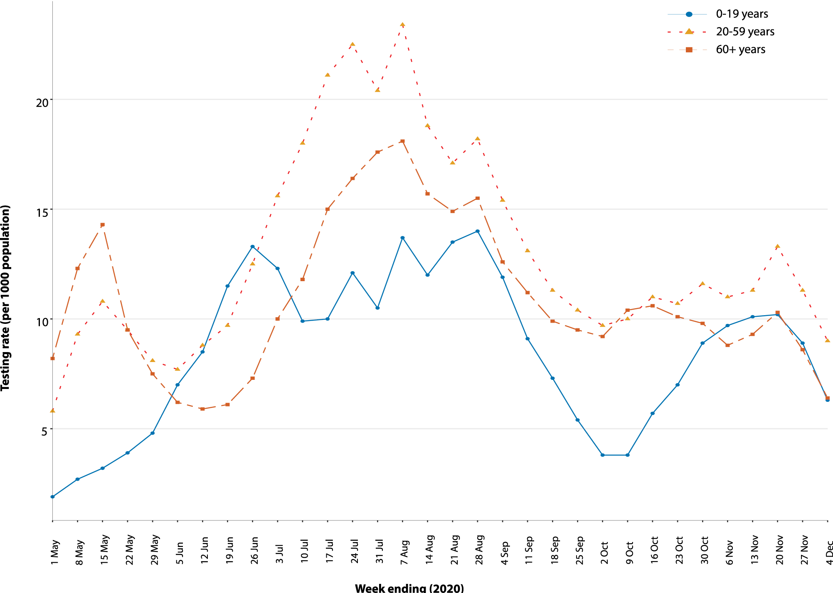
a Data provided by jurisdictions to the NIR weekly.
b The jurisdictions reporting each week (i.e. the denominator population) may vary.

Countries and territories in Australia’s near region
According to WHO, as of 6 December 2020, 46 countries and territories in Australia’s near region (WHO’s South East Asia (SEARO) and Western Pacific (WPRO) regions) reported 784,104 newly-confirmed cases and 10,798 deaths in this reporting period, bringing the cumulative cases in the two regions to 11.9 million and 186,180 cumulative deaths.¹⁵ Testing rates per million are variable across and within countries, indicating that reported cases may not be reflecting the true infection rate.
Countries in the regions that reported the highest number of new cases were:
- India reported 13% fewer new cases and 9% fewer deaths than in the last reporting period (548,416 new cases; 9,644,222 cumulative cases; 6,995 new deaths; 140,182 cumulative deaths);
- Indonesia reported a 20% increase in new cases and a 36% increase in deaths compared to the last fortnightly reporting period (76,399 new cases; 569,707 cumulative cases; 1,815 new deaths; 17,589 cumulative deaths);
- Bangladesh reported a 10% increase in new cases and a 46% increase in deaths compared to the last fortnightly reporting period (30,598 new cases; 476,879 cumulative cases; 457 new deaths; 6,807 cumulative deaths);
- Japan reported a 23% increase in new cases and a more than 17% increase in deaths compared to the last fortnightly reporting period (29,919 new cases; 160,098 cumulative cases; 341 new deaths; 2,315 cumulative deaths); and
- Nepal reported 28% fewer new cases and a 16% increase in new deaths compared to the last reporting period (21,246 new cases; 239,885 cumulative cases; 272 new deaths; 1,577 cumulative deaths).
Countries such as Fiji, the Solomon Islands, Singapore, Marshall Islands, New Caledonia and New Zealand are detecting cases mainly among international arrivals while in quarantine.^{30,31} Fourteen Pacific Island countries reported no new cases in the past reporting fortnight.
Table 7 outlines the current Transmission Classification set by WHO for Australia’s near region. Under the WHO’s classification, Australia has a transmission classification of ‘Clusters of cases’.
Table 7: Transmission patterns for countries in Australia’s near region, WHO,³² 6 December 2020
Category | Country
No cases  Countries/territories/areas with no cases | American Samoa, Cook Islands, Kiribati, Federated States of Micronesia, Nauru, Niue, Palau, Pitcairn Islands, Samoa, Tokelau, Tonga, and Tuvalu
Sporadic cases  Countries/territories/areas with one or more cases, imported or locally detected | Bhutan, Cambodia, Fiji, French Polynesia, Wallis and Futuna, Lao PDR, Marshall Islands, New Caledonia, Solomon Islands, Timor-Leste and Vanuatu
Clusters of cases  Countries/territories/areas experiencing cases, clustered in time, geographic location and/or by common exposures | China, Guam, Japan, Malaysia, Maldives, India, Myanmar, Nepal, New Zealand, Republic of Korea, Singapore, Sri Lanka, Thailand, Vietnam and Australia
Community transmission  Countries /territories/areas experiencing larger outbreaks of local transmission defined through an assessment of factors including, but not limited to:  - large numbers of cases not linkable to transmission chains  - large numbers of cases from sentinel lab surveillance or increasing positive tests through sentinel samples (routine systematic testing of respiratory samples from established laboratories)  - multiple unrelated clusters in several areas of the country/territory/area. | Bangladesh, Indonesia, Papua New Guinea and Philippines
Globally, reported new cases decreased by 800,000 from the previous fortnightly reporting period to 7.9 million in this reporting period, and reported new deaths due to COVID-19 increased from 135,900 to 144,113 across the six WHO regions in the past reporting fortnight. These numbers do not suggest a decreasing trend; rather, they suggest that insufficient testing and likely high rates of undetected cases remain in several countries where high positivity rates are reported. To date, over 65.8 million COVID-19 cases and 1.5 million deaths have been reported globally. New cases and deaths in the Region of the Americas account for nearly half of all new cases and over one third of all new deaths this fortnight. The countries experiencing the greatest number of new cases were the United States of America, India, Brazil, the Russian Federation, and Italy. The highest numbers of reported deaths from COVID-19 were reported in the United States of America, Italy, Mexico, Brazil and the Russian Federation.
An international summary by WHO Region can be found in the WHO Epidemiological Update dated 8 December 2020.^{32,33}

Interpretation
As in previous reports, there has been an overall downward trend in COVID-19 cases following a secondary peak in late July 2020. The local and national epidemiology of COVID-19 continues to inform the public health response. With small numbers of locally-acquired cases in the last fortnight, jurisdictions continued to further ease restrictions.
The most recent outbreak in Australia was associated with a cluster of cases in South Australia, known as the ‘Parafield cluster’. A total of 33 cases are known to be associated with this cluster.³⁴ The first case in this cluster was reported on 15 November, with the last case reported on 29 November. The successful control of this outbreak was achieved by rapid public health interventions along with intensive contact tracing efforts.
Australia continues to experience low levels of community transmission of COVID-19; however, testing rates have decreased by 29% since the last reporting period. Moreover, according to FluTracking data, fewer than half those in the community with ‘fever and cough’ were tested for SARS-CoV-2, while rates of self-reported illness have remained stable. The decline in testing in this reporting period is part of a longer-term trend since the end of October. Whilst the decline likely coincides with the number of cases and respiratory illness in the community, it is important for people to present for testing as soon as symptoms present, even if mild.
Overseas-acquired cases in quarantine remain the greatest source of new COVID-19 cases reported in Australia. Locally-acquired cases reported in the last fortnight have had linkages to quarantine settings, highlighting the importance of ongoing surveillance in these settings.
Cumulative demographic trends to date show that: persons aged ≥ 90 years have the highest cumulative rate of infection; children aged 0–9 years have the lowest rate of infection; and cases in Aboriginal and Torres Strait Islander people account for less than 1% of all confirmed cases. Currently the median age of cases tends to be 37 years old, which has remained unchanged since the beginning of August.
It is important to note that changes in notifications over time are strongly influenced by a range of factors other than disease incidence. These factors include changes in testing policies; screening programs, including the preferential testing of high-risk populations; and periodic awareness campaigns.

Definitions
“Cluster” in relation to COVID-19 refers to two or more cases (who do not reside in the same household) that are epidemiologically related in time, place or person where a common source (such as an event or within a community) of infection is suspected but not yet established.
“COVID-19” is the disease caused by a novel coronavirus—SARS-CoV-2—that emerged in China in late 2019. ‘CO’ stands for corona-, ‘V’ stands for virus, ‘ID’ stands for infectious disease, and ‘-19’ refers to the year that this disease was first reported.
“COVID-19 associated death” is defined for surveillance purposes as a death in a probable or confirmed COVID-19 case, unless there is a clear alternative cause of death that cannot be related to COVID-19 (e.g. trauma).³⁵ There should be no period of complete recovery from COVID-19 between illness and death. Where a Coroner’s report is available, these findings are to be observed.
“Date of illness onset” is derived from data collected by the NNDSS and represents the diagnosis date, or reported true onset of disease date. If unknown, the earliest of specimen collection date, notification date or notification receive date is used.
“Notification received date” is reported in the NNDSS and represents the date the case is first notified on the NNDSS. As notification can only occur after testing is completed and information processed, counts for a defined period will vary according to the date type used.
“Outbreak” in relation to COVID-19 refers to two or more cases (who do not reside in the same household) among a specific group of people and/or over a specific period of time where illness is associated with a common source (such as an event or within a community). Some states and territories may report a single case associated with a residential aged care facility as an outbreak.
“SARS-CoV-2” is the virus that causes the disease COVID-19. It is a betacoronavirus genetically related to the 2003 Severe acute respiratory syndrome coronavirus (SARS-CoV).
“This reporting period” refers to the period covered by this report, i.e. 23 November – 6 December 2020.

Acknowledgements
This report represents surveillance data reported through Communicable Diseases Network Australia (CDNA) as part of the nationally-coordinated response to COVID-19. We thank public health staff from incident emergency operations centres and public health units in state and territory health departments, and the Australian Government Department of Health, along with state and territory public health laboratories. We thank those who provided data from surveillance systems, such as Commonwealth respiratory clinics, SPRINT-SARI, Flutracking, and FluCan.
This is the last Communicable Diseases Intelligence COVID-19 epidemiology report for 2020. Report 32 will be made available in January 2021.

Author details

Corresponding author
COVID-19 National Incident Room Surveillance Team, Australian Government Department of Health, GPO Box 9484, MDP 14, Canberra, ACT 2601. Email: epi.coronavirus@health.gov.au

References
- Rockett RJ, Arnott A, Lam C, Sadsad R, Timms V, Gray KA et al. Revealing COVID-19 transmission in Australia by SARS-CoV-2 genome sequencing and agent-based modeling. Nat Med. 2020. doi: https://doi.org/10.1038/s41591-020-1000-7.
- World Health Organization (WHO). Transmission of SARS-CoV-2: implications for infection prevention precautions. Scientific brief. [Internet.] Geneva: WHO; 9 July 2020. [Accessed on 14 October 2020.] Available from: https://www.who.int/news-room/commentaries/detail/transmission-of-sars-cov-2-implications-for-infection-prevention-precautions.
- McAloon C, Collins Á, Hunt K, Barber A, Byrne AW, Butler F et al. Incubation period of COVID-19: a rapid systematic review and meta-analysis of observational research. BMJ Open. 2020;10(8). doi: https://doi.org/10.1136/bmjopen-2020-039652.
- Australian Government Department of Health. Australian National Disease Surveillance Plan for COVID-19. [Internet.] Canberra: Australian Government Department of Health; 30 May 2020. Available from: https://www.health.gov.au/resources/publications/australian-national-disease-surveillance-plan-for-covid-19.
- Yuan Z, Xiao Y, Dai Z, Huang J, Zhang Z, Chen Y. Modelling the effects of Wuhan’s lockdown during COVID-19, China. Bull World Health Organ. 2020;98(7):484–94.
- Rothan HA, Byrareddy SN. The epidemiology and pathogenesis of coronavirus disease (COVID-19) outbreak. J Autoimmun. 2020;109. doi: https://doi.org/10.1016/j.jaut.2020.102433.
- Hu Y, Sun J, Dai Z, Deng H, Li X, Huang Q et al. Prevalence and severity of corona virus disease 2019 (COVID-19): A systematic review and meta-analysis. J Clin Virol. 2020; 127. doi: https://doi.org/10.1016/j.jcv.2020.104371.
- WHO. Report of the WHO-China Joint Mission on Coronavirus Disease 2019 (COVID-19). Geneva: WHO; 2020. [Accessed on 14 October 2020.] Available from: https://www.who.int/docs/default-source/coronaviruse/who-china-joint-mission-on-covid-19-final-report.pdf.
- Australian Government Department of Health. Coronavirus Disease 2019 (COVID-19): CDNA national guidelines for public health units. Canberra: Australian Government Department of Health; 28 October 2020. [Accessed on 9 November 2020.] Available from: https://www1.health.gov.au/internet/main/publishing.nsf/Content/7A8654A8CB144F5FCA2584F8001F91E2/$File/COVID-19-SoNG-v3.10.pdf.
- Dalton C, Durrheim D, Fejsa J, Francis L, Carlson S, d’Espaignet ET et al. Flutracking: a weekly Australian community online survey of influenza-like illness in 2006, 2007 and 2008. Commun Dis Intell Q Rep. 2009;33(3):316–22.
- Monash Health. FluCAN (Influenza surveillance): FluCAN (The Influenza Complications Alert Network) [Internet.] Melbourne: Monash Health; 2020. Available from: https://monashhealth.org/services/monash-infectious-diseases/research/influenza-research/flucan-influenza-surveillance-2/.
- Australian and New Zealand Intensive Care Society (ANZICS). SPRINT-SARI: Short period incidence study of severe acute respiratory infection. [Internet.] Camberwell: ANZICS; 2020. Available from: https://www.anzics.com.au/current-active-endorsed-research/sprint-sari/.
- Global Initiative on Sharing All Influenza Data (GISAID). [Website.] Berlin: Federal Republic of Germany, Freunde von GISAID e.V.; 2020. [Accessed on 15 October 2020.] Available from: https://www.gisaid.org/.
- Bedford T, Neher R, Hadfield J, Hodcroft E, Sibley T, Huddleston J et al. Nextstrain: Genomic epidemiology of novel coronavirus - Oceania-focused subsampling. [Internet.] Nextstrain; 2020. [Accessed on 15 October 2020.] Available from: https://nextstrain.org/ncov/oceania.
- WHO. WHO Coronavirus Disease (COVID-19) dashboard. [Internet.] Geneva: WHO; 6 December 2020. [Accessed on 7 December 2020.] Available from: https://covid19.who.int/.
- Australian Government Department of Health. Coronavirus (COVID-19) advice for the health and aged care sector. [Internet.] Canberra: Australian Government Department of Health; 2020. [Accessed 13 August 2020.] Available from: https://www.health.gov.au/news/health-alerts/novel-coronavirus-2019-ncov-health-alert/coronavirus-covid-19-advice-for-the-health-and-aged-care-sector.
- Communicable Diseases Network Australia (CDNA). Coronavirus disease 2019 (COVID-19) outbreaks in residential care facilities: CDNA national guidelines for the prevention, control and public health management of COVID-19 outbreaks in residential care facilities in Australia. Canberra: Australian Government Department of Health, CDNA; 13 March 2020. [Accessed on 13 August 2020.] Available from: https://www.health.gov.au/sites/default/files/documents/2020/03/coronavirus-covid-19-guidelines-for-outbreaks-in-residential-care-facilities.pdf.
- Seemann T, Lane CR, Sherry NL, Duchene S, Goncalves da Silva A, Caly L et al. Tracking the COVID-19 pandemic in Australia using genomics. Nat Commun. 2020;11(1):4376. doi: https://doi.org/10.1038/s41467-020-18314-x.
- Eden JS, Rockett R, Carter I, Rahman H, de Ligt J, Hadfield J et al. An emergent clade of SARS-CoV-2 linked to returned travellers from Iran. Virus Evol. 2020;6(1):veaa027. doi: https://doi.org/10.1093/ve/veaa027.
- Prime Minister of Australia. National Cabinet media statement. 13 Nov 2020. Prime Minister. [Internet.] Canberra: Australian Government Department of Prime Minister and Cabinet; 13 November 2020. [Accessed on 24 November 2020.] Available from: https://www.pm.gov.au/media/national-cabinet-2.
- Australian Government Department of Health. Framework for national reopening – October 2020. [Internet.] Canberra: Australian Government Department of Health; 23 October 2020. [Accessed on 10 November 2020.] Available from: https://www.health.gov.au/resources/publications/framework-for-national-reopening-october-2020.
- Government of New South Wales. What you can and can’t do under the rules. [Internet.] Sydney: Government of New South Wales; 2020. [Accessed on 10 November 2020.] Available from: https://www.nsw.gov.au/covid-19/what-you-can-and-cant-do-under-rules#recent-and-upcoming-changes.
- Victoria State Government. How we live: information for all Victorians. Victoria moves to COVIDSafe Summer from 11:59pm 6 December 2020. [Internet.] Melbourne: Victoria State Government; 2020. [Accessed on 8 December 2020.] Available from: https://www.coronavirus.vic.gov.au/how-we-live.
- Queensland Government. Queensland’s COVIDSafe future. Brisbane: Queensland Government; 2020. [Accessed on 8 December 2020.] Available from: https://www.covid19.qld.gov.au/__data/assets/pdf_file/0016/127150/DPC7309-COVID-19-Restrictions-roadmap.pdf.
- Government of Western Australia. COVID-19 coronavirus: what you can and can’t do. Information about current restrictions. [Internet.] Perth: Government of Western Australia; 2020. [Accessed on 8 December 2020.] Available from: https://www.wa.gov.au/organisation/department-of-the-premier-and-cabinet/covid-19-coronavirus-what-you-can-and-cant-do.
- Government of South Australia. COVID-19 response: current restrictions. [Internet.] Adelaide: Government of South Australia; 2020. [Accessed on 8 December 2020.] Available from: https://www.covid-19.sa.gov.au/recovery.
- Tasmanian Government. Coronavirus disease (COVID-19). Important community updates. [Internet.] Hobart: Tasmanian Government; 2020. [Accessed on 8 December 2020.] Available from: https://coronavirus.tas.gov.au/facts/important-community-updates.
- Australian Capital Territory Government. Canberra’s recovery plan: easing of restrictions roadmap (as at 02 December 2020). Canberra: Australian Capital Territory Government; 2020. [Accessed on 8 December 2020.] Available from: https://www.covid19.act.gov.au/__data/assets/pdf_file/0004/1664968/PICC0050-COVID-Recovery-Plan_2-December-2020.pdf.
- Northern Territory Government. Coronavirus (COVID-19): New COVID-safe check-in system available next week. [Internet.] Darwin: Northern Territory Government; 24 November 2020. [Accessed on 8 December 2020.] Available from: https://coronavirus.nt.gov.au/updates/items/2020-11-24-new-covid-safe-check-in-system-available-next-week.
- Government of Singapore, Ministry of Health. Situation Report Coronavirus Disease (COVID-19). Singapore: Government of Singapore Ministry of Health; 6 November 2020. [Accessed on 9 December 2020.] Available from: https://www.moh.gov.sg/covid-19/situation-report.
- New Zealand Government Ministry of Health: Data and statistics - current cases. Wellington: New Zealand Government Ministry of Health; 6 December 2020. [Accessed on 7 December 2020.] https://www.health.govt.nz/our-work/diseases-and-conditions/covid-19-novel-coronavirus/covid-19-data-and-statistics/covid-19-current-cases#current-situation.
- WHO. Weekly epidemiological update - 8 December 2020. [Internet.] Geneva: WHO; 8 December 2020. [Accessed on 10 December 2020.] Available from: https://www.who.int/publications/m/item/weekly-epidemiological-update-8-december-2020.
- WHO. Weekly operational update on COVID-19 – 7 December 2020. [Internet.] Geneva: WHO; 7 December 2020. [Accessed on 10 December 2020.] Available from: https://www.who.int/publications/m/item/weekly-operational-update-on-covid-19---7-december-2020.
- South Australia Health (SA Health). COVID-19 update 7 December 2020. [Internet.] Adelaide: Government of South Australia; 7 December 2020. Available from: https://www.sahealth.sa.gov.au/wps/wcm/connect/public+content/sa+health+internet/about+us/news+and+media/all+media+releases/covid-19+update+7+december+2020.
- Australian Bureau of Statistics. Articles. Measuring excess mortality in Australia during the COVID-19 pandemic: methodology. [Internet.] Canberra: Australian Bureau of Statistics; 25 November 2020. [Accessed on 25 November 2020.] Available from: https://www.abs.gov.au/articles/measuring-excess-mortality-australia-during-covid-19-pandemic#methodology.

Appendix A: Supplementary figures and tables
Table A.1: COVID-19 case notifications and rates per 100,000 population, by age group and sex, Australia, 6 December 2020
Age group | This reporting period |  |  |  |  |  | Cumulative
 | Cases |  |  | Rate per 100,000 population |  |  | Cases |  |  | Rate per 100,000 population
 | Male | Female | People | Male | Female | People | Male | Female | People | Male | Female | People
0 to 9 | 3 | 7 | 10 | 0.2 | 0.5 | 0.3 | 756 | 687 | 1,443 | 46.2 | 44.3 | 45.3
10 to 19 | 3 | 1 | 4 | 0.2 | 0.1 | 0.1 | 1,209 | 1,167 | 2,376 | 77.0 | 78.6 | 77.8
20 to 29 | 9 | 9 | 18 | 0.5 | 0.5 | 0.5 | 3,018 | 3,306 | 6,346 | 162.4 | 183.6 | 173.4
30 to 39 | 20 | 16 | 36 | 1.1 | 0.9 | 1.0 | 2,479 | 2,424 | 4,918 | 136.3 | 130.6 | 133.8
40 to 49 | 15 | 3 | 18 | 0.9 | 0.2 | 0.5 | 1,814 | 1,756 | 3,598 | 112.1 | 106.0 | 109.9
50 to 59 | 8 | 9 | 17 | 0.5 | 0.6 | 0.6 | 1,607 | 1,710 | 3,325 | 106.6 | 108.7 | 107.9
60 to 69 | 0 | 5 | 5 | 0.0 | 0.4 | 0.2 | 1,177 | 1,208 | 2,387 | 92.6 | 90.0 | 91.3
70 to 79 | 0 | 1 | 1 | 0.0 | 0.1 | 0.1 | 851 | 754 | 1,605 | 97.8 | 81.8 | 89.6
80 to 89 | 0 | 0 | 0 | 0.0 | 0.0 | 0.0 | 492 | 777 | 1,269 | 137.7 | 168.5 | 155.0
90 and over | 0 | 0 | 0 | 0.0 | 0.0 | 0.0 | 229 | 552 | 782 | 333.7 | 413.3 | 386.8

Appendix B: Frequently asked questions
Q: Can I request access to the COVID-19 data behind your CDI fortnightly reports?
A: National notification data on COVID-19 confirmed cases is collated in the National Notifiable Disease Surveillance System (NNDSS) based on notifications made to state and territory health authorities under the provisions of their relevant public health legislation.
Normally, requests for the release of data from the NNDSS requires agreement from states and territories via the Communicable Diseases Network Australia, and, depending on the sensitivity of the data sought and proposed, ethics approval may also be required.
Due to the COVID-19 response, unfortunately, specific requests for NNDSS data have been put on hold. We are currently looking into options to be able to respond to data requests in the near future.
We will continue to publish regular summaries and analyses of the NNDSS dataset and recommend the following resources be referred to in the meantime:
- NNDSS summary tables: http://www9.health.gov.au/cda/source/cda-index.cfm
- Daily case summary of cases: https://www.health.gov.au/news/health-alerts/novel-coronavirus-2019-ncov-health-alert/coronavirus-covid-19-current-situation-and-case-numbers
- Communicable Diseases Intelligence COVID-19 epidemiology report: https://www1.health.gov.au/internet/main/publishing.nsf/Content/novel_coronavirus_2019_ncov_weekly_epidemiology_reports_australia_2020.htm
- State and territory public health websites.
Q: Can I request access to data at postcode level of confirmed cases?
A: Data at this level cannot be released without ethics approval and permission would need to be sought from all states and territories via the Communicable Diseases Network Australia. As noted above, specific requests for NNDSS data are currently on hold.
Where current or recent reported case numbers are high enough to justify it, a GIS/mapping analysis of cases will be included in the Communicable Diseases Intelligence COVID-19 epidemiology report. In order to protect privacy of confirmed cases, data in this map will be presented at SA3 level.
Q: Where can I find more detailed data on COVID-19 cases?
A: We are currently looking into ways to provide more in-depth epidemiological analyses of COVID-19 cases, with regard to transmission and severity, including hospitalisation. These analyses will continue to be built upon in future iterations of the Communicable Diseases Intelligence report.
Q: Where do I find the COVID-19 background information which was included as Appendix A in previous fortnightly epidemiology reports?
A: This information was most recently published in Epidemiology Report 24 (https://doi.org/10.33321/cdi.2020.44.75). Additional information can be found in the CDNA Series of National Guidelines (SoNG) for COVID-19. (https://www1.health.gov.au/internet/main/publishing.nsf/Content/cdna-song-novel-coronavirus.htm).

Communicable Diseases Intelligence
ISSN: 2209-6051 Online

Communicable Diseases Intelligence (CDI) is a peer-reviewed scientific journal published by the Office of Health Protection, Department of Health. The journal aims to disseminate information on the epidemiology, surveillance, prevention and control of communicable diseases of relevance to Australia.

Editor: Tanja Farmer
Deputy Editor: Simon Petrie
Design and Production: Kasra Yousefi
Editorial Advisory Board: David Durrheim, Mark Ferson, John Kaldor, Martyn Kirk and Linda Selvey

Website: http://www.health.gov.au/cdi

Contacts
Communicable Diseases Intelligence is produced by:
Health Protection Policy Branch, Office of Health Protection, Australian Government Department of Health
GPO Box 9848, (MDP 6) CANBERRA ACT 2601

Email: cdi.editor@health.gov.au

Submit an Article
You are invited to submit your next communicable disease related article to the Communicable Diseases Intelligence (CDI) for consideration. More information regarding CDI can be found at: http://health.gov.au/cdi.
Further enquiries should be directed to: cdi.editor@health.gov.au.

This journal is indexed by Index Medicus and Medline.

Creative Commons Licence - Attribution-NonCommercial-NoDerivatives CC BY-NC-ND
© 2020 Commonwealth of Australia as represented by the Department of Health
This publication is licensed under a Creative Commons Attribution-NonCommercial-NoDerivatives 4.0 International Licence from https://creativecommons.org/licenses/by-nc-nd/4.0/legalcode (Licence). You must read and understand the Licence before using any material from this publication.

Restrictions
The Licence does not cover, and there is no permission given for, use of any of the following material found in this publication (if any):
- the Commonwealth Coat of Arms (by way of information, the terms under which the Coat of Arms may be used can be found at www.itsanhonour.gov.au);
- any logos (including the Department of Health’s logo) and trademarks;
- any photographs and images;
- any signatures; and
- any material belonging to third parties.

Disclaimer
Opinions expressed in Communicable Diseases Intelligence are those of the authors and not necessarily those of the Australian Government Department of Health or the Communicable Diseases Network Australia. Data may be subject to revision.

Enquiries
Enquiries regarding any other use of this publication should be addressed to the Communication Branch, Department of Health, GPO Box 9848, Canberra ACT 2601, or via e-mail to: copyright@health.gov.au

Communicable Diseases Network Australia
Communicable Diseases Intelligence contributes to the work of the Communicable Diseases Network Australia.
http://www.health.gov.au/cdna

