COVID-19, Australia: Epidemiology Report 15: Reporting week ending 23:59 AEST 10 May 2020
COVID-19 National Incident Room Surveillance Team
Notified cases of COVID-19 and associated deaths reported to the National Notifiable Diseases Surveillance System (NNDSS) to 10 May 2020.

Summary
Confirmed cases in Australia notified up to 10 May 2020
Notifications | 6,971
Deaths | 98
The incidence of new cases of COVID-19 has reduced dramatically since a peak in mid-march. The reduction in international travel, social distancing measures and public health action have likely been effective in slowing the spread of the disease, in the Australian community.
Cases of COVID-19 continue to be notified by jurisdictions, albeit at a slowed rate. Testing rates over the past week have increased markedly, with a very low proportion of people testing positive. These low rates of detection are indicative of low levels of COVID-19 transmission. It is important that testing rates and community adherence to public health measures remain high to support the continued suppression of the virus, particularly in vulnerable high-risk groups and settings.
In the past reporting week new cases in Australia are mostly considered to be locally acquired, consistent with the drop in international travel. Most locally-acquired cases can be linked back to a known case or cluster. Although the proportion of locally-acquired cases has increased, the overall rate of cases, regardless of place of acquisition, continues to decrease.
The crude case fatality rate in Australia remains low (1.4%), compared with the WHO reported global rate (6.9%). The low case fatality rate is likely reflective of high case detection and high quality of health care services in Australia. Deaths from COVID-19 in Australia have occurred predominantly among the elderly and those with comorbidities, with no deaths occurring in those under 40 years.
The highest rate of COVID-19 continues to be among people aged 60–79 years, with a third of these cases associated with several outbreaks linked to cruise ships. The lowest rate of disease is in young children, a pattern reflected in international reports.
Internationally, cases continue to increase, with some areas such as Brazil and India showing a dramatic rise in reported cases. Although some low-income countries have currently reported few cases, it is possible that this is due to limited diagnostic and public health capacity, and may not be reflective of disease occurrence.
Keywords: SARS-CoV-2; novel coronavirus; 2019-nCoV; coronavirus disease 2019; COVID-19; acute respiratory disease; epidemiology; Australia
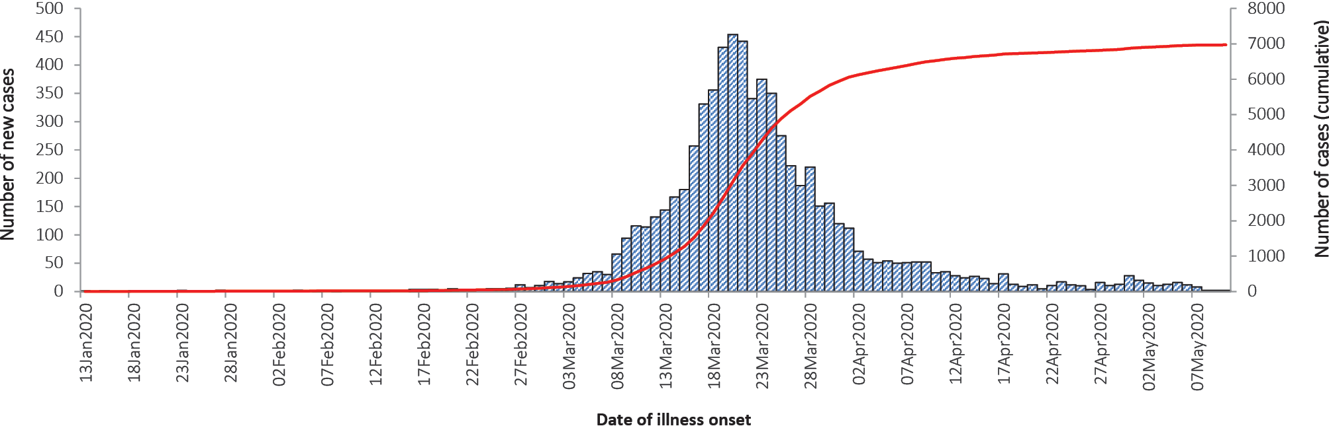

Australian cases: descriptive epidemiology

National trends and geographical distribution
Following the national peak in cases during the week 16–22 March, the incidence of new cases has continued to decrease, indicative of a steady reduction in transmission. The incidence of new cases continues to decline or remain steady in all jurisdictions.
At the jurisdictional level NSW, Vic, Qld, SA, and ACT reported their highest rates of new cases during the week 16–22 March (Figure 1). The majority of cases continue to be notified from major metropolitan areas with very few cases for remote or very remote areas (Figures 2 and 3). The highest cumulative rates of COVID-19 have been reported from NSW and Tasmania (Table 1). The high rates in these states have likely been driven by outbreaks or large clusters, including cruise-ship-related outbreaks in NSW and a recent large outbreak in North West Tasmania.
Across all cases, the median time between onset of symptoms and laboratory testing was 3 days (interquartile range, IQR: 1–6 days). This reflects an increase from a median of 2 days in the week of 13–19 April but is still lower than at the beginning of the epidemic.
Table 1: Notifications and rates of COVID-19 and diagnostic tests performed, Australia, by jurisdiction
Jurisdiction | Cases per 100,000 population |  | Total cases | Cumulative rate  (per 100,000 population) | Cumulative number of tests performed (proportion of tests positive %)
 | 4–10 May | 27 April – 3 May
NSW | 0.16 | 0.35 | 3,085 | 38.1 | 304,464 (1.01)
Vic | 0.58 | 1.17 | 1,497 | 22.7 | 226,889 (0.66)
Qld | 0.04 | 0.10 | 1,051 | 20.6 | 135,806 (0.77)
WA | 0.04 | 0.04 | 536 | 20.4 | 55,758 (0.96)
SA | – | – | 439 | 25.1 | 69,178 (0.63)
Tas | 0.19 | 0.56 | 227 | 42.5 | 18,545 (1.22)
NT | – | – | 29 | 11.8 | 5,495 (0.53)
ACT | – | – | 107 | 25.1 | 11,737 (0.91)
Australia | 0.22 | 0.45 | 6,971 | 27.5 | 827,872 (0.84)

Figure 1: Weekly COVID-19 new case notifications per 100,000 population, as at 10 May 2020, by jurisdiction
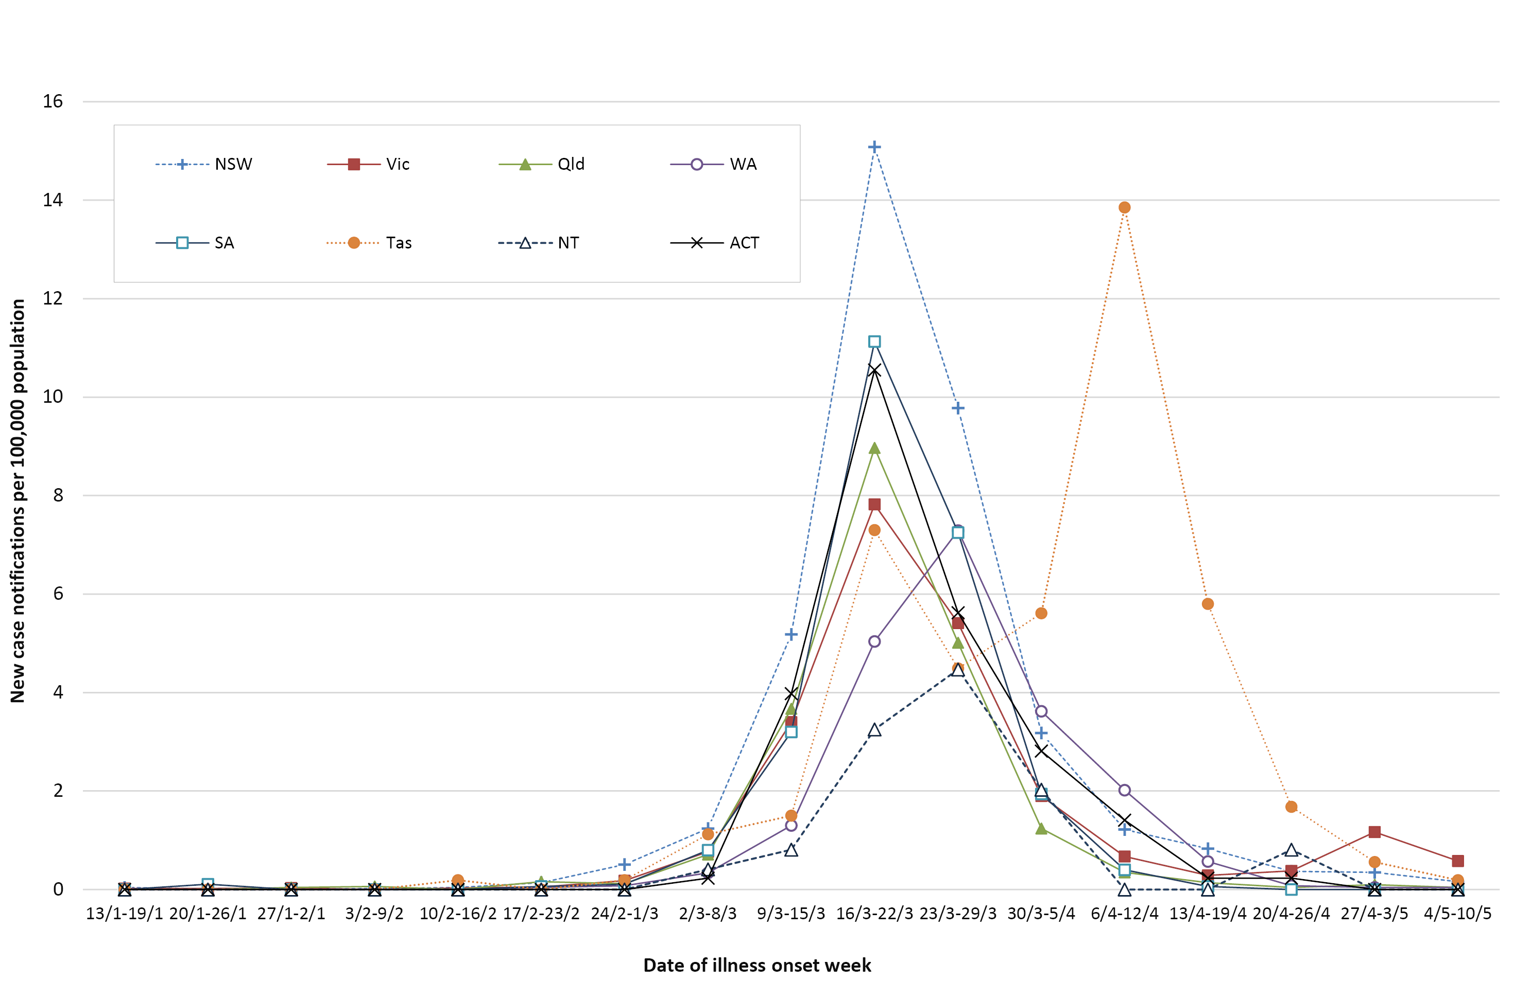

Figure 2: Number of cumulative new confirmed cases of COVID-19, Australia, by location of usual residence and statistical area level 3 (SA3),ª 7 day heat maps for the four most recent weekly reporting periods^{b}
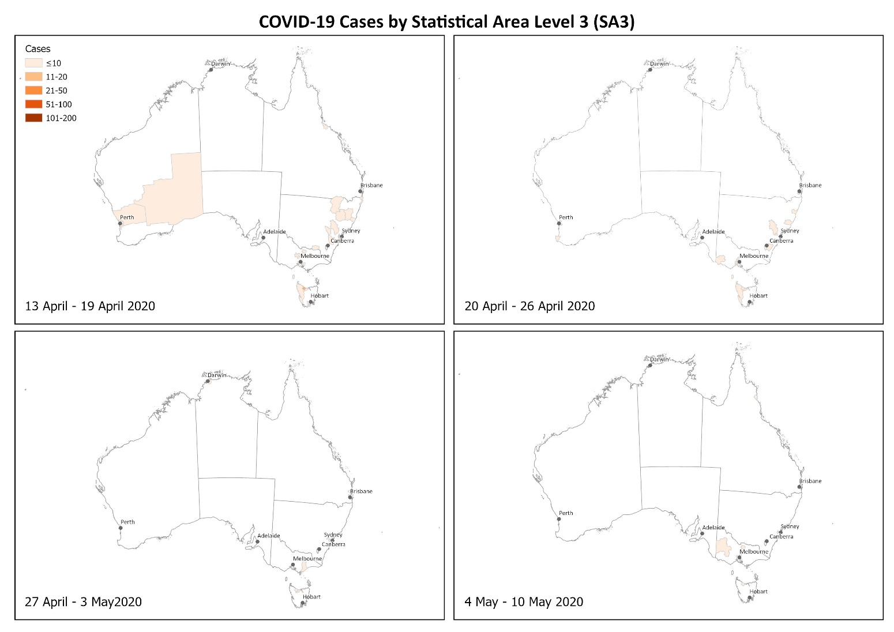
a Represents the usual location of residence of a case, which does not necessarily mean that this is the place where they acquired their infection or were diagnosed. Overseas residents who do not have a usual place of residence in Australia are not shown.
b Based on diagnosis date from NNDSS reporting period up to 23:59 AEST 10 May 2020.

Figure 3: Number of cumulative new confirmed cases of COVID-19, Australia, by location of usual residence and selected areas,ª 7 day heat maps for the four most recent weekly reporting periods^{b}
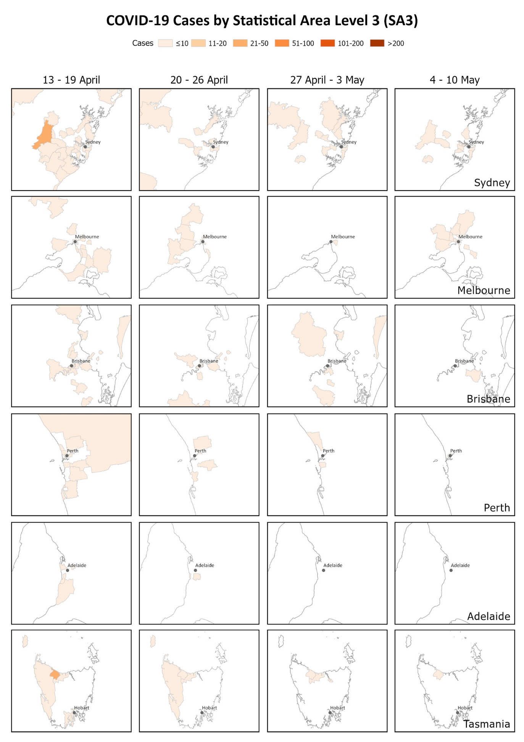
a Represents the usual location of residence of a case, which does not necessarily mean that this is the place where they acquired their infection or were diagnosed. Overseas residents who do not have a usual place of residence in Australia are not shown.
b Based on diagnosis date from NNDSS reporting period up to 23:59 AEST 10 May 2020.

Aboriginal and Torres Strait Islander persons
Fifty-nine cases (0.8%) have been reported in Aboriginal and Torres Strait Islander persons since the start of the epidemic in Australia. These cases were reported across several jurisdictions, with the majority reported in areas classified as ‘Major cities of Australia’ based on the case’s usual place of residence (Table 2). No cases among Aboriginal and Torres Strait Islander persons have been notified from remote or very remote areas of Australia.
Across all Australian cases, completeness of the Indigenous status field was approximately 95%.
Table 2: COVID-19 cases, Australia, notified among persons by remoteness classification
Population | Major cities of Australia | Inner regional Australia | Outer regional Australia | Remote/very remote Australia | Total
Aboriginal and Torres Strait Islander persons | 39 | 13 | 7 | 0 | 59
All persons | 5,437 | 829 | 380 | 37 | 6,971ª
a Total includes 181 overseas residents and 107 persons with unknown remoteness classification.
Thirty-six percent (n = 21) of cases in Aboriginal and Torres Strait Islander persons acquired their infection overseas, while 51% (n = 30) of cases acquired their infection domestically. Eight (14%) were still under investigation at the time of this report.
The median age of COVID-19 cases among Aboriginal and Torres Strait Islander persons is 34 years (interquartile range: 21–55 years), which is lower than the median age of non-Indigenous COVID-19 cases.
Of the cases notified amongst Aboriginal and Torres Strait Islander persons, 10% were admitted to hospital, which is similar to the proportion of all cases hospitalised (all cases = 12%). Of cases in Aboriginal and Torres Strait Islander persons, none were reported as being admitted to ICU.

Age and gender distribution
The highest rate of disease was among those in the 60–69 years age group, followed closely by the 70–79 years age group, with 44 cases and 41 cases per 100,000 population respectively (Figure 4). The high rate amongst those in the 60–69 and 70–79 years age groups is linked to outbreaks on cruise ships, with 29% of cases in the 60–69 years age group and 43% in the 70–79 years age group acquiring their infection at sea.
The lowest rate of disease was among children in the 0–9 years age group, with 2.6 cases per 100,000 population. Among those in the 10–19 years age group, the rate of disease was 7.0 cases per 100,000 population. The number of cases among school-aged children aged 5–18 years was 172 cases (2.5% of total cases). This is consistent with international reports, which indicate a low rate of infection among children. A similar pattern was observed with other coronaviruses such as SARS and MERS with low rates of infection in children.¹
Notifications by gender differed by age group with a higher rate of notifications in females in the 20–29 age group and a higher rate in males in the 40–49 years age group, as well as in those aged over 60 years (Figure 4). It is unlikely that this disparity reflects differences in underlying susceptibility to COVID-19; instead, it is more likely linked to transmission and possibly to differences in travel patterns.

Figure 4: COVID-19 rates per 100,000 population of all cases notified in Australia, by age group and gender
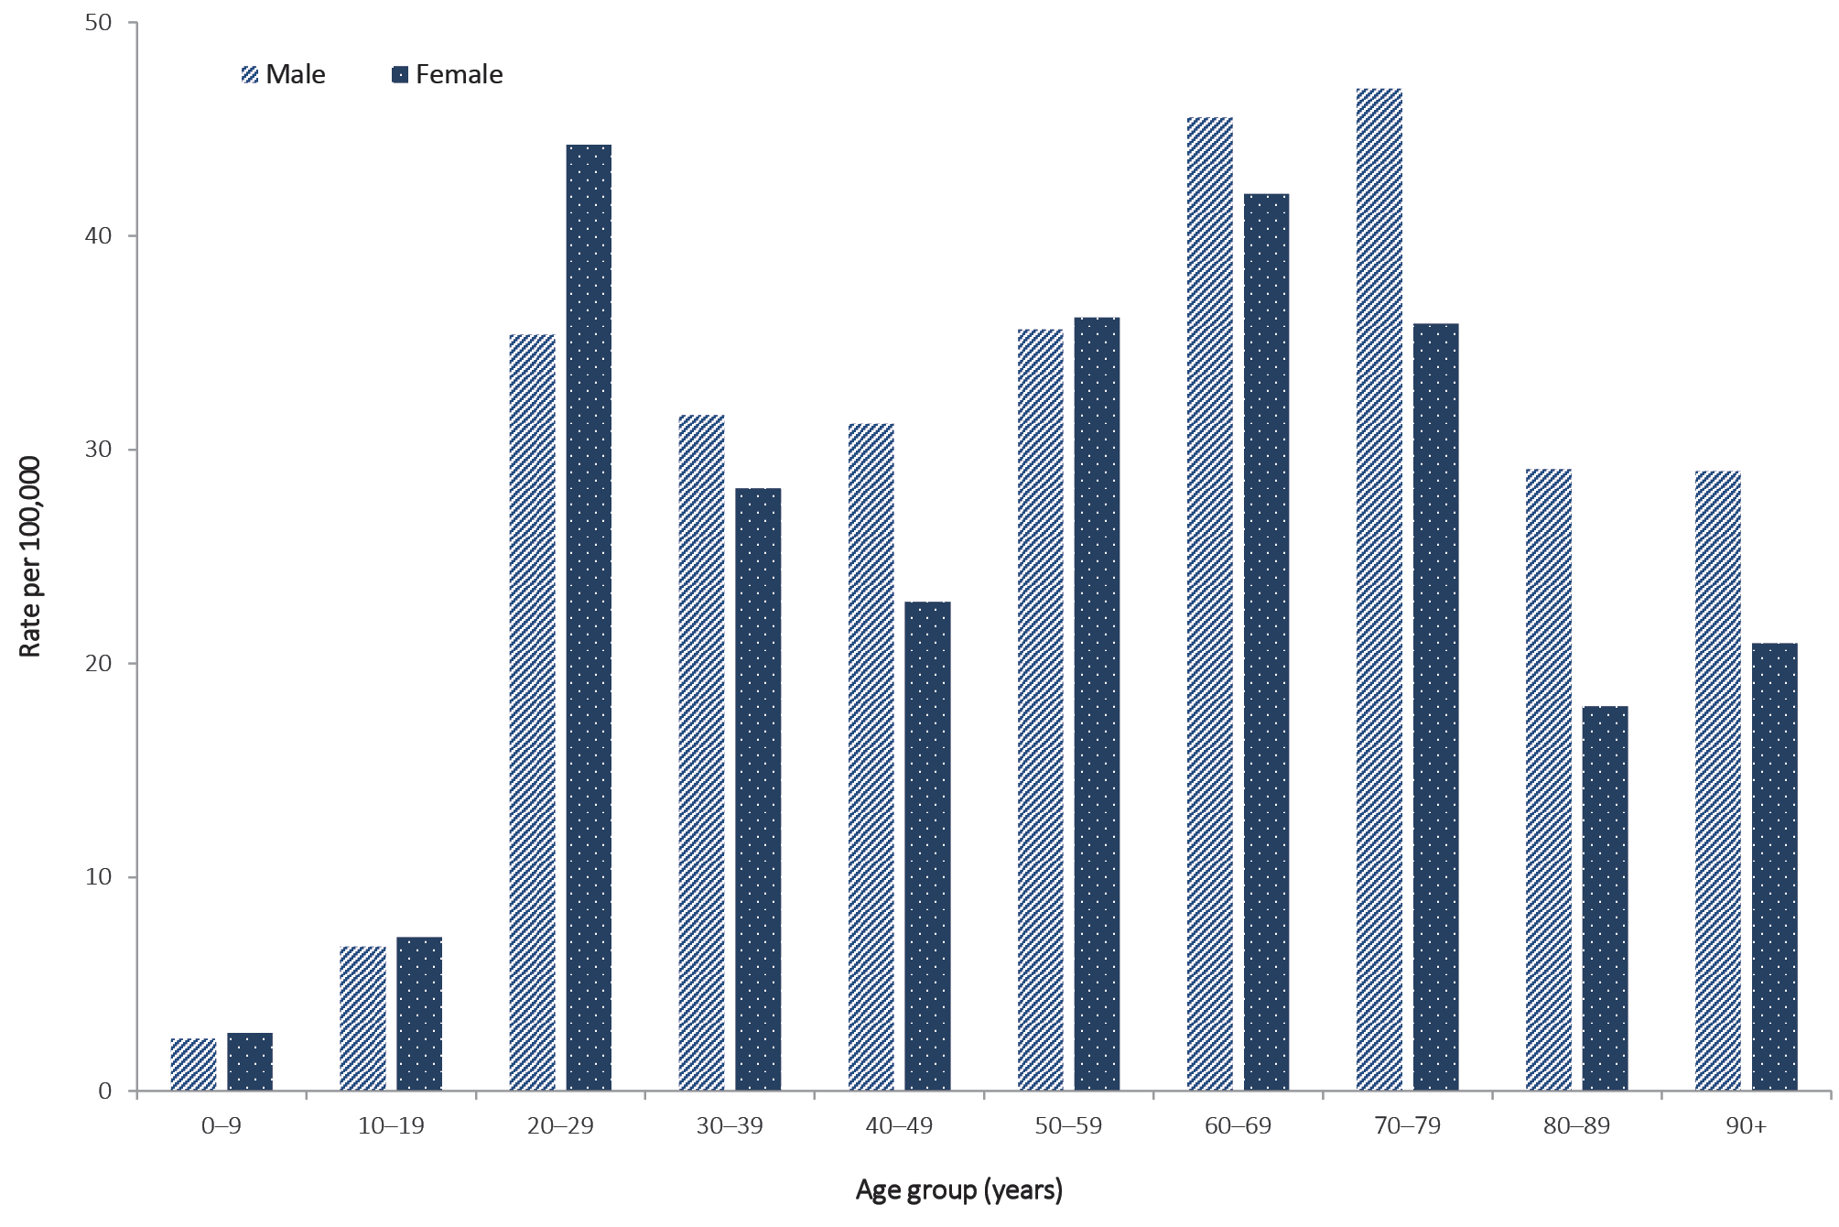

Source of infection
Most cases of COVID-19 notified in Australia in this reporting week were considered to be locally acquired, likely due to the reduction in international travel. However the rate of new cases continues to be low, irrespective of place of acquisition, with a decrease in rate observed for all places of acquisition. Of the cases considered to be locally acquired most are associated with contacts of confirmed cases or are associated with known outbreaks.
Of all cases with a reported place of acquisition, 62% had a recent international travel history and 27% were considered to have been locally acquired from a confirmed case. The rate of new cases has declined in all place of acquisition categories with the steepest decline observed in cases acquired overseas – likely due to the reduction in international travel (Table 3, Figure 5). Of the locally-acquired cases, most were considered to be contacts of a confirmed case, with a very small proportion of cases not able to be epidemiologically linked to a confirmed case. Cases where a place of acquisition has not been reported (0.6%) are currently under public health investigation.
In this reporting week, the overseas-acquired cases have reported travel history to the Southern and Central Asia, Americas, and European regions (Figure 6). In the previous reporting week, 27 March – 3 May, the number of overseas-acquired cases was highest among those who reported travel history to Southern and Central Asia.

Figure 5: Rate of weekly confirmed cases in Australia by date of illness onsetª and place of acquisition
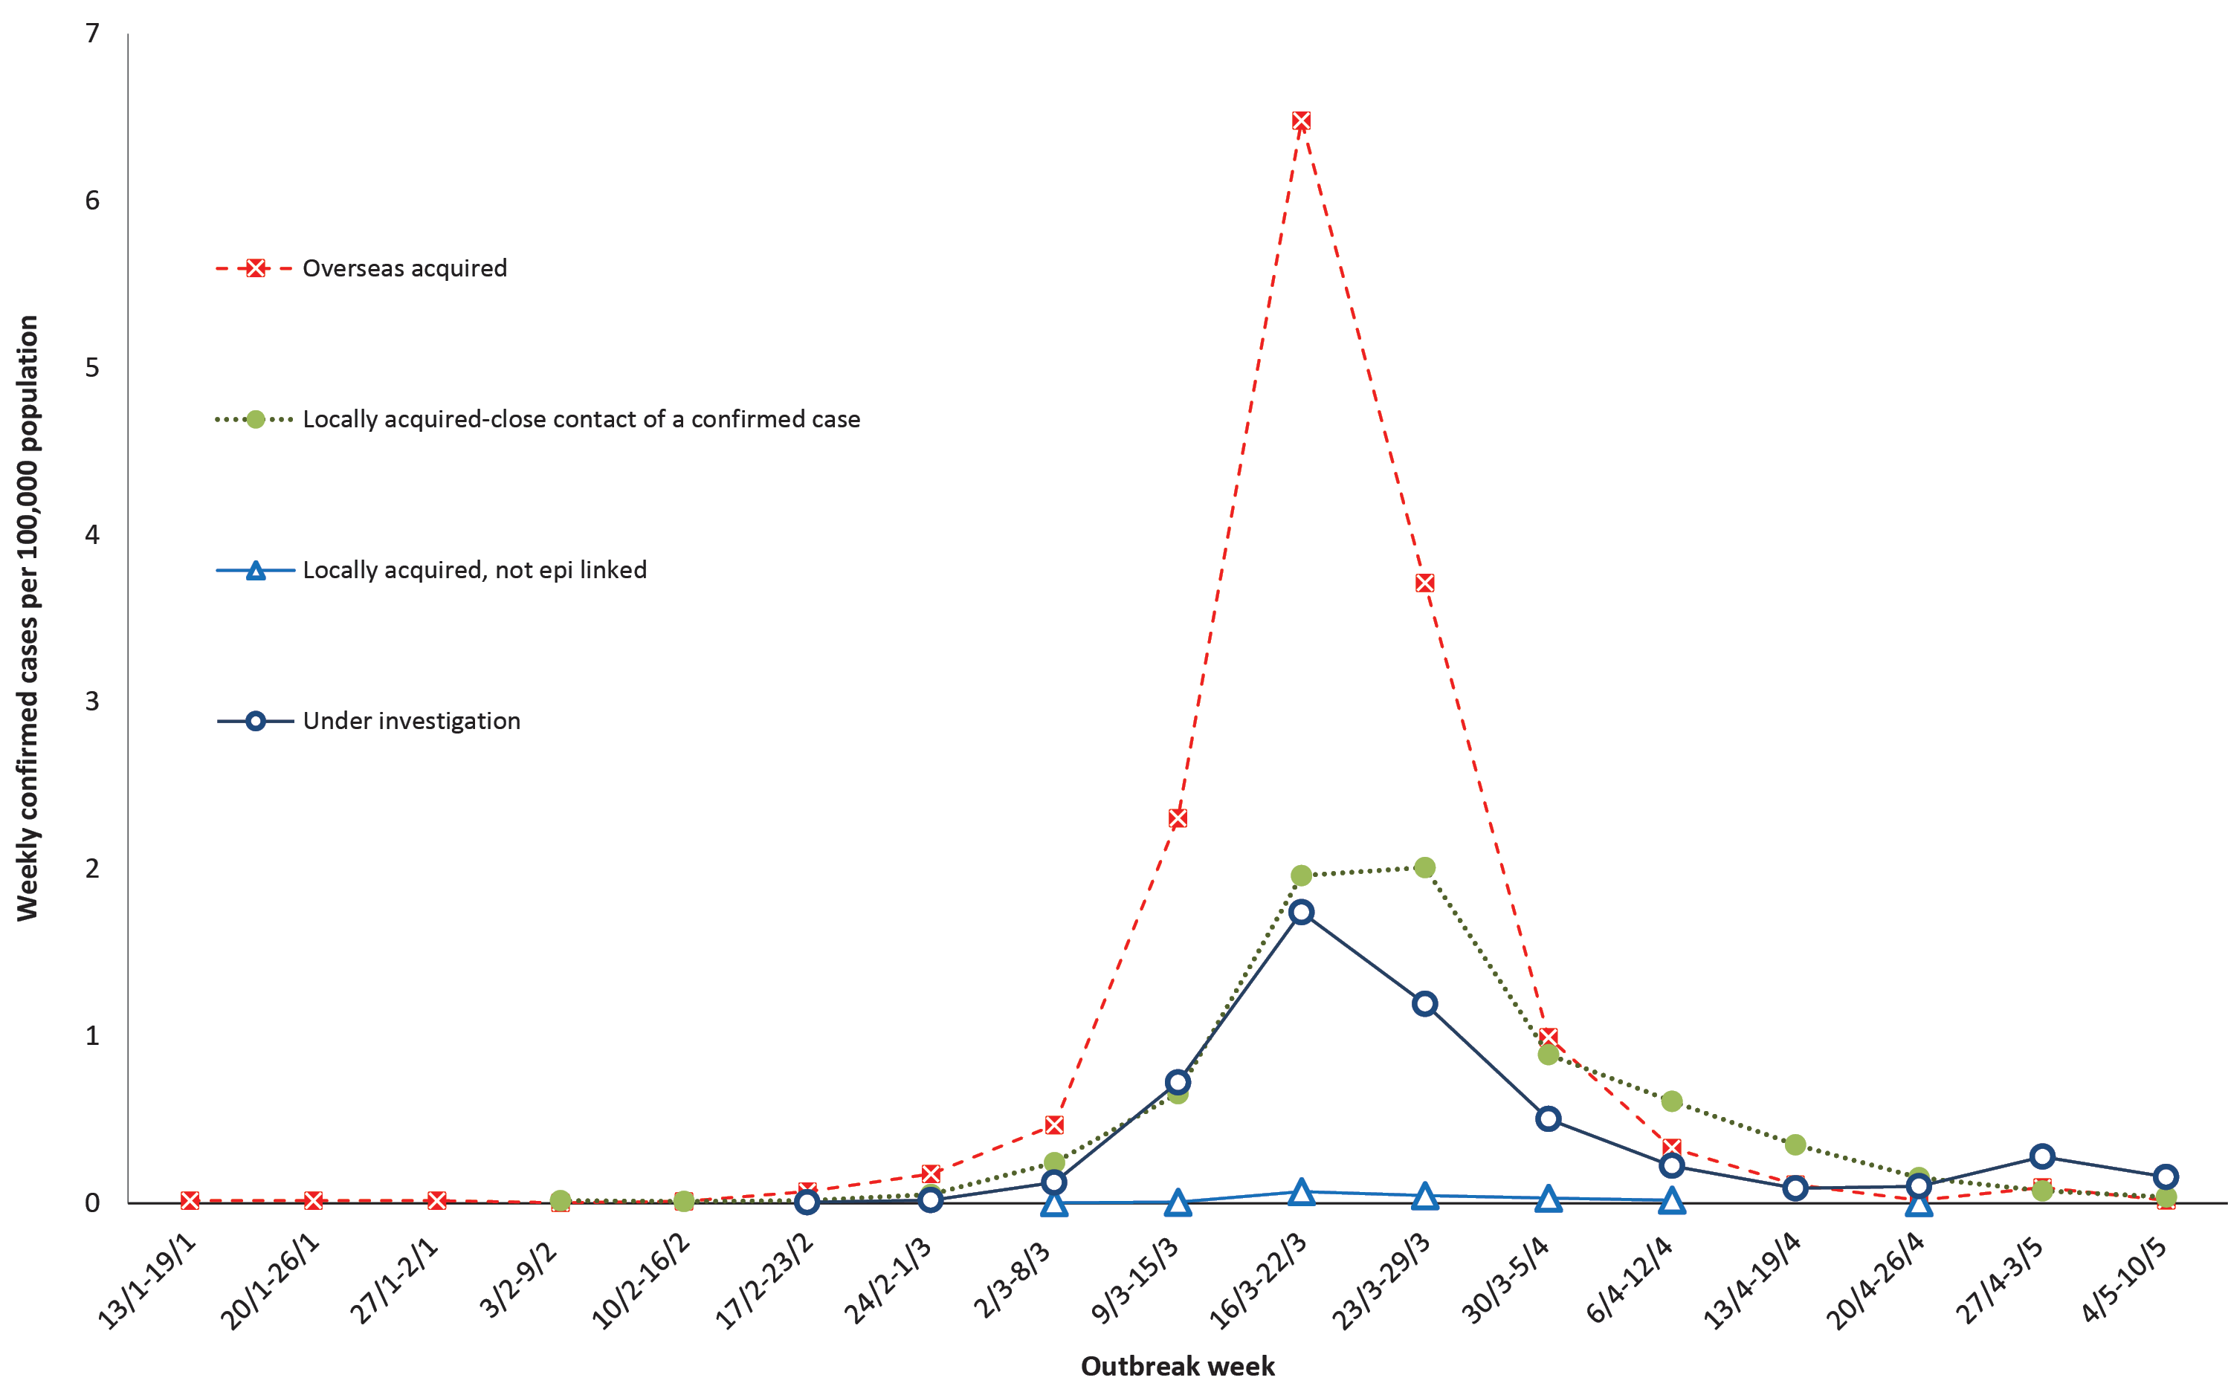
a Note that this graph is from NNDSS where there is a data completeness lag compared to more current proportions presented in text.

Table 3: Rate of weekly confirmed cases in Australia (per 100,000 population) by date of illness onsetª and place of acquisition
Week | Overseas acquired | Locally acquired—close contact of a confirmed case | Locally acquired, not epi linked | Under investigation
13–19 April | 0.11 | 0.343 | – | 0.083
20–26 April | 0.012 | 0.146 | 0.004 | 0.047
27 April – 3 May | 0.032 | 0.051 | – | 0.032
4–10 May | 0.02 | 0.039 | – | 0.158
a Based on diagnosis date from NNDSS reporting period up to 23:59 AEST 10 May 2020
Figure 6: Overseas-acquired confirmed cases in Australia by week of date of illness onset, by travel history regions

Cluster and outbreak investigations

Investigations are taking place in states and territories in relation to a number of clusters and outbreaks of COVID-19. To date the largest outbreaks have been associated with cruise ships, with some other large domestic clusters associated with aged care and healthcare facilities and private functions, such as weddings.

Cluster:
The term ‘cluster’ in relation to COVID-19 refers to two or more cases (who do not reside in the same household) that are epidemiologically related in time, place or person where a common source (such as an event or within a community) of infection is suspected but not yet established.
Outbreak:
The term ‘outbreak’ in relation to COVID-19 refers to two or more cases (who do not reside in the same household) among a specific group of people and/or over a specific period of time where illness is associated with a common source (such as an event or within a community).
Cruise ships account for a substantial proportion of cases of COVID-19 in Australia. Of cases with a reported place of acquisition, 18% (n = 1,107) were acquired at sea on a cruise ship. The number of new cases acquired at sea on cruise ships has decreased in comparison to previous weeks; this in part reflects the implementation of public health responses, in particular the cruise ship arrivals ban. There have been 25 deaths among cases acquired on cruise ships in Australia.
Residents of aged care facilities are at increased risk of COVID-19 infection due to the environment of communal living facilities and are more vulnerable to serious complications if they do become infected. As of 10 May 2020, there have been 121 cases of COVID-19 associated with 26 residential aged care facilities, with 39 recoveries and 26 deaths. Sixty-three of these cases occurred in aged care residents, with the remaining 58 cases occurring in care staff. In addition, there have been 41 cases associated with 29 in-home Commonwealth funded aged care services providing support to older Australians who live at home, with 27 recoveries and 3 deaths. Thirty-one of these cases occurred in care recipients, with the remaining 10 cases occurring in care staff. Advice and guidelines have been provided to aged care services, including the release of an outbreak management guide.

Symptom profile
The symptoms reported by COVID-19 cases in Australia are consistent with a mild respiratory infection in the majority of cases. The most common symptoms reported (Figure 7) were cough (69%), fever (47%), sore throat (40%) and headache (36%). In addition, loss of smell was reported from 609 cases and loss of taste from 580 cases. These conditions were reported in approximately 12% of cases, noting that this is currently not a standard field in NNDSS, and is likely to under-represent those presenting with these symptoms.
In a minority of cases more severe complications are reported, with pneumonia and/or acute respiratory disease (ARD) reported in 3% of cases with symptoms.
The symptom profile of Australian cases is broadly similar to the symptoms reported by COVID-19 cases internationally. Among EU/EEA countries, fever/chills, dry or productive cough and sore through were the most commonly reported symptoms.² Differences in reported symptoms will be influenced by differences in surveillance strategies and symptom reporting across countries.

Figure 7: Variation in combinations of COVID-19 symptoms in confirmed cases, Australiaª
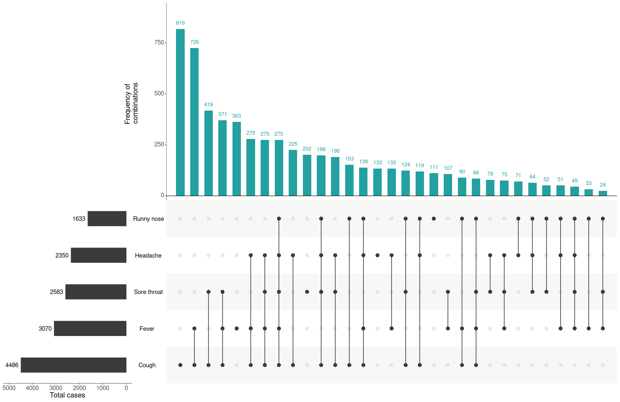
a This figure shows the variation in combinations of symptoms observed in reported cases (n = 6,476) for the five most frequently observed symptoms (cough, fever, sore throat, headache, runny nose). The horizontal bars on the left show the frequency of symptom occurrence in any combination with other symptoms. The circles and lines indicate particular combinations of symptoms observed in individual patients. The vertical green bars indicate the frequency of occurrence of the corresponding combination of symptoms.

Severity
Higher disease severity, as indicated by hospitalisation and death, was associated with increased age and comorbidities (Figure 8). The median age of cases who were hospitalised (median: 61, interquartile range (IQR): 43–72 years) and died (median: 80, IQR: 74–86) was higher than for cases overall (median: 47 years, IQR: 29–62 years). This is consistent with international reporting and reflects a greater risk of severe disease, complications, and deaths in the elderly (Tables 4 and 5).
Figure 8: Age distribution of all cases, hospitalised cases, and deaths with median, interquartile range, and range
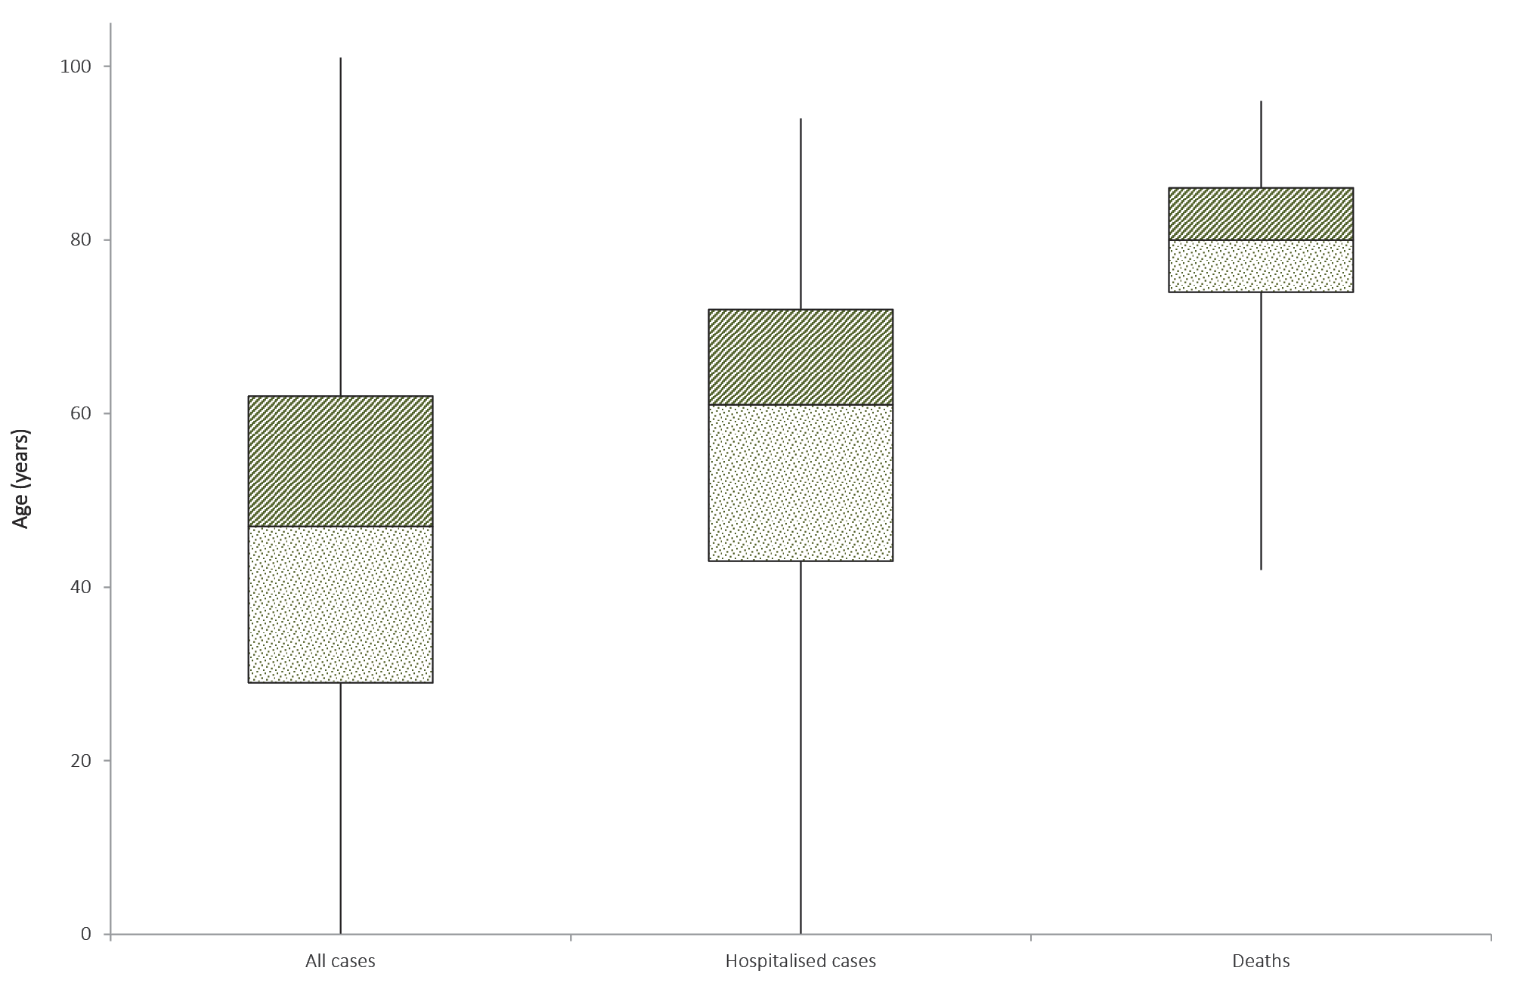
Table 4: Demographics of all cases, hospitalised cases and deaths, Australia
 | All cases |  |  | Hospitalisation |  |  | Death
 | Male | Female | Persons | Male | Female | Persons | Male | Female | Persons
Median age (IQR) | 48  (30–63) | 47  (28–62) | 47  (29–62) | 62  (45–73) | 60  (40–71) | 61  (43–72) | 79  (74–85) | 81  (76–89) | 80  (74–86)
Crude CFRª | 1.6% | 1.3% | 1.4% | 8.6% | 6.9% | 7.9% | – | – | –
a CFR = case fatality rate.

Table 5: Crude CFR of all cases and hospitalised cases, Australia, by age group
Age group | All cases |  | Hospitalisation
 | CFR | Total cases | CFR | Total cases
Under 50 | 0.03% | 3,747 | 0.4% | 273
50–59 | 0.2% | 1,107 | 1.5% | 131
60–69 | 1.0% | 1,142 | 5.5% | 183
70 and over | 8.6% | 975 | 19.7% | 279
All age groups | 1.4% | 6,971 | 7.9% | 866

The crude case fatality rate and the proportion of cases requiring hospitalisation in Australia both remain substantially lower than the corresponding values reported from many other comparable high-income countries. Of total cases of COVID-19 notified in Australia, 866 (12%) were admitted to hospital compared to 42% of cases reported requiring hospitalisation in the EU/EEA. It is noted that the higher proportion reported by EU/EEA is affected by each country’s testing strategies, with some European countries now only testing hospitalised individuals for COVID-19.²
The highest rate of hospitalised cases in Australia was among the 70–79 age group (10.5 per 100,000 populations), followed by the 80–89 years age group (9.2 per 100,000).
Approximately 3% of hospitalised cases were children and young adults aged 19 years and under. Of this group, the highest proportion of hospitalised cases was among children aged 5 and under, with hospitalisation of 12% of cases. Some of these hospitalisations may be precautionary, rather than necessarily being due to illness severity. Of the hospitalised cases among children and young adults, two were admitted to ICU with one receiving ventilation; both cases were both aged 10–19 years.
The most commonly reported comorbid conditions among hospitalised cases were cardiac disease (19%), diabetes (18%) and chronic respiratory conditions (13%). Obesity was reported as a comorbid condition by 7% (n = 43) of hospitalised cases (Table 6).
Of the hospitalised COVID-19 cases, 18% (n = 159) were admitted to an intensive care unit (ICU), with 45 cases receiving ventilation. The most commonly-reported comorbid conditions among cases admitted to an ICU were diabetes (29%) and cardiac disease (25%), which is similar to the most commonly reported comorbid conditions among hospitalised cases. Compared with hospitalised cases, a greater proportion of cases admitted to an ICU or receiving ventilation (15% and 24% respectively) were reported as being obese.
Among those aged 19 years and under, asthma was the most common comorbid condition, reported by 12% (n = 23) of all cases and 27% (n = 3) of hospitalised cases in this age group. This aligns generally with the broader population, with 10.3% (95% CI 9.3–11.3%) of young Australians aged 0–17 estimated to have asthma in 2017–2018.³
Of all cases, 29% reported one or more comorbid conditions, 6% reported two or more and 2% reported three or more. The proportion of COVID-19 cases who reported one or more comorbid conditions increased with the level of care required, with 73% of ventilated cases reporting comorbid conditions.
The median age of cases who died was 80 years (IQR: 74–86 years). Fifty-five of the cases were male and 43 were female. The most commonly reported comorbid conditions among COVID-19 deaths were cardiac disease (32%), diabetes (26%) and chronic respiratory disease (22%). Immunosuppressive condition/therapy (18%) and neurological disorder (18%) were also more commonly reported among deceased cases. Comorbid conditions were more common among cases who died, with 74% reported to have one or more specified comorbid conditions, 42% with two or more and 14% with three or more.
Similar comorbidities have been reported from COVID-19 cases internationally, with cardiac disorder (excluding hypertension), chronic lung disease (excluding asthma) and diabetes the most commonly reported underlying health conditions in EU/EEA countries and the US.^{2,4} As in Australia, the proportion of cases with underlying conditions in these countries increased with COVID-19 severity.
Table 6: Common COVID-19 comorbidities for all cases, hospitalised cases, cases admitted to ICU and cases ventilated in ICU
 | All cases  (n = 5,074)ª | Hospitalised cases (n = 600)ª | Cases admitted to ICU (n = 124)ª | Cases ventilated in ICU (n = 33)ª
Common comorbidities
Cardiac disease (excluding hypertension) | 407 (8%) | 112 (19%) | 25 (20%) | 6 (18%)
Diabetes | 365 (7%) | 107 (18%) | 29 (23%) | 9 (27%)
Chronic respiratory condition (excluding asthma) | 173 (3%) | 75 (13%) | 17 (14%) | 4 (12%)
Obesity | 196 (4%) | 43 (7%) | 18 (15%) | 8 (24%)
Number of specified comorbidities^{b}
One or more | 1,478 (29%) | 329 (55%) | 80 (65%) | 24 (73%)
Two or more | 327 (6%) | 105 (18%) | 31 (25%) | 8 (24%)
Three or more | 77 (2%) | 37 (6%) | 13 (10%) | 3 (9%)
a Excludes those with missing data on comorbidities or where comorbidity is unknown.
b Includes asthma, chronic respiratory conditions (excluding asthma), cardiac disease (excluding hypertension), immunosuppressive condition/therapy, diabetes, obesity, liver disease, renal disease and neurological disorder.

Public health response measures
Since COVID-19 first emerged internationally, Australia has implemented public health measures in response to the disease’s epidemiology, both overseas and in Australia (Figure 9). These measures are focused on domestic and international travel and public gatherings; priorities for testing and quarantining of suspected cases and close contacts; guidance on effective social distancing; and the protection of vulnerable populations such as those in residential care facilities and remote Aboriginal and Torres Strait Islander communities.
On Friday 8 May, the Australian Government announced a three-step framework for easing COVID-19 restrictions. Progress will be reviewed every three weeks to assess the impact of these changes, with the intention of achieving a COVID safe Australia in July 2020. States and territories will ease restrictions at their own pace depending on the current public health situation and local epidemiology, noting that restrictions in these jurisdictions also differ slightly. The Northern Territory, Western Australia and Tasmania have announced ‘roadmaps’ for easing of restrictions with set dates for each step of their respective plans. New South Wales, Queensland and the Australian Capital Territory have announced initial or further easing of restrictions during this reporting period but have not published roadmaps for future easing of restrictions. Victoria and South Australia have not announced easing of restrictions during the current reporting period. A summary of key announcements from this reporting week regarding easing of restrictions in states and territories is at Table 7.
The Australian Health Protection Principal Committee issues advice to inform the national public health response to the pandemic. This advice has most recently included national principles for resumption of sport and recreation activities. The Australian Government has also launched a voluntary app called COVIDSafe, a new tool to help speed up notification of people exposed to COVID-19. All Australians are being encouraged to download the COVIDSafe app to hasten the relaxing of physical distancing measures, with more than 5.3 million Australians downloading the app so far. Key aspects of Australia's evolving public health response are summarised in Table 8.

Table 7: State and territory announcements for easing COVID-19 restrictions, from 3 May to 10 May 2020
Jurisdiction | Announcement or restrictions which have been eased
New South Wales | On 10 May, the NSW Government announced that from 15 May the following restrictions will be eased:⁵  - Gatherings of up to 10 people will be permitted outdoors, in cafes and restaurants, or in places of worship;  - Up to 5 visitors may gather in a household;  - Weddings up to 10 guests, indoor funerals up to 20 mourners and outdoor funerals up to 30 mourners; and  - Use of outdoor equipment and outdoor pools permitted with restrictions.
Queensland | On 8 May, the QLD Government announced the following restrictions will be eased:⁶  - From 10 May, up to 5 visitors from one household or 2 visitors from different households were permitted; and  - From 11 May, community kindergarten, school children in years prep, 1, 11 or 12 and school children of essential workers will be permitted to attend school.
Western Australia | On 10 May, the WA Government announced a roadmap for easing restrictions. In phase 2 from May 18 the following restrictions will be eased:⁷  - Indoor and outdoor gatherings of up to 20 people permitted. Weddings and funerals may have 20 indoor or 30 people outdoors. Cafes and restaurants, places of worship, sports classes and community facilities permitted up to 20 patrons; and  - Regional travel restrictions to be relaxed.
Tasmania | On 8 May, the Tasmanian Government released a phased roadmap for easing of restrictions. In phase 1 from May 11 the following restrictions will be eased:⁸  - Funerals may have 20 mourners attend;  - Aged care visits to recommence with up to two visitors once per week;  - National parks and reserves within 30km available for exercise; and  - TAFE education permitted for some small groups for practical learning.
Australian Capital Territory | From 8 May the following restrictions were eased:⁹  - All indoor and outdoor gatherings may have up to 10 people, including household gatherings, places of worship, outdoor personal fitness and open houses for real estate; and  - Weddings up to 10 guests, indoor funerals up to 20 mourners and outdoor funerals up to 30 mourners.  The ACT Government have announced that public schools will return to on-campus learning over a four week period commencing from 18 May.⁹
Northern Territory | On May 8, Northern Territory updated their roadmap for easing of restrictions. In phase 2 from May 15 the following restrictions will be eased:¹⁰  - Cafes, restaurants, food courts, indoor markets and bars to reopen;  - Sporting clubs, gymnasiums, physical training and exercise classes including dance to recommence; and  - Libraries, playgrounds, places of worship, art galleries, museums and zoos to reopen.

Table 8: Timeline of key COVID-19 related events, including Australian public health response activities.
Date | Event / response activity
8 May 2020 | The Australian Government announces a three-step plan to ease COVID-19 restrictions.¹¹
1 May 2020 | AHPPC releases a statement on risk management for re-opening boarding schools and school-based residential colleges.¹²
26 April 2020 | The Australian Government launches a new voluntary coronavirus app, COVIDSafe.¹³
24 April 2020 | AHPPC provides statements on the recommencement of kidney transplantation, updated advice regarding schools, and use of PPE in hospital with patients with COVID-19.¹⁴
21 April 2020 | AHPPC provides advice for residential aged care facilities about minimising the impact of COVID-19 with information on entry restrictions, managing illness in visitors and staff, and hygiene measures.¹⁵
21 April 2020 | The Australian Government announces the gradual ease of restrictions on elective surgery from Tuesday 28 April 2020.¹⁶
16 April 2020 | AHPPC provides advice on reducing the potential risk of COVID-19 transmission in schools.¹⁷
9 April 2020 | Air crew on international flights will be required to self-isolate at their place of residence (or hotel if not in their local city) between flights or for 14 days, whichever is shorter.¹⁸
30 March 2020 | Special provisions be applied to vulnerable people in the workplace and application of additional regional social distancing measures to combat COVID-19.¹⁹
29 March 2020 | Both indoor and outdoor public gatherings limited to two persons only.
28 March 2020 | All people entering Australia required to undertake a mandatory 14-day quarantine at designated facilities (e.g. hotels) in their port of arrival.
26 March 2020 | Restricted movement into certain remote areas to protect community members from COVID-19.
24 March 2020 | - Temporary suspension of all non-urgent elective procedures in both the public and private sector;  - Progressive scale up of social distancing measures with stronger measures in relation to non-essential gatherings, and considerations of further more intense options; and  - Aged care providers limit visits to a maximum of two visitors at one time per day.
25 March 2020 | - School-based immunisation programs, with the exception of the delivery of meningococcal ACWY vaccine, are paused; and  - Australian citizens and Australian permanent residents are restricted from travelling overseas.
21 March 2020 | Qld, WA, NT and SA close borders to non-essential travellers.
20 March 2020 | - Travel ban on foreign nationals entering Australia;  - Restriction of travel to remote communities; and  - Tasmania closes borders to non-essential travellers.
18 March 2020 | - DFAT raises travel advice for all overseas destinations to Level 4 'Do Not Travel';  - Continuation of a 14-day quarantine requirement for all returning travellers; and  - Restrictions on indoor gatherings.
16 March 2020 | Non-essential static gatherings of > 500 people banned.
15 March 2020 | All overseas arrivals required to self-isolate for 14 days and cruise ship arrivals banned.
8 March 2020 | Restrictions on COVID-19 contacts and travellers from listed higher risk countries.
5 March 2020 | Restrictions on travel from Republic of Korea.
1 March 2020 | Restrictions on travel from Islamic Republic of Iran.

International situation²⁰
As at 18:00 AEST 10 May 2020, the total number of confirmed COVID-19 cases and deaths reported to the World Health Organization (WHO) from the 216 affected countries territories and regions was 3,917,366 cases and 274,361 deaths. Over the past four weeks, the number of new cases per week has remained consistent at approximately 550,000 and in the last week the number of new cases was 567,580. All WHO regions reported an increase in cases and deaths in the past week. The sharpest increase in both cases and deaths was reported from the South-East Asia region (49% and 41%, respectively) and the lowest increase was reported from the Western Pacific region (5% and 4%, respectively). Overall, approximately 57% of the total COVID-19 deaths are from the European Region, 36% from the Americas, and 7% from the remaining Regions.

Figure 9: COVID-19 notifications in Australia by date of onset, from 13 January to 10 May 2020,ª with timing of key public health measures
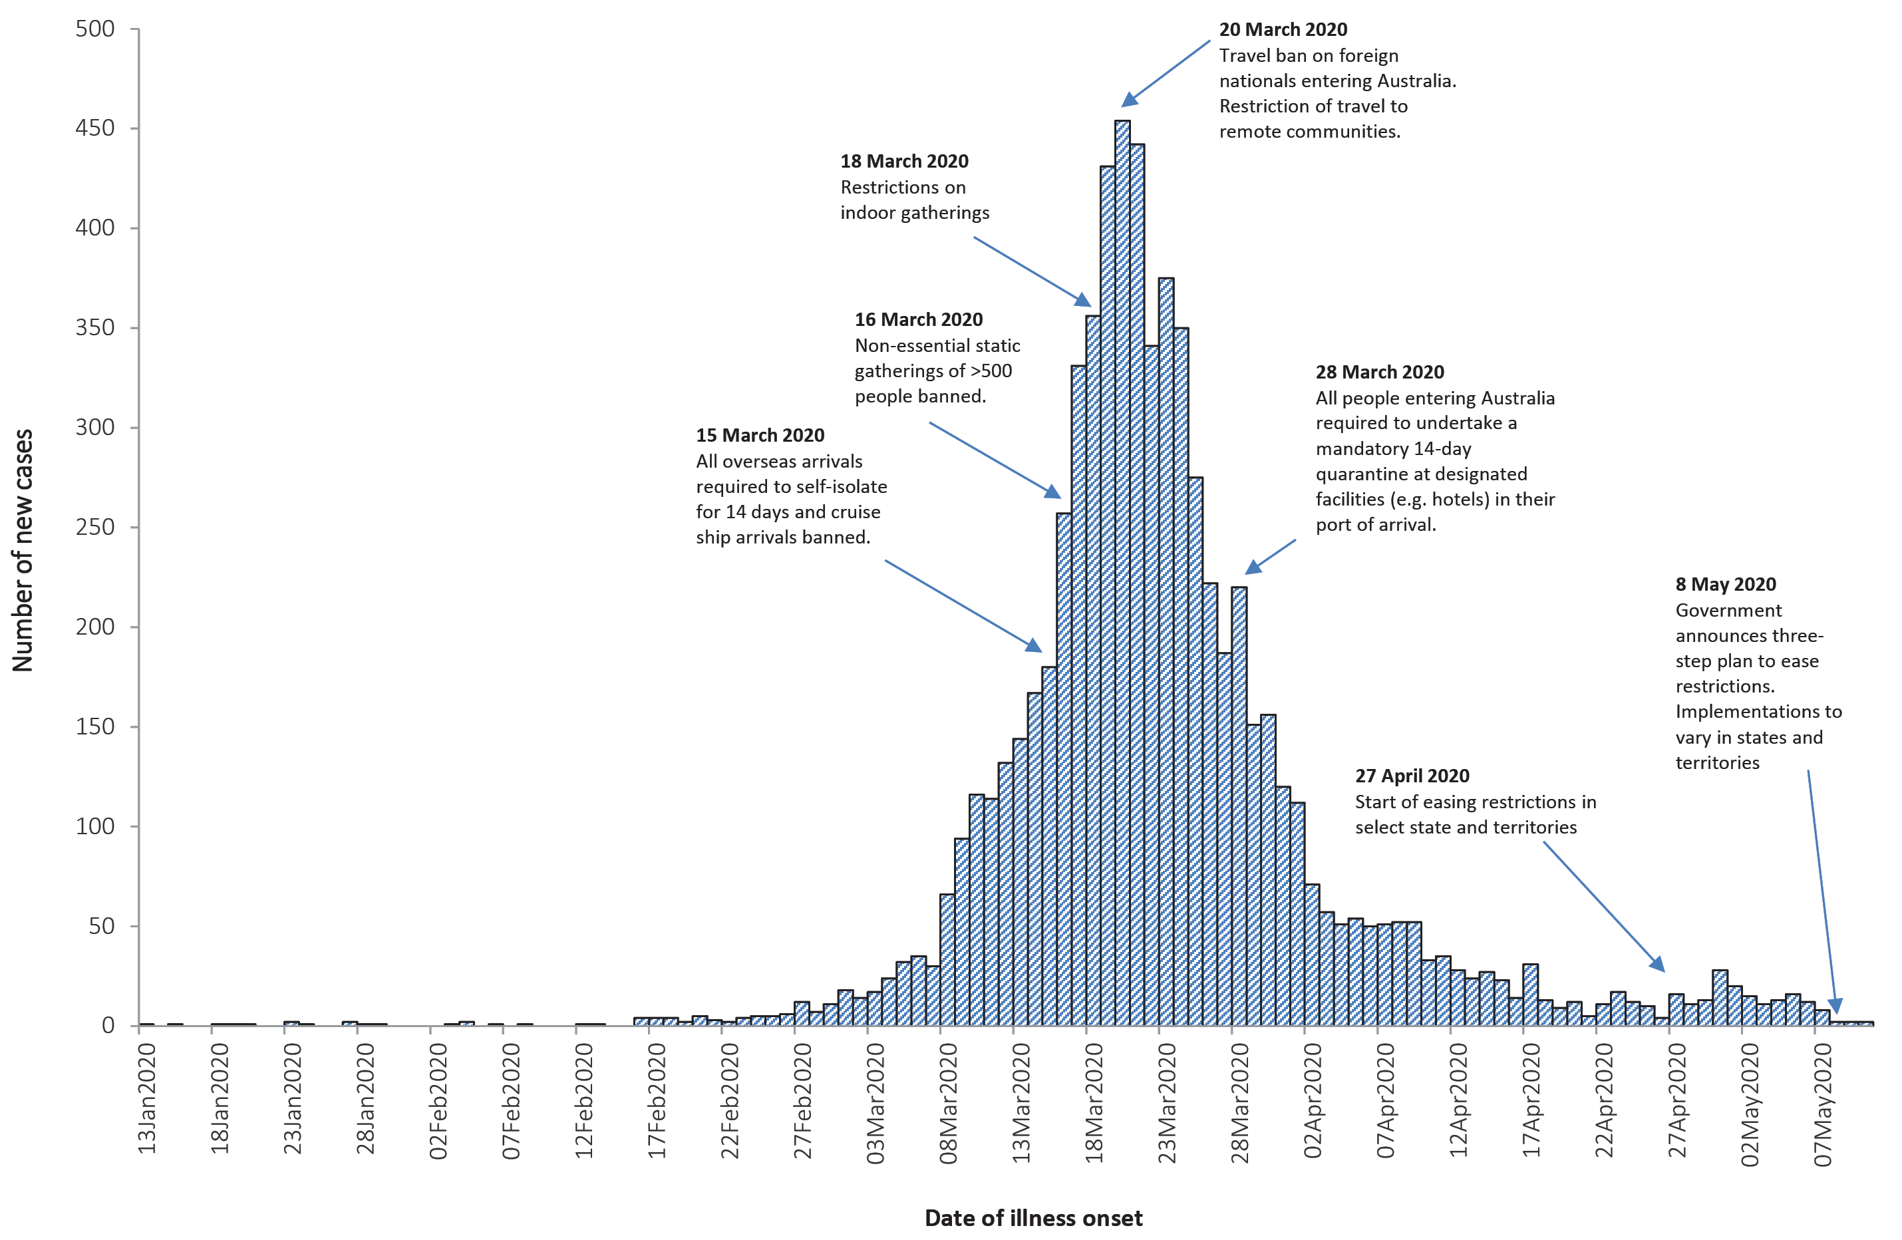
a Due to reporting delays, interpret the latest days’ new cases with caution.
Figure 10: Number of COVID-19 cases (logarithmic scale) by selected country and days since passing 100 cases, up to 10 May 2020
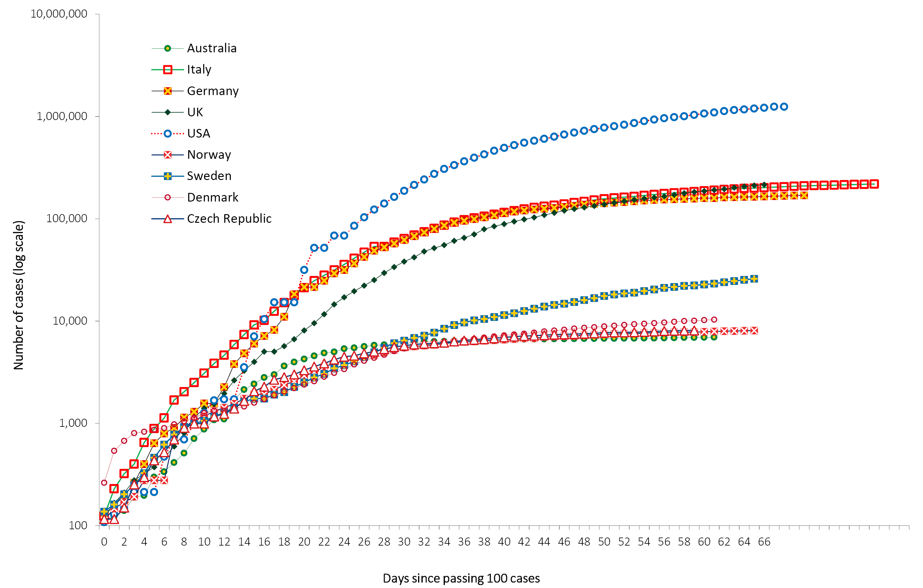

Figure 11: Number of COVID-19 deaths (logarithmic scale) by selected country and days since passing 50 deaths, up to 10 May 2020
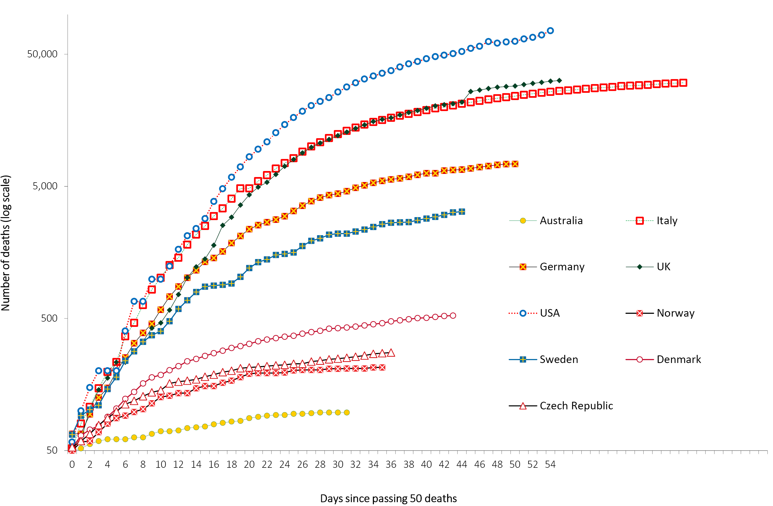

Background
The current estimates on epidemiological parameters including severity, transmissibility and incubation period are uncertain. Estimates are likely to change as more information becomes available.

Transmission
Human-to-human transmission of SARS-CoV-2 is via droplets and fomites from an infected person to a close contact.²¹ A virological analysis of hospitalised cases found active virus replication in upper respiratory tract tissues, with pharyngeal virus shedding during the first week of symptoms.²² However, current evidence does not support airborne or faecal-oral spread as major factors in transmission.²¹
Viral RNA has been identified in respiratory track specimens 1–2 days prior to symptoms onset, and has been observed after symptom cessation. In 50% of the patients, seroconversion occurred after seven days with a range of up to 14 days; this seroconversion was not followed by a rapid decline in viral load.²³ However, it is unknown if detection of viral RNA correlates with shedding of live virus and transmission risk.^{2,23}
A recent study suggests that children do not play a key role in household transmission and are unlikely to be the primary source of household infections.²⁴ In a population-based study in Iceland, children under 10 years old had a lower incidence of SARS-CoV-2 infection than adults; 6.7% vs. 13.7% in children and adults respectively.²⁵

Incubation period
Estimates of median incubation period, based on seven published studies, are 5 to 6 days (ranging from 1 to 14 days). Patients with long incubation periods do occasionally occur; however, they are likely to be ‘outliers’ who should be studied further but who are unlikely to represent a change in epidemiology of the virus.^{26,27}

Molecular epidemiology
Since December 2019, the virus has diversified into multiple lineages as it has spread globally, with some degree of geographical clustering. The whole genome sequences currently available from Australian cases are dispersed across these lineages, reflecting multiple concurrent introductions into Australia.^{28,29} Genomic clusters—closely related sequences reflecting local transmission chains—have also been identified in Australia.²⁸ Genomic epidemiology has successfully been used to link to known genomic clusters many cases that were epidemiologically classified as ‘locally acquired – contact not identified’.²⁸

Clinical features
COVID-19 presents as mild illness in the majority of cases, with cough and fever being the most commonly reported symptoms. Severe or fatal outcomes are more likely to occur in the elderly or those with comorbid conditions.^{21,30}
Some COVID-19 patients show neurological signs such as headache, nausea and vomiting. There is evidence that SARS-CoV-2 viruses are not always confined to the respiratory tract and may invade the central nervous system inducing neurological symptoms. As such, it is possible that invasion of the central nervous system is partially responsible for the acute respiratory failure of COVID-19 patients.³¹
There is some evidence to suggest that impairment or loss of the sense of smell (hyposmia/anosmia) or taste (hypoguesia/aguesia) is associated with COVID-19.^{32,33} This is supported by research finding a biological mechanism for the SARS-CoV-2 virus to cause olfactory dysfunction.^{34,35}
Examination of cases and their close contacts in China found a positive association between age and time from symptom onset to recovery. The study also found an association between clinical severity and time from symptom onset to time to recovery. Compared to people with mild disease, those with moderate and severe disease were associated with a 19% and 58% increase in time to recovery, respectively.³⁶
Several studies have identified cardiovascular implications resulting from COVID-19.^{37–39} Vascular inflammation has been observed in a number of cases and may be a potential mechanism for myocardial injury which can result in cardiac dysfunction and arrhythmias.
Recently published literature outside of Wuhan found that approximately 10% of all cases developed gastrointestinal symptoms associated with COVID-19 infection either on admission or during hospitalisation.^{40,41} This number is higher than the 3% previously reported in Wuhan.

There have been some reported instances of children with COVID-19 presenting with a rare clinical presentation resembling Kawasaki disease.^{42,43} Kawasaki disease is a rare acute febrile illness with inflammation of small- and medium-sized blood vessels throughout the body, in particular, the coronary arteries (blood vessels around the heart). It predominantly affects children under 5 years and the cause is unknown. In Australia, there are usually around 200 to 300 cases diagnosed per year of Kawasaki disease.⁴⁴ Evidence of the association between COVID-19 and the development of Kawasaki disease is currently inconclusive and further investigation is needed due to variability in clinical presentations in reported paediatric cases.

Treatment
Current clinical management of COVID-19 cases focuses on early recognition, isolation, appropriate infection control measures and provision of supportive care.⁴⁵ Whilst there is no specific antiviral treatment currently recommended for patients with suspected or confirmed SARS-CoV-2 infection, multiple clinical trials are underway to evaluate a number of therapeutic agents, including remdesivir, lopinavir/ritonavir, and chloroquine or hydroxychloroquine.^{46,47} Several COVID-19 vaccines have commenced clinical trials.

Data considerations
Data were extracted from the NNDSS on 12 May 2020, by diagnosis date. Due to the dynamic nature of the NNDSS, data in this extract are subject to retrospective revision and may vary from data reported in published NNDSS reports and reports of notification data by states and territories.

Acknowledgements
This report represents surveillance data reported through CDNA as part of the nationally-coordinated response to COVID-19. We thank public health staff from incident emergency operations centres in state and territory health departments, and the Australian Government Department of Health, along with state and territory public health laboratories.

Author details

Corresponding author
COVID-19 National Incident Room Surveillance Team, Australian Government Department of Health, GPO Box 9484, MDP 14, Canberra, ACT 2601.
Email: epi.coronavirus@health.gov.au

References
- Zimmermann P, Curtis N. Coronavirus infections in children including COVID-19: an overview of the epidemiology, clinical features, diagnosis, treatment and prevention options in children. Pediatr Infect Dis J. 2020;39(5):355–368. doi: https://doi.org/10.1097/INF.0000000000002660.
- European Centre for Disease Prevention and Control (ECDC). Rapid risk assessment: Coronavirus disease 2019 (COVID-19) pandemic: increased transmission in the EU/EEA and the UK – ninth update. [Internet.] Solna: ECDC; 23 April 2020. Available from: https://www.ecdc.europa.eu/en/publications-data/rapid-risk-assessment-coronavirus-disease-2019-covid-19-pandemic-ninth-update.
- Australian Bureau of Statistics. 4364.0.55.001 - National Health Survey: First Results, 2017-18. [Internet.] Canberra: Australian Government, Australian Bureau of Statistics; 2018. [Accessed on 12 May 2020.] Available from: https://www.abs.gov.au/AUSSTATS/abs@.nsf/DetailsPage/4364.0.55.0012017-18.
- Centers for Disease Control and Prevention (CDC). COVIDView: a weekly surveillance summary of U.S. COVID-19 activity. Key updates for week 18, ending May 2, 2020. [Internet.] Atlanta: United States Government Department of Health and Human Services, CDC; 2020. [Accessed on 14 May 2020.] Available from: https://www.cdc.gov/coronavirus/2019-ncov/covid-data/pdf/covidview-05-08-2020.pdf.
- Government of New South Wales. NSW to ease COVID-19 restrictions from Friday 15 May. [Internet.] Sydney: Government of New South Wales; 2020. [Accessed on 12 May 2020.] Available from: https://www.nsw.gov.au/news/nsw-to-ease-covid-19-restrictions-from-friday-15-may.
- Queensland Department of Health. Home Confinement, Movement and Gathering Direction (No. 4): Understanding this direction. [Internet.] Brisbane: Queensland Governent, Department of Health; 2020. [Accessed on 12 May 2020.] Available from: https://www.health.qld.gov.au/system-governance/legislation/cho-public-health-directions-under-expanded-public-health-act-powers/home-confinement-movement-gathering-direction/help.
- Department of the Premier and Cabinet. COVID-19 coronavirus: WA Roadmap. [Internet.] Perth: Government of Western Australia, Department of the Premier and Cabinet; 2020. [Accessed on 12 May 2020.] Available from: https://www.wa.gov.au/organisation/department-of-the-premier-and-cabinet/covid-19-coronavirus-wa-roadmap.
- Department of Premier and Cabinet. Tasmania’s Roadmap to Recovery. [Internet.] Hobart: Tasmanian Government, Department of Premier and Cabinet; 2020. [Accessed on 12 May 2020.] Available from: http://www.premier.tas.gov.au/releases/tasmanias_roadmap_to_recovery.
- Australian Capital Territory Government. Some easing of COVID-19 restrictions begins. [Internet.] Canberra: Australian Capital Territory Government; 2020. [Accessed on 12 May 2020.] Available from: https://www.act.gov.au/our-canberra/latest-news/2020/may/some-easing-of-covid-19-restrictions-begins.
- Northern Territory Government. Roadmap to the new normal. [Internet.] Darwin: Northern Territory Government; 2020. [Accessed on 12 May 2020.] Available from: https://coronavirus.nt.gov.au/steps-to-restart/roadmap-new-normal.
- Department of the Prime Minister and Cabinet. Update on coronavirus measures. [Internet.] Canberra: Australian Government, Department of the Prime Minister and Cabinet; 2020. [Accessed on 12 May 2020.] Available from: https://www.pm.gov.au/media/update-coronavirus-measures-08may20.
- Australian Government Department of Health. Australian Health Protection Principal Committee (AHPPC) statement on risk management for re-opening boarding schools and school-based residential colleges. [Internet.] Canberra: Australian Government Department of Health; 2020. [Accessed 5 May 2020.] Available from: https://www.health.gov.au/news/australian-health-protection-principal-committee-ahppc-statement-on-risk-management-for-re-opening-boarding-schools-and-school-based-residential-colleges.
- Australian Government Department of Health. COVIDSafe: New app to slow the spread of coronavirus. [Internet.] Canberra: Australian Government Department of Health; 2020. [Accessed 26 April 2020.] Available from: https://www.health.gov.au/news/covidsafe-new-app-to-slow-the-spread-of-coronavirus.
- Australian Government Department of Health. Australian Health Protection Principal Committee (AHPPC) coronavirus (COVID-19) statements on 24 April 2020. [Internet.] Canberra: Australian Government Department of Health; 2020. [Accessed 28 April 2020.] Available from: https://www.health.gov.au/news/australian-health-protection-principal-committee-ahppc-coronavirus-covid-19-statements-on-24-april-2020.
- Australian Government Department of Health. Australian Health Protection Principal Committee (AHPPC) advice on residential aged care facilities. [Internet.] Canberra: Australian Government Department of Health; 2020. [Accessed 28 April 2020.] Available from: https://www.health.gov.au/news/australian-health-protection-principal-committee-ahppc-advice-on-residential-aged-care-facilities.
- Australian Government Department of Health. Government eases elective surgery restrictions. [Internet.] Canberra: Australian Government Department of Health; 2020. [Accessed 28 April 2020.] Available from: https://www.health.gov.au/news/government-eases-elective-surgery-restrictions.
- Australian Government Department of Health. Australian Health Protection Principal Committee (AHPPC) advice on reducing the potential risk of COVID-19 transmission in schools. [Internet.] Canberra: Australian Government Department of Health; 2020. [Accessed 20 April 2020.] Available from: https://www.health.gov.au/news/australian-health-protection-principal-committee-ahppc-advice-on-reducing-the-potential-risk-of-covid-19-transmission-in-schools.
- Australian Government Department of Prime Minister and Cabinet. Media Statement, 9 April 2020. [Internet.] Canberra: Australian Government Department of Prime Minister and Cabinet; 2020. Available from: https://www.pm.gov.au/media/update-coronavirus-measures-3.
- Australian Government Department of Health. Australian Health Protection Principal Committee (AHPPC) Advice to National Cabinet on 30 March 2020. [Internet.] Canberra: Australian Government Department of Health; 2020. [Accessed 8 April 2020.] Available from: https://www.health.gov.au/news/australian-health-protection-principal-committee-ahppc-advice-to-national-cabinet-on-30-march-2020.
- World Health Organization (WHO). Coronavirus disease 2019 (COVID-19) situation report – 111. [Internet.] Geneva: WHO; 2020. [Accessed 12 May 2020.] Available from: https://www.who.int/docs/default-source/coronaviruse/situation-reports/20200510covid-19-sitrep-111.pdf.
- WHO. Report of the WHO-China joint mission on coronavirus disease 2019 (COVID-19). [Internet.] Geneva: WHO; 2020. [Accessed 1 Mar 2020.] Available from: https://www.who.int/docs/default-source/coronaviruse/who-china-joint-mission-on-covid-19-final-report.pdf.
- Zhou F, Yu T, Du R, Fan G, Liu Y, Liu Z et al. Clinical course and risk factors for mortality of adult inpatients with COVID-19 in Wuhan, China: a retrospective cohort study. Lancet. 2020;395:1054–62.
- Wölfel R, Corman VM, Guggemos W, Seilmaier M, Zange S, Müller MA et al. Virological assessment of hospitalized patients with COVID-2019. Nature. 2020. doi: https://doi.org/10.1038/s41586-020-2196-x.
- Zhu Y, Bloxham CJ, Hulme KD, Sinclair JE, Tong ZW, Steele LE et al. Children are unlikely to have been the primary source of household SARS-CoV-2 infections. medRxiv. 2020. doi: https://doi.org/10.1101/2020.03.26.20044826.
- Gudbjartsson DF, Helgason A, Jonsson H, Magnusson OT, Melsted P, Norddahl GL et al. Spread of SARS-CoV-2 in the Icelandic population. N Engl J Med. 2020. doi: https://doi.org/10.1056/NEJMoa2006100.
- WHO. Coronavirus disease 2019 (COVID-19) situation report – 29. [Internet.] Geneva: WHO; 2020. [Accessed 22 Feb 2020.] Available from: https://www.who.int/docs/default-source/coronaviruse/situation-reports/20200218-sitrep-29-covid-19.pdf.
- Pung R, Chiew CJ, Young BE, Chin S, Chen M, Clapham HE. Investigation of three clusters of COVID-19 in Singapore: implications for surveillance and response measures. Lancet. 2020;395(10229):1039–46.
- Rockett RJ, Arnott A, Lam C, Sadsad R, Timms V, Gray KA et al. Revealing COVID-19 transmission by SARS-CoV-2 genome sequencing and agent based modelling. bioRxiv. doi: https://doi.org/10.1101/2020.04.19.048751.
- Nextstrain team. Genomic epidemiology of novel coronavirus – Oceania-focused subsampling. [Internet.] [Accessed on 5 May 2020.] Available online: https://nextstrain.org/ncov/oceania?c=division&f_country=Australia&l=radial.
- Sun P, Qiu S, Liu Z, Ren J, Xi JJ. Clinical characteristics of 50466 patients with 2019-nCoV infection. medRxiv. 2020. doi: https://doi.org/10.1101/2020.02.18.20024539.
- Li B, Bai W, Hashikawa T. The neuroinvasive potential of SARS-CoV-2 may be at least partially responsible for the respiratory failure of COVID-19 patients. J Med Virol. 2020. doi: https://doi.org/10.1002/jmv.25728.
- Mao L, Jin H, Wang M, Hu Y, Chen S, He Q et al. Neurological manifestations of hospitalized patients with coronavirus disease 2019 in Wuhan, China. JAMA Neurol. 2020;e201127. doi: https://doi.org/10.1001/jamaneurol.2020.1127.
- Drew DA, Nguyen LH, Steves CJ, Wolf J, Spector TC, Chan AT. Rapid implementation of mobile technology for real-time epidemiology of COVID-19. medRxiv. 2020. doi: https://doi.org/10.1101/2020.04.02.20051334.
- Venkatakrishnan AJ, Puranik A, Anand A, Zemmour D, Yao X, Wu X et al. Knowledge synthesis from 100 million biomedical documents augments the deep expression profiling of coronavirus receptors. bioRxiv. 2020. doi: https://doi.org/10.1101/2020.03.24.005702.
- Brann DH, Tsukahara T, Weinreb C, Logan DW, Datta SR. Non-neural expression of SARS-CoV-2 entry genes in the olfactory epithelium suggests mechanisms underlying anosmia in COVID-19 patients. bioRxiv. 2020. doi: https://doi.org/10.1101/2020.03.25.009084.
- Bi Q, Wu Y, Mei S, Ye C, Zou X, Zhang Z et al. Epidemiology and transmission of COVID-19 in Shenzhen China: analysis of 391 cases and 1286 of their close contacts. medRxiv. 2020. doi: https://doi.org/10.1101/2020.03.03.20028423.
- Inciardi RM, Lupi L, Zaccone G, Italia L, Raffo M, Tomasoni D et al. Cardiac involvement in a patient with coronavirus disease 2019 (COVID-19). JAMA Cardiol. 2020. doi: https://doi.org/10.1001/jamacardio.2020.1096.
- Guo T, Fan Y, Chen M, Wu X, Zhang L, He T et al. Cardiovascular implications of fatal outcomes of patients with coronavirus disease 2019 (COVID-19). JAMA Cardiol. 2020. doi: https://doi.org/10.1001/jamacardio.2020.1017.
- Madjid M, Safavi-Naeini P, Solomon SD, Vardeny O. Potential effects of coronaviruses on the cardiovascular system: a review. JAMA Cardiol. 2020. doi: https://doi.org/10.1001/jamacardio.2020.1286.
- Lin L, Jiang X, Zhang Z, Huang S, Zhang Z, Fang Z et al. Gastrointestinal symptoms of 95 cases with SARS-CoV-2 infection. Gut. 2020. doi: https://doi.org/10.1136/gutjnl-2020-321013.
- Jin X, Lian JS, Hu JH, Gao J, Zheng L, Zhang YM et al. Epidemiological, clinical and virological characteristics of 74 cases of coronavirus-infected disease 2019 (COVID-19) with gastrointestinal symptoms. Gut. 2020. doi: https://doi.org/10.1136/gutjnl-2020-320926.
- Riphagen S, Gomez X, Gonzalez-Martinez C, Wilkinson N, Theocharis P. Hyperinflammatory shock in children during COVID-19 pandemic. Lancet. 2020. doi: https://doi.org/10.1016/S0140-6736(20)31094-1.
- Morand A, Urbina D, Fabre A. COVID-19 and Kawasaki like disease: the known-known, the unknown-known and the unknown-unknown. Preprints. 2020;2020050160. doi: https://doi.org/10.20944/preprints202005.0160.v1.
- Royal Children's Hospital Melbourne (RCH). Kids health info: Kawasaki disease. [Internet.] Melbourne: RCH; 2020. [Accessed on 14 May 2020.] Available from: https://www.rch.org.au/kidsinfo/fact_sheets/Kawasaki_disease/.
- WHO. Clinical management of severe acute respiratory infection when novel coronavirus (nCoV) infection is suspected. [Internet.] Geneva: WHO; 2020. [Accessed 23 Feb 2020.] Available from: https://www.who.int/publications-detail/clinical-management-of-severe-acute-respiratory-infection-when-novel-coronavirus-(ncov)-infection-is-suspected.
- Harrison C. Coronavirus puts drug re-purposing on the fast track. Nat Biotechnol. 2020. doi: https://doi.org/10.1038/d41587-020-00003-1.
- Wang M, Cao R, Zhang L, Yang X, Liu J, Xu M et al. Remdesivir and chloroquine effectively inhibit the recently emerged novel coronavirus (2019-nCoV) in vitro. Cell Research. 2020;30;269–71.

Appendix A: Frequently asked questions
Q: Can I request access to the COVID-19 data behind your CDI weekly reports?
A: National notification data on COVID-19 confirmed cases is collated in the National Notifiable Disease Surveillance System (NNDSS) based on notifications made to state and territory health authorities under the provisions of their relevant public health legislation.
Normally, requests for the release of data from the NNDSS requires agreement from states and territories via the Communicable Diseases Network Australia, and, depending on the sensitivity of the data sought and proposed, ethics approval may also be required.
Due to the COVID-19 response, unfortunately, specific requests for NNDSS data have been put on hold. We are currently looking into options to be able to respond to data requests in the near future.
We will continue to publish regular summaries and analyses of the NNDSS dataset and recommend the following resources be referred to in the meantime:
- NNDSS summary tables: http://www9.health.gov.au/cda/source/cda-index.cfm
- Daily case summary of cases: https://www.health.gov.au/news/health-alerts/novel-coronavirus-2019-ncov-health-alert/coronavirus-covid-19-current-situation-and-case-numbers
- Communicable Diseases Intelligence COVID-19 weekly epidemiology report: https://www1.health.gov.au/internet/main/publishing.nsf/Content/novel_coronavirus_2019_ncov_weekly_epidemiology_reports_australia_2020.htm
- State and territory public health websites.
Q: Can I request access to data at post-code level of confirmed cases?
A: Data at this level cannot be released without ethics approval and permission would need to be sought from all states and territories via the Communicable Diseases Network Australia. As noted above, specific requests for NNDSS data are currently on hold.
A GIS/mapping analysis of cases will be included in each Communicable Diseases Intelligence COVID-19 weekly epidemiology report. In order to protect privacy of confirmed cases, data in this map will be presented at SA3 level.
Q: Where can I find more detailed data on COVID-19 cases?
A: We are currently looking into ways to provide more in-depth epidemiological analyses of COVID-19 cases, with regard to transmission and severity, including hospitalisation. These analyses will continue to be built upon in future iterations of the weekly Communicable Diseases Intelligence report.
Communicable Diseases Intelligence
ISSN: 2209-6051 Online

Communicable Diseases Intelligence (CDI) is a peer-reviewed scientific journal published by the Office of Health Protection, Department of Health. The journal aims to disseminate information on the epidemiology, surveillance, prevention and control of communicable diseases of relevance to Australia.

Editor: Tanja Farmer
Deputy Editor: Simon Petrie
Design and Production: Kasra Yousefi
Editorial Advisory Board: David Durrheim, Mark Ferson, John Kaldor, Martyn Kirk and Linda Selvey

Website: http://www.health.gov.au/cdi

Contacts
Communicable Diseases Intelligence is produced by:
Health Protection Policy Branch, Office of Health Protection, Australian Government Department of Health
GPO Box 9848, (MDP 6) CANBERRA ACT 2601

Email: cdi.editor@health.gov.au

Submit an Article
You are invited to submit your next communicable disease related article to the Communicable Diseases Intelligence (CDI) for consideration. More information regarding CDI can be found at: http://health.gov.au/cdi.
Further enquiries should be directed to: cdi.editor@health.gov.au.

This journal is indexed by Index Medicus and Medline.

Creative Commons Licence - Attribution-NonCommercial-NoDerivatives CC BY-NC-ND
© 2020 Commonwealth of Australia as represented by the Department of Health
This publication is licensed under a Creative Commons Attribution-NonCommercial-NoDerivatives 4.0 International Licence from https://creativecommons.org/licenses/by-nc-nd/4.0/legalcode (Licence). You must read and understand the Licence before using any material from this publication.

Restrictions
The Licence does not cover, and there is no permission given for, use of any of the following material found in this publication (if any):
- the Commonwealth Coat of Arms (by way of information, the terms under which the Coat of Arms may be used can be found at www.itsanhonour.gov.au);
- any logos (including the Department of Health’s logo) and trademarks;
- any photographs and images;
- any signatures; and
- any material belonging to third parties.

Disclaimer
Opinions expressed in Communicable Diseases Intelligence are those of the authors and not necessarily those of the Australian Government Department of Health or the Communicable Diseases Network Australia. Data may be subject to revision.

Enquiries
Enquiries regarding any other use of this publication should be addressed to the Communication Branch, Department of Health, GPO Box 9848, Canberra ACT 2601, or via e-mail to: copyright@health.gov.au

Communicable Diseases Network Australia
Communicable Diseases Intelligence contributes to the work of the Communicable Diseases Network Australia.
http://www.health.gov.au/cdna

Data caveats: Based on data extracted from the National Notifiable Diseases Surveillance System (NNDSS) on 12 May 2020. Due to the dynamic nature of the NNDSS, data in this extract are subject to retrospective revision and may vary from data reported in published NNDSS reports and reports of notification data by states and territories.

