COVID-19 Australia: Epidemiology Report 59
Reporting period ending 13 March 2022
COVID-19 National Incident Room Surveillance Team

Summary

Four-week reporting period (14 February – 13 March 2022)
The case data provided in this report includes confirmed cases reported to the National Interoperable Disease Surveillance System (NINDSS). The case data does not include cases that are positive on rapid antigen tests (RAT) only. Therefore, case numbers, particularly since January 2022, will under-represent the incidence of disease in the community. Due to NINDSS transmission issues, data are not available since 10 January 2022 for the Northern Territory and since 5 March 2022 for Western Australia.
Trends – In the last four weeks from 14 February to 13 March 2022, there were over 276,000 polymerase chain reaction (PCR) confirmed cases of coronavirus disease 2019 (COVID-19) reported in Australia, with weekly cases increasing across the four-week reporting period. In the most recent fortnight, a total of 148,850 confirmed cases were notified (an average of 10,632 cases per day), compared to 127,450 in the previous fortnight (9,104 cases per day).
Age group – In the four weeks ending 13 March 2022, PCR confirmed notification rates were stable and similar across all age groups. Notification rates across the four-week reporting period were highest in children aged 17 years and under (732 per 100,000 population). Across the entire Omicron wave to date (15 December 2021 – 13 March 2022), the highest PCR confirmed notification rate was in adults aged 18 to 29 years (13,224 per 100,000 population).
Aboriginal and Torres Strait Islander persons – Between 14 February and 13 March 2022, there were 9,955 new PCR confirmed cases notified in Aboriginal and Torres Strait Islander people. In the current Omicron wave (15 December 2021 – 13 March 2022) there have been 58,736 confirmed cases of COVID-19 notified in Aboriginal and Torres Strait Islander people, representing 3.1% (58,736/1,919,886) of all confirmed cases; 22% (429,177/1,919,886) of confirmed cases notified in that same period had an unknown or missing Indigenous status. Therefore, the number of cases classified as Aboriginal and Torres Strait Islander people is likely an underestimate.
Severity – During the reporting period to 27 February 2022, the notification rate of confirmed cases with severe illness continued to decline following an apparent peak in the week ending 16 January 2022, at approximately 3.7 per 100,000 population. Using date of death, during the four-week reporting period, 490 new COVID-19-associated deaths among confirmed cases were notified.
Virology – Nationally, SARS-CoV-2 strains from 3.1 % of COVID-19 cases have been sequenced from the start of the pandemic. Of the cases in Austrakka, 23,436 have been identified as the Omicron Variant of Concern (VOC); 78.33% are the BA.1 sub-lineage; 14.95% are of the BA.1.1 sub-lineage; and 6.72% are of the BA.2 sub-lineage. There has been a notable shift in the number of cases sequenced as BA.2 since 14 February 2022, accompanied by a reduction in BA.1 and BA.1.1.

International situation – According to the World Health Organization (WHO), cumulative global COVID-19 cases stood at more than 455 million, with over 6 million deaths reported globally, as of 13 March 2022. In Australia’s near region, the South East Asia and Western Pacific Regions reported nearly 16 million newly-confirmed cases and over 37,000 deaths in the four-week period to 13 March 2022.
Keywords: SARS-CoV-2; novel coronavirus; 2019-nCoV; coronavirus disease 2019; COVID-19; acute respiratory disease; epidemiology; Australia
This reporting period covers the four-week period of 14 February – 13 March 2022. Within this period, data for each week is compared. The previous reporting period was the preceding four weeks (17 January – 13 February 2022).¹ The reporting period for Paediatric Inflammatory Multisystem Syndrome-Temporally associated with SARS-COV-2 (PIMS-TS) cases covers up to 28 February 2022.
The focus of this report is on the epidemiological situation in Australia since the beginning of the current Omicron wave. For the purposes of this report, 15 December 2021 is used as a proxy for the beginning of this wave. This date was chosen as, from this date onwards, the majority of sequenced cases were Omicron. Readers are encouraged to consult prior reports in this series for information on the epidemiology of COVID-19 in Australia.
From report 46 onward, and unless otherwise specified, tabulated data and data within the text are extracted from the National Interoperable Notifiable Diseases Surveillance System (NINDSS) based on ‘notification received date’ rather than ‘diagnosis date’ (see the Technical Supplement for definitions).² As a case’s diagnosis date can be several days prior to the date of its notification, there is potential for newly-notified cases to be excluded from the case count in the current reporting period when reporting by ‘diagnosis date’. Using ‘notification received date’ ensures that the case count for the reporting period better reflects the number of newly-notified cases. As the graphs presented in this report, based on NINDSS data, reflect a longer time period (i.e. year to date and entire pandemic), these will continue to be based on diagnosis date to enable a more accurate understanding of infection risk and local transmission.
Further, as a result of community transmission levels, the increase in international arrivals and reduced quarantine and testing requirements, the ability of jurisdictions to accurately report place of acquisition has been greatly reduced. This directly impacts the value of data around international arrivals. Therefore, from this report onwards, cases will no longer be separated into ‘locally acquired’ or ‘overseas acquired’. All case numbers should be interpreted as the aggregate of all places of acquisition.
Due to NINDSS transmission issues, data are not available since 10 January 2022 for the Northern Territory and since 5 March 2022 for Western Australia.

Background and data sources
See the Technical Supplement for general information on COVID-19 including modes of transmission, common symptoms and severity.²

Activity

COVID-19 trends

(NINDSS and jurisdictional reporting to the National Incident Centre)
Cumulatively, from the beginning of the pandemic to 13 March 2022, jurisdictions within Australia have reported 3,216,255 COVID-19 cases (PCR confirmed and RAT probable cases) to the National Incident Centre (Table 1). In the same time period, there have been 2,154,440 PCR confirmed cases of COVID-19 reported to NINDSS nationally. The difference in these case numbers is largely due to the current exclusion of RAT probable cases from NINDSS. As RAT probable cases were yet to be reliably captured in NINDSS, the remaining analyses in this report are limited to PCR confirmed cases only.
Table 1: PCR confirmed and RAT positive COVID-19 cases by jurisdiction, 1 January 2020 – 13 March 2022^{a,b}
 | Australia (total) | ACT | NSW | NT | Qld | SA | Tas. | Vic. | WA
Cases – PCR confirmed cases | 2,321,858 | 40,378 | 986,185 | 12,525 | 390,913 | 144,486 | 20,793 | 692,158 | 34,420
Cases – RAT positive cases | 894,397 | 19,503 | 303,739 | 32,534 | 11,400 | 35,766 | 38,120 | 436,674 | 16,661
Cases – total | 3,216,255 | 59,881 | 1,289,924 | 45,059 | 402,313 | 180,252 | 58,913 | 1,128,832 | 51,081
a Source: Jurisdictional reporting to the National Incident Centre.
b ACT: Australian Capital Territory; NSW: New South Wales; NT: Northern Territory; Qld: Queensland; SA: South Australia; Tas.: Tasmania; Vic.: Victoria; WA: Western Australia.
Of notifications in NINDSS, the number of confirmed cases nationally has increased overall across the four-week reporting period. Trends in weekly case numbers varied across jurisdictions over the four-week period. The Australian Capital Territory, New South Wales, South Australia and Western Australia showed increasing case numbers over the reporting period; in Western Australia, weekly case numbers increased six-fold over the three weeks for which data is available, from 943 cases during the week ending 20 February 2022 to 6,024 cases in the week ending 6 March 2022. In the most recent week, the highest PCR confirmed notification rate was in South Australia (694 per 100,000 population), while in the previous three weeks, the highest notification rate was observed in the Australian Capital Territory (Table 2).

Table 2: PCR confirmed COVID-19 cases by jurisdiction and date of notification, 15 December 2021 – 13 March 2022^{a,b}
Jurisdiction | Reporting period |  |  |  |  |  |  |  | Current ‘Omicron’ wave
 | 14–20 February 2022 |  | 21–27 February 2022 |  | 28 February – 6 March 2022 |  | 7 – 13 March 2022 |  | 15 December 2021 – 13 February 2022
 | No. of cases | Rate^{c} | No. of cases | Rate^{c} | No. of cases | Rate^{c} | No. of cases | Rate^{c} | No. of cases | Rate^{c}
ACT | 1,744 | 403.5 | 2,177 | 503.6 | 2,897 | 670.2 | 2,851 | 659.5 | 38,681 | 8,948.4
NSW | 23,403 | 285.8 | 19,112 | 233.4 | 26,157 | 319.4 | 36,804 | 449.4 | 767,166 | 9,367.9
NT^{d} | NA | — | NA | — | NA | — | NA | — | NA | —
Qld | 13,500 | 258.6 | 11,504 | 220.3 | 9,792 | 187.5 | 8,707 | 166.8 | 380,793 | 7,293.3
SA | 7,669 | 432.5 | 8,943 | 504.3 | 10,428 | 588.1 | 12,314 | 694.4 | 146,875 | 8,282.8
Tas. | 1,042 | 192.4 | 1,062 | 196.1 | 1,118 | 206.5 | 1,213 | 224.0 | 20,952 | 3,869.4
Vic. | 17,290 | 260.0 | 15,515 | 233.3 | 14,882 | 223.8 | 15,649 | 235.4 | 550,847 | 8,284.5
WA^{d} | 943 | 35.2 | 3,517 | 131.2 | 6,024 | 224.6 | NA | — | 11,737 | 437.7
Australia | 65,607 | 254.9 | 61,843 | 240.3 | 71,311 | 277.1 | 77,539 | 301.2 | 1,919,886 | 7,459.0
a Source: NINDSS, extract from 16 March 2022 for notifications from 15 December 2021 to 13 March 2022.
b ACT: Australian Capital Territory; NSW: New South Wales; NT: Northern Territory; Qld: Queensland; SA: South Australia; Tas.: Tasmania; Vic.: Victoria; WA: Western Australia.
c Rates are per 100,000 population for the given time period. Population data based on Australian Bureau of Statistics (ABS) Estimated Resident Population (ERP) as at June 2021. The ABS June 2021 ERP was ACT: 432,266; NSW: 8,189,266; NT: 246,338; Qld: 5,221,170; SA: 1,773,243; Tas.: 541,479; Vic.: 6,649,159; WA: 2,681,633; Australia: 25,739,256.
d Due to NINDSS transmission issues, data are not available (NA) since 10 January 2022 for the Northern Territory and since 5 March 2022 for Western Australia.
Prior to December 2021, the number of cases diagnosed each week had peaked in October 2021, at approximately 15,000 cases diagnosed per week. From December 2021, confirmed case numbers increased steeply to a peak of over 450,000 cases diagnosed in the week ending 9 January 2022, then declined until 6 February 2022. Since 6 February 2022, PCR confirmed case numbers have plateaued (Figure 1). As trends are presented using diagnosis date rather than notification date, case numbers for the most recent week are likely an underestimate; additional cases may be identified in the coming week that have a diagnosis date in these periods. In addition, case numbers since January 2022 are an underestimate as RAT probable cases are excluded from these counts.

Figure 1: Confirmed weekly COVID-19 notified cases by diagnosis date, 13 December 2021 – 13 March 2022^{a,b}
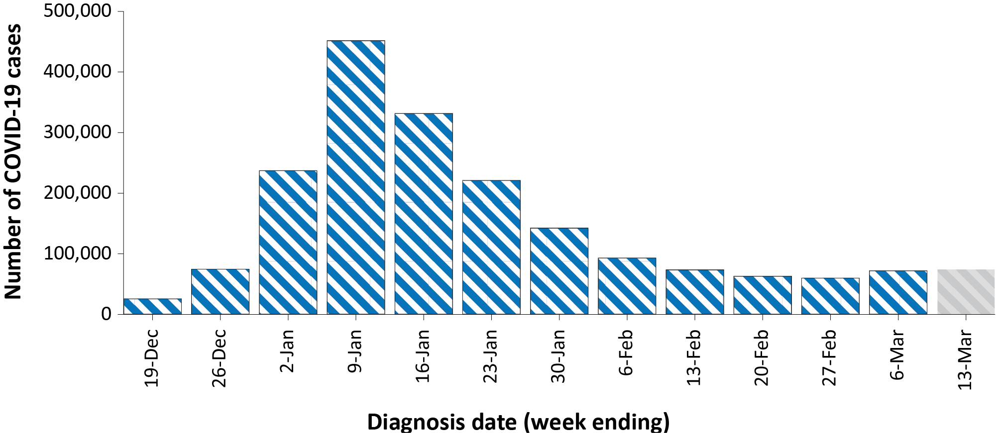
a Source: NINDSS, extract from 16 March 2022 for notifications to 13 March 2022.
b The shaded bar at the right represents the most recent reporting week and should be interpreted with caution as additional cases may be identified in the coming week that have a diagnosis date during this period.

Demographic features

(NINDSS)
In the reporting period between 14 February and 13 March 2022, the highest PCR confirmed notification rate was among children aged 17 years and under at 732 per 100,000, and the lowest rates were observed among people aged 70 years and over. Across all age groups, weekly case notification rates have remained stable over the four-week reporting period (Figure 2). For the entire Omicron wave to date (15 December 2021 – 13 March 2022), the highest PCR confirmed notification rate was in adults aged 18 to 29 years (Appendix A, Table A.1). For this age group, the weekly notification rate peaked in the week ending 9 January 2022 at over 4,400 per 100,000 population.
Among paediatric age groups, the highest notification rate during the reporting period was in children aged 5 to 11 years, at over 2,000 per 100,000 population (Figure 2). Among children, cases notification rates were similar from mid-January 2022 to early February 2022. However, in the current reporting period, case rates among children have diverged, with rates decreasing in infants aged 0 to 4 years, and rates remaining steady in children aged 5 to 17 years.

Figure 2: PCR confirmed COVID-19 case rates for (a) all ages and (b) children, by age group by week, Australia, 29 November 2021 – 13 March 2022ª
a
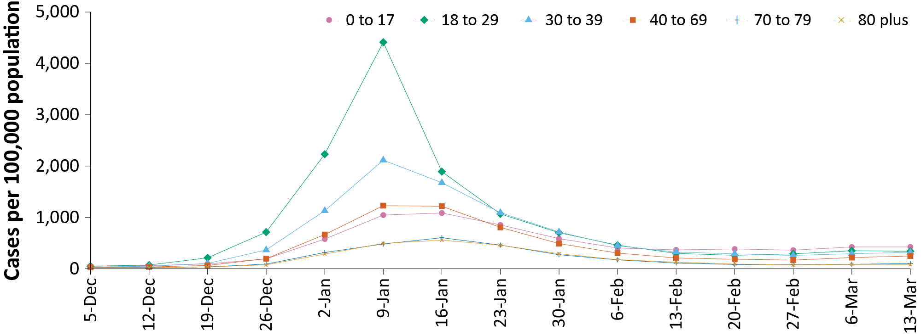
b
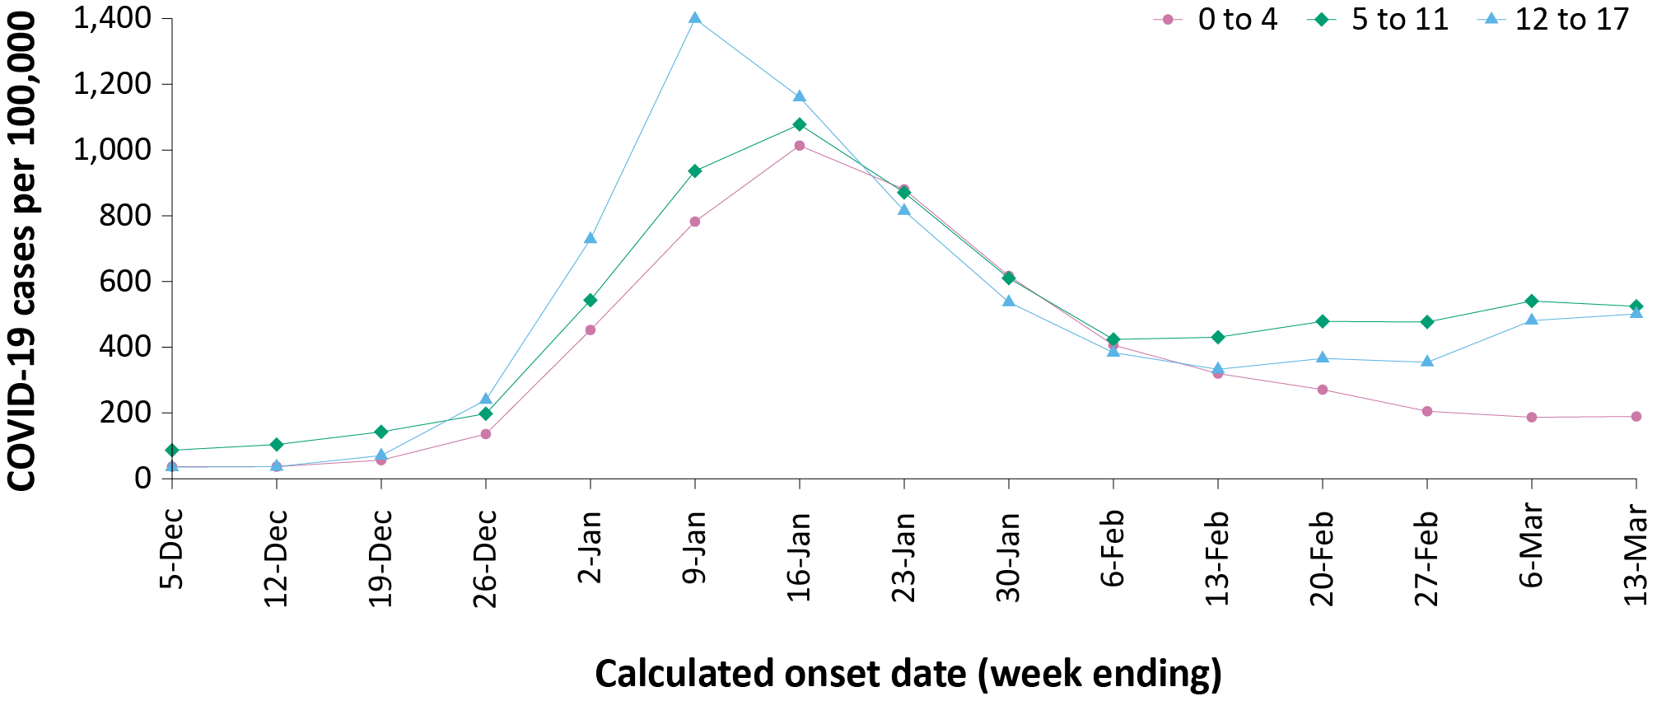
a Source: NINDSS, extract from 16 March 2022 for notifications from 29 November 2021 to 13 March 2022.

Aboriginal and Torres Strait Islander persons

(NINDSS)
Overall, since the start of the pandemic, Indigenous status is unknown for 22% of confirmed cases. Therefore, the number of cases classified as Aboriginal and Torres Strait Islander people is likely an underrepresentation.
During the reporting period, there were 9,955 new confirmed cases notified in Aboriginal and Torres Strait Islander people. The number of confirmed cases notified each week decreased over the four weeks (Table 3). In the current Omicron wave (15 December 2021 – 13 March 2022) there have been 58,736 confirmed cases of COVID-19 notified in Aboriginal and Torres Strait Islander people, representing 3.1% (58,736/1,919,886) of all confirmed cases.
Of the PCR confirmed cases notified in Aboriginal and Torres Strait Islander people from 15 December 2021 to date, 48% (28,170/58,736) resided in a regional or remote area (Table 4). It should be noted that the reliance on RATs for diagnosing COVID-19 is greater in regional and remote areas than in major cities, resulting in a larger under-count of cases in regional and remote areas than in major cities when counting PCR confirmed cases only.
Nationally, there have been 93 deaths among PCR confirmed cases reported in Aboriginal and Torres Strait Islander people since the start of the pandemic to 13 March 2022. This includes 43 from New South Wales, 21 from Queensland, 16 from the Northern Territory, eight from South Australia and five from Victoria. An additional 249 Aboriginal and Torres Strait Islander cases have been admitted to intensive care units (ICU) nationally. During the pandemic to date, the overall notification rate, to NINDSS, of severe cases (measured as those who were admitted to ICU or died) in Aboriginal and Torres Strait Islander people was 39.1 per 100,000 population (Table 5). Note that ICU status in NINDSS is likely incomplete.
Table 3: PCR confirmed cases of COVID-19 among Aboriginal and Torres Strait Islander peoples by jurisdiction and calendar year, by date of notification, 31 December 2021 – 13 March 2022ª
Jurisdiction | 14–20 February 2022 | 21–27 February 2022 | 28 February – 6 March 2022 | 7–13 March 2022 | 15 December 2021 – 13 March 2022 (Omicron wave)
Australian Capital Territory | 54 | 40 | 61 | 57 | 732
New South Wales | 1,152 | 879 | 929 | 1,175 | 29,164
Northern Territory^{b} | NA | NA | NA | NA | 619^{b}
Queensland | 889 | 697 | 462 | 442 | 16,576
South Australia | 507 | 467 | 515 | 400 | 5,744
Tasmania | 37 | 43 | 59 | 43 | 653
Victoria | 237 | 216 | 151 | 166 | 4,963
Western Australia^{b} | 29 | 76 | 148 | NA | 285^{b}
Total | 2,913 | 2,425 | 2,333 | 2,284 | 58,736
a Source: NINDSS, extract from 16 March 2022 for notifications from to 13 March 2022.
b Due to NINDSS transmission issues, data are not available (NA) since 10 January 2022 for the Northern Territory (NT) and since 5 March 2022 for Western Australia (WA). The number of cases reported for NT and WA in the current wave will be incomplete.

Table 4: PCR confirmed cases of COVID-19 among Aboriginal and Torres Strait Islander people by area of remoteness, 15 December 2021 – 13 March 2022ª
Jurisdiction^{b} | Major city | Inner regional | Outer regional | Remote^{c} | Overseas resident | Unknown | Total
Australian Capital Territory | 699 | 15 | 4 | 0 | 0 | 14 | 732
New South Wales | 17,058 | 8,684 | 2,618 | 554 | 11 | 225 | 29,164
Northern Territory^{d} | 0 | 0 | 252 | 326 | 0 | 38 | 619
Queensland | 5,956 | 3,061 | 6,400 | 1,128 | 1 | 30 | 16,576
South Australia | 2,868 | 469 | 1,315 | 974 | 84 | 33 | 5,744
Tasmania | 9 | 411 | 225 | 5 | 0 | 1 | 653
Victoria | 3,296 | 1,286 | 372 | 0 | 0 | 8 | 4,963
Western Australia^{d} | 213 | 13 | 19 | 39 | 0 | 1 | 285
Australia | 30,099 | 13,939 | 11,205 | 3,026 | 96 | 350 | 58,736
a Source: NINDSS, extract from 16 March 2022 for notifications to 13 March 2022.
b Cases are classified based on jurisdiction of notification not jurisdiction of residence. Some cases are notified to a different jurisdiction to their location of residence.
c ‘Remote’ here also includes areas classified as ‘very remote’.
d Due to NINDSS transmission issues, data are not available since 10 January 2022 for the Northern Territory (NT) and since 5 March 2022 for Western Australia (WA). The number of cases reported for NT and WA in the current wave will be incomplete.
Table 5: PCR confirmed COVID-19 cases in Aboriginal and Torres Strait Islander people by age and highest level of illness severity, Australia, 1 January 2020 to 13 March 2022
Age group (years) | 15 December 2021 – 13 March 2022  (Omicron wave) |  |  |  | 16 June 2021 – 14 December 2021  (Delta wave) |  |  |  | 1 January 2020 – 13 March 2022  (Pandemic to date)
 | ICUª | Diedª | ICU or died^{b} | Rate ICU or died^{b} | ICUª | Diedª | ICU or diedª | Rate ICU or died^{b} | ICUª | Diedª | ICU or diedª | Rate ICU or died^{b}
0–17 | 11 | 1 | 11 | 3.4 | 8 | 0 | 8 | 2.5 | 19 | 1 | 19 | 5.9
18–59 | 68 | 21 | 86 | 20.6 | 84 | 11 | 88 | 21.1 | 153 | 32 | 175 | 41.9
60+ | 49 | 46 | 83 | 147.1 | 26 | 14 | 33 | 58.5 | 77 | 60 | 118 | 209.1
All | 128 | 68 | 180 | 22.5 | 118 | 25 | 129 | 16.2 | 249 | 93 | 312 | 39.1
a ICU and died are not mutually exclusive, ‘died’ can include cases who died with or without prior admission to ICU. Therefore, the number of cases admitted to ICU or having died will not equal the sum of cases in ICU or died.
b Rate per 100,000 population for the given time period.

Vaccinations

(Department of Health)
As at 13 March 2022, a total of 55,114,521 doses of COVID-19 vaccine had been administered (Table 6), including 1,259,058 doses provided to aged care and disability residents. Nationally, 20,963,330 people aged 12 years or over (95.9%) had received at least one dose. This includes 20,522,465 people aged 12 years or over (93.9%) who were fully vaccinated. Among children aged 5–11 years, 1,164,963 (51.2%) had received at least one dose, including 173,887 (7.6%) who were fully vaccinated. Nationally, 12,195,821 people aged 16 years and over (59.1%) had received more than two doses.
Table 6: Total number of vaccinations administered, by jurisdiction, Australia, 13 March 2022ª
Jurisdiction | Total number of doses administered | Percentage of people aged 12 and over who have had two or more doses
Australian Capital Territory | 1,411,276 | > 99%
New South Wales | 17,163,054 | 93.6%
Northern Territory | 535,432 | 87.8%
Queensland | 10,453,072 | 90.0%
South Australia | 3,788,224 | 91.6%
Tasmania | 1,228,045 | 97.3%
Victoria | 14,560,832 | 93.1%
Western Australia | 5,974,586 | 94.9%
Aged care and disability facilities^{b} | 1,259,058 | NA
Primary care^{c} | 33,490,258 | NA
Total | 55,114,521 | 93.9%
a Source: Australian Government Department of Health website.⁴
b Commonwealth vaccine doses administered in aged care and disability facilities.
c Commonwealth vaccine doses administered in primary care settings.

Severity

(NINDSS, SPRINT-SARI)
Given the delay between illness onset and severe illness, and so as to provide a more accurate assessment of severity, cases with an onset in the last two weeks were excluded from analyses on the weekly rate of cases with severe illness (defined as cases admitted to ICU or died) and on the proportion of cases admitted to ICU or died.
During the reporting period to 27 February 2022, the notification rate of confirmed cases with severe illness continued to decline, following an apparent peak in the week ending 16 January 2022, at approximately 3.7 per 100,000 population (Figure 3). This is more than twice the peak rate of severe cases observed during the Delta wave, of 1.2 per 100,000 population in the week ending 5 September 2021. Rates of severe cases continue to be greater in older age groups (Figure 4).

Figure 3: COVID-19 cases, deaths and ICU admissions, Australia, by date of onset, Australia, 31 May 2021 to 13 March 2022^{a,b}
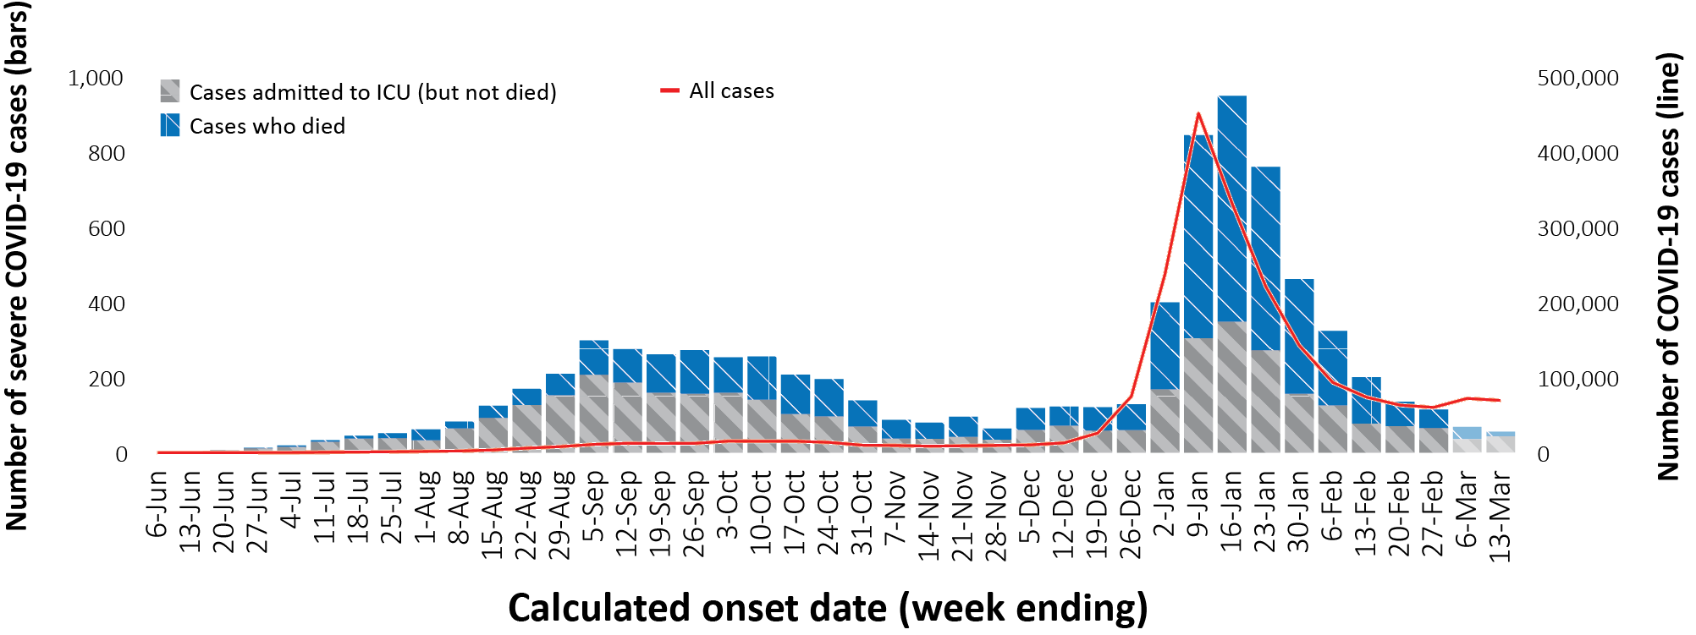
a NINDSS, extract from 16 March 2022, for cases notified to 13 March 2022.
b The shaded bars at the right represent the most recent two reporting weeks and should be interpreted with caution as cases with an illness onset in these weeks may not have yet developed severe disease.
Figure 4: Age-specific rates of COVID-19 cases admitted to ICU or died, by date of diagnosis, Australia, 31 May 2021 to 27 February 2022ª
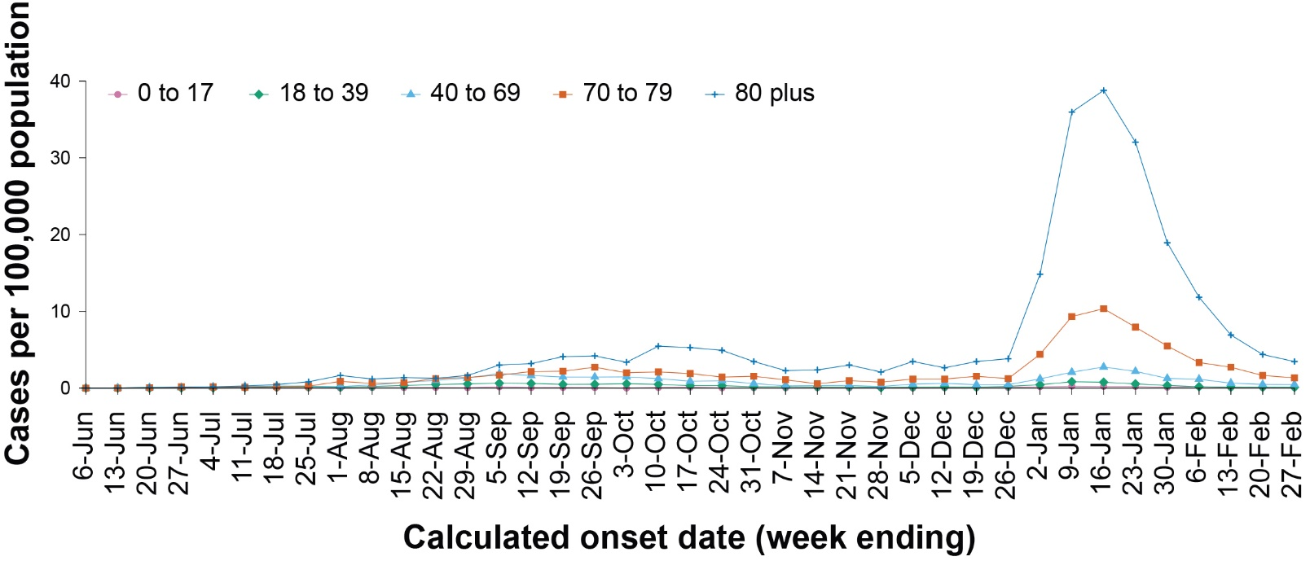
a NINDSS, extract from 16 March 2022. Includes cases with an illness onset up to 27 February; cases with an illness onset in the last two weeks (28 February – 13 March 2022) were excluded to account for the delay between onset and development of severe illness.

ICU admissions
From 1 February 2021 to 13 March 2022, there were 3,884 COVID-19 cases admitted to ICUs participating in the sentinel surveillance system, Short Period Incidence Study of Severe Acute Respiratory Infection (SPRINT-SARI),⁵ with 215 of these admitted during this reporting period (14 February – 13 March 2022).

Risk factors for severe disease
Comorbidity data extracted from SPRINT-SARI reflect the sickest patients with COVID-19 managed in ICU; data are therefore not generalisable to all cases (Table 7). In patients admitted to ICU with COVID-19 since 1 February 2021, the most prevalent comorbidity was diabetes, followed by obesity (a body mass index of > 30 or weight over 120 kg). Of those adult patients admitted to ICU since 1 February 2021 for whom comorbidity data was known, 68% (2,248/3,284) had at least one comorbidity; 32% of patients (1,036/3,284) had none of the listed comorbidities recorded.
Table 7: Comorbidities for adult COVID-19 cases (aged greater than or equal to 18 years) amongst those admitted to ICU, Australia, 1 February 2021 – 13 March 2022ª
Comorbidity | ICU casesª (n = 3,284) (%)
Cardiac disease (n = 3,259) | 536 (16%)
Chronic respiratory condition (n = 3,260)^{b} | 614 (19%)
Diabetes (n = 3,249) | 1,036 (32%)
Obesity (n = 3,193) | 999 (31%)
Chronic renal disease (n = 3,242) | 295 (9%)
Chronic neurological condition (n = 3,244) | 113 (4%)
Malignancy (n = 3,255) | 196 (6%)
Chronic liver disease (n = 3,255) | 112 (3%)
Immunosuppression (n = 3,240) | 291 (9%)
Number of specified comorbidities (n = 3,284)^{c}
No comorbidities | 1,036 (32%)
One or more | 2,248 (68%)
Two or more | 1,171 (36%)
Three or more | 508 (15%)
a Source: SPRINT-SARI.5 Only includes adult cases (≥ 18 years old) and excludes those with missing data on comorbidities or where comorbidity is unknown.
b Includes asthma.
c Includes chronic respiratory conditions, cardiac disease (excluding hypertension), immunosuppressive condition/therapy, diabetes, obesity, liver disease, renal disease and neurological disorder.

COVID-19 deaths
There were 490 COVID-19 associated deaths among PCR-confirmed cases notified during the reporting period. The weekly number of deaths has decreased over the last four weeks, with 48 deaths reported in the most recent week, compared with 217 in the week ending 20 February 2022. This brings the total number of COVID-19-associated deaths among cases reported in NINDSS to 5,058 (Table 8).
For people aged 60 years and over, the population mortality rate for the current Omicron wave to date has exceeded that of the entire Delta wave (Table 9).

Table 8: Deaths associated with COVID-19 by reporting period, Australia, 1 January 2020 – 13 March 2022^{a,b}
Jurisdiction | 14–20 February 2022 | 21–27 February 2022 | 28 February – 6 March 2022 | 7 – 13 March 2022 | 15 December 2021 – 13 March 2022  (Omicron wave) | 1 January 2020 – 13 March 2022  (Pandemic to date)
ACT | 1 (0.5%) | 1 (0.7%) | 0 (0.0%) | 1 (2.1%) | 20 (0.7%) | 32 (0.6%)
NSW | 91 (41.9%) | 49 (34.3%) | 29 (35.4%) | 28 (58.3%) | 1,127 (39.4%) | 1,769 (35.0%)
NT | 2 (0.9%) | 5 (3.5%) | 1 (1.2%) | 1 (2.1%) | 21 (0.7%) | 22 (0.4%)
Qld | 59 (27.2%) | 25 (17.5%) | 17 (20.7%) | 5 (10.4%) | 509 (17.8%) | 518 (10.2%)
SA | 6 (2.8%) | 11 (7.7%) | 6 (7.3%) | 2 (4.2%) | 220 (7.7%) | 224 (4.4%)
Tas. | 0 (0.0%) | 1 (0.7%) | 1 (1.2%) | 0 (0.0%) | 9 (0.3%) | 23 (0.5%)
Vic. | 58 (26.7%) | 51 (35.7%) | 28 (34.1%) | 11 (22.9%) | 953 (33.3%) | 2,461 (48.7%)
WA | 0 (0.0%) | 0 (0.0%) | 0 (0.0%) | 0 (0.0%) | 0 (0.0%) | 9 (0.2%)
Total | 217 (100.0%) | 143 (100.0%) | 82 (100.0%) | 48 (100.0%) | 2,859 (100.0%) | 5,058 (100.0%)
a Source: NINDSS, extract from 16 March 2022 for deaths to 13 March 2022.
b Deaths are categorised into time periods using date of death. Deaths with a missing date of death are classified using date of illness onset.
Table 9: COVID-19 associated deaths notified to NINDSS, by age group and date of onset, 1 January 2020 to 13 March 2022ª
Age group (years) | 15 December 2021 – 13 March 2022 (Omicron wave) |  | 16 June 2021 – 14 December 2021  (Delta wave) |  | 1 January 2020 – 13 March 2022  (Pandemic to date)
 | Deaths | Population mortality rate^{b} | Deaths | Population mortality rate^{b} | Deaths | Population mortality rate^{b}
0–4 | 2 | 0.1 | 0 | 0 | 2 | 0.1
5–11 | 1 | < 0.05 | 1 | < 0.05 | 2 | 0.1
12–15 | 0 | 0 | 1 | 0.1 | 1 | 0.1
16–17 | 0 | 0 | 0 | 0 | 0 | 0
18–29 | 6 | 0.1 | 8 | 0.2 | 16 | 0.4
30–39 | 25 | 0.7 | 21 | 0.6 | 48 | 1.3
40–49 | 39 | 1.2 | 46 | 1.4 | 87 | 2.6
50–59 | 96 | 3.1 | 117 | 3.7 | 228 | 7.3
60–69 | 263 | 9.6 | 206 | 7.5 | 507 | 18.5
70–79 | 598 | 30.6 | 351 | 18 | 1,107 | 56.7
80–89 | 1,049 | 119.7 | 420 | 47.9 | 1,844 | 210.4
90+ | 684 | 308.2 | 213 | 96 | 1,215 | 547.4
Unknown | 1 | N/A | 0 | N/A | 1 | N/A
Total | 2,764 | 10.7 | 1,384 | 5.4 | 5,058 | 19.7
a Source: NINDSS, extract from 16 March 2022.
b Population mortality rates are presented per 100,000 population for the given time period.

Genomic surveillance and virology

Communicable Disease Genomics Network, AusTrakka and jurisdictional sequencing laboratories)
Nationally, 3.12% of COVID-19 cases have had SARS-CoV-2 isolates sequenced since the start of the pandemic, based on jurisdictional reporting (Table 10). Case numbers and sequencing proportion are based on polymerase chain reaction (PCR) results only, as rapid antigen tests do not allow for sequencing. The significant rise in case numbers nationally during this reporting period has required jurisdictional laboratories to sample isolates to sequence for surveillance purposes, resulting in a drop in the overall proportion sequenced. However, overall output of number of cases sequenced per reporting period remains similar to, or higher than, previous reporting periods (Figure 5).

Variants of concern (VOC)
Of the cases in Austrakka, 23,436 have been identified as the Omicron VOC to date (Table 11); 78.33% are of the BA.1 sub-lineage; 14.95% are of the BA.1.1 sub-lineage; and 6.72% are of the BA.2 sub-lineage. There has been a notable increase in the proportion of the BA.2 sub-lineage in samples collected since late February 2022 (Figure 6). For samples collected in the last 21 days (21 February to 13 March 2022), the BA.2 sub-lineage constituted 35% (629/1,797) of the Omicron sequences (Figure 6 blue square and associated lineage percentages).
Further information on variants is available in the Technical Supplement.²
Table 10: Australian SARS-CoV-2 genome sequences and proportion of positive cases sequenced, 14 February – 13 March 2022 and cumulative to date
Measure | Reporting period  14 February 2022 – 13 March 2022 | Cumulative  23 January 2020 – 13 March 2022
SARS-CoV-2 cases sequencedª | 4,253 | 77,773
Percentage of positive cases sequenced^{b} | 1.44% | 3.12%
a Based on individual jurisdictional reports of sequences and case numbers. Calculations of the percentage of cases sequenced based on the number of sequences available in AusTrakka may not always be up-to-date, since this may include duplicate samples from cases and may not represent all available sequence data.
b Total SARS-CoV-2 case numbers as reported by jurisdictional laboratories based on PCR results only. Cases identified via rapid antigen testing are reported differently by each jurisdiction and cannot be followed up for sequencing. They are therefore not included in the sequencing proportions reported here. Sequencing of samples from cases identified in the reporting period may be in process at the time of reporting. Remaining unsequenced samples may be due to jurisdictional sequencing strategy, or where samples have been deemed unsuitable for sequencing (typically because viral loads were too low for sequencing to be successful).
Figure 5: Samples in AusTrakka from 11 October 2021 to 13 March 2022, by lineage and date of collectionª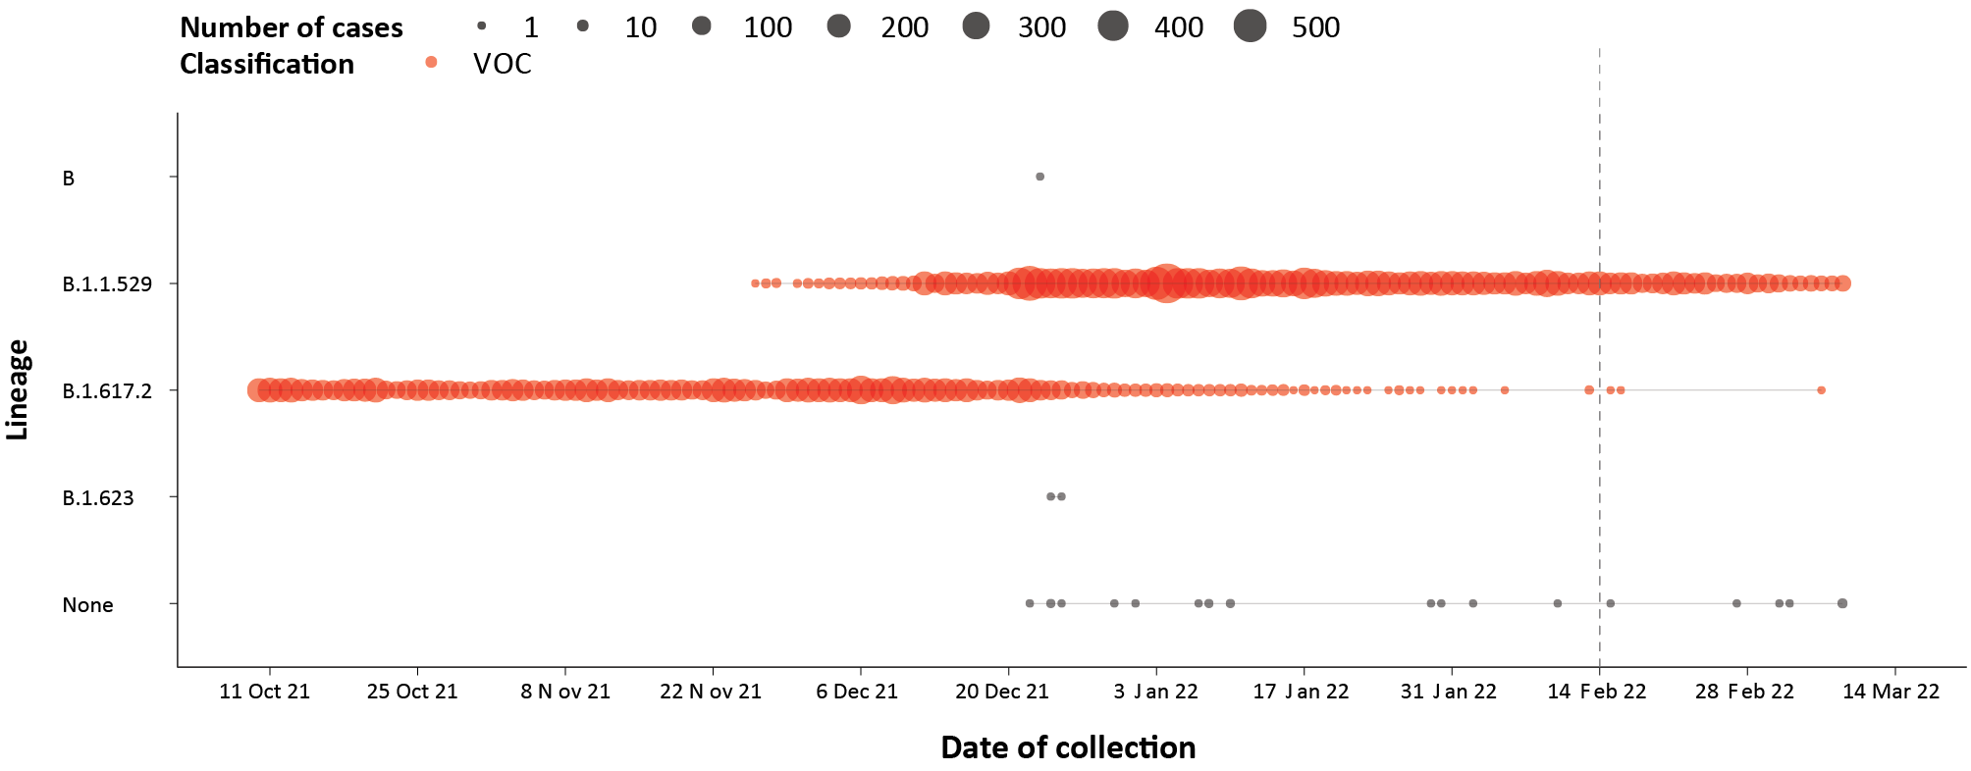
a The start of the current reporting period (14 February to 13 March 2022) is marked by the dotted line, and variant of concern samples are coloured red. The size of the circle is proportional to the number of samples in the lineage at each time point.
Figure 6: Sequences in Austrakka by Omicron sub-lineage and collection date, 17 January to 14 March 2022ª
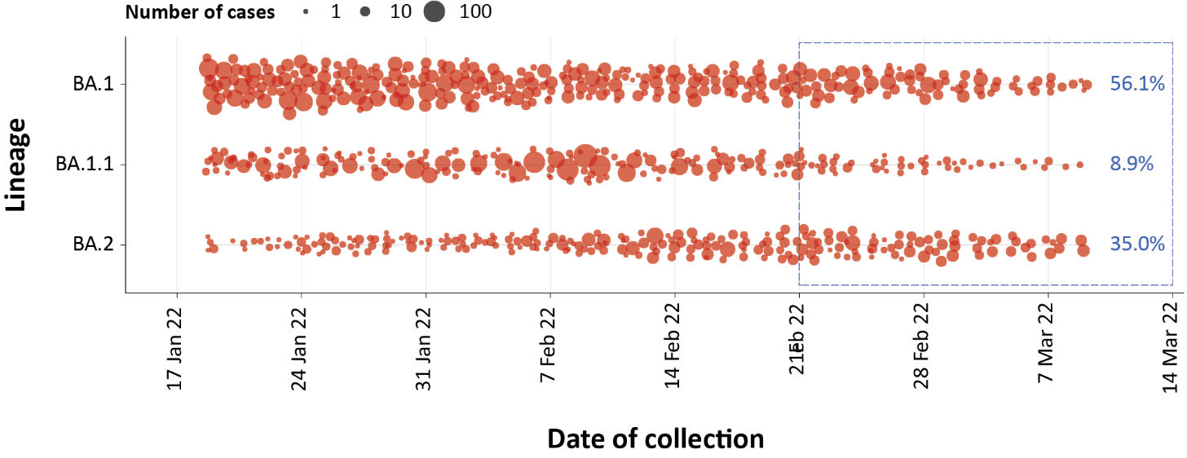
a The size of each dot is proportional to the number of sequences observed in each jurisdiction each day. The blue square and numbers in blue show the proportion of each sub-lineage in the past 21-day period.

Table 11: Australian SARS-CoV-2 genome sequences in Austrakka identified as variants of concern, 23 January 2020 – 13 March 2022ª
VOC lineage | B.1.617.2 (Delta)^{b} | B.1.1.529 (Omicron)^{c}
Number of sequences | 31,444 | 23,436
a The number of sequences may have reduced from previous reports due to de-duplication and the adoption of a new genomic coverage threshold.
b Includes AY sublineages.
c Includes Omicron-like sequences

Testing

(State and territory reporting)
From the commencement of the pandemic to 13 March 2022, over 64 million COVID-19 PCR tests have been conducted nationally. Jurisdictional PCR testing rates are driven by current case numbers, testing policies and numbers of people experiencing symptoms. The number, rates and percent positivity of RATs cannot be calculated, as there is currently no reporting of negative RATs.
During the four-week reporting period from 14 February 2022 to 13 March 2022, over 2.3 million PCR tests were conducted. During the reporting period, weekly PCR testing rates were relatively stable across all jurisdictions, except Western Australia where PCR testing rates increased in consecutive weeks throughout the reporting period (Figure 7).
Figure 7: SARS-CoV-2 polymerase chain reaction (PCR) testing rates per 1,000 population and percent positivity by jurisdiction and date of notification, 31 May 2021 – 13 March 2022ª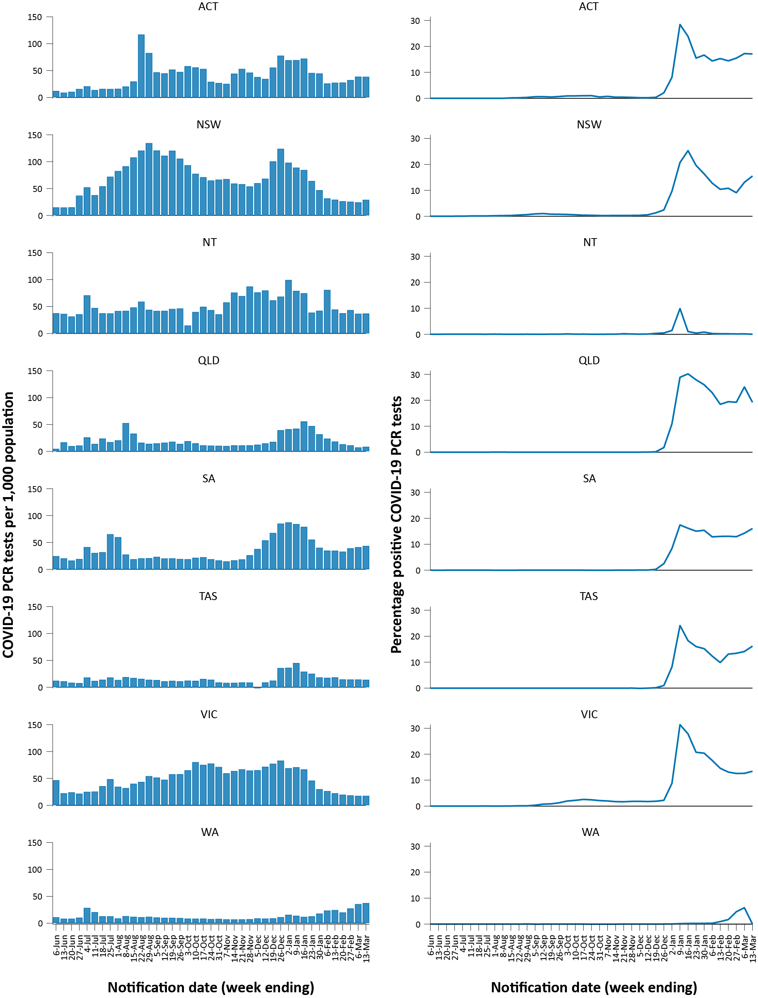
a Source: testing data provided by jurisdictions to the NIR daily, current to 13 March 2022; case data extracted from NINDSS on 16 March 2022 for cases with a notification date up to 13 March 2022; population data based on Australian Bureau of Statistics (ABS) Estimated Resident Population (ERP) as at June 2021.

From 14 February 2022 to the week ending 13 March 2022, PCR percent positivity increased in most jurisdictions apart from Queensland. In the most recent week, percent positivity was below 20% in all jurisdictions. Note that the Northern Territory and Western Australia are missing testing positivity data from 10 January 2022 and 5 March 2022, respectively.

Acute respiratory illness

(FluTracking, ASPREN, and Commonwealth Respiratory Clinics)
Based on self-reported FluTracking data,⁷ prevalence of fever and cough in the community over this reporting period increased from 0.7% to 1.2% (Figure 8). The prevalence of runny nose and sore throat symptoms also increased consistently throughout the reporting period from 0.7% to 1.3%; the latter value is notably higher than the prevalence of 0.9% that was observed for runny nose and sore throat symptoms during the apparent peak of the Omicron wave (9–16 January 2022).
Figure 8: Weekly trends in respiratory illness amongst FluTracking survey participants (age-standardised) compared to the average of the previous five years, Australia, by epidemiological week,ª 1 January 2021 – 13 March 2022^{b}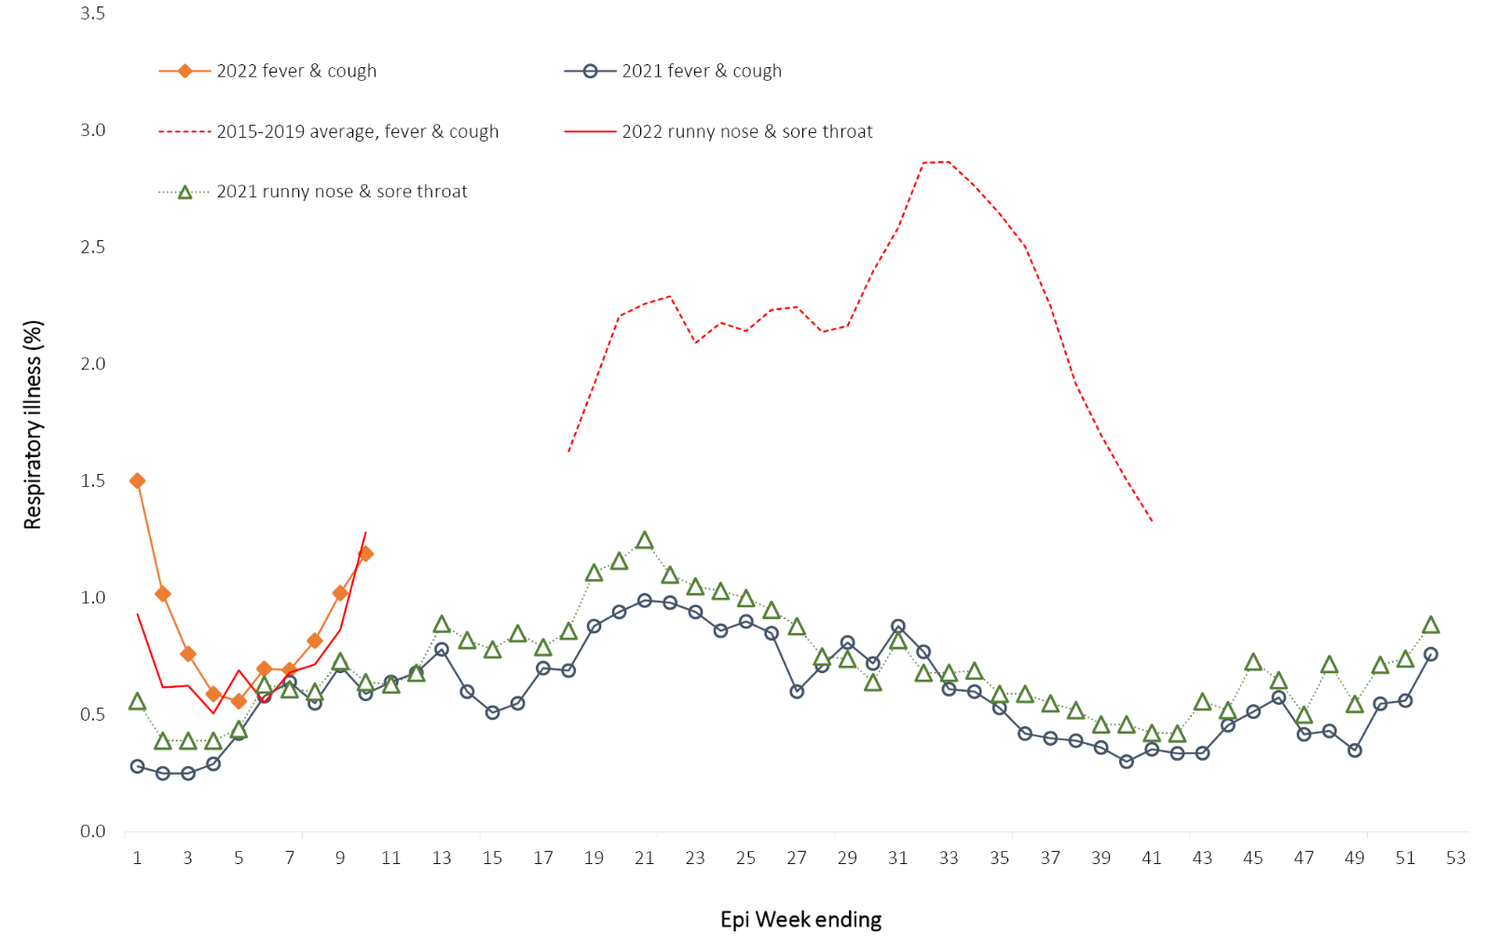
a Epidemiological weeks are a standardised method for numbering weeks across years, with the first epidemiological week of any year ending on the first Saturday in January.
b In years prior to 2020, FluTracking was activated during the main Influenza season from May to October. A historical average beyond the week ending 11 October (epidemiological week 41) is therefore not available. In 2020, FluTracking commenced ten weeks early to capture data for COVID-19. Data on runny nose and sore throat were only collected systematically after 29 March 2020, therefore a historical average for this symptom profile is unavailable.
In this reporting period, acute respiratory illness was highest in those aged 0–9 years, based on both self-reported FluTracking data and presentations to Commonwealth Respiratory Clinics. This is a change from previous reporting periods in 2022, where those aged 30–39 years had the highest rates.
In this reporting period, rates of self-reported runny nose and sore throat were significantly higher amongst females than males, at 9.1 per 1000 FluTracking participants compared to 5.8 per 1000 FluTracking participants respectively, although rates of self-reported fever and cough were slightly higher amongst males. Rates of fever and cough by jurisdiction ranged from 3.6 per 1,000 FluTracking participants in Western Australia to 7.3 per 1,000 participants in the Australian Capital Territory. Rates of runny nose and sore throat ranged from 3.6 per 1,000 FluTracking participants in the Northern Territory to 9.8 per 1,000 FluTracking participants in the Australian Capital Territory. Overall, rates for both sets of symptoms increased from the previous reporting period.
Over the reporting period, FluTracking data indicated that 40% of those in the community with ‘fever and cough’ were tested for SARS-CoV-2 with a PCR test and 85% were tested using a RAT (noting that in some instances RATs will be followed up by a PCR test for the same case). Of those with ‘runny nose and sore throat’, 14% were tested for SARS-CoV-2 using a PCR test and 74% were tested using a RAT. Of those with ‘fever and cough’ who tested for SARS-CoV-2, 54% who were tested with a PCR test, and 45% who were tested with a RAT, were positive. In comparison, of participants with ‘runny nose and sore throat’ who tested for SARS-CoV-2, 12% of those tested by PCR, and 4.6% of those tested by RAT, tested positive. Note that participants with one set of symptoms are not excluded from having the other.
In the most recent four-week period, testing rates for fever and cough were highest in South Australia for PCR (59.3%) and in Tasmania for RATs (92.6%), and were lowest in Tasmania for PCR (29.6%) and in Western Australia for RATs (64.8%). Testing rates for runny nose and sore throat were highest in South Australia for PCR (29.7%) and in the Northern Territory for RATs (80.0%), and lowest in the Northern Territory for PCR (0.0%) and in South Australia for RATs (57.8%). It is important to acknowledge that there may be legitimate reasons why people did not get tested, including barriers to accessing testing. Symptoms reported to FluTracking are not specific to COVID-19 and may also be due to chronic diseases.
From 14 February to 13 March 2022, there were 65,709 assessments at Commonwealth Respiratory Clinics. Of these, there were 59,411 assessments with consent to share information, with 92% (54,769/59,411) tested for SARS-CoV-2. Of those who tested, 14% (7,505/54,769) were found to be positive.

Countries and territories in Australia’s near region
According to WHO, countries and territories in the South East Asian and Western Pacific regions reported 15,792,815 newly-confirmed cases and 37,377 deaths in the four-week period to 13 March 2022, bringing the cumulative cases in the two regions to 89 million, and cumulative deaths in these regions to over 960,000.⁸ New case numbers in the South East Asian region over this four-week reporting period were similar to the prior four weeks, whilst new cases in the Western Pacific region have more than doubled. The number of new deaths in the four-week reporting period have followed the same pattern as cases, with decreases in the South East Asian region compared to the previous four weeks, whilst new deaths have almost doubled for the Western Pacific region. The increase of new cases in the Western Pacific region during the four-week period to 13 March 2022 was largely driven by cases in the Republic of Korea, Vietnam and Japan.⁹
Table 12 outlines the new cases and deaths in the four-week period to 13 March 2022 and cumulative cases and deaths for the pandemic in selected countries with the highest number of new cases in the South East Asian region and the Western Pacific region.
As of 13 March 2022, over 455 million COVID-19 cases and over 6 million deaths have been reported globally since the start of the pandemic, with a global case fatality rate (CFR) of 1.3%. The two regions reporting the largest burden of disease over the past four weeks were the European region (40% of total cases) and the region of the Americas (35% of total cases).
Table 12: Cumulative cases and deaths, and new cases and deaths reported in the four-week period to 13 March 2022 for selected countries in Australia’s near region according to WHOª
Country | Cumulative cases | New cases reported in the last 4 weeks | Change in new cases in the last 4 weeks^{b} | Cumulative deaths | New deaths reported in the last 4 weeks | Change in new deaths in the last 4 weeks^{b}
South East Asian region
Indonesia | 5,890,495 | 1,082,717 | +102% | 152,166 | 6,990 | +595%
Thailand | 3,184,825 | 591,498 | +120% | 23,709 | 1,273 | +149%
India | 42,990,991 | 359,570 | -93% | 515,850 | 7,185 | -68%
Bangladesh | 1,949,486 | 39,822 | -86% | 29,111 | 292 | -57%
Nepal | 977,937 | 4,878 | -96% | 11,950 | 58 | -79%
Western Pacific region
Republic of Korea | 6,556,432 | 5,205,805 | +691% | 10,395 | 3,314 | +330%
Vietnam | 5,903,147 | 3,418,666 | +617% | 41,290 | 2,428 | -28%
Japan | 5,720,394 | 1,888,430 | -5% | 26,029 | 5,827 | +229%
Australia | 3,163,767 | 660,694 | -44% | 5,571 | 1,025 | -46%
Philippines | 3,670,175 | 35,945 | -92% | 57,441 | 2,511 | 21%
a Source: World Health Organization Coronavirus (COVID-19) Dashboard, accessed 16 March 2022.
b Percent change in the number of newly confirmed cases/deaths in the most recent four-week period compared to the four weeks prior.

Acknowledgements
We thank public health staff from incident emergency operations centres and public health units in state and territory health departments, and the Australian Government Department of Health, along with state and territory public health laboratories. We thank those who have provided data from surveillance systems, such as Commonwealth respiratory clinics, ASPREN, FluTracking, FluCAN, SPRINT-SARI, Communicable Disease Genomics Network, AusTrakka and jurisdictional sequencing laboratories.

Author details

Corresponding author
COVID-19 National Incident Room Surveillance Team
Australian Government Department of Health, GPO Box 9484, MDP 14, Canberra, ACT 2601.
Email: epi.coronavirus@health.gov.au

References
- COVID-19 National Incident Room Surveillance Team. COVID-19 Australia: Epidemiology Report 58: Reporting period ending 13 February 2022. Commun Dis Intell (2018). 2022;46. doi: https://doi.org/10.33321/cdi.2022.46.9.
- COVID-19 National Incident Room Surveillance Team. Technical supplement. COVID-19 Australia: Epidemiology reporting. Commun Dis Intell (2018). 2021;45. doi: https://doi.org/10.33321/cdi.2021.45.2.
- Australian Government Department of Health. Coronavirus disease 2019 (COVID-19): CDNA national guidelines for public health units. [Internet.] Canberra: Australian Government Department of Health; 14 January 2022. [Accessed on 21 January 2022.] Available from: https://www1.health.gov.au/internet/main/publishing.nsf/Content/cdna-song-novel-coronavirus.htm.
- Australian Government Department of Health. Vaccination numbers and statistics. [Internet.] Canberra: Australian Government Department of Health; 2022. [Accessed on 14 February 2022.] Available from: https://www.health.gov.au/initiatives-and-programs/covid-19-vaccines/numbers-statistics.
- Australian and New Zealand Intensive Care Research Centre (ANZIC-RC). SPRINT-SARI: Short period incidence study of severe acute respiratory infection. [Internet.] Melbourne: Monash University, ANZIC-RC; 2020. Available from: https://www.monash.edu/medicine/sphpm/anzicrc/research/sprint-sari.
- Communicable Diseases Genomics Network (CDGN). AusTrakka. [Website.] Melbourne: CDGN; 2020. Available from: https://www.cdgn.org.au/austrakka.
- Dalton C, Durrheim D, Fejsa J, Francis L, Carlson S, d’Espaignet ET et al. Flutracking: a weekly Australian community online survey of influenza-like illness in 2006, 2007 and 2008. Commun Dis Intell Q Rep. 2009;33(3):316–22.
- World Health Organization (WHO). WHO Coronavirus Disease (COVID-19) dashboard. [Internet.] Geneva: WHO; 2021. Available from: https://covid19.who.int/.
- WHO. Weekly epidemiological update on COVID-19 – 15 March 2022. [Internet.] Geneva: WHO; 15 March 2022. [Accessed on 17 March 2022.] Available from: https://www.who.int/publications/m/item/weekly-epidemiological-update-on-covid-19---15-march-2022.

Appendix A: Supplementary figures and tables
Table A.1: COVID-19 cases and rates per 100,000 population, by age group, sex, and notification received date, Australia, 15 December 2021 – 13 March 2022^{a,b}
Age group (years) | Four-week reporting period |  |  |  |  |  | Current ‘Omicron’ wave
 | 14 February – 13 March 2022 |  |  |  |  |  | 15 December 2021 – 13 March 2022
 | Cases |  |  | Rate per 100,000 population |  |  | Cases |  |  | Rate per 100,000 population
 | Male | Female | People | Male | Female | People | Male | Female | People | Male | Female | People
0–4 | 6,994 | 6,359 | 13,427 | 893.7 | 861.2 | 882.8 | 43,380 | 39,799 | 83,685 | 5,543.4 | 5,390.1 | 5,502.3
5–11 | 24,091 | 22,539 | 46,770 | 2,051.3 | 2,023.9 | 2,044.1 | 84,043 | 79,827 | 164,709 | 7,156.1 | 7,168.1 | 7,198.6
12–15 | 11,750 | 11,461 | 23,294 | 1,799.4 | 1,852.9 | 1,831.9 | 41,360 | 43,187 | 85,008 | 6,333.8 | 6,981.9 | 6,685.3
16–17 | 3,970 | 4,527 | 8,532 | 1,308.2 | 1,581.0 | 1,446.6 | 23,568 | 27,354 | 51,239 | 7,766.2 | 9,552.9 | 8,687.4
18–29 | 23,665 | 27,732 | 51,618 | 1,142.5 | 1,393.9 | 1,271.1 | 256,005 | 276,864 | 537,002 | 12,359.1 | 13,916.5 | 13,223.9
30–39 | 19,685 | 25,148 | 44,993 | 1,055.9 | 1,312.4 | 1,190.1 | 164,088 | 178,843 | 345,085 | 8,801.4 | 9,333.0 | 9,127.8
40–49 | 17,970 | 22,586 | 40,716 | 1,100.6 | 1,358.7 | 1,235.7 | 116,500 | 132,450 | 250,223 | 7,135.3 | 7,967.9 | 7,594.0
50–59 | 10,887 | 11,681 | 22,652 | 709.3 | 726.0 | 720.6 | 88,571 | 96,429 | 186,009 | 5,770.9 | 5,993.6 | 5,917.0
60–69 | 6,505 | 6,811 | 13,366 | 490.5 | 482.5 | 488.2 | 56,948 | 57,152 | 114,660 | 4,293.9 | 4,048.7 | 4,187.9
70–79 | 3,746 | 3,313 | 7,092 | 396.0 | 329.1 | 363.2 | 29,736 | 26,625 | 56,718 | 3,143.6 | 2,644.8 | 2,904.7
80–89 | 1,466 | 1,414 | 2,916 | 378.3 | 289.3 | 332.8 | 11,778 | 11,928 | 23,952 | 3,039.1 | 2,440.3 | 2,733.2
90 and over | 337 | 544 | 906 | 433.2 | 377.4 | 408.2 | 2,670 | 4,529 | 7,328 | 3,432.4 | 3,141.7 | 3,301.7
a Source: NINDSS, extract from 16 March 2022 for notifications up to 13 March 2022. Excludes cases where age or sex data is missing.
b Population data based on Australian Bureau of Statistics (ABS) Estimated Resident Population (ERP) as at June 2021.

Communicable Diseases Intelligence
ISSN: 2209-6051 Online

Communicable Diseases Intelligence (CDI) is a peer-reviewed scientific journal published by the Office of Health Protection and Response, Department of Health. The journal aims to disseminate information on the epidemiology, surveillance, prevention and control of communicable diseases of relevance to Australia.

Editor: Jennie Hood
Deputy Editor: Simon Petrie
Design and Production: Kasra Yousefi
Editorial Advisory Board: David Durrheim, Mark Ferson, John Kaldor, Martyn Kirk and Linda Selvey

Website: http://www.health.gov.au/cdi

Contacts
CDI is produced by the Office of Health Protection and Response, Australian Government Department of Health, GPO Box 9848, (MDP 6) CANBERRA ACT 2601

Email: cdi.editor@health.gov.au

Submit an Article
You are invited to submit your next communicable disease related article to the Communicable Diseases Intelligence (CDI) for consideration. More information regarding CDI can be found at: http://health.gov.au/cdi.
Further enquiries should be directed to: cdi.editor@health.gov.au.

This journal is indexed by Index Medicus and Medline.

Creative Commons Licence - Attribution-NonCommercial-NoDerivatives CC BY-NC-ND
© 2022 Commonwealth of Australia as represented by the Department of Health
This publication is licensed under a Creative Commons Attribution-NonCommercial-NoDerivatives 4.0 International Licence from https://creativecommons.org/licenses/by-nc-nd/4.0/legalcode (Licence). You must read and understand the Licence before using any material from this publication.

Restrictions
The Licence does not cover, and there is no permission given for, use of any of the following material found in this publication (if any):
- the Commonwealth Coat of Arms (by way of information, the terms under which the Coat of Arms may be used can be found at www.itsanhonour.gov.au);
- any logos (including the Department of Health’s logo) and trademarks;
- any photographs and images;
- any signatures; and
- any material belonging to third parties.

Disclaimer
Opinions expressed in Communicable Diseases Intelligence are those of the authors and not necessarily those of the Australian Government Department of Health or the Communicable Diseases Network Australia. Data may be subject to revision.

Enquiries
Enquiries regarding any other use of this publication should be addressed to the Communication Branch, Department of Health, GPO Box 9848, Canberra ACT 2601, or via e-mail to: copyright@health.gov.au

Communicable Diseases Network Australia
Communicable Diseases Intelligence contributes to the work of the Communicable Diseases Network Australia.
http://www.health.gov.au/cdna

Previously known as the National Notifiable Diseases Surveillance System (NNDSS).
These data are provided by the national pathogen genomic sequence and analysis platform, AusTrakka,⁶ and from jurisdictional pathogen sequencing laboratories to summarise the genomic epidemiology of SARS-CoV-2 in Australia. Numbers are subject to change retrospectively and sequences are not able to be obtained from all samples (see Technical Supplement).²

