COVID-19 Australia: Epidemiology Report 52
Reporting period ending 10 October 2021
COVID-19 National Incident Room Surveillance Team

Summary

Two-week reporting period:
Trends – The weekly number of new coronavirus disease 2019 (COVID-19) cases increased over the last two weeks. The daily average of 2,195 cases for this reporting period was higher than the previous fortnight’s daily average of 1,730 cases. There were 30,727 cases of COVID-19 reported this fortnight, bringing the 2021 cumulative case count to 101,723.
Local cases – More than 99% (30,672/30,727) of COVID-19 cases reported this fortnight are known to be locally acquired (including cases under initial investigation). The majority of these cases were reported in Victoria (68%; 20,936/30,672), followed by New South Wales (30%; 9,254/30,672).
Clusters and high-risk settings – As at 10 October 2021, there were 63,338 locally-acquired cases in New South Wales, including 438 deaths, since the first case of the Sydney Metropolitan outbreak was reported on 16 June 2021. Genomic testing showed that the outbreak’s primary case was infected with the ‘Delta’ SARS-CoV-2 variant of concern (B.1.617.2). Several cases in other states had also been linked to this cluster. For the second fortnight in a row, the fortnightly number of new locally-acquired cases reported in New South Wales decreased, with 9,254 locally-acquired cases reported this reporting period, compared to 14,973 locally-acquired cases reported in the previous reporting period. At the end of this reporting period, new case numbers were reducing in south-western and western Sydney and increasing case numbers were being seen in multiple regional areas.
As at 10 October 2021, there were 33,065 cases, including 93 deaths, associated with the Victorian outbreaks since the first cases were reported on 5 August 2021. These primary cases involved the Delta variant and were closely associated with the current New South Wales and recent July 2021 Victorian outbreaks. The number of cases reported this reporting period was more than twice that of the previous reporting period. Most cases in the Victorian outbreaks were in Greater Melbourne; however, the number of new cases in regional Victoria increased during the reporting period.
As at 10 October 2021, a total of 1,234 cases, including six deaths, had been reported as part of the Australian Capital Territory outbreak. The primary case in the outbreak was reported on 12 August 2021 and was infected with the Delta variant. The number of new cases associated with the Australian Capital Territory outbreak in this reporting period was approximately 1.8 times the number in the previous reporting period.
In Queensland, 17 had have been reported as part of unlinked outbreaks in Queensland since 28 September 2021, when four under-investigation cases were reported, not linked to the previous Sunnybank cluster. The most recent locally-acquired case in Queensland was detected on 5 October 2021.
Aboriginal and Torres Strait Islander persons – During the reporting period, 1,309 new Aboriginal and Torres Strait Islander cases were notified, of which 1,135 were from New South Wales, 97 from Victoria, 75 from the Australian Capital Territory and one each from Queensland and Tasmania. To date in 2021, there were 4,330 cases and nine deaths reported among Aboriginal and Torres Strait Islander people. Of locally-acquired cases notified among Aboriginal and Torres Strait Islander people in 2021, 31% (1,353/4,325) lived in a regional or remote area.
Overseas cases – There were 51 overseas-acquired cases this reporting period, with the largest number of cases reported in Queensland (31%; 16/51).
Severity – In 2021, based on the highest level of severity reported for cases with an illness onset up to 26 September 2021, 0.7% of cases were reported to have died, 1.6% of cases required intensive care and a further 11.8% required admission to hospital, noting that cases may be hospitalised for reasons other than clinical COVID-19 related care. Given the delay between illness onset and severe illness, cases with an onset in the last two weeks were excluded from the analysis on severity. During the reporting period, 186 new COVID-19-associated deaths were notified.
Vaccinations – As at 10 October 2021, there had been 30,706,847 doses of COVID-19 vaccine administered in Australia. Nationally, 16,995,261 people aged 16 years or over (82.4%) had received at least one dose and 12,871,326 people aged 16 years or over (62.4%) were fully vaccinated.

Four-week reporting period:
Virology – Nationally, SARS-CoV-2 strains from 27% of COVID-19 cases have been sequenced during the pandemic. During 2021, there has been an increase in the number of cases infected with SARS-CoV-2 variants of concern (VOC) in Australia. AusTrakka is actively monitoring and reporting on these variants and has so far identified 17,281 samples of Delta (B.1.617.2); 568 samples of Alpha (B.1.1.7); 100 samples of Beta (B.1.351); and eight samples of Gamma (P.1) in Australia.
International situation – According to the World Health Organization (WHO), cumulative global COVID-19 cases stood at more than 237 million, with over 4.8 million deaths reported globally, as of 10 October 2021. In Australia’s near region, the South East Asia and Western Pacific Regions reported over 2.6 million newly-confirmed cases and almost 40,000 deaths in the four-week period to 10 October 2021.
Keywords: SARS-CoV-2; novel coronavirus; 2019-nCoV; coronavirus disease 2019; COVID-19; acute respiratory disease; epidemiology; Australia

Two-week reporting period (27 September – 10 October 2021)
This reporting period covers the two-week period 27 September – 10 October 2021, with data for this period compared to that from the previous two-week reporting period (13–26 September 2021).¹ The focus of this report is on the epidemiological situation in Australia since the beginning of 2021. Readers are encouraged to consult prior reports in this series for information on the epidemiology of cases in Australia in 2020.
Included in this report, with a reporting period of four weeks, are sections on genomic surveillance and virology, acute respiratory illness, testing, public health response measures, and the international situation. The reporting period for these topics is 13 September – 10 October 2021. For comparability, the previous reporting period is the preceding four weeks (16 August – 12 September 2021).²
From report 47 onward, the section on severity is included in the two-week reporting period; previously, a four-week reporting period had been adopted for that section.
From report 46 onward, and unless otherwise specified, tabulated data and data within the text are extracted from the National Interoperable Notifiable Diseases Surveillance System (NINDSS) based on ‘notification received date’ rather than ‘diagnosis date’ (see the Technical Supplement for definitions).³ As a case’s diagnosis date can be several days prior to the date of its notification, there is potential for newly-notified cases to be excluded from the case count in the current reporting period when reporting by ‘diagnosis date’. Using ‘notification received date’ ensures that the case count for the reporting period better reflects the number of newly-notified cases. As the graphs presented in this report, based on NINDSS data, reflect a larger time period (i.e. year to date and entire pandemic), these will continue to be based on diagnosis date to enable a more accurate understanding of infection risk and local transmission.

Background and data sources
See the Technical Supplement for general information on COVID-19 including modes of transmission, common symptoms and severity.³

Activity

COVID-19 trends

(NINDSS and jurisdictional reporting to NIR)
The number of cases reported this fortnight was higher than the number reported in the previous fortnight. A total of 30,727 cases were notified in this two-week reporting period (an average of 2,195 cases per day), compared to 24,220 cases (an average of 1,730 cases per day) in the previous reporting period. The majority of cases occurred in Victoria (68%; 20,941/30,727), followed by New South Wales (30%; 9,266/30,727) (Table 1).

Table 1: COVID-19 notifications by jurisdiction and source of acquisition, with a notification received date of 27 September – 10 October 2021ª
Source^{b} | ACT | NSW | NT | Qld | SA | Tas. | Vic. | WA | Australia
Overseas acquired | 0 | 11 | 7 | 16 | 0 | 0 | 5 | 12 | 51
Local, source known | 349 | 3,156 | 0 | 6 | 0 | 0 | 9,092 | 0 | 12,603
Local, source unknown | 97 | 229 | 0 | 1 | 0 | 0 | 46 | 0 | 373
Local, investigation ongoing | 0 | 5,813 | 0 | 0 | 0 | 0 | 0 | 0 | 5,813
Interstate, source known | 12 | 5 | 0 | 0 | 0 | 0 | 0 | 0 | 17
Interstate, source unknown | 5 | 3 | 0 | 2 | 8 | 1 | 0 | 0 | 19
Under investigation | 0 | 48 | 0 | 1 | 0 | 0 | 11,798 | 0 | 11,847
Missing source of acquisition | 0 | 1 | 0 | 0 | 2 | 0 | 0 | 1 | 4
Total new cases | 463 | 9,266 | 7 | 26 | 10 | 1 | 20,941 | 13 | 30,727
a Source: NINDSS extract from 12 October 2021 for notifications to 10 October 2021.
b ACT: Australian Capital Territory; NSW: New South Wales; NT: Northern Territory; Qld: Queensland; SA: South Australia; Tas.: Tasmania; Vic.: Victoria; WA: Western Australia.

In the year to date, from 1 January 2021 to 10 October 2021, there have been 101,723 COVID-19 cases reported nationally. Until the week ending 20 June 2021, the number of weekly cases diagnosed this year had been below 180 cases per week. Since then, cases have increased and there have been over 1,000 cases diagnosed each week since the week ending 25 July 2021 and over 10,000 cases diagnosed each week since the week ending 5 September 2021. In the latest fortnight, case numbers decreased but still exceeded 10,000 each week, noting that this most recent week is likely an underestimate as additional cases may be identified in the coming week that have a diagnosis date in this period (Figure 1). The current peak in 2021 was 15,000 cases per week, which occurred in the week ending 3 October 2021. This peak considerably surpasses the two distinct peaks experienced in March and July of 2020, when new cases diagnosed per week reached approximately 2,700 and 3,000, respectively (Figure 2). Cumulatively, since the beginning of the epidemic in Australia, there have been 130,138 COVID-19 cases reported in Australia.

Figure 1: COVID-19 notified cases by source of acquisition and diagnosis date, 28 December 2020 – 10 October 2021^{a,b}
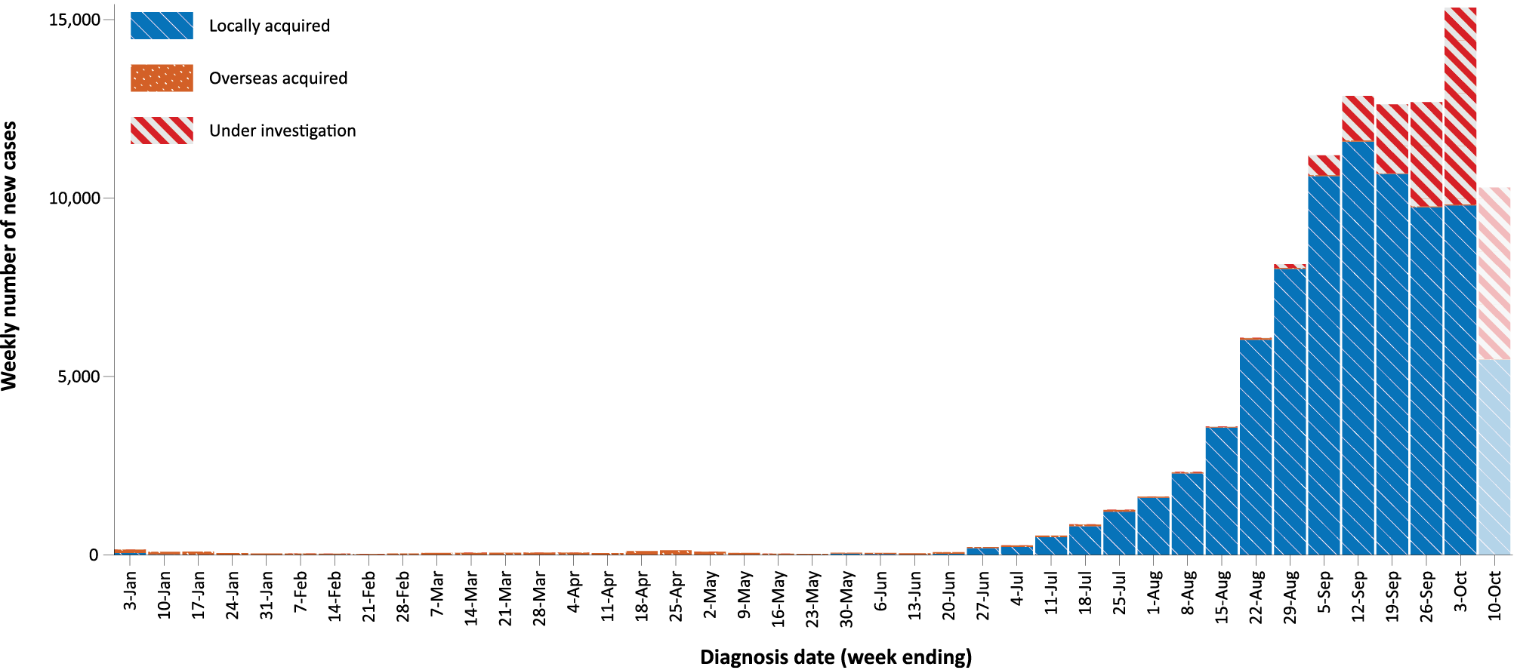
a Source: NINDSS, extract from 12 October 2021 for notifications to 10 October 2021.
b The lighter bar at the right of the graph represents the most recent reporting week and should be interpreted with caution, as additional cases may be identified in the coming week that have a diagnosis date during this period.
Figure 2: COVID-19 notified cases by source of acquisition and diagnosis date, 2 March 2020 – 10 October 2021^{a,b}
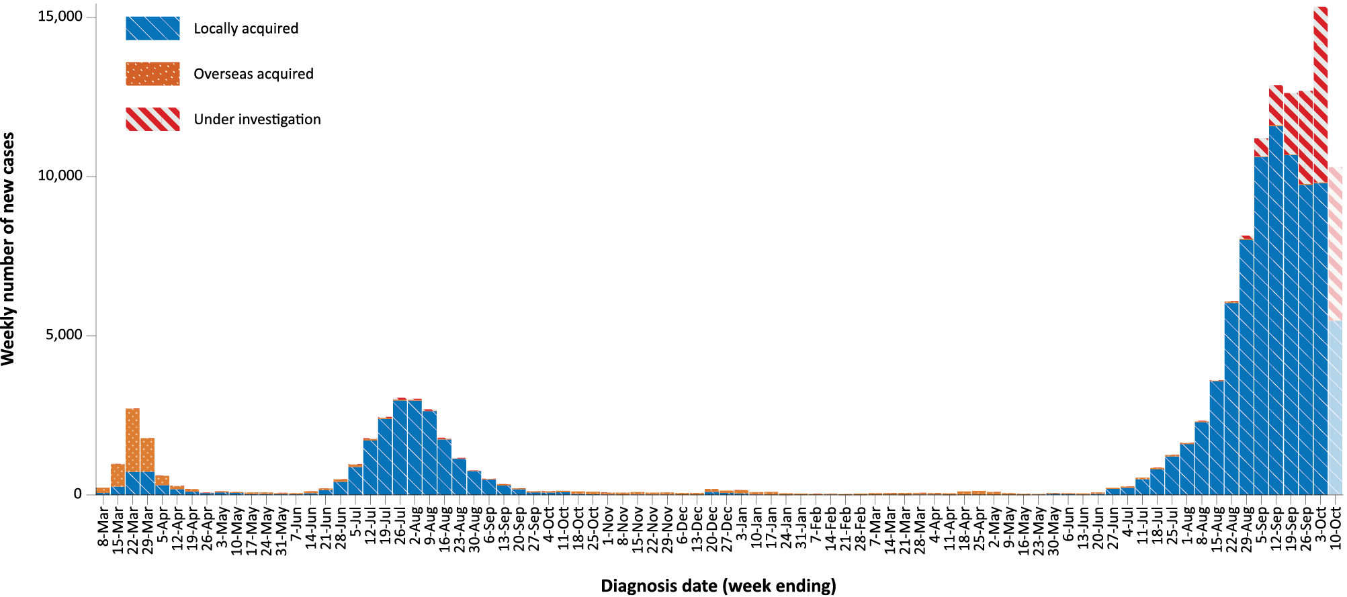
a Source: NINDSS, extract from 12 October 2021 for notifications to 10 October 2021.
b The lighter bar at the right of the graph represents the most recent reporting week and should be interpreted with caution, as additional cases may be identified in the coming week that have a diagnosis date during this period.

Source of acquisition

(NINDSS)
In this reporting period, > 99% of cases notified (30,672/30,727) were considered to be locally acquired (including cases under initial investigation), comprising 41% (12,603/30,676) locally acquired with known source, 1% (373/30,672) locally acquired with unknown source, 19% (5,813/30,676) under ongoing investigation, 39% (11,847/30,672) under initial investigation, and 36 interstate-acquired cases; < 1% of cases (51/30,727) were overseas acquired and four cases were missing a source of acquisition (Table 1).
Victoria reported the majority of locally-acquired cases (68%; 20,936/30,672) in this fortnight, followed by New South Wales (30%; 9,254/30,672). In the reporting period, 43% of locally-acquired cases (12,620/30,672) had a known contact or link to a cluster; 392 cases (232 in New South Wales, 102 in the Australian Capital Territory, 46 in Victoria, eight in South Australia, and one each in Queensland and Tasmania) had an unknown source. At the end of the reporting period, the source of acquisition was under initial or ongoing investigation for 17,660 cases.
For 2021 to date, New South Wales had the highest notification rate for locally-acquired cases with 773.0 notifications per 100,000 population, followed by Victoria with a rate of 525.3 notifications per 100,000 population and the Australian Capital Territory with a rate of 286.1 notifications per 100,000 population (Table 2). Excluding interstate-acquired cases, Tasmania reported that it had been more than a year since the last locally-acquired case (Table 3).

Table 2: Locally-acquired COVID-19 case numbers and rates per 100,000 population by jurisdiction and reporting period, Australia, with a notification received date from 1 January to 10 October 2021ª
Jurisdiction | Reporting period | Reporting period | Cases this year
 | 27 September –  10 October 2021 | 13–26 September 2021 | 1 January – 10 October 2021
 | Number of cases^{b} | Number of cases^{b} | Number of cases^{b} | Rate per 100,000 population^{c}
ACT | 463 | 259 | 1,234 | 286.1
NSW | 9,254 | 14,973 | 63,135 | 773.0
NT | 0 | 1 | 12 | 4.9
Qld | 10 | 8 | 252 | 4.9
SA | 8 | 0 | 39 | 2.2
Tas. | 1 | 0 | 2 | 0.4
Vic. | 20,936 | 8,943 | 35,177 | 525.3
WA | 0 | 1 | 18 | 0.7
Australia | 30,672 | 24,185 | 99,869 | 388.6
a Source: NINDSS, data extract from 12 October 2021 for notifications to 10 October 2021.
b This total includes cases under initial investigation and excludes overseas acquired and cases with a missing source of acquisition. In reports prior to report 51, cases under initial investigation were excluded from this total.
c Population data based on Australian Bureau of Statistics (ABS) Estimated Resident Population (ERP) as at June 2020.
Table 3: Days since last locally-acquired COVID-19 case (source unknown and source known), by jurisdiction and diagnosis date, 10 October 2021ª
Jurisdiction | Locally acquired — source unknown^{b} |  | Locally acquired — source known^{b}
 | Date of last case | Days since last case | Date of last case | Days since last case
ACT | 9 October 2021 | 1 | 10 October 2021 | 0
NSW | 10 October 2021 | 0 | 10 October 2021 | 0
NT | NA^{c} | NA^{c} | 6 July 2021 | 96
Qld | 25 September 2021 | 15 | 2 October 2021 | 8
SA | 24 March 2020 | 565 | 3 August 2021 | 68
Tas. | 9 August 2020 | 427 | 24 April 2020 | 534
Vic. | 8 October 2021 | 2 | 10 October 2021 | 0
WA | 3 April 2020 | 555 | 2 August 2021 | 69
a Source: NINDSS, extract from 12 October 2021 for notifications to 10 October 2021.
b This does not include locally-acquired cases that were interstate acquired or under initial investigation.
c NA: not applicable. The Northern Territory has not reported any locally-acquired cases with an unknown source of infection.
In the reporting period, Queensland reported the largest number of overseas-acquired cases (31%; 16/51), followed by Western Australia (24%; 12/51) and New South Wales (22%; 11/51) (Table 1). In the past 28 days (13 September to 10 October 2021), 48% (40/84) of confirmed overseas-acquired cases had an unknown country of acquisition. Cases acquired at sea (41%; 18/44) were the most frequent of those with an identified country of acquisition in the past 28 days, followed by cases acquired in Pakistan (16%; 7/44) The number of cases acquired in different countries is influenced by travel patterns of returning Australians, travel restrictions, and the prevalence of COVID-19 in the country of travel.

Demographic features

(NINDSS)
In this reporting period, the largest proportion of cases occurred in those aged 20 to 29 years (22%; 6,642/30,727). For this year, the highest notification rate has been in those aged 20 to 29 years with a rate of 603.9 cases per 100,000 population (Figure 3; Appendix A, Table A.1). Adults aged 70 to 79 years have had the lowest notification rate this year with a rate of 127.7 cases per 100,000 population.
Figure 3: Cumulative COVID-19 cases for the calendar year to date, by age group and sex, Australia, with a diagnosis date of 1 January 2021 – 10 October 2021ª
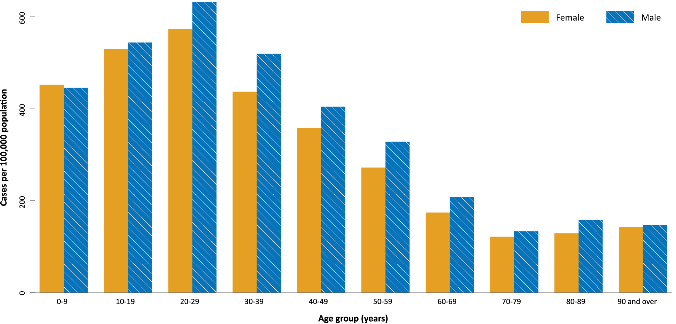
a Source: NINDSS, extract from 12 October 2021 for notifications to 10 October 2021.
In 2021, notification rates were similar among males and females in those aged 0 to 19 years and those over 90 years of age. In all other age groups, notification rates were higher among males than females (Figure 3; Appendix A, Table A.1). The median age of cases in this reporting period was 28 years (range: 0 to 105 years; interquartile range, IQR: 17 to 44 years).

Aboriginal and Torres Strait Islander persons

(NINDSS)
During the reporting period, there were 1,309 new cases notified in Aboriginal and Torres Strait Islander people, with 1,135 from New South Wales, 97 from Victoria, 75 from the Australian Capital Territory, and one each from Queensland and Tasmania. Since the beginning of 2021, there have been 4,330 confirmed cases of COVID-19 notified in Aboriginal and Torres Strait Islander people, representing 4% (4,330/101,723) of all confirmed cases this year. Of the locally-acquired cases notified in 2021, 31% (1,353/4,325) resided in a regional or remote area (Table 4).
Table 4: Confirmed cases of COVID-19 among Aboriginal and Torres Strait Islander people by place of acquisition and area of remoteness, 1 January – 10 October 2021ª
Jurisdiction | Locally acquired, Australia^{b} |  |  |  |  |  | Overseas acquired | Total
 | Major city | Inner regional | Outer regional | Remote^{c} | Overseas resident | Unknown
ACT | 117 | 0 | 0 | 0 | 0 | 0 | 0 | 117
NSW | 2,703 | 736 | 255 | 311 | 5 | 43 | 1 | 4,054
NT | 0 | 0 | 0 | 0 | 0 | 0 | 0 | 0
Qld | 3 | 0 | 1 | 0 | 0 | 0 | 3 | 7
SA | 0 | 0 | 0 | 0 | 0 | 0 | 0 | 0
Tas. | 0 | 1 | 0 | 0 | 0 | 0 | 0 | 1
Vic. | 101 | 34 | 15 | 0 | 0 | 0 | 0 | 150
WA | 0 | 0 | 0 | 0 | 0 | 0 | 1 | 1
Australia | 2,924 | 771 | 271 | 311 | 5 | 43 | 5 | 4,330
a Source: NINDSS, extract from 12 October 2021 for notifications to 10 October 2021.
b ‘Locally acquired’ includes cases under initial investigation. Note, in previous reports ‘locally acquired’ excluded cases under initial investigation.
c ‘Remote’ here also includes areas classified as ‘very remote’.
The majority of cases reported in Aboriginal and Torres Strait Islander people in 2021 have been associated with the Sydney Metropolitan and Western Regional outbreaks in New South Wales. There have been 4,051 locally-acquired cases (including cases under initial investigation) reported in Aboriginal and Torres Strait Islander people in New South Wales since 16 June 2021 when the Sydney Metropolitan outbreak began. Since the start of the pandemic, there have been nine COVID-19 associated deaths in Aboriginal and Torres Strait Islander people, which were associated with the current outbreaks in New South Wales.
In total, from January 2020 to 10 October 2021, there have been 4,478 cases in Aboriginal and Torres Strait Islander people, representing approximately 3% (4,478/130,138) of all confirmed cases in Australia. Indigenous status was unknown for approximately 23% (29,817/130,138) of confirmed cases, with the majority of these associated with more recently reported cases in New South Wales and Victoria.
As at 10 October 2021, it has been 0 days since the last locally-acquired Aboriginal and Torres Strait Islander case was diagnosed and 85 days since the last overseas-acquired Aboriginal and Torres Strait Islander case was diagnosed. To date, the majority of Aboriginal and Torres Strait Islander cases were reported as locally acquired (99%; 4,441/4,478), including 75 cases under initial investigation and 37 cases that were overseas acquired. The median age of locally-acquired Aboriginal and Torres Strait Islander cases was 22 years old (range 0 to 99 years, IQR: 10 to 36 years), while the median age of overseas-acquired cases was 40 years old (range 7 to 75 years; IQR: 27 to 57 years). Overall, the distribution among males and females was similar at 49% (2,201/4,470) and 51% (2,269/4,470) of cases, respectively, where the denominator is cases for which sex was known.
Given the delay between onset and severe illness, cases with an onset in the last two weeks were excluded from the following analysis on severity. In 2021, based on the highest level of severity reported for cases with an illness onset up to 26 September 2021, 0.3% of cases in Aboriginal and Torres Strait Islander people were reported to have died, 1.2% of cases required intensive care and a further 11.4% required admission to hospital (Table 5). Note that hospitalisation data in NINDSS should be interpreted with caution: hospitalisation is not always reflective of severe illness, as cases may be hospitalised for reasons other than clinical COVID-19 related care; additionally, hospitalisation and ICU status in NINDSS is likely incomplete.
Table 5: COVID-19 cases in Aboriginal and Torres Strait Islander people by age and highest level of illness severity, Australia, 1 January to 26 September 2021ª
Age group | Count |  |  |  |  | % of total cases by age group
 | Not severe^{b} | Hospitalised only  (not ICU or died) | ICU  (but not died) | Died | Total cases | Hospitalised only  (not ICU or died) | ICU  (but not died) | Died
0-4 | 343 | 22 | 0 | 0 | 365 | 6.0% | 0.0% | 0.0%
5-11 | 448 | 15 | 1 | 0 | 464 | 3.2% | 0.2% | 0.0%
12-15 | 270 | 10 | 2 | 0 | 282 | 3.5% | 0.7% | 0.0%
16-17 | 125 | 11 | 1 | 0 | 137 | 8.0% | 0.7% | 0.0%
18-29 | 685 | 94 | 5 | 0 | 784 | 12.0% | 0.6% | 0.0%
30-39 | 439 | 75 | 5 | 0 | 519 | 14.5% | 1.0% | 0.0%
40-49 | 284 | 62 | 8 | 2 | 356 | 17.4% | 2.2% | 0.6%
50-59 | 187 | 43 | 10 | 4 | 244 | 17.6% | 4.1% | 1.6%
60-69 | 52 | 31 | 5 | 2 | 90 | 34.4% | 5.6% | 2.2%
70-79 | 11 | 5 | 2 | 1 | 19 | 26.3% | 10.5% | 5.3%
80-89 | 1 | 2 | 0 | 1 | 4 | 50.0% | 0.0% | 25.0%
90+ | 0 | 1 | 0 | 0 | 1 | 100.0% | 0.0% | 0.0%
Unknown | 0 | 0 | 0 | 0 | 0 | 0.0% | 0.0% | 0.0%
Total | 2,845 | 371 | 39 | 10 | 3,265 | 11.4% | 1.2% | 0.3%
a Source: NINDSS, extract from 12 October 2021 for notifications to 26 September 2021.
b ‘Not severe’ includes all cases that were not hospitalised, admitted to ICU or died.

Vaccinations

(Department of Health)
As of 10 October 2021, a total of 30,706,847 doses of COVID-19 vaccine had been administered (Table 6), including 1,056,627 doses provided to aged care and disability residents. Nationally, 16,995,261 people aged 16 years or over (82.4%) had received at least one dose. This includes 12,871,326 people aged 16 and over (62.4%) who were fully vaccinated. Among people aged 12–15 years, 649,489 people (52.2%) had received at least one dose, including 126,960 (10.2%) who were fully vaccinated.
Table 6: Total number of vaccinations administered, by jurisdiction, Australia, 10 October 2021ª
Jurisdiction | Total number of doses administered | Percentage of people aged 16 and over who have had at least one dose^{b,c} | Percentage of people aged 16 and over who are fully vaccinated^{c}
ACT | 760,548 | > 95% | 73.6%
NSW | 11,055,061 | 90.4% | 74.0%
NT | 285,073 | 68.5% | 56.5%
Qld | 5,261,080 | 70.2% | 52.7%
SA | 1,868,871 | 72.9% | 55.0%
Tas. | 647,591 | 80.3% | 65.0%
Vic. | 8,175,899 | 85.8% | 59.3%
WA | 2,652,724 | 70.1% | 52.0%
Aged care and disability facilities^{d} | 1,056,827 | NA | NA
Primary care^{e} | 16,781,250 | NA | NA
Total | 30,706,847 | 82.4% | 62.4%
a Source: Australian Government Department of Health website.⁴
b Includes people who are fully vaccinated.
c Population data based on Australian Bureau of Statistics (ABS) Estimated Resident Population (ERP) as at June 2020.
d Commonwealth vaccine doses administered in aged care and disability facilities.
e Commonwealth vaccine doses administered in primary care settings.

Clusters and outbreaks

Sydney Metropolitan Outbreak and New South Wales Regional Outbreak – New South Wales
In total, as at 10 October 2021, there had been 63,338 locally-acquired cases in New South Wales, including 438 deaths, reported following notification of the outbreak’s first case on 16 June 2021. Genomic testing results showed that the first case was infected with the Delta SARS-CoV-2 variant of concern (B.1.617.2); however, the sequence did not match cases from the Victorian Delta variant outbreak that occurred from May to June 2021. This sequence had not been seen in Australia previously, but matched one from the United States of America.
The number of new locally-acquired cases continued to decrease this fortnight, with 9,254 locally-acquired cases (including cases under initial investigation) reported this reporting period, compared to 14,973 such cases reported in the previous reporting period. Following the initial start of the outbreak in south-east Sydney, the largest number of new cases were subsequently reported among residents of south-western and western Sydney, with cases also reported in residents of regional and remote areas in New South Wales, particularly in western New South Wales. At the end of the most recent reporting period, case numbers were reducing in south-western and western Sydney, while increasing case numbers were being seen in regional areas, including Illawarra, Wollongong and the Hunter New England regions.

Metropolitan Melbourne and Victorian Regional Outbreak – Victoria
As at 10 October 2021, 33,065 locally-acquired cases, including 93 deaths, reported in Victoria since two unlinked cases were reported on 5 August 2021. The size of the Victorian outbreak continued to increase during the reporting period, with the number of locally-acquired cases (including those under investigation) in Victoria this fortnight (20,936 cases) more than twice that of the previous fortnight (8,943 cases). Investigations into the source of the outbreak were ongoing, but genomic testing had determined that these outbreaks involved the Delta variant and were genomically closely associated with recent clusters in New South Wales and the previous two seeding events in Victoria from July 2021.
Most cases in the outbreak were in the northern and western suburbs of Greater Melbourne. However, since 20 August 2021, cases had also been reported in regional Victoria. In the past two weeks, there was a considerable increase in the number of cases identified in regional residents, with 983 locally-acquired cases (including cases under investigation) reported to NINDSS in regional residents in the reporting period, compared with 156 such cases in the previous reporting period.

Canberra – Australian Capital Territory
As at 10 October 2021, a total of 1,234 cases had been reported in the Australian Capital Territory’s outbreak. The first case in the Territory’s outbreak, which was the first locally-acquired case in the Australian Capital Territory in over a year, was reported on 12 August 2021 and was confirmed to have the Delta variant. The source of infection remained under investigation at the end of this reporting period, though it was genomically related to the Sydney Metropolitan Outbreak. The number of new cases in the Australian Capital Territory during this reporting period (463) was approximately 1.8 times the number in previous reporting period (259).

Queensland
As at 10 October 2021, seventeen cases had been reported as part of unlinked outbreaks in Queensland since 28 September 2021, when four under investigation cases were reported, not linked to the previous Sunnybank cluster. The most recent locally acquired case in Queensland was detected on 5 October 2021.

Severity

(NINDSS, SPRINT-SARI)

Hospitalisation and intensive care unit admission
Given the delay between illness onset and severe illness, to provide a more accurate assessment of the highest level of severity, cases with an onset in the last two weeks were excluded from the analysis. In 2021, based on the highest level of severity reported for cases with an illness onset up to 26 September, 0.7% of cases were reported to have died, 1.6% of cases required intensive care and a further 11.8% required admission to hospital (Table 7). The majority of hospitalisations in 2021 were associated with the current outbreak in New South Wales. Note that hospitalisation data in NINDSS should be interpreted with caution: hospitalisation is not always reflective of severe illness, as cases may be hospitalised for reasons other than clinical COVID-19 related care; additionally, hospitalisation and intensive care unit (ICU) status in NINDSS is likely incomplete.

Table 7: COVID-19 cases by age group and highest level of illness severity, 1 January 2021 – 26 September 2021^{a,b}
Age group | Count |  |  |  |  | % of cases
 | Not severe | Hospitalised only | ICU | Died | Total cases | Hospitalised only | ICU | Died
 |  | (not ICU or died) | (not died) |  |  | (not ICU or died) | (not died)
0–4 | 5,035 | 323 | 5 | 0 | 5,363 | 6.0% | 0.1% | 0.0%
5–11 | 7,251 | 244 | 2 | 0 | 7,497 | 3.3% | 0.0% | 0.0%
12–15 | 4,424 | 199 | 4 | 1 | 4,628 | 4.3% | 0.1% | 0.0%
16–17 | 2,395 | 112 | 7 | 0 | 2,514 | 4.5% | 0.3% | 0.0%
18–29 | 17,480 | 1,632 | 111 | 6 | 19,229 | 8.5% | 0.6% | 0.0%
30–39 | 11,714 | 1,690 | 168 | 8 | 13,580 | 12.4% | 1.2% | 0.1%
40–49 | 7,703 | 1,495 | 215 | 21 | 9,434 | 15.8% | 2.3% | 0.2%
50–59 | 5,419 | 1,280 | 304 | 52 | 7,055 | 18.1% | 4.3% | 0.7%
60–69 | 2,625 | 921 | 239 | 82 | 3,867 | 23.8% | 6.2% | 2.1%
70–79 | 943 | 611 | 115 | 130 | 1,799 | 34.0% | 6.4% | 7.2%
80–89 | 317 | 384 | 24 | 152 | 877 | 43.8% | 2.7% | 17.3%
90+ | 75 | 90 | 0 | 55 | 220 | 40.9% | 0.0% | 25.0%
Age unknown | 2 | 0 | 0 | 0 | 2 | 0.0% | 0.0% | 0.0%
Total | 65,383 | 8,981 | 1,194 | 507 | 76,065 | 11.8% | 1.6% | 0.7%
a Source: NINDSS, extract from 12 October 2021 for notifications to 26 September 2021. Includes cases notified from 1 January 2021, with an illness onset up to 26 September 2021; cases with an illness onset in the last two weeks (27 September 2021 to 10 October 2021) were excluded to account for the delay between onset and development of severe illness.
b ‘Not severe’ includes all cases that were not hospitalised, admitted to ICU or died.
In the year to date to 10 October 2021, there were 1,322 COVID-19 cases admitted to ICUs participating in the sentinel surveillance system, Short Period Incidence Study of Severe Acute Respiratory Infection (SPRINT-SARI),⁵ with 236 of these admitted during this reporting period (27 September – 10 October 2021).

Risk factors for severe disease
The proportion of cases who were admitted to hospital generally increased as a person’s age increased (Table 7).
Comorbidity data extracted from SPRINT-SARI reflect the sickest patients with COVID-19 managed in ICU; data are therefore If not generalisable to all cases (Table 8). In patients admitted to ICU with COVID-19 since 1 February 2021, the most prevalent comorbidity was obesity (a body mass index of > 30 or weight over 120 kg), closely following by diabetes. Of those adult patients admitted to ICU this year for whom comorbidity data was known, 62% (656/1,057) had at least one comorbidity; 38% (401/1,057) of patients had none of the listed comorbidities recorded.

Table 8: Comorbidities for adult COVID-19 cases (aged greater than or equal to 18 years) amongst those admitted to ICU, Australia, 1 February 2021 – 10 October 2021ª
Comorbidity | ICU casesª (n = 1,292) (%)
Cardiac disease (n = 1,047) | 110 (11)
Chronic respiratory condition (n = 1,048) ^{b} | 155 (15)
Diabetes (n = 1,043) | 315 (30)
Obesity (n = 1,016) | 332 (33)
Chronic renal disease (n = 1,043) | 51 (5)
Chronic neurological condition (n = 1,044) | 30 (3)
Malignancy (n = 1,045) | 33 (3)
Chronic liver disease (n = 1,046) | 23 (2)
Immunosuppression (n = 1,044) | 33 (3)
Number of specified comorbidities (n = 1,057) ^{c,d}
One or more | 656 (62)
Two or more | 282 (27)
Three or more | 100 (9)
No comorbidities | 401 (38)
a Source: SPRINT-SARI. Only includes adult cases (≥ 18 years old) and excludes those with missing data on comorbidities or where comorbidity is unknown.
b Includes asthma.
c Includes chronic respiratory conditions, cardiac disease (excluding hypertension), immunosuppressive condition/therapy, diabetes, obesity, liver disease, renal disease and neurological disorder.
d Excludes cases where comorbidity data is missing or unknown for all comorbidities.

COVID-19 deaths
In the past two weeks, there were 186 deaths associated with COVID-19, 122 in New South Wales, 59 in Victoria and five in the Australian Capital Territory. This brings the total number of COVID-19 associated deaths in 2021 to 541 (Table 9).
Table 9: Deaths associated with COVID-19 by reporting period, Australia, 1 January 2020 – 10 October 2021ª
Reporting period | Number of deaths^{b}
Reporting period 27 September – 10 October 2021 | 186
Year to date 1 January 2021 – 10 October 2021 | 541
Epidemic to date 1 January 2020 – 10 October 2021 | 1,450
a Source: NINDSS, extract from 12 October 2021, based on notification received date.

Figure 4: Samples in AusTrakka from 26 April to 10 October 2021, by lineage and date of collectionª
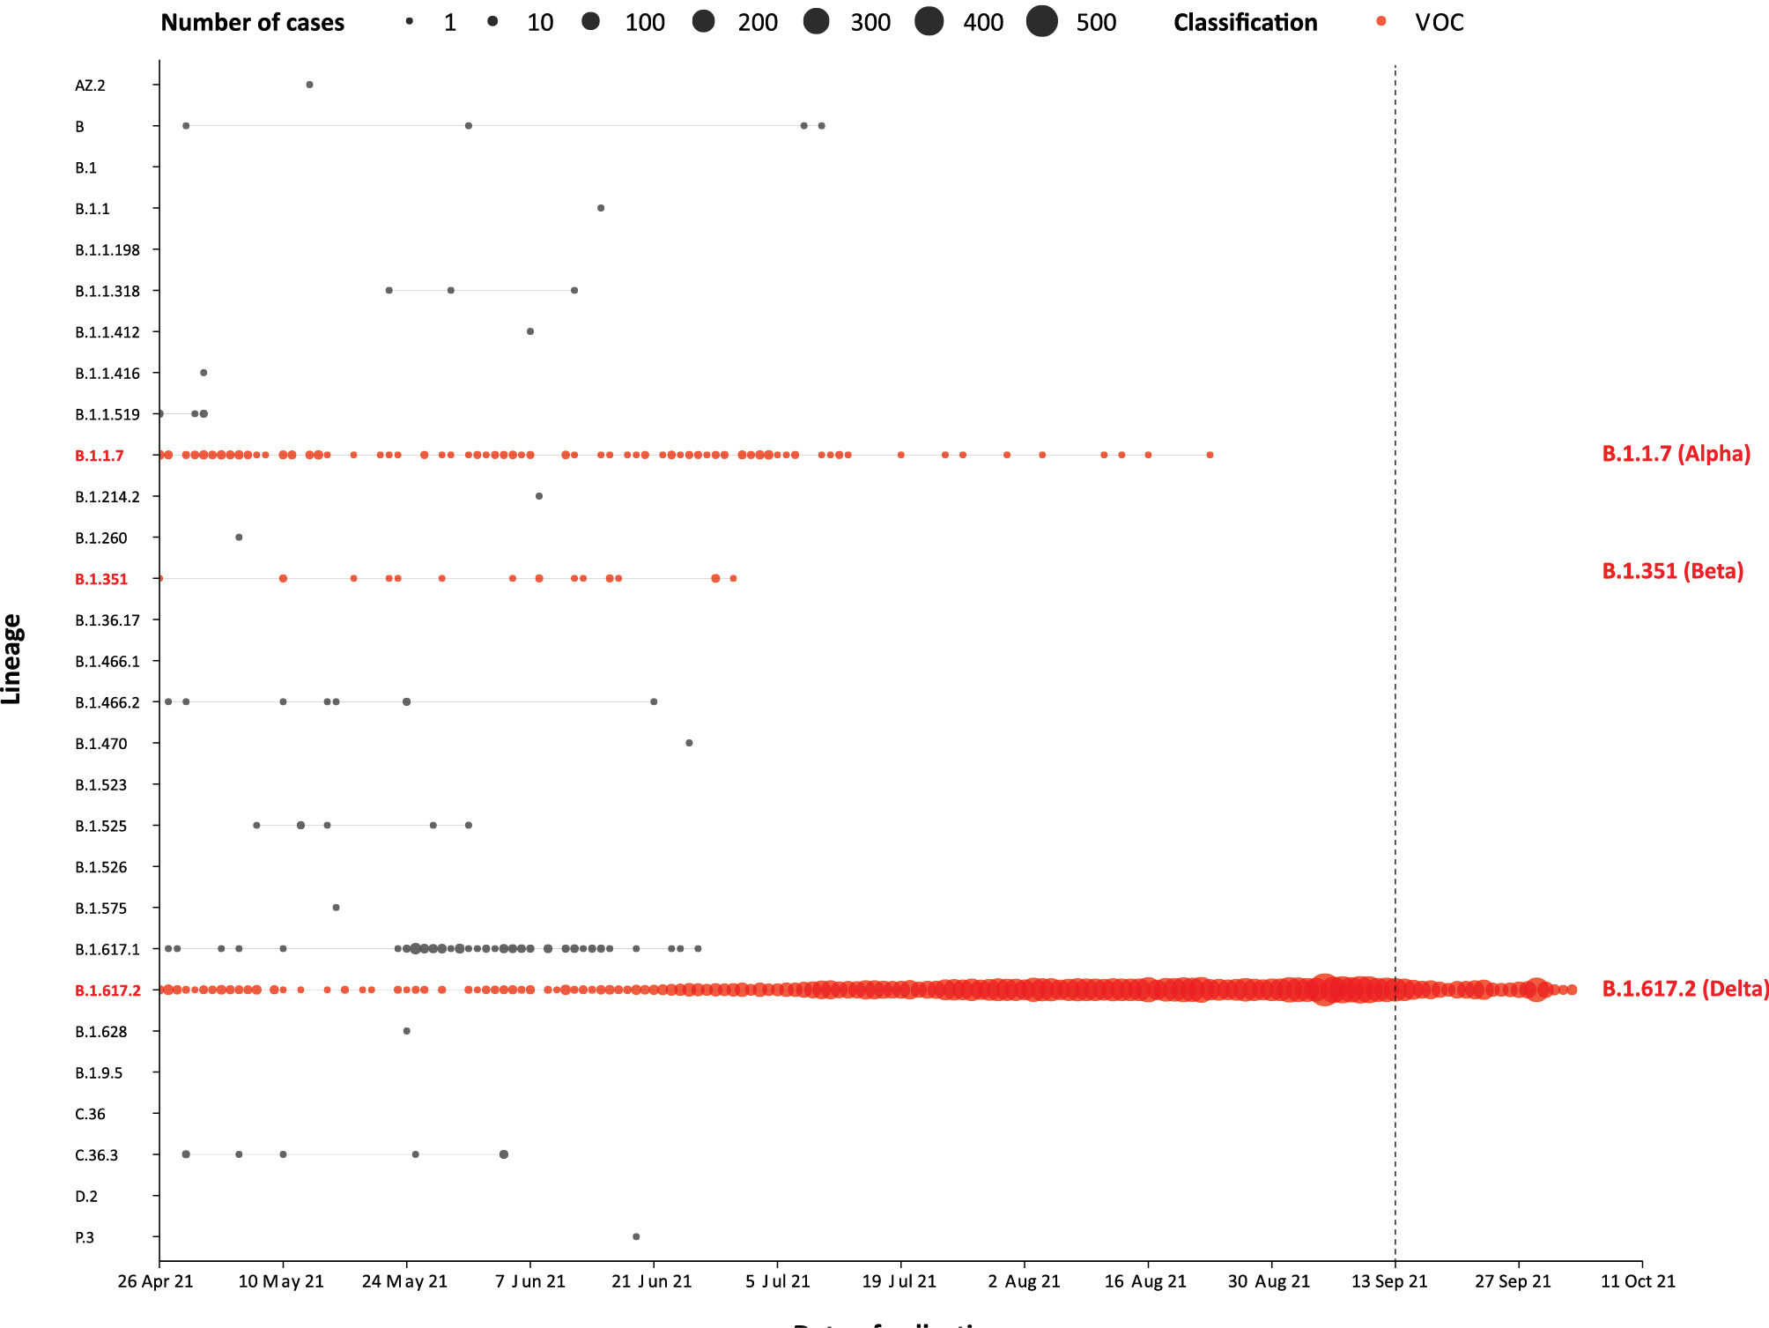
a The start of the current reporting period (13 September – 10 October 2021) is marked by the dotted line, and variant-of-concern samples are coloured red. The size of the circle is proportional to the number of samples in the lineage at each time point.

Four-week reporting period (16 August – 12 September 2021)

Genomic surveillance and virology

(Communicable Disease Genomics Network, AusTrakka and jurisdictional sequencing laboratories)
Nationally, 27% of COVID-19 cases have been sequenced since the start of the pandemic in January 2020, based on jurisdictional reporting (Table 10).

Table 10: Australian SARS-CoV-2 genome sequences and proportion of positive cases sequenced, 13 September – 10 October 2021 and cumulative to date
Measure | Reporting period 13 September to 10 October 2021 | Cumulative 23 January 2020 to 10 October 2021
SARS-CoV-2 cases sequencedª | 3,379 | 34,374
Percentage of positive cases sequenced^{b} | 6.2% | 27%
a Based on individual jurisdictional reports of sequences and case numbers. Calculations of the percentage of cases sequenced based on the number of sequences available in AusTrakka6 may not always be up-to-date, since this may include duplicate samples from cases and may not represent all available sequence data.
b Total SARS-CoV-2 case numbers as reported by jurisdictional laboratories. In most jurisdictions, sequencing has been attempted on all suitable samples (one sample per case). Sequencing of samples from cases identified in the reporting period may be in process at the time of reporting. Remaining unsequenced samples may be due to jurisdictional sequencing strategy, or where samples have been deemed unsuitable for sequencing (typically because viral loads were too low for sequencing to be successful).

Variants of concern
AusTrakka is actively monitoring and reporting on the four lineages designated Variants of Concern (VOC) by international organisations, including the World Health Organisation: Alpha (B.1.1.7); Beta (B.1.351); Gamma (P.1); and Delta (B.1.617.2) (Table 11). All four variants display characteristic sets of mutation, including a number of variations in the genomic region encoding the spike protein thought to have the potential to increase transmissibility and/or immune evasion.^{7,8} On 1 June 2021 WHO announced a new nomenclature system for VOCs, using letters of the Greek alphabet,⁹ to facilitate communication and reduce stigmatisation associated with geography-based colloquial terms. Further information on variants is available in the Technical Supplement. On 27 September 2021, Kappa (B.1.617.1), which had been classified as a VOC in Australia, was reclassified as a Variant of Interest (VOI) by the Communicable Diseases Genomics Network Variants of Concern Taskforce. As such, Kappa is no longer included in AuskTrakka VOC reporting.
Table 11: Australian SARS-CoV-2 genome sequences in AusTrakka identified as variants of concern, 23 January 2020 – 10 October 2021
VOC lineage | Number of samples
B.1.1.7 (Alpha)ª | 568
B.1.351 (Beta) | 100
P.1 (Gamma) | 8
B.1.617.2 (Delta)^{b} | 17,281
a Includes Q sublineages.
b Includes AY sublineages.
Further information on variants is available in the Technical Supplement.³

Testing

(State and territory reporting)
Between 1 January and 8 October 2021, over 28 million tests have been conducted nationally. During the four-week testing reporting period (11 September to 8 October 2021), over 4.6 million individuals were tested, at a rate of 179 individuals tested per 1,000 population, noting that individuals tested in multiple weeks could be counted more than once (Table 12). Jurisdictional testing rates are driven by current case numbers, testing policies and numbers of people experiencing symptoms.
Table 12: Individuals undergoing diagnostic tests for SARS-CoV-2,ª by jurisdiction and reporting period, with a notification received date of 11 September – 10 October 2021
Jurisdiction | Individuals testedª |  |  | Individuals testedª
 | 25 September to 8 October 2021 |  |  | 11 September to 24 September 2021
 | n^{b} | Positivity (%) | Per 1,000 population^{c} | n^{b} | Positivity (%) | Per 1,000 population^{c}
ACT | 48,745 | 0.92 | 113 | 43,128 | 0.61 | 100
NSW | 1,159,223 | 0.82 | 142 | 1,318,821 | 1.17 | 161
NT | 13,617 | 0.04 | 55 | 14,156 | 0.04 | 57
Qld | 154,497 | 0.02 | 30 | 145,283 | < 0.01 | 28
SA | 57,022 | 0.02 | 32 | 56,537 | < 0.01 | 32
Tas. | 12,599 | < 0.01 | 23 | 12,399 | < 0.01 | 23
Vic. | 764,635 | 2.65 | 114 | 725,339 | 1.22 | 108
WA | 34,295 | 0.04 | 13 | 40,145 | < 0.01 | 15
Australia | 2,244,633 | 1.35 | 87 | 2,355,808 | 1.04 | 92
a In order to more accurately reflect positivity rates, numbers of individuals tested is presented rather than total number of tests. The number of individuals tested is the sum of number of individuals tested in each week (Saturday to Friday) in each jurisdiction. Individuals who were tested in more than one week could be counted more than once.
b Total cumulative tests counts the total number of tests performed, not the number of individuals tested.
c Population data based on Australian Bureau of Statistics (ABS) Estimated Resident Population (ERP) as at June 2020.d
Testing rates increased substantially from the week ending 23 July 2021 onwards, due to the re-inclusion of data from New South Wales in testing rates (Figure 5). Testing rates remained high during the reporting period. Those aged 20 to 39 years continued to have the highest rates of testing, followed by those aged 40 to 59 years old. Testing rates were lowest in those aged 0 to 19.
The percent positivity remains low, at 1.2% for the four-week reporting period, reflecting a high surveillance capacity and rapid case identification. Since the week ending 23 July 2021, the national percent positivity has increased from approximately 0.1% to 1.4% in the week ending 8 October 2021, while testing rates have remained high and relatively steady, at or above 40 per 1,000 population per week (Figure 6). The increase in percent positivity during the reporting period was mainly driven by an increased percent positivity in Victoria (Table 12).

Figure 5: SARS-CoV-2 polymerase chain reaction (PCR) testing rates per 1,000 population per week by age group and notification received date, Australia, 26 December 2020 – 8 October 2021^{a,b,c}
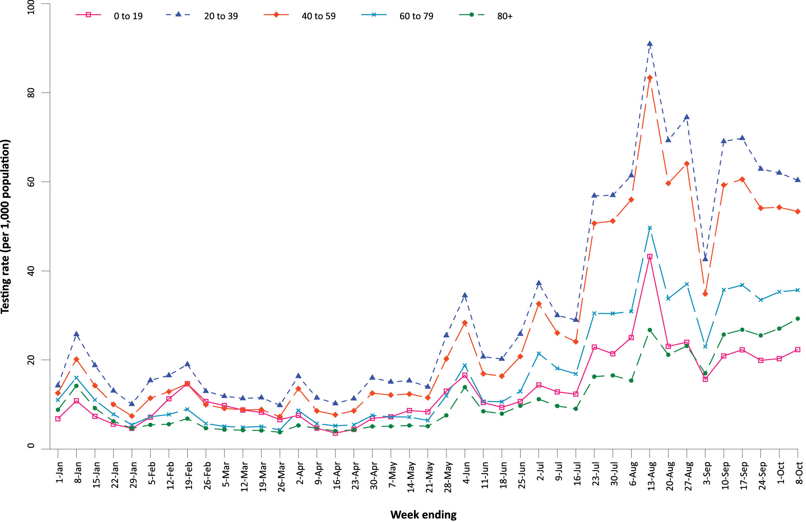
a Source: testing data provided by jurisdictions to the NIR weekly, current to 8 October 2021; population data based on Australian Bureau of Statistics (ABS) Estimated Resident Population (ERP) as at June 2020.
b The jurisdictions reporting each week (i.e. the denominator population) may vary.
c From 22 May to 4 June and 26 June to 9 July, data for Queensland were unavailable. From 19 June 2021 to 16 July 2021, data for New South Wales were unavailable. From 28 August to 3 September 2021, data for New South Wales and the Australian Capital Territory were unavailable.

Figure 6: SARS-CoV-2 polymerase chain reaction (PCR) testing rates per 1,000 population per week and percent positivity by specimen date, Australia, 26 December 2020 – 8 October 2021^{a,b,c}
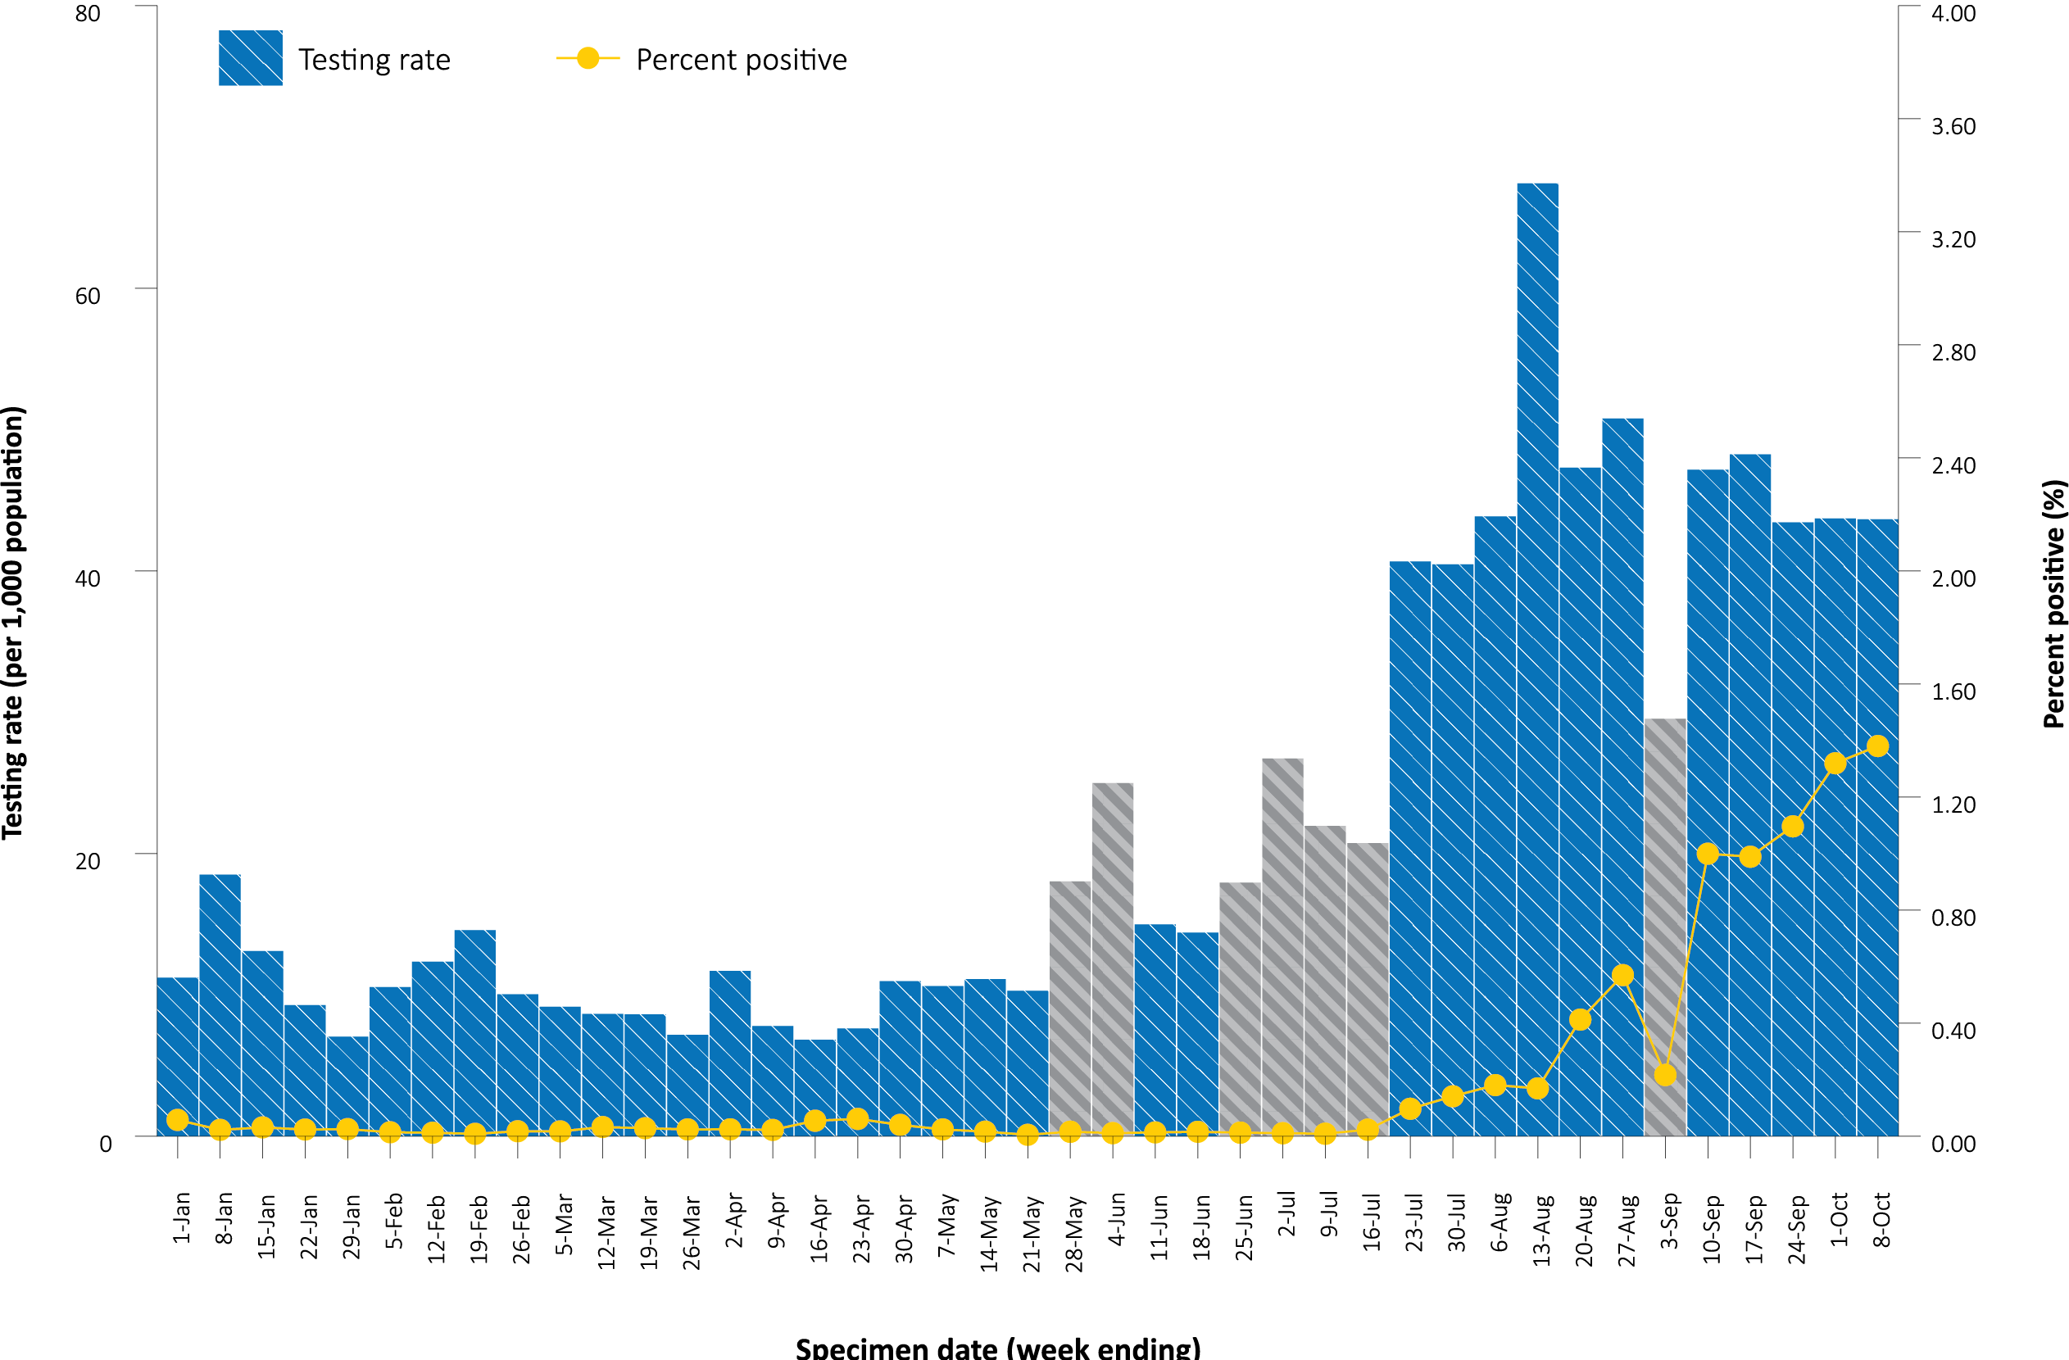
a Source: testing data provided by jurisdictions to the NIR weekly, current to 8 October 2021; case data extracted from NINDSS on 12 October 2021 for cases with a specimen date up to 8 October 2021; population data based on Australian Bureau of Statistics (ABS) Estimated Resident Population (ERP) as at June 2020.
b The jurisdictions reporting each week (i.e. the denominator population) may vary.
c Grey bars indicate weeks where jurisdictional reporting was incomplete. From 22 May to 4 June and from 26 June to 9 July, data for Queensland were unavailable. From 19 June 2021 to 16 July 2021, data for New South Wales were unavailable. From 28 August to 3 September 2021, data for New South Wales and the Australian Capital Territory were unavailable

Acute respiratory illness

(FluTracking, ASPREN, and Commonwealth Respiratory Clinics)
Based on self-reported FluTracking data,¹⁰ prevalence of fever and cough in the community remained at < 1%, and was slightly lower than that reported in the previous four-week reporting period (Figure 7). Runny nose and sore throat symptoms in the community were slightly lower during this reporting period compared to the previous four weeks, with the prevalence in the community remaining low at < 1%.
In this reporting period, acute respiratory illness was highest in those aged 0 to 9 years and 30 to 39 years, based on both self-reported FluTracking data and presentations to Commonwealth Respiratory Clinics. Females reported respiratory illness more frequently than males. Rates of fever and cough by jurisdiction ranged from 0.7/1,000 FluTracking participants in the Australian Capital Territory to 6.6/1,000 participants in Tasmania.
FluTracking data indicated that 49% of those in the community with ‘fever and cough’ and 34% of those with ‘runny nose and sore throat’ were tested for SARS-CoV-2. This represents a slight decrease in SARS-CoV-2 testing for ‘sore throat and runny nose’ and a similar level of testing for ‘fever and cough’ since the previous reporting period. In the four-week reporting period, testing rates were highest in the Australian Capital Territory and lowest in Western Australia for both sets of symptoms. It is important to acknowledge that there may be legitimate reasons why people did not get tested, including barriers to accessing testing. Symptoms reported to FluTracking are not specific to COVID-19 and may also be due to chronic diseases.
During this reporting period, there were 138,751 assessments at Commonwealth Respiratory Clinics. Of these, there were 125,546 assessments with consent to share information, with 97% (121,986/125,546) tested for SARS-CoV-2. There were 543 cases reported at these clinics in this reporting period, representing a percent positivity of < 1% (543/121,986).
Figure 7: Weekly trends in respiratory illness amongst FluTracking survey participants (age-standardised) compared to the average of the previous five years, Australia, by epidemiological week,ª 1 March 2020 – 10 October 2021^{b}
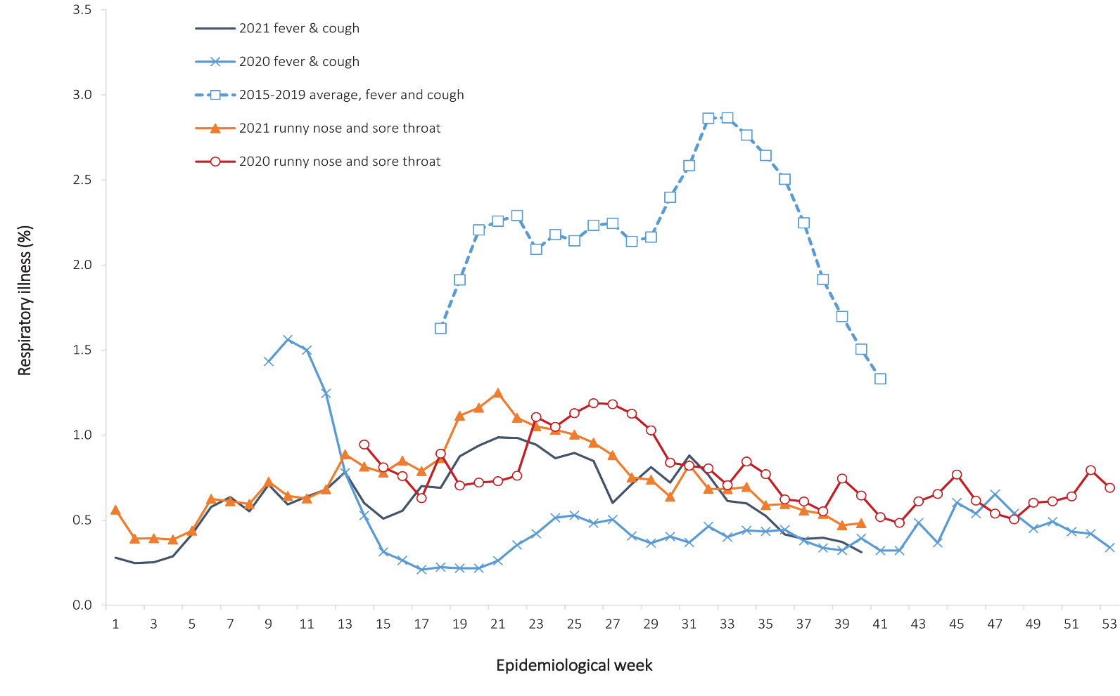
a Epidemiological weeks are a standardised method for numbering weeks across years, with the first epidemiological week of any year ending on the first Saturday in January.
b In years prior to 2020, FluTracking was activated during the main Influenza season from May to October. A historical average beyond the week ending 11 October (epidemiological week 41) is therefore not available. In 2020, FluTracking commenced ten weeks early to capture data for COVID-19. Data on runny nose and sore throat were only collected systematically after 29 March 2020, therefore a historical average for this symptom profile is unavailable.

Public health response measures
Since COVID-19 first emerged internationally, Australia has implemented public health measures informed by the disease’s epidemiology. States and Territories have decision making authority in relation to public health measures and have implemented or eased restrictions at their own pace (Figure 8; Appendix A, Table A.2), depending on the local public health and epidemiological situation, and in line with the ‘Framework for National Reopening’.¹¹ Nationwide requirements regarding air travel, including pre-flight testing for travellers entering Australia and requirements to wear face masks when flying domestically or internationally, remain in place. During the current reporting period, there was community transmission occurring in the Australian Capital Territory, New South Wales, and Victoria.
Figure 8: COVID-19 notifications in Australia by week of diagnosis and jurisdiction, 31 May – 10 October 2021, with timing of key public health measures
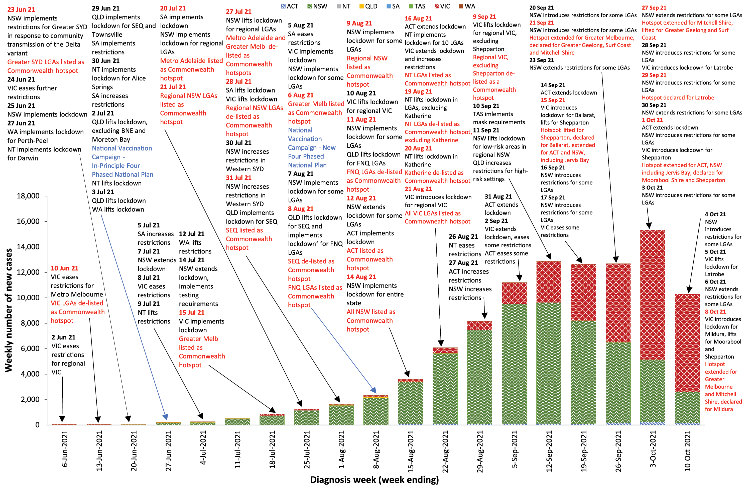

Countries and territories in Australia’s near region
According to WHO, countries and territories in the South East Asian and Western Pacific regions reported 2,670,228 newly-confirmed cases and 39,729 deaths in the four-week period to 10 October 2021, bringing the cumulative cases in the two regions to over 52 million, and cumulative deaths in these regions to over 802,000.¹² New case numbers and deaths incidence have continued to trend downward in the south east Asian region, driven by decreasing cases in India, Indonesia and Thailand. Both the number of new cases and new deaths in the Western Pacific Region in the past four weeks have declined compared to the previous four-week period. The highest numbers of new cases in the Western Pacific region during the four-week period to 10 October 2021 were in the Philippines, Malaysia and Viet Nam.¹³
Table 13 outlines the new cases and deaths in the four-week period to 10 October 2021 and cumulative cases and deaths for the pandemic in selected countries with the highest number of new cases in the South East Asian region and the Western Pacific region.
Table 13: Cumulative cases and deaths, and new cases and deaths reported in the four-week period to 10 October 2021 for selected countries in Australia’s near region according to WHOª
Country | Cumulative cases | New cases reported in the last 4 weeks | Change in new cases in the last 4 weeks^{b} | Cumulative deaths | New deaths reported in the last 4 weeks | Change in new deaths in the last 4 weeks^{b}
South East Asian region
India | 33,953,475 | 716,554 | -31% | 450,589 | 7,934 | -31%
Thailand | 1,710,884 | 328,711 | -31% | 17,691 | 3,338 | -51%
Indonesia | 4,227,932 | 60,421 | -81% | 142,651 | 3,762 | -82%
Myanmar | 478,651 | 46,818 | -40% | 18,134 | 1,604 | -51%
Sri Lanka | 526,383 | 40,461 | -69% | 13,331 | 2,035 | -61%
Western Pacific region
Philippines | 2,654,403 | 448,447 | -6% | 39,505 | 4,527 | -8%
Malaysia | 2,332,221 | 371,721 | -35% | 27,265 | 6846 | -16%
Viet Nam | 836,134 | 234,785 | -30% | 20,442 | 5,424 | -43%
Japan | 1,710,394 | 78,303 | -84% | 17,927 | 1,185 | -12%
Mongolia | 321,107 | 65,493 | -10% | 1,346 | 370 | +256%
a Source: World Health Organization Coronavirus (COVID-19) Dashboard,12 accessed 13 October 2021.
b Percent change in the number of newly confirmed cases/deaths in the most recent four-week period compared to the four weeks prior.

As of 10 October 2021, over 237 million COVID-19 cases and 4.8 million deaths have been reported globally, with a global case fatality rate (CFR) of 2%. The two regions reporting the largest burden of disease over the past four weeks were the European Region (36% of cases) and the Region of the Americas (35% of cases), noting that case data for the Region of the Americas may be incomplete at the time of reporting.

Acknowledgements
We thank public health staff from incident emergency operations centres and public health units in state and territory health departments, and the Australian Government Department of Health, along with state and territory public health laboratories. We thank those who have provided data from surveillance systems, such as Commonwealth respiratory clinics, ASPREN, FluTracking, FluCAN, SPRINT-SARI, Communicable Disease Genomics Network, AusTrakka and jurisdictional sequencing laboratories.

Author details

Corresponding author
COVID-19 National Incident Room Surveillance Team
Australian Government Department of Health, GPO Box 9484, MDP 14, Canberra, ACT 2601. Email: epi.coronavirus@health.gov.au

References
- COVID-19 National Incident Room Surveillance Team. COVID-19 Australia: Epidemiology Report 51: Reporting period ending 26 September 2021. Commun Dis Intell (2018). 2021;45. doi: https://doi.org/10.33321/cdi.2021.45.54.
- COVID-19 National Incident Room Surveillance Team. COVID-19 Australia: Epidemiology Report 50: Reporting period ending 12 September 2021. Commun Dis Intell (2018). 2021;45. doi: https://doi.org/10.33321/cdi.2021.45.50.
- COVID-19 National Incident Room Surveillance Team. Technical supplement. COVID-19 Australia: Epidemiology reporting. Commun Dis Intell (2018). 2021;45. doi: https://doi.org/10.33321/cdi.2021.45.2.
- Australian Government Department of Health. Getting vaccinated for COVID-19: Australia’s vaccine rollout. [Internet.] Canberra: Australian Government Department of Health; 2021. [Accessed on 12 October 2021.] Available from: https://www.health.gov.au/initiatives-and-programs/covid-19-vaccines/getting-vaccinated-for-covid-19#australias-vaccine-rollout.
- Australian and New Zealand Intensive Care Research Centre (ANZIC-RC). SPRINT-SARI: Short period incidence study of severe acute respiratory infection. [Internet.] Melbourne: Monash University, ANZIC-RC; 2020. Available from: https://www.monash.edu/medicine/sphpm/anzicrc/research/sprint-sari.
- Communicable Diseases Genomics Network (CDGN). AusTrakka. [Website.] Melbourne: CDGN; 2020. Available from: https://www.cdgn.org.au/austrakka.
- World Health Organization (WHO). Coronavirus disease (COVID-19) Weekly Epidemiological Update and Weekly Operational Update. [Internet.] Geneva: WHO; June 2021. [Accessed on 14 October 2021.] Available from: https://www.who.int/emergencies/diseases/novel-coronavirus-2019/situation-reports/.
- Allen H, Vusirikala A, Flannagan J, Twohig KA, Zaidi A, Groves N et al. Increased household transmission of COVID-19 cases associated with SARS-CoV-2 Variant of Concern B.1.617.2: a national case-control study. Knowledge Hub (khub); 2021. [Accessed on 14 October 2021.] Available from: https://khub.net/documents/135939561/405676950/Increased+Household+Transmission+of+COVID-19+Cases+-+national+case+study.pdf/7f7764fb-ecb0-da31-77b3-b1a8ef7be9aa.
- WHO. Tracking SARS-CoV-2 variants. [Internet.] Geneva: WHO; 15 June 2021. [Accessed on 14 October 2021.] Available from: https://www.who.int/en/activities/tracking-SARS-CoV-2-variants/.
- Dalton C, Durrheim D, Fejsa J, Francis L, Carlson S, d’Espaignet ET et al. Flutracking: a weekly Australian community online survey of influenza-like illness in 2006, 2007 and 2008. Commun Dis Intell Q Rep. 2009;33(3):316–22.
- Australian Government Department of Health. Framework for national reopening – October 2020. [Internet.] Canberra: Australian Government Department of Health; 23 October 2020. [Accessed on 10 November 2020.] Available from: https://www.health.gov.au/resources/publications/framework-for-national-reopening-october-2020.
- WHO. WHO Coronavirus Disease (COVID-19) dashboard. [Internet.] Geneva: WHO; 2021. Available from: https://covid19.who.int/.
- WHO. Weekly epidemiological update on COVID-19 – 13 October 2021. [Internet.] Geneva: WHO; 13 October 2021. [Accessed on 14 October 2021.] Available from: https://www.who.int/publications/m/item/weekly-epidemiological-update-on-covid-19---13-october-2021.
- Australian Capital Territory Government. ACT COVID-19 Update - 14 September 2021. [Internet.] Canberra: Australian Capital Territory Government; 14 September 2021. [Accessed on 14 October 2021.] Available from: https://www.covid19.act.gov.au/news-articles/act-covid-19-update-14-september-2021.
- Australian Capital Territory Government. ACT COVID-19 Update - 27 September 2021. [Internet.] Canberra: Australian Capital Territory Government; 27 September 2021. [Accessed on 14 October 2021.] Available from: https://www.covid19.act.gov.au/news-articles/act-covid-19-update-27-september-2021.
- Australian Capital Territory Government. mRNA vaccines now available for everyone aged 60 years and over. [Internet.] Canberra: Australian Capital Territory Government; 30 September 2021. [Accessed on 14 October 2021.] Available from: https://www.covid19.act.gov.au/news-articles/mrna-vaccines-now-available-for-everyone-aged-60-years-and-over.
- Australian Capital Territory Government. ACT COVID-19 Update - 1 October 2021. [Internet.] Canberra: Australian Capital Territory Government; 1 October 2021. [Accessed on 14 October 2021.] Available from: https://www.covid19.act.gov.au/news-articles/act-covid-19-update-1-october-2021.
- Government of New South Wales Department of Health (NSW Health). Public health alert - Changes to stay-at-home orders for regional NSW local governments. [Internet.] Sydney: Government of New South Wales, NSW Health; 16 September 2021. [Accessed on 14 October 2021.] Available from: https://www.health.nsw.gov.au/news/pages/20210916_02.aspx.
- NSW Health. Public health alert -Stay at home order for Hilltops and Glen Innes LGAs. [Internet.] Sydney: Government of New South Wales, NSW Health; 17 September 2021. [Accessed on 14 October 2021.] Available from: https://www.health.nsw.gov.au/news/pages/20210917_02.aspx.
- NSW Health. Public health alert - Stay-at-home Order for Cowra LGA. [Internet.] Sydney: Government of New South Wales, NSW Health; 20 September 2021. [Accessed on 14 October 2021.] Available from: https://www.health.nsw.gov.au/news/pages/20210920_01.aspx.
- NSW Health. Stay-at-home order for Kempsey Byron Tweed LGAs. [Internet.] Sydney: Government of New South Wales, NSW Health; 21 September 2021. [Accessed on 14 October 2021.] Available from: https://www.health.nsw.gov.au/news/pages/20210921_02.aspx.
- NSW Health. Stay-at-home orders lifted for Albury and Lismore Local Government Areas. [Internet.] Sydney: Government of New South Wales, NSW Health; 22 September 2021. [Accessed on 14 October 2021.] Available from: https://www.health.nsw.gov.au/news/pages/20210922_01.aspx.
- NSW Health. Stay-at-home orders lifted for Gilgandra, Brewarrina, Narromine local government areas. [Internet.] Sydney: Government of New South Wales, NSW Health; 22 September 2021. [Accessed on 14 October 2021.] Available from: https://www.health.nsw.gov.au/news/pages/20210922_02.aspx.
- NSW Health. Stay-at-home orders lifted for two NSW Local Government Areas. [Internet.] Sydney: Government of New South Wales, NSW Health; 23 September 2021. [Accessed on 14 October 2021.] Available from: https://www.health.nsw.gov.au/news/pages/20210923_01.aspx.
- NSW Health. Stay-at-home orders extended for Cowra. [Internet.] Sydney: Government of New South Wales, NSW Health; 27 September 2021. [Accessed on 14 October 2021.] Available from: https://www.health.nsw.gov.au/news/pages/20210927_03.aspx.
- NSW Health. Stay at home orders lifted for Tweed and Byron Shire local government areas. [Internet.] Sydney: Government of New South Wales, NSW Health; 28 September 2021. [Accessed on 14 October 2021.] Available from: https://www.health.nsw.gov.au/news/pages/20210928_01.aspx.
- NSW Health. Stay-at-home orders introduced for Port Macquarie and Muswellbrook. [Internet.] Sydney: Government of New South Wales, NSW Health; 28 September 2021. [Accessed on 14 October 2021.] Available from: https://www.health.nsw.gov.au/news/pages/20210928_02.aspx.
- NSW Health. Stay-at-home orders introduced for Oberon. [Internet.] Sydney: Government of New South Wales, NSW Health; 29 September 2021. [Accessed on 14 October 2021.] Available from: https://www.health.nsw.gov.au/news/pages/20210929_01.aspx.
- NSW Health. Changes to stay-at-home orders for regional NSW local government areas. [Internet.] Sydney: Government of New South Wales, NSW Health; 30 September 2021. [Accessed on 14 October 2021.] Available from: https://www.health.nsw.gov.au/news/pages/20210930_00.aspx.
- NSW Health. Stay-at-home orders introduced for Kyogle and Narromine. [Internet.] Sydney: Government of New South Wales, NSW Health; 30 September 2021. [Accessed on 14 October 2021.] Available from: https://www.health.nsw.gov.au/news/pages/20210930_03.aspx.
- NSW Health. Non-urgent elective day surgery to recommence at private facilities in Greater Sydney. [Internet.] Sydney: Government of New South Wales, NSW Health; 1 October 2021. [Accessed on 14 October 2021.] Available from: https://www.health.nsw.gov.au/news/pages/20211001_01.aspx.
- NSW Health. Stay-at-home order introduced for Casino. [Internet.] Sydney: Government of New South Wales, NSW Health; 1 October 2021. [Accessed on 14 October 2021.] Available from: https://www.health.nsw.gov.au/news/pages/20211001_02.aspx.
- NSW Health. Stay-at-home order introduced for Lismore. [Internet.] Sydney: Government of New South Wales, NSW Health; 3 October 2021. [Accessed on 14 October 2021.] Available from: https://www.health.nsw.gov.au/news/pages/20211003_02.aspx.
- NSW Health. Changes to stay-at-home orders for regional NSW local government areas. [Internet.] Sydney: Government of New South Wales, NSW Health; 4 October 2021. [Accessed on 14 October 2021.] Available from: https://www.health.nsw.gov.au/news/pages/20211004_01.aspx.
- NSW Health. Further changes to stay-at-home orders for regional NSW local government areas. [Internet.] Sydney: Government of New South Wales, NSW Health; 4 October 2021. [Accessed on 14 October 2021.] Available from: https://www.health.nsw.gov.au/news/pages/20211004_02.aspx.
- NSW Health. Changes to stay-at-home orders for regional NSW local government areas. [Internet.] Sydney: Government of New South Wales, NSW Health; 6 October 2021. [Accessed on 14 October 2021.] Available from: https://www.health.nsw.gov.au/news/pages/20211006_01.aspx.
- Victoria State Government Department of Health and Human Services (DHHS). Coronavirus update for Victoria - 15 September 2021. [Internet.] Melbourne: Victoria State Government, DHHS; 15 September 2021. [Accessed on 14 October 2021.] Available from: https://www.dhhs.vic.gov.au/coronavirus-update-victoria-15-september-2021.
- DHHS. Coronavirus update for Victoria - 16 September 2021. [Internet.] Melbourne: Victoria State Government, DHHS; 16 September 2021. [Accessed on 14 October 2021.] Available from: https://www.dhhs.vic.gov.au/coronavirus-update-victoria-16-september-2021.
- DHHS. Coronavirus update for Victoria - 17 September 2021. [Internet.] Melbourne: Victoria State Government, DHHS; 17 September 2021. [Accessed on 14 October 2021.] Available from: https://www.dhhs.vic.gov.au/coronavirus-update-victoria-17-september-2021.
- DHHS. City of Latrobe to enter seven day lockdown tonight. [Internet.] Melbourne: Victoria State Government, DHHS; 28 September 2021. [Accessed on 14 October 2021.] Available from: https://www.dhhs.vic.gov.au/city-latrobe-enter-seven-day-lockdown-tonight.
- DHHS. Coronavirus update for Victoria - 1 October 2021. [Internet.] Melbourne: Victoria State Government, DHHS; 1 October 2021. [Accessed on 14 October 2021.] Available from: https://www.dhhs.vic.gov.au/coronavirus-update-victoria-1-october-2021.
- DHHS. Lockdown restrictions in City of Latrobe to lift tonight - 5 October 2021. [Internet.] Melbourne: Victoria State Government, DHHS; 5 October 2021. [Accessed on 14 October 2021.] Available from: https://www.dhhs.vic.gov.au/lockdown-restrictions-city-latrobe-lift-tonight-5-october-2021.
- DHHS. Mildura to enter seven-day lockdown tonight - 8 October 2021. [Internet.] Melbourne: Victoria State Government, DHHS; 8 October 2021. [Accessed on 14 October 2021.] Available from: https://www.dhhs.vic.gov.au/mildura-enter-seven-day-lockdown-tonight.
- DHHS. Lockdown restrictions in Moorabool to lift tonight - 8 October 2021. [Internet.] Melbourne: Victoria State Government, DHHS; 8 October 2021. [Accessed on 14 October 2021.] Available from: https://www.dhhs.vic.gov.au/lockdown-restrictions-moorabool-lift-tonight.
- DHHS. Lockdown restrictions in Shepparton to lift tonight - 8 October 2021. [Internet.] Melbourne: Victoria State Government, DHHS; 8 October 2021. [Accessed on 14 October 2021.] Available from: https://www.dhhs.vic.gov.au/lockdown-restrictions-shepparton-lift-tonight.
- DHHS. Coronavirus update for Victoria - 08 October 2021. [Internet.] Melbourne: Victoria State Government, DHHS; 8 October 2021. [Accessed on 14 October 2021.] Available from: https://www.dhhs.vic.gov.au/coronavirus-update-victoria-08-october-2021.
- Government of Western Australia. Pfizer COVID-19 vaccines available for over 60s. [Internet.] Perth: Government of Western Australia, Department of the Premier and Cabinet; 14 September 2021. [Accessed on 14 October 2021.] Available from: https://www.wa.gov.au/government/announcements/pfizer-covid-19-vaccines-available-over-60s.
- Government of Western Australia. Public health advice issued for Western Australians. [Internet.] Perth: Government of Western Australia, Department of the Premier and Cabinet; 22 September 2021. [Accessed on 14 October 2021.] Available from: https://www.wa.gov.au/government/announcements/public-health-advice-issued-western-australians-1.
- Government of Western Australia. Mandatory COVID-19 vaccines for Western Australian ‘at risk’ port workers. [Internet.] Perth: Government of Western Australia, Department of the Premier and Cabinet; 22 September 2021. [Accessed on 14 October 2021.] Available from: https://www.wa.gov.au/government/announcements/mandatory-covid-19-vaccines-western-australian-risk-port-workers.
- Government of Western Australia. New mandatory vaccination requirements for ‘at risk’ transport, freight and logistics drivers coming into WA. [Internet.] Perth: Government of Western Australia, Department of the Premier and Cabinet; 24 September 2021. [Accessed on 14 October 2021.] Available from: https://www.wa.gov.au/government/announcements/new-mandatory-vaccination-requirements-risk-transport-freight-and-logistics-drivers-coming-wa.
- Government of Western Australia. COVID-19 vaccine mandatory for FIFO and other resources sector workers. [Internet.] Perth: Government of Western Australia, Department of the Premier and Cabinet; 5 October 2021. [Accessed on 14 October 2021.] Available from: https://www.wa.gov.au/government/announcements/covid-19-vaccine-mandatory-fifo-and-other-resources-sector-workers.
- Government of Western Australia. Mandatory COVID-19 vaccines for primary and community health workers. [Internet.] Perth: Government of Western Australia, Department of the Premier and Cabinet; 9 October 2021. [Accessed on 14 October 2021.] Available from: https://www.wa.gov.au/government/announcements/mandatory-covid-19-vaccines-primary-and-community-health-workers.

Appendix A: Supplementary figures and tables
Table A.1: COVID-19 cases and rates per 100,000 population, by age group, sex, and diagnosis date, Australia, 10 October 2021^{a,b}
Age group | This reporting period |  |  |  |  |  | This year^{c}
 | 27 September – 10 October 2021 |  |  |  |  |  | 1 January 2021 – 10 October 2021
 | Cases |  |  | Rate per 100,000 population |  |  | Cases |  |  | Rate per 100,000 population
 | Male | Female | People | Male | Female | People | Male | Female | People | Male |  | Female | People
0–9 | 2,087 | 2,084 | 4,186 | 128 | 135 | 131 | 7,275 | 6,983 | 14,328 | 444.5 | 451.0 |  |  | 449.9
10–19 | 2,715 | 2,469 | 5,206 | 171 | 165 | 169 | 8,609 | 7,940 | 16,601 | 542.9 | 529.1 |  |  | 537.8
20–29 | 3,461 | 3,163 | 6,642 | 188 | 178 | 184 | 11,619 | 10,179 | 21,851 | 631.3 | 572.5 |  |  | 603.9
30–39 | 2,809 | 2,513 | 5,343 | 151 | 132 | 142 | 9,625 | 8,295 | 17,971 | 518.3 | 436.3 |  |  | 478.2
40–49 | 1,947 | 1,846 | 3,808 | 119 | 111 | 116 | 6,580 | 5,943 | 12,560 | 403.5 | 356.8 |  |  | 381.0
50–59 | 1,428 | 1,332 | 2,770 | 94 | 83 | 89 | 4,988 | 4,336 | 9,361 | 327.5 | 271.4 |  |  | 300.0
60–69 | 795 | 758 | 1,559 | 61 | 55 | 58 | 2,706 | 2,416 | 5,137 | 207.1 | 173.8 |  |  | 190.5
70–79 | 347 | 371 | 724 | 38 | 38 | 39 | 1,212 | 1,173 | 2,400 | 132.9 | 121.2 |  |  | 127.7
80–89 | 194 | 192 | 389 | 52 | 41 | 46 | 585 | 610 | 1,201 | 157.7 | 128.7 |  |  | 142.2
90 and over | 38 | 57 | 95 | 52 | 41 | 45 | 107 | 196 | 303 | 146.2 | 141.9 |  |  | 143.4
a Source: NINDSS, extract from 12 October 2021 for notifications up to 10 October 2021.
b Population data based on Australian Bureau of Statistics (ABS) Estimated Resident Population (ERP) as at June 2020.
c Note the change to focus on rates in this year only. For cumulative rates since the beginning of the epidemic in Australia, readers are encouraged to consult previous reports.
Table A.2: State and territory changes to COVID-19 restrictions, Australia, 13 September – 10 October 2021
Jurisdiction | Summary of changes to COVID-19 restrictions
ACT | From 14 September, the Australian Capital Territory (ACT) extended the lockdown for an additional four weeks until 15 October 2021.¹⁴  From 17 September, ACT amended lockdown restrictions including:¹⁴  - Recommencement of outdoor social and recreational sport up to five people.  - Allowing small businesses currently operating via click and collect to have up to five people in the business at any one time or one person per 4m², whichever is lesser.  - Recommencement of in-person house inspections via appointment with only household members and one real estate agent.  - Grade 12 students to return to classrooms from 5 October 2021.  From 27 September, ACT announced further details on the ACT Pathway Forward; the lockdown will be lifted from 15 October 2021 when the community reaches its 80 per cent vaccination threshold.¹⁵  From 30 September, ACT announced Pfizer and Moderna COVID-19 vaccines are available for everyone aged 60 and over.¹⁶  From 1 October, ACT amended lockdown restrictions to allow outdoor bootcamps, personal training and coaching to recommence with no more than two people excluding instructors.¹⁷
NSW | From 16 September, New South Wales (NSW) introduced stay-at-home orders (orders) for the local government areas (LGAs) of Albury and Lismore. NSW lifted orders for the LGAs of Bega Valley, Blayney, Bogan, Cabonne, Dungog, Forbes, Muswellbrook, Narrabri, Parkes, Singleton, Snowy Monaro and Upper Hunter Shire.¹⁸  From 17 September, NSW introduced orders for the LGAs of Hilltops and Glen Innes for seven days.¹⁹  From 20 September, NSW introduced orders for the LGA of Cowra for seven days.²⁰  From 21 September, NSW introduced orders for the LGAs of Kempsey, Byron Shire and Tweed for seven days.²¹  From 22 September, NSW lifted orders for the LGAs of Albury and Lismore.²² Orders were also lifted for the LGAs of Gilgandra, Brewarrina and Narromine.²³  From 23 September, NSW lifted orders for the LGAs of Glen Innes and Orange. Orders were extended for the LGAs of Hilltops and Young for seven days.²⁴  From 27 September, NSW extended orders for the LGA of Cowra for seven days. Orders were lifted for the LGA of Yass Valley.²⁵  From 28 September, NSW lifted orders for the LGAs of Tweed and Byron Shire.²⁶ Orders were introduced for the LGAs of Port Macquarie and Muswellbrook for seven days. Orders were lifted for the LGA of Kempsey.²⁷  From 29 September, NSW introduced orders for the LGA of Oberon for seven days.²⁸  From 30 September, NSW extended orders for the LGAs of Bathurst Regional, Bourke, City of Broken Hill, Central Coast, City of Cessnock, Dubbo Regional, Eurobodalla, Goulburn Mulwaree, Kiama, City of Lake Macquarie, City of Lithgow, City of Maitland, City of Newcastle, Port Stephens, Queanbeyan-Palerang Regional, City of Shellharbour, City of Shoalhaven, and Wingecarribee until 11 October.²⁹ Orders were introduced for the LGAs of Kyogle and Narromine until 11 October.³⁰  From 1 October, NSW announced non-urgent elective day surgery would recommence at private facilities in Greater Sydney.³¹ Orders were introduced for the LGA of Casino until 11 October.³²  From 3 October, NSW introduced orders for the LGA of Lismore until 11 October.³³  From 4 October, NSW introduced orders for the LGA of Gunnedah until 11 October. Orders for the LGAs of Cowra and Port Macquarie were lifted as scheduled.³⁴ Orders were introduced for parts of the Mid Coast LGA and extended for the LGA of Muswellbrook until 11 October.³⁵  From 6 October, NSW extended orders for the LGAs of Oberon, Snowy Monaro Regional, and Menindee and Sunset Strip in Central Darling Shire until 11 October.³⁶
NT | Nil.
Qld | Nil.
SA | Nil.
Tas | Nil.
Vic | From 15 September, Victoria (Vic) introduced lockdown restrictions for the LGA of the City of Ballarat. Lockdown restrictions were lifted for the LGA of Greater Shepparton.³⁷  From 16 September, Vic introduced restrictions for the construction sector with workers no longer permitted to travel between regional Victoria and Greater Melbourne for work.³⁸  From 17 September, Vic eased restrictions on outdoor social interaction and gatherings, outdoor exercise and the distance people can travel from their home in the lockdown areas of metropolitan Melbourne and Ballarat. In regional Victoria (excluding Ballarat), gyms and swimming pools can also reopen with capacity limits.³⁹  From 28 September, Vic introduced lockdown restrictions for the LGA of the City of Latrobe with restrictions aligned to those in Greater Melbourne excluding the curfew.⁴⁰  From 1 October, Vic introduced lockdown restrictions for the LGAs of Greater Shepparton and Moorabool Shire with restrictions aligned to those in Greater Melbourne excluding the curfew.⁴¹ Vic announced restrictions will ease for the construction sector from 4 October, with five workers plus a supervisor allowed at small sites, and up to 25 per cent capacity at large sites. Workers are required to carry an Authorised Worker Permit.⁴¹  From 5 October, Vic lifted lockdown restrictions for the LGA of the City of Latrobe.⁴²  From 8 October, Vic introduced lockdown restrictions for the LGA of the Rural City of Mildura for seven days.⁴³ Lockdown restrictions were lifted for the LGA of Moorabool Shire and Greater Shepparton.^{44,45} Vic announced eased restrictions to allow people to remove masks to consume alcohol outdoors from midnight 8 October.⁴⁶
WA | From 14 September, Western Australia (WA) announced Pfizer COVID-19 vaccines are available for everyone aged 60 and over.⁴⁷  From 22 September, WA announced a list of exposure locations in response to a positive case in a truck driver from NSW.⁴⁸ WA also issued public health directions for mandatory COVID-19 vaccinations for port workers.⁴⁹  From 24 September, WA issued public health directions for mandatory COVID-19 vaccinations for transport, freight, and logistics drivers from high or extreme risk jurisdictions:  - From 24 October, workers must have at least their first dose of vaccine to enter WA.⁵⁰  From 5 October, WA issued public health directions for mandatory COVID-19 vaccinations for fly-in-fly-out workers on mining and resource sites, people who work in remote operations, or run critical infrastructure, including remote train and port control:  - From 1 December, workers must have at least their first dose of vaccine, and their second dose by 1 January 2022.⁵¹  From 9 October, WA issued public health directions for mandatory COVID-19 vaccinations for primary and community health service workers.⁵²

Communicable Diseases Intelligence
ISSN: 2209-6051 Online

Communicable Diseases Intelligence (CDI) is a peer-reviewed scientific journal published by the Office of Health Protection and Response, Department of Health. The journal aims to disseminate information on the epidemiology, surveillance, prevention and control of communicable diseases of relevance to Australia.

Editor: Jennie Hood
Deputy Editor: Simon Petrie
Design and Production: Kasra Yousefi
Editorial Advisory Board: David Durrheim, Mark Ferson, John Kaldor, Martyn Kirk and Linda Selvey

Website: http://www.health.gov.au/cdi

Contacts
CDI is produced by the Office of Health Protection and Response, Australian Government Department of Health, GPO Box 9848, (MDP 6) CANBERRA ACT 2601

Email: cdi.editor@health.gov.au

Submit an Article
You are invited to submit your next communicable disease related article to the Communicable Diseases Intelligence (CDI) for consideration. More information regarding CDI can be found at: http://health.gov.au/cdi.
Further enquiries should be directed to: cdi.editor@health.gov.au.

This journal is indexed by Index Medicus and Medline.

Creative Commons Licence - Attribution-NonCommercial-NoDerivatives CC BY-NC-ND
© 2021 Commonwealth of Australia as represented by the Department of Health
This publication is licensed under a Creative Commons Attribution-NonCommercial-NoDerivatives 4.0 International Licence from https://creativecommons.org/licenses/by-nc-nd/4.0/legalcode (Licence). You must read and understand the Licence before using any material from this publication.

Restrictions
The Licence does not cover, and there is no permission given for, use of any of the following material found in this publication (if any):
- the Commonwealth Coat of Arms (by way of information, the terms under which the Coat of Arms may be used can be found at www.itsanhonour.gov.au);
- any logos (including the Department of Health’s logo) and trademarks;
- any photographs and images;
- any signatures; and
- any material belonging to third parties.

Disclaimer
Opinions expressed in Communicable Diseases Intelligence are those of the authors and not necessarily those of the Australian Government Department of Health or the Communicable Diseases Network Australia. Data may be subject to revision.

Enquiries
Enquiries regarding any other use of this publication should be addressed to the Communication Branch, Department of Health, GPO Box 9848, Canberra ACT 2601, or via e-mail to: copyright@health.gov.au

Communicable Diseases Network Australia
Communicable Diseases Intelligence contributes to the work of the Communicable Diseases Network Australia.
http://www.health.gov.au/cdna

SARS-CoV-2 testing (to 10 September 2021) does not align precisely with the epidemiology report’s stated effective date, consistent with the regular reporting arrangements for those data sources.
Previously known as the National Notifiable Diseases Surveillance System (NNDSS).
Almost all cases under initial investigation are known to be locally acquired. Therefore, case numbers and rates of locally-acquired cases reported in this section include cases under initial investigation. The inclusion of cases under initial investigation among jurisdictional locally-acquired case totals differs from the data analysis in reports prior to and including report 50, and represents also a minor change in practice from report 51, in which cases missing a source of acquisition were also included among cases considered to be locally acquired. Accordingly, comparison of locally-acquired case numbers and case rates from this report with values tabulated in previous reports should be undertaken with care.
Overall dose count includes instances of more than two doses per person in a small number of cases.
These data are provided by the national pathogen genomic sequence and analysis platform, AusTrakka,⁶ and from jurisdictional pathogen sequencing laboratories to summarise the genomic epidemiology of SARS-CoV-2 in Australia. Numbers are subject to change retrospectively and sequences are not able to be obtained from all samples (see Technical Supplement).³

