COVID-19 Australia: Epidemiology Report 37
Reporting period ending 14 March 2021
COVID-19 National Incident Room Surveillance Team
Trends – Australia continues to report low numbers of COVID-19 cases. The daily average number of cases for this reporting period was eight compared to an average of five cases per day in the previous fortnight, due to an increase in the number of overseas-acquired cases. There were 106 cases of COVID-19 and no deaths this fortnight, bringing the cumulative case count to 29,051 with 909 deaths.
Demographics – Demographic trends have remained consistent this reporting period: persons aged ≥ 90 years had the highest cumulative rate of infection; children aged 0–9 years had the lowest rate of infection; and cases in Aboriginal and Torres Strait Islander persons accounted for less than 1% of all confirmed cases.
Local cases – There were two locally-acquired cases reported in Australia this fortnight, one each from New South Wales and Queensland, both linked to cases in hotel quarantine. Six further cases, likely overseas-acquired, were reported as under initial investigation at the end of the reporting period, five in Queensland and one in South Australia.
Overseas cases – There were 98 overseas-acquired cases this reporting period, an increase compared to the previous reporting period when there were 56 overseas-acquired cases. Of these, 41% (40/98) were from New South Wales and 33% (32/98) were from Queensland, with the remainder dispersed across all jurisdictions except Tasmania and the Northern Territory.
Testing – A cumulative total of 14,933,604 tests have been conducted in Australia. The cumulative nationwide proportion of positive tests remains low at 0.2%.
Vaccinations – As at 14 March, 164,437 Australians have received a COVID-19 vaccine.

Summary
This reporting period covers the last two weeks (1–14 March 2021). The previous reporting period is the preceding two weeks (15–28 February 2021). As Australia continues to experience low numbers of COVID-19 cases, this report has transitioned to a brief update on case numbers each fortnight and a more detailed analysis every four weeks. Acute respiratory illness, severity, clusters and outbreaks, public health response measures, virology and the international situation are reported in detail on a four-weekly basis and are not included in this report. The latest information on these topics can be found in Epidemiology Report 36,¹ state and territory health websites, the World Health Organization’s weekly situation reports, and the Department of Health’s current situation and case numbers webpage.
Keywords: SARS-CoV-2; novel coronavirus; 2019-nCoV; coronavirus disease 2019; COVID-19; acute respiratory disease; epidemiology; Australia

Background and data sources
See the Technical Supplement for information on coronavirus disease 19 (COVID-19) including modes of transmission, common symptoms and severity.²

Activity

COVID-19 trends

(NNDSS and jurisdictional reporting to NIR)
As at 14 March 2021, there were 29,051 COVID-19 cases including 909 deaths reported nationally, with two distinct peaks in March and July (Figure 1). In this reporting period, there were 106 cases and no deaths reported. On average, eight cases were notified each day over this reporting period, an increase from the average of five cases reported per day over the previous reporting period. The largest number of cases diagnosed this fortnight was from New South Wales (39%; 41/106), closely followed by Queensland (36%; 38/106) (Table 1).
Figure 1: Cumulative COVID-19 notified cases by source of acquisition and diagnosis date, Australia, until week ending 14 March 2021ª
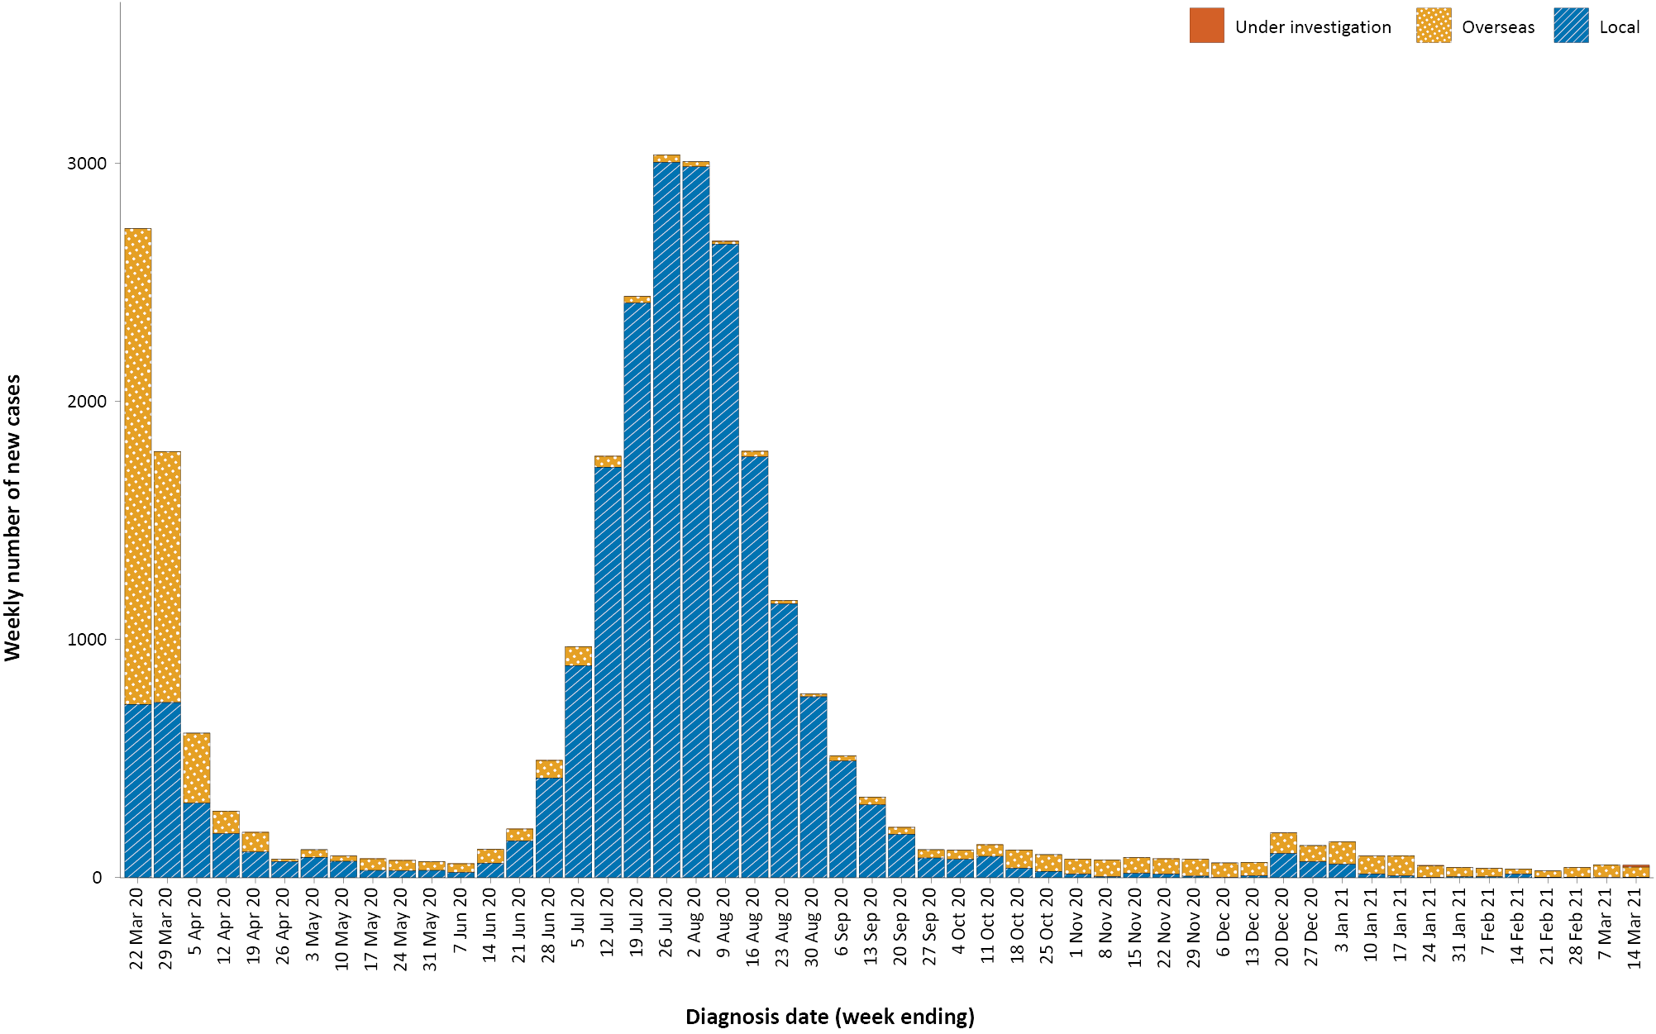
a Source: NNDSS, extracted 16 March 2021.

Table 1: COVID-19 notifications by jurisdiction and source of acquisition, Australia, 1–14 March 2021ª
Source | NSW | Vic. | Qld^{b} | WA | SA^{b} | Tas. | NT | ACT | Australia
Overseas | 40 | 2 | 32 | 7 | 12 | 0 | 0 | 5 | 98
Local (subtotal) | 1^{c} | 0 | 1 | 0 | 0 | 0 | 0 | 0 | 2
source known | 0 | 0 | 1 | 0 | 0 | 0 | 0 | 0 | 1
source unknown | 0 | 0 | 0 | 0 | 0 | 0 | 0 | 0 | 0
interstate, source known | 0 | 0 | 0 | 0 | 0 | 0 | 0 | 0 | 0
interstate, source unknown | 0 | 0 | 0 | 0 | 0 | 0 | 0 | 0 | 0
investigation ongoing | 1 | 0 | 0 | 0 | 0 | 0 | 0 | 0 | 1
Under initial investigation | 0 | 0 | 5 | 0 | 1 | 0 | 0 | 0 | 6
Total | 41 | 2 | 38 | 7 | 13 | 0 | 0 | 5 | 106
a Source: NNDSS, using diagnosis date, extracted on 16 March 2021.
b Overseas-acquired infections from Queensland and South Australia were classified as under initial investigation at the time of reporting.
c At the time of reporting, a locally-acquired case from New South Wales was under ongoing investigation as to the source.

Source of acquisition

(NNDSS)
In this reporting period, the majority of cases were reported as overseas acquired (92%; 98/106). There were two cases reported as locally acquired this fortnight, a decrease from the previous reporting period. At the end of this reporting period, six cases were classified as under initial investigation (Table 1).
Cumulatively, the infection rate for all locally-acquired cases is highest in Victoria with 290 infections per 100,000 population (Table 2). The rate of infection in Tasmania is 28 infections per 100,000 population, largely as a result of an outbreak in North West Tasmanian hospitals in April 2020, which represented half of all their cases. Nationally, it has been 58 days since there was a locally-acquired case of unknown source (Table 3).

Table 2: Locally-acquired COVID-19 case numbers and rates per 100,000 population by jurisdiction and reporting period, Australia, 15 February to 14 March 2021ª
Jurisdiction | Reporting period  15–28 February 2021 | Reporting period  1–14 March 2021 | Cumulative cases  23 January 2020 – 14 March 2021
 | Number of cases | Number of cases | Number of cases | Rate per 100,000 population^{b}
NSW | 0 | 1 | 2,177 | 26.7
Vic. | 4 | 0 | 19,410 | 290.0
Qld | 0 | 1 | 303 | 5.9
WA | 0 | 0 | 99 | 3.8
SA | 0 | 0 | 186 | 10.5
Tas. | 0 | 0 | 149 | 27.5
NT | 0 | 0 | 4 | 1.6
ACT | 0 | 0 | 29 | 6.7
Australia | 4 | 2 | 22,357 | 87.0
a Source: NNDSS, using diagnosis date, extracted on 16 March 2021.
b Population data based on Australian Bureau of Statistics (ABS) Estimated Resident Population (ERP) as at June 2020. Note that small discrepancies in rates between previous reports and this one will be due to the updated reference population (previous reports used ABS ERP December 2019).
Table 3: Days since last locally-acquired COVID-19 case (source known and source unknown), by jurisdiction, reported by notification received date, 14 March 2021^{a,b}
Jurisdiction | Locally acquired — source unknown |  | Locally acquired — source known
 | Date of last case | Days since last case | Date of last case | Days since last case
NSW | 15 January 2021 | 58 | 13 March 2021 | 1
Vic. | 5 January 2021 | 68 | 25 February 2021 | 17
Qld | 26 August 2020 | 200 | 12 March 2021 | 2
WA | 12 April 2020 | 336 | 1 February 2021 | 41
SA | 15 April 2020 | 333 | 29 November 2020 | 105
Tas. | 11 August 2020 | 215 | 6 May 2020 | 312
NT^{c} | NA | NA | 4 April 2020 | 344
ACT | 28 March 2020 | 351 | 9 July 2020 | 248
a Source: NNDSS, using notification received date, extracted on 16 March 2021.
b Apparent mismatches between case numbers per reporting fortnight in Table 2 and dates of most recent cases in Table 3 can arise through the use of diagnosis dates for Table 2 versus notification received dates in Table 3.
c The Northern Territory has not reported any locally-acquired cases with an unknown source of infection.
In this reporting period, the largest number of overseas-acquired cases was reported in New South Wales (41%; 40/98), followed by Queensland (33%; 32/98). The higher number of overseas-acquired cases reported in New South Wales reflects the number of managed international arrivals there. The increase in overseas-acquired cases in Queensland is likely related to returning travellers from Papua New Guinea, a country that is experiencing an outbreak of cases at the moment.

Demographic features

(NNDSS)
In this reporting period, the largest number of cases occurred in those aged 30 to 39 years (24/106 cases). For all notifications to date, the highest rate of infection is in those aged 90 and over with a rate of 386.8 per 100,000 population (Appendix A, Table A.1). Children under 10 years old have the lowest rate of infection (46.7 cases per 100,000 population).
Cumulatively, the male-to-female rate ratio of cases is approximately 1:1 in most age groups. Notification rates are higher among females than among males in the 20–29 years age group and those aged ≥ 80 years old, and higher among males than among females in the 70–79 years age group (Figure 2). The largest difference in cumulative rates is in the 90 years and over age group, where the cumulative rate among males is 335.2 cases per 100,000 population and among females 412.6 cases per 100,000 population (Appendix A, Table A.1).
Figure 2: Cumulative COVID-19 cases, by age group and sex, Australia, 23 January 2020 to 14 March 2021ª
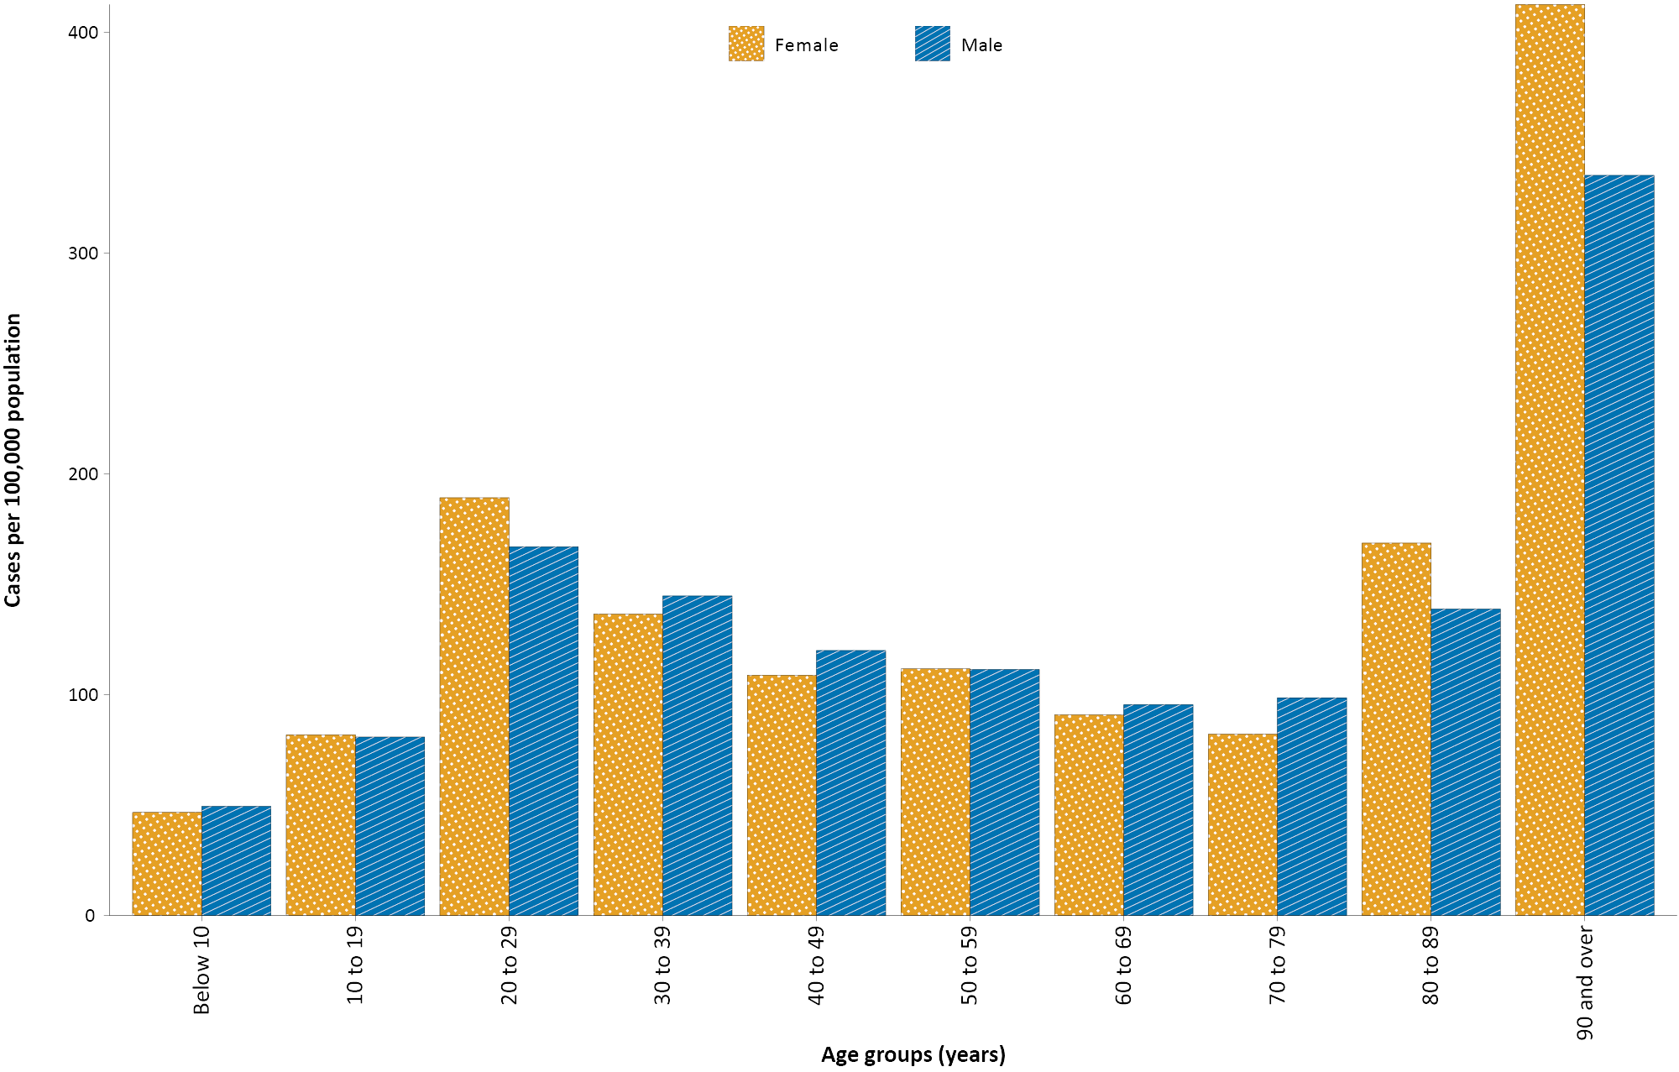
a Source: NNDSS, extracted on 16 March 2021.
Since the beginning of the epidemic in Australia, the median age of all cases is 37 years (interquartile range, IQR: 25–56), which has not changed since the beginning of August. Prior to 1 June 2020, COVID-19 cases were slightly older, with a median age of 46 years (IQR: 29–62), associated with a high proportion of cases having a recent travel history or acquisition on a cruise ship. In cases reported after 1 June 2020, the median age is 34 years (IQR: 23–53), reflecting transmission in the community and across a range of settings, especially in Victoria. The median age of cases in this reporting period was 34 years (IQR: 27–48).

Aboriginal and Torres Strait Islander persons

(NNDSS)
There have been 150 confirmed cases of COVID-19 notified in Aboriginal and Torres Strait Islander people since the beginning of the epidemic. Overall, Aboriginal and Torres Strait Islander people represented approximately 0.5% (150/28,901) of all confirmed cases. Table 4 compares the remoteness of cases in Aboriginal and Torres Strait Islander people with those in the non-Indigenous population.
Table 4: COVID-19 notifications by Aboriginal and Torres Strait Islander status by jurisdiction, source of acquisition and remoteness classification, Australia, 14 March 2021ª
 | Locally acquired |  |  |  | Interstate acquired | Overseas acquired | Unknown^{b} | Total
 | Major cities of Australia | Inner regional Australia | Outer regional Australia | Remote / very remote Australia
Aboriginal and  Torres Strait Islander | 91 | 15 | 6 | 1 | 2 | 34 | 1 | 150
Non-Indigenous | 20,706 | 921 | 221 | 16 | 125 | 6,682 | 230 | 28,901
a Source: NNDSS, extracted on 16 March 2021.
b Includes 26 non-Indigenous cases classified as overseas residents who were diagnosed in Australia.
The median age of COVID-19 cases in Aboriginal and Torres Strait Islander people is 31 years old (IQR: 21–50), which is younger than for non-Indigenous cases where the median age is 37 years old (IQR: 25–56).
The notification rate across all age groups remains higher in non-Indigenous people than in Aboriginal and Torres Strait Islander people (Figure 3). The age-standardised Aboriginal and Torres Strait Islander:non-Indigenous notification rate ratio is 0.2, indicating that the Aboriginal and Torres Strait Islander population has a lower COVID-19 case rate than the non-Indigenous population after accounting for differences in age structure. Amongst Aboriginal and Torres Strait Islander cases, the highest notification rate is in those aged 70–79 years (36.0 cases per 100,000 population), followed by the 60–69 years age group (34.4 cases per 100,000 population). Similar to non-Indigenous cases, children aged 0–9 years have the lowest notification rate among Aboriginal and Torres Strait Islander cases (6.9 cases per 100,000 population).

Figure 3: National COVID-19 notification rate per 100,000 population by age group, Aboriginal and Torres Strait Islander people and non-Indigenous people, Australia, 23 January 2020 – 14 March 2021ª
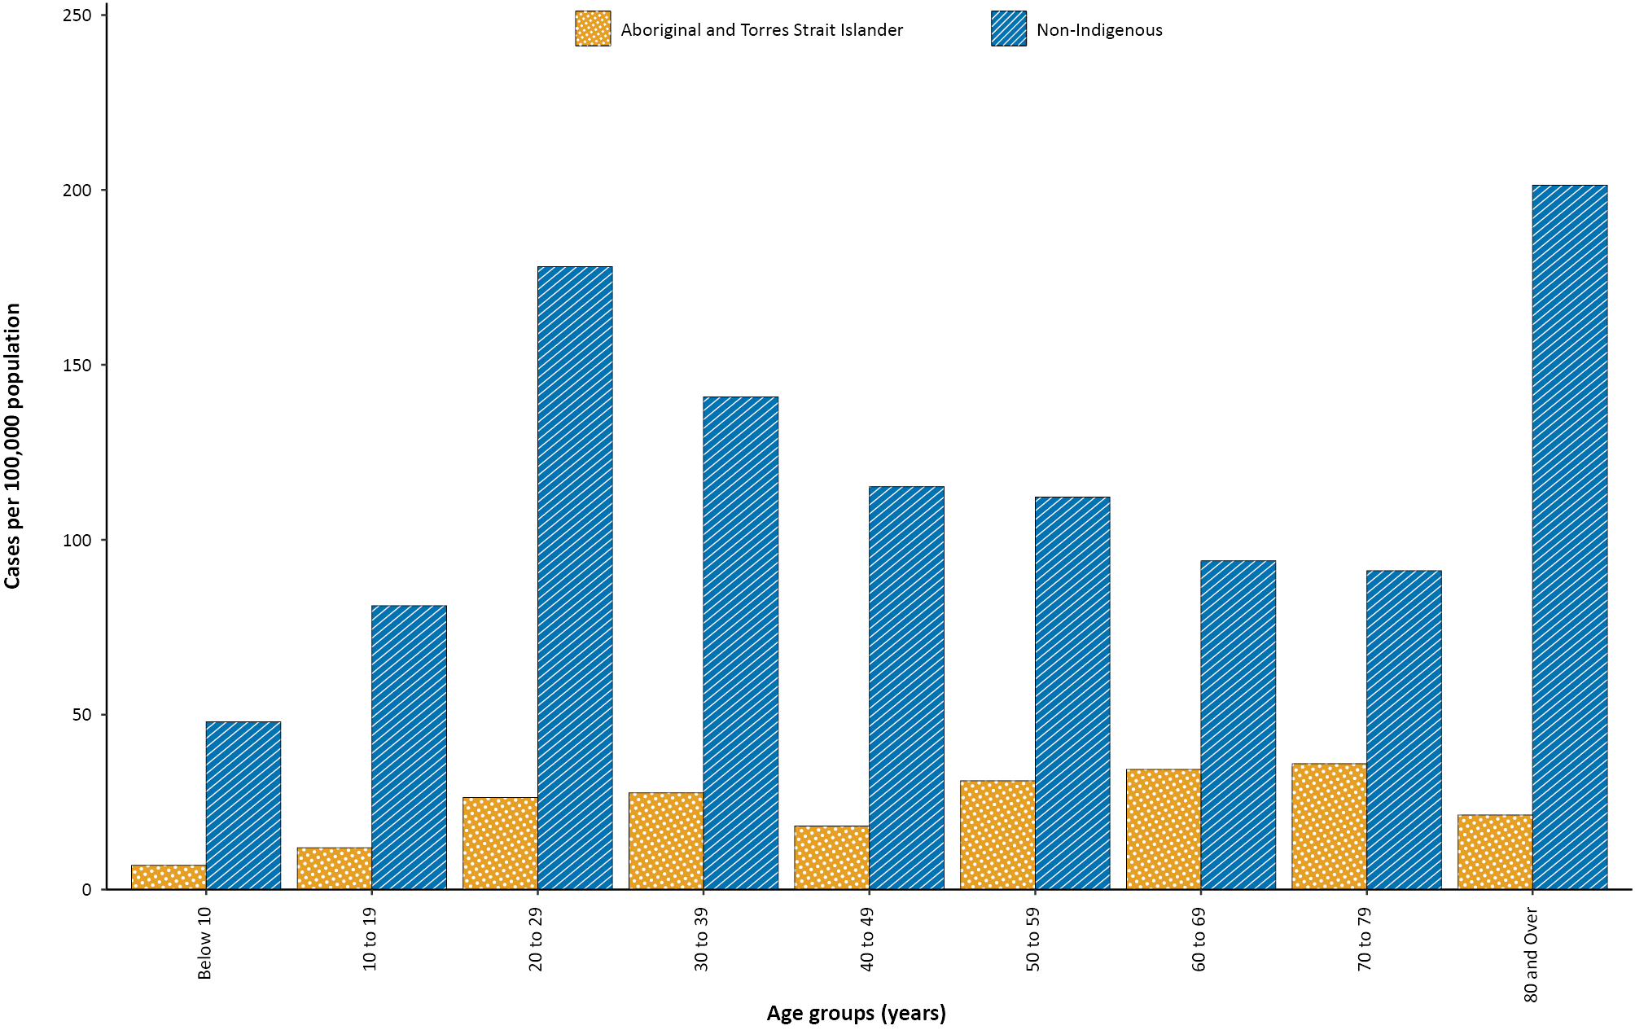
a Source: NNDSS, extracted on 16 March 2021.

Testing

(State and territory reporting)
As at 14 March 2021, a cumulative total of 14,933,604 tests have been conducted in Australia. The cumulative nationwide proportion of positive tests remains low at 0.2%. With the exception of Victoria, the cumulative testing positivity in individual jurisdictions is < 0.2%.
Testing rates decreased in all age groups over the two-week period ending 14 March 2021 (Figure 4). Testing rates were highest in major cities and urban areas of Australia; lower testing rates, with little variation between classification areas, were seen across regional and remote areas across Australia.

Figure 4: SARS-CoV-2 polymerase chain reaction (PCR) testing rates per 1,000 population per week by age group, Australia, 1 May 2020 – 12 March 2021^{a,b}
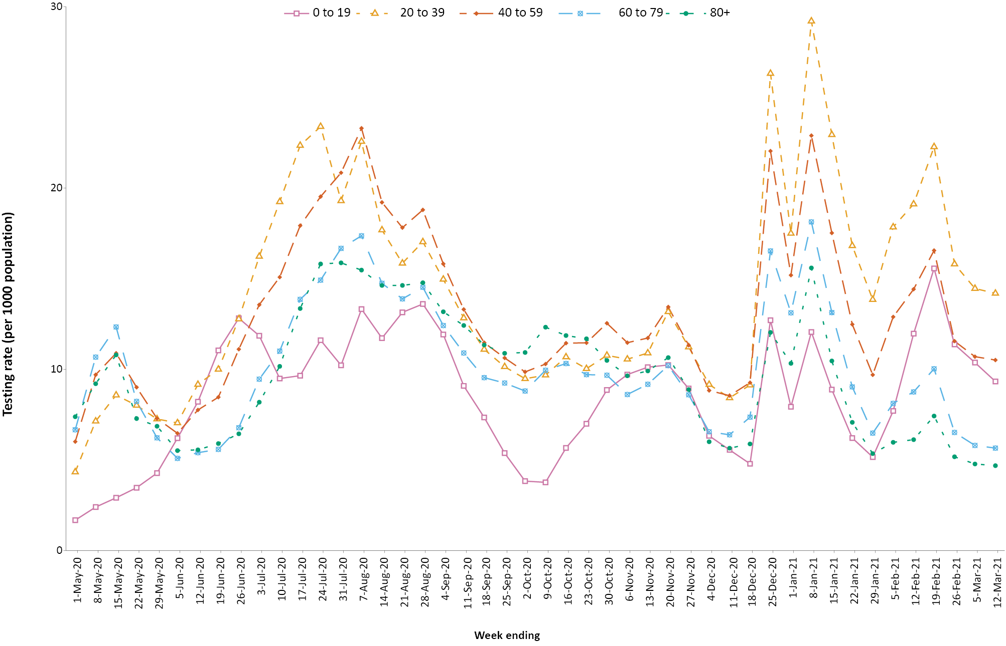
a Source: Jurisdictional reporting to the NIR.
b The jurisdictions reporting each week (i.e. the denominator population) may vary.

Vaccinations

(Department of Health)
As of 14 March 2021, 164,437 Australians have received a COVID-19 vaccine (Table 5), including 39,760 aged care and disability residents.

Table 5: Total number of people vaccinated, by jurisdiction, Australia, 14 March 2021ª
Jurisdiction | Total number of people vaccinated
NSW | 37,553
Vic. | 31,808
Qld | 18,705
WA | 18,892
SA | 6,984
Tas. | 3,853
NT | 3,519
ACT | 3,363
Commonwealth^{b} | 39,760
Total | 164,437
a Source: Australian Government Department of Health website (https://www.health.gov.au/initiatives-and-programs/covid-19-vaccines/getting-vaccinated-for-covid-19#australias-vaccine-rollout).
b Aged care and residential disability.

Acknowledgements
We thank public health staff from incident emergency operations centres and public health units in state and territory health departments, and the Australian Government Department of Health, along with state and territory public health laboratories. We thank those who have provided data from surveillance systems, such as Commonwealth respiratory clinics, Flutracking, and FluCAN.

Author details

Corresponding author
COVID-19 National Incident Room Surveillance Team
Australian Government Department of Health, GPO Box 9484, MDP 14, Canberra, ACT 2601.
Email: epi.coronavirus@health.gov.au

References
- COVID-19 National Incident Room Surveillance Team. COVID-19 Australia: Epidemiology Report 36: Fortnightly reporting period ending 28 February 2021. Commun Dis Intell (2018). 2021;45. doi: https://doi.org/10.33321/cdi.2021.45.14.
- COVID-19 National Incident Room Surveillance Team. Technical supplement: COVID-19 Australia: epidemiology reporting. Commun Dis Intell (2018). 2021;45. doi: https://doi.org/10.33321/cdi.2021.45.2.

Appendix A: Supplementary figures and tables
Table A.1: COVID-19 case notifications and rates per 100,000 population, by age group and sex, Australia, 14 March 2021ª
Age group | This reporting period  1–14 March 2021 |  |  |  |  |  | Cumulative  23 January 2020 – 14 March 2021
 | Cases |  |  | Rate per 100,000 population |  |  | Cases |  |  | Rate per 100,000 population
 | Male | Female | People | Male | Female | People | Male | Female | People | Male | Female | People
0 to 9 | 6 | 4 | 10 | 0.4 | 0.3 | 0.3 | 809 | 721 | 1,533 | 49.4 | 46.7 | 48.1
10 to 19 | 5 | 4 | 9 | 0.3 | 0.3 | 0.3 | 1,269 | 1,215 | 2,484 | 80.8 | 81.8 | 81.3
20 to 29 | 6 | 12 | 18 | 0.3 | 0.7 | 0.5 | 3,102 | 3,407 | 6,530 | 167.0 | 189.2 | 178.5
30 to 39 | 14 | 10 | 24 | 0.8 | 0.5 | 0.7 | 2,632 | 2,533 | 5,180 | 144.7 | 136.5 | 141.0
40 to 49 | 15 | 7 | 22 | 0.9 | 0.4 | 0.7 | 1,943 | 1,802 | 3,773 | 120.0 | 108.8 | 115.2
50 to 59 | 11 | 3 | 14 | 0.7 | 0.2 | 0.5 | 1,680 | 1,756 | 3,443 | 111.4 | 111.7 | 111.8
60 to 69 | 7 | 0 | 7 | 0.6 | 0.0 | 0.3 | 1,214 | 1,221 | 2,437 | 95.5 | 90.9 | 93.2
70 to 79 | 1 | 0 | 1 | 0.1 | 0.0 | 0.1 | 858 | 757 | 1,615 | 98.6 | 82.1 | 90.1
80 to 89 | 1 | 0 | 1 | 0.3 | 0.0 | 0.1 | 496 | 778 | 1,274 | 138.8 | 168.7 | 155.6
90 and over | 0 | 0 | 0 | 0.0 | 0.0 | 0.0 | 230 | 551 | 782 | 335.2 | 412.6 | 386.8
a Source: NNDSS, extracted on 14 March 2021.

Communicable Diseases Intelligence
ISSN: 2209-6051 Online

Communicable Diseases Intelligence (CDI) is a peer-reviewed scientific journal published by the Office of Health Protection and Response, Department of Health. The journal aims to disseminate information on the epidemiology, surveillance, prevention and control of communicable diseases of relevance to Australia.

Editor: Jennie Hood
Deputy Editor: Simon Petrie
Design and Production: Kasra Yousefi
Editorial Advisory Board: David Durrheim, Mark Ferson, John Kaldor, Martyn Kirk and Linda Selvey

Website: http://www.health.gov.au/cdi

Contacts
CDI is produced by Environmental Health and Health Protection Policy Branch, Office of Health Protection and Response, Australian Government Department of Health, GPO Box 9848, (MDP 6) CANBERRA ACT 2601

Email: cdi.editor@health.gov.au

Submit an Article
You are invited to submit your next communicable disease related article to the Communicable Diseases Intelligence (CDI) for consideration. More information regarding CDI can be found at: http://health.gov.au/cdi.
Further enquiries should be directed to: cdi.editor@health.gov.au.

This journal is indexed by Index Medicus and Medline.

Creative Commons Licence - Attribution-NonCommercial-NoDerivatives CC BY-NC-ND
© 2021 Commonwealth of Australia as represented by the Department of Health
This publication is licensed under a Creative Commons Attribution-NonCommercial-NoDerivatives 4.0 International Licence from https://creativecommons.org/licenses/by-nc-nd/4.0/legalcode (Licence). You must read and understand the Licence before using any material from this publication.

Restrictions
The Licence does not cover, and there is no permission given for, use of any of the following material found in this publication (if any):
- the Commonwealth Coat of Arms (by way of information, the terms under which the Coat of Arms may be used can be found at www.itsanhonour.gov.au);
- any logos (including the Department of Health’s logo) and trademarks;
- any photographs and images;
- any signatures; and
- any material belonging to third parties.

Disclaimer
Opinions expressed in Communicable Diseases Intelligence are those of the authors and not necessarily those of the Australian Government Department of Health or the Communicable Diseases Network Australia. Data may be subject to revision.

Enquiries
Enquiries regarding any other use of this publication should be addressed to the Communication Branch, Department of Health, GPO Box 9848, Canberra ACT 2601, or via e-mail to: copyright@health.gov.au

Communicable Diseases Network Australia
Communicable Diseases Intelligence contributes to the work of the Communicable Diseases Network Australia.
http://www.health.gov.au/cdna

https://www.health.gov.au/news/health-alerts/novel-coronavirus-2019-ncov-health-alert#local-outbreak-information.
https://www.who.int/emergencies/diseases/novel-coronavirus-2019/situation-reports/.
https://www.health.gov.au/news/health-alerts/novel-coronavirus-2019-ncov-health-alert/coronavirus-covid-19-current-situation-and-case-numbers.

