COVID-19 Australia: Epidemiology Report 36
Reporting period ending 28 February 2021
COVID-19 National Incident Room Surveillance Team

Summary
Two-week reporting period:
Trends – The number of COVID-19 cases reported in Australia remains low. The daily average number of cases for this reporting period was five, the same as the previous fortnight. There were 64 cases of COVID-19 and no deaths this fortnight, bringing the cumulative case count to 28,937 with 909 deaths.
Local cases – There were four locally-acquired cases reported in Australia this fortnight, all linked to a cluster of cases in hotel quarantine in Victoria. This is a decrease on the previous fortnight.
Overseas cases – There were 56 overseas-acquired cases this reporting period. Of these, more than half (35/56) were from New South Wales, with the remainder dispersed across all jurisdictions.
Testing – Testing rates increased slightly by 3% compared to the previous fortnight. The cumulative positivity rate remains low at 0.2%.
Vaccinations – Australia began its COVID-19 vaccination program during this reporting period. As at 28 February, 33,702 Australians had received one dose of the Pfizer vaccine.
Four-week reporting period:
Virology – Nationally, SARS-CoV-2 strains from 58% of COVID-19 cases have been sequenced during the pandemic. During the first two months of 2021, there has been an increase in the number of cases infected with SARS-CoV-2 variants of concern (VOC) in Australia. AusTrakka is actively monitoring and reporting on these variants, including: B.1.1.7 (a.k.a. VOC-202012/01 or 20I/501Y.V1); B.1.351 (a.k.a. VOC-202012/02 or 20H/501Y.V2); and P.1 (a.k.a. VOC-202101/02 or 20J/501Y.V3).
Severity – For all cases since the beginning of the pandemic, 14% have been admitted to hospital. According to sentinel surveillance data, 19% of hospitalised patients were admitted to the intensive care unit. Australia’s case fatality rate has remained stable at 3.1%, with no COVID-19 related deaths occurring in the past four weeks.
Hospital occupancy – The average daily number of COVID-19 cases in hospital across Australia for the reporting period was 12, a decrease compared to the daily average from the previous reporting period of 32.
Public health measures – During the current reporting period, there were short-term higher level restriction periods in Western Australia and Victoria in response to cases found to be infected with SARS-CoV-2 variants of concern.
International situation – Cumulative global COVID-19 cases and deaths now exceed 113 million and 2.5 million respectively. A number of countries continued to report high numbers of cases and deaths, with some reporting over 500,000 new cases and 10,000 COVID-19 deaths in the past four weeks.
This reporting period covers the last two weeks (15–28 February 2021). The previous reporting period is the preceding two weeks (1–14 February 2021). As Australia continues to experience low numbers of COVID-19 cases, this report has transitioned to a brief update on case numbers each fortnight and a more detailed analysis every four weeks. Acute respiratory illness, severity, clusters and outbreaks, public health response measures, virology and the international situation are reported in detail on a four-weekly basis and are included in this report. The reporting period for these topics covers 1–28 February 2021. For comparability, the previous reporting period is the preceding four weeks (4–31 January 2021).
Keywords: SARS-CoV-2; novel coronavirus; 2019-nCoV; coronavirus disease 2019; COVID-19; acute respiratory disease; epidemiology; Australia

In focus:

Genomics surveillance and virology

Communicable Disease Genomics Network, AusTrakka and jurisdictional sequencing laboratories
Genomic surveillance of SARS-CoV-2 is a significant component of Australia’s response to COVID-19 and is established as part of the national approach to surveillance. This is being facilitated by the recently-endorsed National Microbial Genomics Implementation Plan,¹ operationalised through the Communicable Diseases Genomics Network (CDGN), an expert reference panel of the national Public Health Laboratory Network (PHLN) and linked to the Communicable Diseases Network Australia (CDNA).
A key feature of this genomic surveillance is AusTrakka,² a national platform for real-time analysis of integrated pathogen genomic data for public health across Australia. The AusTrakka platform provides a central, secure and private online location to share, store, analyse and view aggregated national and jurisdictional data. Public health laboratories in every state and territory have been routinely uploading their SARS-CoV-2 sequences to AusTrakka and GISAID (the global initiative on sharing avian influenza data), allowing for efficient national and international information sharing and rapid identification of multi-jurisdictional outbreaks and ongoing national genomic surveillance of cases and variants of concern (VOC).
This section aims to assist with the understanding of public health genomics relating to COVID-19 and variants of concern in Australia by detailing:
- how representative the current Australian SARS-CoV-2 sequences are;
- the genetic lineages (see Technical Supplement)³ of SARS-CoV-2 in Australia; and
- the public health impacts of pathogen sequencing on the COVID-19 response.
The information presented here was provided by the National Analysis Team of AusTrakka and from jurisdictional pathogen sequencing laboratories to summarise the genomic epidemiology of SARS-CoV-2 in Australia. Numbers are subject to change retrospectively and sequences are not able to be obtained from all samples for a range of reasons. Samples with low viral loads, such as those collected from cases late in their disease episode (common in returned travellers), are less likely to be successfully sequenced (see Technical Supplement for more information).³

How representative are current Australian SARS-CoV-2 sequences?
Nationally, SARS-CoV-2 strains from 58% of COVID-19 cases have been sequenced over the duration of the pandemic, based on jurisdictional reporting (Table 1). Australia’s strategy of attempting to sequence all cases of COVID-19 has resulted in one of the highest proportion of cases sequenced across the world. A high proportion of SARS-CoV-2 cases being sequenced increases the confidence around identifying the infection source based on viral genomics.
Table 1: Australian SARS-CoV-2 genome sequences and proportion of positive cases sequenced,^{a,b} 1–28 February 2021 and cumulative to date
Measure | Reporting period  1–28 February 2021 | Cumulative 23 January 2020 – 28 February 2021
SARS-CoV-2 cases sequenced^{c} | 68 | 16,820
Percentage of positive cases sequenced | 41% | 58%
a Sequencing has been attempted on all suitable available samples (one sample per case). Sequencing of samples from cases identified in the reporting period may be in process at the time of reporting. Remaining unsequenced samples have been deemed unsuitable for sequencing (typically because viral loads were too low for sequencing to be successful).
b Cumulative sequence numbers have decreased from the previous report due to data review and cleaning.
c Based on individual jurisdictional reports of sequences and case numbers. Calculations of the percentage of cases sequenced based on the number of sequences available in AusTrakka may not always be up-to-date, since this may include duplicate samples from cases and may not represent all available sequence data.

What genetic lineages of SARS-CoV-2 are being detected in Australia?
The SARS-CoV-2 lineage nomenclature is hierarchically organised following a phylogenetic tree structure.⁴ It describes major lineages with letters of the alphabet (A, B, etc.), and then sub-lineages using numbers separated by period symbols (“.”). During the past 24-week period (14 September 2020 – 28 February 2021), there were 121 genomic lineages represented in AusTrakka, with changes in lineage composition over time shown in Figure 1. Over the four weeks between 1 February and 28 February 2021, the most common lineage was B.1.1.7, a variant of concern (VOC) further described below, and mainly associated with overseas travellers in quarantine and a local outbreak in Victoria. More information on lineages and variants is available in the Technical Supplement.³

Figure 1: SARS-CoV-2 viral sequence lineages reported to AusTrakka, Australia, 14 September 2020 to 28 February 2021ª
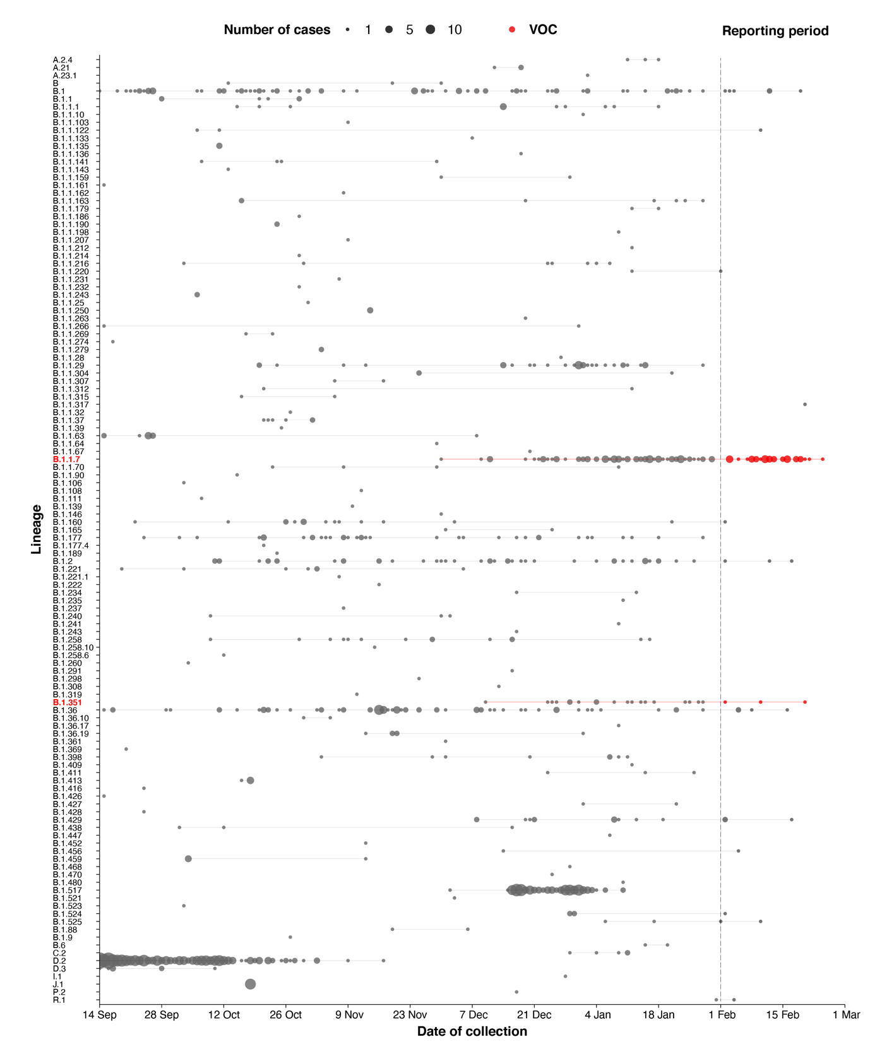
a Interpretation: The start of the current reporting period (1 February to 28 February 2021) is marked by the dotted line, and variant of concern samples are coloured red. The size of the circle is proportional to the number of samples in the lineage at each time point.

Variants of concern
During the first two months of 2021 there was an increase in the number of VOC observed in cases in Australia. AusTrakka actively monitored and reported on three variants: B.1.1.7 (aka VOC-202012/01 or 20I/501Y.V1); B.1.351 (aka VOC-202012/02 or 20H/501Y.V2); and P.1 (aka VOC-202101/02 or 20J/501Y.V3). All three variants display an unusually high number of mutations,^{5–7} including a number of variations in the genomic region encoding the spike protein thought to have the potential to increase transmissibility.^{8,9}

B.1.1.7 (VOC-202012/01)
The B.1.1.7 lineage is characterised by 17 mutations, including spike protein mutations N501Y and P681H, and a 2 amino acid deletion of residues 69,70 (IHV68I).⁷ The strain first emerged in the United Kingdom in September 2020, where it has become dominant and has displaced other strains. The B.1.1.7 strain has now been detected in more than 90 countries worldwide.

B.1.351 (501Y.V2)
The B.1.351 lineage is characterised by nine characteristic mutations, including spike protein mutations K417T, E484K and N501Y.⁵ In addition to potentially increased transmissibility there is concern that the E484K mutation may affect antibody-mediated neutralisation of the virus.¹⁰ The B.1.351 strain was first detected in South Africa in October 2020 and has since been documented in more than 40 countries, including becoming the dominant variant in Zambia.

P.1 (501Y.V3)
The most recently emerging VOC is P.1, a sub-cluster within lineage B.1.1.28 that is characterised by 17 mutations, including the same spike protein mutations K417T, E484K and N501Y as B.1.351.¹¹ The B.1.1.28 lineage was common to Brazil, but in December 2020 reports emerged from Brazil's Amazonas region of a surge in cases associated with the P.1 lineage.⁶ In late December the P.1 variant was reported in four COVID-19 cases in Japan detected during airport screening and has now been seen in more than 20 countries. At the time of reporting, there were no cases with the P.1 lineage in AusTrakka.

What are the public health impacts of SARS-CoV-2 genomic epidemiology?
Notable recent examples of the importance of SARS-CoV-2 genomics in informing jurisdictional public health responses include:
- Identifying and monitoring VOC through genomic surveillance in returned travellers, thus enabling public health teams to implement precautionary measures to minimise risk of onwards transmission of these strains;
- Providing information to support the determination of whether prolonged PCR positive results are likely due to continued shedding of the virus, or re-infection;
- Allowing assessment by public health and clinical panels of difficult cases within jurisdictions, related to clinically confusing or uncertain molecular and serological test results;
- Assisting with quarantine hotel investigation;
- Identifying potential inflight transmission of non-related cases to support a public health investigation; and
- Providing evidence on the elimination of clusters of local transmission.

Two-week reporting period (15–28 February 2021):

Background and data sources
See the Technical Supplement for information on coronavirus disease 19 (COVID-19) including modes of transmission, common symptoms and severity.³

Activity

COVID-19 trends

(NNDSS and jurisdictional reporting to NIR)
As at 28 February 2021, there were 28,937 COVID-19 cases including 909 deaths reported nationally, with two distinct peaks in March and July (Figure 2). In this reporting period, there were 64 cases and no deaths reported. On average, five cases were notified each day over this reporting period, similar to the previous reporting period. The largest number of cases diagnosed this fortnight was from New South Wales with more than half of all cases (58%; 37/64), followed by Queensland (16%; 10/64) (Table 2).
Figure 2: COVID-19 notified cases by source of acquisition and diagnosis date, Australia, week ending 28 February 2021ª
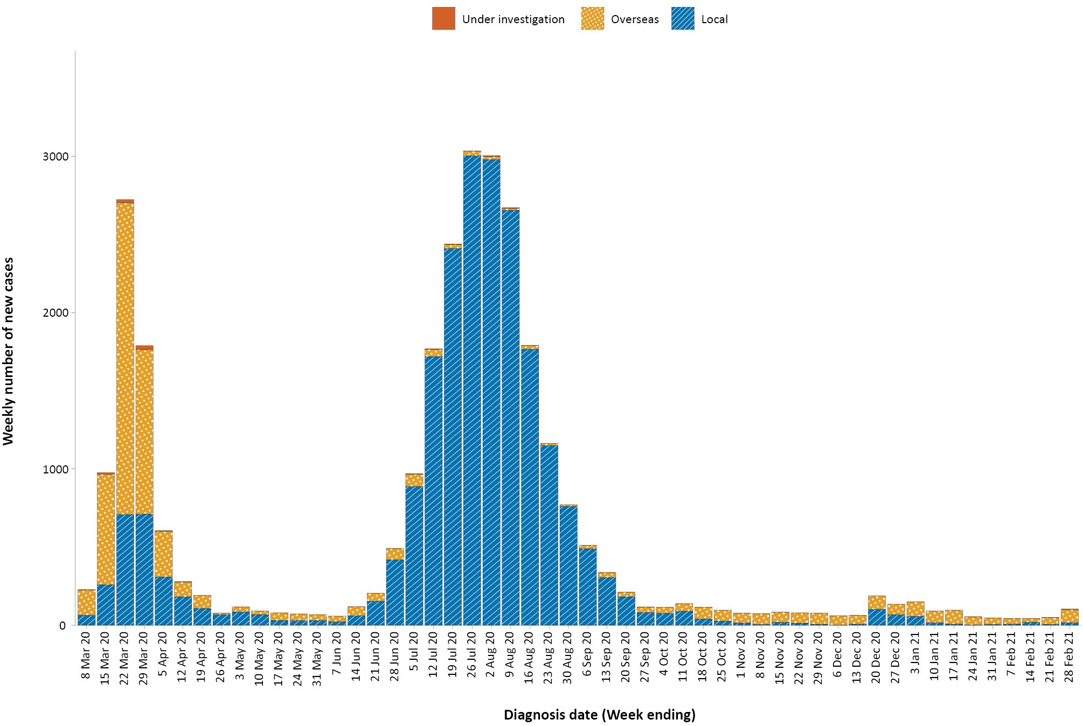
a Source: NNDSS.

Source of acquisition

(NNDSS)
In this reporting period, 88% (56/64) of cases were acquired overseas. There were four locally-acquired cases in Victoria, a decrease from 17 locally-acquired cases in the previous fortnight. At the end of this reporting period, there were four cases reported as under investigation (Table 2).
Table 2: COVID-19 notifications by jurisdiction and source of acquisition, Australia, 15–28 February 2021
Source | NSWª | Vic. | Qldª | WA | SA | Tas. | NT | ACT | Australia
Overseas | 35 | 1 | 8 | 3 | 7 | 0 | 2 | 0 | 56
Local — source known | 0 | 4 | 0 | 0 | 0 | 0 | 0 | 0 | 4
Local — source unknown | 0 | 0 | 0 | 0 | 0 | 0 | 0 | 0 | 0
Local — interstate | 0 | 0 | 0 | 0 | 0 | 0 | 0 | 0 | 0
Under investigation | 2 | 0 | 2 | 0 | 0 | 0 | 0 | 0 | 4
Total | 37 | 5 | 10 | 3 | 7 | 0 | 2 | 0 | 64
a Overseas-acquired infections from New South Wales and Queensland were classified as under investigation at the time of reporting.
Cumulatively, the infection rate to date for all locally-acquired cases was highest in Victoria with 294.4 infections per 100,000 population (Table 3). The rate of infection in Tasmania remained at 27.9 infections per 100,000 population, largely as a result of an outbreak in North West Tasmanian hospitals in April 2020, which represented half of all their cases. Nationally, it has been 44 days since there was a locally-acquired case of unknown source (Table 4).
Table 3: Locally-acquired COVID-19 case numbers and rates per 100,000 population by jurisdiction and reporting period, Australia, 28 February 2021
Jurisdiction | Reporting period  1–14 February 2021 | Reporting period  15–28 February 2021 | Cumulative cases  23 January 2020 – 28 February 2021
 | Number of cases | Number of cases | Number of cases | Rate per 100,000 population
NSW | 0 | 0 | 2,176 | 26.9
Vic. | 17 | 4 | 19,410 | 294.4
Qld | 0 | 0 | 302 | 5.9
WA | 0 | 0 | 99 | 3.8
SA | 0 | 0 | 185 | 10.6
Tas. | 0 | 0 | 149 | 27.9
NT | 0 | 0 | 4 | 1.6
ACT | 0 | 0 | 29 | 6.8
Australia | 17 | 4 | 22,354 | 88.2

Table 4: Days since last locally-acquired COVID-19 case (source known and source unknown), by jurisdiction, reported by notification received date, 28 February 2021ª
Jurisdiction | Locally acquired — source unknown |  | Locally acquired — source known
 | Date of last case | Days since last case | Date of last case | Days since last case
NSW | 15 January 2021 | 44 | 5 February 2021 | 23
Vic. | 5 January 2021 | 54 | 25 February 2021 | 3
Qld | 26 August 2020 | 186 | 12 January 2021 | 47
WA | 12 April 2020 | 322 | 1 February 2021 | 27
SA | 15 April 2020 | 319 | 29 November 2020 | 91
Tas. | 11 August 2020 | 201 | 6 May 2020 | 298
NT^{b} | NA | NA | 4 April 2020 | 330
ACT | 28 March 2020 | 337 | 9 July 2020 | 234
a Apparent mismatches between case numbers per reporting fortnight in Table 3 and dates of most recent cases in Table 4 can arise through the use of onset dates for Table 3 versus notification received dates in Table 4.
b The Northern Territory has not reported any locally-acquired cases with an unknown source of infection.
In this reporting period, the largest number of overseas-acquired cases was reported in New South Wales (63%; 35/56), followed by Queensland (14%; 8/56).
In this reporting period, the largest numbers of overseas-acquired cases with reported countries of acquisition were from India (13%; 7/56) followed by the United States of America (11%; 6/56). The number of cases by country is influenced by travel patterns of returning Australians as well as by the prevalence of COVID-19 in the country the person is arriving from.

Demographic features

(NNDSS)
In this reporting period, the largest number of cases occurred in those aged 30 to 39 years (25/64 cases). For all notifications to date, the highest rate of infection was in those aged 90 and over with a rate of 386.8 per 100,000 population (Appendix A, Table A.1). Children under 10 years old had the lowest rate of infection (47.7 cases per 100,000 population), despite comparable testing rates in this age group.
Cumulatively, the male-to-female rate ratio of cases was approximately 1:1 in most age groups. Notification rates were higher among females than among males in the 20–29 years age group and those aged ≥ 80 years old, and higher among males than among females in the 70–79 years age group (Figure 3). The largest difference in cumulative rates was in the 90 years and over age group, where the cumulative rate among males was 335.2 cases per 100,000 population and among females 412.6 cases per 100,000 population (Appendix A, Table A.1).

Figure 3: Cumulative COVID-19 cases, by age group and sex, Australia, 23 January 2020 to 28 February 2021
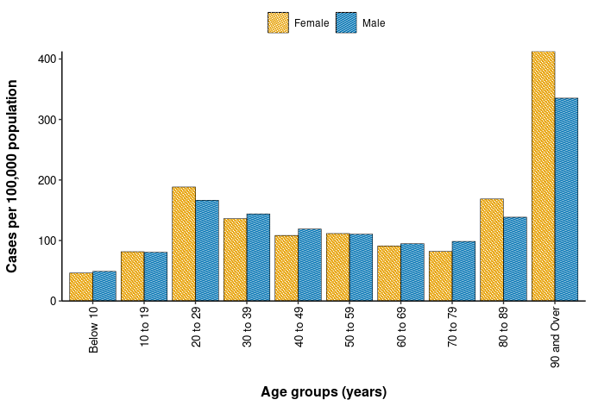
Since the beginning of the epidemic in Australia, the median age of all cases was 37 years (interquartile range, IQR: 25–56) which has not changed since the beginning of August. Prior to 1 June 2020, COVID-19 cases were slightly older, with a median age of 46 years (IQR: 29–62), associated with a high proportion of cases having a recent travel history or acquisition on a cruise ship. In cases reported after 1 June 2020, the median age was 34 years (IQR: 23–53) reflecting transmission in the community and across a range of settings, especially in Victoria. The median age of cases in this reporting period was 35 years (IQR: 30–43).

Aboriginal and Torres Strait Islander persons

(NNDSS)
There have been 150 confirmed cases of COVID-19 notified in Aboriginal and Torres Strait Islander people since the beginning of the epidemic. One new overseas-acquired Aboriginal and Torres Strait Islander case was notified in the reporting period. Overall, Aboriginal and Torres Strait Islander people represent approximately 0.5% (150/28,937) of all confirmed cases. Table 5 compares the remoteness of cases in Aboriginal and Torres Strait Islander people with those in the non-Indigenous population.

Table 5: COVID-19 notifications by Aboriginal and Torres Strait Islander status by jurisdiction, source of acquisition and remoteness classification, Australia, 23 January 2020 – 28 February 2021
 | Locally acquired |  |  |  | Interstate acquired | Overseas acquired | Unknownª | Total
 | Major Cities of Australia | Inner Regional Australia | Outer Regional Australia | Remote / Very Remote Australia
Aboriginal and  Torres Strait Islander | 91 | 16 | 6 | 1 | 1 | 34 | 1 | 150
non-Indigenous | 20,751 | 928 | 223 | 16 | 59 | 6,571 | 239 | 28,787
a Includes 26 non-Indigenous cases classified as overseas residents who were diagnosed in Australia.
The median age of COVID-19 cases in Aboriginal and Torres Strait Islander people was 31 years old (IQR: 21–50), which was younger than for non-Indigenous cases where the median age was 37 years old (IQR: 25–56).
The notification rate across all age groups was higher in non-Indigenous people than in Aboriginal and Torres Strait Islander people (Figure 4). The age-standardised Aboriginal and Torres Strait Islander:non-Indigenous notification rate ratio was 0.2, indicating that the Aboriginal and Torres Strait Islander population had a significantly lower COVID-19 case rate than the non-Indigenous population after accounting for differences in age structure. Amongst Aboriginal and Torres Strait Islander cases, the highest notification rate was in those aged 70–79 years (36.0 cases per 100,000 population), followed by the 60–69 years age group (34.4 cases per 100,000 population). Similar to non-Indigenous cases, children aged 0–9 years had the lowest notification rate among Aboriginal and Torres Strait Islander cases (6.9 cases per 100,000 population).

Figure 4: National COVID-19 notification rate per 100,000 population by age group, Aboriginal and Torres Strait Islander people and non-Indigenous people, Australia, 23 January 2020 – 28 February 2021
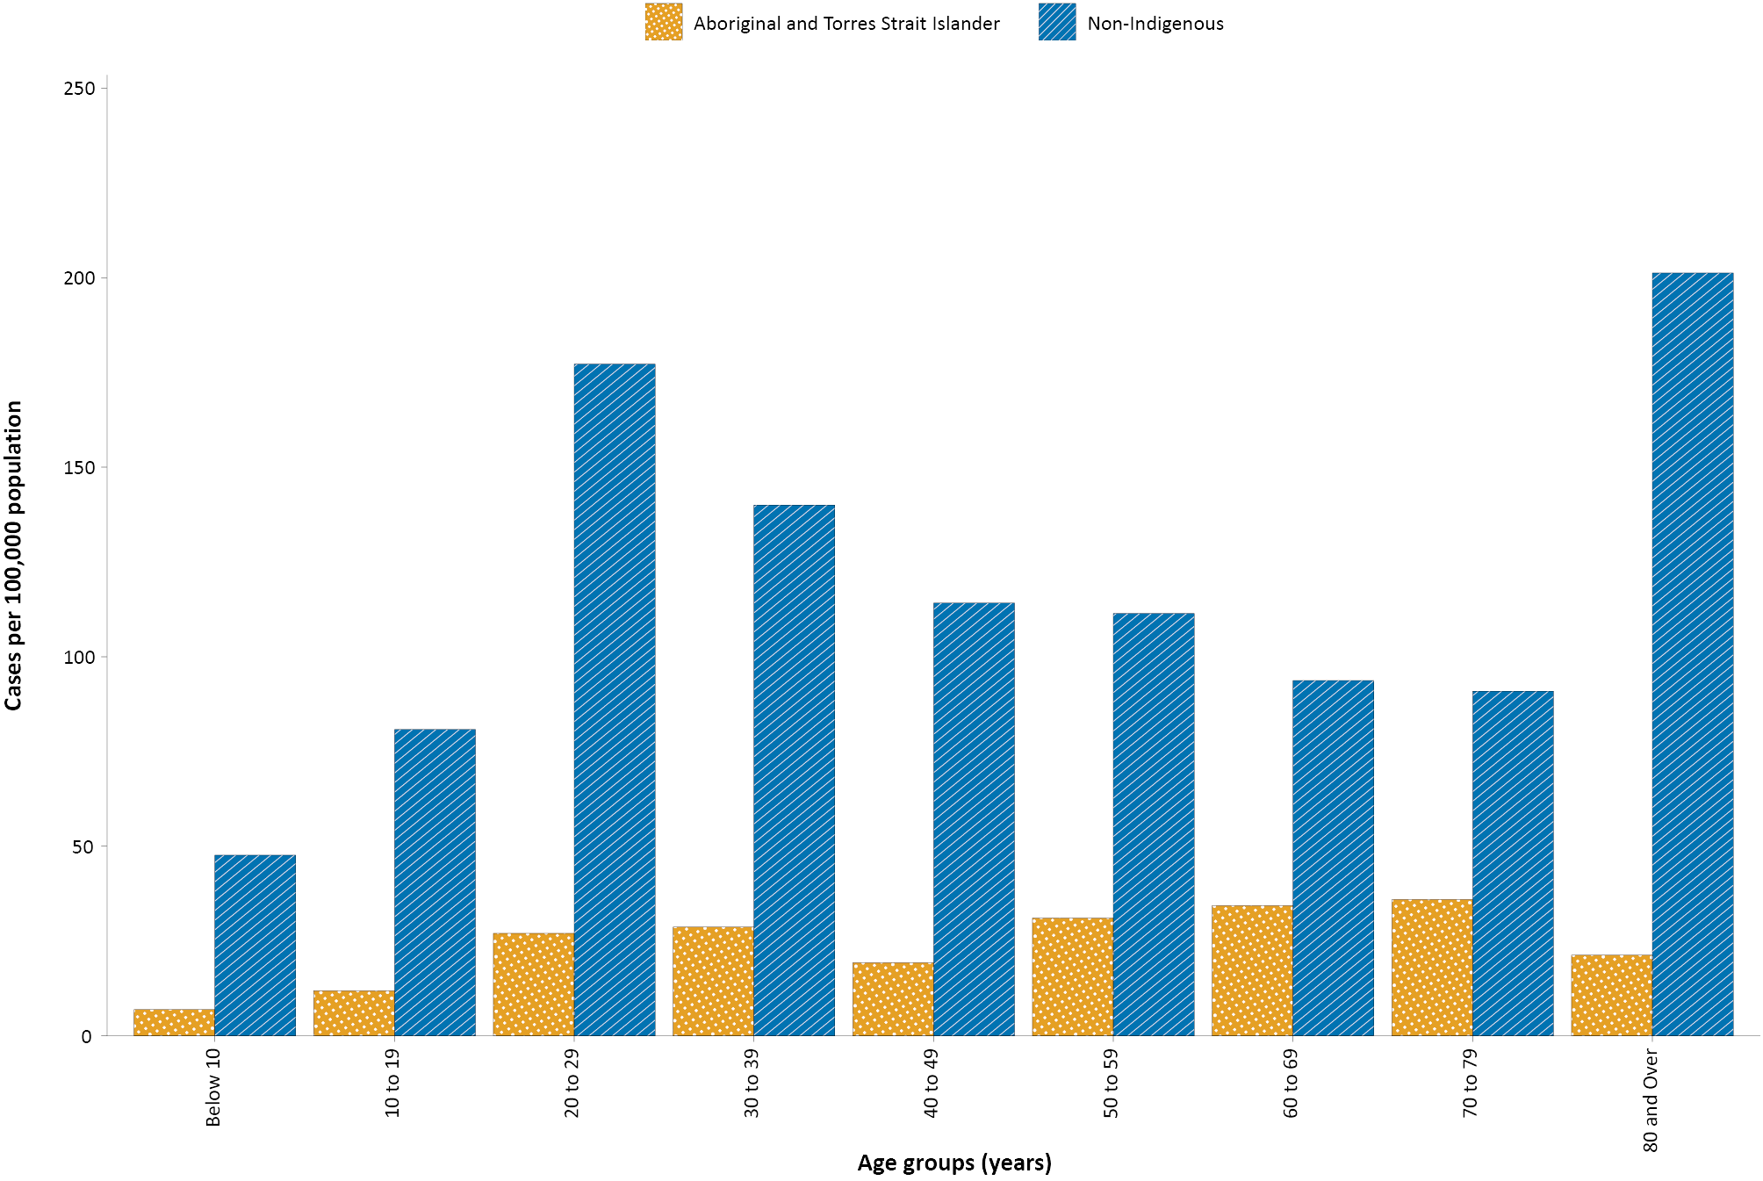

Testing

(State and territory reporting)
As at 28 February 2021, a cumulative total of 14,349,465 tests were conducted in Australia. The cumulative nationwide proportion of positive tests remained low at 0.2% (Table 6). With the exception of Victoria, the cumulative testing positivity in individual jurisdictions was < 0.2%.

Table 6: Diagnostic tests performed, by jurisdiction, Australia, 28 February 2021
Jurisdiction | Tests performed  1–14 February 2021 |  |  | Tests performed  15–28 February |  |  | Cumulative tests performed  to 28 February
 | n | Positivity (%) | Per 1,000 populationª | n | Positivity (%) | Per 1,000 populationª | n | Positivity (%) | Per 1,000 populationª
NSW | 164,862 | 0.02 | 20.4 | 216,960 | 0.02 | 26.8 | 5,011,674 | 0.10 | 619.8
Vic. | 236,997 | 0.01 | 35.9 | 266,306 | 0.00 | 40.4 | 4,960,442 | 0.41 | 752.3
Qld | 90,811 | 0.01 | 17.8 | 97,967 | 0.01 | 19.2 | 1,953,278 | 0.07 | 383.6
WA | 101,015 | 0.01 | 38.5 | 39,793 | 0.01 | 15.2 | 862,767 | 0.11 | 329.1
SA | 69,911 | 0.01 | 39.9 | 59,799 | 0.01 | 34.1 | 1,091,410 | 0.06 | 622.8
Tas. | 6,313 | 0.00 | 11.8 | 8,384 | 0.00 | 15.7 | 173,783 | 0.13 | 325.1
NT | 9,818 | 0.05 | 39.9 | 12,854 | 0.02 | 52.2 | 124,444 | 0.08 | 505.7
ACT | 7,404 | 0.00 | 17.4 | 8,495 | 0.00 | 19.9 | 171,667 | 0.07 | 402.8
Australia | 687,131 | 0.01 | 27.1 | 710,558 | 0.01 | 28.0 | 14,349,465 | 0.20 | 565.9
a Population data based on Australian Bureau of Statistics (ABS) Estimated Resident Population (ERP) as at 30 December 2019
During this reporting period, 710,558 tests were conducted nationally, with a positivity rate of 0.01%. This represented a 3% increase in tests conducted compared to the previous two-week reporting period; this increase was consistent across all jurisdictions except Western Australia and South Australia. The decrease in testing rates in Western Australia this reporting period coincides with easing of public health measures in the state. Jurisdictional testing rates are driven by both current case numbers and numbers of people experiencing symptoms. All states reported a positivity rate of < 0.1% in this reporting period. The low national positivity rate, along with high rates of testing, indicates a low prevalence of COVID-19 nationally.
For the two-week period ending 28 February 2021, testing rates decreased among all age groups after an increase in the first two weeks of February (Figure 5). Testing rates among children and young adults aged 0–19 years tended to be lower than those of other age groups, except in recent months, likely due to the return of students to school. Testing rates were highest in major cities and urban areas of Australia; lower testing rates, with little variation between classification areas, were seen across regional and remote areas across Australia.

Figure 5: SARS-CoV-2 polymerase chain reaction (PCR) testing rates per 1,000 population per week by age group, Australia, 1 May 2020 – 26 February 2021^{a,b}
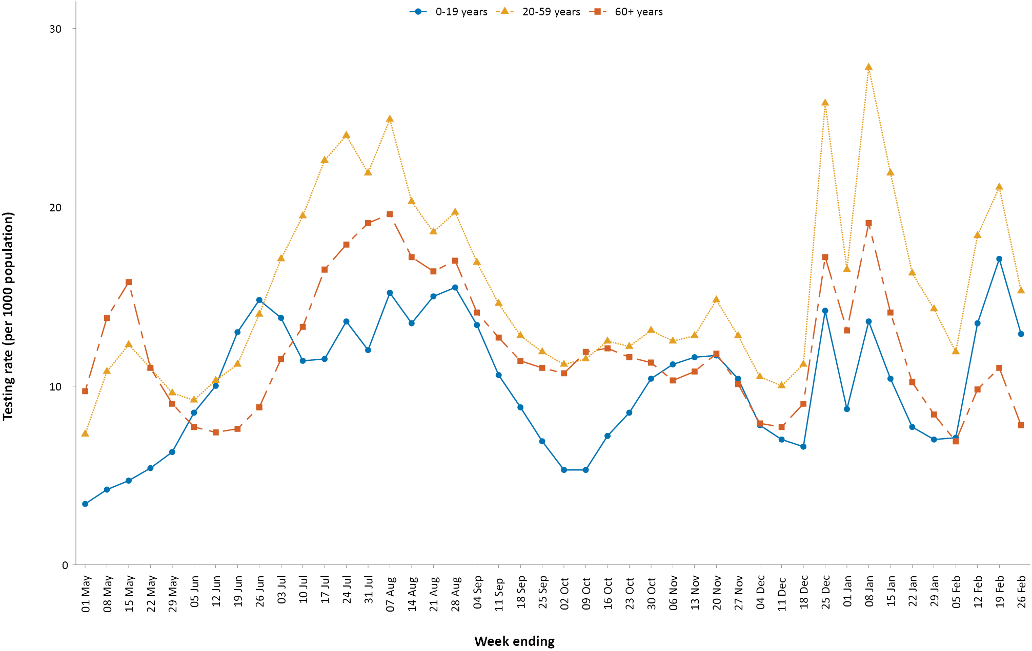
a Data provided by jurisdictions to the NIR weekly.
b The jurisdictions reporting each week (i.e. the denominator population) may vary.

Vaccinations

(Department of Health)
Australia’s vaccination program began this reporting period. At 28 February, 33,702 Australians had been vaccinated with a first dose of Pfizer vaccine, including 10,071 aged care and disability residents.¹²

Four-week reporting period (1–28 February 2021):

Acute respiratory illness

(FluTracking and Commonwealth Respiratory Clinics)
Based on self-reported FluTracking data,¹³ prevalence of fever and cough in the community remained low at less than 0.7% (Figure 6). Runny nose and sore throat symptoms in the community remained stable during this reporting period and the prevalence in the community remained at less than 1%.

Figure 6: Weekly trends in respiratory illness amongst FluTracking survey participants (age-standardised) compared to the average of the previous five years, Australia, 1 March 2020 – 28 February 2021ª
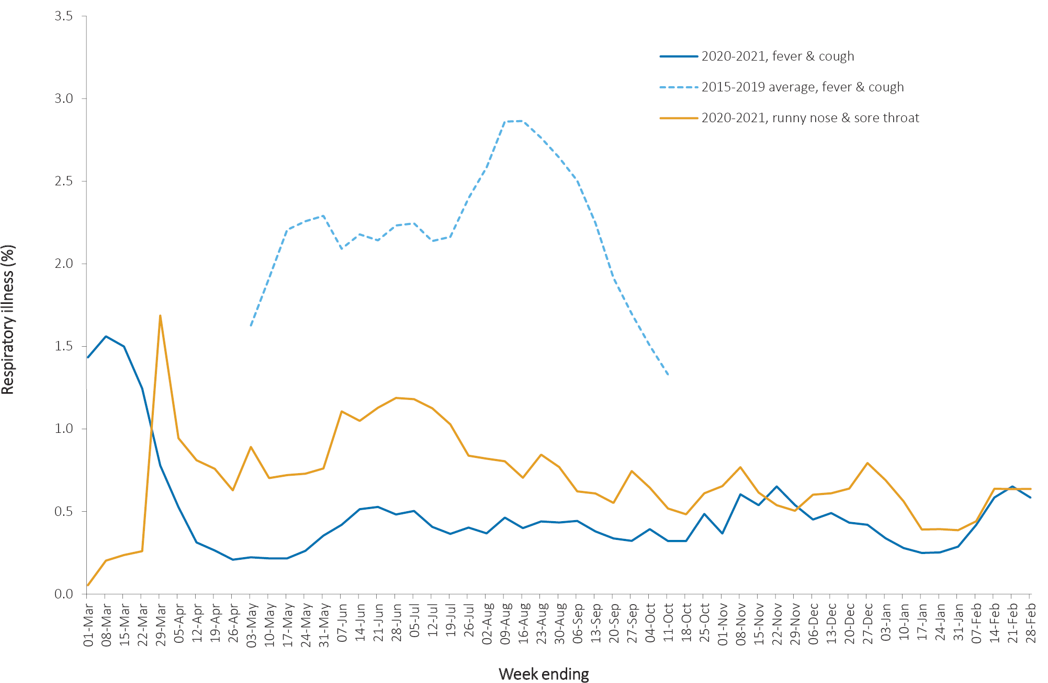
a In years prior to 2020, FluTracking was activated during the main Influenza season from May to October. A historical average beyond the week ending 11 October is therefore not available. In 2020, FluTracking commenced 10 weeks early to capture data for COVID-19. Data on runny nose and sore throat were only collected systematically after 29 March 2020, therefore a historical average for this symptom profile is unavailable.
In this reporting period, acute respiratory illness was highest in those aged under 10 years old, based on both self-reported FluTracking data and presentations to Commonwealth Respiratory Clinics. Females reported respiratory illness more frequently than males. Rates of fever and cough by jurisdiction ranged from 2.1/1,000 FluTracking participants in Western Australia to 6.4/1,000 participants in the Australian Capital Territory.
FluTracking data indicated that 54.7% of those in the community with ‘fever and cough’ and 20.7% of those with ‘runny nose and sore throat’ were tested for SARS-CoV-2. This represented a slight decrease in testing among those with ‘fever and cough’ since the previous reporting period and a decrease in testing among those self-reporting ‘sore throat and runny nose’. Testing rates varied by jurisdiction and symptom. For fever and cough, rates were lowest in Western Australia and highest in South Australia. For runny nose and sore throat, rates were lowest in Western Australia and highest in Victoria. It is important to acknowledge that there may be legitimate reasons why people did not get tested, including barriers to accessing testing. Symptoms reported to Flutracking were not specific to COVID-19 and may also be due to chronic diseases.
During this reporting period, there were 38,818 assessments at Commonwealth Respiratory Clinics with 96% tested for SARS-CoV-2. The positivity rate for SARS-CoV-2 at these clinics was < 0.1% for this reporting period.
In patients experiencing influenza-like illness in this reporting period who were tested through the Australian Sentinel Practice Research Network (ASPREN) and Victorian Sentinel Practice Influenza Network (VicSPIN) general practitioner (GP) sentinel surveillance systems, the most frequent respiratory viruses detected were respiratory syncytial virus (RSV) and rhinoviruses.
Based on FluTracking data, the rate of self-reported fever and cough among Aboriginal and Torres Strait Islander peoples was higher than that observed in all other participants this reporting period. The rate for health care worker participants reporting these symptoms during this period was similar to that observed for all other participants based on FluTracking data.
Based on all presentations to Commonwealth Respiratory Clinics to date, the principal symptoms reported in COVID-19 cases were cough, sore throat, tiredness, runny nose, and fever.

Severity

(NNDSS, FluCAN)
Based on NNDSS data, there have been 27,780 COVID-19 cases with hospitalisation status known to date. Of these cases, 14% were hospitalised. It should be noted that it cannot be discerned from these data what proportion of those hospitalised were done so for isolation rather than clinical reasons. Since 16 March 2020, FluCAN has recorded 481 COVID-19 cases hospitalised in sentinel sites,¹⁴ of which 93 (19%) were admitted to an intensive care unit (ICU).
There were three hospital admissions for confirmed COVID-19 cases in participating sites since the last severity report (COVID-19 epidemiology report 34: data to 31 January 2021).¹⁵

Length of hospital stay
Length of hospital stay for patients with confirmed COVID-19 increases with advancing age category (Table 7). Length of stay in ICU for survivors can be found in a previous severity report (data to 22 November 2020).¹⁶
Table 7: Hospital length of stay for confirmed COVID-19 cases discharged alive from sentinel sites Australia between 16 March 2020 and 28 February 2021ª
Age group (years) | Hospital length of stayª
 | n | Median (IQR) | Mean (SD)
< 18 | 42 | 2.0 (1.0–7.0) | 5.3 (6.9)
18–39 | 82 | 5.0 (2.0–10.0) | 7.0 (7.1)
40–59 | 111 | 8.0 (4.0–14.0) | 10.8 (15.9)
60–79 | 99 | 10.0 (6.0–15.0) | 12.0 (10.9)
≥ 80 | 45 | 12.0 (8.0–16.0) | 12.6 (7.3)
Total | 379 | 8.0 (3.0–13.0) | 9.9 (11.5)
a Source: FluCAN. Includes patients with a discharge outcome and discharge date.

Characteristics of those with severe COVID-19 disease
The median age of cases who were hospitalised in sentinel sites since 16 March 2020 (57 years; IQR: 38–73) and admitted to ICU (59 years; IQR: 46–68) was higher than for cases overall (37 years; IQR: 25–56). The ratio of males to females (1.2:1) remained stable for hospitalised cases, with slightly higher numbers of admissions for males. Of those hospitalised in sentinel sites (n = 481),¹⁶ six (1.2%) were identified as Aboriginal and Torres Strait Islander people (1 unknown and 8 missing data; > 98% completeness). Comorbidity and other risk factor analysis can be found in a previous severity report (data to 25 October 2020).¹⁷ Risk factor data have not been updated in the present report, as hospital cohorts have changed little in the intervening months.

COVID-19 deaths
Overall, the crude case fatality rate (CFR) remains stable at 3.1% (Table 8), with no cases reported as having died since the previous severity report (data to 31 January 2021).¹⁵ The highest CFR was in males over the age of 80 years, particularly those admitted to hospital. For hospitalised cases, the total number who have died in hospital remains unchanged since the last severity report (data to 31 January 2021).¹⁵ The CFR rate amongst those admitted to ICU was last reported in issue 30 (13.2%; data to 22 November 2020).¹⁶
Table 8: Number of fatalities and CFR for all cases and for hospitalised cases, by age group and sex, Australia, 23 January 2020 – 28 February 2021
 | All casesª  n (CFR) |  |  | Hospitalisation^{b}  n (CFR)
 | Male | Female | Persons | Male | Female | Persons
Total | 440 (3.1) | 469 (3.2) | 909 (3.1) | 27(11.8) | 21 (10.6) | 48 (11.2)
< 50 | 5 (0.1) | 0 (0.0) | 5 (0.0) | 0 (0.0) | 0 (0.0) | (0.0)
50–64 | 19(0.8) | 10 (0.4) | 29 (0.6) | 1 (1.9) | 3(7.9) | 4 (4.4)
65–79 | 119(8.8) | 63 (5.0) | 182 (7.0) | 11 (21.2) | 2 (6.5) | 13 (15.7)
80+ | 297(41.1) | 396(29.8) | 693 (33.7) | 15 (46.9) | 16 (36.4) | 31 (40.8)
a Source: NNDSS. (Total cases = 28,937).
b Source: FluCAN. Includes 21 sentinel hospitals. (Total cases with a discharge outcome = 428).

Hospital occupancy
The average daily number of COVID-19 cases in hospital during the past four weeks across the country was 12; this was a decrease on the previous reporting period’s daily average of 32 (4–31 January 2021). Hospitalised cases were distributed across six jurisdictions with no confirmed hospitalised cases reported in the past four weeks in Tasmania or the Australian Capital Territory (Figure 7). It should be noted that current local hospitalisation policies for cases in hotel quarantine differ across jurisdictions. In some states and territories, cases who test positive in hotel quarantine may be routinely transferred to hospital for isolation rather than clinical care. Intensive care occupancy due to COVID-19 reached a daily maximum of one individual during the reporting period; this occurred in Victoria.

Figure 7: Number of daily hospitalised confirmed cases of COVID-19 cases, by jurisdiction (1–28 February, 2021)ª
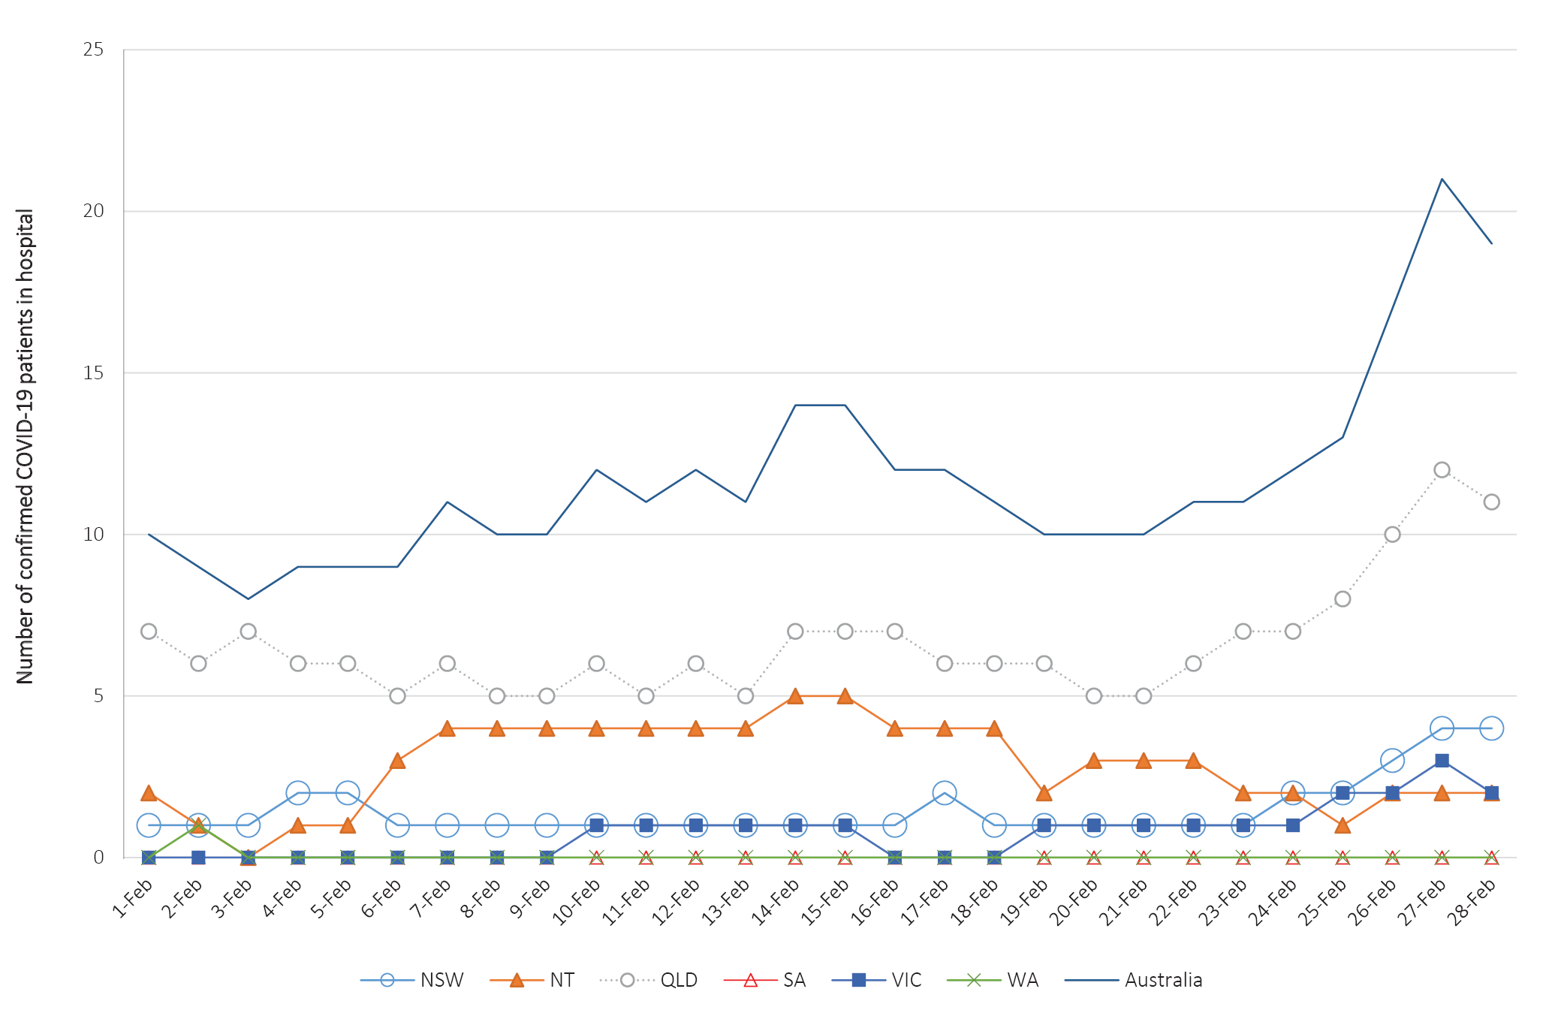
a Source: Daily report from jurisdictional health departments.

Clusters and outbreaks

(State and territory reporting)
For the month ending 28 February 2021, there were five new outbreaks, associated with 45 cases reported to COVID-Net. Outbreaks were reported in Victoria (4) and Western Australia (1) and occurred in association with managed quarantine facilities (4) and a food premises (1). At the end of the reporting period, there were two open but related outbreaks, both of which were in Victoria. One of these was associated with a managed quarantine facility with 24 cases, which included cases from another outbreak associated with a food premises with 11 cases.
Nationally, since the beginning of the epidemic, there have been 867 outbreaks associated with 14,133 cases; 2,067 hospitalisations; and 802 deaths. Consistent with the national epidemic, the first peak in outbreaks occurred in mid-March. This was followed by a rapid increase in outbreaks which began in early July, corresponding with community transmission in Victoria.
The median number of cases in each outbreak was six (range 2–331). Forty percent (345/867) of outbreaks had 6–24 cases, and almost a third (32%, 279/867) had only 3–5 cases. The number of cases associated with outbreaks was consistent across the two peaks in mid-March and July. The largest single jurisdictional outbreak occurred in in a residential aged care facility and was associated with 301 cases.
The largest number of outbreaks occurred in workplace/industry settings (191/867, 22% outbreaks, 1587/14,133, 11% cases), followed by educational facilities (123/867, 14% outbreak; 1195/14,133, 8% cases), aged care facilities (115/867, 13% outbreaks; 5289/14,113, 37% cases), and hospitals (83/867, 10% outbreaks; 1327/14,133, 9% cases) (Figure 8). Despite having a low percentage of outbreaks (34/867, 4%), food industry settings resulted in a substantial amount of cases (1129/14,133, 8%).
Figure 8: Number of outbreaks and cases by setting, Australia, 28 February 2021
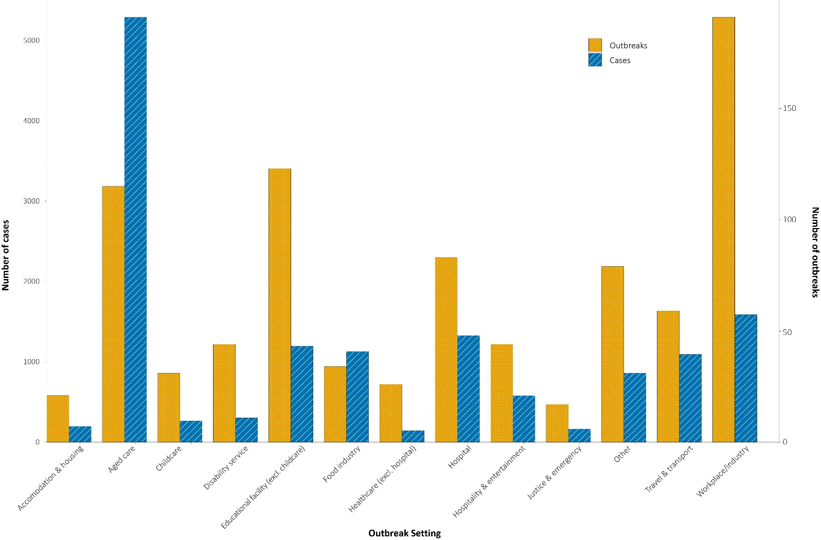

Public health response measures
Since COVID-19 first emerged internationally, Australia has implemented public health measures informed by epidemiological features of the disease (Figure 9). States and territories have decision making authority in relation to public health measures and have implemented or eased restrictions at their own pace, depending on the local public health and epidemiological situation (Table 9), and in line with the ‘Framework for National Reopening’.¹⁸ Nationally, there have been a range of new public health measures in response to cases infected with SARS-CoV-2 variants of concern. These include the introduction of pre-flight testing for travellers entering Australia and requirements to wear face masks when flying domestically or internationally. During the current reporting period, there were short-term higher level restriction periods in Western Australia (as previously reported) and Victoria in response to cases found to be infected with SARS-CoV-2 variants of concern.
Table 9. State and territory changes to COVID-19 restrictions, Australia, 1 February to 28 February 2021
Jurisdiction | Summary of changes to COVID-19 restrictions
New South Wales | From 12 February, New South Wales eased restrictions for Greater Sydney:¹⁹  - Density restrictions have reduced to 1 person per 2 square meters at all indoor venues, excluding gyms,  - Face masks are no longer mandatory in all indoor settings (required on public transport).  From 12 February, New South Wales implemented retrospective quarantine requirements for those entering from Victoria.  From 17 February, New South Wales lifted quarantine requirements for those entering from Victoria.  From 26 February, New South Wales eased restrictions for Greater Sydney:²⁰  - Cap of 50 visitors per day in private households,  - At weddings, 30 people are allowed to dance at a time,  - Cap of 50 people in gym classes, subject to 4 square meter rule.
Victoria | From 11:59pm 12 February, the entirety of Victoria entered a five day period of higher level restrictions in response to cases of variant B.1.1.7. Individuals were required to stay home unless:²¹  - Shopping for necessary goods and services,  - Care and caregiving,  - Exercise with up to one other person or member of household or an intimate partner,  - Attending permitted work.  The following higher level restrictions were also imposed:  - Travel further than 5 km from an individual’s home is prohibited (some exceptions apply),  - Face masks mandatory outside of home premises.  From 11:59pm 17 February, Victoria eased the following restrictions:²²  - Able to leave home for any reason,  - Face masks remain mandatory indoors (including workplaces) and outside when physical distancing is not possible,  - Cap of 5 visitors per day in private households,  - Gatherings of up to 20 people permitted outdoors in public places,  - Schools have been re-opened,  - Seated entertainment venues can operate with a patron cap of 50% of seating capacity up to a maximum of 300 patrons (density restrictions apply in foyers, bars and bathrooms of venues),  - No cap on the number of attendees at wedding, funerals and religious gatherings (density restrictions apply),  - Exercise and recreation facilities can re-open (density restrictions apply).
Queensland | From 13 February, Queensland closed the border to Victoria and implemented retrospective quarantine requirements.²³  From 27 February, Queensland opened the border to Victoria.
Western Australia | From 6:00pm 5 February, Perth metropolitan area and the Peel and South West regions higher level restrictions period concluded. South West regions returned to restrictions prior to this period. Perth metropolitan area and Peel region entered into post-restriction transition measures:²⁴  - Face masks mandatory in any setting outside of private households (exception is vigorous exercise whilst outside),  - Private gatherings of up to 20 people are permitted,  - Hospitality, retail and wedding venues must abide by density restrictions up to a cap of 150 attendees,  - Restaurants, pubs and bars can only operate with seated services,  - Schools have been re-opened (students are exempt from mask mandate while on school premises).  From 12 February, Western Australia closed the border to Victoria.²⁵  From 14 February, Western Australia lifted further restrictions:  - Venues must comply with density restrictions,  - Wearing a face mask is no longer mandatory (exceptions apply).  From 20 February, Western Australia opened the border to Victoria (Self-quarantine and testing requirements still apply).²⁴
South Australia | From 13 February, South Australia closed the border to Victoria and implemented retrospective quarantine requirements.)²⁶  From 17 February, South Australia opened the border to Victoria (Travel from Greater Melbourne is still prohibited).  From 26 February, South Australia eased the following restrictions:²⁷  - Venues not exceeding capacity of 200 patrons can allow dancing and drinking,  - Venues with capacity between 200-1000 patrons can allow dancing (cap of 50 patrons on the dance floor at a time),  - South Australia opened the border to Greater Melbourne.
Tasmania | From 5 February, Tasmania opened the border to Western Australia (mandatory 14 day quarantine remains in place for the Perth and Peel regions).²⁸  From 8 February, Tasmania removed remaining quarantine requirements for Perth and Peel regions.  From 11 February, Tasmania eased the following restrictions:²⁹  - Entertainment venues can apply for an increase in patron numbers.  From 12 February, Tasmania declared Victoria as ‘high risk’ and closed the border to non-residents, with returning Tasmanian residents required to follow quarantine directions.²⁸  From 20 February, Tasmania opened their border to Victoria and reduced quarantine requirements.
Australian Capital Territory | From 1 February, Australian Capital Territory closed the border to non-ACT residents who have travelled to hotspot areas in Western Australia and implemented retrospective quarantine requirements.³⁰  From 5 February, Australia Capital Territory lifted travel restrictions and quarantine requirements for Western Australia.  From 12 February, Australian Capital Territory closed the border to non-ACT residents who have travelled to Victoria and implemented quarantine requirements.³¹  From 17 February, Australia Capital Territory opened the border to Victoria and lifted quarantine requirements.³⁰  From 20 February, Australia Capital Territory eased the following restrictions:³²  - Businesses can have 25 patrons in their venue after which density restrictions apply,  - Cinemas, theatres and indoor performance venues can operate at 75% capacity,  - Outdoor stadiums and ovals can operate at 100% capacity for fixed seating,  - Patrons can now stand while eating and drinking in indoor and outdoor venues.
Northern Territory | From 1 February, Northern Territory opened borders to New South Wales hotspots and lifted quarantine requirements for travellers from these areas.³³  From 4 February, Northern Territory closed borders and implemented quarantine directives to travellers from certain Victorian suburbs identified as hotspots.  From 5 February, Northern Territory opened borders to travellers from Western Australia.  From 12 February, Northern Territory closed borders to all of Greater Melbourne and Tullamarine as a result of Victoria’s higher level restrictions.  From 17 February, Northern Territory opened its border to Victoria and lifted quarantine directives.

Figure 9: COVID-19 notifications in Australia by week of diagnosis and jurisdiction to 28 February 2021 with timing of key public health measures
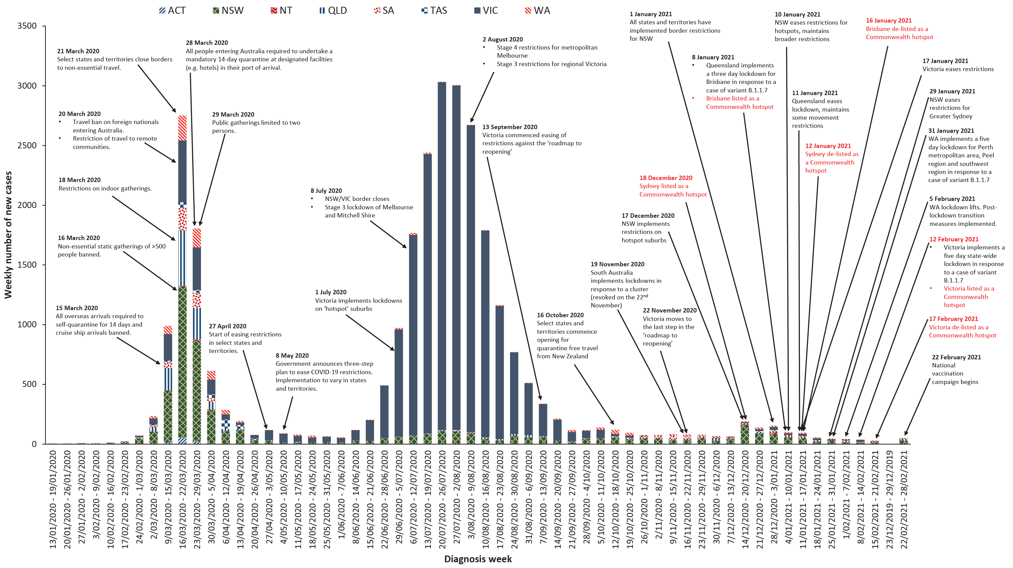

Countries and territories in Australia’s near region
According to the World Health Organization (WHO), 46 countries and territories in Australia’s near region (WHO’s South East Asia (SEARO) and Western Pacific (WPRO) regions) reported 860,842 newly-confirmed cases and 14,724 deaths in the four-week period 1–28 February 2021, bringing the cumulative cases in the two regions to 15.1 million and 237,019 cumulative deaths.³⁴ In the Western Pacific, there were 35% fewer new cases while new deaths increased slightly by 2.7% in the last four weeks compared to the previous four-week period. Similarly, cases and deaths in South East Asia decreased in the four-week period by 18% and 22% respectively (660,286 new cases and 10,306 new deaths), compared to the preceding four-week period. India, Indonesia, Bangladesh, Japan and Malaysia, countries that have previously reported the highest numbers of new cases in the region, have reported a decrease in the numbers of new cases in this reporting period and a trend of decreasing numbers of deaths.
Countries such as Fiji, the Solomon Islands, Marshall Islands, and New Caledonia detected cases mainly among international arrivals while in quarantine. Since the last report, New Zealand reported 69 new cases of which 12 were detected in the community. In response to a community case of unknown origin confirmed on 27 February 2021, New Zealand initiated a seven-day lockdown in Auckland and Level 2 restrictions in the rest of the country. Thirteen Pacific Island countries reported no new cases in the past month.
Table 10 outlines the current Transmission Classification set by WHO for Australia’s near region. Under the WHO’s classification, Australia has a transmission classification of ‘sporadic cases’.
Table 10: Transmission patterns for countries in Australia’s near region, WHO, 28 February 2021ª
Category | Country
No cases  Countries/territories/areas with no cases | American Samoa, Cook Islands, Democratic People’s Republic of Korea, Kiribati, Marshall Islands, Federated States of Micronesia, Nauru, Niue, Palau, Pitcairn Islands, Samoa, Solomon Islands, Tokelau, Tonga, Tuvalu and Vanuatu
Sporadic cases  Countries/territories/areas with one or more cases, imported or locally detected | Australia, Brunei Darussalam, Cambodia, Fiji, French Polynesia, Lao PDR, New Caledonia, Singapore, Timor-Leste, Wallis and Futuna
Clusters of cases  Countries/territories/areas experiencing cases, clustered in time, geographic location and/or by common exposures | Bhutan, China, Guam, India, Japan, Malaysia, Maldives, Mongolia, Myanmar, Nepal, New Zealand, Republic of Korea, Sri Lanka, Thailand, and Vietnam
Community transmission  Countries /territories/areas experiencing larger outbreaks of local transmission defined through an assessment of factors including, but not limited to:  large numbers of cases not linkable to transmission chains large numbers of cases from sentinel lab surveillance or increasing positive tests through sentinel samples (routine systematic testing of respiratory samples from established laboratories) multiple unrelated clusters in several areas of the country/territory/area. | Bangladesh, Indonesia, Papua New Guinea and Philippines
a Classifications are as indicated in reference 35.
Globally, reported new cases and deaths declined in the past four weeks; 38% fewer new cases and 20% fewer deaths were reported since 31 January, the end of the last reporting period. To date, over 113 million COVID-19 cases and 2.5 million deaths have been reported globally. Two regions continued to report the largest burden of disease, with the Region of the Americas accounting for around 44.5% of all new cases and 47.8% of all newly reported deaths, and Europe accounting for 34.1% of all new cases and 34.2% of newly reported deaths. The highest number of new cases in the past four weeks was in the United States of America (2,498,366; 7,527 new cases per 1 million population), followed by Brazil (1,337,117; 6,290 new cases per 1 million population), France (544,857; 8,078 new cases per 1 million population), the Russian Federation (395,640; 2,743 new cases per 1 million population), and the United Kingdom (374,431; 5,569 new cases per 1 million population). The highest number of deaths from COVID-19 in the last four weeks was reported in the United States of America (73,587), followed by Brazil (31,169), Mexico (27,895), the United Kingdom (17,134) and Germany (13,100).
An international summary by WHO Region can be found in the WHO Epidemiological Update dated 3 March 2021.^{34,36}

Acknowledgements
We thank public health staff from incident emergency operations centres and public health units in state and territory health departments, and the Australian Government Department of Health, along with state and territory public health laboratories. We thank those who have provided data from surveillance systems, such as Commonwealth respiratory clinics, ASPREN, Flutracking, FluCAN, Communicable Disease Genomics Network, AusTrakka and jurisdictional sequencing laboratories.

Author details

Corresponding author
COVID-19 National Incident Room Surveillance Team
Australian Government Department of Health, GPO Box 9484, MDP 14, Canberra, ACT 2601.
Email: epi.coronavirus@health.gov.au

References
- Australian Government Department of Health. Implementation plan for the National Microbial Genomics Framework 2021–2022. Canberra: Australian Government Department of Health; 8 February 2021. [Accessed on 4 March 2021.] Available from: https://www.health.gov.au/resources/publications/implementation-plan-for-the-national-microbial-genomics-framework-2021-2022.
- Communicable Diseases Genomics Network (CDGN). AusTrakka. [Website.] Melbourne: CDGN; 2020. Available from: https://www.cdgn.org.au/austrakka.
- COVID-19 National Incident Room Surveillance Team. Technical supplement. COVID-19 Australia: Epidemiology reporting. Commun Dis Intell (2018). 2021;45. doi: https://doi.org/10.33321/cdi.2021.45.2.
- Rambaut A, Homles EC, O’Toole Á, Hill V, McCrone JT, Ruis C et al. A dynamic nomenclature proposal for SARS-CoV-2 lineages to assist genomic epidemiology. Nat Microbiol. 2020;5:1403–7. doi: https://doi.org/10.1038/s41564-020-0770-5.
- Tegally H, Wilkinson E, Giovanetti M, Iranzadeh A, Fonseca V, Giandhari J et al. Emergence and rapid spread of a new severe acute respiratory syndrome-related coronavirus 2 (SARS-CoV-2) lineage with multiple spike mutations in South Africa. medRxiv. 2020. doi: https://doi.org/10.1101/2020.12.21.20248640.
- Naveca F, Nascimento V, Souza V, Corado A, Nascimento F, Silva G et al. COVID-19 epidemic in the Brazilian state of Amazonas was driven by long-term persistence of endemic SARS-CoV-2 lineages and the recent emergence of the new variant of concern P.1. Research Square. 2021. doi: https://doi.org/10.21203/rs.3.rs-275494/v1.
- Rambaut A, Loman N, Pybus O, Barclay W, Barrett J, Carabelli A et al. Preliminary genomic characterisation of an emergent SARS-CoV-2 lineage in the UK defined by a novel set of spike mutations. [Internet.] December 2020. [Accessed on 4 March 2021.] Available from: https://virological.org/t/preliminary-genomic-characterisation-of-an-emergent-sars-cov-2-lineage-in-the-uk-defined-by-a-novel-set-of-spike-mutations/563.
- Chen J, Wang R, Wang M, Wei GW. Mutations strengthened SARS-CoV-2 infectivity. J Mol Biol. 2020;432(19):5212–26.
- Teruel N, Mailhot O, Najmanovich RJ. Modelling conformational state dynamics and its role on infection for SARS-CoV-2 Spike protein variants. bioRxiv. 2021. doi: https://doi.org/2020.12.16.423118.
- Nelson G, Buzko O, Spilman P, Niazi K, Rabizadeh S, Soon-Shiong P. Molecular dynamic simulation reveals E484K mutation enhances spike RBD-ACE2 affinity and the combination of E484K, K417N and N501Y mutations (501Y.V2 variant) induces conformational change greater than N501Y mutant alone, potentially resulting in an escape mutant. bioRxiv. 2021. doi: https://doi.org/2021.01.13.426558.
- Faria NR, Claro IM, Candido D, Moyses Franco L, Andrade PS, Coletti TM et al. Genomic characterisation of an emergent SARS-CoV-2 lineage in Manaus: preliminary findings. [Internet.] 13 January 2021. [Accessed on 4 March 2021.] Available from: https://virological.org/t/genomic-characterisation-of-an-emergent-sars-cov-2-lineage-in-manaus-preliminary-findings/586.
- Australian Government Department of Health. How COVID-19 vaccines will be distributed. [Internet.] Canberra: Australian Government Department of Health; 1 March 2021. [Accessed on 4 March 2021.] Available from: https://www.health.gov.au/initiatives-and-programs/covid-19-vaccines/getting-vaccinated-for-covid-19/how-covid-19-vaccines-will-be-distributed.
- Dalton C, Durrheim D, Fejsa J, Francis L, Carlson S, d’Espaignet ET et al. Flutracking: a weekly Australian community online survey of influenza-like illness in 2006, 2007 and 2008. Commun Dis Intell Q Rep. 2009;33(3):316–22.
- Monash Health. FluCAN (Influenza surveillance): FluCAN (The Influenza Complications Alert Network). [Internet.] Melbourne: Monash Health; 2020. Available from: https://monashhealth.org/services/monash-infectious-diseases/research/influenza-research/flucan-influenza-surveillance-2/.
- COVID-19 National Incident Room Surveillance Team. COVID-19 Australia: Epidemiology Report 34: Reporting period ending 31 January 2021. Commun Dis Intell (2018). 2021;45. doi: https://doi.org/10.33321/cdi.2021.45.8.
- COVID-19 National Incident Room Surveillance Team. COVID-19 Australia: Epidemiology Report 30: Fortnightly reporting period ending 22 November 2020. Commun Dis Intell (2018). 2020;44. doi: https://doi.org/10.33321/cdi.2020.44.91.
- COVID-19 National Incident Room Surveillance Team. COVID-19 Australia: Epidemiology Report 28: Fortnightly reporting period ending 25 October 2020. Commun Dis Intell (2018). 2020;44. doi: https://doi.org/10.33321/cdi.2020.44.84.
- Australian Government Department of Health. Framework for national reopening – October 2020. [Internet.] Canberra: Australian Government Department of Health; 23 October 2020. [Accessed on 10 November 2020.] Available from: https://www.health.gov.au/resources/publications/framework-for-national-reopening-october-2020.
- Government of New South Wales. COVID-19 restrictions update for the Greater Sydney region. [Internet.] Sydney: Government of New South Wales; 10 February 2021. [Accessed on 18 February 2021.] Available from: https://www.nsw.gov.au/media-releases/covid-19-restrictions-update-for-greater-sydney-region.
- Government of New South Wales. Restrictions will be eased from 26 February. [Internet.] Sydney: Government of New South Wales; 24 February 2021. [Accessed on 25 February 2021.] Available from: https://www.nsw.gov.au/media-releases/restrictions-will-be-eased-from-26-february.
- Victoria State Government. How we live - Information for all Victorians. Victoria’s COVIDSafe Settings. [Internet.] Melbourne: Victoria State Government; 2021. [Accessed on 18 February 2021.] Available from: https://www.coronavirus.vic.gov.au/how-we-live.
- Victoria State Government. COVIDSAFE summer – from 11:59pm Wednesday 17 February 2021. Melbourne: Victoria State Government; 2021. [Accessed on 18 February 2021.] Available from: https://www.premier.vic.gov.au/sites/default/files/2021-02/210217%20-%20Full%20list%20of%20restrictions.pdf.
- Queensland Health. COVID-19 update: Queensland COVID-19 statistics. [Internet.] Brisbane: Queensland Government, Queensland Health; 2021. [Accessed on 19 February 2021.] Available from: https://www.qld.gov.au/health/conditions/health-alerts/coronavirus-covid-19/current-status/urgent-covid-19-update.
- Government of Western Australia. COVID-19 coronavirus: What you can and can’t do. Information about current restrictions in Western Australia. [Internet.] Perth: Government of Western Australia; 2021. [Accessed on 19 February 2021.] Available from: https://www.wa.gov.au/organisation/department-of-the-premier-and-cabinet/covid-19-coronavirus-what-you-can-and-cant-do.
- Government of Western Australia. COVID-19 coronavirus: Travel and quarantine. [Internet.] Perth: Government of Western Australia; 2021. [Accessed on 19 February 2021.] Available from: https://www.wa.gov.au/organisation/department-of-the-premier-and-cabinet/covid-19-coronavirus-travel-and-quarantine.
- Government of South Australia. Travel restrictions. [Internet.] Adelaide: Government of South Australia; 2021. [Accessed on 19 February 2021.] Available from: https://www.covid-19.sa.gov.au/restrictions-and-responsibilities/travel-restrictions.
- Government of South Australia. Victorian restrictions to ease Friday. [Internet.] Adelaide: Government of South Australia; 2021. [Accessed on 25 February 2021.] Available from: https://www.covid-19.sa.gov.au/latest-news/victorian-restrictions-to-ease-friday.
- Tasmanian Government. Coronavirus disease (COVID-19). Media releases. [Internet.] Hobart: Tasmanian Government; 2021. [Accessed on 26 February 2021.] Available from: https://coronavirus.tas.gov.au/media-releases.
- Tasmanian Government. Coronavirus disease (COVID-19). Important community updates. [Internet.] Hobart: Tasmanian Government; 2021. [Accessed on 26 February 2021.] Available from: https://coronavirus.tas.gov.au/facts/important-community-updates.
- Australian Capital Territory Government. COVID-19: updates. [Internet.] Canberra: Australian Capital Territory Government; 2021. [Accessed on 26 February 2021.] Available from: https://www.covid19.act.gov.au/updates.
- Australian Capital Territory Government. COVID-19: new travel restrictions for people who have visited Victoria. [Internet.] Canberra: Australian Capital Territory Government; 12 February 2021. [Accessed on 26 February 2021.] Available from: https://www.covid19.act.gov.au/news-articles/new-travel-restrictions-for-people-who-have-visited-victoria.
- Australian Capital Territory Government. COVID-19: latest changes. [Internet.] Canberra: Australian Capital Territory Government; 2021. [Accessed on 26 February 2021.] Available from: https://www.covid19.act.gov.au/what-you-can-do/latest-changes.
- Northern Territory Government. Coronavirus (COVID-19): updates. [Internet.] Darwin: Northern Territory Government; 2021. [Accessed on 26 February 2021.] Available from: https://coronavirus.nt.gov.au/updates.
- World Health Organization (WHO). WHO Coronavirus Disease (COVID-19) dashboard. [Internet.] Geneva: WHO; 2021. Available from: https://covid19.who.int/.
- WHO. Weekly epidemiological update - 23 February 2021. [Internet.] Geneva: WHO; 23 February 2021. [Accessed on 3 March 2021.] Available from: https://www.who.int/publications/m/item/weekly-epidemiological-update---23-february-2021.
- WHO. Weekly epidemiological update - 3 March 2021. [Internet.] Geneva: WHO; 3 March 2021. [Accessed on 4 March 2021.] Available from: https://www.who.int/publications/m/item/weekly-epidemiological-update---3-march-2021.

Appendix A: Supplementary figures and tables
Table A.1: COVID-19 case notifications and rates per 100,000 population, by age group and sex, Australia, 28 February 2021
Age group | This reporting period  1–28 February 2021 |  |  |  |  |  | Cumulative  23 January 2020 – 28 February 2021
 | Cases |  |  | Rate per 100,000 population |  |  | Cases |  |  | Rate per 100,000 population
 | Male | Female | People | Male | Female | People | Male | Female | People | Male | Female | People
0 to 9 | 3 | 0 | 3 | 0.2 | 0.0 | 0.1 | 802 | 719 | 1,521 | 49.0 | 46.4 | 47.7
10 to 19 | 2 | 2 | 4 | 0.1 | 0.1 | 0.1 | 1,264 | 1,211 | 2,475 | 80.5 | 81.5 | 81.0
20 to 29 | 3 | 5 | 8 | 0.2 | 0.3 | 0.2 | 3,094 | 3,392 | 6,508 | 166.5 | 188.4 | 177.9
30 to 39 | 11 | 14 | 25 | 0.6 | 0.8 | 0.7 | 2,619 | 2,528 | 5,162 | 144.0 | 136.2 | 140.5
40 to 49 | 10 | 2 | 12 | 0.6 | 0.1 | 0.4 | 1,924 | 1,793 | 3,745 | 118.9 | 108.3 | 114.4
50 to 59 | 6 | 1 | 7 | 0.4 | 0.1 | 0.2 | 1,667 | 1,753 | 3,427 | 110.6 | 111.5 | 111.3
60 to 69 | 1 | 1 | 2 | 0.1 | 0.1 | 0.1 | 1,207 | 1,222 | 2,431 | 94.9 | 91.0 | 93.0
70 to 79 | 2 | 1 | 3 | 0.2 | 0.1 | 0.2 | 857 | 756 | 1,613 | 98.5 | 82.0 | 90.0
80 to 89 | 0 | 0 | 0 | 0.0 | 0.0 | 0.0 | 495 | 778 | 1,273 | 138.5 | 168.7 | 155.5
90 and over | 0 | 0 | 0 | 0.0 | 0.0 | 0.0 | 230 | 551 | 782 | 335.2 | 412.6 | 386.8

Communicable Diseases Intelligence
ISSN: 2209-6051 Online

Communicable Diseases Intelligence (CDI) is a peer-reviewed scientific journal published by the Office of Health Protection and Response, Department of Health. The journal aims to disseminate information on the epidemiology, surveillance, prevention and control of communicable diseases of relevance to Australia.

Editor: Jennie Hood
Deputy Editor: Simon Petrie
Design and Production: Kasra Yousefi
Editorial Advisory Board: David Durrheim, Mark Ferson, John Kaldor, Martyn Kirk and Linda Selvey

Website: http://www.health.gov.au/cdi

Contacts
CDI is produced by Environmental Health and Health Protection Policy Branch, Office of Health Protection and Response, Australian Government Department of Health, GPO Box 9848, (MDP 6) CANBERRA ACT 2601

Email: cdi.editor@health.gov.au

Submit an Article
You are invited to submit your next communicable disease related article to the Communicable Diseases Intelligence (CDI) for consideration. More information regarding CDI can be found at: http://health.gov.au/cdi.
Further enquiries should be directed to: cdi.editor@health.gov.au.

This journal is indexed by Index Medicus and Medline.

Creative Commons Licence - Attribution-NonCommercial-NoDerivatives CC BY-NC-ND
© 2021 Commonwealth of Australia as represented by the Department of Health
This publication is licensed under a Creative Commons Attribution-NonCommercial-NoDerivatives 4.0 International Licence from https://creativecommons.org/licenses/by-nc-nd/4.0/legalcode (Licence). You must read and understand the Licence before using any material from this publication.

Restrictions
The Licence does not cover, and there is no permission given for, use of any of the following material found in this publication (if any):
- the Commonwealth Coat of Arms (by way of information, the terms under which the Coat of Arms may be used can be found at www.itsanhonour.gov.au);
- any logos (including the Department of Health’s logo) and trademarks;
- any photographs and images;
- any signatures; and
- any material belonging to third parties.

Disclaimer
Opinions expressed in Communicable Diseases Intelligence are those of the authors and not necessarily those of the Australian Government Department of Health or the Communicable Diseases Network Australia. Data may be subject to revision.

Enquiries
Enquiries regarding any other use of this publication should be addressed to the Communication Branch, Department of Health, GPO Box 9848, Canberra ACT 2601, or via e-mail to: copyright@health.gov.au

Communicable Diseases Network Australia
Communicable Diseases Intelligence contributes to the work of the Communicable Diseases Network Australia.
http://www.health.gov.au/cdna

New outbreaks as reported to COVID-Net in the reporting period, some outbreaks are reported retrospectively.
Cases may be counted more than once if they are associated with multiple clusters.
Open outbreaks are defined as those where a new epidemiologically-linked case was identified in the previous 14 days. Note the period of surveillance for clusters reporting differs from this reporting period.
Changes in the past 30 days reflects new and reconciled numbers due to data cleaning.
For a listing of definitions of outbreak settings, please refer to Appendix A of the Technical Supplement.³

