COVID-19 Australia: Epidemiology Report 25
Fortnightly reporting period ending 13 September 2020
COVID-19 National Incident Room Surveillance Team
Unless indicated, the source of all data, including notified cases of COVID-19 and associated deaths, is the National Notifiable Diseases Surveillance System (NNDSS) to 13 September 2020. Due to the dynamic nature of NNDSS data, data in this report are subject to retrospective revision and may vary from data reported in published NNDSS reports and reports of notification data by states and territories. Case numbers for the most recent dates of illness onset may be subject to revision, due to reporting delays.
Confirmed cases in Australia | Last reporting periodª  17—30 August | This reporting periodª  31 August—13 September | Cumulative^{b}  As at 13 September 2020
Notifications | 1,948 | 764 | 26,753
Deaths | 53 | 6 | 674
a Based on diagnosis date.
b Based on notification date.

Summary (31 August—13 September)
- The number of new cases reported nationally this fortnight was 764, a 61% decrease from the previous fortnight (1,948). On average this represented 55 cases diagnosed each day over the reporting period, a decrease from 125 cases per day over the previous reporting period.
- 84% of all cases (640/764) were reported in Victoria, with a smaller number of cases reported from New South Wales (95), Queensland (22), Western Australia (4) and South Australia (3).
- In Victoria, 97% of cases (621) were locally acquired and were mostly reported from residential aged care facilities; and 3% of cases (19) were reported as under investigation at the date of extract this reporting period.
- Excluding Victoria, 124 cases were reported nationally, 32% (40) were overseas acquired; 65% (81) were locally acquired, predominantly in New South Wales (62); and 2% (3) of cases were under investigation at this time, all reported in Queensland.
- The continued decrease in new cases observed this fortnight in Victoria is likely associated with the enhanced public health measures that are currently in place in Victoria. Locally-acquired cases which were predominantly associated with several interconnected clusters continued to be reported in New South Wales.
- In Queensland, 82% of cases (18/22) were reported as locally acquired from two clusters associated with immigration centres or correctional facilities.
- A total of 6 deaths were reported from cases diagnosed in this reporting period—all from Victoria, all aged 50 years or older, three male and three female.
- Although testing rates have declined gradually over the past month they remain high at 14.5 tests per 1,000 population per week. The overall positivity rate for the reporting period was 0.13%. Victoria reported a positivity rate of 0.39% for this reporting period while in all other jurisdictions the positivity rate was 0.05% or lower.
- For this report, “In focus” is paediatric inflammatory multisystem syndrome temporally associated with SARS-COV-2 (PIMS-TS).
- A review of Australia’s public health response to COVID-19 (as at 13 September 2020) is at Appendix A.
Keywords: SARS-CoV-2; novel coronavirus; 2019-nCoV; coronavirus disease 2019; COVID-19; acute respiratory disease; epidemiology; Australia
Figure 1. New and cumulative COVID-19 notifications by diagnosis week ending 13 September 2020,ª Australia
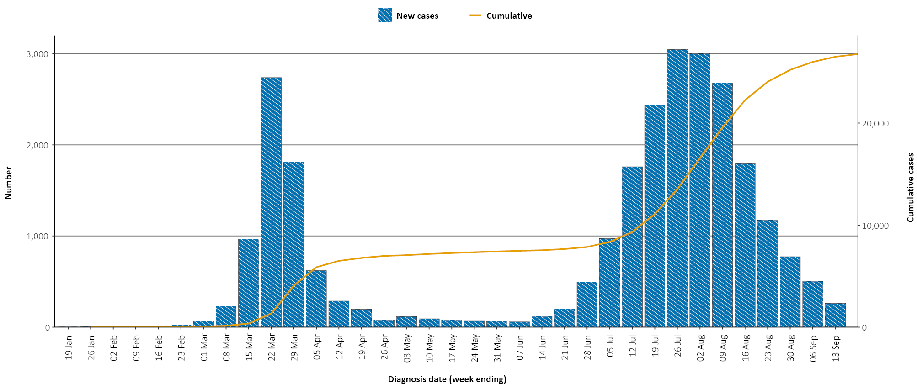
a Illnesses that began within 7 days prior to 13 September 2020 may not yet be reported and interpretation of trends during this period should be undertaken with caution.

In focus: Paediatric inflammatory multisystem syndrome temporally associated with SARS-CoV-2 (PIMS-TS)
Paediatric inflammatory multisystem syndrome temporally associated with SARS-CoV-2 (PIMS-TS) is an uncommon but serious syndrome in children with exposure to SARS-CoV-2.¹ This syndrome has been reported in Europe, the United Kingdom (UK) and the United States of America (USA, where it is referred to as multisystem inflammatory syndrome in children, MIS-C). Since first described in the UK in April 2020, PIMS-TS has been reported internationally in children from countries that are experiencing widespread community-based transmission of SARS-CoV-2 and therefore much higher rates of paediatric disease. Internationally, approximately 1,000 cases have been reported in the literature, with case incidence of PIMS-TS noted to increase in the months after COVID-19 cases peak.^{2–8}
Most children (aged less than 16 years) present with PIMS-TS two to four weeks after exposure to SARS-CoV-2.⁹ Children with asymptomatic COVID-19, or those who only experience mild symptoms, may still develop PIMS-TS. Presentation of PIMS-TS has similarities with Kawasaki disease (KD) and toxic shock syndrome (TSS). Patients may present with fever, gastrointestinal symptoms (abdominal pain, diarrhoea and vomiting), rash, conjunctival injection and tachycardia.¹⁰ Most patients require hospital management. Myocardial dysfunction requiring admission to an Intensive Care Unit (ICU) occurs in at least half the patients. Coronary artery aneurysms occur in about 15 per cent of patients. Extracorporeal membrane oxygenation (ECMO) has been needed in some cases. The majority of cases have recovered.
In Australia, enhanced surveillance for PIMS-TS is undertaken by the Paediatric Active Enhanced Disease Surveillance (PAEDS) network. The PAEDS network is a hospital-based active surveillance system employing prospective case ascertainment for selected serious childhood diseases of public health importance and adverse events following immunisation to inform health.¹¹ The case definition established by PAEDS is based on clinical criteria in combination with laboratory evidence of current or previous SARS-CoV-2 infection or contact with a confirmed COVID-19 case;¹² and aligns with the WHO case definition and substantially overlaps with UK and US case definitions.¹³
Since surveillance commenced on 1 July 2020, PAEDS has identified two cases of ‘confirmed’ PIMS-TS (both in Victoria) and two cases of ‘possible’ PIMS-TS (one in Victoria and one in New South Wales). These cases were identified at PAEDS sentinel hospital sites amongst 308 reported cases of COVID-19 in children to 10 September 2020. Over the same period, 2,260 cases of COVID-19 in children up to the age of 16 years were notified to the National Notifiable Diseases Surveillance System (NNDSS). This number of PIMS-TS cases sits within the expected range based on the emerging international experience of approximately 5-20 cases per 1,000 of COVID-19 in children and young adults.³
Of the PIMS-TS cases identified in Australia to date:
- All four cases were aged over 5 and under 18 years;
- Three (75%) were male;
- No cases reported an underlying medical condition;
- All four cases identified as non-Indigenous;
- Two of the cases (50%) were admitted to ICU;
- All cases have shown favourable recovery.
PAEDS has also attempted to retrospectively identify cases of PIMS-TS back to 1 January 2020 by reviewing all cases of KD and COVID-19 to determine if clinical criteria for PIMS-TS were met. KD is also an uncommon disease, which predominantly affects children under 5 years of age. No additional cases prior to the commencement of prospective surveillance were identified. PAEDS collaborates with national networks to ensure any cases of PIMS-TS are rapidly detected and comprehensively investigated.¹⁴
Ongoing enhanced surveillance of PIMS-TS is necessary to strengthen the body of knowledge for this rare, but clinically significant, complication of SARS-CoV-2 infection. While the overall risk for any severe COVID-19 outcomes in children in the Australian context remains extremely low, understanding who is at greatest risk of PIMS-TS and how it presents will better equip clinicians to recognise and diagnose the syndrome and to provide prompt treatment and reduce the risk of long term or severe complications.

Australian cases: descriptive epidemiology

Transmission trends
Since the first case of COVID-19 was identified in Australia, all states and territories have experienced COVID-19 cases, with some jurisdictions experiencing higher numbers and more community-associated transmission. These differences arise from factors including state demographics, population size, and patterns of overseas arrivals.
As at 13 September 2020 there were 26,753 COVID-19 cases, including 674 deaths, reported nationally with two distinct peaks in March and July (Figure 2). During this reporting period, there were 764 cases reported, including 6 deaths. On average, 55 cases were diagnosed each day over the reporting period, a decrease from 139 cases per day over the previous reporting period. The majority of the recently-diagnosed cases were from Victoria (640; 84%), followed by New South Wales (95; 12%). A small number of cases were reported in Queensland (22), Western Australia (4), and South Australia (3). No new cases were reported from Tasmania, the Northern Territory or the Australian Capital Territory. Most cases in this period were reported to reside in major metropolitan areas (Figure 5 and Appendix B, Figure B.2).
While there has been a continued decline in case numbers from Victoria, there is still a degree of ongoing community transmission. During this reporting period locally-acquired cases linked to interconnected clusters continued to be reported in New South Wales, and in Queensland clusters of cases associated with immigration centres or correctional facilities were identified.
Figure 2. COVID-19 notifications, Victoria and all other jurisdictions, by week and source of acquisition, as at 13 September 2020
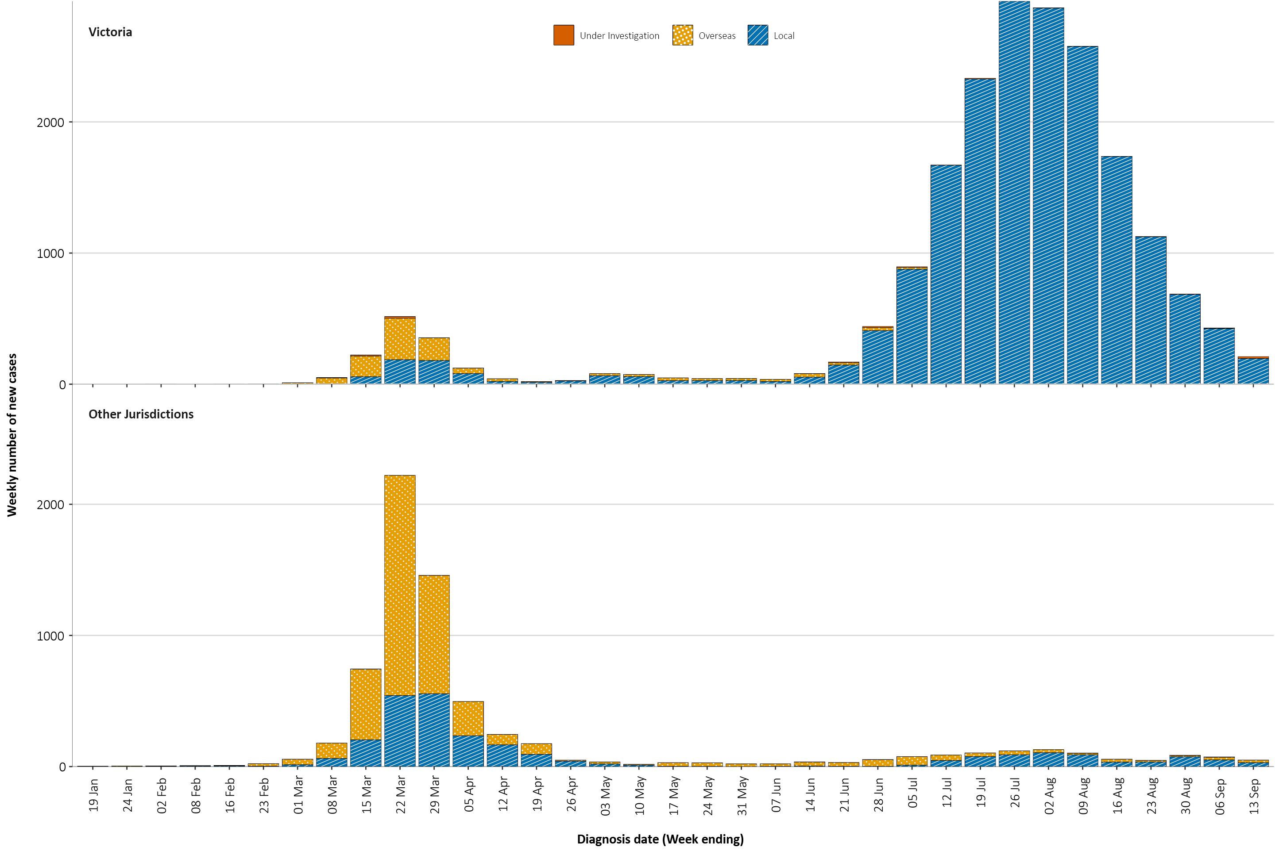

Figure 3. Heat map showing COVID-19 locally-acquired case notifications by place of residence, Australia, 31 August to 13 September 2020^{a,b}
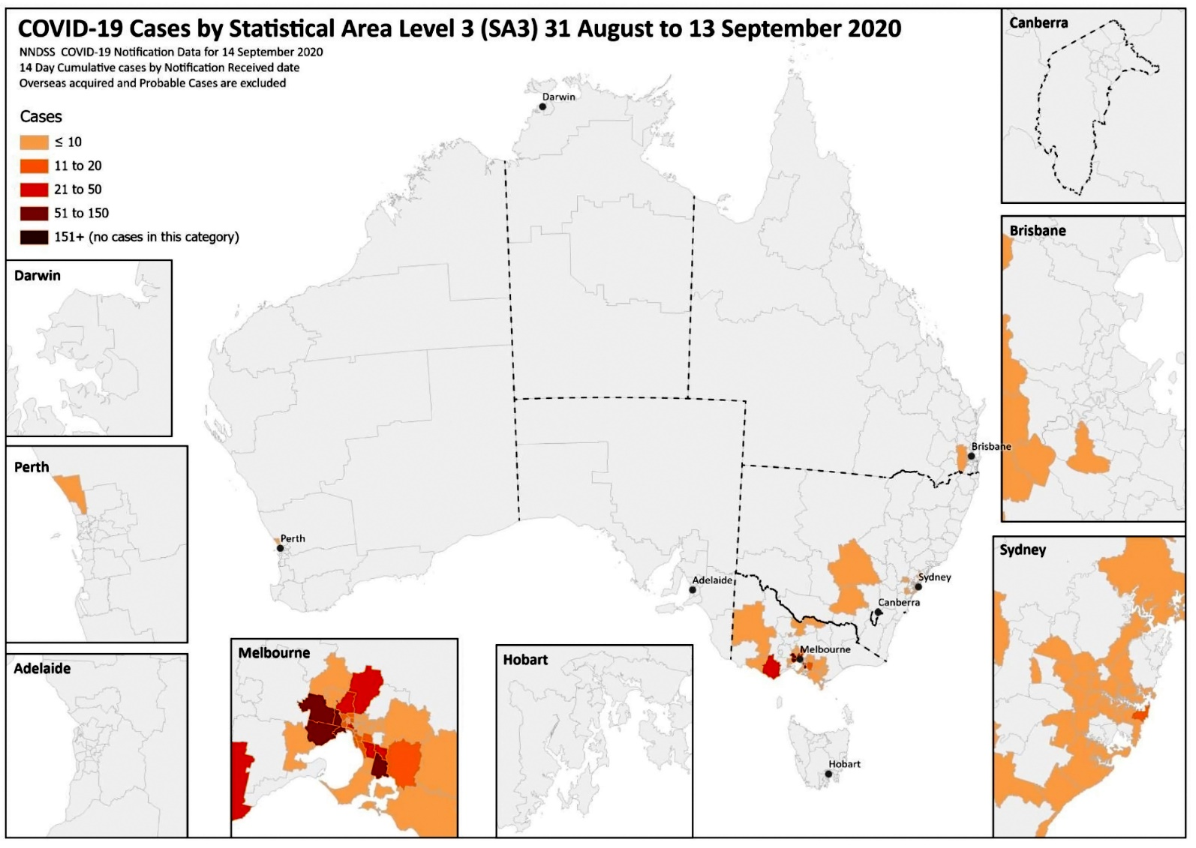
a Source: NNDSS.
b Note: WA did not have locally acquired cases for the reporting period. This case was a result of interstate travel.

Source of acquisition
For this reporting period, 85% of all cases were reported as locally acquired. The source of acquisition for 7% (56/764) of these cases could not be identified, which is lower than the previous reporting period (14%; 261/1,948). In total, 3% (22/764) of cases reported this fortnight remain under investigation and less than 5% (40/764) were reported as overseas acquired (Table 1).
Table 1. COVID-19 notifications by jurisdiction and source of acquisition, 31 August – 13 September 2020
Source | NSW | Vic | Qld | WA | SA | Tas | NT | ACT | Australia
Overseas | 33 | 0 | 1 | 4 | 2 | 0 | 0 | 0 | 40
Local—source known | 57 | 571 | 18 | 0 | 0 | 0 | 0 | 0 | 646
Local—source unknown | 5 | 50 | 0 | 0 | 1 | 0 | 0 | 0 | 56
Under investigation | 0 | 19 | 3 | 0 | 0 | 0 | 0 | 0 | 22
Total | 95 | 640 | 22 | 4 | 3 | 0 | 0 | 0 | 764
For this reporting period, 84% (640/764) of cases have been reported from Victoria with 89% (571/640) of these cases reported as locally acquired with known source, 8% (50/640) as locally acquired with unknown source, and 3% (19/640) as under investigation (though likely locally acquired). (Table 1). In Victoria the proportion of cases reported as under investigation at the end of each reporting period continues to decrease, and the proportion of cases considered to have an unknown source is also declining over time.
Excluding Victoria, for all other cases (124) in this reporting period the majority of cases (77%; 95/124) were reported by New South Wales; an increasing proportion were reported in Queensland (18%; 22/124). Additionally, for cases outside Victoria: 60% (75/124) are reported as locally acquired with known source; 5% (6/124) of cases are reported as locally acquired with unknown source; 32% (40/124) of cases are reported as overseas acquired and 2% (3/124) of cases reported are under investigation (Table 1).
Overseas-acquired cases were reported from New South Wales (33), Western Australia (4), South Australia (2) and Queensland (1). The higher number of cases reported in New South Wales possibly reflects the number of returned travellers being managed there. These proportions are similar to the previous reporting period with the majority of overseas acquired cases quarantining in New South Wales before returning to home states or territories.
The national rate of infection in locally-acquired cases in this reporting period was 2.9 cases per 100,000 population, which is a decrease from the rate observed in the previous reporting period (7.6 cases per 100,000 population, Table 2).
Table 2. Locally-acquired COVID-19 case numbers and rates per 100,000 population by jurisdiction and reporting period, as at 13 September 2020
Jurisdiction | Reporting period  17—30 August |  | Reporting period  31 August — 13 September |  | Cumulative cases
 | Number of cases | Rate per 100,000 populationª | Number of cases | Rate per 100,000 populationª | Number of cases | Rate per 100,000 populationª
NSW | 89 | 1.1 | 62 | 0.8 | 1,890 | 23.4
Vic | 1,814 | 27.5 | 640 | 9.7 | 18,884 | 286.4
Qld | 21 | 0.4 | 21 | 0.4 | 299 | 5.9
WA | 1 | 0 | 0 | 0 | 102 | 3.9
SA | 1 | 0.1 | 1 | 0.1 | 151 | 8.6
Tas | 0 | 0 | 0 | 0 | 149 | 27.9
NT | 0 | 0 | 0 | 0 | 6 | 2.4
ACT | 0 | 0 | 0 | 0 | 29 | 6.8
Australia | 1,926 | 7.6 | 724 | 2.9 | 21,510 | 84.8
a Population data based on Australian Bureau of Statistics (ABS) Estimated Resident Population (ERP) as at 30 December 2019.

In this reporting period, the rate of infection for locally-acquired cases in Victoria decreased from 27.5 per 100,000 population (last reporting period) to 9.7 per 100,000 population. For this reporting period, the infection rate in all other jurisdictions was less than 0.8 per 100,000 population.
Cumulatively, the infection rate to date for all locally-acquired cases is highest in Victoria with 286.4 infections per 100,000 population. While the last reported case in Tasmania was in the fortnight ending 16 August, they continue to have the second highest infection rate with 27.9 infections per 100,000. This was predominantly associated with the outbreak in North West Tasmanian hospitals in April 2020.

Clusters and outbreaks
Nationally, excluding New South Wales, for the fortnight ending 13 September 2020, there was a total of 89 open outbreaks (defined as those where a new epidemiologically-linked case was identified in the previous 14 days). Of these, 87 (98%) were reported in Victoria, with 2 open outbreaks also reported from Queensland. Outbreaks were reported most frequently from residential aged care settings (44) followed by workplaces (18) and hospitals (15). Outbreaks ranged in size, with the largest outbreak encompassing 247 cases in a residential aged care facility. Prominent workplace settings included warehouses, abattoirs/meat packing facilities, distribution centres and manufacturers.
Residents of aged care facilities are at increased risk of COVID-19 infection due to the environment of communal living facilities and are more vulnerable to serious complications if they do become infected. As at 13 September 2020, there have been 4,132 cases of COVID-19 associated with 217 residential aged care facilities, with 3,139 recoveries and 599 deaths. 1,997 of these cases occurred in aged care residents, with the remaining 2,135 cases occurring in care staff. The Commonwealth is actively supporting services with reported incidents and outbreaks of COVID-19 providing access to personal protective equipment and additional staffing resources where required. Advice and guidelines have been provided to aged care services, including the release of an outbreak management guide.^{15,16}

Testing
As at 13 September 2020, a total of 7,016,090 tests have been conducted in Australia. While rates of testing remain high, with 14.5 tests conducted per 1,000 population nationally during the most recent reporting week, this rate represents a recent decline from a peak of 19.4 tests per 1,000 population per week at the beginning of August. The cumulative nationwide proportion of positive tests remains low at less than 0.4% (Table 3). With the exception of Victoria, the cumulative testing positivity in individual jurisdictions is lower than 0.3%.

Table 3. Diagnostic tests performed in Australia, by jurisdiction, as at 13 September 2020ª
Jurisdiction | Tests performed |  |  | Tests performed |  |  | Cumulative tests performed
 | 17 August—30 August |  |  | 31 August – 13 September |  |  | to 13 September
 | N | Positivity (%) | Per 100,000 population ^{a,b} | N | Positivity (%) | Per 100,000 population ^{a,b} | N | Positivity (%) | Per 100,000 population ^{a,b}
NSW | 335,335 | 0.03 | 4,147 | 279,862 | 0.05 | 3,461 | 2,480,838 | 0.17 | 30,683
Vic | 258,467 | 0.88 | 3,920 | 214,684 | 0.39 | 3,256 | 2,488,773 | 0.80 | 37,744
Qld | 163,530 | 0.02 | 3,211 | 133,974 | 0.02 | 2,631 | 1,022,898 | 0.11 | 20,086
WA | 56,036 | 0.00 | 2,137 | 46,441 | 0.01 | 1,771 | 423,003 | 0.11 | 16,134
SA | 52,335 | 0.02 | 2,987 | 39,880 | 0.01 | 2,276 | 377,283 | 0.17 | 21,530
Tas | 8,539 | 0.00 | 1,597 | 7,835 | 0.00 | 1,466 | 95,127 | 0.24 | 17,794
NT | 4,850 | 0.00 | 1,971 | 5,575 | 0.00 | 2,265 | 40,952 | 0.08 | 16,640
ACT | 9,961 | 0.00 | 2,337 | 12,247 | 0.00 | 2,874 | 87,216 | 0.13 | 20,466
Australia | 889,053 | 0.27 | 3,506 | 740,498 | 0.13 | 2,920 | 7,016,090 | 0.38 | 27,669
a Data in this table are based on reports of notification by states and territories.
b Population data based on Australian Bureau of Statistics (ABS) Estimated Resident Population (ERP) as at 30 December 2019.

During this reporting period 740,498 tests were conducted nationally, with a positivity rate of 0.13%. All states except Victoria reported a positivity rate of 0.05% or lower. Victoria reported a positivity rate of 0.39%, which is a decrease from the previous reporting period (0.88%). The low national positivity rate, along with high rates of testing, suggests an overall low prevalence of COVID-19 nationally.
For the fortnight ending 11 September 2020, testing rates declined across age groups that were less than 60 years of age, but increased in those that were 60 years and older (Figure 4).

Figure 4. SARS-CoV-2 (PCR) testing rates per 1,000 population per week by age group,^{a,b} Australia, 1 May to 11 September 2020
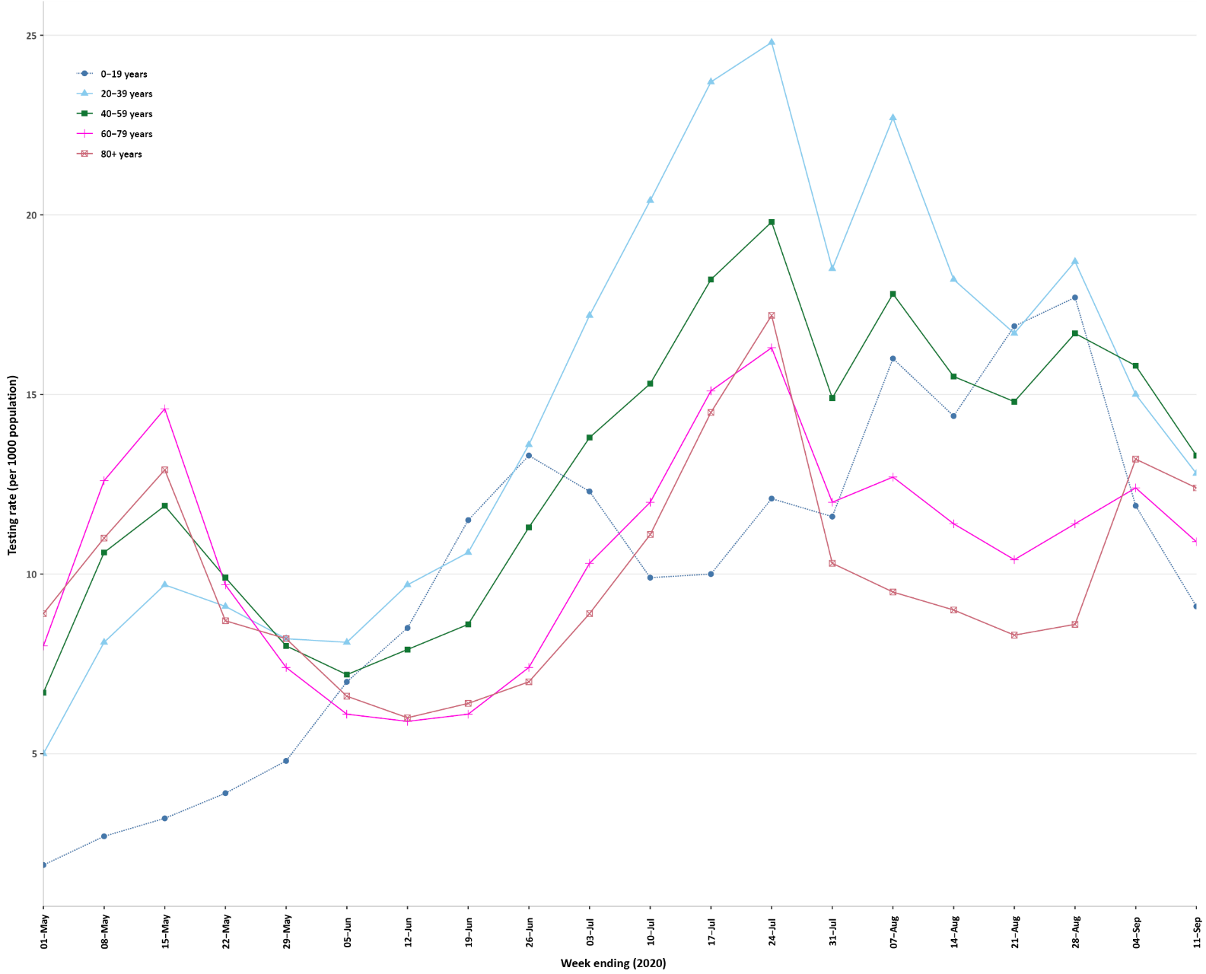
a Data provided by jurisdictions to the National Incident Room (NIR) weekly.
b The jurisdictions reporting each week (i.e. the denominator population) may vary.

Viral genomics
There are currently 7,311 SARS-CoV-2 genome sequences available from Australian cases on the global sequence repository, GISAID.¹⁷ These sequences are dispersed throughout the global lineages, reflecting multiple concurrent introductions into Australia.^{18–20} Recent Australian SARS-CoV-2 sequences from the last month include 20 collected from New South Wales, 14 from Queensland, and 2 from South Australia. Most of these sequences from the last month belong to the B.1.1.25 lineage, reflecting ongoing local transmission of this lineage. Other lineages that were detected sporadically e.g. B.1.113, most likely represent independent introductions from quarantined travellers returned from overseas but which are not associated with any community transmission. Additional epidemiological data would be required to verify this.

Aboriginal and Torres Strait Islander persons
There have been 145 cases of COVID-19 notified in Aboriginal and Torres Strait Islander persons. This represents approximately 0.5% of all confirmed cases. Table 4 compares the remoteness of cases in Aboriginal and Torres Strait Islander persons with those in the Non-Indigenous population. While approximately 21% of all cases notified in Aboriginal and Torres Strait Islander persons (31/145) are reported as acquired overseas, no new cases have been reported as overseas acquired since the end of August. Recent cases have been reported as locally acquired, predominantly in Victoria.
Table 4. COVID-19 notifications by Aboriginal and Torres Strait Islander status by jurisdiction, source of acquisition and remoteness classification as at 13 September 2020
 | Locally-acquired |  |  |  | Overseas acquired | Unknown | Total
 | Major Cities of Australia | Inner Regional Australia | Outer Regional Australia | Remote / Very Remote Australia
Aboriginal and  Torres Strait Islanderª | 88 | 16 | 6 | 3 | 31 | 1 | 145
Non-Indigenous^{b} | 19,966 | 923 | 228 | 21 | 5,212 | 258 | 26,608
a Excludes 1 probable Aboriginal and Torres Strait Islander case.
b Includes 29 Non-Indigenous cases classified as overseas residents who were diagnosed in Australia and 229 Non-Indigenous cases with an unknown remoteness classification.

The median age of COVID-19 cases in Aboriginal and Torres Strait Islander persons is 31.5 years (interquartile range, IQR: 21.0–49.5), which is younger than for Non-Indigenous cases where the median age is 37 years (IQR: 25.0–57.0).
By sex, there is a higher proportion of cases in Aboriginal and Torres Strait Islander females (58%; 84 cases) than in Non-Indigenous females (51%; 13,667 cases). The differences observed in sex for Aboriginal and Torres Strait Islander people likely reflect the small number of cases rather than any specific transmission pattern.
Overall, Aboriginal and Torres Strait Islander males are reporting a slightly higher proportion of cases in the less than 10 years (12%) and 20 to 29 year (28%) age groups compared to Non-Indigenous people (5% and 22% respectively). This group also reports a lower proportion of cases in both the 40–49 (10%) and 50–59 year (8%) age groups compared to Non-Indigenous males (13% and 12% respectively) (Figure 5). Aboriginal and Torres Strait Islander males report no cases 80 years or older.

Figure 5. National COVID-19 notifications by age group and sex, Aboriginal and Torres Strait Islander persons and Non-Indigenous Australians as at 13 September 2020
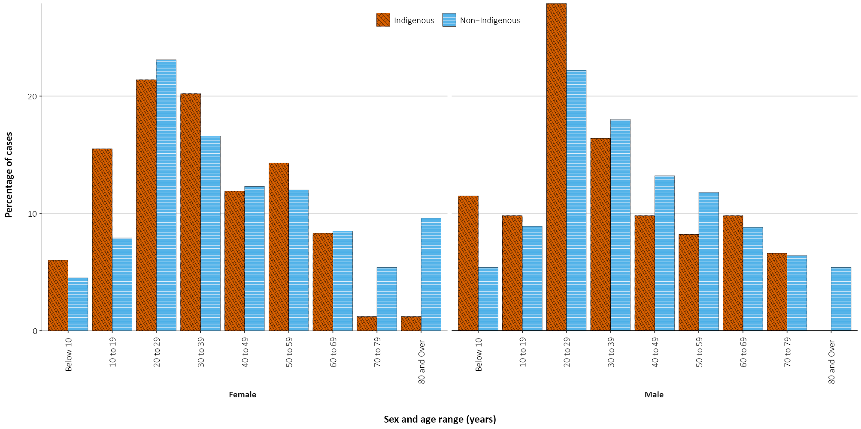
Aboriginal and Torres Strait Islander females are reporting a much higher proportion of cases in the 10–19 year age group (16%) than is seen among non-Indigenous females (8%), though there are only 13 cases that are included in this age and sex grouping and small changes may have a large impact on proportions. However, the proportion in females aged 70 years and over is much lower than in non-Indigenous females aged 70 years and over (Figure 7).

Demographics of cases
Historically, cases of COVID-19 have been reported in all age groups. In this reporting period, the largest number of cases has again occurred in those aged 20–29 years (184 cases), with the highest rate of infection for this period again occurring in the 90 years and older age group (19.3 per 100,000 population). This is a decrease from the previous reporting period where a rate of 52.4 cases per 100,000 population was reported for this age group. The pattern observed in cases per 100,000 population by sex for this reporting period (Figure 6) is representative of the rate observed cumulatively (Figure 7).

Figure 6. New COVID-19 case notifications, cases, by age group and sex, 30 August to 13 September 2020, Australia
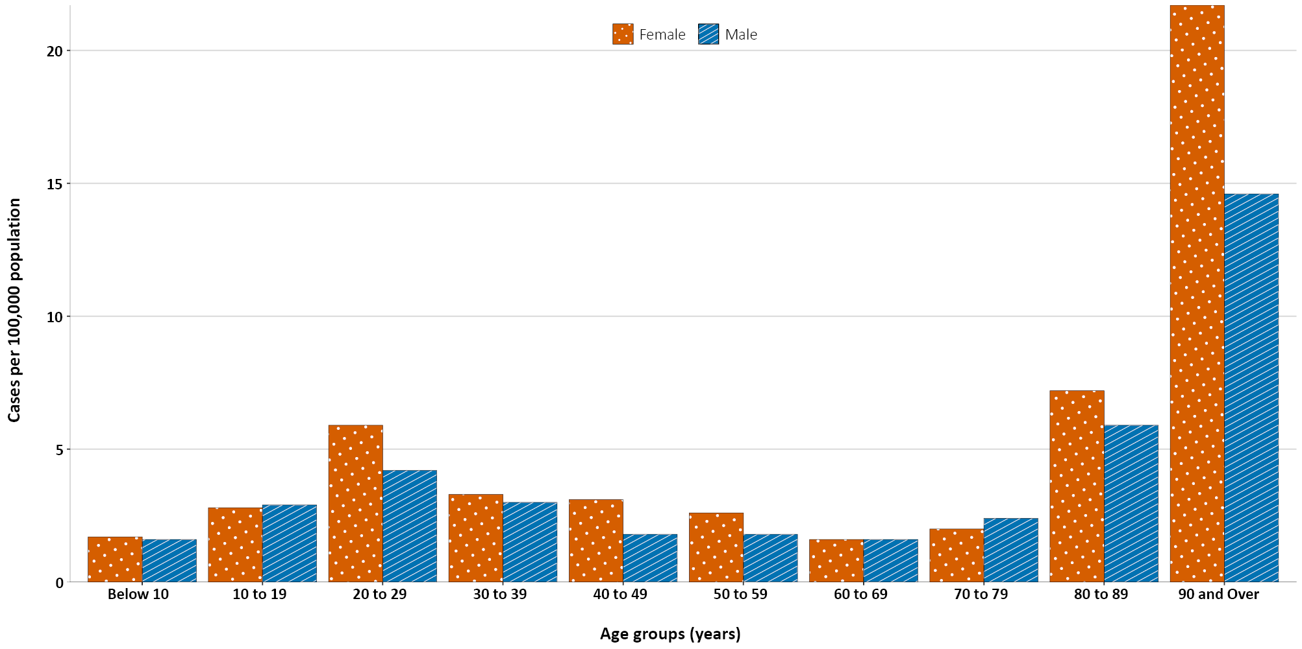
Figure 7. Cumulative COVID-19 cases, by age group and sex, as at 13 September 2020, Australia
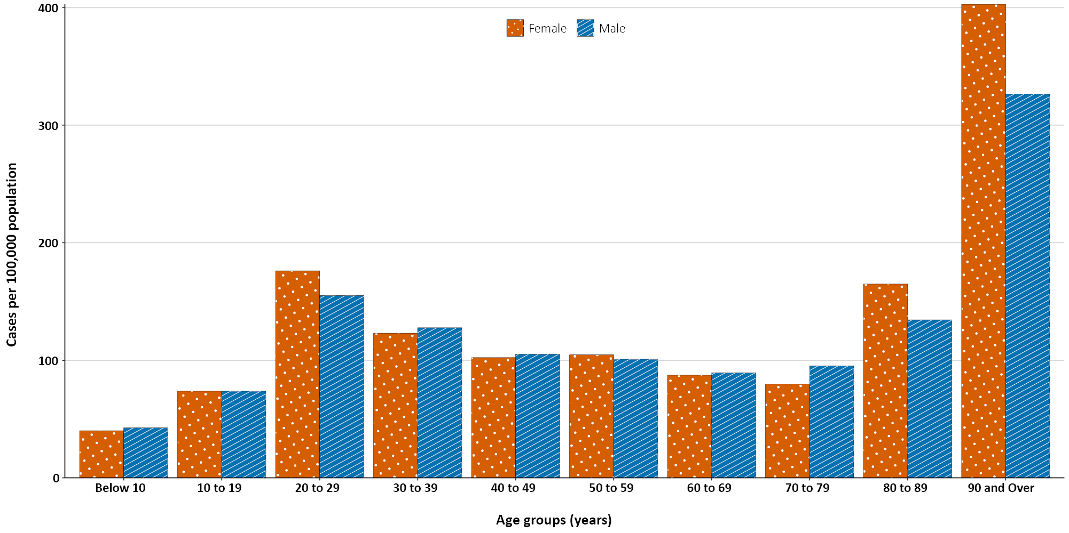
For all notifications to date, the highest rate of infection remains in those aged 90 years and over with a rate of 377.4 per 100,000 population (Appendix B, Table B.1). Children aged 0–9 years continue to have the lowest rate of infection (41.4 cases per 100,000 population), with testing rates comparable to other age groups.
In this reporting period, school-aged children (defined as those aged 5 to 17 years) accounted for 12% of all cases, which is a higher proportion than they comprise in both the previous reporting period (11%) and cumulatively (8%). People aged 80 years and over represent a similar proportion of the cases reported in this reporting period and the previous reporting period at 12%. This is higher than this age group represents in cumulative cases (8%), reflecting the ongoing transmission through aged care facilities. Higher rates among females were observed among those in the 20 to 59 years age groups and aged 80 years and over, with a far higher rate in females 90 or over (21.7 infections per 100,000 population, compared to 14.6 infections per 100,000 population in males).
Cumulatively, all cases show a median age of 37 years (IQR: 25 to 57) which has not changed since the beginning of August. Prior to 1 June 2020, the population diagnosed was slightly older, with a median age of 46 years (IQR: 29 to 62) and was associated with a high proportion of cases having a recent travel history or acquisition on a cruise ship. In cases reported after 1 June 2020, the median age is 35 years (IQR: 23 to 54) reflecting wider transmission in the community and across a range of demographics and settings, especially in Victoria. The median age of cases in this reporting fortnight is 34 years (IQR: 23 to 57).
Cumulatively, the male to female per capita rate is close to 1:1 across different age groups, except in the 20–29 years age group and those aged 80 years and over where there is a higher per capita rate among females (Figure 7). The largest difference between the two categories is seen in the 90 years and over age group where males report a cumulative rate of 326.4 cases per 100,000 population and females report a higher rate of 402.8 cases per 100,000 population (Appendix B, Table B.1).

Acute respiratory illness surveillance
Over this two-week reporting period, 49,110 assessments were recorded for patients with acute respiratory illness who consented to share information, of whom 47,510 (96.7%) were tested for SARS-CoV-2, 25 of which were positive (numbers were correct as at 15 September 2020).

Public health response measures
Since COVID-19 first emerged internationally, Australia has implemented public health measures informed by the disease’s epidemiology (Figure 8). On 8 May, the Australian Government announced a three-step framework for easing COVID-19 restrictions. Building on this framework, on 4 September, the Australian Government announced a plan to develop a ‘Roadmap for Recovery’ to reopen by Christmas.²¹ States and territories ease restrictions at their own pace depending on the local public health and epidemiological situation (Table 5).

Figure 8. COVID-19 notifications in Australia by week of diagnosis and jurisdiction to 13 September 2020 with timing of key public health measures
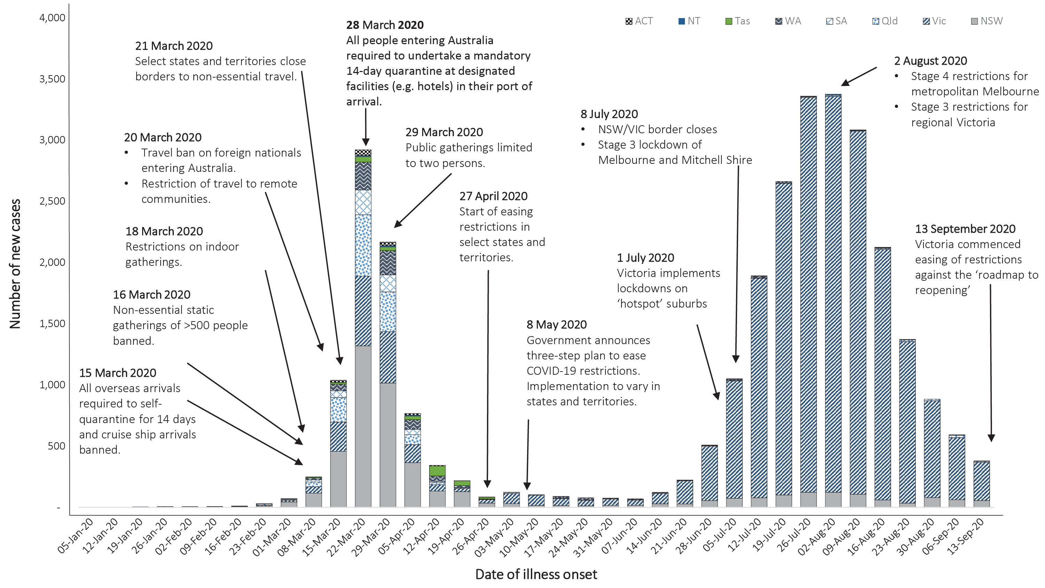

Table 5. State and territory changes to COVID-19 restrictions, from 31 August to 13 September 2020
Jurisdiction | Summary of changes to COVID-19 restrictions
New South Wales | No changes to restrictions during this reporting period.²⁴
Victoria | From 13 September, Metropolitan Melbourne moved to step 1 easing of restrictions:²⁵  - Limited in-person visits for individuals in single households  - Two people can meet outdoors for two hours  - Professional respite care for people with complex needs  - From 13 September, Regional Victoria moved to step 2 easing of restrictions:²⁵  - Up to 5 people from two households permitted to gather outdoors  - Limited in-person visits for individuals in single households  - Childcare open and schools undertake a staged return  - Retail open with density restrictions
Queensland | From 2 September the following restrictions were implemented:²³  - Cap of 30 people in a households including visitors  - Cap of 30 people in a public gathering  - Listed Government Areas have a cap of 10 people in households and public gatherings
Western Australia | No further easing of restrictions during this reporting period.²⁶
South Australia | From 5 September the following restrictions were eased:²⁷  - Up to 150 people permitted at weddings and funerals  - Consumption of food and alcohol permitted at bars
Tasmania | No further easing of restrictions has occurred during this reporting period.²⁸
Australian Capital Territory | No further easing of restrictions has occurred during this reporting period.²⁹
Northern Territory | No further easing of restrictions has occurred during this reporting period.30
During the current reporting period, Victoria has announced a ‘roadmap to reopening’ and commenced easing restrictions with metropolitan Melbourne moving to step 1 and regional Victoria moving to step 2.²² Comparatively, Queensland implemented restrictions on household gatherings in response to clusters of cases.²³
A review of Australia’s public health response to date is at Appendix A.

International situation
All data reported below was extracted from the WHO Dashboard on 14 September 2020 unless otherwise specified.³¹
On 13 September 2020, more than 216 countries, regions and areas had reported 28,640,529 COVID-19 cases and 917,404 deaths to the World Health Organization (WHO) representing a 15.1% increase in global cases and a 9.3% increase in deaths in the past fortnight.³¹ Globally, the number of new cases has been relatively stable since late July, noting variability by region.
In this reporting period, the regions reporting the largest proportions of new cases were the Americas (42%, a decrease from 49%) and South East Asia (35%, an increase from 29%), indicating that South East Asia’s burden of global cases is sharply increasing. The South East Asia Region has experienced an increase of 32% in fortnightly reported cases. A proportional increase in reported deaths may occur in the coming weeks with the degree of impact dependent on the demographic affected and health care access and capacity.
The Americas continue to be the epicentre of the global pandemic representing approximately 51% of cumulative cases and 56% of cumulative deaths. Cases in the South East Asia Region now represent 19% of the cumulative global burden of cases and 10% of deaths, surpassing the cumulative caseload in Europe where cases represent 17% and deaths 25% of the respective global totals. The global case fatality rate (CFR) is approximately 3.2% and is decreasing as case identification improves. The global cumulative per capita rates are 372.9 cases and 11.9 deaths per 100,000 population.

Western Pacific Region
The cumulative number of cases in the region stands at 546,552 (1.9% of cases globally) including 11,886 deaths (1.3% globally). In this reporting period, 58,981 new cases were reported. This represents a 24% decrease in fortnightly reported cases and comprises 1.6% of the global total number of new cases in this reporting period. The region reports a cumulative rate of 28.8 cases per 100,000 people (compared to 372.9 cases per 100,000 globally) and a mortality rate of 0.6 deaths per 100,000 population (compared to 11.9 deaths per 100,000 globally).
The highest numbers of overall cases in the region have been observed in the Philippines and Japan (Figure 9). In this reporting period, the highest number of new cases has also been observed in the Philippines, representing 75.8% of new regional cases. In the previous reporting period, Cambodia, Fiji, New Caledonia and Lao People’s Democratic Republic reported no new cases. In this reporting period, all countries in the region reported at least one new case, with Guam and French Polynesia experiencing large increases (111% and 41% respectively) in the number of new cases (538 and 552 respectively).
In New Zealand, the ‘Auckland August Cluster’ is the only remaining locally-acquired cluster, accounting for most of New Zealand’s 68 new cases in the past fortnight. By 13 September 2020, the cluster was linked to a total of 178 cases.³² Auckland returned to Alert Level 2 on 30 August 2020, joining the rest of New Zealand and will remain in place until at least 23 September 2020.³³
In Papua New Guinea, as at 13 September 2020, there have been 511 cases and 6 deaths. While the majority of cases have been reported in the National Capital District, followed by Western Province where most cases are linked to a large local cluster at a mining site, the country also reported new cases of COVID-19 in East Sepik and West New Britain.³⁴ WHO reports that testing in the country remains ‘critically low’ making it difficult to understand the extent of transmission. Of provinces with sporadic cases, most report that cases have had a travel history from Port Moresby, or contact with a positive case from Port Moresby, potentially indicating wider transmission.³⁴

South East Asia Region
In this reporting period, the South East Asia region has seen a large increase in new case numbers. Cumulatively the region has reported approximately 5.38 million cases (19% of the global total) and 92,391 deaths (10% of the global total), with 1.30 million new cases in this reporting period (a 32% increase to the number reported in the previous reporting period). Regionally, the per capita burden of disease is increasing, with the cumulative case rate now at 269.4 cases (72% of the global rate) and 4.6 deaths (38% of the global rate) per 100,000 population in this reporting period.
New cases in the South East Asia region remain largely concentrated in India where 1.21 million new cases were notified in this reporting period, comprising 93% of new cases reported regionally in this period (Figure 9). The Republic of the Union of Myanmar has reported a sharp increase in case numbers with 2,047 of its cumulative case total of 2,796 reported in this reporting period (more than double the number reported in the previous reporting period) (Figure 9). The majority of cases are locally transmitted in the Yangon region, leading to a lockdown in the area on 9 September 2020 and a widespread government response of community testing and extension of preventative measures until 30 September 2020.³⁵
Figure 9. Number of COVID-19 cases (logarithmic scale) by selected country and days since passing 100 cases, to 13 September 2020
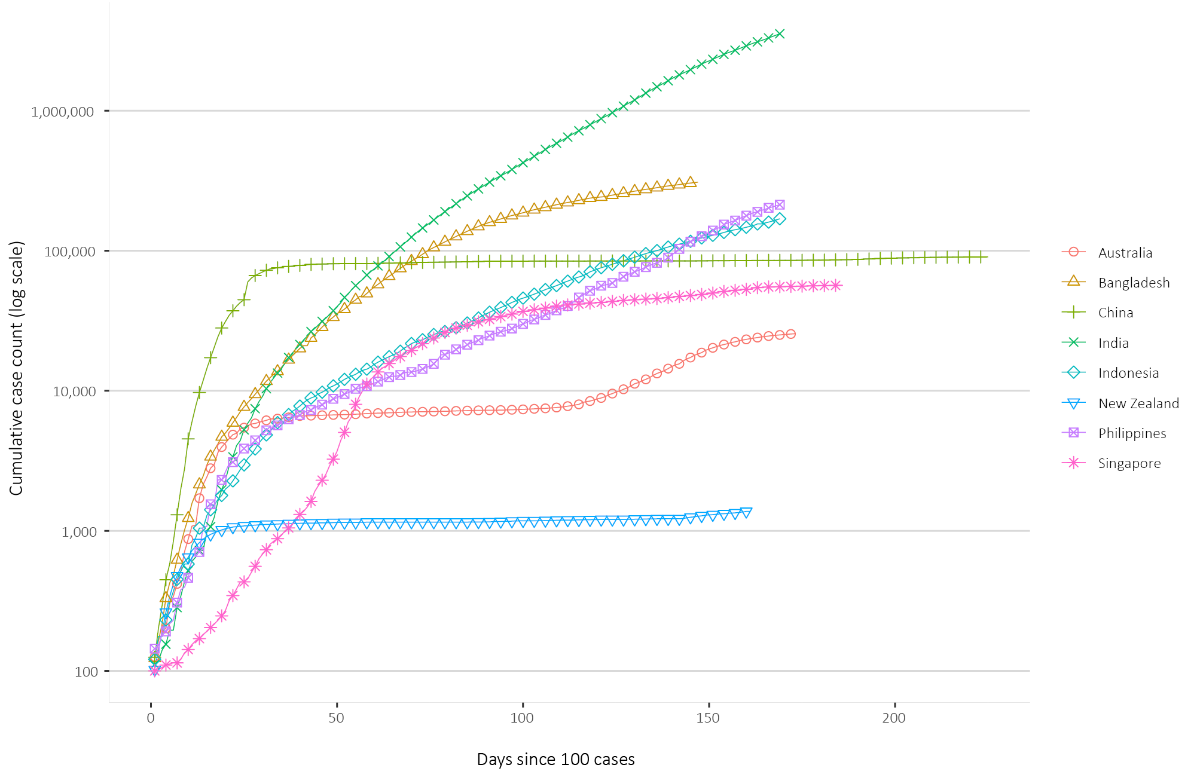
In this reporting period, Nepal has experienced a sharp increase of 15,780 confirmed cases representing a 42% increase of cumulative cases in the previous fortnight. On 9 September 2020, the government announced a loosening of the lockdown while maintaining some restrictions for the Kathmandu Valley where the majority of cases are reported. Indonesia reported a fortnightly case increase of 27% in this reporting period, and although largely concentrated in Jakarta, COVID-19 has spread to all 34 provinces. Stay-at-home restrictions and business closure measures have been put in place on 14 September 2020 and will remain until further notice.³⁶

Data considerations
Data were extracted from the NNDSS on 15 September 2020 for notifications received up to 13 September. Due to the dynamic nature of the NNDSS, numbers presented in this report are subject to revision and may vary from numbers previously reported and from case notifications released by states and territories.

Definitions
“Cluster” in relation to COVID-19 refers to two or more cases (who do not reside in the same household) that are epidemiologically related in time, place or person where a common source (such as an event or within a community) of infection is suspected but not yet established.
“COVID-19” is the disease caused by a novel coronavirus that emerged in China in late 2019. ‘CO’ stands for corona-, ‘V’ stands for virus, ‘ID’ stands for infectious disease, and ‘-19’ refers to the year that this disease was first reported.
“COVID-19 associated death” is defined for surveillance purposes as a death in a probable or confirmed COVID-19 case, unless there is a clear alternative cause of death that cannot be related to COVID-19 (e.g. trauma).³⁷ There should be no period of complete recovery from COVID-19 between illness and death. Where a Coroner’s report is available, these findings are to be observed.
“Date of illness onset” is derived from data collected by the NNDSS and represents the diagnosis date, or reported true onset of disease date. If unknown, the earliest of specimen collection date, notification date or notification receive date is used.
“Notification received date” is reported in the NNDSS and represents the date the case is first notified on the NNDSS. As notification can only occur after testing is completed and information processed, counts for a defined period will vary according to the date type used.
“Outbreak” in relation to COVID-19 refers to two or more cases (who do not reside in the same household) among a specific group of people and/or over a specific period of time where illness is associated with a common source (such as an event or within a community). Some states and territories may report a single case associated with a residential aged care facility as an outbreak.
“SARS-CoV-2” is the virus that causes the disease COVID-19. It is a betacoronavirus genetically related to the 2003 Severe acute respiratory syndrome coronavirus (SARS-CoV).
“This reporting period” refers to the period covered by this report, i.e. 31 August – 13 September 2020.

Acknowledgements
This report represents surveillance data reported through CDNA as part of the nationally-coordinated response to COVID-19. We thank public health staff from incident emergency operations centres in state and territory health departments, and the Australian Government Department of Health, along with state and territory public health laboratories.
The supplementary report at Appendix A was prepared by the public health technical team within the NIR. In particular we thank Dr Madeleine Marsland, Dr Elise Firman, Dr Jill Padrotta and, from the NIR Surveillance team, Ms Polly Wallace.

Author details

Corresponding author
COVID-19 National Incident Room Surveillance Team, Australian Government Department of Health, GPO Box 9484, MDP 14, Canberra, ACT 2601. Email: epi.coronavirus@health.gov.au

References
- Williams P, Sydney Children’s Hospital Network. COVID-19 literature repository: SARS-CoV-2 and inflammatory syndromes in children. Randwick: Sydney Children’s Hospital; 27 May 2020. [Accessed on 17 September 2020.] Available from: https://www.schn.health.nsw.gov.au/files/attachments/pims-ts_pw_27may2020.pdf.
- Davies P, Evans C, Kanthimathinathan HK, Lillie J, Brierley J, Waters G et al. Intensive care admissions of children with paediatric inflammatory multisystem syndrome temporally associated with SARS-CoV-2 (PIMS-TS) in the UK: a multicentre observational study. Lancet Child Adolesc Health. 2020;4:669–77.
- Dufort EM, Koumans EH, Chow EJ, Rosenthal EM, Muse A, Rowlands J et al. Multisystem inflammatory syndrome in children in New York State. N Engl J Med. 2020;383:347–58.
- Feldstein LR, Rose EB, Horwitz SM, Collins JP, Newhams MM, Son MBF et al. Multisystem inflammatory syndrome in U.S. children and adolescents. N Engl J Med. 2020;383:334–46.
- Ahmed M, Advani S, Moreira A, Zoretic S, Martinez J, Chorath K et al. Multisystem inflammatory syndrome in children: A systematic review. EClinicalMedicine. 2020;100527. doi: https://doi.org/10.1016/j.eclinm.2020.100527.
- Godfred-Cato S, Bryant B, Leung J, Oster ME, Conklin L, Abrams J et al. COVID-19–associated multisystem inflammatory syndrome in children — United States, March–July 2020. MMWR Morb Mortal Wkly Rep. 2020;69(32):1074–80.
- Toubiana J, Poirault C, Corsia A, Bajolle F, Fourgeaud J, Angoulvant F et al. Kawasaki-like multisystem inflammatory syndrome in children during the covid-19 pandemic in Paris, France: prospective observational study. BMJ. 2020;369:m2094. doi: https://doi.org/10.1136/bmj.m2094.
- Verdoni L, Mazza A, Gervasoni A, Martelli L, Ruggeri M, Ciuffreda M et al. An outbreak of severe Kawasaki-like disease at the Italian epicentre of the SARS-CoV-2 epidemic: an observational cohort study. Lancet. 2020;395(10239):1771–8.
- Centers for Disease Control and Prevention (CDC). Multisystem Inflammatory Syndrome (MIS-C). [Internet.] Atlanta: CDC; 2020. [Accessed on 17 September 2020.] Available from: https://www.cdc.gov/mis-c/cases/index.html.
- Safer Care Victoria (SCV), Victorian Agency for Health Information (VAHI). Alert: paediatric inflammatory multisystem syndrome. [Internet.] Melbourne: Victoria State Government, SCV, VAHI; 2020. [Accessed on 17 September 2020.] Available from: https://www.bettersafercare.vic.gov.au/news-and-media/alert-paediatric-inflammatory-multisystem-syndrome.
- Paediatric Active Enhanced Disease Surveillance (PAEDS). [Website.] Sydney: National Centre for Immunisation Research and Surveillance (NCIRS), PAEDS; 2020. Available from: http://www.paeds.org.au/.
- PAEDS. Surveillance and research: PIMS-TS. Case definition of paediatric inflammatory multisystem syndrome temporally associated with SARS-CoV-2 (PIMS-TS). [Internet.] Sydney: NCIRS, PAEDS; 2020. [Accessed on 17 September 2020.] Available from: http://paeds.org.au/our-work/surveillance-and-research.
- Whittaker E, Bamford A, Kenny J, Kaforou M, Jones CE, Shah P et al. Clinical characteristics of 58 children with a pediatric inflammatory multisystem syndrome temporally associated with SARS-CoV-2. JAMA. 2020;324(3):259–69.
- PAEDS. COVID-19, Kawasaki Disease (KD) and PIMS-TS in children. [Internet.] Sydney: NCIRS, PAEDS; 15 May 2020. [Accessed on 17 September 2020.] Available from: http://www.paeds.org.au/covid-19-kawasaki-disease-kd-and-pims-ts-children.
- Australian Government Department of Health. Coronavirus (COVID-19) advice for the health and aged care sector. [Internet.] Canberra: Australian Government Department of Health; 2020. [Accessed 13 August 2020.] Available from: https://www.health.gov.au/news/health-alerts/novel-coronavirus-2019-ncov-health-alert/coronavirus-covid-19-advice-for-the-health-and-aged-care-sector.
- Communicable Diseases Network Australia (CDNA). Coronavirus disease 2019 (COVID-19) outbreaks in residential care facilities: CDNA national guidelines for the prevention, control and public health management of COVID-19 outbreaks in residential care facilities in Australia. Canberra: Australian Government Department of Health, CDNA; 13 March 2020. [Accessed on 13 August 2020.] Available from: https://www.health.gov.au/sites/default/files/documents/2020/03/coronavirus-covid-19-guidelines-for-outbreaks-in-residential-care-facilities.pdf.
- Global Initiative on Sharing All Influenza Data (GISAID). [Website.] Berlin: Federal Republic of Germany, Freunde von GISAID e.V.; 2020. [Accessed on 17 September 2020.] Available from: https://www.gisaid.org/.
- Rockett RJ, Arnott A, Lam C, Sadsad R, Timms V, Gray KA et al. Revealing COVID-19 transmission in Australia by SARS-CoV-2 genome sequencing and agent-based modeling. Nat Med. 2020. doi: https://doi.org/10.1038/s41591-020-1000-7.
- Seemann T, Lane C, Sherry N, Duchene S, Goncalves da Silva A, Caly L et al. Tracking the COVID-19 pandemic in Australia using genomics. medRxiv. 2020 doi: https://doi.org/10.1101/2020.05.12.20099929.
- Eden JS, Rockett R, Carter I, Rahman H, de Ligt J, Hadfield J et al. An emergent clade of SARS-CoV-2 linked to returned travellers from Iran. Virus Evol. 2020;6(1):veaa027. doi: https://doi.org/10.1093/ve/veaa027.
- Prime Minister of Australia. Media statement: 04 Sep 2020. [Internet.] Canberra: Australian Government, Department of Prime Minister and Cabinet; 4 September 2020. [Accessed on 16 September 2020.] Available from: https://www.pm.gov.au/media/national-cabinet-040920.
- Victoria State Government. Coronavirus (COVID-19) roadmap to reopening. [Internet.] Melbourne: Victoria State Government; 2020. [Accessed on 16 September 2020.] Available from: https://www.vic.gov.au/coronavirus-covid-19-restrictions-roadmaps.
- Queensland Government. Going out, travel, recreation and gathering in Queensland. [Internet.] Brisbane: Queensland Government; 2020. [Accessed on 16 September 2020.] Available from: https://www.qld.gov.au/health/conditions/health-alerts/coronavirus-covid-19/current-status/public-health-directions/movements-gatherings.
- Government of New South Wales. What you can and can’t do under the rules. [Internet.] Sydney: Government of New South Wales; 2020. [Accessed on 16 September 2020.] Available from: https://www.nsw.gov.au/covid-19/what-you-can-and-cant-do-under-rules.
- Victoria State Government.Second Step - coronavirus road to recovery. [Internet.] Melbourne: Victoria State Government; 2020. [Accessed on 15 September 2020.] Available from: https://www.vic.gov.au/second-step-coronavirus-road-to-recovery.
- Government of Western Australia. COVID-19 coronavirus: WA Roadmap. [Internet.] Perth: Government of Western Australia; 2020. [Accessed on 15 September 2020.] Available from: https://www.wa.gov.au/organisation/department-of-the-premier-and-cabinet/covid-19-coronavirus-wa-roadmap.
- Government of South Australia. COVID-19 response: COVID response updates. [Internet.] Adelaide: Government of South Australia; 2020. [Accessed on 15 September 2020.] Available from: https://www.covid-19.sa.gov.au/recovery.
- Tasmanian Government. Coronavirus disease (COVID-19): current restrictions. [Internet.] Hobart: Tasmanian Government; 2020. [Accessed on 16 September 2020.] Available from: https://www.coronavirus.tas.gov.au/families-community/current-restrictions.
- Australian Capital Territory Government. Canberra’s recovery plan: easing of restrictions. [Internet.] Canberra: Australian Capital Territory Government; 21 August 2020. [Accessed on 1 September 2020.] Available from: https://www.covid19.act.gov.au/community/canberra-recovery.
- Northern Territory Government. Roadmap to the new normal. [Internet.] Darwin: Northern Territory Government; 2020. [Accessed on 16 September 2020.] Available from: https://coronavirus.nt.gov.au/roadmap-new-normal.
- World Health Organization (WHO). WHO Coronavirus Disease (COVID-19) dashboard. [Internet.] Geneva: WHO; 13 September 2020. [Accessed on 14 September 2020.] Available from: https://covid19.who.int/.
- New Zealand Government Ministry of Health. COVID-19 - Significant clusters. [Internet.] Wellington: New Zealand Government Ministry of Health; 2020. [Accessed on 14 September 2020.] Available from: https://www.health.govt.nz/our-work/diseases-and-conditions/covid-19-novel-coronavirus/covid-19-current-situation/covid-19-current-cases/covid-19-significant-clusters.
- New Zealand Government. Current alert level. [Internet.] Wellington: New Zealand Government; 2020. [Accessed on 14 September 2020.] Available from: https://covid19.govt.nz/covid-19/current-alert-level/.
- Papua New Guinea National Department of Health, WHO Representative Office for Papua New Guinea. Papua New Guinea Coronavirus Disease 2019 (COVID-19) Health Situation Report #38: 14 September 2020. Port Moresby: Papua New Guinea National Department of Health; 2020. [Accessed on 15 September 2020.] Available from: https://www.who.int/docs/default-source/wpro---documents/countries/papua-new-guinea/covid-19/png-covid-19-health-situation-report-38.pdf.
- Ministry of Health and Sports (Myanmar) Department of Public Health Central Epidemiology Unit. Situation Report 159: 13 September 2020. Naypyidaw: Government of Myanmar Ministry of Health and Sports; [Accessed on 13 Sept 2020.] Available from: http://mohs.gov.mm/su/pwgi6286PW.
- Kementerian Kesehatan Republik Indonesia. Infeksi Emerging. [Internet.] Jakarta: Indonesian Government Ministry of Health; 2020. [Accessed on 15 September 2020.] Available from: https://covid19.kemkes.go.id/situasi-infeksi-emerging/info-corona-virus/situasi-terkini-perkembangan-coronavirus-disease-covid-19-14-september-2020/.
- Australian Government Department of Health. Coronavirus Disease 2019 (COVID-19): CDNA National guidelines for public health units. [Internet.] Canberra: Australian Government Department of Health; 24 August 2020. [Accessed on 3 September 2020.] Available from: https://www1.health.gov.au/internet/main/publishing.nsf/Content/cdna-song-novel-coronavirus.htm.
- Australian Government Department of Health. Coronavirus (COVID-19) in Australia – Pandemic Health Intelligence Plan. [Internet.] Canberra: Australian Government Department of Health; 2020. [Accessed on 28 July 2020.] Available from: https://www.health.gov.au/news/health-alerts/novel-coronavirus-2019-ncov-health-alert/easing-of-coronavirus-covid-19-restrictions/coronavirus-covid-19-in-australia-pandemic-health-intelligence-plan.
- Australian Government Department of Health. Easing of coronavirus (COVID-19) restrictions. The 3-step framework for a COVIDSafe Australia. [Internet.] Canberra: Australian Government Department of Health; 2020. [Accessed on 28 July 2020.] Available from: https://www.health.gov.au/news/health-alerts/novel-coronavirus-2019-ncov-health-alert/coronavirus-covid-19-restrictions/easing-of-coronavirus-covid-19-restrictions#the-3step-framework-for-a-covidsafe-australia.
- Golding N, Shearer FM, Moss R, Dawson P, Liu D, Ross JV et al. Estimating temporal variation in transmission of SARS-CoV-2 and physical distancing behaviour in Australia: Technical Report 17 July 2020. Melbourne: Doherty Institute; 2020. [Accessed on 18 August 2020.] Available from: https://www.doherty.edu.au/uploads/content_doc/Technical_report_4_update_29July2020.pdf.
- Victorian Department of Health and Human Services (DHHS). Victoria’s restriction levels. [Internet.] Melbourne: Victoria State Government, DHHS; 2020. [Accessed on 29 July 2020.] Available from: https://www.dhhs.vic.gov.au/victorias-restriction-levels-covid-19.
- Queensland Government. Roadmap to easing restrictions. [Internet.] Brisbane: Queensland Government; 2020. [Accessed on 29 July 2020.] Available from: https://www.covid19.qld.gov.au/government-actions/roadmap-to-easing-queenslands-restrictions.
- Government of South Australia. South Australian roadmap for easing COVID-19 restrictions. Adelaide: Government of South Australia; 2020. [Accessed on 29 July 2020.] Available from: https://www.covid-19.sa.gov.au/__data/assets/pdf_file/0012/195879/200059.4-COVID-19-RoadMap-23June-V7.pdf.
- Australian Capital Territory Government. Changes to restrictions. [Internet.] Canberra: Australian Capital Territory Government; 2020. [Accessed on 29 July 2020.] Available from: https://www.covid19.act.gov.au/what-you-can-do/faqs-changes-to-restrictions.

Appendix A: A review of Australia’s public health response to COVID-19

Introduction
In early January 2020, Australia received reports of a cluster of cases of a novel coronavirus detected in Wuhan, Hubei Province, China. Between 17 January and 20 January, 136 new cases were identified in patients with previously unexplained pneumonia, bringing the total number to 204 confirmed cases. This significant increase, combined with limited evidence of human-to-human transmission, resulted in the activation of the National Incident Room (NIR).
Australia’s public health response to COVID-19 has been guided by the expertise of the Communicable Diseases Network Australia (CDNA), the Public Health Laboratory Network (PHLN), the Infection Control Expert Group (ICEG) and the Australian Health Protection Principal Committee (AHPPC).

Implementation of initial public health measures
Throughout late January and February, Australia monitored the evolving international situation and aimed to prevent importation of cases into Australia. From 29 January, close contacts of confirmed cases and travellers from Hubei Province China were required to quarantine in their homes for 14 days. Targeted international border measures were progressively expanded as the virus spread to new regions including mainland China, Iran, Italy and South Korea (Table A.1). Repatriated Australians from outbreak epicentres, including Wuhan and the Diamond Princess cruise ship (Japan), were required to undertake a 14-day stay in a designated quarantine facility.
Despite these efforts to prevent importation, during March 2020, transmission of COVID-19 progressively increased in Australia, culminating in a spike of several hundred cases reported each week (Figure 1). Modelling indicated that Australia was on the verge of an epidemic. Without implementing broad public health measures, a significant proportion of the population would contract the virus, leading to the healthcare system being overwhelmed and many deaths. On 27 February, the Prime Minister declared the COVID-19 outbreak a national pandemic, and on 12 March the World Health Organization declared a global pandemic.
On the advice of CDNA and AHPPC, throughout March and April 2020, Australia implemented a series of public health measures in response to the COVID-19 pandemic. These measures were broadly aimed at reducing the introduction and transmission of COVID-19 in the community; protecting vulnerable population groups including older Australians and Aboriginal and Torres Strait Islander communities; and building and safeguarding Australia’s health system capacity.
Key public health related measures are shown in Figure 8 and a complete list is provided in Table A.1. Broadly, these measures included:
- International border restrictions
- Domestic border restrictions by most states and territories
- Public health measures (eg. testing, contact tracing and quarantine/isolation)
- Individual measures (eg. personal hygiene and physical distancing)
- Community-level physical distancing measures (eg. restricting mass gatherings)
- Health system capacity measures (eg. increasing PPE supplies, training critical care staff, and securing pathology resources to test for COVID-19)

Table A.1. COVID-19 actions taken to date in Australia, 13 September 2020
Action category
International border measures
- Listed human disease
- Enhanced border screening
- Targeted border measures
  - Restrictions on travellers (air) from affected regions in China
  - Restrictions extended to travellers (air) from South Korea, Iran, Italy and China
  - Restrictions to cruise ship arrivals
  - Closure of external borders to foreign nationals
- Requirement to self-isolate (quarantine) for 14 days on return from overseas travel
- Mandated quarantine in designated facilities for 14 days on return from overseas travel
- Routine testing of individuals in designated quarantine facilities during the 14 day quarantine
Public health measures
- Intensive testing and isolation of suspected and confirmed cases
- Regular review and refinement of testing criteria to broaden as necessary and feasible
- Contact tracing and quarantine of close contacts
- Public messaging to self-quarantine and seek early medical care if experiencing respiratory symptoms (supported by HealthDirect, Symptom Checker, Telehealth, Respiratory clinics)
- Protection of the vulnerable – restrictions on visitors to aged care facilities and rural and remote communities (as per the Biosecurity Determination and Jurisdictional Directions)
- Stay-at-home policies aimed at people who are at high-risk of severe disease
- Stay-at-home policies for general public unless leaving to go to work, get supplies, medical care, or exercise
- Enhanced testing of community members to detect underlying transmission (e.g. ‘testing blitz’)
- COVIDSafe app launched to support contact tracing
Individual measures
- Hand hygiene
- Respiratory hygiene and cough etiquette
- 1.5m social/physical distancing rule
Community-level social/physical distancing measures
- Restrictions on gathering size (500 persons outside and 100 persons inside)
- Restrictions on indoor gathering density (1 person per 4 square metres)
- Restrictions on gathering size (10 persons outside and inside)
- Restrictions on and closure of non-essential businesses, premises and places
- Some schools pupil free or closed to varying degrees
- Restrictions on gathering size (2 persons outside unless household group)
- Restrictions on visitors to RACF and hospitals
Domestic travel restrictions
- Closure of some domestic borders to non-residents and returning residents requiring 14 days quarantine
- Hard closure of some domestic borders
- Lockdowns of geographically localised areas with elevated risk of community transmission
Health system capacity measures
- Secure surge and continued supply of equipment and consumables, including laboratory and PPE supplies
- Support COVID clinics, primary care and respiratory clinics
- Build public health capacity for surveillance and contact tracing, including laboratory capacity
- Build hospital and ICU bed capacity including staff training and redirecting hospital flow
- Secure additional ventilators, ICU equipment and consumables
- Elective surgery restrictions (to conserve PPE and contribute to increase ICU)

Impact of initial measures
Modelling has shown that by early April the effective reproduction number (R_{eff}) was less than one in all states and territories across Australia. Restrictions on international traveller arrivals, and imposing mandatory quarantine periods followed by enforced hotel quarantine, were critical to reducing importation of additional cases into Australia. Physical distancing and public health measures effectively minimised the limited local transmission already occurring. The combination of measures employed proved highly successful in suppressing growth of COVID-19 cases and ensuring sufficient health system capacity to manage the pandemic (Figure 6). By mid-April, Australia reported fewer than 30 new cases nationally each day, with the majority of these cases being acquired overseas and detected in hotel quarantine.

Adjustment of restrictions
The suppression strategy implemented by the Australian Government is intended to enable a degree of balance in the trade-off between adequately controlling virus transmission, and minimising economic and social disruption. Following Australia’s success in suppressing COVID-19, on 8 May the Australian Government announced the National Cabinet’s three-step framework for easing restrictions under the Pandemic Health Intelligence Plan.³⁸ Under the three-step framework, it was planned that restrictions would progressively ease over a period of three months to allow time to assess the impact of adjusting measures.³⁹
During March 2020, most states and territories in Australia implemented domestic border controls. By May 2020, this created a dichotomy wherein some states and territories achieved a state of no community transmission, whilst other states continued a ‘suppression’ strategy with some community transmission. As a result of this dichotomy, under the three-step framework, states and territories adjusted restrictions at their own pace depending on the local public health and epidemiological situation.
Broadly, measures that were adjusted across most states and territories included:
- Some public health measures (e.g. stay at home orders for the general public)
- Most community level physical distancing measures (macro-distancing) (e.g. restrictions on gathering size in households and public places, restrictions on visiting Residential Aged Care Facilities (RACF) and hospitals)
- Some health system capacity measures (e.g. restrictions on elective surgeries)
- Some relaxation of domestic border closures
By June or July 2020, most states and territories moved through the three-step framework and substantially eased restrictions. However, there was significant variability in the approaches adopted by states and territories (Table A.2). Some states including Western Australia and the Northern Territory have eased restrictions beyond the three-step framework without experiencing a resurgence of cases. Conversely, a resurgence of cases in Victoria, and later clusters in New South Wales and Queensland, has led to re-implementation of restrictions in response to the evolving situation (Figure 8 and Table A.2).

A resurgence of cases
From mid to late June until the end of this reporting period, there has been a resurgence of cases reported in Australia. This ‘second wave’ was primarily attributed to locally-acquired cases in Victoria, with some limited instances reported in New South Wales and Queensland. Unlike the ‘first wave’ in March where most cases were associated with returned international travellers, this resurgence has primarily been associated with local clusters and outbreaks, leading to community transmission in Victoria with a high proportion of cases having no known epidemiological link. As a result of this community-level transmission, the public health response prioritised case detection with high testing rates, isolation and management; contact tracing and quarantining of close contacts; and preventing spread to rural and remote regions.
In early July, Victoria implemented targeted lockdowns in suburbs with high levels of community transmission, before ordering metropolitan Melbourne into ‘stage 3’ restrictions (Figure 8). In addition, the border between New South Wales and Victoria closed to prevent exportation of cases into other states and territories. Throughout July, the epidemiological and public health situation continued to escalate, resulting in a higher peak in daily case notifications than in the ‘first wave’. Victoria progressively scaled up restrictions and on 2 August implemented ‘stage 4’ restrictions for metropolitan Melbourne and ‘stage 3’ restrictions for regional Victoria, and mandated the use of facemasks throughout Victoria (Figure 8).
As the outbreak evolved, states and territories across Australia reassessed plans to further ease restrictions. Surrounding jurisdictions including New South Wales, South Australia and Queensland tightened domestic border closures and re-implemented some restrictions on gatherings as a preventive measure. Consequently, the resurgence was largely contained to Victoria.
A national surge response has supported Victorian public health capacity. This included the establishment of the Victorian Aged Care Response Centre (VACRC) and national support for contact tracing efforts. Throughout August and September, case numbers in Victoria have progressively declined. On 13 September, Victoria commenced easing of restrictions against their ‘roadmap to reopening’,²² with metropolitan Melbourne entering ‘step 1’ and regional Victoria entering ‘step 2’. These steps do not align with the National Cabinet’s broader three-step framework, and will allow a slower reopening with the last step anticipated in November.
Table A.2. State and territory progress easing COVID-19 restrictions against National Cabinet’s three-step framework, 13 September 2020
Jurisdiction
New South Wales²⁴
- Commenced step 1 easing of restrictions on 15 May
- Commenced step 2 easing of restrictions on 1 June
- Commenced step 3 easing of restrictions on 1 July
- From 8 July the New South Wales/Victoria border closed
- Between 14 and 24 July re-implemented some step 2 restrictions
Victoria⁴¹
- Commenced step 1 easing of restrictions on 12 May
- Commenced step 2 easing of restrictions on 1 June
- Reduced easing of restrictions on 22 June due to increased transmission
- From 1 July implemented lockdowns in jurisdictional declared hotspot suburbs
- From 8 July implemented stage 3 lockdowns for metropolitan Melbourne and Mitchell Shire
- From 2 August implemented stage 4 lockdowns for metropolitan Melbourne and stage 3 lockdowns for regional Victoria and mandated the use of facemasks
- From 13 September commenced step 1 easing of restrictions in metropolitan Melbourne and step 2 easing of restrictions in regional Victoria, against Victoria’s ‘roadmap to reopening’
Queensland⁴²
- Commenced step 1 easing of restrictions on 8 May
- Commenced step 2 easing of restrictions on 1 June
- Commenced step 3 easing of restrictions on 3 July
- From 10 July domestic borders reopened (except to Victoria and people from jurisdictional declared hotspots)
- From 5 August domestic border closed to New South Wales
- From 2 September re-implemented some restrictions on gatherings
Western Australia²⁶
- Commenced step 1 easing of restrictions on 27 April
- Commenced step 2 easing of restrictions on 18 May
- Commenced step 3 easing of restrictions on 5 June
- Eased restrictions beyond the 3-step framework on 27 June
South Australia⁴³
- Commenced step 1 easing of restrictions on 11 May
- Commenced step 2 easing of restrictions on 1 June
- Commenced step 3 easing of restrictions on 29 June
- From 19 July border reopened to people from NT, Qld, WA and Tas
- Between 5 and 14 August re-implemented restrictions on gatherings
- From 28 August, commenced re-easing of restrictions to step 3
Tasmania28
- Commenced step 1 easing of restrictions on 18 May
- Commenced step 2 easing of restrictions on 5 June
- Commenced step 3 easing of restrictions on 26 June
Australian Capital Territory⁴⁴
- Commenced step 1 easing of restrictions on 8 May
- Commenced step 2 easing of restrictions on 29 May
- Commenced step 3 easing of restrictions on 10 August
Northern Territory30
- Commenced step 1 easing of restrictions on 1 May
- Commenced step 2 easing of restrictions on 15 May
- Commenced step 3 easing of restrictions on 5 June
- From 17 July domestic borders reopened (except to people from jurisdictional declared hotspots)

Adapting to an evolving situation
Modelling shows that as restrictions have eased across states and territories, the state-wide local transmission potential has increased.⁴⁰ As transmission potential increases, there is greater potential for the virus to establish and maintain community transmission. Consequently, it has been important for states and territories that have significantly eased restrictions to continue to prioritise preventing importation and maintaining micro-distancing behaviours (eg. physical distancing of 1.5 metres).
As part of the three-step framework, states and territories that implemented domestic border restrictions in March had planned to ease these restrictions in July. Due to the evolving situation in Victoria, although domestic border restrictions were eased in July, most states and territories maintained restrictions for those travelling from, or who have recently been in, Victoria. These measures are intended to prevent importation of locally acquired cases, which in states and territories with a high transmission potential, could lead to rapid propagation of growth.
National Cabinet have recently reviewed the three-step framework. Building on this framework, seven of eight jurisdictions have agreed in-principle to develop a ‘Roadmap for Recovery’ for adjusting restrictions throughout the remainder of 2020.²¹

Conclusion
The national public health response must be scalable and flexible. There is the potential for the virus to rapidly spread, and for COVID-19 case numbers to escalate once seeded. States and territories must respond quickly when cases emerge to avoid rapid propagation of growth. Australia must continue to balance controlling the disease against the significant societal, economic and other health impacts of restrictions. A delicate balance exists on a local and national scale to ensure the best outcome for Australia and its people.

Appendix B: Supplementary figures and tables
Table B.1. COVID-19 case notifications and rates per 100,000 populationª, by age group and sex, 13 September 2020, Australia
Age Group | This reporting period  31 August—13 September 2020 |  |  |  |  |  | Cumulative
 | Cases |  |  | Rate per 100,000 population |  |  | Cases |  |  | Rate per 100,000 population
 | Male | Female | Total | Male | Female | Total | Male | Female | Total | Male | Female | Total
0—9 | 26 | 27 | 53 | 1.6 | 1.7 | 1.7 | 695 | 622 | 1,318 | 42.5 | 40.1 | 41.4
10—19 | 46 | 42 | 88 | 2.9 | 2.8 | 2.9 | 1,157 | 1,095 | 2,252 | 73.7 | 73.7 | 73.7
20—29 | 78 | 106 | 184 | 4.2 | 5.9 | 5.0 | 2,881 | 3,172 | 6,078 | 155.1 | 176.1 | 166.1
30—39 | 55 | 62 | 117 | 3.0 | 3.3 | 3.2 | 2,322 | 2,282 | 4,620 | 127.7 | 123.0 | 125.7
40—49 | 29 | 52 | 81 | 1.8 | 3.1 | 2.5 | 1,701 | 1,695 | 3,425 | 105.1 | 102.3 | 104.6
50—59 | 27 | 41 | 68 | 1.8 | 2.6 | 2.2 | 1,521 | 1,647 | 3,177 | 100.9 | 104.7 | 103.1
60—69 | 20 | 21 | 41 | 1.6 | 1.6 | 1.6 | 1,136 | 1,172 | 2,310 | 89.3 | 87.3 | 88.4
70—79 | 21 | 18 | 39 | 2.4 | 2.0 | 2.2 | 828 | 736 | 1,564 | 95.2 | 79.8 | 87.3
80—89 | 21 | 33 | 54 | 5.9 | 7.2 | 6.6 | 480 | 760 | 1,240 | 134.3 | 164.8 | 151.5
90 + | 10 | 29 | 39 | 14.6 | 21.7 | 19.3 | 224 | 538 | 763 | 326.4 | 402.8 | 377.4
a Cases and rates for persons include 83 cases identified as gender X or unknown gender.

Figure B.1. Variation in combinations of COVID-19 symptoms in confirmed cases as at 13 September 2020, Australiaª
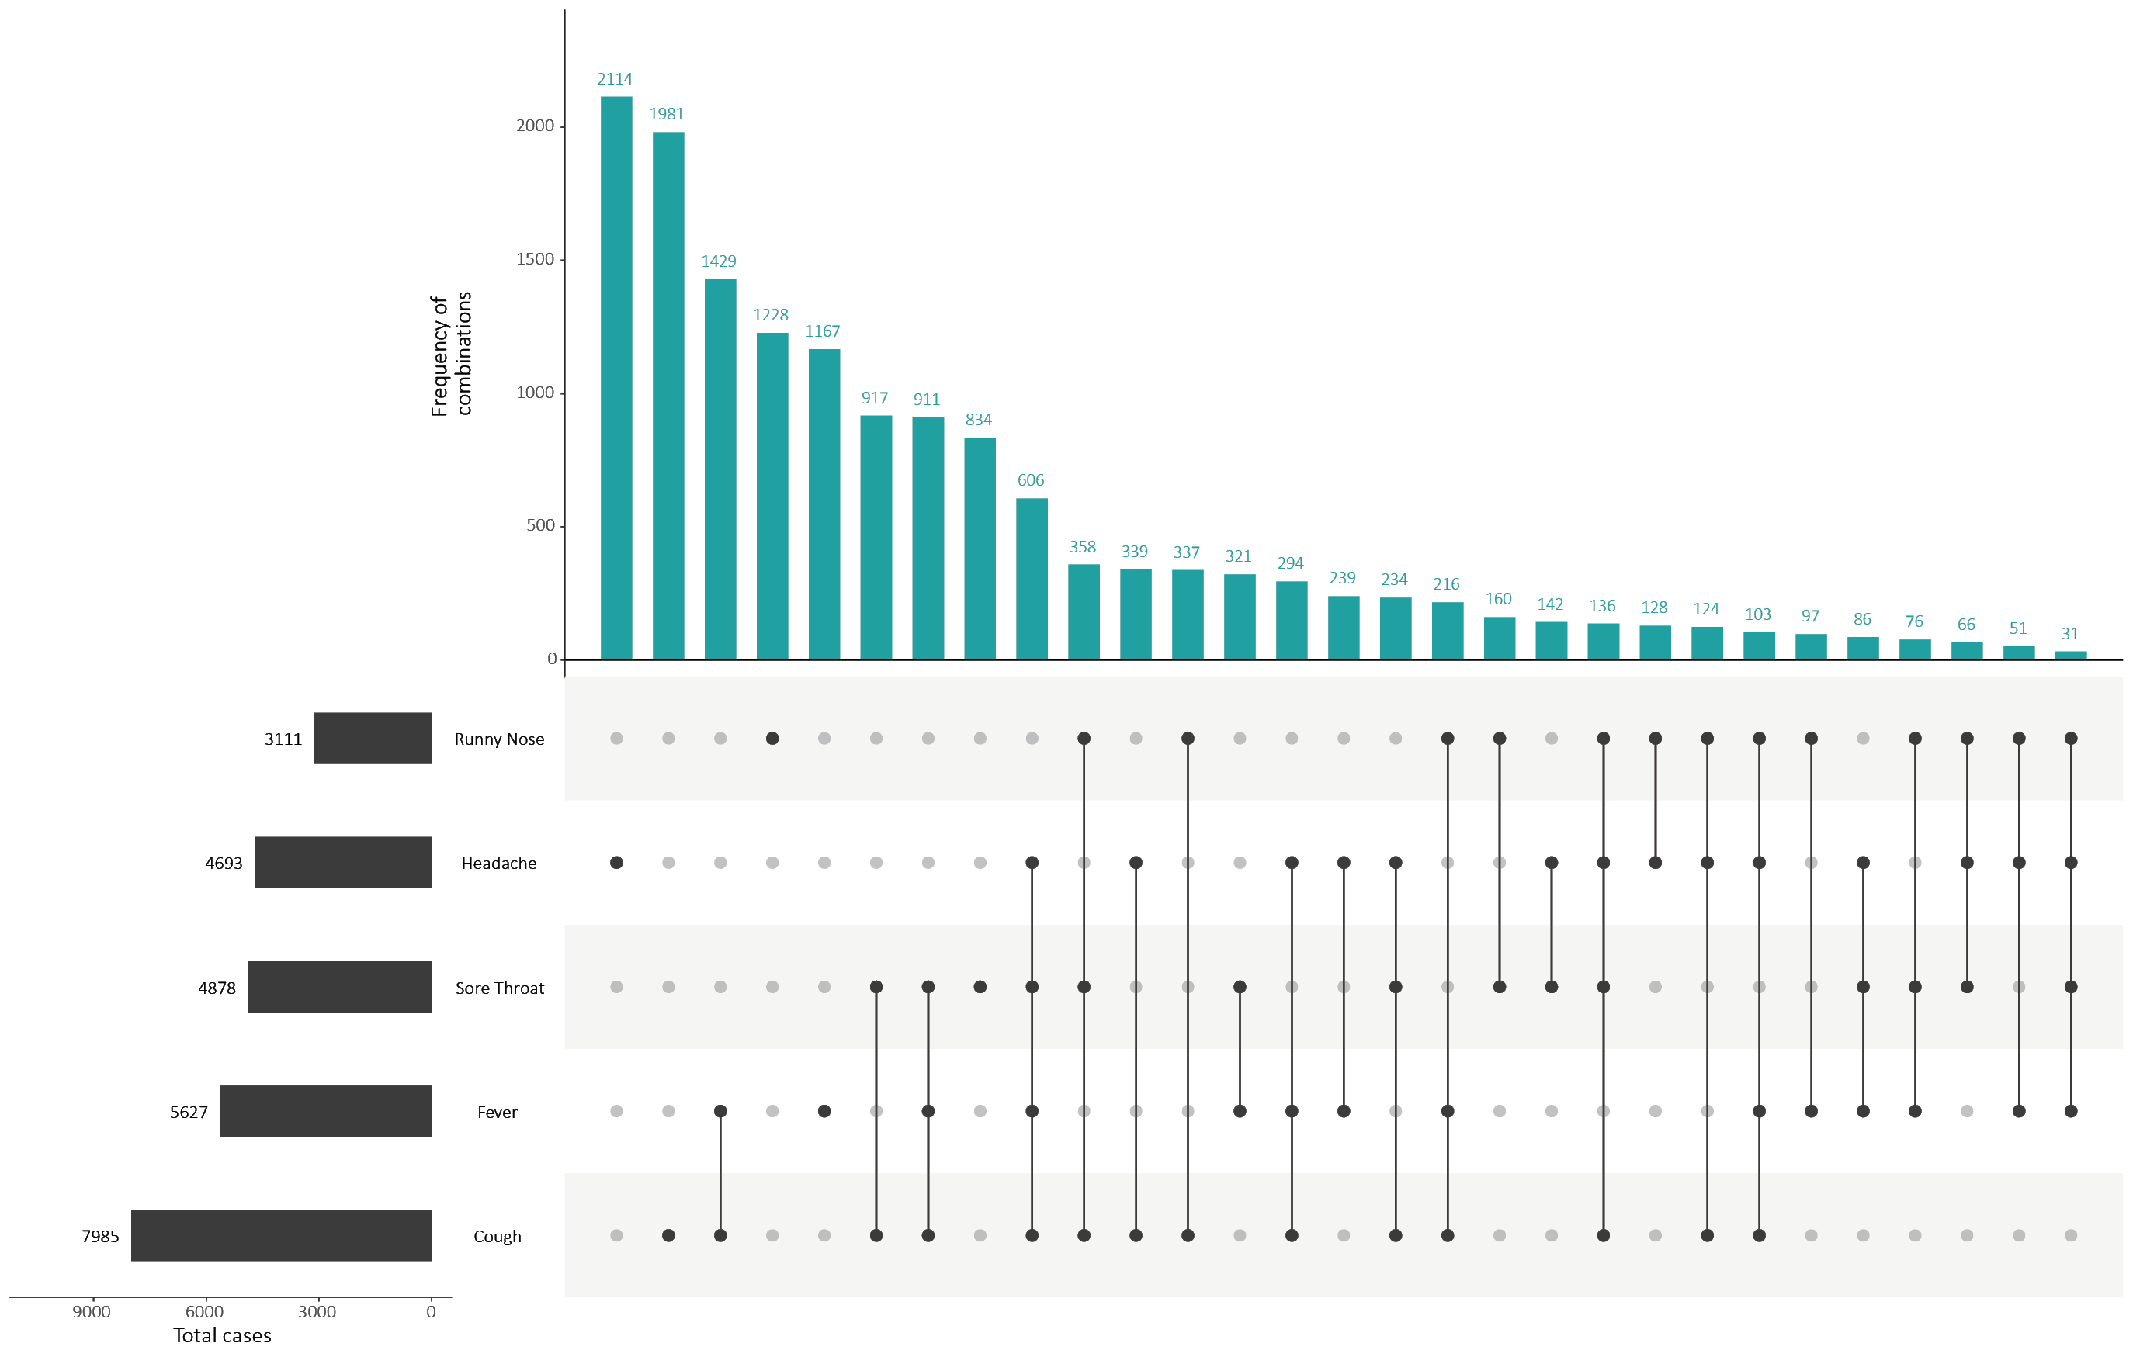
a This figure shows the variation in combinations of symptoms observed in reported cases (n = 12,636) for the five most frequently observed symptoms (cough, fever, headache, sore throat, runny nose). The horizontal bars on the left show the frequency of symptom occurrence in any combination with other symptoms. The circles and lines indicate particular combinations of symptoms observed in individual patients. The vertical green bars indicate the frequency of occurrence of the corresponding combination of symptoms.

Figure B.2. Heat maps showing COVID-19 locally-acquired case notifications by place of residence, Australia, 31 August to 13 September 2020
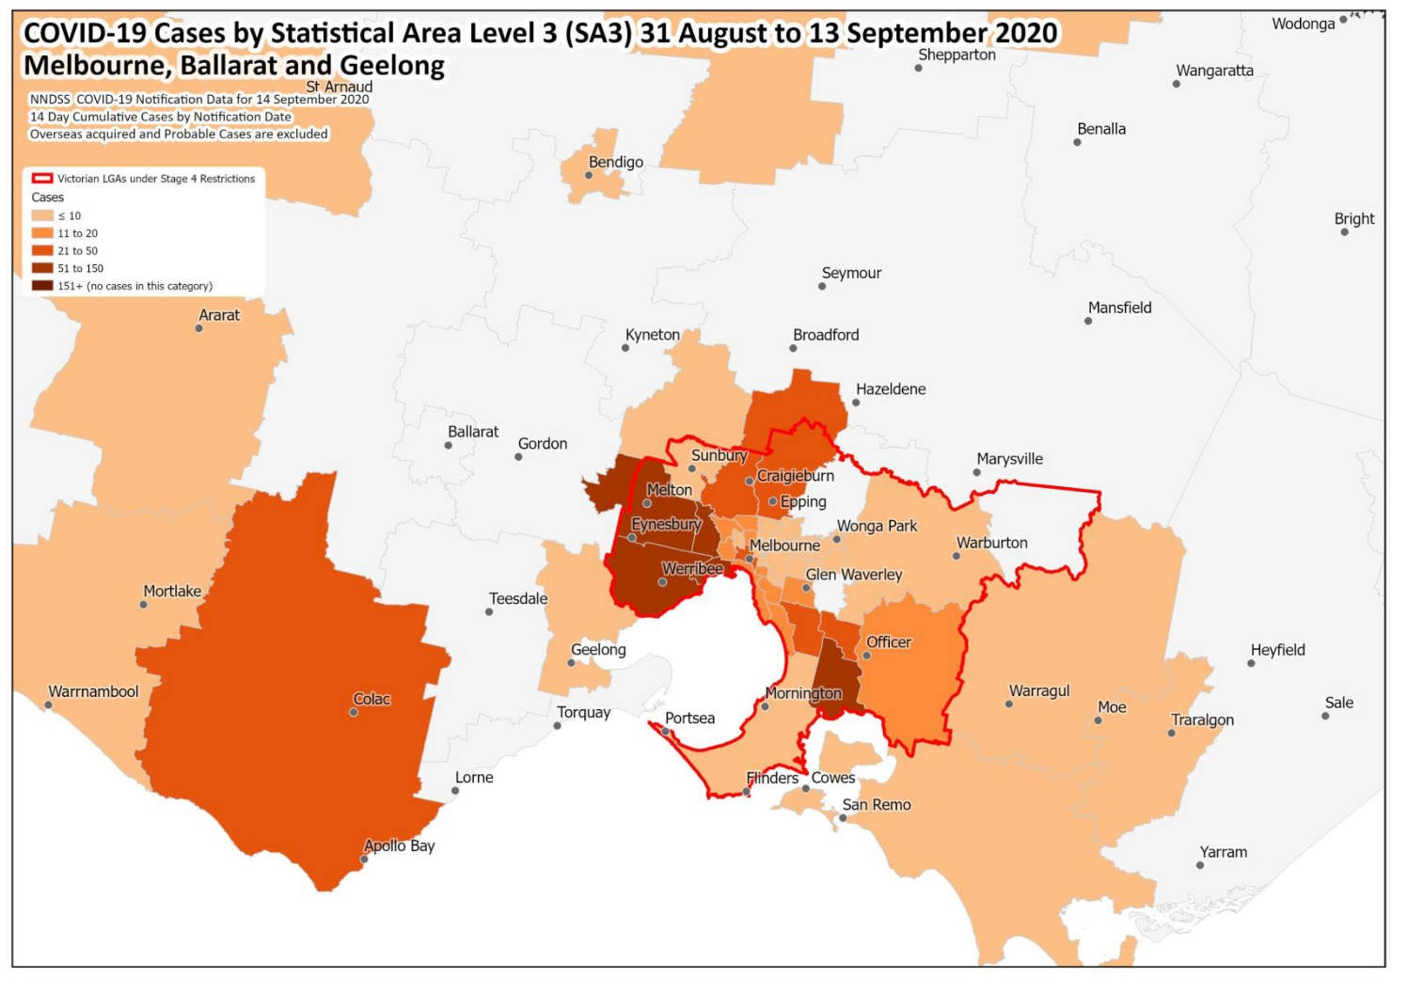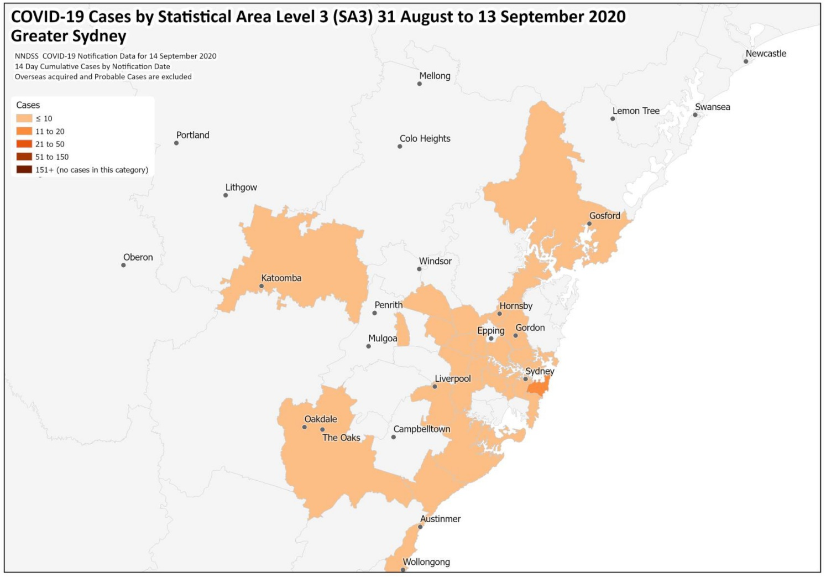
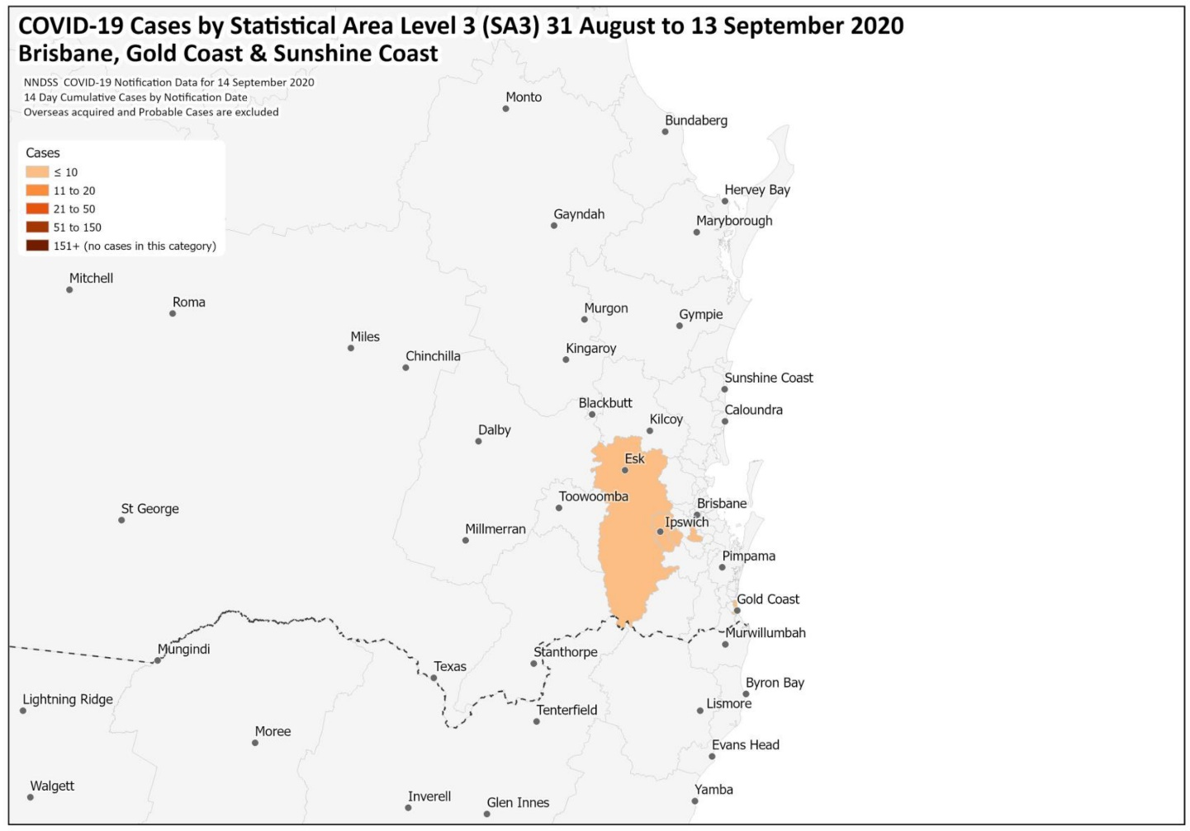
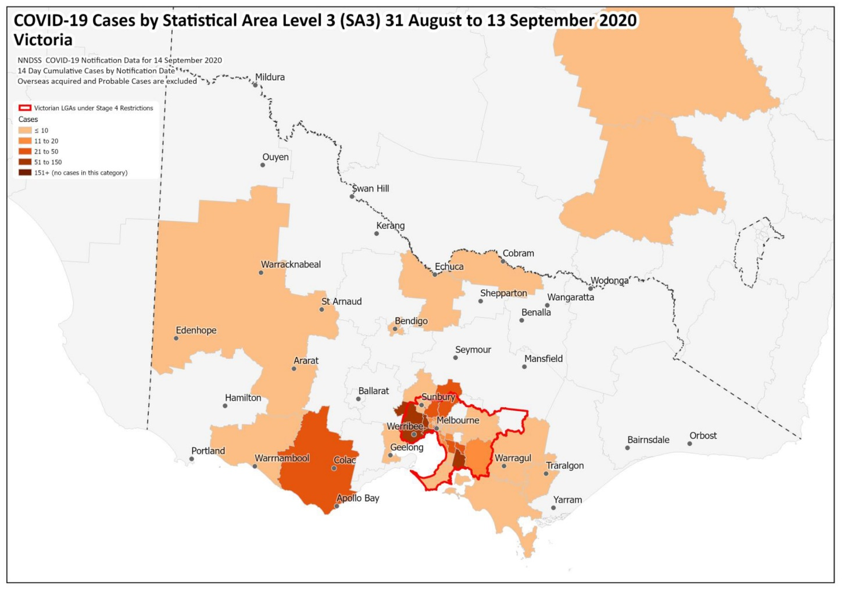

Appendix C: Frequently asked questions
Q: Can I request access to the COVID-19 data behind your CDI fortnightly reports?
A: National notification data on COVID-19 confirmed cases is collated in the National Notifiable Disease Surveillance System (NNDSS) based on notifications made to state and territory health authorities under the provisions of their relevant public health legislation.
Normally, requests for the release of data from the NNDSS requires agreement from states and territories via the Communicable Diseases Network Australia, and, depending on the sensitivity of the data sought and proposed, ethics approval may also be required.
Due to the COVID-19 response, unfortunately, specific requests for NNDSS data have been put on hold. We are currently looking into options to be able to respond to data requests in the near future.
We will continue to publish regular summaries and analyses of the NNDSS dataset and recommend the following resources be referred to in the meantime:
- NNDSS summary tables: http://www9.health.gov.au/cda/source/cda-index.cfm
- Daily case summary of cases: https://www.health.gov.au/news/health-alerts/novel-coronavirus-2019-ncov-health-alert/coronavirus-covid-19-current-situation-and-case-numbers
- Communicable Diseases Intelligence COVID-19 epidemiology report: https://www1.health.gov.au/internet/main/publishing.nsf/Content/novel_coronavirus_2019_ncov_weekly_epidemiology_reports_australia_2020.htm
- State and territory public health websites.
Q: Can I request access to data at post-code level of confirmed cases?
A: Data at this level cannot be released without ethics approval and permission would need to be sought from all states and territories via the Communicable Diseases Network Australia. As noted above, specific requests for NNDSS data are currently on hold.
Where current or recent reported case numbers are high enough to justify it, a GIS/mapping analysis of cases will be included in the Communicable Diseases Intelligence COVID-19 epidemiology report. In order to protect privacy of confirmed cases, data in this map will be presented at SA3 level.
Q: Where can I find more detailed data on COVID-19 cases?
A: We are currently looking into ways to provide more in-depth epidemiological analyses of COVID-19 cases, with regard to transmission and severity, including hospitalisation. These analyses will continue to be built upon in future iterations of the Communicable Diseases Intelligence report.
Q: Where do I find the COVID-19 background information which was included as Appendix A in previous fortnightly epidemiology reports?
A: This information was most recently published in Epidemiology Report 24 (https://doi.org/10.33321/cdi.2020.44.75.) Additional information can be found in the CDNA Series of National Guidelines (SoNG) for COVID-19. (https://www1.health.gov.au/internet/main/publishing.nsf/Content/cdna-song-novel-coronavirus.htm)
Communicable Diseases Intelligence
ISSN: 2209-6051 Online

Communicable Diseases Intelligence (CDI) is a peer-reviewed scientific journal published by the Office of Health Protection, Department of Health. The journal aims to disseminate information on the epidemiology, surveillance, prevention and control of communicable diseases of relevance to Australia.

Editor: Tanja Farmer
Deputy Editor: Simon Petrie
Design and Production: Kasra Yousefi
Editorial Advisory Board: David Durrheim, Mark Ferson, John Kaldor, Martyn Kirk and Linda Selvey

Website: http://www.health.gov.au/cdi

Contacts
Communicable Diseases Intelligence is produced by:
Health Protection Policy Branch, Office of Health Protection, Australian Government Department of Health
GPO Box 9848, (MDP 6) CANBERRA ACT 2601

Email: cdi.editor@health.gov.au

Submit an Article
You are invited to submit your next communicable disease related article to the Communicable Diseases Intelligence (CDI) for consideration. More information regarding CDI can be found at: http://health.gov.au/cdi.
Further enquiries should be directed to: cdi.editor@health.gov.au.

This journal is indexed by Index Medicus and Medline.

Creative Commons Licence - Attribution-NonCommercial-NoDerivatives CC BY-NC-ND
© 2020 Commonwealth of Australia as represented by the Department of Health
This publication is licensed under a Creative Commons Attribution-NonCommercial-NoDerivatives 4.0 International Licence from https://creativecommons.org/licenses/by-nc-nd/4.0/legalcode (Licence). You must read and understand the Licence before using any material from this publication.

Restrictions
The Licence does not cover, and there is no permission given for, use of any of the following material found in this publication (if any):
- the Commonwealth Coat of Arms (by way of information, the terms under which the Coat of Arms may be used can be found at www.itsanhonour.gov.au);
- any logos (including the Department of Health’s logo) and trademarks;
- any photographs and images;
- any signatures; and
- any material belonging to third parties.

Disclaimer
Opinions expressed in Communicable Diseases Intelligence are those of the authors and not necessarily those of the Australian Government Department of Health or the Communicable Diseases Network Australia. Data may be subject to revision.

Enquiries
Enquiries regarding any other use of this publication should be addressed to the Communication Branch, Department of Health, GPO Box 9848, Canberra ACT 2601, or via e-mail to: copyright@health.gov.au

Communicable Diseases Network Australia
Communicable Diseases Intelligence contributes to the work of the Communicable Diseases Network Australia.
http://www.health.gov.au/cdna

This report addresses indicators listed in the CDNA National Surveillance Plan 2020.

