• Volume • • Electronic publication date:

Report on influenza viruses received and tested by the Melbourne WHO Collaborating Centre for Reference and Research on Influenza during 2023

Tanya R Diefenbach-Elstob, Olivia Lay, Tasoula Zakis, Nikita Deshpande, Sally Soppe, Heidi Peck, Saira Hussain, Yi-Mo Deng, Clyde Dapat, Kanta Subbarao, Ian G Barr

# Abstract

As part of its role in the World Health Organization’s (WHO) Global Influenza Surveillance and Response System (GISRS), the WHO Collaborating Centre for Reference and Research on Influenza in Melbourne received a record 15,014 human influenza-positive samples during 2023. Viruses were analysed for their antigenic, genetic, and antiviral susceptibility properties. Selected viruses were propagated in qualified cells or embryonated hens’ eggs for potential use in seasonal influenza virus vaccines. During 2023, influenza A(H1N1)pdm09 and influenza B/Victoria viruses predominated, accounting for 37% and 28% respectively of all viruses received, compared to 12% for influenza A(H3N2). The majority of A(H1N1)pdm09, A(H3N2) and influenza B viruses analysed at the Centre were found to be antigenically and genetically similar to the respective WHO recommended vaccine strains for the southern hemisphere in 2023. Of 5,531 samples tested for susceptibility to the neuraminidase inhibitors oseltamivir and zanamivir, seven A(H1N1)pdm09 viruses showed highly reduced inhibition against oseltamivir.

Keywords: influenza; vaccine; GISRS; surveillance; laboratory; annual report; WHO

# Introduction

The WHO Collaborating Centre for Reference and Research on Influenza in Melbourne (the Centre) is part of the World Health Organization (WHO) Global Influenza Surveillance and Response System (GISRS). GISRS is a global network of laboratories that was established in 1952 to monitor changes in influenza viruses circulating in the human population, with the aim of reducing influenza’s impact through the use of vaccines and antiviral drugs.1,2 The Centre in Melbourne, designated by WHO in 1992, is one of five Collaborating Centres, with the others located in Atlanta, Beijing, London, and Tokyo. These Centres monitor antigenic and genetic changes in circulating human influenza viruses, and participate in making the WHO biannual recommendations on which influenza strains should be included in the vaccine for the upcoming influenza season in the northern or southern hemisphere. This report summarises the results of virological surveillance activities undertaken at the Centre in Melbourne during 2023. Influenza activity during 2020–2021 was sharply reduced by government restrictions and non-pharmaceutical interventions that were introduced in response to the COVID-19 pandemic: according to National Notifiable Diseases Surveillance System (NNDSS) data, there were only 21,352 laboratory-confirmed influenza notifications in 2020 and 749 notifications in 2021, compared to 313,648 notifications in 2019.3,4 However, there was substantially increased influenza activity during 2022 and 2023, with 233,447 and 288,992 notifications respectively.3

Two types of influenza viruses (A and B) cause significant disease in humans. Influenza A viruses are further classified into subtypes based on their haemagglutinin (HA) and neuraminidase (NA) surface proteins. Globally, there are currently two influenza A subtypes circulating in the human population: A(H1N1)pdm09 and A(H3N2). Influenza B viruses are not classified into subtypes, although in past years there have been two distinct co-circulating lineages: B/Victoria/2/1987 (B/Victoria lineage) and B/Yamagata/16/1988 (B/Yamagata lineage). However, no B/Yamagata viruses have been confirmed since March 2020, and it has been postulated that during the COVID-19 pandemic this lineage may have become extinct.5 Influenza C viruses are also detected each year from humans, but these viruses do not cause severe disease and are not a major focus of influenza surveillance.

# Methods

The Centre receives influenza-positive samples for surveillance purposes from submitting laboratories predominantly in Australia and other countries in the Asia-Pacific region. This report includes all surveillance samples received by the Centre in 2023; thus, a small number of viruses collected in earlier years are also included.

Virus isolation

All A(H1N1)pdm09 and influenza B original clinical specimens and viral isolates received at the Centre were passaged in cell culture using Madin-Darby Canine Kidney (MDCK) cells, while all A(H3N2) original clinical specimens and viral isolates were passaged in MDCK-SIAT-1 cells.6 Untyped influenza A viruses were passaged in MDCK-SIAT-1 cells. A subset of influenza-positive original clinical samples were directly inoculated into eggs and a qualified cell line (MDCK 33016PF) to generate potential candidate influenza vaccine viruses.

## Antigenic analysis

The antigenic properties of influenza viral isolates were analysed using the haemagglutination inhibition (HI) assay as previously described,7 and a subset of A(H3N2) viruses were additionally analysed by the focus reduction assay (FRA). HI assays were performed manually or using the TECAN Freedom EVO200 robot platform which incorporates a camera (SciRobotics, Kfar Saba, Israel) and imaging software (FluHemaTM) for analysis. In HI assays, viruses were tested for their ability to agglutinate red blood cells (RBC) in the presence of receptor-destroying enzyme (RDE)-treated post-infection ferret antisera raised against several reference viruses. Turkey RBCs were used for A(H1N1)pdm09 and B viruses, and guinea pig RBCs were used for A(H3N2) viruses. Isolates were identified as antigenically similar to the reference strain if the test samples had a titre that was no more than fourfold lower than the titre of the homologous reference strain. In 2023, results were reported with reference to the viruses that were recommended for inclusion in the 2023 southern hemisphere influenza vaccine (Table 1).

Table 1: Southern hemisphere influenza vaccine reference strains used for reporting purposes by the Centre, 2023

| Subtype/lineage | 2023 cell | 2023 egg |
| --- | --- | --- |
| A(H1N1)pdm09 | A/Sydney/5/2021 (H1N1pdm09)-like | A/Sydney/5/2021 (H1N1pdm09)-like |
| A(H3N2) | A/Darwin/6/2021 (H3N2)-like | A/Darwin/9/2021 (H3N2)-like |
| B/Victoria-lineage | B/Austria/1359417/2021 (B/Victoria lineage)-like | B/Austria/1359417/2021 (B/Victoria lineage)-like |
| B/Yamagata-lineage | B/Phuket/3073/2013 (B/Yamagata lineage)-like | B/Phuket/3073/2013 (B/Yamagata lineage)-like |

In recent years (including 2023), HI assays involving A(H3N2) viruses have been performed in the presence of 20 nM oseltamivir carboxylate (OC) to reduce non-specific binding of the NA protein.8 The addition of OC can reduce the number of influenza virus isolates that could be tested by HI, as viruses may lose the ability to bind RBC. This was not the case in 2023, as none of the H3N2 viruses lost their ability to bind to RBC, and all isolates with sufficient titre were able to be tested using the HI assay. The Centre still tested a subset of H3N2 viruses using the FRA, a microneutralisation assay which is more sensitive than the HI assay and does not require binding to RBCs.6 The FRA utilised the same ferret antisera as the HI assay and was performed as previously described,7 but with 1.2% Avicell RC591 (IMCD Mulgrave, Australia) replacing carboxymethyl cellulose.

## Genetic analysis

For influenza-positive samples that failed to grow in MDCK cells, real-time reverse transcription (RT-PCR) was performed to determine the influenza type/subtype/lineage using the CDC Influenza Virus Real-Time RT-PCR PCR kit.9,10,[1] A subset of influenza viruses underwent genetic analysis by sequencing of viral RNA, usually of HA and NA genes as well as the matrix gene for influenza A viruses. Whole genome sequencing (WGS) of a smaller subset of viruses was performed by next generation sequencing (NGS) using Illumina iSeq100 or Oxford Nanopore Technology (ONT) MinION platforms according to the manufacturer’s recommendations.

For sequencing, RNA was extracted from isolates or original clinical specimens using either a manual QIAGEN QIAamp Viral RNA kit or the automated QIAGEN QIAXtractor platform. A small number of samples were Sanger sequenced following RT-PCR with the BIOLINE MyTaq one step reverse transcription PCR kit; gene-specific primers (primer sequences available on request) were used to amplify the HA, NA, and MP genes, and then sequencing was carried out on purified PCR products using an Applied Biosystems 3500XL Genetic Analyzer (Applied Biosystems, Foster City, CA, USA) as previously described.11 Sequence assembly was performed using Geneious Prime software version 9.0.4 (Biomatters Ltd, Auckland, New Zealand).

Most samples were sequenced using the multi-fragment RT-PCR (mRT-PCR) for either WGS or targeted sequencing of the HA, NA, and MP genes for influenza A, or the HA and NA genes for influenza B, using SuperScriptIV one-step RT-PCR System (ThermoFisher) with primer sets as described previously.12,13 NGS was conducted using an Illumina iSeq 100 according to the manufacturer’s recommendations. Sequence data was analysed using an adaption of the IRMA pipeline.12,14 Phylogenetic analysis was performed using the Augur pipeline,15 and trees were constructed using IQ-TREE 2,16 with 1,000 bootstrap replicates and generalized-time reversible (GTR) model, and visualised using ggtree.17 Some viruses were sequenced externally with results provided by the submitting laboratory.

HA clade nomenclature was updated for A(H1N1)pdm09 and A(H3N2) viruses during 2023. Consequently, all clades were verified against data uploaded to Nextclade, and/or against internal or external sequencing results (for viruses not uploaded to Nextclade).

## Antiviral drug susceptibility testing

Circulating viruses were tested for their susceptibility to the currently used neuraminidase inhibitors oseltamivir (Tamiflu) and zanamivir (Relenza). Virus isolates were tested for antiviral susceptibility using a fluorescence-based neuraminidase inhibition assay (NAI) with the substrate 2’-(4-methylumbelliferyl)-α-D-N-acetylneuraminic acid (MUNANA). The susceptibility of test viruses to the antiviral drugs was measured in terms of the drug concentration needed to reduce the influenza neuraminidase enzymatic activity by 50% (IC50) and compared to values obtained with reference viruses of the same subtype or lineage. NAI assays were performed as previously described,18 either manually or with the incorporation of a robotic platform by TECAN EVO200 and Infinite 200 Pro for liquid handling and fluorescence measurements respectively (Tecan Australia). For reporting purposes, highly reduced susceptibility of influenza A viruses has been defined by WHO as a ≥ 100-fold increase in IC50 compared to normally susceptible influenza A viruses in an NAI assay.19 For influenza B viruses, this figure was a ≥ 50 fold-increase compared to normal influenza B viruses.19 However, it should be noted that the relationship between the IC50 value and the clinical effectiveness of a neuraminidase inhibitor is not yet well understood and a small or moderate reduction in inhibition may not be clinically significant.

Viruses found to have highly reduced susceptibility to either oseltamivir or zanamivir underwent genetic analysis using Sanger sequencing or NGS to determine the presence of amino acid substitutions in the NA protein that are associated with reduced inhibition by neuraminidase inhibitors. For example, a change from histidine to tyrosine at position 275 (H275Y) of the NA protein of A(H1N1)pdm09 viruses is known to significantly reduce inhibition by oseltamivir, as does the H273Y NA mutation in B viruses.18 Genetic evidence of reduced susceptibility to baloxavir marboxil was identified using Sanger sequencing or NGS of the PA gene, as well as from mutations identified in external sequencing results provided by submitting laboratories.

## Candidate vaccine strains

The viruses used to produce human influenza vaccines are required by regulatory authorities to be isolated and passaged in embryonated hens’ eggs or qualified cell lines,20–22 directly from human clinical respiratory samples. The Centre has undertaken primary isolation of selected viruses from clinical samples directly into eggs, using previously described methods.23 Briefly, the viruses were inoculated into the amniotic cavity of embryonated eggs; once virus growth was established, isolates were passaged in the allantoic cavity until a sufficient titre was obtained. Egg incubation conditions differed slightly, with A(H1N1)pdm09 and A(H3N2) viruses incubated at 35 °C for three days, and influenza B viruses incubated at 33 °C for three days. In addition, selected clinical samples were inoculated into the qualified cell line MDCK 33016PF (Seqirus Limited, Holly Springs, NC, USA)24 and incubated at 35 °C for three days, with viral growth monitored by haemagglutination of turkey or guinea pig RBC. These isolates were then analysed by HI assay, real time RT-PCR and genetic sequencing using the methods described above.

# Results

During 2023, the Centre received 15,014 samples (including 13,226 clinical specimens, 1,050 virus isolates, 733 specimen and isolate pairs, and five RNA/DNA samples) from 47 laboratories in 23 countries (Figure 1). Australian laboratories sent the highest number of samples to the Centre (n = 12,136; 81%), followed by laboratories in Fiji (n = 663; 4.4%), New Zealand (n = 371; 2.5%), and Malaysia (n = 334; 2.2%). Of the 15,014 samples received, 13,864 (92%) were collected in 2023. The majority of samples collected in 2023 were received by the Centre during the May–August period (n = 7,888/13,864; 57%). Figure 2 depicts the weekly temporal distribution of samples sent to the Centre in 2023 by type and subtype/lineage. During 2023, A(H1N1)pdm09 was the predominant circulating strain, closely followed by B/Victoria, with less A(H3N2) received throughout most of the year. No influenza B samples were identified as B/Yamagata viruses.

Figure 1: Geographic distribution of influenza laboratories sending viruses to the Centre in 2023

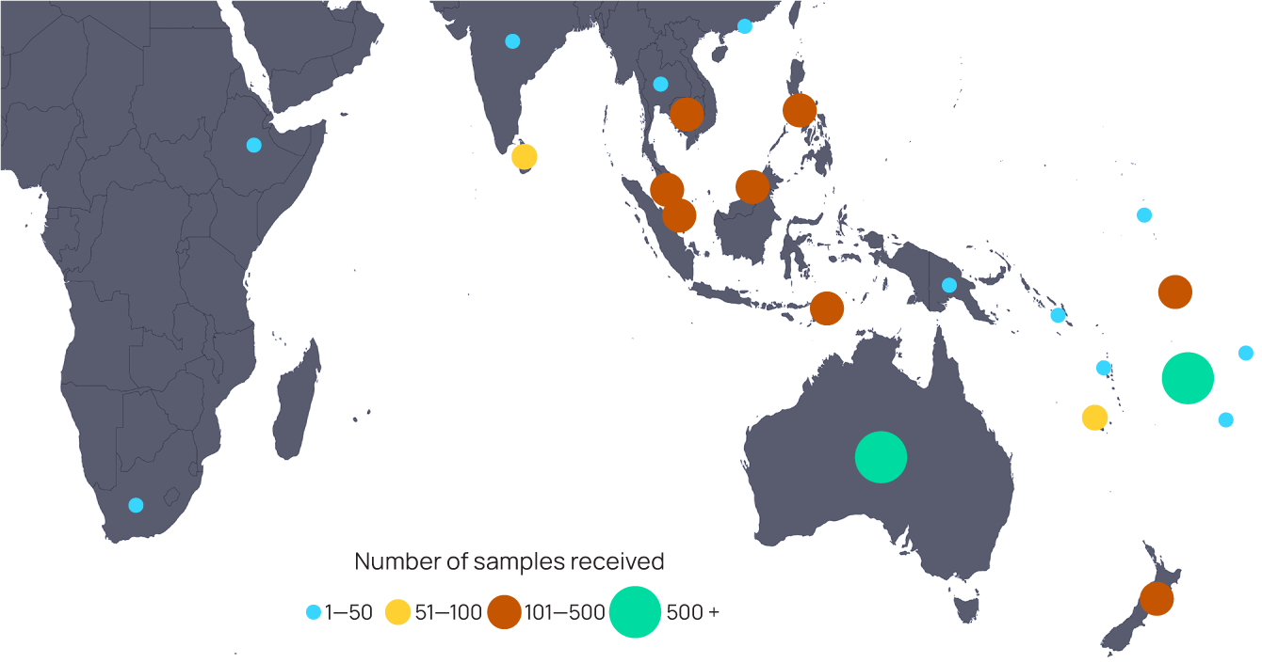

Figure 2: Number of samples received at the Centre during 2023 by week of sample receipt

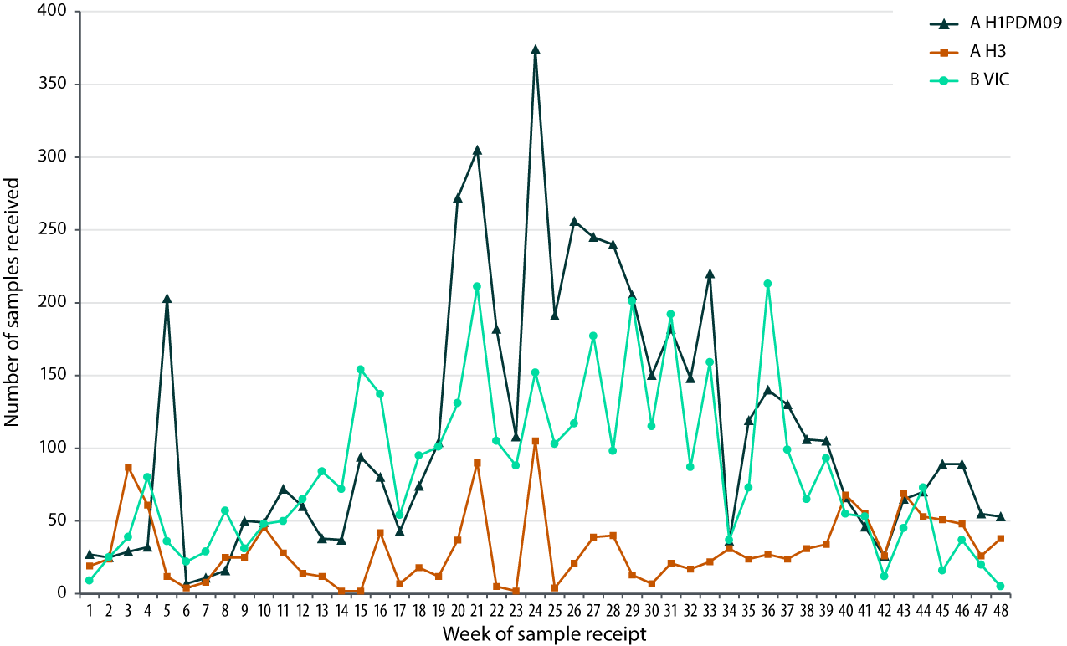

Overall, isolation and re-passaging was attempted for 12,645 (84%) of the samples received, yielding 8,122 isolates (overall isolation rate of 64%). Isolation rates were lower for clinical specimens (60%) than for recovery of virus isolates (96%). Of the viruses for which type and subtype could be confirmed, isolation rates by cell propagation were 82% (3,899/4,751) for influenza A(H1N1)pdm09; 84% (1,417/1,695) for A(H3N2); and 68% (2,772/4,099) for B/Victoria positive samples.

There were no isolates with a known subtype or lineage that did not reach sufficient titres for antigenic analysis.

A total of 7,984 viral isolates were successfully characterised by HI assay and compared to the 2023 reference viruses (Table 2). In addition, real-time RT-PCR was attempted on 2,434 samples to determine their type/subtype or lineage. Sanger, ONT, and/or NGS techniques were used to attempt sequencing of the HA genes of 3,743 viruses. The full genomes of 399 viruses were obtained using NGS. Of the samples for which antigenic or genetic analysis was undertaken (n = 10,422), influenza A(H1N1)pdm09 viruses predominated, comprising 42% (n = 4,391) of viruses received and analysed, followed by influenza B/Victoria with 38% (n = 4,008) of viruses received and analysed.

Table 2: Antigenic analysis of viruses received by the Centre in 2023, by geographic region of origin

| Region | A(H1N1)pdm09a reference strain: A/Sydney/5/2021 (cell) | | A(H3N2)a reference strain: A/Darwin/6/2021 (cell) | | B/Victoria reference strain: B/Austria/1359417/2021 (cell) | | B/Yamagata reference strain: B/Phuket/3073/2013 (cell) | |
| --- | --- | --- | --- | --- | --- | --- | --- | --- |
| Like | Low reactor (%) | Like | Low reactor (%) | Like | Low reactor (%) | Like | Low reactor (%) |
| Africa | — | — | 26 | 1 (3.7) | — | — | — | — |
| Australasia | 3,322 | 17 (0.5) | 961 | 73 (7.1) | 2,150 | 1 (0.05) | — | — |
| East Asia | 15 | 0 (0) | 14 | 0 (0) | 1 | 0 (0) | — | — |
| South Asia | 13 | 0 (0) | 16 | 0 (0) | 8 | 0 (0) | — | — |
| South East Asia | 184 | 1 (0.5) | 254 | 12 (4.5) | 338 | 2 (0.6) | — | — |
| South Pacific | 284 | 1 (0.4) | 54 | 1 (1.8) | 235 | 0 (0) | — | — |
| Total | 3,818 | 19 (0.5) | 1,325 | 87 (6.2) | 2,732 | 3 (0.1) | — | — |

a A small number of A(H1N1)pdm09 and A(H3N2) virus isolates that were obtained could not be analysed by HI assay due to low haemagglutination assay (HA) titre in turkey red blood cells [for A(H1N1)pdm09)] or guinea pig red blood cells in the presence of oseltamivir [for A(H3N2)].

A(H1N1)pdm09 viruses

Of the 3,837 A(H1N1)pdm09 isolates analysed by HI assay using ferret antisera in 2023, the majority (99.5%) were antigenically similar to the cell-propagated vaccine reference strain A/Sydney/5/2021 (Table 2). There were no A(H1N1)pdm09 viruses isolated by cell culture that did not reach sufficient titres for antigenic analysis.

Sequencing was attempted on 1,811 viruses, with results obtained for 1,673 viruses. Sequencing and phylogenetic analysis of HA genes from 1,695 viruses (including a small number of viruses sequenced externally) showed that A(H1N1)pdm09 viruses received during 2023 and able to be sequenced fell into the 6B.1A.5 clade, and subclades 6B.1A.5a.1 (n = 1; 0.1%), 6B.1A.5a.2a (n = 1,563; 92%), and 6B.1A.5a.2a.1 (n = 131; 8%) (Figure 3), compared to the 2023 southern hemisphere vaccine reference strain, A/Sydney/5/2021, that was in subclade 6B.1A.5a.2a.

Twenty-two A(H1N1)pdm09 viruses were inoculated into eggs for isolation of candidate vaccine viruses, with 13 (59%) successfully isolated. Successful isolations included 12 viruses from genetic subclade 6B.1A.5a.2a. Twenty-two A(H1N1)pdm09 viruses were inoculated into the qualified cell line MDCK 33016PF, of which 11 (50%) grew successfully, consisting of nine viruses from genetic subclade 6B.1A.5a.2a and two from 6B.1A.5a.2a.1.

Of the 2,619 A(H1N1)pdm09 viruses tested, seven viruses (one from India and six from Australia) exhibited highly reduced inhibition by oseltamivir, with all carrying the NA H275Y mutation known to cause high-level inhibition. No viruses exhibited highly reduced susceptibility to zanamivir. Furthermore, no viruses were identified with genetic evidence of baloxavir marboxil resistance (based on sequencing of 233 viruses for PA gene I38 and E23 mutations).

Figure 3: Phylogenetic tree of haemagglutinin (HA) genes of A(H1N1)pdm09 viruses received by the Centre during 2023

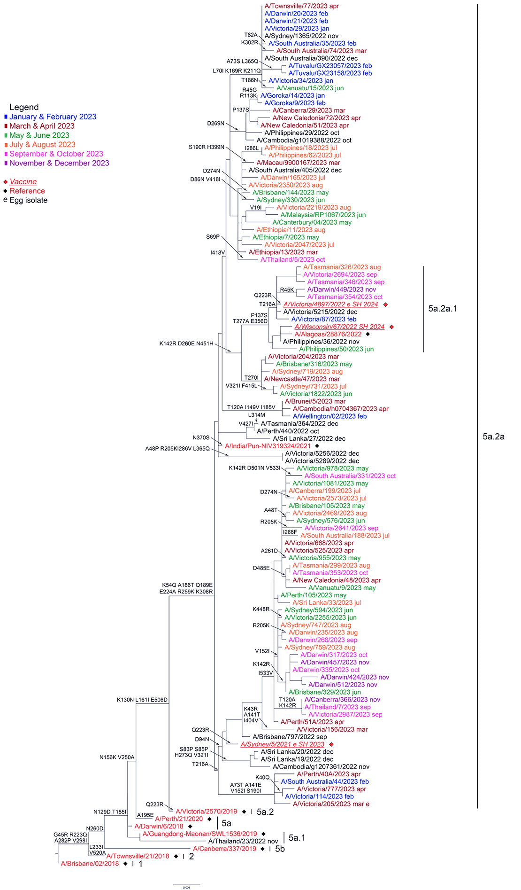

## A(H3N2) viruses

Antigenic analysis of 1,412 A(H3N2) isolates using the HI assay showed that 94% were antigenically similar to the cell-propagated reference strain A/Darwin/6/2021 (Table 2). Only one A(H3N2) virus isolate did not reach sufficient titre when tested by HI assay in the presence of OC.

A total of 98 A(H3N2) viruses were analysed using FRA. The FRA indicated that 11 of these viruses (11%) showed a greater than fourfold difference in titre compared to the cell-propagated reference strain A/Darwin/6/2021, while ten (10%) had a greater than fourfold difference in titre compared to the egg-propagated reference strain A/Darwin/9/2021.

Sequencing was attempted on the HA genes of 743 A(H3N2) viruses, with 722 yielding results (Figure 4). Phylogenetic analysis of the HA genes of 792 viruses sent to the Centre (including viruses sequenced externally) indicated that the majority of circulating viruses fell into subclade 3C.2a1b.2a.2a.3a.1 (n = 657; 83%), while the 2023 southern hemisphere vaccine reference strain A/Darwin/6/2021 was in subclade 3C.2a1b.2a.2a. The remaining viruses fell into subclades 3C.2a1b.2a.2a (n = 10; 1.3%); 3C.2a1b.2a.2a.1 (n = 5; 0.6%); 3C.2a1b.2a.2a.1b (n = 32; 4.0%); 3C.2a1b.2a.2a.3 (n = 21; 2.7%); 3C.2a1b.2a.2a.3a (n = 2; 0.3%); 3C.2a1b.2a.2a.3b (n = 20; 2.5%); and 3C.2a1b.2a.2b (n = 45; 5.7%).

Twenty-one A(H3N2) viruses were inoculated into eggs, of which 13 (62%) grew successfully, consisting of three viruses from genetic subclade 3C.2a1b.2a.2a.1b, five from 3C.2a1b.2a.2a.3a.1, and five from 3C.2a1b.2a.2b. Twenty-seven A(H3N2) viruses were inoculated into the qualified cell line MDCK 33016PF, of which 20 (74%) grew successfully, consisting of two viruses from genetic subclade 3C.2a1b.2a.2a.1b, nine from 3C.2a1b.2a.2a.3a.1, and nine from 3C.2a1b.2a.2b.

None of the 1,093 A(H3N2) viruses tested with the NAI assay showed highly reduced susceptibility to oseltamivir or zanamivir. Likewise, no viruses were identified with genetic evidence of resistance to baloxavir marboxil (based on sequencing of 206 viruses for PA gene I38 and E23 mutations).

## Influenza B viruses

A total of 2,735 B/Victoria viruses were characterised by HI assay (Table 2), with 99.9% (n = 2,732) found to be antigenically similar to the cell-propagated B/Austria/1359417/2021 vaccine virus.

Sequencing was attempted on 1,154 B/Victoria viruses, with 1,076 yielding results (Figure 5). Phylogenetic analysis on the HA genes of 1,092 viruses (including viruses sequenced externally) indicated that all circulating B/Victoria viruses received by the Centre fell into clade V1A.3a.2, which included the 2023 vaccine strain B/Austria/1359417/2021.

Three B/Victoria viruses were inoculated into eggs, of which two (67%) grew successfully, both from genetic subclade V1A.3a.2. Thirteen B/Victoria viruses were inoculated into the qualified cell line MDCK 33016PF, of which 9 (69%) grew successfully, all from genetic subclade V1A.3a.2.

Of the 1,818 B/Victoria viruses tested with the NAI assay, none showed highly reduced susceptibility to oseltamivir or zanamivir, and no viruses were identified with genetic evidence of resistance to baloxavir marboxil (based on sequencing of 191 viruses for PA gene I38 mutations).

Figure 4: Phylogenetic tree of haemagglutinin (HA) genes of A(H3N2) viruses received by the Centre during 2023

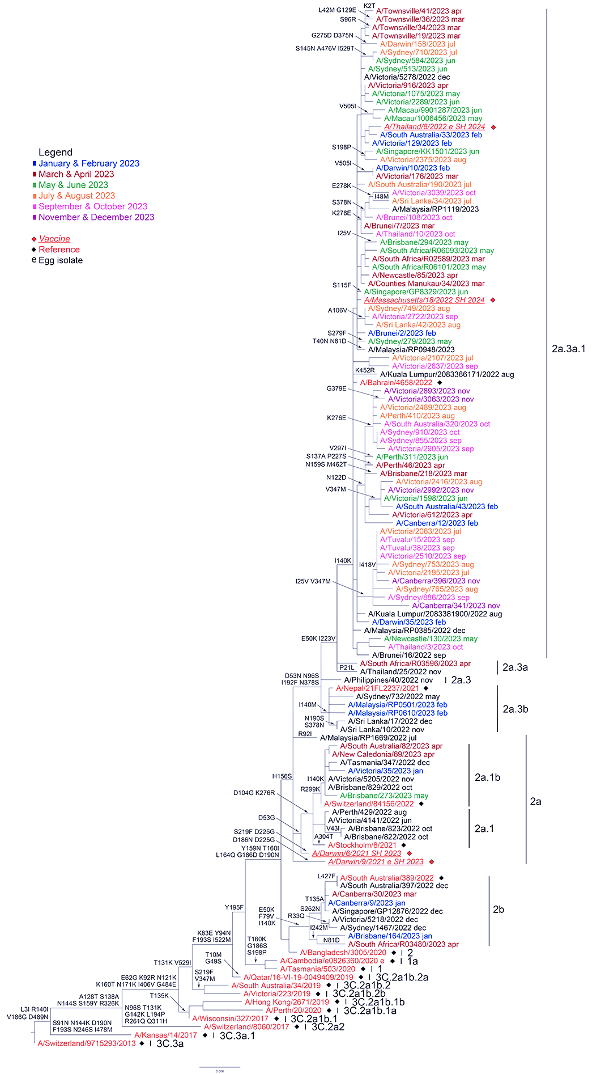

Figure 5: Phylogenetic tree of haemagglutinin (HA) genes of B/Victoria-lineage viruses received by the Centre during 2023

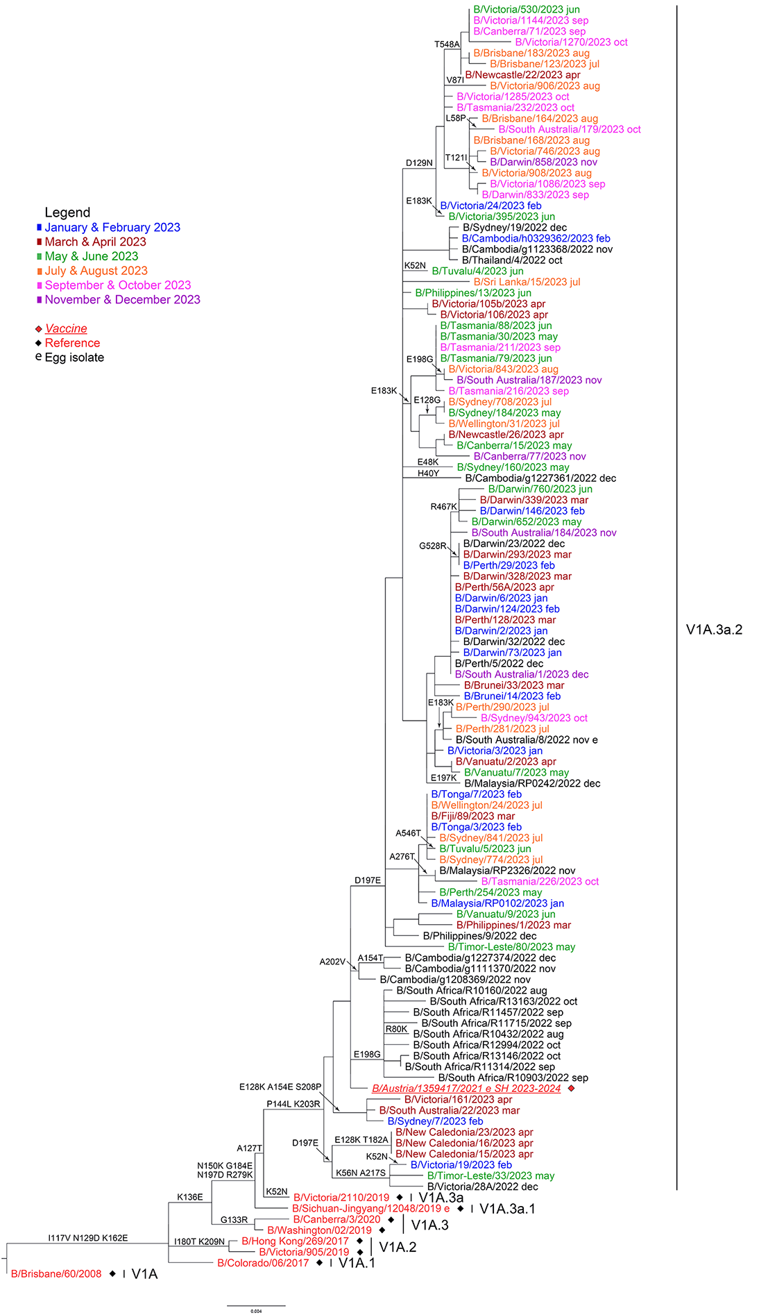

# Discussion

During 2023, the Centre received the highest number of samples since annual reporting commenced in 1997.25–47 Substantially more samples were received than during 2020 and 2021—which were heavily impacted by the global reduction in influenza activity that occurred following emergence of SARS-CoV-2 and the COVID-19 pandemic and introduction of non-pharmaceutical interventions by many countries—and more than during 2022, when influenza activity returned to pre-pandemic levels.4,45,47,48 The high number of samples received correlated with the large number of laboratory-confirmed influenza notifications in Australia (n = 288,992) during the 2023 Australian influenza season.3 The 2023 Australian influenza season was characterised by early activity and a longer duration than 2022, with a peak in influenza notifications in late June.49 This activity was reflected in the timing of samples received by the Centre, with 47% of samples collected in 2023 received at the Centre during the May–July period.

Geographically, most notifications of laboratory-confirmed influenza were made in New South Wales, which saw 57,665 notifications during the May–July period.3 Lower numbers of notifications were made in Queensland (n = 48,607) and Victoria (n = 25,326) for the same period.3 However, notifications increased earlier in Queensland, which saw the highest numbers of notifications of all jurisdictions in March (n = 3,197), April (n = 4,086), and May (n = 11,437).3 Peak influenza activity occurred during the May–July period in all jurisdictions except the Northern Territory, which saw a peak of 359 notifications in March, and a later peak of 424 notifications in November.3

The predominant circulating virus reported to the Australian National Notifiable Diseases Surveillance System (NNDSS) was influenza A (58%), with A(H1N1)pdm09 predominant in influenza samples that could be subtyped.49 Influenza B accounted for a further 40% of notifications.49 This is in agreement with samples from Australia received by the Centre, with A(H1N1)pmd09 and influenza B viruses accounting for the majority of viruses analysed. Globally, influenza A(H1N1)pdm09, A(H3N2), and influenza B viruses co-circulated in varying proportions. During the period February–August 2023 there were more detections of influenza A, although influenza B was predominant in Europe, Northern Africa, and Tropical South America.50 Detections of influenza A were also higher during the September 2023 – January 2024 period, although influenza B was predominant in Temperate South America, Middle Africa, and Southern Africa.51

In general, older populations tend to be more affected by influenza in years when A(H3N2) viruses predominate, while younger populations are usually more affected by A(H1N1)pdm09.52 This pattern was evident during 2023, with the highest notification rates observed among children (2,984 notifications per 100,000 population among those aged 5–9 years; 2,042 per 100,000 population among those aged < 5 years; and 1,872 per 100,000 population among those aged 10–14 years), while the lowest notification rates were among adults aged 70–74 years (397 per 100,000 population).49 There were 376 influenza-associated deaths notified to the NNDSS, with a median age at death of 76 years (range: 0–101 years).49

Antigenic analysis of influenza A(H1N1)pdm09 viruses indicated that the majority (99.5%) of viruses displayed similar antigenic characteristics to the cell-propagated vaccine strain, A/Sydney/5/2021. Most circulating A(H1N1)pdm09 viruses were in the genetic subclade 6B.1A.5a.2a, with emergence of a smaller but growing percentage of viruses in the 6B.1A.5a.2a.1 subclade. As a result, the 2024 southern hemisphere A(H1N1)pdm09 vaccine component was updated to an A/Victoria/4897/2022-like virus.

Most influenza A(H3N2) viruses received by the Centre were antigenically like the cell-propagated vaccine reference strain, A/Darwin/6/2021, and were part of the same overall genetic group (3C.2a1b.2a.2a), although most viruses fell into the minor subclade 3C.2a1b.2a.2a.3a.1. Genetic diversity was evident among A(H3N2) viruses received, and the recommended vaccine strain for the southern hemisphere in 2024 was updated to an A/Thailand/8/2022-like virus, a 3C.2a1b.2a.2a.3a.1 subgroup virus.

All influenza B isolates that were analysed at the Centre belonged to the B/Victoria-lineage. Most of these viruses were antigenically like the B/Austria/1359417/2021 vaccine strain, and all belonged to the same genetic subgroup (V1A.3a.2). There was no change to the recommended vaccine strain for B/Victoria for 2024. Globally, no B/Yamagata viruses have been detected since March 2020, and it is hypothesised that this strain is now extinct.5,53,54 The southern hemisphere vaccine composition recommendation for 2024 was updated to recommend the use of a B/Phuket/3073/2013 (B/Yamagata lineage)-like virus only in quadrivalent vaccines, with a B/Austria/1359417/2021 (B/Victoria lineage)-like virus recommended for use in trivalent vaccines.50 It is anticipated that B/Yamagata lineage viruses will be removed from influenza vaccines over the next year or two due to their apparent extinction.

With the ongoing evolution of seasonal influenza viruses and the absence of an effective universal vaccine, it is essential that influenza surveillance and regular updating of seasonal influenza vaccines continues. The work performed at the Centre in Melbourne contributes to the ongoing efforts of the WHO GISRS to better control the disease burden of influenza, and to provide effective countermeasures, such as vaccines, to reduce the impact of influenza on the human population.

# Acknowledgments

The authors would like to thank all the National Influenza Centres and other contributing laboratories who sent influenza positive samples to the Centre during 2023. The Melbourne WHO Collaborating Centre for Reference and Research on Influenza is supported by the Australian Government Department of Health and Aged Care.

# Author details

Dr Tanya R Diefenbach-Elstob, Epidemiologist,1

Ms Olivia Lay, Medical Scientist,1

Ms Tasoula Zakis, Medical Scientist,1

Dr Nikita Deshpande, Medical Scientist,1

Ms Sally Soppe, Medical Scientist,1

Ms Heidi Peck, Head – Serology,1

Dr Saira Hussain, Head – Antiviral drug sensitivity,1

Dr Yi-Mo Deng, Head – Genetic analysis,1

Dr Clyde Dapat, Head – Bioinformatics,1

Prof Kanta Subbarao, Director,1

Prof Ian G Barr, Deputy Director.1

1. WHO Collaborating Centre for Reference and Research on Influenza

Corresponding author

Dr Tanya R Diefenbach-Elstob,

Epidemiologist, WHO Collaborating Centre for Reference and Research on Influenza, 792 Elizabeth Street, Melbourne VIC 3001

email: [tanya.diefenbachelstob@influenzacentre.org](mailto:tanya.diefenbachelstob@influenzacentre.org)

Phone: +61 3 9342 9304

# References

1. Hay AJ, McCauley JW. The WHO global influenza surveillance and response system (GISRS)—a future perspective. *Influenza Other Respir Viruses*. 2018;12(5):551–7. doi: <https://doi.org/10.1111/irv.12565>.
2. Monto AS. Reflections on the global influenza surveillance and response system (GISRS) at 65 years: an expanding framework for influenza detection, prevention and control. *Influenza Other Respir Viruses*. 2018;12(1):10–2. doi: <https://doi.org/10.1111/irv.12511>.
3. Australian Government Department of Health and Aged Care. National communicable disease surveillance dashboard. [Webpage.] Canberra: Australian Government Department of Health and Aged Care; 2024. [Accessed on 2 April 2024.] Available from: <https://nindss.health.gov.au/pbi-dashboard/>.
4. Sullivan SG, Carlson S, Cheng AC, Chilver MB, Dwyer DE, Irwin M et al. Where has all the influenza gone? The impact of COVID-19 on the circulation of influenza and other respiratory viruses, Australia, March to September 2020. *Euro Surveill*. 2020;25(47):2001847.   
   doi: <https://doi.org/10.2807/1560-7917.ES.2020.25.47.2001847>.
5. Koutsakos M, Wheatley AK, Laurie K, Kent SJ, Rockman S. Influenza lineage extinction during the COVID-19 pandemic? *Nat Rev Microbiol*. 2021;19(12):741–2.   
   doi: <https://doi.org/10.1038/s41579-021-00642-4>.
6. Oh DY, Barr IG, Mosse JA, Laurie KL. MDCK-SIAT1 cells show improved isolation rates for recent human influenza viruses compared to conventional MDCK cells. *J Clin Microbiol*. 2008;46(7):2189–94. doi: <https://doi.org/10.1128/JCM.00398-08>.
7. Hobson D, Curry RL, Beare AS, Ward-Gardner A. The role of serum haemagglutination-inhibiting antibody in protection against challenge infection with influenza A2 and B viruses. *J Hyg (Lond)*. 1972;70(4):767–77. doi: <https://doi.org/10.1017/s0022172400022610>.
8. Lin YP, Gregory V, Collins P, Kloess J, Wharton S, Cattle N et al. Neuraminidase receptor binding variants of human influenza A(H3N2) viruses resulting from substitution of aspartic acid 151 in the catalytic site: a role in virus attachment? *J Virol*. 2010;84(13):6769–81. doi: <https://doi.org/10.1128/JVI.00458-10>.
9. Shu B, Kirby MK, Davis WG, Warnes C, Liddell J, Liu J et al. Multiplex real-time reverse transcription PCR for influenza A virus, influenza B virus, and severe acute respiratory syndrome coronavirus 2. *Emerg Infect Dis*. 2021;27(7):1821–30. doi: <https://doi.org/10.3201/eid2707.210462>.
10. Shu B, Wu KH, Emery S, Villanueva J, Johnson R, Guthrie E et al. Design and performance of the CDC real-time reverse transcriptase PCR swine flu panel for detection of 2009 A (H1N1) pandemic influenza virus. *J Clin Microbiol*. 2011;49(7):2614–9. doi: <https://doi.org/10.1128/JCM.02636-10>.
11. Deng YM, Spirason N, Iannello P, Jelley L, Lau H, Barr IG. A simplified Sanger sequencing method for full genome sequencing of multiple subtypes of human influenza A viruses. *J Clin Virol*. 2015;68:43–8. doi: <https://doi.org/10.1016/j.jcv.2015.04.019>.
12. Zhou B, Deng YM, Barnes JR, Sessions OM, Chou TW, Wilson M et al. Multiplex reverse transcription-PCR for simultaneous surveillance of influenza A and B viruses. *J Clin Microbiol*. 2017;55(12):3492–501. doi: <https://doi.org/10.1128/JCM.00957-17>.
13. Zhou B, Donnelly ME, Scholes DT, St George K, Hatta M, Kawaoka Y et al. Single-reaction genomic amplification accelerates sequencing and vaccine production for classical and swine origin human influenza A viruses. *J Virol*. 2009;83(19):10309–13. doi: <https://doi.org/10.1128/JVI.01109-09>.
14. Shepard SS, Meno S, Bahl J, Wilson MM, Barnes J, Neuhaus E. Viral deep sequencing needs an adaptive approach: IRMA, the iterative refinement meta-assembler. *BMC Genomics*. 2016;17(1):708. doi: <https://doi.org/10.1186/s12864-016-3030-6>.
15. Hadfield J, Megill C, Bell SM, Huddleston J, Potter B, Callender C et al. Nextstrain: real-time tracking of pathogen evolution. *Bioinformatics*. 2018;34(23):4121–3. doi: <https://doi.org/10.1093/bioinformatics/bty407>.
16. Minh BQ, Schmidt HA, Chernomor O, Schrempf D, Woodhams MD, von Haeseler A et al. IQ-TREE 2: new models and efficient methods for phylogenetic inference in the genomic era. *Mol Biol Evol*. 2020;37(5):1530–4. doi: <https://doi.org/10.1093/molbev/msaa015>.
17. Yu G. Using ggtree to visualize data on tree-like structures. *Curr Protoc Bioinformatics*. 2020;69(1):e96. doi: <https://doi.org/10.1002/cpbi.96>.
18. Hurt AC, Besselaar TG, Daniels RS, Ermetal B, Fry A, Gubareva L et al. Global update on the susceptibility of human influenza viruses to neuraminidase inhibitors, 2014–2015. *Antiviral Res*. 2016;132:178–85. doi: <https://doi.org/10.1016/j.antiviral.2016.06.001>.
19. World Health Organization (WHO) Global Influenza Programme. Laboratory methodologies for testing the antiviral susceptibility of influenza viruses: Neuraminidase inhibitor (NAI). [Webpage.] Geneva: WHO; 2023. [Accessed on 29 March 2023.] Available from: <https://www.who.int/teams/global-influenza-programme/laboratory-network/quality-assurance/antiviral-susceptibility-influenza/neuraminidase-inhibitor>.
20. Gerdil C. The annual production cycle for influenza vaccine. *Vaccine*. 2003;21(16):1776–9. doi: <https://doi.org/10.1016/s0264-410x(03)00071-9>.
21. Stöhr K, Bucher D, Colgate T, Wood J. Influenza virus surveillance, vaccine strain selection, and manufacture. *Methods Mol Biol*. 2012;865:147–62. doi: <https://doi.org/10.1007/978-1-61779-621-0_9>.
22. Weir JP, Gruber MF. An overview of the regulation of influenza vaccines in the United States. *Influenza Other Respir Viruses*. 2016;10(5):354–60. doi: <https://doi.org/10.1111/irv.12383>.
23. WHO Global Influenza Surveillance Network. *Manual for the laboratory diagnosis and virological surveillance of influenza*. Geneva: WHO; I January 2011. Available from: <https://www.who.int/publications/i/item/manual-for-the-laboratory-diagnosis-and-virological-surveillance-of-influenza>.
24. Roth B, Mohr H, Enders M, Garten W, Gregersen JP. Isolation of influenza viruses in MDCK 33016PF cells and clearance of contaminating respiratory viruses. *Vaccine*. 2012;30(3):517–22. doi: <https://doi.org/10.1016/j.vaccine.2011.11.063>.
25. Curran M, Hampson A. National influenza surveillance 1997. *Commun Dis Intell*. 1998;22(5):69–74.
26. Halliday L, Roberts L, Hampson A. Annual report of the National Influenza Surveillance Scheme, 1998. *Commun Dis Intell*. 1999;23(7):185–92.
27. Thomson J, Lin M, Hampson A. Annual report of the National Influenza Surveillance Scheme, 1999. *Commun Dis Intell*. 2000;24(6):145–52.
28. Firestone SM, Barr IG, Roche PW, Walker JC. Annual report of the National Influenza Surveillance Scheme, 2005. *Commun Dis Intell Q Rep*. 2006;30(2):189–200.
29. Li J, Hampson A, Roche PW, Yohannes K, Spencer JD. Annual report of the National Influenza Surveillance Scheme, 2004. *Commun Dis Intell Q Rep*. 2005;29(2):125–36.
30. Roche P, Spencer J, Hampson A. Annual report of the National Influenza Surveillance Scheme, 2001. *Commun Dis Intell Q Rep*. 2002;26(2):204–13.
31. Roche P, Spencer J, Merianos A, Hampson A. Annual report of the National Influenza Surveillance Scheme, 2000. *Commun Dis Intell Q Rep*. 2001;25(3):107–12.
32. Yohannes K, Roche P, Hampson A, Miller M, Spencer J. Annual report of the National Influenza Surveillance Scheme, 2003. *Commun Dis Intell Q Rep*. 2004;28(2):160–8.
33. Yohannes K, Roche P, Spencer J, Hampson A. Annual report of the National Influenza Surveillance Scheme, 2002. *Commun Dis Intell Q Rep*. 2003;27(2):162–72.
34. O’Brien K, Barr IG. Annual report of the National Influenza Surveillance Scheme, 2006. *Commun Dis Intell Q Rep*. 2007;31(2):167–79.
35. Owen R, Barr IG, Pengilley A, Liu C, Paterson B, Kaczmarek M et al. Annual report of the National Influenza Surveillance Scheme, 2007. *Commun Dis Intell Q Rep*. 2008;32(2):208–26.
36. Kaczmarek M, Owen R, Barr IG. Annual report of the National Influenza Surveillance Scheme, 2008. *Commun Dis Intell Q Rep*. 2010;34(1):8–22.
37. Pennington K, Owen R, Mun J. Annual report of the National Influenza Surveillance Scheme, 2009. *Commun Dis Intell Q Rep*. 2017;41(4):E383–454.
38. Gavin K, Owen R, Barr IG. Annual report of the National Influenza Surveillance Scheme, 2010. *Commun Dis Intell Q Rep*. 2017;41(4):E348–68.
39. Sullivan SG, Chow MK, Barr IG, Kelso A. Influenza viruses received and tested by the Melbourne WHO Collaborating Centre for Reference and Research on Influenza annual report, 2014. *Commun Dis Intell Q Rep*. 2015;39(4):E602–11.
40. Leung VK, Deng YM, Kaye M, Buettner I, Lau H, Leang SK et al. Annual report on influenza viruses received and tested by the Melbourne WHO Collaborating Centre for Reference and Research on Influenza in 2016. *Commun Dis Intell (2018)*. 2019;43. doi: <http://doi.org/10.33321/cdi.2019.43.3>.
41. Leung VK, Spirason N, Lau H, Buettner I, Leang SK, Chow MK. Influenza viruses received and tested by the Melbourne WHO Collaborating Centre for Reference and Research on Influenza annual report, 2015. *Commun Dis Intell Q Rep*. 2017;41(2):E150–60.
42. Peck H, Moselen J, Brown SK, Triantafilou M, Lau H, Grau M et al. Report on influenza viruses received and tested by the Melbourne WHO Collaborating Centre for Reference and Research on Influenza in 2019. *Commun Dis Intell (2018)*. 2021;45. doi: <https://doi.org/10.33321/cdi.2021.45.43>.
43. Roe M, Kaye M, Iannello P, Lau H, Buettner I, Tolosa MX et al. Report on influenza viruses received and tested by the Melbourne WHO Collaborating Centre for Reference and Research on Influenza in 2017. *Commun Dis Intell (2018)*. 2019;43. doi: <https://doi.org/10.33321/cdi.2019.43.25>.
44. Price OH, Spirason N, Rynehart C, Brown SK, Todd A, Peck H et al. Report on influenza viruses received and tested by the Melbourne WHO Collaborating Centre for Reference and Research on Influenza in 2018. *Commun Dis Intell (2018)*. 2020;44. doi: <https://doi.org/10.33321/cdi.2020.44.16>.
45. O’Neill G, Aziz A, Kuba M, Brown SK, Lau H, Soppe S et al. Report on influenza viruses received and tested by the Melbourne WHO Collaborating Centre for Reference and Research on Influenza during 2020–2021. *Commun Dis Intell (2018)*. 2022;46. doi: <https://doi.org/10.33321/cdi.2022.46.63>.
46. Communicable Disease Epidemiology and Surveillance Section. Report of the National Influenza Surveillance Scheme, 2011 to 2018. *Commun Dis Intell (2018)*. 2022;46. doi: <https://doi.org/10.33321/cdi.2022.46.12>.
47. Diefenbach-Elstob TR, Chanthalavanh P, Bobbitt ME, Brown SK, Rynehart C, Spirason N et al. Report on influenza viruses received and tested by the Melbourne WHO Collaborating Centre for Reference and Research on Influenza during 2022. *Commun Dis Intell (2018)*. 2023;47. doi: <https://doi.org/10.33321/cdi.2023.47.43>.
48. WHO Global Influenza Programme. *Influenza Update N° 384: 04 January 2021, based on data up to 20 December 2020*. Geneva: WHO; 4 January 2021. Available from: <https://cdn.who.int/media/docs/default-source/influenza/influenza-updates/2020/2021_01_04_surveillance_update_384.pdf>.
49. Australian Government Department of Health and Aged Care. *Australian Influenza Surveillance Report – 2023 End of Season Summary*. Canberra: Australian Government Department of Health and Aged Care; December 2023. Available from: <https://www.health.gov.au/sites/default/files/2023-12/aisr-2023-national-influenza-season-summary.pdf>.
50. WHO. *Recommended composition of influenza virus vaccines for use in the 2024 southern hemisphere influenza season*. Geneva: WHO; 29 September 2023. Available from: <https://www.who.int/publications/m/item/recommended-composition-of-influenza-virus-vaccines-for-use-in-the-2024-southern-hemisphere-influenza-season>.
51. WHO. *Recommended composition of influenza virus vaccines for use in the 2024–2025 northern hemisphere influenza season*. Geneva: WHO; 23 February 2024. Available from: <https://www.who.int/publications/m/item/recommended-composition-of-influenza-virus-vaccines-for-use-in-the-2024-2025-northern-hemisphere-influenza-season>.
52. Thompson WW, Shay DK, Weintraub E, Brammer L, Bridges CB, Cox NJ et al. Influenza-associated hospitalizations in the United States. *JAMA*. 2004;292(11):1333–40. doi: <https://doi.org/10.1001/jama.292.11.1333>.
53. Dhanasekaran V, Sullivan S, Edwards KM, Xie R, Khvorov A, Valkenburg SA et al. Human seasonal influenza under COVID-19 and the potential consequences of influenza lineage elimination. *Nat Commun*. 2022;13(1):1721. doi: <https://doi.org/10.1038/s41467-022-29402-5>.
54. Paget J, Caini S, Del Riccio M, van Waarden W, Meijer A. Has influenza B/Yamagata become extinct and what implications might this have for quadrivalent influenza vaccines? *Euro Surveill*. 2022;27(39):2200753. doi: <https://doi.org/10.2807/1560-7917.ES.2022.27.39.2200753>.

© Commonwealth of Australia as represented by the Department of Health and Aged Care

ISSN: 2209-6051 Online

This journal is indexed by Index Medicus and Medline.

Creative Commons Licence

This publication is licensed under a Creative Commons Attribution-NonCommercial-NoDerivatives 4.0 International Licence (CC BY-NC-ND) available from <https://creativecommons.org/licenses/by-nc-nd/4.0/legalcode> (Licence). You must read and understand the Licence before using any material from this publication.

Restrictions

The Licence does not cover, and there is no permission given for, use of any of the following material found in this publication (if any):

* the Commonwealth Coat of Arms (by way of information, the terms under which the Coat of Arms may be used can be found on the Department of Prime Minister and Cabinet website;
* any logos (including the Department of Health and Aged Care’s logo) and trademarks;
* any photographs and images;
* any signatures; and
* any material belonging to third parties.

Disclaimer

Opinions expressed in *Communicable Diseases Intelligence* are those of the authors and not necessarily those of the Department of Health and Aged Care or the Communicable Diseases Network Australia. Data may be subject to revision.

Enquiries

Enquiries regarding any other use of this publication should be addressed to the CDI Editor at: [cdi.editor@health.gov.au](mailto:cdi.editor@health.gov.au).

Communicable Diseases Network Australia

Communicable Diseases Intelligence contributes to the work of the [Communicable Diseases Network Australia](http://www.health.gov.au/cdna).

About Communicable Diseases Intelligence

*Communicable Diseases Intelligence* (CDI) is a peer-reviewed scientific journal published by the Health Security & Emergency Management Division, Department of Health and Aged Care. The journal aims to disseminate information on the epidemiology, surveillance, prevention and control of communicable diseases of relevance to Australia.

**Editor**: Christina Bareja • **Deputy Editor**: Simon Petrie • **Design and Production**: Lisa Thompson

**Editorial Advisory Board**: David Durrheim, Mark Ferson, Clare Huppatz, John Kaldor, Martyn Kirk and Meru Sheel

Submit an Article

Submit your next communicable disease related article to CDI for consideration. [Information for authors](https://www1.health.gov.au/internet/main/publishing.nsf/Content/cda-pubs-cdi-auth_inst.htm) and details on how to [submit your publication](https://www1.health.gov.au/internet/main/publishing.nsf/Content/cda-pubs-cdi-auth_inst.htm#submission_package) is available on our website, or by email at [cdi.editor@health.gov.au](mailto:cdi.editor@health.gov.au).

Contact us

Communicable Diseases Intelligence (CDI)

Health Security & Emergency Management Division

Department of Health and Aged Care

GPO Box 9848, CANBERRA ACT 2601

Website: [www.health.gov.au/cdi](http://www.health.gov.au/cdi)

Email: [cdi.editor@health.gov.au](mailto:cdi.editor@health.gov.au)

1. The CDC Influenza Virus Real-Time RT-PCR Influenza A/B Typing Panel (RUO) (Catalog No. FluRUO-01), FR-198, was obtained through the International Reagent Resource, Influenza Division, WHO Collaborating Center for Surveillance, Epidemiology and Control of Influenza, Centers for Disease Control and Prevention, Atlanta, Georgia, United States of America (<https://www.internationalreagentresource.org/>).