2025 • Volume • • Electronic publication date:

Emergence of locally acquired Japanese encephalitis virus in Australia, January 2021–June 2022: a national case series

Amanda Reyes Veliz, Stacey Kane, Anna Glynn-Robinson

# Abstract

Background and methods

In March 2022, an outbreak of Japanese encephalitis virus (JEV) infection was identified in temperate south-eastern Australia, with detections in humans and animals. The unexpected emergence of JEV prompted a national public health response and a Communicable Disease Incident of National Significance was declared. JEV has previously only been identified in tropical north-eastern Australia in localised outbreaks. This article provides a descriptive analysis of the human case epidemiology of the national outbreak from 1 January 2021 to 30 June 2022.

Results

There were 42 confirmed and probable human cases of JEV identified as acquired in Australia between 1 January 2021 and 30 June 2022. Seven deaths occurred (case fatality rate: 17%). Cases were identified in five Australian jurisdictions (New South Wales, Victoria, Queensland, South Australia and the Northern Territory). The majority of cases were aged 60 years and over (55%; 23/42), with a median age of 61.5 years (range: 0–79 years; interquartile range: 45–70 years); cases were predominantly of non-Indigenous status (90%; 38/42). Sixty-seven percent (28/42) were male. Of the cases with geographical data available (n = 41), all were likely exposed to the virus in 31 unique local government areas across regional and remote Australia.

Conclusions

Cases were detected across Australia in five jurisdictions, requiring a national public health response, to detect and prevent further cases. There was widespread geographical distribution over 18 months. Given the risk of further cases and possible endemicity of JEV being established in Australia, expanded environmental and human surveillance programs are required.

Keywords: emerging diseases; infectious diseases; Japanese encephalitis; Japanese encephalitis virus; flaviviruses; mosquitos; Australia

# Background

Japanese Encephalitis Virus (JEV) is a mosquito-borne RNA virus belonging to the genus *Flavivirus*, with five distinct genotypes (GI–GV). Mosquitos transmit JEV to a range of vertebrate hosts, including water birds and pigs, to maintain a natural and domestic transmission cycle.1–3 Whilst humans are susceptible to JEV infection, they do not transmit the virus.3

Although most cases of JEV infection are asymptomatic, some may experience a mild febrile illness and approximately 1% of infections may result in Japanese encephalitis (JE).3,4 The estimated annual incidence of JE is 68,000–100,000 cases worldwide.5,6 This is likely underestimated, given limitations of surveillance in endemic countries.1 The mortality rate of JE is estimated to be in the range 16–24%, with 44–49% of surviving cases experiencing ongoing neurological sequelae.7

JEV has spread extensively over the last 50 years through South East Asia and the Western Pacific,3,8 and is endemic in over 24 countries across these regions.9 In Australia, JEV cases have been limited to small localised outbreaks, or imported following overseas acquisition during travel to JEV-endemic countries.10 JEV was first detected in Australia in 1995, when an outbreak of three cases was identified on Badu Island in the Torres Strait.11 Two cases occurred in 1998, with one case identified in the Torres Strait and the other on Cape York Peninsula, which was the first detection of JEV on mainland Australia.12

Environmental surveillance programs for JEV were conducted in the Torres Strait between 1995 and 2005 and in north-eastern Australia since 1998.13 Between 1995 and 2005, the continuous presence of JEV in mosquitos and pigs was detected in both regions.13–17 Following this period, there were no further cases or environmental or animal detections.8,13,18 The status of JEV in the Torres Strait since 2005 remains unknown.13

In early 2021, a single JEV case was detected in a resident of the Tiwi Islands in the Northern Territory.19 In February 2022, JEV was detected and confirmed in commercial piggeries in Victoria, New South Wales, South Australia and Queensland.20 This was the first time that JEV had been detected in south-eastern Australia. Human cases were identified in multiple states and territories during February–June 2022.

The 2021 Northern Territory case and the February 2022 detections in commercial piggeries were identified as the same JEV genotype (Genotype IV),21 and were unrelated to previous incursions of JEV in Australia (Genotype II).11,15 An outbreak investigation commenced, incorporating human, animal, environmental and laboratory sectors.

On 4 March 2022, the JEV outbreak was declared a ‘Communicable Disease Incident of National Significance’ (CDINS) as the first human cases of JEV were confirmed.22 This paper describes the epidemiology of human JEV cases reported in Australia during the period between January 2021 and June 2022.

# Methods

## Case definition

Human cases of confirmed and probable JEV infection (Box 1), reported in Australia between 1 January 2021 and 30 June 2022, are included. The outbreak case definition evolved over time, with the presented version endorsed in September 2022. Laboratories testing for JEV applied the Public Health Laboratory Network (PHLN) flavivirus laboratory case definition (amended in May 2022).23

## Data sources

De-identified line-listed case data were provided by states and territories via a Research Electronic Data Capture (REDCap) database and the National Notifiable Disease Surveillance System (NNDSS), to the Australian Government Department of Health and Aged Care under the auspices of the *National Health Security Act 2007*. Data were extracted from the REDCap database and the NNDSS on 17 January 2023; due to the dynamic nature of these databases, the data are subject to retrospective revision.

Cases, or their next of kin, were interviewed by state and territory health departments, using either a state-based questionnaire or a national questionnaire developed in March 2022. Most cases were interviewed using state-based questionnaires, which collected similar information but were tailored to each jurisdiction. Data collected included demographic, symptom, outcome, exposure information, and all locations cases had visited in the 21 days prior to symptom onset. If case interviews were not possible, states and territories reviewed clinical records.

Based on exposure location information, the local government area (LGA) of likely exposure was determined by states and territories through epidemiological assessment. Where cases had spent part of their exposure period in multiple LGAs and there was plausible risk exposure within each LGA, assigning a single LGA of likely exposure was difficult; therefore, some cases were assessed to have more than one LGA of likely exposure.

Box 1: Japanese encephalitis virus outbreak case definitions, as endorsed by the Communicable Diseases Network Australia

**Confirmed case**: a person with Japanese encephalitis virus (JEV) infection diagnosed by a reference laboratory requiring *laboratory definitive evidence* only on a specimen with collection date from 1 January 2021, where Australia is the likely place of acquisition.

**Probable case**: a person with JEV infection diagnosed by a reference laboratory requiring *laboratory suggestive evidence* on a specimen with collection date from 1 January 2021, where Australia is the likely place of acquisition **AND EITHER**

1. epidemiological evidence

**OR**

1. clinical evidence with onset of clinical symptoms from 1 January 2021.

**Epidemiological evidence**

A person who has spent time from 1 January 2021 in a location considered high risk for JEV in Australia. High risk locations include: areas where there are confirmed detections of JEV in humans, mosquitoes, or animals; being in proximity to domestic or feral pigs in occupational, residential or recreational settings; or areas where occupational or recreational outdoor activities are undertaken near potentially productive mosquito habitat.

**Clinical evidence**

A person presenting with encephalitic disease (acute meningoencephalitis) or non-encephalitic case (acute febrile illness with headache, with or without myalgia and rash with an onset of illness).

**Recommended laboratory practises for the diagnosis of JEV (as described in the Public Health Laboratory Network flavivirus laboratory case definition)**

* JEV specific nucleic acid amplification methods were used on cerebrospinal fluid (CSF), whole blood and urine samples targeting non-structural proteins and the E gene.
* JEV specific serology was performed on CSF and serum samples to detect JEV-specific immunoglobulin M (IgM) using enzyme immunoassays. Cross-reactivity of antibodies against other flaviviruses is common and serological tests for Dengue virus (DENV), Murray Valley encephalitis virus (MVEV) and Kunjin strain of West Nile Virus (WNVKUN) were also undertaken to aid interpretation of likely cause of IgM rise.

## Data management and analysis

We conducted descriptive analysis of JEV cases. Cases were stratified by sex, age, Indigenous status, jurisdiction of residence, and likely exposure location. The Australian Bureau of Statistics (ABS) national and state Estimated Resident Populations from December 2021 were used to calculate rates per 100,000 population.24 Analyses were conducted in R studio v4.0.0 (2020) and Microsoft Excel version 2108 (2022). Cases were analysed by date of onset or, where date of onset was not reported, by first specimen collection date. Cases reported without an onset or first specimen collection date were excluded from analysis.

LGAs were applied as per the Australian Statistical Geography Standard (ASGS) statistical area.25 To analyse cases by ASGS 2016 remoteness areas (‘major city’, ‘regional’ and ‘remote’),26 the ‘LGA of likely exposure’ and the ‘LGA of residence’ were categorised using Arc GIS Pro 10.3 mapping software (2022). If the LGA of residence overlapped the ASGS remoteness areas, data from the REDCap database were matched to NNDSS using jurisdictional IDs to identify the case postcode of residence. This postcode was used to determine the ASGS remoteness area of residence. Mapping of postcodes for ‘likely exposure’ to ASGS remoteness area was not possible, as these data were not collected nationally.

To determine the proximity of the ‘LGA of likely exposure’ to the ‘LGA of residence’, distance-driving times were analysed. If a case had multiple ‘LGAs of likely exposure’, the shortest distance to the LGA of residence was selected. Given the large geographical areas of LGAs reported, this analysis only approximates distance.

## Ethical issues

Ethics approval was provided by Australian National University Human Research Ethics Committee, protocol number 2017/909 for this paper.

# Results

In the period from 1 January 2021 to 30 June 2022, there were 42 cases of JEV (32 confirmed and 10 probable) reported in Australia from New South Wales, Victoria, Queensland, South Australia and the Northern Territory (Table 1).

The national outbreak peaked in February 2022, with most cases (93%; 39/42) occurring over a 14-week period from December 2021 to March 2022 (Figure 1). Whilst cases in Victoria occurred consistently, with notifications on nine of the 14 weeks during this period, Queensland cases were intermittent, occurring a month apart. In New South Wales and South Australia, cases occurred over the same seven-week period from January 2022 to March 2022. The two cases identified in residents of the Northern Territory were sporadic and detected before and after the peak of cases in early 2022. The two cases that reported symptom onset in the first half of 2021 were identified as having likely exposure in the Northern Territory: one a resident of the Northern Territory and the other a Victorian resident who was likely exposed while travelling in the Northern Territory.

Table 1: Demographic characteristics of Japanese encephalitis virus cases (confirmed and probable), Australia,a 1 January 2021 – 30 June 2022

| Category | | Number of cases | Percentage of cases | Rate per 100,000 population |
| --- | --- | --- | --- | --- |
| Jurisdiction of residenceb | NSW | 13 | 31% | 0.2 |
| NT | 2 | 5% | 0.8 |
| Qld | 5 | 12% | 0.1 |
| SA | 9 | 21% | 0.5 |
| Vic. | 13 | 31% | 0.2 |
| Sex | Female | 14 | 33% | 0.1 |
| Male | 28 | 67% | 0.2 |
| Age group | 0–9 | 2 | 5% | 0.1 |
| 10–19 | 2 | 5% | 0.1 |
| 20–29 | 1 | 2% | 0.0 |
| 30–39 | 4 | 10% | 0.1 |
| 40–49 | 4 | 10% | 0.1 |
| 50–59 | 6 | 14% | 0.2 |
| 60–69 | 12 | 29% | 0.4 |
| 70–79 | 11 | 26% | 0.6 |
| 80 and over | 0 | 0% | 0.0 |
| Indigenous statusc | Indigenous | 4 | 10% | 0.5 |
| Non-Indigenous | 38 | 90% | 0.2 |

a Source: Australian Government Department of Health and Aged Care Japanese Encephalitis Virus Outbreak REDCap Database.

b NSW: New South Wales; NT: Northern Territory; Qld: Queensland; SA: South Australia; Vic.: Victoria.

c Cases with unknown Indigenous status were categorised as non-Indigenous.

Most cases were male (67%; 28/42), with a rate of 0.20 per 100,000 male population, double the female rate (0.10 per 100,000 female population) (Table 1). The median age of cases was 61.5 years (range: 0–79 years; interquartile range [IQR]: 45–70 years) with more than half aged 60 years and over (55%; 22/40).

The overall male to female ratio was 2:1, but when analysed by age group, this ratio varied, with a male to female ratio of 1:1 in the 40–49 years and 50–59 years age groups, versus 4.5:1 in the 70–79 years age group.

Four cases were reported in Aboriginal and/or Torres Strait Islander peoples (0.5 per 100,000 Aboriginal and Torres Strait Islanders population). The cases in Aboriginal and Torres Islander peoples occurred in New South Wales and the Northern Territory and were younger than the overall outbreak cohort, with a median age of 15 years (range: 7–45 years).

Figure 1: Japanese encephalitis virus cases (confirmed and probable) in Australia by jurisdiction of residence and symptom onset week,a,b 1 January 2021 – 30 June 2022

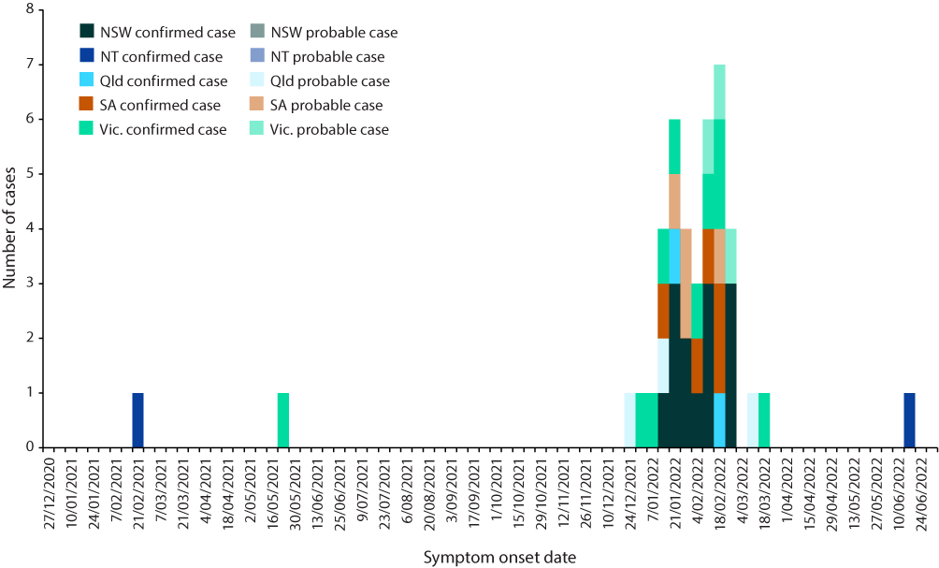

a Source: Australian Government Department of Health and Aged Care Japanese Encephalitis Virus Outbreak REDCap Database.

b Date of symptom onset or date of first specimen collection if date of symptom onset is missing.

Eighty-three percent (35/42) of cases were hospitalised, of which 57% (20/35) were admitted to an intensive care unit (ICU; Table 2). Most cases hospitalised (65%; 23/35) and admitted to ICU (65%; 13/20) were male. Six cases (6/42) were reported with co-infections, all of whom were hospitalised. Of these, four were reported to be co-infected with coronavirus disease 2019 (COVID-19) and two with Ross River virus infection.

Seven cases were reported to have died due to JEV infection, with an overall case fatality rate of 17% (Table 2). All of these cases were aged over 40 years; four were male (57%).

Table 2: Japanese encephalitis virus case (confirmed and probable) outcomes by jurisdiction of residence, Australia,a 1 January 2021 – 30 June 2022

| Jurisdiction of residenceb | Hospitalisations | | Admission to ICU | | Deaths | |
| --- | --- | --- | --- | --- | --- | --- |
| Number | Proportion | Number | Proportion | Number | Proportion |
| NSW | 11 | 31% | 7 | 35% | 2 | 29% |
| NT | 2 | 6% | 1 | 5% | 1 | 14% |
| Qld | 3 | 9% | 2 | 10% | 1 | 14% |
| SA | 9 | 26% | 5 | 25% | 2 | 29% |
| Vic. | 10 | 29% | 5 | 25% | 1 | 14% |
| Total | 35 | 100% | 20 | 100% | 7 | 100% |

a Source: Australian Government Department of Health and Aged Care Japanese Encephalitis Virus Outbreak REDCap Database.

b NSW: New South Wales; NT: Northern Territory; Qld: Queensland; SA: South Australia; Vic.: Victoria.

## Geographical distribution

There were 41 cases (98%; 41/42) with exposure location data available. Of these, 93% (38/41) reported one ‘likely LGA of exposure’, and 7% (3/41) reported more than one ‘likely LGA of exposure’. There were 31 unique LGAs identified across five jurisdictions as exposure locations (New South Wales (10); Northern Territory (3); Queensland (7); South Australia (5); Victoria (6)). All LGAs were located in either regional or remote Australia.

The LGAs where exposures occurred varied by different periods of the outbreak. For cases with symptom onset between 1 January 2021 and 31 December 2021, there were seven LGAs identified as exposure locations. Two were identified in the Northern Territory, in March 2021 and May 2021; four were identified in Queensland, and one in Victoria, in December 2021 (Figure 2a). When cases increased in January 2022 (Figure 2b), 13 cases reported exposures in 13 LGAs across Queensland (n = 3), New South Wales (n = 3), Victoria (n = 3), and South Australia (n = 4). In the peak of the outbreak in February 2022 (Figure 2c), 21 cases reported exposures in 13 LGAs, with the highest density localised to south-eastern Australia in New South Wales (n = 6), Victoria (n = 3) and South Australia (n = 2), and two LGAs in south-west Queensland. From 1 March 2022 to 30 June 2022 (Figure 2d), exposures were reported across four LGAs in Victoria (n = 1), Queensland (n = 1), New South Wales (n = 1) and the Northern Territory (n = 1). There were only four LGAs where exposures occurred in more than one of these time periods.

Figure 2: Time series maps of human Japanese encephalitis virus cases (confirmed and probable) by likely local government areas (LGA) of exposure (n = 41)a,b and symptom onset,c 1 January 2021 – 30 June 2022,d Australia

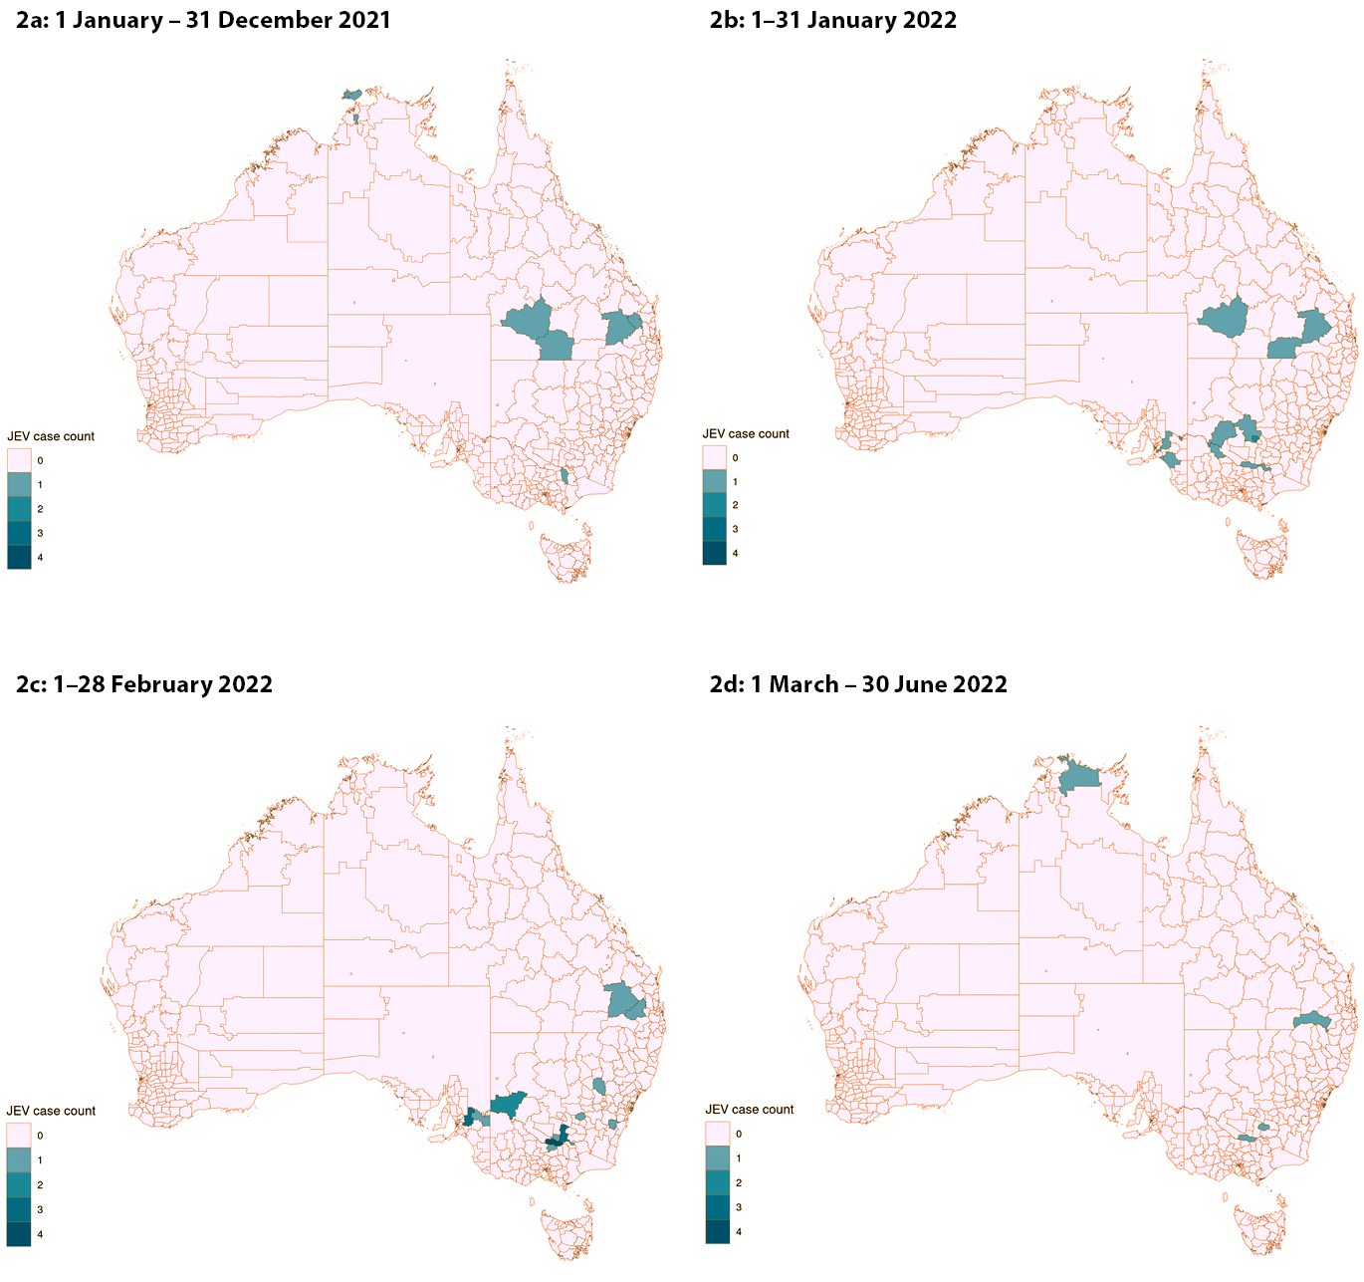

a Cases with unknown ‘likely LGA of exposure’ are excluded from time series maps.

b Cases may have more than one LGA listed as the ‘likely LGA of exposure’, therefore the number of LGAs reported will not be equal to the number of cases reported.

c Date of symptom onset or date of first specimen collection if date of symptom onset is missing.

d Source: Australian Government Department of Health and Aged Care Japanese Encephalitis Virus Outbreak REDCap Database.

## Environmental exposures of cases

Eighty-three percent (35/42) of cases reported at least one occupational, environmental, or recreational exposure, of whom 80% (28/35) reported more than one. The most commonly reported exposures were ‘living on or visiting a rural property or area’ (57%; 20/35), ‘water sports/fishing/boating’ (40%; 14/35) and ‘camping’ (40%; 14/35) (Table 3).

For cases aged 60 years and over, the most common exposure reported was ‘camping’ (55%; 11/20), whilst for those under 60 years, most reported ‘living on or visiting rural property or area’ (78%; 14/18). Reported exposures differed between males and females, with males reporting ‘water sports/fishing/boating’ (56%; 14/25) whilst females reported ‘Living on or visiting a rural property or area’ (62%; 8/13).

Data collected, regarding exposure to any animal or vectors associated with the JEV transmission cycle, indicated that 71% of cases (30/42) reported at least one animal or vector exposure. Mosquito exposure (90%; 27/30) was the most common (Table 4).

Table 3: Japanese encephalitis virus cases (confirmed and probable) by occupational, environmental and recreational exposures, Australia,a 1 January 2021 – 30 June 2022 (n = 35)

| Occupational, environmental or recreational exposures | Number of casesb | Percentagec |
| --- | --- | --- |
| Live on or visit a rural property/rural area | 20 | 57 |
| Camping | 14 | 40 |
| Water sports/fishing/boating | 14 | 40 |
| Farmer/farm worker | 9 | 26 |
| Works outside | 8 | 23 |
| Gardening | 4 | 11 |
| Spent time in parklands (e.g. State or National Parks; botanical gardens; golf courses etc.) | 2 | 6 |
| Piggery (including pig abattoir, pork rendering plant, animal/feed transport related to pigs) | 1 | 3 |
| Hunting (e.g. pig hunting) | 1 | 3 |
| Agricultural show | 0 | 0 |
| Environmental health (incl. state, council etc.) | 0 | 0 |
| Veterinary practice | 0 | 0 |
| Laboratory | 0 | 0 |
| Other exposured | 5 | 13 |

a Source: Australian Government Department of Health and Aged Care Japanese Encephalitis Virus Outbreak REDCap Database.

b Cases may have reported more than one exposure and therefore total number of exposures will not be equal to the total number of cases.

c The denominator is total number of cases who reported occupational/environmental data (n = 35).

d ‘Other exposures’ include travel for work, outdoor recreational activities such as swimming.

Table 4: Japanese encephalitis virus cases (confirmed and probable) by animal exposures, Australia,a 1 January 2021 – 30 June 2022 (n = 30)

| Animal or vector exposures | Number of casesb | Percentagec |
| --- | --- | --- |
| Mosquitoes | 27 | 90 |
| Birds | 4 | 13 |
| Horses | 3 | 18 |
| Pigs | 2 | 7 |
| Bats | 0 | 0 |
| Other animalsd | 6 | 20 |

a Source: Australian Government Department of Health and Aged Care Japanese Encephalitis Virus Outbreak REDCap Database.

b Cases may have reported more than one exposure and therefore total number of exposures will not be equal to the total number of cases.

c The denominator is total number of cases who reported animal or vecor exposure data (n = 30).

d ‘Other animals’ include sheep, cattle, dogs, cats and rabbits.

## Location of infection

Of the 41 cases with exposure data available, the ‘likely LGA of exposure’ for 16 cases (39%) did not match their LGA of residence. For these cases, the ‘likely LGA of exposure’ was more than an hour’s drive from their LGA of residence, with 56% (9/16) reporting residing in a ‘major city’. The most common exposures reported by these cases included ‘camping’ (75%; 12/16) and ‘water sports/fishing/boating’ (38%; 6/16).

There were 25 cases (61%, 25/41) where the likely LGA of exposure matched their LGA of residence. The most common exposures reported by these cases included ‘living on or visiting a rural property or area’ (60%; 15/25) and ‘water sports/fishing/boating’ (28%; 7/25). Only 4% of these cases (1/25) reported ‘camping’ as a potential exposure.

# Discussion

This article describes the epidemiology of an outbreak of JEV that occurred in Australia between 1 January 2021 and 30 June 2022. There were 42 confirmed and probable cases of JEV reported across five jurisdictions during this period, with 83% hospitalised (n = 35) and a CFR of 17% (n = 7). Compared with previously detected locally acquired cases of JEV in Australia,11,12 this outbreak had more cases; had a longer period of transmission; and occurred over a larger geographical area.

Before this outbreak, JEV was rarely locally acquired in Australia, and vaccines were only recommended for travellers to endemic countries and for residents of the Torres Strait.27,28 Most of the Australian population is unvaccinated against JEV and susceptible to infection. Where JEV is endemic internationally, disease predominantly impacts children; however, when JEV is introduced into a population, cases are mostly observed in adults.4,29 Our analysis reflects this, with most cases occurring in adults aged over 18 years (93%; n = 39).

In previous Australian outbreaks, human cases and environmental detections remained localised to the Torres Strait and Cape York Peninsula. Our paper shows that JEV had spread to new geographical areas in Australia during the outbreak, with cases likely acquiring their infection across 31 LGAs in New South Wales, Victoria, South Australia, Queensland, and the Northern Territory. The first cases detected in 2021 were localised to two LGAs in the Northern Territory, but by early 2022, cases had been identified in an additional 29 LGAs across four other jurisdictions.

From February 2022 to May 2022, there were reports of environmental and animal JEV detections.20 This includes detections in over 70 commercial piggeries across New South Wales, Queensland, Victoria and South Australia,20 and detections of JEV in feral pigs in the Northern Territory,29 as well as inconclusive results in horses in New South Wales.30 There were also detections from mosquitoes and seroconversion in sentinel chickens.31,32 Human cases in this outbreak reflect the wide geographical distribution of environmental and animal detections of JEV in Australia. There were reported environmental and animal detections in LGAs where human JEV cases have not yet been detected.29,32–35 Considering the geographical spread already seen in this outbreak, it is possible that human cases of JEV could be detected in these areas in the future.

The surge of JEV cases in Australia is likely to have been accelerated by favourable weather conditions, such as the record-breaking rain and flood events across Australia preceding and during the outbreak period.36,37 These weather events likely provided habitats for the proliferation and expansion of mosquito and waterbird populations across large parts of Australia.16,38 Water birds are natural reservoirs of JEV, and have been implicated in introducing JEV into new geographic areas that follow their migratory patterns.39

JEV is closely related to other mosquito-borne viruses that are endemic to Australia, including Murray Valley Encephalitis Virus (MVEV) and West Nile Virus Kunjin subtype (WNVKUN).40 Virus isolation and vector competence studies have identified the *Culex sitiens* subgroup of mosquitos, including *Culex annulirostris*, to be the likely principal vectors of JEV in Australia.16,41 *Culex annulirostris* is also the principal vector of MVEV and WNVKUN.18,42 Previous outbreaks of MVEV were associated with heavy rainfall and flooding events.43 Given the similarities between JEV and other mosquito-borne viruses, it is possible that JEV will follow similar geographical distribution and seasonal patterns in the future.

All cases in this outbreak likely acquired their JEV infection in regional and remote areas of Australia. This replicates epidemiological patterns found in JEV-endemic countries.4 Some cases in this outbreak did not live where they were likely exposed and had driven at least one hour to their potential exposure location and reported outdoor activities including camping and water sports, fishing and boating. This indicates that travellers, as well as residents of high-risk areas in Australia, in regional and remote areas, need to be targeted in public health campaigns about their risk of exposure to JEV.

Public health actions in response to the outbreak included offering JEV vaccination to high-risk populations,44 and communication campaigns regarding mosquito awareness. Our analysis has shown sustained transmission of JEV in some parts of Australia, with the latest cases in this outbreak occurring more than a year after JEV was first detected in the Northern Territory. As there have also been extensive environmental and animal detections, it is possible that JEV may become endemic across mainland Australia. Vaccination and mosquito control methods have proven to be effective at reducing the burden of JEV.1 Further research and surveillance are required to understand the extent of JEV spread across Australia, and implications for the public health response.

## Limitations

There are several limitations associated with our analysis. There were different case questionnaires used over time in this outbreak, and data may not have been collected consistently across cases. Determining likely exposure location by states and territories was subjective, dependent on case interview data, and may not truly reflect where a case was exposed to JEV, particularly if the case spent their exposure period in multiple LGAs. Future investigation and mapping of environmental and animal detections may assist in further targeting future public health activities. We have not included analysis about environmental and animal detections as it is out of scope of this paper.

As approximately 1% of JEV infections result in clinical disease,4 the cases described in this article likely under-represent the true JEV infection rate in Australia. Testing for JEV focused on patients with unexplained encephalitis,22 therefore cases that were asymptomatic or had milder disease were unlikely to be tested and are not included in this cohort. In serosurveys in regional NSW and Victoria, JEV antibodies were found in 3.3% and 9% of all participants in Victoria and New South Wales respectively.46,47 Additionally, longer-term illness outcomes were not captured in the outbreak response database and therefore are not able to be reported here.

# Conclusion

In this outbreak, there was unprecedented detection of human JEV cases across a vast geographical area in Australia. As human cases and environmental and animal detections emerged over an 18-month period, there is potential for future detections of JEV in humans to occur in new and known geographical areas of Australia. Given the risk of further cases, and of JEV becoming endemic in Australia, ongoing and extended environmental and human surveillance is required.

# Acknowledgments

The authors would like to thank all state and territory health departments, as well as the Communicable Diseases Network Australia. We acknowledge the work of various public health professionals and laboratory staff around Australia who interviewed patients, tested specimens, and investigated the JEV outbreak.

# Author details

Amanda Reyes Veliz,1,2

Stacey Kane,1

Anna Glynn-Robinson2

1. Health Protection Policy and Surveillance Division, Australian Government Department of Health and Aged Care, Canberra, Australian Capital Territory, Australia
2. National School of Epidemiology and Public Health, Australian National University, Canberra, Australian Capital Territory, Australia

Corresponding author

Amanda Reyes Veliz

Health Protection Policy and Surveillance Division, Australian Government Department of Health, Canberra, Australia

Email: CDESS@health.gov.au

# References

1. Erlanger TE, Weiss S, Keiser J, Utzinger J, Wiedenmayer K. Past, present, and future of Japanese encephalitis. *Emerg Infect Dis*. 2009;15(1):1–7. doi: https://doi/org/10.3201/eid1501.080311.
2. Le Flohic G, Porphyre V, Barbazan P, Gonzalez JP. Review of climate, landscape, and viral genetics as drivers of the Japanese encephalitis virus ecology. *PLOS Negl Trop Dis*. 2013;7(9):e2208. doi: https://doi/org/10.1371/journal.pntd.0002208.
3. van den Hurk AF, Ritchie SA, Mackenzie JS. Ecology and geographical expansion of Japanese encephalitis virus. *Annu Rev Entomol*. 2009;54(1):17–35. doi: https://doi/org/10.1146/annurev.ento.54.110807.090510.
4. Turtle L, Solomon T. Japanese encephalitis — the prospects for new treatments. *Nat Rev Neurol*. 2018;14(5):298–313. doi: https://doi/org/10.1038/nrneurol.2018.30.
5. Campbell GL, Hills SL, Fischer M, Jacobson JA, Hoke CH, Hombach JM et al. Estimated global incidence of Japanese encephalitis: a systematic review. *Bull World Health Organ*. 2011;89(10):766–74E. doi: https://doi/org/10.2471/BLT.10.085233.
6. Quan TM, Thao TTN, Duy NM, Nhat TM, Clapham H. Estimates of the global burden of Japanese encephalitis and the impact of vaccination from 2000–2015. Elife. 2020;9:e51027. doi: https://doi/org/10.7554/eLife.51027.
7. Cheng Y, Tran Minh N, Tran Minh Q, Khandelwal S, Clapham HE. Estimates of Japanese Encephalitis mortality and morbidity: a systematic review and modeling analysis. *PLOS Negl Trop Dis*. 2022;16(5):e0010361. doi: https://doi/org/10.1371/journal.pntd.0010361.
8. Mackenzie JS, Johansen CA, Ritchie SA, van den Hurk AF, Hall RA. Japanese encephalitis as an emerging virus: the emergence and spread of Japanese encephalitis virus in Australasia. *Curr Top Microbiol Immuno*l. 2002;267:49–73. doi: https://doi/org/10.1007/978-3-642-59403-8_3.
9. World Health Organization (WHO). Japanese encephalitis. [Online fact sheet.] Geneva: WHO; 9 May 2019. [Accessed on 21 September 2022.] Available from: https://www.who.int/news-room/fact-sheets/detail/japanese-encephalitis.
10. NNDSS Annual Report Working Group. Australia’s notifiable disease status, 2016: annual report of the National Notifiable DIseases Surveillance System. *Commun Dis Intell*. (2018). 2021;45. doi: https://doi.org/10.33321/cdi.2021.45.28.
11. Hanna JN, Ritchie SA, Phillips DA, Shield J, Bailey MC, Mackenzie JS et al. An outbreak of Japanese encephalitis in the Torres Strait, Australia, 1995. *Med J Aust*. 1996;165(5):256–60. doi: https://doi/org/10.5694/j.1326-5377.1996.tb124960.x.
12. Hanna JN, Ritchie SA, Phillips DA, Lee JM, Hills SL, van den Hurk AF et al. Japanese encephalitis in north Queensland, Australia, 1998. *Med J Aust*. 1999;170(11):533–6. doi: https://doi/org/10.5694/j.1326-5377.1999.tb127878.x.
13. van den Hurk AF, Pyke AT, Mackenzie JS, Hall-Mendelin S, Ritchie SA. Japanese encephalitis virus in Australia: from known known to known unknown. *Trop Med Infect Dis*. 2019;4(1):38. doi:https://doi/org/10.3390/tropicalmed4010038.
14. Shield J, Hanna J, Phillips D. Reappearance of the Japanese encephalitis virus in the Torres Strait, 1996. *Commun Dis Intell*. 1996;20(8):191.
15. Pyke AT, Williams DT, Nisbet DJ, van den Hurk AF, Taylor CT, Johansen CA et al. The appearance of a second genotype of Japanese encephalitis virus in the Australasian region. *Am J Trop Med Hyg*. 2001;65(6):747–53. doi: https://doi/org/10.4269/ajtmh.2001.65.747.
16. van den Hurk AF, Skinner E, Ritchie SA, Mackenzie JS. The emergence of Japanese encephalitis virus in Australia in 2022: existing knowledge of mosquito vectors. *Viruses*. 2022;14(6):1208. doi: https://doi/org/10.3390/v14061208.
17. van den Hurk AF, Montgomery BL, Northill JA, Smith IL, Zborowski P, Ritchie SA et al. Short report: the first isolation of Japanese encephalitis virus from mosquitoes collected from mainland Australia. *Am J Trop Med Hyg*. 2006;75(1):21–5.
18. Hemmerter S, Slapeta J, van den Hurk AF, Cooper RD, Whelan PI, Russell RC et al. A curious coincidence: mosquito biodiversity and the limits of the Japanese encephalitis virus in Australasia. *BMC Evol Biol*. 2007;7:100. doi: https://doi/org/10.1186/1471-2148-7-100.
19. Waller C, Tiemensma M, Currie BJ, Williams DT, Baird RW, Krause VL. Japanese encephalitis in Australia — a sentinel case. *N Engl J Med*. 2022;387(7):661–2. doi: https://doi/org/10.1056/NEJMc2207004.
20. Australian Government Department of Agriculture Fisheries and Forestry. Japanese encephalitis virus. [Webpage.] Canberra: Australian Government Department of Agriculture, Fisheries and Forestry; 1 September 2022. [Accessed on 28 September 2022.] Available from: https://www.agriculture.gov.au/biosecurity-trade/pests-diseases-weeds/animal/japanese-encephalitis.
21. Howard-Jones AR, Pham D, Jeoffreys N, Eden JS, Hueston L, Kesson AM et al. Emerging genotype IV Japanese encephalitis virus outbreak in New South Wales, Australia. *Viruses*. 2022;14(9):1853. doi: https://doi/org/10.3390/v14091853.
22. Australian Government Department of Health and Aged Care. Japanese encephalitis virus situation declared a Communicable Disease Incident of National Significance. [Media release.] Canberra: Australian Government Department of Health and Aged Care; 4 March 2022. [Accessed on 24 September 2022.] Available from: https://www.health.gov.au/news/japanese-encephalitis-virus-situation-declared-a-communicable-disease-incident-of-national-significance.
23. Public Health Laboratory Network (PHLN). *Flavivirus. Laboratory case definition*. Canberra: Australian Government Department of Health and Aged Care, PHLN; 2 May 2022. Available from: https://www.health.gov.au/sites/default/files/documents/2022/07/flavivirus-laboratory-case-definition.pdf.
24. Australian Bureau of Statistics. National, state and territory population. Reference period March 2022. [Webpage.] Canberra: Australian Bureau of Statistics; 21 September 2022. [Accessed on 27 September 2022.] Available from: https://www.abs.gov.au/statistics/people/population/national-state-and-territory-population/mar-2022.
25. Australian Bureau of Statistics. Local Government Areas: Australian Statistical Geography Standard (ASGS) Edition 3. Reference period: July 2021 – June 2026. [Webpage.] Canberra: Australian Bureau of Statistics; 6 October 2021. [Accessed on 4 November 2022.] Available from: https://www.abs.gov.au/statistics/standards/australian-statistical-geography-standard-asgs-edition-3/jul2021-jun2026/non-abs-structures/local-government-areas#cite-window1.
26. Australian Bureau of Statistics. Remoteness Structure: Australian Statistical Geography Standard (ASGS) Edition 3. Reference period: July 2021 – June 2026. [Webpage.] Canberra: Australian Bureau of Statistics; 20 July 2021. [Accessed on 4 November 2022.] Available from: https://www.abs.gov.au/statistics/standards/australian-statistical-geography-standard-asgs-edition-3/jul2021-jun2026/remoteness-structure#cite-window1.
27. Australian Government Department of Health and Aged Care. Japanese encephalitis virus (JEV) vaccines. [Webpage.] Canberra: Australian Government Department of Health and Aged Care; 23 September 2022. [Accessed on 4 November 2022.] Available from: https://www.health.gov.au/health-alerts/japanese-encephalitis-virus-jev/vaccines.
28. Australian Government Department of Health and Aged Care, Australian Immunisation Handbook. Japanese encephalitis. [Webpage.] Canberra: Australian Government Department of Health and Aged Care; 19 May 2022. [Accessed on 7 August 2023.] Available from: https://immunisationhandbook.health.gov.au/contents/vaccine-preventable-diseases/japanese-encephalitis.
29. Hills SL, Netravathi M, Solomon T. Japanese encephalitis among adults: a review. *Am J Trop Med Hyg*. 2023;108(5):860–4. doi: https://doi.org/10.4269/ajtmh.23-0036.
30. Northern Territory Government Department of Health (NT Health). NT on alert for Japanese encephalitis. [Internet.] Darwin: NT Health; 7 June 2022. [Accessed on 28 September 2022.] Available from: https://health.nt.gov.au/news/nt-on-alert-for-japanese-encephalitis.
31. New South Wales Government Department of Primary Industries (NSW DPI). Japanese encephalitis. [Webpage.] Sydney: NSW DPI; 2022. [Accessed on 30 September 2022.] Available from: https://www.dpi.nsw.gov.au/biosecurity/animal/info-vets/japanese-encephalitis.
32. Government of South Australia Department of Health (SA Health). *South Australian Arbovirus and Mosquito Monitoring and Control Annual Report: 2021–2022*. Adelaide: SA Health; 2023. [Accessed on 30 May 2023.] Available from: https://www.sahealth.sa.gov.au/wps/wcm/connect/1d27806b-5806-45fe-8c18-0d292036b8e1/South+Australian+Arbovirus+and+Mosquito+Monitoring+and+Control+Annual+Report+for+the+2021-2022+season.pdf.
33. New South Wales Government Department of Health (NSW Health). *NSW Arbovirus Surveillance & Mosquito Monitoring 2021–2022, Weekly Update: Week ending 23 April 2022 (Report Number 24)*. Sydney: NSW Health; 2022. [Accessed on 30 May 2023.] Available from: https://www.health.nsw.gov.au/environment/pests/vector/Publications/nswasp-weekly-report-2022-04-23.pdf.
34. Victorian State Government Department of Agriculture (Agriculture Victoria). Japanese encephalitis current situation. [Internet.] Melbourne: Agriculture Victoria; 5 July 2022. [Accessed on 30 September 2022.] Available from: https://agriculture.vic.gov.au/biosecurity/animal-diseases/important-animal-diseases/japanese-encephalitis/japanese-encephalitis-current-situation.
35. Government of South Australia Department of Primary Industries and Regions. Japanese encephalitis. [Webpage.] Adelaide: Government of South Australia Department of Primary Industries and Regions; 2022. [Accessed on 30 September 2022.] Available from: https://www.pir.sa.gov.au/emergencies_and_recovery/japanese_encephalitis.
36. NSW Health. Japanese encephalitis. [Webpage.] Sydney: NSW Health; 2022. [Accessed on 30 September 2022.] Available from: https://www.health.nsw.gov.au/environment/pests/vector/Pages/japanese-encephalitis.aspx.
37. Australian Government Bureau of Meteorology (BoM). *Special Climate Statement 76 – Extreme rainfall and flooding in south-eastern Queensland and eastern New South Wales*. Canberra: BoM; 25 May 2022. [Accessed on 30 September 2022.] Available from: http://www.bom.gov.au/climate/current/statements/scs76.pdf?20220525.
38. BoM. *Special Climate Statement 75 – Australia’s wettest November on record*. Canberra: BoM; 14 February 2022. [Accessed on 30 September 2022.] Available from: http://www.bom.gov.au/climate/current/statements/scs75.pdf?20220214.
39. Dubach I. Current floods essential for long-term future of waterbirds: annual survey. [Press release.] Sydney: University of New South Wales; 17 December 2021. Available from: https://www.unsw.edu.au/news/2021/12/current-floods-essential-for-long-term-future-of-waterbirds--ann.
40. Mulvey P, Duong V, Boyer S, Burgess G, Williams DT, Dussart P et al. The ecology and evolution of Japanese encephalitis virus. *Pathogens*. 2021;10(12):1534. doi: https://doi/org/10.3390/pathogens10121534.
41. Mansfield KL, Horton DL, Johnson N, Li L, Barrett ADT, Smith DJ et al. Flavivirus-induced antibody cross-reactivity. *J Gen Virol*. 2011;92(Pt 12):2821–9. doi: https://doi/org/10.1099/vir.0.031641-0.
42. Johansen CA, van den hurk AF, Pyke AT, Zborowski P, Phillips DA, Mackenzie JS et al. Entomological investigations of an outbreak of Japanese encephalitis virus in the Torres Strait, Australia, in 1998. *J Med Entomol*. 2001;38(4):581–8. doi: https://doi/org/10.1603/0022-2585-38.4.581.
43. Floridis J, McGuinness SL, Kurucz N, Burrow JN, Baird R, Francis JR. Murray Valley encephalitis virus: an ongoing cause of encephalitis in Australia’s north. *Trop Med Infect Dis*. 2018;3(2):49. doi: https://doi/org/10.3390/tropicalmed3020049.
44. Selvey LA, Dailey L, Lindsay M, Armstrong P, Tobin S, Koehler AP et al. The changing epidemiology of Murray Valley encephalitis in Australia: the 2011 outbreak and a review of the literature. *PLoS Negl Trop Dis*. 2014;8(1):e2656. doi: https://doi/org/10.1371/journal.pntd.0002656.
45. Australian Government Department of Health and Aged Care. *CDNA advice regarding vaccination against Japanese encephalitis virus*. Canberra: Australian Government Department of Health and Aged Care; 16 March 2022. [Accessed on 29 October 2022.] Available from: https://www.health.gov.au/resources/publications/cdna-advice-regarding-vaccination-against-japanese-encephalitis-virus.
46. NSW Health. *Summary of NSW Japanese encephalitis virus serosurvey results*. Sydney: NSW Health; September 2022. [Accessed on 20 September 2022.] Available from: https://www.health.nsw.gov.au/environment/pests/vector/Documents/jev-serosurvey-report.pdf.
47. Victorian State Government Department of Health (Vic Health). Serosurvey for Japanese encephalitis virus in northern Victoria. [Webpage.] Melbourne: Vic Health; 2 March 2023. [Accessed on 20 December 2023.] Available from: https://www.health.vic.gov.au/infectious-diseases/serosurvey-for-japanese-encephalitis-in-northern-victoria.

© Commonwealth of Australia as represented by the Department of Health and Aged Care

ISSN: 2209-6051 Online

This journal is indexed by Index Medicus and Medline.

Creative Commons Licence

This publication is licensed under a Creative Commons Attribution-NonCommercial-NoDerivatives 4.0 International Licence (CC BY-NC-ND) available from https://creativecommons.org/licenses/by-nc-nd/4.0/legalcode (Licence). You must read and understand the Licence before using any material from this publication.

Restrictions

The Licence does not cover, and there is no permission given for, use of any of the following material found in this publication (if any):

* the Commonwealth Coat of Arms (by way of information, the terms under which the Coat of Arms may be used can be found on the Department of Prime Minister and Cabinet website;
* any logos (including the Department of Health and Aged Care’s logo) and trademarks;
* any photographs and images;
* any signatures; and
* any material belonging to third parties.

Disclaimer

Opinions expressed in *Communicable Diseases Intelligence* are those of the authors and not necessarily those of the Department of Health and Aged Care or the Communicable Diseases Network Australia. Data may be subject to revision.

Enquiries

Enquiries regarding any other use of this publication should be addressed to the CDI Editor at: cdi.editor@health.gov.au.

Communicable Diseases Network Australia

Communicable Diseases Intelligence contributes to the work of the [Communicable Diseases Network Australia](http://www.health.gov.au/cdna).

About Communicable Diseases Intelligence

*Communicable Diseases Intelligence* (CDI) is a peer-reviewed scientific journal published by the Health Security & Emergency Management Division, Department of Health and Aged Care. The journal aims to disseminate information on the epidemiology, surveillance, prevention and control of communicable diseases of relevance to Australia.

**Editor**: Christina Bareja • **Deputy Editor**: Simon Petrie • **Design and Production**: Lisa Thompson

**Editorial Advisory Board**: David Durrheim, Mark Ferson, Clare Huppatz, John Kaldor, Martyn Kirk and Meru Sheel

Submit an Article

Submit your next communicable disease related article to CDI for consideration. [Information for authors](https://www1.health.gov.au/internet/main/publishing.nsf/Content/cda-pubs-cdi-auth_inst.htm) and details on how to [submit your publication](https://www1.health.gov.au/internet/main/publishing.nsf/Content/cda-pubs-cdi-auth_inst.htm#submission_package) is available on our website, or by email at [cdi.editor@health.gov.au](mailto:cdi.editor@health.gov.au).

Contact us

Communicable Diseases Intelligence (CDI)

Health Security & Emergency Management Division

Department of Health and Aged Care

GPO Box 9848, CANBERRA ACT 2601

Website: [www.health.gov.au/cdi](http://www.health.gov.au/cdi)

Email: [cdi.editor@health.gov.au](mailto:cdi.editor@health.gov.au)