2024 • Volume 48 • https://doi.org/10.33321/cdi.2024.48.17 • Electronic publication date: 10/04/2024

The first confirmed outbreak of chikungunya reported in Timor-Leste, 2024
Filipe de Neri Machado, Anthony DK Draper, Anferida Monteiro Fernandes, Frederico Bosco Alves dos Santos, Marcelo Amaral Mali, Ari J Pereira Tilman, Endang Soares da Silva, Elizabeth Hornay, Antonio Salles de Sousa, Tessa Oakley, Edinha da Cruz, Nevio Sarmento, Maria AV Niha, Ana Fatima Soares, Eva Estrelita Cardoso Gomes, Jose de Deus Alves, Jose Paulo Soares, Joshua R Francis, Jennifer Yan, Merita Antonio Monteiro

Abstract
Timor-Leste is a mountainous, half-island nation with a population of 1.3 million, which shares a land border with Indonesia and is 550 km from Darwin, Australia. Since independence in 2002, Timor-Leste has achieved significant development; however, high levels of poverty remain. Chikungunya virus (CHIKV) is endemic in over 100 countries in Africa, Asia, Europe and in the Americas. It is transmitted by the bite of infected Aedes aegypti or Ae. albopictus mosquitoes, which are present in Timor-Leste and which contribute to annual rainy-season dengue virus (DENV) outbreaks. Symptomatic people typically suffer from acute onset of fever, usually accompanied by severe arthritis or arthralgia. Joint pain can be debilitating for several days, and may sometimes last for weeks, months or years. Unlike DENV infection which has significant mortality, most people recover completely. Between 2002 and 2023, there were 26 cases of CHIKV notified in Australia who acquired their infection in Timor-Leste; however, laboratory testing capability for CHIKV in Timor-Leste only became available in 2021 using polymerase chain reaction (PCR). The first locally diagnosed case was notified in November 2023. In January 2024, an outbreak of CHIKV was recognised in Timor-Leste for the first time, with 195 outbreak cases reported during 1–31 January 2024; all were PCR positive. There were no cases hospitalised, and no deaths. The median age of cases was 17 years (range 1–76 years); 51% were males. Cases were reported across the country; most (88/195) were from Dili, although the highest incidence was seen in the neighbouring municipality of Ermera (monthly incidence rate of 58.8 cases per 100,000 population).
This first reported outbreak of CHIKV in Timor-Leste highlights the need for improved mosquito-borne illness control and response strategies, including minimising breeding sites and promoting early presentation for treatment and differential diagnosis from DENV, and consideration of the deployment of Wolbachia-infected mosquitoes, particularly as they have shown to reduce the transmission of CHIKV, DENV and Zika virus, all of which pose threats in Timor-Leste.
Keywords: chikungunya; arbovirus; mosquito-borne disease; surveillance; Timor-Leste; outbreak; low-resource setting

Background
Timor-Leste is a mountainous, half-island nation with a population of 1.3 million,1 which shares a land border with Indonesia and is 550 km from Darwin, Australia.2 Since independence in 2002, Timor-Leste has achieved significant development; however, high levels of poverty remain.1 Timor-Leste consists of 13 municipalities, the most populous of which is the municipality of Dili which includes the capital city, Dili (Figure 1).3 The majority of the population (71.2%) lives in rural areas and 64.6% of the population is aged less than 30 years.4
Figure 1: Map of Timor-Leste showing the 13 municipalities
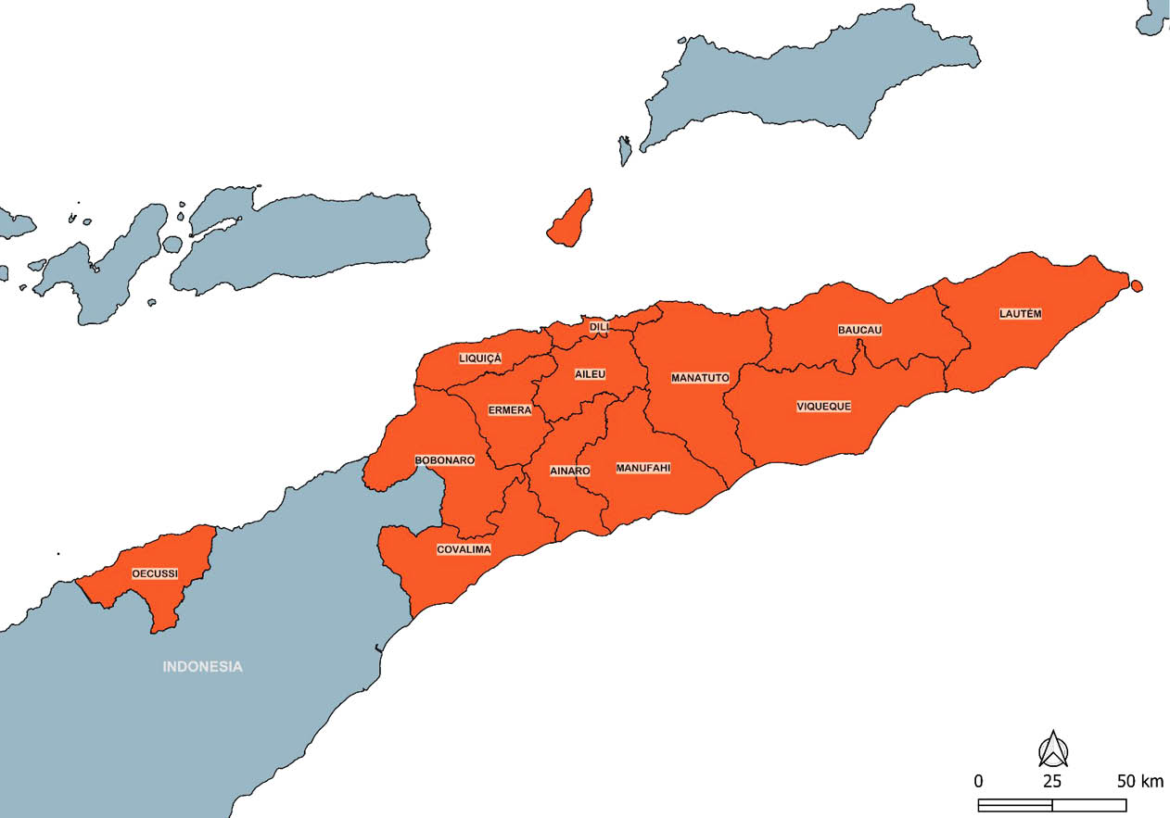
Timor-Leste experiences a tropical climate with a dry season (May–November) and a rainy season (December–April).5 This provides ideal breeding conditions for Aedes aegypti and Ae. albopictus mosquitoes which can transmit both chikungunya virus (CHIKV) and dengue virus (DENV).6
The first isolation of CHIKV was in Tanzania in 1952; it has since been detected in over 100 countries in Africa, Asia, Europe and the Americas.7 People who develop symptomatic infection typically do so 4–8 days (range: 1–12 days) after being bitten by an infected mosquito.7 Typical symptomology includes acute onset of fever, usually accompanied by severe arthritis or arthralgia. This joint pain can be debilitating and it usually lasts a few days. However, sometimes this pain can last for weeks, months or years.8 Unlike DENV, which causes up to 40,000 deaths globally each year,9 most people infected with CHIKV fully recover; however, there have been occasional reports of eye, heart, and neurological complications.7 Vertical transmission between mother and neonate has also been observed, resulting in neonatal CHIKV infection.10
In Timor-Leste, CHIKV has been a notifiable condition since 2018;11 however, there has not been the laboratory capability in Timor-Leste to test for it. In 2021, Timor-Leste began using the Ausdiagnostics mosquito-borne disease multiplex polymerase chain reaction (PCR) panel, in the context of ongoing investment in laboratory strengthening, supported by the Australian Government.12,13 The first case of CHIKV notified in Timor-Leste was in November 2023. However, evidence of CHIKV in Timor-Leste has been present since independence in 2002. Between 2002 and 2023, there were 26 cases of CHIKV notified in Australia who acquired their infection in Timor-Leste.14 This includes seven travellers who were notified in the Northern Territory, which has close links to Timor-Leste.15,16 Routine surveillance detected an outbreak of CHIKV in January 2024.
We briefly describe the first confirmed outbreak of CHIKV in Timor-Leste in 2024.

Methods
A confirmed outbreak case was defined as any person in Timor-Leste who tested positive to CHIKV by PCR and was notified to the surveillance department, with specimen collection date after 1 January 2024.11 A probable outbreak case was defined as any person in Timor-Leste notified to the surveillance department, who in the absence of PCR test for CHIKV, had acute onset of fever AND either severe arthralgia or severe arthritis, since 1 January 2024, and with these symptoms not explained by another diagnosis.17 Laboratory testing was undertaken on ethylenediaminetetraacetic acid (EDTA) anti-coagulated whole blood samples at the National Health Laboratory in Dili. Specimens were transported to Dili from other municipalities using government vehicle, ambulance, mini-bus (mikrolet) or motorcycle.
Case demographic information was collected using a standardised case questionnaire form also used for DENV notifications. Data was entered into Microsoft Excel 2016 (Microsoft, USA), which was also used to perform descriptive analysis and produce graphs.
Ethics approval was not required, as this outbreak investigation was conducted under the auspices of routine communicable disease surveillance and response activity.

Results
During 1–31 January 2024 there were 195 outbreak cases (Figure 2); 195 confirmed and 0 probable; no cases were hospitalised; there were no deaths; 52% of cases were male. The highest number of cases (88 cases, incidence rate 26.3 cases per 100,000) was notified in Dili municipality; the highest incidence rate of disease was in the neighbouring municipality of Ermera, with a monthly incidence rate of 58.8 cases per 100,000 (Table 1). The median age of cases was 17 years (range: 1–76 years). All laboratory-confirmed cases were detected using PCR. Cases of CHIKV were notified from five of the 13 municipalities in Timor-Leste.
Figure 2: Epidemic curve of outbreak cases by diagnosis date (specimen collection date for confirmed cases or onset date for probable cases), 1–31 January 2024, Timor-Leste
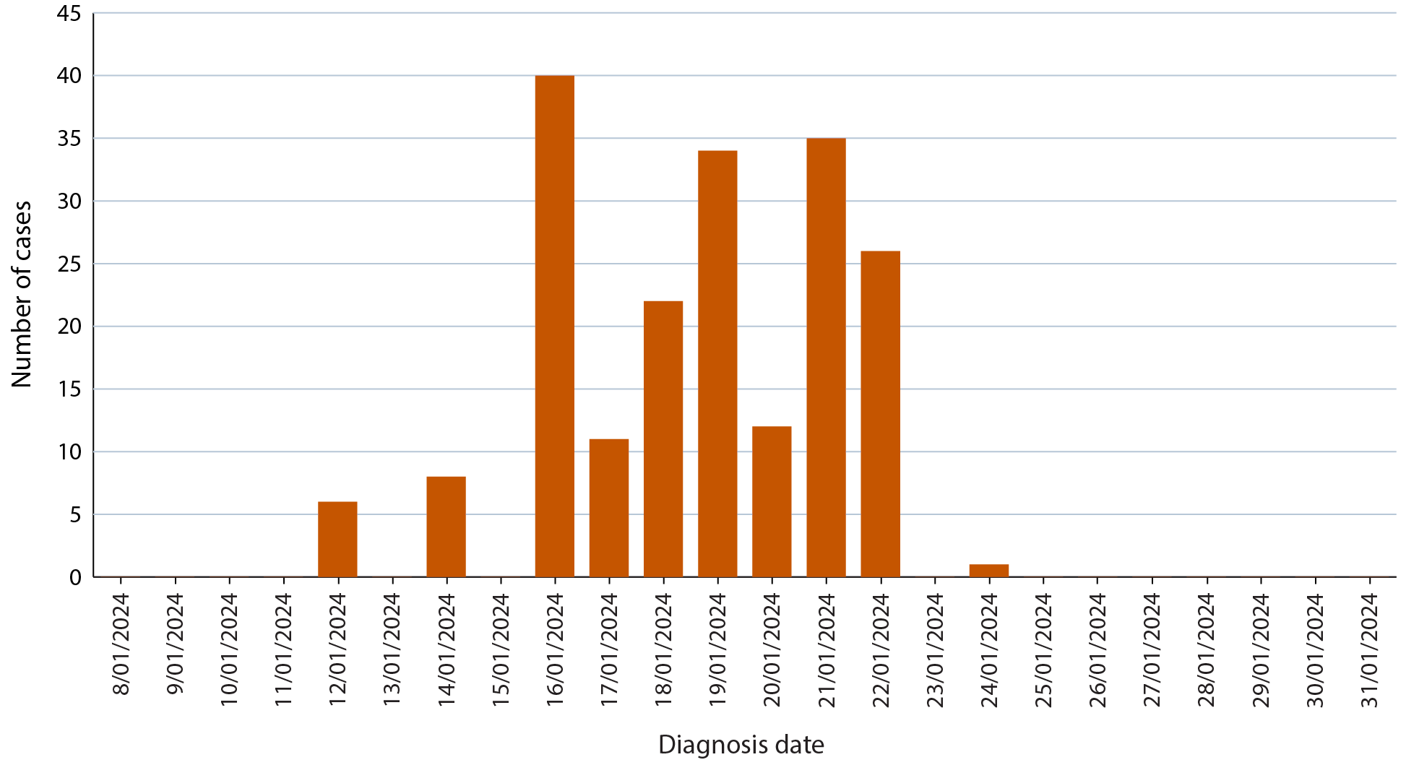
Table 1: Number of chikungunya outbreak cases (confirmed and probable) and monthly incidence rate (per 100,000 population), by municipality, Timor-Leste, 1–31 January 2024
Municipality | Cases | Incidence rate (per 100,000 population)
Aileu | 0 | 0
Ainaro | 0 | 0
Baucau | 0 | 0
Bobonaro | 5 | 4.7
Covalima | 0 | 0
Dili | 88 | 26.3
Ermera | 81 | 58.8
Lautem | 7 | 10.0
Liquiḉa | 14 | 16.7
Manatuto | 0 | 0
Manufahi | 0 | 0
Oecusse | 0 | 0
Viqueque | 0 | 0
Total | 195 | 14.5

Discussion
This paper presents the first confirmed outbreak of CHIKV in Timor-Leste, although the existence of the virus in the country has been demonstrated since at least 2002. This could represent the first outbreak of CHIKV or it could represent improved case ascertainment during a time of peak transmission. It is likely that the true incidence of CHIKV over the past two decades was high, despite very few notifications from Timor-Leste during this period. Many people only experience mild symptoms, and are thus unlikely to present to health centres and health posts for treatment and subsequent PCR testing.7
Also, since the symptoms of DENV and CHIKV overlap somewhat, there is the chance that some cases of CHIKV were considered as suspected DENV7 cases by clinicians and only tested for DENV, given the high incidence of DENV and the ready availability of DENV rapid test kits even at remote health posts. The multiplex PCR testing platform used to test for CHIKV has only been available at the National Health Laboratory in the capital of Dili since 2021. It was introduced in the context of investments in laboratory strengthening which have been supported by the Australian Government.18 The lack of notified cases after 25 January coincided with the exhaustion of the limited supplies of the reagents, rather than an end of transmission. Challenges in specimen transport may have provided a disincentive to collecting and sending samples for testing. Likewise, although public and clinician awareness of DENV in Timor-Leste was and remains high, there has been limited information on the incidence of CHIKV in the country and limited awareness of the ability to test for CHIKV as a differential diagnosis. Human resource constraints, particularly in remote areas, may have contributed to the absence of reports of cases that met the probable case definition. Likewise, the relatively low severity of CHIKV symptoms means that the true number of cases in the outbreak is likely much higher than the confirmed cases reported. This outbreak report highlights that public and clinician awareness of CHIKV should be heightened.
The virus is transmitted by the same Aedes spp. vectors that transmit Zika virus and DENV. In Timor-Leste, DENV results in significant morbidity and mortality, particularly during annual wet season outbreaks. Health promotion messages that encourage people with suspected arboviral infection to present early for treatment should continue, as an accurate diagnosis can guide appropriate care to reduce morbidity and prevent deaths.
Strategies for mosquito control in Timor-Leste currently focus on fogging and applying larvicides around locations where cases of DENV or CHIKV are notified. DENV-focused public health messaging occurs, which encourages community members to minimise breeding sites and larval habitats by encouraging proper rubbish disposal and removing items that can pool water such as old tyres, cans, bottles, and other receptacles.19 Many government agencies, private companies and other volunteer groups regularly collect rubbish in public spaces each Friday in an activity known as ‘limpeza’.20 The focus of public health messaging during the rainy season is on:
- covering up, especially during the day-time biting hours of the mosquito;
- looking for water reservoirs around the home and tipping them out to prevent breeding sites; and
- covering containers and other receptacles where adult mosquitoes live.21
Despite constant vector control and sanitation efforts, the incidence of diseases transmitted by Aedes spp. mosquitoes remains high in Timor-Leste.22,23 Introduction of Wolbachia-infected Ae. aegypti mosquitoes is a public health strategy that has had marked effects on the transmission of DENV, Zika and CHIKV in other nations including Australia, Indonesia and Brazil, and which would be anticipated to be similarly effective in urbanised settings within Timor-Leste.24,25,26,27,28

Conclusion
This first confirmed outbreak of CHIKV in Timor-Leste demonstrates that CHIKV is endemic in the country and outbreaks can occur. The availability and use of improved diagnostic tests (particularly PCR) improves the understanding of the epidemiology of CHIKV and other mosquito-borne diseases. Current conditions in Timor-Leste provide favourable conditions for Aedes spp. mosquitoes and existing strategies for vector control are not sufficiently mitigating the transmission of DENV and CHIKV to prevent outbreaks. The deployment of Wolbachia-infected mosquitoes should be considered in Timor-Leste, particularly in Dili, as it has been shown to reduce transmission of CHIKV, DENV and Zika virus.

Acknowledgements
We acknowledge the workers in the Timor-Leste Ministry of Health.

Author details
Filipe de Neri Machado,1
Anthony DK Draper,2,3,4
Anferida Monteiro Fernandes,2
Frederico Bosco Alves dos Santos,1
Marcelo Amaral Mali,1
Ari J Pereira Tilman,5
Endang Soares da Silva,5
Elizabeth Hornay,5
Antonio Salles de Sousa,2,5
Tessa Oakley,2,5
Edinha da Cruz,6
Nevio Sarmento,2
Maria AV Niha,7,8
Ana Fatima Soares,7
Eva Estrelita Cardoso Gomes,8
Jose de Deus Alves,9
Jose Paulo Soares,6
Joshua R Francis,2
Jennifer Yan,2
Merita Antonio Monteiro1
- Instituto Nacional de Saúde Pública de Timor-Leste, Comoro, Timor-Leste
- Menzies School of Health Research, Charles Darwin University, Dili, Timor-Leste.
- National Centre for Epidemiology and Population Health, Australian National University, Canberra, Australia
- Centre for Disease Control, Public Health Unit, Top End Health Service, Northern Territory Government Department of Health, Darwin, Northern Territory, Australia.
- Laboratorio Nacional da Saude, Bidau, Timor-Leste
- Centro de Saude Internamento, Ermera, Timor-Leste
- Surveillance Department, Ministry of Health, Comoro, Timor-Leste
- World Health Organization, Timor-Leste Office, Caicoli, Timor-Leste
- Centro de Saude Comoro, Comoro, Timor-Leste
Corresponding author
Anthony Draper
Centre for Disease Control, Public Health Division, Northern Territory Government Department of Health, PO Box 45096, Casuarina NT 0811.
Telephone: +61 8 8922 7635.
Facsimile: +61 8 8922 8310.
Email: anthony.draper@nt.gov.au

References
- World Bank. The World Bank in Timor-Leste: Overview. [Internet.] Washington DC: World Bank; April 2022. Available from: https://www.worldbank.org/en/country/timor-leste/overview.
- Government of Timor-Leste. About Timor-Leste. [Internet.] Dili: Government of Timor-Leste; 2022. Available from: http://timor-leste.gov.tl/?p=547&lang=en.
- Government of Timor-Leste. Administrative Division. [Internet.] Dili: Government of Timor-Leste; 2022. Available from: http://timor-leste.gov.tl/?p=91&lang=en.
- Government of Timor-Leste. Timor-Leste Population and Housing Census 2022: Preliminary Results. Dili: Government of Timor-Leste, United Nations Population Fund (UNFPA); November 2022. Available from: https://timor-leste.unfpa.org/sites/default/files/pub-pdf/censuspreliminaryresults2022_4.pdf.
- Government of Timor-Leste. About Timor-Leste: Geography and Climate. [Webpage.] Dili: Government of Timor-Leste; 2023. Available from https://www.timorleste.tl/east-timor/about/geography-climate.
- Wangdi K, Clements ACA, Du T, Nery SV. Spatial and temporal patterns of dengue infections in Timor-Leste, 2005–2013. Parasit Vectors. 2018;11(1):9. doi: https://doi.org/10.1186/s13071-017-2588-4.
- World Health Organization (WHO). Chikungunya. [Webpage.] Geneva: WHO; 8 December 2022. Available from: https://www.who.int/en/news-room/fact-sheets/detail/chikungunya.
- Staples E, Powers A. Arboviral arthritis and rash. In Heymann DL, ed. Control of Communicable Diseases Manual. 20th ed. Fort Worth: American Public Health Association, APHA Press, 2015.
- Centers for Disease Control and Prevention (CDC). About dengue: what you need to know. [Webpage.] Atlanta: Government of the United States of America, Department of Health and Human Services, CDC; 14 June 2023. Available from https://www.cdc.gov/dengue/about/index.html.
- Ferreira FCPADM, da Silva ASV, Recht J, Guaraldo L, Moreira MEL, de Siqueira AM et al. Vertical transmission of chikungunya virus: a systematic review. PLoS One. 2021;16(4):e0249166. doi: https://doi.org/10.1371/journal.pone.0249166. Erratum in: PLoS One. 2022;17(8):e0272761. doi: https://doi.org/10.1371/journal.pone.0272761.
- Timor-Leste Ministry of Health. Integrated Disease Surveillance and Response. A guideline for implementation in Timor-Leste. Dili: Government of Timor-Leste Ministry of Health; September 2022. Available from: https://apps.ms.gov.tl/moh2/idsr.php?lan=eng&p1=003&p2=007&p3=008&p4=009&p5=010.
- Sarmento N, Oakley T, da Silva Soares E, Tilman A, Monteiro M, Alves L et al. Strong relationships between the Northern Territory of Australia and Timor-Leste. Microbiol Aust. 2022;43(3):125–9. doi: https://doi.org/10.1071/MA22039.
- Sarmento N, da Silva ES, Barreto I, Ximenes JC, Angelina JM, Correia DM et al. The COVID-19 laboratory response in Timor-Leste; a story of collaboration. Lancet Reg Health Southeast Asia. 2023;11:100150. doi: https://doi.org/10.1016/j.lansea.2023.100150.
- Australian Government Department of Health and Aged Care. National Notifiable Diseases Surveillance System (NNDSS). [Webpage.] Canberra: Australian Government Department of Health and Aged Care; 14 September 2023. Available from: https://www.health.gov.au/our-work/nndss.
- Northern Territory Government Department of Health (NT Health). Northern Territory Notifiable Diseases Surveillance System (NTNDS). [Intranet.] Darwin: NT Health; 2024.
- Whelan P, Spencer E, Currie BJ. An imported case of chikungunya in the Northern Territory and a summary of the ecology of the disease. N T Dis Control Bull. 2004;11(3):19–22. Available from: https://digitallibrary.health.nt.gov.au/prodjspui/bitstream/10137/506/450/Vol.%2011%20no%203%20September%202004.pdf.
- WHO. Chikungunya outbreak toolbox. [Webpage.] Geneva: WHO; 2022. Available from: https://www.who.int/emergencies/outbreak-toolkit/disease-outbreak-toolboxes/chikungunya-outbreak-toolbox.
- Menzies School of Health Research. MATCH TL. [Webpage.] Darwin: Menzies School of Health Research; 2022. Accessed from: https://www.menzies.edu.au/page/Research/Global_and_Tropical_Health/Timor-Leste/MATCH_TL/.
- Quintero J, Brochero H, Manrique-Saide P, Barrera-Pérez M, Basso C, Romero S et al. Ecological, biological and social dimensions of dengue vector breeding in five urban settings of Latin America: a multi-country study. BMC Infect Dis. 2014;14:38. doi: https://doi.org/10.1186/1471-2334-14-38.
- Government of Timor-Leste. Inisiativa limpeza jerál mantein no hala’o nafatin kada sexta-feira (General cleaning initiative continues and will now take place every Friday). [Media release.] Dili: Government of Timor-Leste; 3 February 2022. Available from: http://timor-leste.gov.tl/?p=30047&lang=en.
- Government of Timor-Leste. National Guidelines for Clinical Management of DENGUE 2022. Dili: Government of Timor-Leste Ministry of Health; 12 December 2022. Available from: https://cdn.who.int/media/docs/default-source/2021-dha-docs/5_national-clinical-guideline-of-dengue-timor-leste_clean_final-12-dec-2022.pdf.
- Viegas da Cruz Z, Araujo AL, Ribas A, Nithikathkul C. Dengue in Timor-Leste during the COVID-19 phenomenon. Front Public Health. 2023;11:1057951. doi: https://doi.org/10.3389/fpubh.2023.1057951.
- Machado FN, Draper ADK, dos Santos FBA, Mali MA, Pereira Tilman AJ, da Silva ES et al. A brief description of the epidemiology of dengue in Dili, Timor-Leste, 2018–2022. Commun Dis Intell (2018). 2024;48. doi: https://doi.org/10.33321/cdi.2024.48.16.
- Ant TH, Mancini MV, McNamara CJ, Rainey SM, Sinkins SP. Wolbachia-Virus interactions and arbovirus control through population replacement in mosquitoes. Pathog Glob Health. 2023;117(3):245–58. doi: https://doi.org/10.1080/20477724.2022.2117939.
- Ribeiro Dos Santos G, Durovni B, Saraceni V, Souza Riback TI, Pinto SB, Anders KL et al. Estimating the effect of the wMel release programme on the incidence of dengue and chikungunya in Rio de Janeiro, Brazil: a spatiotemporal modelling study. Lancet Infect Dis. 2022;22(11):1587–95. doi: https://doi.org/10.1016/S1473-3099(22)00436-4.
- O’Neill SL, Ryan PA, Turley AP, Wilson G, Retzki K, Iturbe-Ormaetxe I et al. Scaled deployment of Wolbachia to protect the community from dengue and other Aedes transmitted arboviruses. Gates Open Res. 2019;2:36. doi: https://doi.org/10.12688/gatesopenres.12844.3.
- Utarini A, Indriani C, Ahmad RA, Tantowijoyo W, Arguni E, Ansari MR et al. Efficacy of Wolbachia-infected mosquito deployments for the control of dengue. N Engl J Med. 2021;384(23):2177–86. doi: https://doi.org/10.1056/NEJMoa2030243.
- World Mosquito Program (WMP). Global Progress – Yogyakarta. [Webpage.] Melbourne: Monash University, WMP; 2023. Available from: https://www.worldmosquitoprogram.org/en/global-progress/indonesia/yogyakarta-city.

Communicable Diseases Intelligence
Communicable Diseases Intelligence (CDI) is a peer-reviewed scientific journal published by the Health Protection Policy & Surveillance Division, Department of Health and Aged Care. The journal aims to disseminate information on the epidemiology, surveillance, prevention and control of communicable diseases of relevance to Australia.
© 2024 Commonwealth of Australia as represented by the Department of Health and Aged Care
ISSN: 2209-6051 Online
This journal is indexed by Index Medicus and Medline.
This publication is licensed under a Creative Commons Attribution-NonCommercial-NoDerivatives 4.0 International Licence (CC BY-NC-ND) available from https://creativecommons.org/licenses/by-nc-nd/4.0/legalcode (Licence). You must read and understand the Licence before using any material from this publication.
Restrictions
The Licence does not cover, and there is no permission given for, use of any of the following material found in this publication (if any):
- the Commonwealth Coat of Arms (by way of information, the terms under which the Coat of Arms may be used can be found at www.pmc.gov.au/resources/commonwealth-coat-arms-information-and-guidelines);
- any logos (including the Department of Health and Aged Care’s logo) and trademarks;
- any photographs and images;
- any signatures; and
- any material belonging to third parties.
Disclaimer
Opinions expressed in Communicable Diseases Intelligence are those of the authors and not necessarily those of the Australian Government Department of Health and Aged Care or the Communicable Diseases Network Australia. Data may be subject to revision.
Enquiries
Enquiries regarding any other use of this publication should be addressed to the CDI Editor at: cdi.editor@health.gov.au
Communicable Diseases Network Australia
Communicable Diseases Intelligence contributes to the work of the Communicable Diseases Network Australia. www.health.gov.au/cdna
Editor: Christina Bareja • Deputy Editor: Simon Petrie • Design and Production: Lisa Thompson
Editorial Advisory Board: David Durrheim, Mark Ferson, Clare Huppatz, John Kaldor, Martyn Kirk, Meru Sheel and Stephanie Williams
Contacts
CDI is produced by:
Health Protection Policy & Surveillance Division, Australian Government Department of Health and Aged Care,
GPO Box 9848, (MDP 6) CANBERRA ACT 2601
Website: www.health.gov.au/cdi
Email: cdi.editor@health.gov.au
Submit an Article
You are invited to submit your next communicable disease related article to the Communicable Diseases Intelligence (CDI) for consideration. More information regarding CDI can be found at: www.health.gov.au/cdi.
Further enquiries should be directed to: cdi.editor@health.gov.au.

