Seasonality in testing and positive respiratory bacterial infections in the Australian Capital Territory, 1997–2007
Xinyi Liu, Aparna Lal, Alice Richardson

Abstract

Background
Chlamydia pneumoniae (Cp) and Mycoplasma pneumoniae (Myco) bacteria are atypical pathogens that can cause pneumonia and exacerbate underlying conditions such as asthma and chronic obstructive pulmonary disease. In the Australian Capital Territory, there is limited information on how seasonal patterns for positive infections and testing may vary, a gap that has implications for control strategies.

Methods
We examined seasonal patterns of immunoassay results of patients from Canberra Hospital, Australia, who were tested for Cp and/or Myco. Pathology data, collected from August 1997 to March 2007 from 7,275 patients, were analysed with time series additive decomposition and time series regression.

Results
The proportion of positive Cp infections was highest in March and April (autumn) and lowest in June and August (winter). The proportion of positive Myco infections was highest in December and January (summer) and lowest in August (winter), even though testing for the pathogen peaked in winter with a low in summer. Models with a long-term trend and a variable for month were a better fit for the data than the null models for both infections.

Conclusion
We found differences in seasonal patterns of testing and in the proportion of positive infections. These findings suggest that preventative measures for common infections need to account for seasonal testing practices so as to build an accurate picture of temporal changes in these infections.
Keywords: time series, seasonal decomposition, Chlamydia pneumoniae, Mycoplasma pneumoniae, Australian Capital Territory

Introduction
Chlamydia pneumoniae (Cp) and Mycoplasma pneumonia (Myco) bacteria are atypical pathogens that can cause pneumonia and exacerbate asthma and chronic obstructive pulmonary disease (COPD). Individuals infected with Cp or Myco are more likely to present with ‘atypical’ general symptoms (e.g. headaches, sweating, and myalgias).¹ Though they differ in their structures and life cycles,² Cp and Myco infections may cause clinically indistinguishable disease patterns among those infected,³ making laboratory testing essential to identify the underlying pathogens.⁴ Deficiencies in testing methods (e.g., commonly-used serological detections are complicated by false negative results in the early acute phase of infection)⁴ and the short epidemic peak present challenges for public health: Cp and Myco infection incidence may increase rapidly, limiting timely control by public health agencies.³ Identifying seasonal patterns of Cp and Myco infections is necessary to efficiently allocate public health resources, to guide early prevention, and to establish vaccine priorities.⁵
For both Cp and Myco, the prevalence of infections varies across time, geographical regions, seasons, study populations, age groups, and possibly bacteria detection techniques.^{4,6–8} The majority of studies suggest that Myco infections exhibit seasonal trends, with weather-related factors such as temperature and humidity cited as possible environmental drivers.⁹ A laboratory-based study has found that survival of airborne Myco is best at 27 °C and a relative humidity of either less than 25% or greater than 90%, while relative humidity levels between 60% and 80% are most lethal to the pathogen.¹⁰ The extreme sensitivity of Myco to relative humidity suggests that control of airborne transmission of Myco may be possible in selected spaces.¹⁰ Lenglet et al. found that the majority of Myco epidemics in North America begin in summer, peak in autumn, and decrease in winter.⁷ Similarly, in Germany, Dumke et al. found that the quarterly incidence of Myco peaked in late autumn and early winter.³
For Cp, seasonality is less clear, with several researchers suggesting that seasonal changes do not affect infection patterns;^{3,4,11} other studies contradict this.^{2,6,12,13} Studies in Suzhou province (China); in Germany; and in Lima (Peru) observed no seasonal differences in the incidence of Cp.^{3,4,11} To date, to the authors’ knowledge, there is little information on how the seasonal patterns for either pathogen vary due to seasonality in testing patterns.
The contradictory nature of existing findings and the limited number of studies utilising Australian data point to a research gap. There is limited information on the seasonal patterns of Myco and Cp in Australia. Global evidence indicates that the seasonal patterns for infections caused by these two pathogens differ, hence, the Cp and Myco data were modelled separately. Combining the two pathogens can mask seasonality³ as well as cyclic epidemic patterns specific to a pathogen¹⁴ and to pathogen-specific biology. Understanding the seasonal patterns can help to identify the drivers of such seasonality, such as attendance at day-care centres, school terms, and ambient temperature. Such knowledge can inform the development of targeted prevention activities and can form the components of an early warning system to help with health resource allocation in areas that may soon experience increases in cases.
This project aims to examine whether respiratory infections caused by Cp and Myco exhibit seasonality and whether this is related to patterns of testing. The project utilises data collected between 1997 and 2007 in the Australian Capital Territory (ACT).

Methods

Data Sources
The study is based on de-identified data collected from 1997 to 2007 and extracted from ACT Pathology Laboratory databases located in the Canberra Hospital. Variables with missing values were removed, as analysis required complete data.¹⁵ Patients with multiple entries (for the same lab test) were removed so as to ensure analysis related solely to single-visit patients.¹⁵ The study sample spanned all age and gender groups.
Pathology data were collected from patients with respiratory diseases who underwent testing for Cp and/or Myco infections. For Myco, a result of < 40 is recorded as negative and ≥ 40 as positive for the infection. For Cp, a result of < 0.9 is recorded as negative, between 0.9 and 1.09 inclusive as indeterminate, and ≥ 1.10 as positive. The immunoassay for the test was carried out in a National Association of Testing Authorities accredited laboratory which also adhered to the Royal College of Pathologists Australasia Quality Assurance Program. We have confidence that the sensitivity (true positive rate) and specificity (true negative rate) of the test are high, and indeed Peeling shows that upper bounds on sensitivity and specificity are 80% and 100% respectively.¹⁶
The Cp infection series began in October 1998 and the Myco infection series began in July 1997. To begin both series in January, three positive cases of the Cp variable (October 1998 to December 1998) and six positive cases of the Myco variable (July 1997 to December 1997) were removed.
Ethics clearance for this project was obtained through the Australian National University (approval number HREC2017-575).

Statistical analysis
Raw data were summarised using time series plots. Two standard statistical methods were then applied to the data:^{17,18} additive time series decomposition and time series regression. Four outcomes were considered: the number of Cp tests; the number of Myco tests; the proportion of positive Cp infection tests; and the proportion of positive Myco infection tests.
Time series regression models were fitted using generalised least squares (GLS) with the best fitting ARMA(p, q) error structure identified in a first stage using Akaike’s Information Criterion (AIC). The full model is:
y_{t} = β₀ + β₁year + β₂year² + β₃I(month = February) + … + β₁₃I(month = December) + ε_{t}
where y_{t} represents the outcome at time t. The coefficient β₀ denotes the intercept of the line, β₁ represents the long-term linear trend component, and β₂ represents a possible long-term quadratic trend component. Coefficients β_{3,} …, β₁₃ represent 11 seasonal components, with January as the baseline. The random error ε_{t} is assumed to be normally distributed with an ARMA error structure estimated from the data.¹⁹
For each outcome, nested models were considered:
- The linear trend model, which included a nonzero component for the long-term trend represented by the β₁ parameter.
- The linear trend + seasonal model, which included long-term trend and seasonal components. This model has nonzero seasonal coefficients β_{3,} …, β₁₃, with the quadratic long-term trend component β₂ kept at zero.
- The quadratic trend + seasonal model, which included nonzero linear and quadratic long-term trend components and seasonal components as in the model expression above.
After selecting the trend and/or seasonal components and fitting a model with an appropriate error structure, residuals were checked to ensure model assumptions were satisfied. Autocorrelation function (ACF) and partial autocorrelation (PACF) plots of the normalised residuals were examined to ensure that the selected model included residuals that contained only noise and no systematic components. In time series data, it is likely that an observed variable’s value in the current period is similar to its value in the previous period or the period prior to that (an autoregressive component); it is also likely that an observed variable’s value in the current period is related to the error component in the previous period or the period prior to that (a moving average component). Therefore, when fitting a regression model to time series data, it is common to include both autoregressive and moving average components in the model.
To compare different models with an autoregressive variance-covariance structure, we used AIC to determine which model best fitted the data. The model with the lowest AIC was chosen. Statistical significance was set at p < 0.05. Analyses were performed using R version 3.6.1.²⁰

Results

Descriptive statistics
The data set comprised tests from 7,275 patients from August 1997 to March 2007. There were 1,633 individuals who tested positive only for Cp infection; 1,880 tested negative, with 3,513 total tests. There were 1,787 individuals who tested positive only for Myco infection; 5,182 tested negative, with 6,969 total tests. Finally, there were 356 individuals who tested positive for both Cp and Myco. These infections were included in both datasets.
Table 1 shows summary statistics of the monthly number of tests and the proportion of positive tests per month. The total number of Cp tests was smaller (M = 34.44, SD = 14.71) than the total number of Myco tests (M = 59.56, SD = 23.83), though the proportion of positive Cp infections (M = 48.02, SD = 13.32) was higher than the proportion of positive Myco infections (M = 25.90, SD = 11.30). The proportion of positive tests was very variable: between 19 and 82 percent for Cp and between 8 and 55 percent for Myco.

Time series plots with additive decomposition
The time series for Cp consists of 99 consecutive months, from January 1999 to March 2007, and 111 consecutive months for Myco, from January 1998 to March 2007. The total number of tests (Figure 1A and C, grey lines) is higher for Myco than for Cp. The proportion of positive Cp tests decreases over time, while the proportion of positive Myco tests increases. In 2004, the proportion of positive Cp tests (Figure 1B) drops to the lowest value across to the entire period (1997–2007). Simultaneously, the proportion of positive Myco tests (Figure 1D) reaches its highest peak.
Using a trend + seasonal decomposition (Figure 1, red lines), the existence of a seasonal pattern in all four series is demonstrated.
Figure 1A shows the decomposed time series for the total number of Cp tests: the trend decreases first and then increases. There is a peak normally in August and September, and a trough in February. Figure 1B shows the decomposed time series for the proportion of tests indicating positive Cp infection: the trend shows a sharp decline in 2004 and then rebounds slightly. There is a peak in March and April, and two valleys in June and August.
The highest total numbers of patients tested for Cp infection and Myco infection were noted in the spring and winter periods, respectively. Pneumonia caused by Cp was most often observed in autumn (March and April), while pneumonia caused by Myco was most commonly observed in summer (December and January). The lowest proportion of pneumonia cases caused by these two microorganisms was noted in winter (June and August).
Seasonal patterns for Cp and Myco suggested that both infections occurred throughout the year, with a single peak between March and April for Cp, and a single peak between December and January for Myco.

Figure 1: Time series plot and additive decomposition of observed time series line (grey) with trend and seasonal line (red)
A. Monthly number of Cp tests
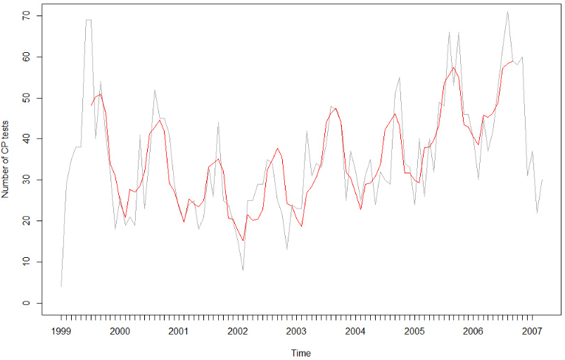
B. Monthly proportion of positive Cp tests
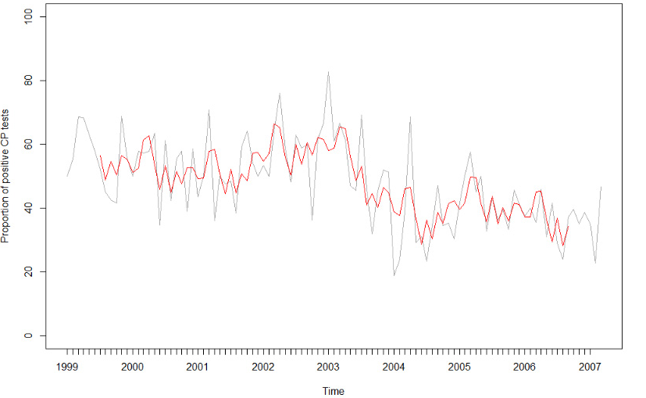

C. Monthly number of Myco tests
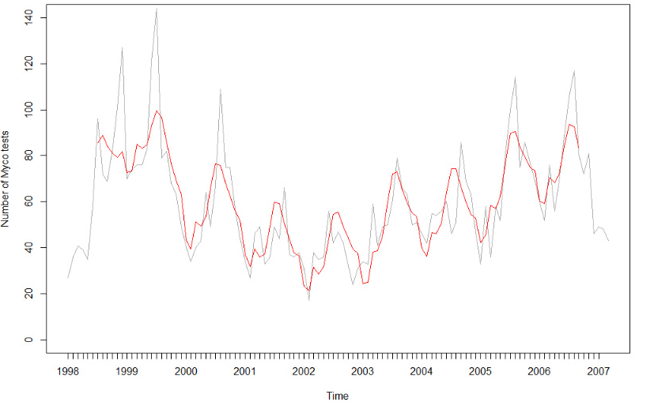
D. Monthly proportion of positive Myco tests
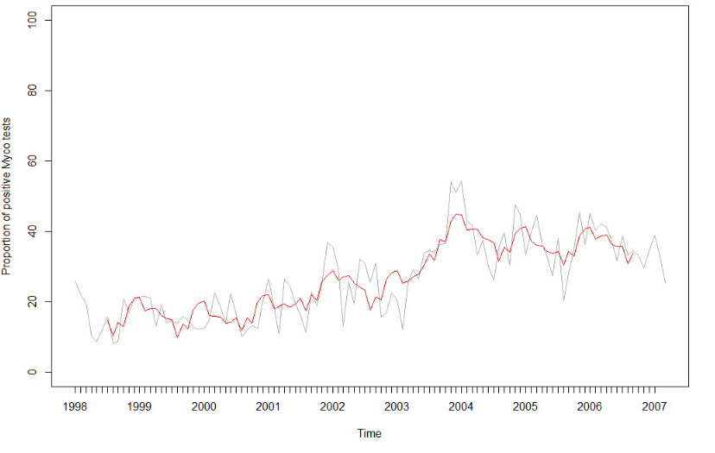
Table 1: Summary statistics for monthly total number of tests and monthly proportion of positive tests
 | Total number of Cp testsª | Total number of Myco testsª | Proportion of tests positive for Cp (%)^{b} | Proportion of tests positive for Myco (%)^{b}
Minimum | 2 | 17 | 18.75 | 8.33
Median | 32.5 | 56 | 47.06 | 25.42
Mean (SD) | 34 (14.7) | 60 (23.8) | 48.02 (13.32) | 25.90 (11.30)
Maximum | 71 | 144 | 82.61 | 54.35
a Monthly total number of patients tested for Cp / Myco.
b Monthly proportion of patients tested and found positive (infected) for Cp / Myco.

Time series regression
Three models were tested for each time series comprising the null model, the trend only model, and the trend + seasonal model. A quadratic term for the monthly number of tests was also explored. The best fitting ARMA model for the errors was selected using AIC (Table 2). Results from the best fitting model, which in each case was the trend + seasonal model, are shown in Tables 3 and 4.
Table 2: AIC values for AR(1) error structure and best fitting ARMA error structure for trend
Infection tested | Data set | Trend | AR(1) model | ARMA model
Cp | Number of tests | Linear in year | 722.5 | ARMA(2,1) 716.97
 |  | Quadratic in year | 724.61 | ARMA(2,1) 717.92
 | Proportion of positive tests | Linear in year | 731.42 | MA(1) 732.18
Myco | Number of tests | Linear in year | 930.93 | AR(1) 930.93
 |  | Quadratic in year | 928.49 | AR(1) 928.49
 | Proportion of positive tests | Linear in year | 738.52 | ARMA(1,1) 736.57

For the number of Cp tests, the trend + seasonal model is the best fitting model (Table 2) with an AIC of 722.5. The coefficients of year and of the months June to October have p < 0.05, indicating a clear seasonality (Table 3). The ACF and PACF (Appendix A) indicate a significant autocorrelation, and the autocorrelation estimate is 0.58.

Table 3: Regression models of Cp tests
Model | Number of Cp tests |  |  | Proportion of positive Cp tests
 |  | Value |  |  | Value
AIC |  | 716.67 |  |  | 731.42
Coefficient | Value | SEª | p | Value | SEª | p
AR(1) | 0.44 | ^{_b} | ^{_b} | – | – | –
AR(2) | 0.32 | ^{_b} | ^{_b} | – | – | –
MA(1) | -0.03 | ^{_b} | ^{_b} | 0.17 | 0.10 | 0.0891
MA(2) | – | – | – | – | – | –
Intercept | -11.78 | 19.04 | 0.5376 | 81.41 | 7.23 | < 0.0001
Year^{c} | 2.76 | 1.42 | 0.0549 | -2.72 | 0.56 | < 0.0001
Yearsq^{d} | – | – | – | – | – | –
February | -0.96 | 3.69 | 0.7961 | -0.2 | 4.66 | 0.9657
March | 5.94 | 3.79 | 0.1199 | 10.37 | 5.13 | 0.0462
April | 6.22 | 4.46 | 0.1663 | 10.23 | 5.38 | 0.0606
May | 7.21 | 4.65 | 0.1253 | 1.86 | 5.41 | 0.7300
June | 13.50 | 4.84 | 0.0065 | -4.75 | 5.42 | 0.3827
July | 18.77 | 4.89 | 0.0002 | 1.55 | 5.42 | 0.7756
August | 20.17 | 4.87 | 0.0001 | -6.57 | 5.42 | 0.2285
September | 21.65 | 4.74 | < 0.0001 | -0.69 | 5.41 | 0.8991
October | 17.72 | 4.51 | 0.0002 | -3.77 | 5.39 | 0.4862
November | 8.83 | 4.01 | 0.0304 | -1.36 | 5.16 | 0.7931
December | 5.14 | 3.95 | 0.1961 | 3.00 | 4.70 | 0.5253
a SE: standard error.
b Not able to be calculated due to non-positive definite covariance matrix.
c Year: years since 1990.
d Yearsq: years since 1990 squared.
For the proportion of positive Cp tests, the trend + seasonal model is the best fitting model with an AIC of 731.42 (Table 2). The coefficients of year and the month of March have p < 0.05, indicating some seasonality. The ACF and PACF (Appendix A) indicate a significant autocorrelation, and the autocorrelation estimate is 0.21.
The total number of Cp tests showed a different seasonal pattern to the model of the proportion of positive Cp infections. The model of the total number of Cp tests had more significant monthly variations (June to October, p < 0.05) while the model of the proportion of tests indicating positive Cp infection had weak monthly variations (March, p < 0.05).
For the number of Myco tests, the trend + seasonal model is the best fitting model (Table 2) with an AIC of 930.9. The coefficients of year and of the months June to October have p < 0.05 (Table 4), indicating a clear seasonality. The ACF and PACF (Appendix A) indicate a significant autocorrelation, and the autocorrelation estimate is 0.69.
For the proportion of positive Myco tests, the trend + seasonal model is the best fitting model with an AIC of 738.5 (Table 2). The coefficients of year and of the months May, August and October have p < 0.05 (Table 4), indicating some seasonality. The ACF and PACF (Appendix A) indicate a significant autocorrelation, and the autocorrelation estimate is 0.58.
Table 4: Regression models of Myco tests
Model | Number of tests |  |  | Proportion of positive tests
 |  | Value |  |  | Value
AIC |  | 928.49 |  |  | 736.6
Coefficient | Value | SEa | p | Value | SEª | p
AR(1) | 0.65 | 0.09 | 0.0228 | 0.81 | 0.17 | <0.0001
AR(2) | – | – | – | – | – | –
MA(1) | – | – | – | -0.36 | 0.13 | 0.0056
MA(2) | – | – | – | – | – | –
Intercept | 169.61 | 63.63 | 0.0089 | -2.78 | 8.27 | 0.7377
Year^{b} | -23.00 | 11.02 | 0.0394 | 2.72 | 0.63 | <0.0001
Yearsq^{c} | 0.97 | 0.46 | 0.0368 | – | – | –
February | -0.31 | 5.38 | 0.9540 | -3.88 | 2.22 | 0.0840
March | 8.56 | 6.90 | 0.2177 | -4.69 | 2.48 | 0.0614
April | 7.73 | 7.88 | 0.3289 | -4.79 | 2.73 | 0.0827
May | 11.17 | 8.37 | 0.1851 | -6.19 | 2.86 | 0.0326
June | 25.00 | 8.59 | 0.0044 | -5.70 | 2.92 | 0.0541
July | 37.49 | 8.56 | <0.0001 | -4.96 | 2.91 | 0.0910
August | 37.95 | 8.49 | <0.0001 | -8.56 | 2.89 | 0.0037
September | 27.85 | 8.26 | 0.0011 | -3.89 | 2.83 | 0.1714
October | 22.81 | 7.82 | 0.0043 | -5.70 | 2.71 | 0.0384
November | 18.15 | 7.03 | 0.0113 | -0.51 | 2.55 | 0.8412
December | 11.47 | 5.56 | 0.0417 | 0.52 | 2.30 | 0.8202
a SE: standard error
b Year: years since 1990.
c Yearsq: years since 1990 squared.

Discussion
We are fortunate that Canberra Hospital allowed us access to the pathology data, which (unlike notification data) record both positive and negative results. These characteristics allowed us to investigate seasonal patterns of respiratory bacteria testing and the proportion of positive infections, with potential implications for public health response and control. We are unaware of other studies within the ACT that have retrospectively investigated seasonality in testing patterns and in positive infection rates. We found considerable inter-annual variability in testing as well as seasonality. In the Australian Capital Territory, testing and detection of Cp and Myco occurs throughout the year. Our analysis found that testing for Cp and Myco peaked during July–August (winter), with a trough occurring in January–February (summer). Conversely, infections caused by Myco were most frequently observed in December and January (summer), and less frequently in August (winter), despite the peak of testing being in winter. Infections of Cp were most common in March and April (autumn).
The summer peak for Myco infections is supported by several studies. Research by Onozuka et al. demonstrated a significant increase in cases of Myco with increasing average temperature.⁹ Tian et al. also found a positive correlation between temperature and Myco infection rates, with the highest incidence recorded in summer and autumn.²¹ Tian et al. posited that because Myco grows optimally at 36–37°C, the summer and autumn months, which are the hottest months of the year, are the most conducive to bacterial growth.²¹ This is also consistent with the finding of del Valle-Mendoza et al. who found that Myco infections were most prevalent in the summer.⁴
The number of tests for both Cp and Myco was highest from June to November (winter–spring), while the proportion of positive tests was highest in March (autumn) for Cp and in December (summer) for Myco, and lowest in August (late winter)¹¹ for both Cp and Myco. This suggests a degree of overtesting in late winter, when the number of tests stays high but the proportion of positive tests tends to decrease at this time. Most other research, e.g. that of Du in Shenzhen, China, finds that winter is the season of peak prevalence of Cp infection; this may be because most studies only report positive cases.⁶ Even in the present study, the seasonality of positive cases (when considered in isolation) closely correlates with the testing patterns. The current research concentrates on testing rather than on the diagnosis of infection, thus our focus is on workforce planning at the testing end of the disease cycle. For example, if we focussed solely on the modelling results of positive cases, this would suggest increased allocation of resources for the entire period from June to November when testing is at its highest (and, as expected, so are the number of positive infections). By analysing the number of positive cases in proportion to testing we get less clear but different seasonal patterns, with a peak for Myco in December and January and a peak for Cp in March. This can help target resource allocation and identify the underlying mechanisms of seasonality, which are less likely to be an artefact of increased testing. The high proportion of positive Myco infections in summer may be due to behavioural factors or climatic factors such as temperature as shown by Chen et al.¹¹
In this study, for both Cp and Myco infections, we show differential seasonal patterns of testing and of the proportion of positive tests, findings which have important implications for public health control of these infections. High testing in certain seasons may dilute the positive rate, since the numerator (actual positive infection patients) is unchanged but the denominator (patients tested for infection) increases. This could cause an incorrect estimation of the actual peak of infection because the total number of tests will dilute the positive proportion. Often, testing data for infections is not available, with recording only of the number of confirmed positive cases. Consequently, the public health response to the actual peak of infection may be misdirected due to a testing artefact rather than an actual increase in infection. This could potentially lead to misallocation of health responses to controlling the peak of infection, as well as a focus on the wrong potential drivers of the infection.
The proportion of positive Cp and Myco infections may be affected by many other factors not accounted for in this study, for example age and gender. In addition, the analysis was conducted only for patients who were tested; accordingly, not all cases in the community were represented, so there are no estimates of actual community burden. As individuals with Myco infections typically experience mild disease symptoms or no symptoms at all, many may not seek health care, leading to under-ascertainment. However, consistent with Onozuka et al.,⁹ under-ascertainment is unlikely to affect the seasonal patterns observed. Future research should examine, in detail, the role of weather-related factors (e.g., rainfall, temperature, humidity) and should examine more diverse populations to improve the generalisability and validity of the findings. Our results highlight some of the complexities of seasonal infections. Combining findings from this and other research will help to develop more accurate estimates of bacterial respiratory infections from routinely collected data.
We provide a population-level view of how testing for respiratory bacterial pathogens has changed across seasons and over time in the ACT. Future studies into the seasonal burden of respiratory infections will need to consider seasonal and other temporal changes in testing patterns.

Acknowledgements
The authors would like to acknowledge Canberra Hospital and pathology partners.

Funding
No external funding was required for this project.

Conflict of interest
The authors declare no conflict of interest.

Author details
Ms Xinyi Liu¹ Dr Aparna Lal^{1*} Associate Professor Alice Richardson^{1,2}
- Research School of Population Health, Australian National University, Acton, Canberra, 2600.
- Statistical Consulting Unit, Australian National University, Acton, Canberra, 2600.

Corresponding author
Dr Aparna Lal
Research School of Population Health, Australian National University, Acton, Canberra, 2600
Telephone: (61)(2)61252309
Email address: Aparna.lal@anu.edu.au

References
- Australian Institute of Health and Welfare (AIHW). Asthma, chronic obstructive pulmonary disease, and other respiratory diseases in Australia. Canberra: Australian Government, AIHW; 20 May 2010. Available from: https://www.aihw.gov.au/reports/chronic-respiratory-conditions/asthma-chronic-obstructive-pulmonary-disease-and/contents/table-of-contents.
- Kicinski P, Wisniewska-Ligier M, Wozniakowska-Gesicka T. Pneumonia caused by Mycoplasma pneumoniae and Chlamydophila pneumoniae in children – comparative analysis of clinical picture. Adv Med Sci. 2011;56(1):56–63.
- Dumke R, Schnee C, Pletz MW, Rupp J, Jacobs E, Sachse K et al. Mycoplasma pneumoniae and Chlamydia pneumoniae infection in community-acquired pneumonia, Germany, 2011–2012. Emerg Infect Dis. 2015;21(3):426–34.
- del Valle-Mendoza J, Orellana-Peralta F, Marcelo-Rodríguez A, Verne E, Esquivel-Vizcarra M, Silva-Caso W et al. High prevalence of Mycoplasma pneumoniae and Chlamydia pneumoniae in children with acute respiratory infections from Lima, Peru. PLoS One. 2017;12(1):e0170787.
- Phares CR, Wangroongsarb P, Chantra S, Paveenkitiporn W, Tondella ML, Benson RF et al. Epidemiology of severe pneumonia caused by Legionella longbeachae, Mycoplasma pneumoniae, and Chlamydia pneumoniae: 1-year, population-based surveillance for severe pneumonia in Thailand. Clin Infect Dis. 2007;45(12): e147–55.
- Du D, Liao S, Wu Y, Jiao Y, Wu D, Wu W et al. Serological analysis and drug resistance of Chlamydia pneumoniae and Mycoplasma pneumoniae in 4500 healthy subjects in Shenzhen, China. Biomed Res Int. 2017;2017:3120138.
- Lenglet A, Herrador Z, Magiorakos AP, Leitmeyer K, Coulombier D, European Working Group on Mycoplasma pneumoniae Surveillance. Surveillance status and recent data for Mycoplasma pneumoniae infections in the European Union and European Economic Area, January 2012. Euro Surveill. 2012;17(5):20075.
- Esposito S, Blasi F, Arosio C, Fioravanti L, Fagetti L, Droghetti R et al. Importance of acute Mycoplasma pneumoniae and Chlamydia pneumoniae infections in children with wheezing. Eur Respir J. 2000;16(6):1142–6.
- Onozuka D, Hashizume M, Hagihara A. Impact of weather factors on Mycoplasma pneumoniae pneumonia. Thorax. 2009;64(6):507–11.
- Wright DN, Bailey GD, Hatch MT. Role of relative humidity in the survival of airborne Mycoplasma pneumoniae. J Bacteriol. 1968;96(4):970–4.
- Chen Z, Ji W, Wang Y, Yan Y, Zhu H, Shao X et al. Epidemiology and associations with climatic conditions of Mycoplasma pneumoniae and Chlamydophila pneumoniae infections among Chinese children hospitalized with acute respiratory infections. Ital J Pediatr. 2013;39(1):34.
- Gencay M, Roth M. Chlamydia pneumoniae infections in asthma: clinical implications. Am J Respir Med. 2003;2(1):31–8.
- Puljiz I, Kuzman I, Dakovic-Rode O, Schönwald N, Mise B. 2006. Chlamydia pneumoniae and Mycoplasma pneumoniae pneumonia: comparison of clinical, epidemiological characteristics and laboratory profiles. Epidemiol Infect. 2006;134(3):548–55.
- Spuesens EB, Fraaij PL, Visser EG, Hoogenboezem T, Hop WC, van Adrichem LN et al. Carriage of Mycoplasma pneumoniae in the upper respiratory tract of symptomatic and asymptomatic children: an observational study. PLoS Med. 2013;10(5):e1001444.
- Richardson A, Hawkins S, Shadabi F, Sharma D, Fulcher J. Enhanced laboratory diagnosis of human Chlamydia pneumoniae infection through pattern recognition derived from pathology database analysis. In: Chetty M, Ahmad S, Ngom A, Teng SW, eds. Supplementary Proceedings. Third IAPR International Conference on Pattern Recognition in Bioinformatics (PRIB 2008). Melbourne, Australia: Monash University: 227–34.
- Peeling RW. Laboratory diagnosis of Chlamydia pneumoniae infections. Can J Infect Dis. 1995;6(4):198–203.
- Kendall M, Stuart A, Ord JK. The Advanced Theory of Statistics, Vol.3. 4th ed. High Wycombe: Charles Griffin; 1983.
- Pinheiro JC, Bates DM. Mixed-effects models in S and S-PLUS. New York: Springer New York; 2000.
- Chatterjee S, Simonoff JS. Handbook of regression analysis. New York: Wiley; 2012.
- R Core Team. R: a language and environment for statistical computing. Vienna: R Foundation for Statistical Computing; 2019. Available from: https://www.R-project.org/.
- Tian D, Jiang R, Chen X, Ye Q. Meteorological factors on the incidence of MP and RSV pneumonia in children. PLoS One. 2017;12(3):e0173409.

Appendix A: Supplemental tables and figures

1. Time series plots of number of positive tests
Figure A.1: Time series plot and additive decomposition observed time series line (grey) with trend and seasonal line (red)
A Monthly number of positive Cp tests
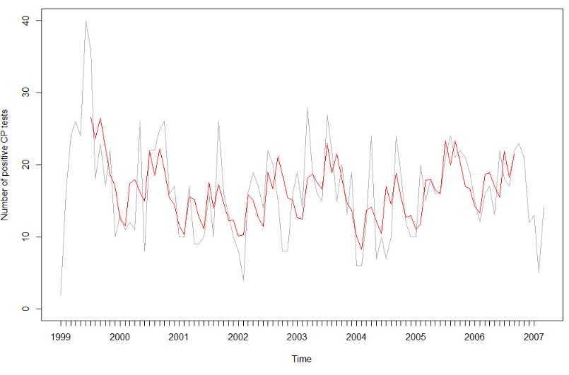
B Monthly number of positive Myco tests
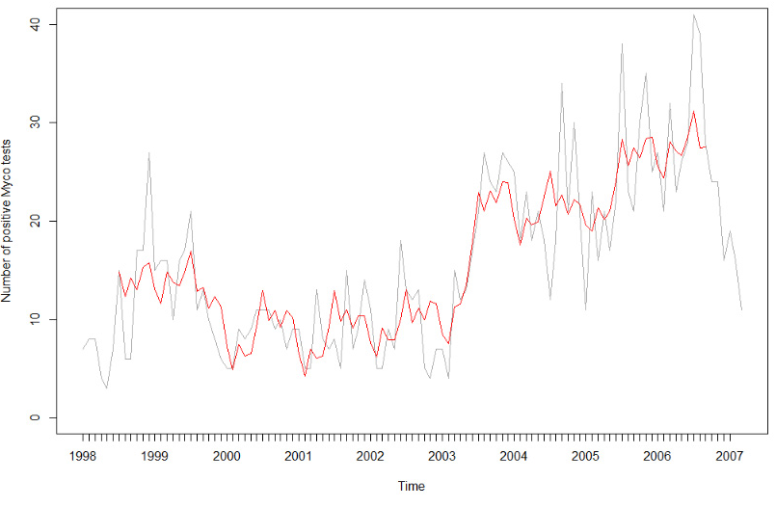

2. Time series regression
Table A.1: Model results for number of positive tests: AR(1) error structure
Model | Number of positive Cp tests |  |  | Number of positive Myco tests
 |  | Value |  |  | Value
AIC |  | 622.43 |  |  | 707.10
Coefficient | Value | SE | p | Value | SE | p
AR(1) | 0.40 | 0.10 | 0.0228 | 0.60 | 0.09 | <0.0001
Intercept | 11.25 | 5.55 | 0.0458 | -10.82 | 5.68 | 0.0593
Yearª | -0.05 | 0.39 | 0.9092 | 1.95 | 0.42 | <0.0001
February | 0.22 | 2.33 | 0.9246 | -1.50 | 1.89 | 0.4295
March | 6.44 | 2.77 | 0.0222 | 0.39 | 2.39 | 0.8711
April | 7.03 | 3.01 | 0.0215 | -0.32 | 2.70 | 0.9050
May | 5.25 | 3.08 | 0.0919 | 0.18 | 2.85 | 0.9484
June | 6.15 | 3.10 | 0.0507 | 3.10 | 2.90 | 0.2882
July | 10.38 | 3.11 | 0.0012 | 7.01 | 2.89 | 0.0167
August | 7.08 | 3.11 | 0.0251 | 4.48 | 2.87 | 0.1212
September | 10.42 | 3.08 | 0.0011 | 5.81 | 2.80 | 0.0405
October | 7.52 | 3.02 | 0.0145 | 3.83 | 2.67 | 0.1543
November | 3.40 | 2.80 | 0.2274 | 5.46 | 2.43 | 0.0244
December | 2.40 | 2.37 | 0.3145 | 3.85 | 1.94 | 0.0498
a Year = years since 1990.

2.1.1. Total number of Cp tests
Figure A.2: ACF and PACF of normalised residuals from trend + seasonal ARMA(2,1) model of number of Cp tests
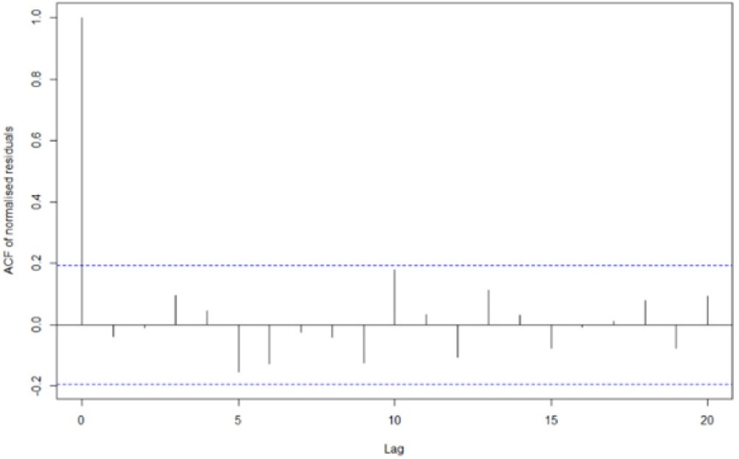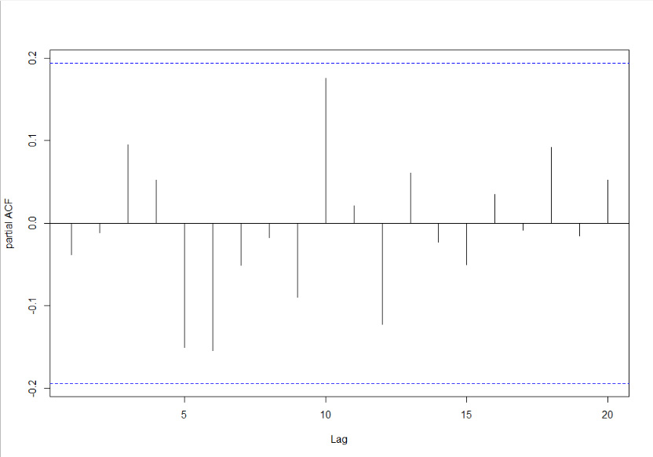

2.1.2. Proportion of positive Cp tests
Figure A.3: ACF and PACF of normalised residuals from trend + seasonal AR(1) model of proportion of positive Cp tests
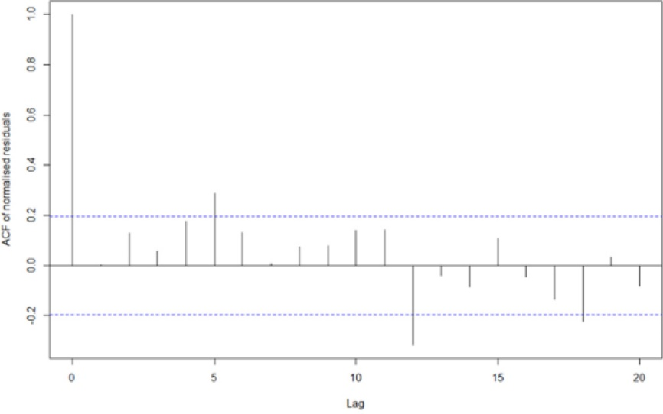

2.1.3. Number of positive Cp tests
Figure A.4: ACF and PACF of normalised residuals from trend + seasonal AR(1) model of number of positive Cp tests
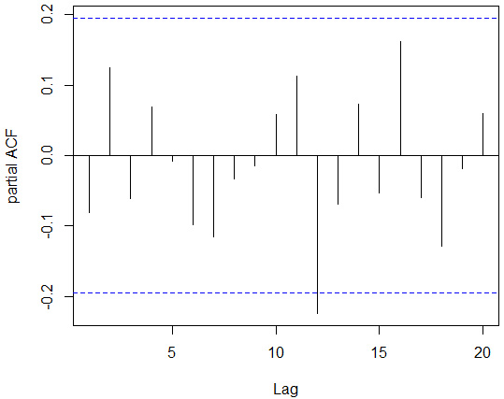

2.2.1. Total number of Myco tests
Figure A.5: ACF and PACF of normalised residuals from quadratic trend + seasonal AR(1) model of number of Myco tests
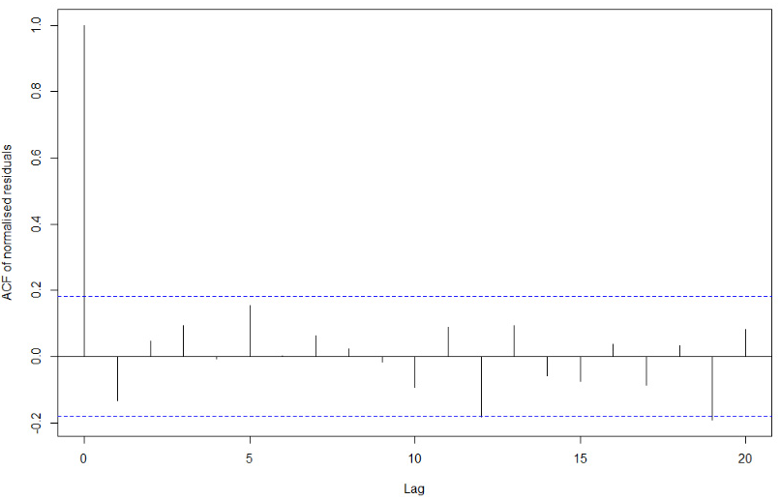
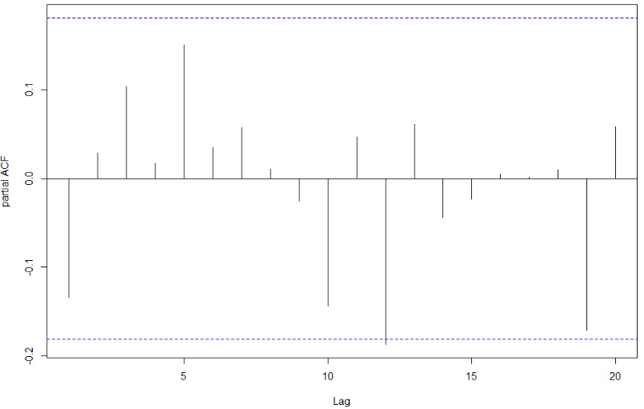

2.2.2. Proportion of positive Myco tests
Figure A.6: ACF and PACF of normalised residuals from trend + seasonal ARMA(1,1) model of proportion of positive Myco tests
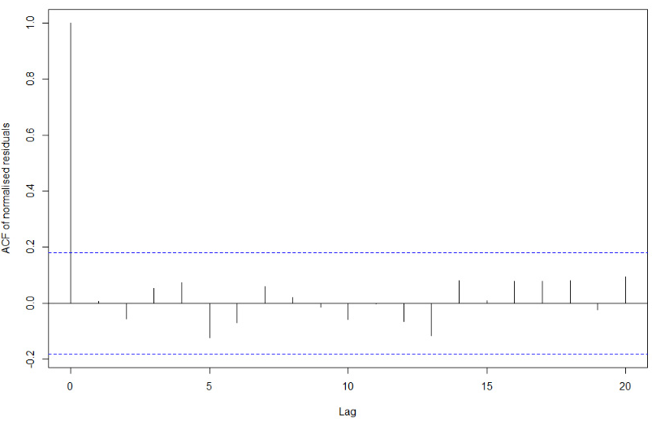
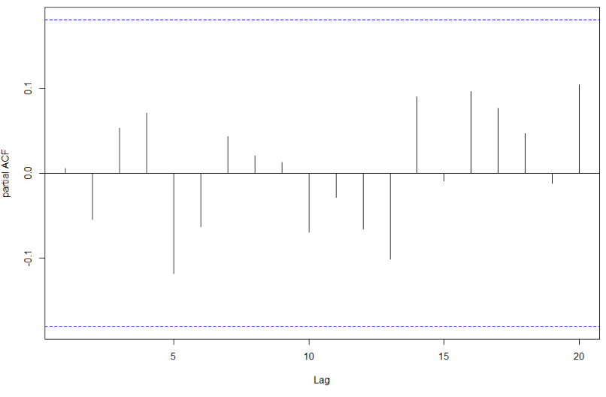

2.2.3 Number of positive Myco tests.
Figure A.7: ACF and PACF of normalised residuals from trend + seasonal AR(1) model of number of positive Myco tests
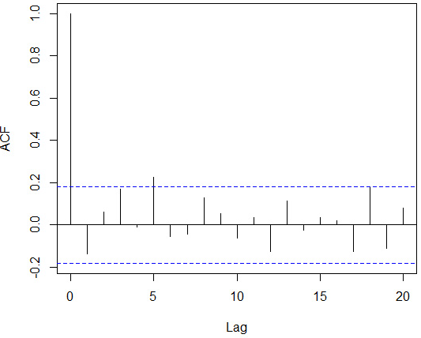
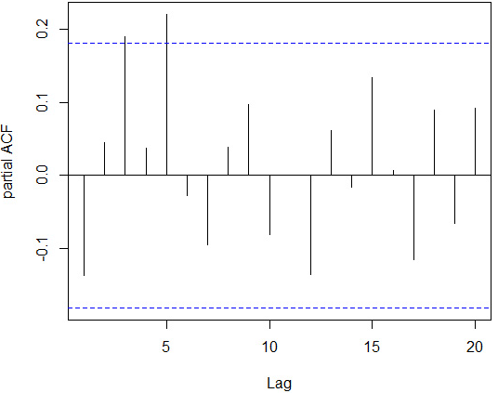

Communicable Diseases Intelligence
ISSN: 2209-6051 Online

Communicable Diseases Intelligence (CDI) is a peer-reviewed scientific journal published by the Office of Health Protection and Response, Department of Health. The journal aims to disseminate information on the epidemiology, surveillance, prevention and control of communicable diseases of relevance to Australia.

Editor: Jennie Hood
Deputy Editor: Simon Petrie
Design and Production: Kasra Yousefi
Editorial Advisory Board: David Durrheim, Mark Ferson, John Kaldor, Martyn Kirk and Linda Selvey

Website: http://www.health.gov.au/cdi

Contacts
CDI is produced by Environmental Health and Health Protection Policy Branch, Office of Health Protection and Response, Australian Government Department of Health, GPO Box 9848, (MDP 6) CANBERRA ACT 2601

Email: cdi.editor@health.gov.au

Submit an Article
You are invited to submit your next communicable disease related article to the Communicable Diseases Intelligence (CDI) for consideration. More information regarding CDI can be found at: http://health.gov.au/cdi.
Further enquiries should be directed to: cdi.editor@health.gov.au.

This journal is indexed by Index Medicus and Medline.

Creative Commons Licence - Attribution-NonCommercial-NoDerivatives CC BY-NC-ND
© 2021 Commonwealth of Australia as represented by the Department of Health
This publication is licensed under a Creative Commons Attribution-NonCommercial-NoDerivatives 4.0 International Licence from https://creativecommons.org/licenses/by-nc-nd/4.0/legalcode (Licence). You must read and understand the Licence before using any material from this publication.

Restrictions
The Licence does not cover, and there is no permission given for, use of any of the following material found in this publication (if any):
- the Commonwealth Coat of Arms (by way of information, the terms under which the Coat of Arms may be used can be found at www.itsanhonour.gov.au);
- any logos (including the Department of Health’s logo) and trademarks;
- any photographs and images;
- any signatures; and
- any material belonging to third parties.

Disclaimer
Opinions expressed in Communicable Diseases Intelligence are those of the authors and not necessarily those of the Australian Government Department of Health or the Communicable Diseases Network Australia. Data may be subject to revision.

Enquiries
Enquiries regarding any other use of this publication should be addressed to the Communication Branch, Department of Health, GPO Box 9848, Canberra ACT 2601, or via e-mail to: copyright@health.gov.au

Communicable Diseases Network Australia
Communicable Diseases Intelligence contributes to the work of the Communicable Diseases Network Australia.
http://www.health.gov.au/cdna

Ref. 17, pp. 410–4.
Ref. 18, pp. 100, 461.
ARMA: autoregressive moving average

