Report on influenza viruses received and tested by the Melbourne WHO Collaborating Centre for Reference and Research on Influenza in 2019
Heidi Peck, Jean Moselen, Sook Kwan Brown, Megan Triantafilou, Hilda Lau, Miguel Grau, Ian G Barr, Vivian KY Leung

Abstract
As part of its role in the World Health Organization’s (WHO) Global Influenza Surveillance and Response System (GISRS), the WHO Collaborating Centre for Reference and Research on Influenza in Melbourne received a record total of 9,266 human influenza positive samples during 2019. Viruses were analysed for their antigenic, genetic and antiviral susceptibility properties. Selected viruses were propagated in qualified cells or embryonated hen’s eggs for potential use in seasonal influenza virus vaccines. In 2019, influenza A(H3N2) viruses predominated over influenza A(H1N1)pdm09 and B viruses, accounting for a total of 51% of all viruses analysed. The majority of A(H1N1)pdm09, A(H3N2) and influenza B viruses analysed at the Centre were found to be antigenically similar to the respective WHO recommended vaccine strains for the Southern Hemisphere in 2019. However, phylogenetic analysis indicated that a significant proportion of circulating A(H3N2) viruses had undergone genetic drift relative to the WHO recommended vaccine strain for 2019. Of 5,301 samples tested for susceptibility to the neuraminidase inhibitors oseltamivir and zanamivir, four A(H1N1)pdm09 viruses showed highly reduced inhibition with oseltamivir, one A(H1N1)pdm09 virus showed highly reduced inhibition with zanamivir and three B/Victoria viruses showed highly reduced inhibition with zanamivir.
Keywords: influenza, vaccines, GISRS, surveillance, laboratory, annual report, WHO

Introduction
The World Health Organization (WHO) Collaborating Centre for Reference and Research on Influenza in Melbourne (the Centre) is part of the World Health Organization Global Influenza Surveillance and Response System (WHO GISRS). GISRS is a worldwide network of laboratories that was established in 1952 to monitor changes in influenza viruses circulating in the human population, with the aim of reducing influenza’s impact through the use of vaccines and antiviral drugs.^{1,2} The Centre in Melbourne is one of five such Collaborating Centres (others are in Atlanta, Beijing, London and Tokyo) that monitor antigenic and genetic changes in circulating human influenza viruses; the Centre participates in making twice-yearly recommendations on which influenza strains should be included in the influenza vaccine for the upcoming influenza season in either the northern or southern hemisphere. This report summarises the results of virological surveillance activities undertaken at the Centre in Melbourne during 2019.
Two types of influenza viruses (A and B) cause significant disease in humans. Influenza A viruses are further classified into subtypes, based on their haemagglutinin (HA) and neuraminidase (NA) surface proteins. Globally, there are currently two influenza A subtypes circulating in the human population – A(H1N1)pdm09 and A(H3N2). Influenza B viruses are not classified into subtypes; however, there are two distinct co-circulating lineages of influenza B viruses – B/Victoria/2/87 (B/Victoria lineage) and B/Yamagata/16/88 (B/Yamagata lineage). Influenza C viruses are also detected each year from humans, but these viruses do not cause severe disease and are not a major focus of influenza surveillance.

Methods

Virus isolation
All A(H1N1)pdm09 and influenza B viral isolates received at the Centre were re-passaged in cell culture using Madin-Darby Canine Kidney (MDCK) cells, whilst all A(H3N2) viral isolates were re-passaged in MDCK-SIAT-1 cells.³ Virus isolation in cell culture was also attempted from a selection of original clinical specimens received using the same cell types as described above when the type/subtype was known. A smaller subset of influenza-positive original clinical samples was directly inoculated into eggs and a qualified cell line to generate potential candidate vaccine viruses (CVV).

Antigenic analysis
The antigenic properties of influenza viral isolates were analysed using the haemagglutination inhibition (HI) assay as previously described⁴ and by the Focus Reduction Assay (FRA) for a subset of A(H3N2) viruses. The majority of the HI assays were performed using the TECAN Freedom EVO200 robot platform which incorporates a camera (SciRobotics, Kfar Saba, Israel) and imaging software (FluHemaTM) for automated analysis. In HI assays, viruses were tested for their ability to agglutinate turkey (A(H1N1)pdm09 and B viruses) or guinea pig (A(H3N2)) red blood cells (RBC) in the presence of post-infection ferret antisera raised against several reference viruses. Isolates were identified as antigenically similar to the reference strain if the test samples had a titre that was no more than 4-fold higher than the titre of the homologous reference strain. During 2019, results were reported with reference to the A/Michigan/45/2009 (H1N1pdm09)-like, A/Switzerland/8060/2017 (H3N2)-like, B/Colorado/06/2017-like (Victoria lineage), and B/Phuket/3073/2013-like (Yamagata lineage) viruses that were recommended for inclusion in the southern hemisphere 2019 influenza vaccine. In recent years (including 2019), HI assays involving A(H3N2) viruses have been performed in the presence of 20 nM oseltamivir carboxylate (OC) to reduce non-specific binding of the NA protein.⁵ The addition of OC reduces the number of influenza virus isolates that can be tested by HI because around 11% of viruses lose the ability to bind RBC and therefore cannot be assayed by HI. To test a subset of these viruses, the Centre has employed the Focus Reduction Assay (FRA), a microneutralisation assay which is more specific and sensitive than the HI assay and does not require binding to RBCs.⁶ The FRA utilised the same ferret antisera as did the HI assay and was performed as previously described,⁷ but with 1.2% Avicell RC591 (IMCD Mulgrave, Australia) replacing the carboxymethyl cellulose.

Genetic analysis
For influenza-positive samples that failed to grow in MDCK cells, real-time reverse transcription polymerase chain reaction (RT-PCR) was performed to determine the influenza type/subtype/lineage using the CDC Influenza Virus Real-Time RT-PCR kit.
A substantial subset of influenza viruses analysed at the Centre underwent genetic analysis by sequencing of viral RNA genes – usually HA and NA genes as well as the matrix gene for influenza A viruses and non-structural protein gene (NS) for influenza B viruses. Whole genome sequencing (WGS) of a smaller subset of viruses was also performed.
For sequencing, RNA was extracted from isolates or original clinical specimens using either a manual QIAGEN QIAamp Viral RNA kit or the automated QIAGEN QIAXtractor platform, followed by RT-PCR using the BIOLINE MyTaq one step RT-PCR kit according to the manufacturer’s recommendations, with gene-specific primers (primer sequences available on request). Conventional Sanger sequencing was carried out on PCR products using an Applied Biosystems 3500XL Genetic Analyzer (Applied Biosystems, Foster City, CA, USA). Sequence assembly was performed using the Geneious Prime software version 9.0.4 (Biomatters Ltd, Auckland, New Zealand).
WGS was performed on a selection of viruses using the SuperScript-III One-Step Platinum Hi-Fi PCR kit according to the manufacturer’s recommendations, with universal primers (primer sequences available on request). WGS was conducted using an Applied Biosystems Ion TorrentTM Personal Genome MachineTM (PGM) System according to the manufacturer’s recommendations. These sequences were analysed using a proprietary pipeline, FluLINE.⁸ Phylogenetic analysis was performed using Geneious 9.0.4 and FigTree v1.3.1 software.

Antiviral drug resistance testing
Circulating viruses were tested for their sensitivity to the currently-used neuraminidase inhibitors oseltamivir (Tamiflu) and zanamivir (Relenza). The neuraminidase inhibition (NAI) assay used was a functional fluorescence-based assay using the substrate 2’-(4-methylumbelliferyl)-α-D-N-acetylneuraminic acid (MUNANA), in which the susceptibility of test viruses to the antiviral drugs was measured in terms of the drug concentration needed to reduce the influenza neuraminidase enzymatic activity by 50% (IC⁵⁰), and compared to values obtained with sensitive reference viruses of the same subtype or lineage. NAI assays were performed as previously described,⁹ with the incorporation of a robotic platform by Tecan EVO 200 and Infinite 200Pro for liquid handling and plate reading (Tecan Australia). For reporting purposes, ‘highly reduced inhibition’ of influenza A viruses has been defined by WHO as a ≥ 100-fold increase in IC⁵⁰ in a NAI assay. For influenza B viruses, this figure was a ≥ 50-fold increase. However, it should be noted that the relationship between the IC⁵⁰ value and the clinical effectiveness of a neuraminidase inhibitor is not yet well understood and a small or medium reduction in inhibition may not be clinically significant.
Viruses found to have highly reduced inhibition by either oseltamivir or zanamivir underwent genetic analysis using pyrosequencing, Sanger sequencing or WGS to determine the presence of amino acid substitutions in the NA protein that were associated with the reduction of inhibition by neuraminidase inhibitors. For example, a change from histidine to tyrosine at position 275 (H275Y) of the NA protein of A(H1N1)pdm09 viruses is known to reduce inhibition by oseltamivir, as does the H273Y NA mutation in B viruses.⁹ Pyrosequencing was also performed on original clinical specimens of selected viruses which may have contained a known mutation such as H275Y if no isolate was available for phenotypic testing. Pyrosequencing was performed as previously described¹⁰ using the MyTaq One-Step RT-PCR Kit (QIAGEN, Hilden, Germany) for virus amplification, with pyrosequencing reactions performed using the PyroMark instrument (QIAGEN, Hilden, Germany).

Candidate vaccine strains
The viruses used in production of human influenza vaccines are required by regulatory authorities to be isolated and passaged in embryonated hen’s eggs or qualified cell lines^{11–13} directly from human clinical respiratory samples. The Centre has undertaken primary isolation of selected viruses from clinical samples directly into eggs, using previously described methods.¹⁴ Briefly, the viruses were inoculated into the amniotic cavity of embryonated eggs and, once virus growth was established, isolates were passaged in the allantoic cavity until a sufficient titre was obtained. Egg incubation conditions differed slightly, with A(H1N1)pdm09 and A(H3N2) viruses incubated at 35 ºC for three days, and influenza B viruses incubated at 33 ºC for three days. In addition, selected clinical samples were inoculated into the qualified cell line MDCK 33016PF (Seqirus Limited, Holly Springs, NC, USA)¹⁵ and incubated at 35 ºC for three days, with viral growth monitored by haemagglutination of turkey or guinea pig RBC. These isolates were then analysed by HI assay, real time RT-PCR and genetic sequencing using the methods described above.

Results
During 2019, the Centre received 9,266 samples (including 7,687 clinical specimens, 1,014 virus isolates and 569 paired specimens and isolates) from 40 laboratories in 17 countries (Figure 1). As in previous years, most samples were submitted by laboratories in the Asia-Pacific region,^{16–19} with the majority received from Australia (7,410 samples; 80%). However, unlike previous years, a large number of samples were received between January and April, which is before the typical Southern Hemisphere temperate regions influenza season. Figure 2 shows the weekly temporal distribution of samples sent to the Centre by type and subtype/lineage. During 2019, influenza A(H3N2) was the predominant circulating strain, followed by A(H1N1)pdm09 and B. For samples received from Australia where the lineage was confirmed, B/Victoria viruses predominated significantly over B/Yamagata viruses (93% and 7% of B viruses respectively). Overall, isolation and re-passaging was attempted for 9,146 (99%) of the samples received and this yielded 6,101 isolates (overall isolation rate of 67%). Isolation rates were lower for clinical specimens (60.5%) than for virus isolates received (94.9%). Of the viruses for which type and subtype could be confirmed, isolation rates by cell propagation were 75% (1,767/2,350) for A(H1N1)pdm09; 81% (3,150/3,911) for A(H3N2); and 81% (1,142/1,407) for influenza B. However, amongst these viruses, 15% (464/3,150) of A(H3N2) isolates did not reach sufficient titres for antigenic analysis. A total of 4,445 viral isolates were successfully characterised by HI assay, and were compared to the 2019 reference viruses (Table 1). In addition, 991 samples were characterised by real-time RT-PCR to determine their type/subtype or lineage. Sanger sequencing and WGS techniques were used to sequence the HA genes of 2,487 viruses. The full genomes of 415 viruses were also sequenced using either Sanger sequencing or WGS. Of the samples for which results could be obtained by antigenic or genetic analysis (n = 6,368), influenza A(H3N2) viruses predominated, comprising 49% (n = 3,133) of viruses received and analysed.
Figure 1: Geographic spread of influenza laboratories sending viruses to the Centre during 2019
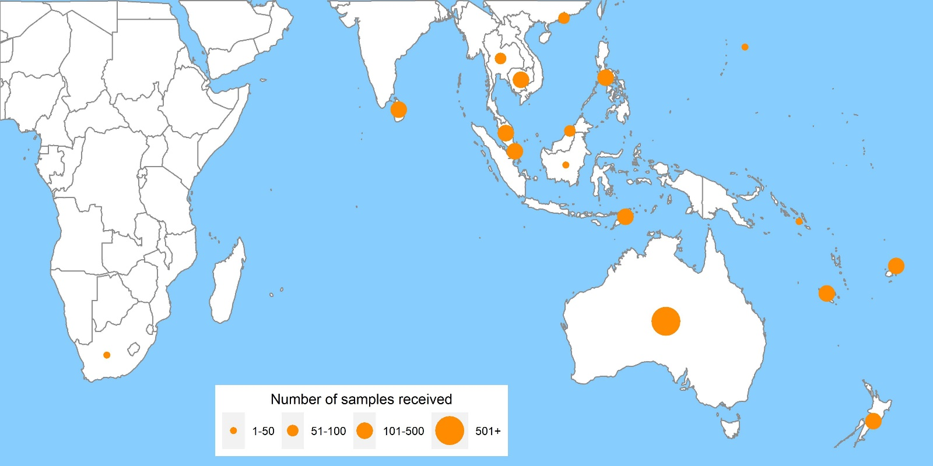

Figure 2: Number of samples received at the Centre by week of sample collection 2019
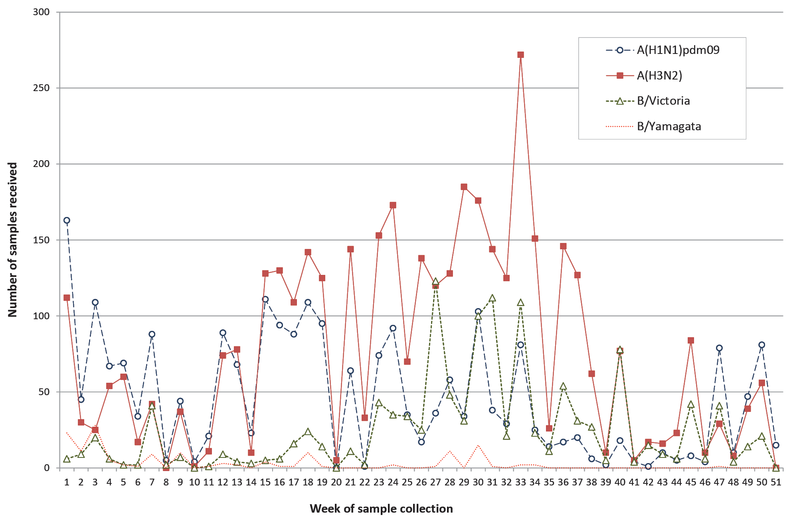
Table 1: Antigenic analysis of viruses received by the Centre in 2019, by geographic region of origin
 | A(H1N1)pdm09 reference strain: |  | A(H3N2)ª reference strain: |  | B/Victoria reference strain: |  | B/Yamagata reference strain:
 | A/Michigan/45/2015 (cell) |  | A/Switzerland/8060/2017 (cell) |  | B/Colorado/06/2017 (cell) |  | B/Phuket/3073/2013 (cell)
Region | Like | Low reactor (%) | Like | Low reactor (%) | Like | Low reactor (%) | Like | Low reactor (%)
Australasia | 1,136 | 31 (2.7%) | 1,214 | 347 (22.2%) | 503 | 64 (11.3%) | 41 | 1 (2.4%)
South East Asia | 298 | 26 (8%) | 58 | 96 (62.3%) | 118 | 48 (28.9%) | 79 | 0
Pacific | 80 | 34 (29.8%) | 25 | 5 (16.7%) | 99 | 22 (18.2%) | 2 | 0
Africa | 3 | 0 | 4 | 11 (73.3%) | 0 | 0 | 0 | 0
South Asia | 13 | 0 | 0 | 5 (100%) | 18 | 0 | 4 | 0
East Asia | 31 | 3 (8.8%) | 4 | 1 (20%) | 11 | 9 (45%) | 1 | 0
Total | 1,561 | 94 (5.7%) | 1,305 | 465 (26.3%) | 749 | 143 (16%) | 127 | 1 (0.8%)
a Note that a small number of A(H3N2) virus isolates that were obtained could not be analysed by HI assay due to low haemagglutination assay (HA) titre in the presence of oseltamivir.

A(H1N1)pdm09
Of the 1,655 A(H1N1)pdm09 isolates analysed by HI assay using ferret antisera in 2019, a majority (94%) were antigenically similar to the vaccine reference strain A/Michigan/45/2015 (Table 1).
Sequencing and phylogenetic analysis of HA genes from 644 viruses showed that all A(H1N1)pdm09 viruses sent to the Centre during 2019 fell into the 6B.1 clade (Figure 3). The majority of these viruses reacted in a similar manner to the 2019 vaccine virus A/Michigan/45/2015 in HI assays using ferret antisera.
Eighteen A(H1N1)pdm09 viruses were inoculated into eggs for isolation of candidate vaccine strains with 16 (89%) successfully isolated; all fell into the genetic subclade 6B.1A. Thirty-nine viruses were inoculated into the qualified cell line MDCK 33016PF, of which 25 (64%) grew successfully and all also fell into the genetic subclade 6B.1A.
Of 1,701 A(H1N1)pdm09 viruses tested, three viruses exhibited highly reduced inhibition by oseltamivir and one virus exhibited highly reduced inhibition by zanamivir. The viruses showing highly reduced inhibition by oseltamivir (two from Australia and one from Malaysia) were confirmed to contain the H275Y substitution in their NA genes, a known mutation that is associated with highly reduced inhibition by oseltamivir. Another NA substitution linked to the reduction in inhibition by zanamivir was also identified in one of the viruses from Australia.²⁰ This virus was confirmed to contain the E119G substitution in its NA gene.

A(H3N2)
Antigenic analysis of 2,104 A(H3N2) subtype isolates using the HI assay showed that 26% were low reactors to the ferret antisera prepared against the cell-propagated reference strain A/Switzerland/8060/2017/2017 (Table 1). However, 99% of viruses were low reactors to the ferret antisera prepared against the egg-propagated strain A/Switzerland/8060/2017 (data not shown). An additional 464 A(H3N2) viruses were inoculated and isolated by cell culture but did not reach sufficient titres for antigenic analysis, whilst a further 334 were successfully isolated but did not reach sufficient titres when tested by HI assay in the presence of oseltamivir carboxylate.
A total of 75 A(H3N2) viruses that could not be characterised by HI assay were analysed using the FRA assay. The FRA assay indicated that 16% of these viruses showed greater than four-fold difference in titre compared to the cell-propagated reference strain A/Switzerland/8060/2017; however, the majority of viruses (93%) had a greater than four-fold difference in titre compared to the egg-propagated strain (data not shown).
The HA genes of 1,309 A(H3N2) viruses were sequenced. Phylogenetic analysis indicated that the majority of circulating viruses fell into subclade 3C.2a1b based on their HA genes, whereas the 2019 vaccine strain, A/Switzerland/8060/2017 fell into subclade 3C.2a2 (Figure 4). A small number of A(H3N2) viruses fell into the 3C.3a and 3C.2a3 clades.
Forty-seven viruses were inoculated into eggs, of which 27 (57%) grew successfully and consisted of 21 viruses from genetic subclades 3C.2a1b+131K and two from 3C.2a1b+135K. Additionally, four subclade 3C.3a viruses were isolated. Fifty-seven viruses were inoculated into the qualified cell line MDCK 33016PF, of which 38 (67%) grew successfully, with 23 viruses from genetic subclades 3C.2a1b+131K, four from 3C.2a1b+135K and 11 from 3C.3a.
None of the 2,323 A(H3N2) viruses tested by NAI assay showed highly reduced inhibition by oseltamivir or zanamivir.

Influenza B
Amongst influenza B viruses received at the Centre during 2019, B/Victoria-lineage viruses were predominant over B/Yamagata-lineage viruses (Figure 2). A total of 1,020 influenza B viruses were characterised by HI assay. Almost all B/Yamagata-lineage viruses were antigenically similar to the B/Phuket/3073/2013-like vaccine virus, while 84% of B/Victoria-lineage viruses were antigenically similar to the B/Colorado/06/2017 vaccine virus (Table 1).
Figure 3: Phylogenetic tree of haemagglutinin genes of A(H1N1)pdm09 viruses received by the Centre during 2019
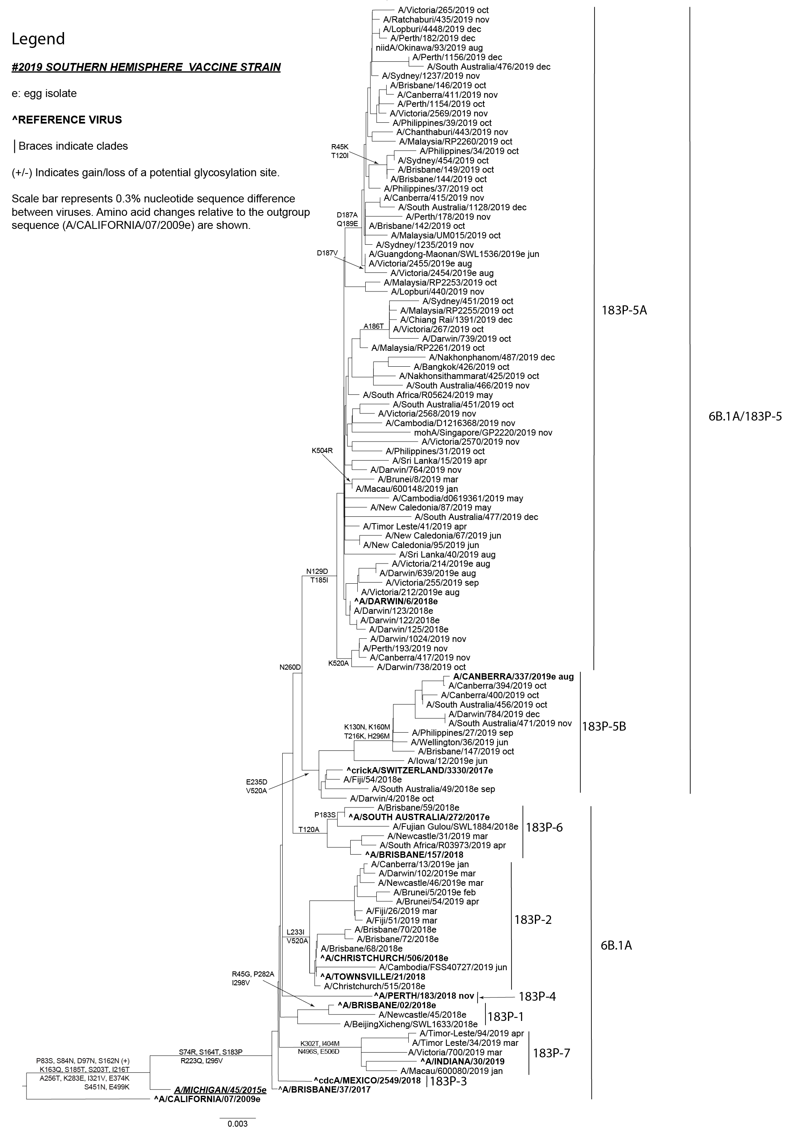
Figure 4: Phylogenetic tree of haemagglutinin genes of A(H3N2) viruses received by the Centre during 2019
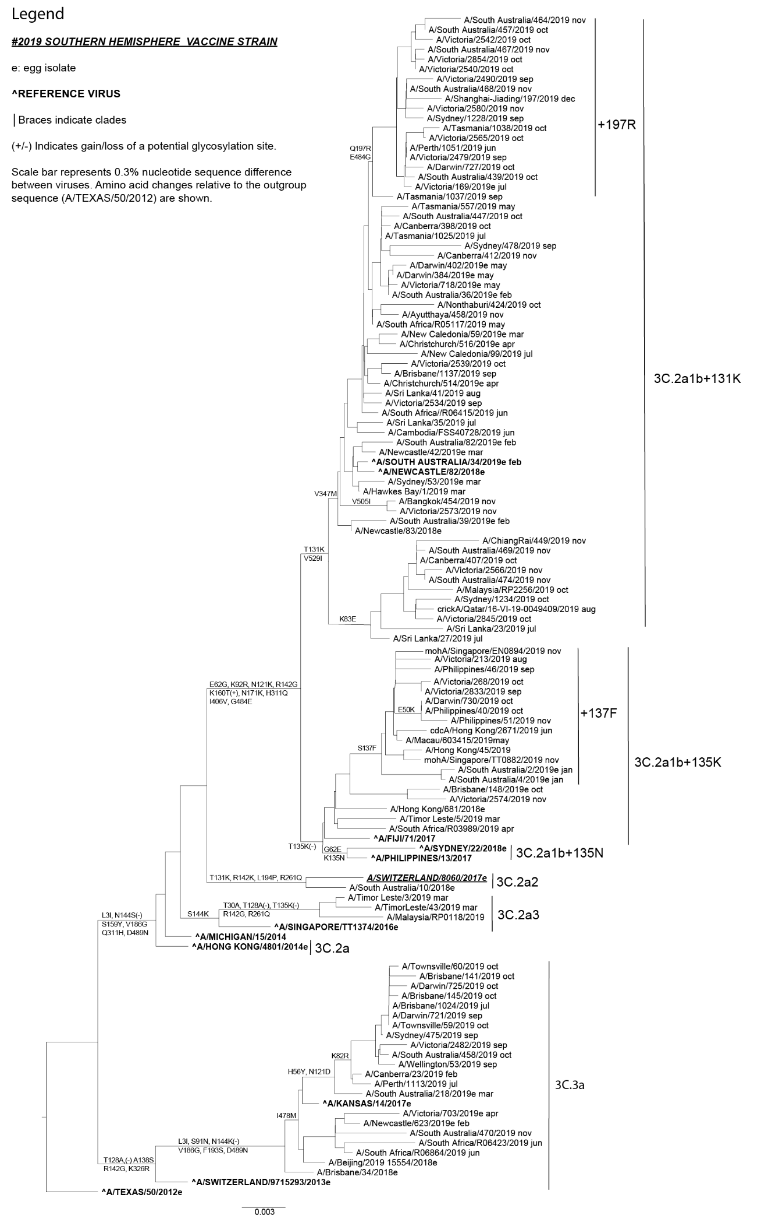
Sequencing was performed on HA genes from 367 B/Victoria viruses and 88 B/Yamagata viruses. A small number of B viruses (51/367; 14%) were genetically similar to the B/Colorado/06/2017 reference virus, with a two-amino-acid deletion in the HA protein (positions 162–163) (Figure 5); however, the majority of viruses (272/367; 74%) had a three-amino-acid deletion in the HA protein at positions 162–164 and formed a separate phylogenetic clade from the B/Colorado/06/2017 clade. All B/Yamagata-lineage viruses belonged to genetic clade 3 (or Y3), which is the same genetic clade as the 2019 vaccine virus B/Phuket/3073/2013 (Figure 6).
Egg isolation was attempted for 15 B/Victoria and eight B/Yamagata-lineage viruses, resulting in the successful isolation of 11 (73%) B/Victoria-lineage viruses and four (50%) B/Yamagata-lineage viruses. All B/Victoria-lineage viruses isolated were from genetic subclade V1A, two of which were further grouped into V1A.1 and eight others in V1A.3. All B/Yamagata-lineage viruses isolated were from genetic clade Y3. For viruses inoculated into the qualified cell line MDCK 33016PF, nine of 16 (56%) B/Victoria-lineage viruses and four (80%) of five B/Yamagata-lineage viruses were isolated. At least one representative from the major clades of each B lineage was isolated. A total of 21 viruses were inoculated into the qualified cell line MDCK 33016PF, of which 13 (62%) grew successfully.
Of 54 B/Yamagata-lineage viruses tested, none displayed highly reduced inhibition by oseltamivir or zanamivir. However, three of the 1,223 B/Victoria-lineage viruses tested showed highly reduced inhibition by zanamivir. Two of the viruses, one each from Malaysia and Australia, contained an E105K substitution in their NA genes, which has been shown to reduce susceptibility to neuraminidase inhibitor drugs.¹⁶ A B/Victoria-lineage virus from Malaysia was found to contain gene sequence coding for a novel dual-amino-acid substitution, T146P + N169S, in its NA gene.

Discussion
During 2019 the Centre received a larger number of samples than in any previous single year,^{17–19,21,22} with the majority of viruses received (80%) from Australia. The high volume of samples received correlated with a record number of laboratory-confirmed influenza notifications in Australia (313,365 cases) during the 2019 Australian influenza season.²³ There was a continuation of intense inter-seasonal activity, with notifications of laboratory-confirmed influenza at the end of May twelve times higher than during the same time period in the previous three years.²⁴ The 2019 Australian season was characterised by an early peak and extended activity, with jurisdictions such as the Australian Capital Territory and Tasmania displaying multiple peaks of activity.²⁵ Unlike previous seasons, where influenza samples received at the Centre typically peaked in August, the Centre saw a dramatic increase in samples received early in the year, peaking in July 2019, with over 1,500 samples received in that month alone.
The geographic spread of influenza around Australia began with a large epidemic of A(H1N1)pdm09 in the Northern Territory, in December 2018. This was followed by large and sustained outbreaks of influenza in eastern Australian jurisdictions, most notably South Australia, in the first quarter of 2019. The Australian Capital Territory and Western Australia had comparatively lower levels of influenza notification but even these both had record notifications in 2019.²⁵
The predominant circulating virus in January and February 2019 across Australia was A(H1N1)pdm09, while influenza A(H3N2) virus submissions began to increase rapidly in March 2019, subsequently becoming the predominant circulating strain in 2019. Influenza A(H3N2) viruses accounted overall for 51% of samples submitted to the Centre, followed by A(H1N1)pdm09 (30%), while influenza B viruses comprised 18% of samples received. Globally, influenza A viruses were predominant in 2019, with co-circulation of A(H1N1)pdm09 and A(H3N2). In the southern hemisphere, A(H1N1)pdm09 predominated in South America, followed by A(H3N2). By contrast, A(H3N2) predominated in South Africa with very few detections of A(H1N1)pdm09, while in tropical Asia, A(H1N1)pdm09 was the dominant circulating strain followed by B/Victoria viruses.²⁶
Figure 5: Phylogenetic tree of haemagglutinin genes of B/Victoria-lineage viruses received by the Centre during 2019
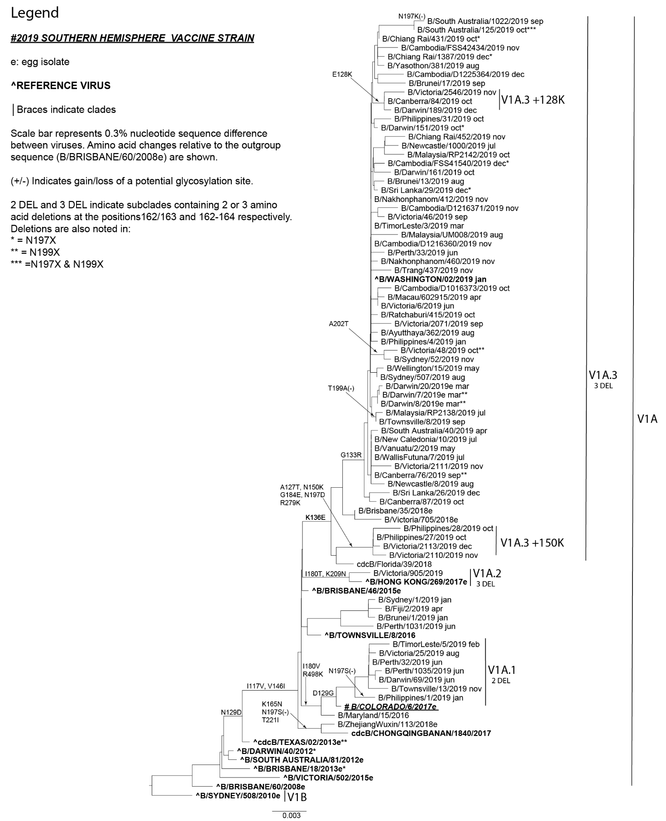

Figure 6: Phylogenetic tree of haemagglutinin genes of B/Yamagata-lineage viruses received by the Centre during 2019
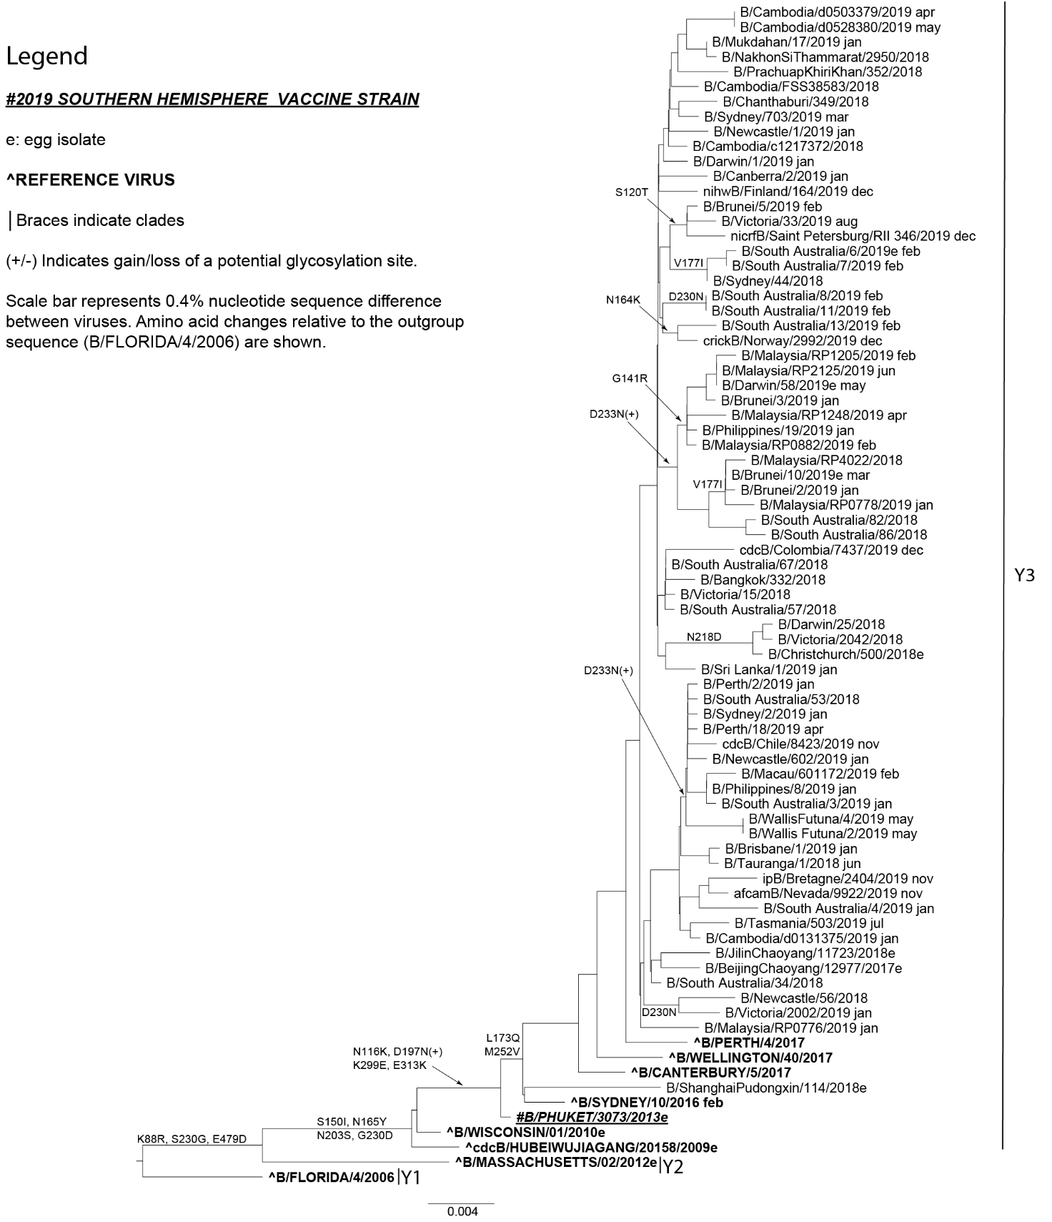

Older adults are typically more affected in years when A(H3N2) viruses predominate, while younger populations are usually more affected by A(H1N1)pdm09.²⁷ Consistent with this observation, high notification rates occurred in 2019 among children aged 5–9 years (2,646 per 100,000 population) and adults aged ≥ 85 years (2,370 per 100,000 population) in Australia.²³ Deaths associated with influenza and pneumonia were the ninth leading cause of death in 2019, with 4,124 deaths recorded.²⁸
Most of the influenza A(H1N1)pdm09 viruses received were antigenically and genetically similar to the vaccine strain, A/Brisbane/02/2018, which is in the 6B.1A/183P-1 genetic clade. A number of A(H1N1)pdm09 viruses had amino acid changes in the HA gene, most significantly at residues 156 and 250; the former mutation has been previously associated with significant antigenic changes in the haemagglutination inhibition (HI) assay. These viruses were first detected in Fiji and Brunei in early 2019 and were subsequently seen in some returned travellers from these regions to Australia. These antigenically-distinct viruses comprised 5.7% of the A(H1N1)pdm09 viruses tested and were in the 6B.1A/183-P2 genetic clade. Mid-season vaccine effectiveness (VE) estimates suggest that vaccine protection in Australia for all age groups was highest against A(H1N1)pdm09 viruses among both primary care (62%, 95% CI: 39,78) and hospitalised patients (70%, 95% CI: 49, 82).²⁹
Antigenic analysis of A(H3N2) viruses showed that the majority of viruses displayed similar antigenic characteristics to the cell-propagated vaccine strain, A/Switzerland/8060/2017. As in previous years, there have been ongoing difficulties in the antigenic characterisation of A(H3N2) viruses. Evolutionary changes in this subtype continue to pose challenges in detecting antigenic changes using the HI assay.^{5,30} Oseltamivir carboxylate was used in the HI assay to prevent binding of the NA protein to red blood cells, which resulted in a small number of A(H3N2) viruses having insufficient titre to be tested in the HI assay (16% of A(H3N2) viruses isolated). The FRA continued to be used as complementary antigenic assay but remains time- and labour-intensive. Of the viruses analysed by FRA, 75% and 7%, respectively, were antigenically similar to the cell- and egg-propagated reference strain (A/Switzerland/8060/2017).
There were several distinct genetic clades amongst circulating A(H3N2) viruses, with the majority of viruses belonging to the 3C.2a1b+131K HA clade, followed by the 3C.2a1b+135K HA clade. Interestingly, 3C.2a2 viruses, which were represented by the 2019 Southern Hemisphere vaccine strain A/Switzerland/8060/2018, only accounted for a very small proportion of circulating viruses during 2019 and also led to a change in the 2020 Southern Hemisphere A(H3N2) vaccine component to an A/South Australia/34/2019-like virus.³¹
The majority of influenza B isolates analysed at the Centre belonged to the B/Victoria-lineage (86%). These B/Victoria-lineage viruses were mostly antigenically similar to the vaccine strain B/Colorado/6/2017; however, the majority were phylogenetically similar to a new variant that had previously emerged in the Northern Hemisphere. This variant contained a three-amino-acid deletion in the HA gene, from HA positions 162–164, and made up 64% of viruses genetically analysed at the Centre. The increase in circulation of this deletion variant also contributed to an increase in low-reacting viruses in the HI assay, indicating a corresponding antigenic change compared to the vaccine virus. This led to the subsequent change in the recommendation for the 2020 Southern Hemisphere B/Victoria-lineage vaccine component to a B/Washington/02/2019-like triple HA deletion virus.³¹ B/Yamagata viruses comprised only 10% of influenza B viruses analysed at the Centre, and all these viruses were antigenically and genetically similar to the vaccine strain, B/Phuket/3073/2013.
With the ongoing evolution of influenza viruses and the absence of an effective universal vaccine, there remains a need for continuous influenza surveillance and regular updating of influenza vaccines. The work performed by the Centre in Melbourne is part of the ongoing efforts of the WHO GISRS to perform these tasks in an effort to better control the disease burden of influenza.

Acknowledgements
The authors would like to thank all the National Influenza Centres and other contributing laboratories who sent influenza-positive samples to the Centre during 2019. We thank Ms Leah Gillespie for technical advice and thank Dr Kanta Subbarao for her comments and input to this report. The FluLINE was developed by October Sessions and Uma Kamaraj from Duke-NUS Medical School, Singapore. The Melbourne WHO Collaborating Centre for Reference and Research on Influenza is supported by the Australian Government Department of Health.

Author details
Ms Heidi Peck, Head – Serology¹
Ms Jean Moselen, Medical Scientist¹
Mrs Sook Kwan Brown, Medical Scientist¹
Ms Megan Triantafilou, Medical Scientist¹
Ms Hilda Lau, Medical Scientist¹
Mr Miguel Grau, Bioinformatician¹
Prof. Ian G Barr, Deputy Director¹
Ms Vivian KY Leung, Epidemiologist¹
- WHO Collaborating Centre for Reference and Research on Influenza

Corresponding author
Ms Vivian Leung
WHO Collaborating Centre for Reference and Research on Influenza, Peter Doherty Institute for Infection and Immunity, 792 Elizabeth St, Melbourne VIC 3000 AUSTRALIA.
Email: vivian.leung@influenzacentre.org

References
- Hay AJ, McCauley JW. The WHO global influenza surveillance and response system (GISRS)—a future perspective. Influenza Other Respir Viruses. 2018;12(5):551–7.
- Monto AS. Reflections on the Global Influenza Surveillance and Response System (GISRS) at 65 years: an expanding framework for influenza detection, prevention and control. Influenza Other Respir Viruses. 2018;12(1):10–2.
- Oh DY, Barr IG, Mosse JA, Laurie KL. MDCK-SIAT1 cells show improved isolation rates for recent human influenza viruses compared to conventional MDCK cells. J Clin Microbiol. 2008;46(7):2189–94.
- Hobson D, Curry RL, Beare AS, Ward-Gardner A. The role of serum haemagglutination-inhibiting antibody in protection against challenge infection with influenza A2 and B viruses. J Hyg (Lond). 1972;70(4):767–77.
- Lin YP, Gregory V, Collins P, Kloess J, Wharton S, Cattle N et al. Neuraminidase receptor binding variants of human influenza A(H3N2) viruses resulting from substitution of aspartic acid 151 in the catalytic site: a role in virus attachment? J Virol. 2010;84(13):6769–81.
- Okuno Y, Tanaka K, Baba K, Maeda A, Kunita N, Ueda S. Rapid focus reduction neutralization test of influenza A and B viruses in microtiter system. J Clin Microbiol. 1990;28(6):1308–13.
- Tilmanis D, van Baalen C, Oh DY, Rossignol JF, Hurt AC. The susceptibility of circulating human influenza viruses to tizoxanide, the active metabolite of nitazoxanide. Antiviral Res. 2017;147:142–8.
- Zhou B, Deng YM, Barnes JR, Sessions OM, Chou TW, Wilson M et al. Multiplex reverse transcription-PCR for simultaneous surveillance of influenza A and B viruses. J Clin Microbiol. 2017;55(12):3492–501.
- Hurt AC, Besselaar TG, Daniels RS, Ermetal B, Fry A, Gubareva L et al. Global update on the susceptibility of human influenza viruses to neuraminidase inhibitors, 2014–2015. Antiviral Res. 2016;132:178–85.
- Deng YM, Caldwell N, Barr IG. Rapid detection and subtyping of human influenza A viruses and reassortants by pyrosequencing. PLoS One. 2011;6(8):e23400. doi: https://doi.org/10.1371/journal.pone.0023400.
- Gerdil C. The annual production cycle for influenza vaccine. Vaccine. 2003;21(16):1776–9.
- Stohr K, Bucher D, Colgate T, Wood J. Influenza virus surveillance, vaccine strain selection, and manufacture. Meth Mol Biol. 2012;865:147–62.
- Weir JP, Gruber MF. An overview of the regulation of influenza vaccines in the United States. Influenza Other Respir Viruses. 2016;10(5):354–60.
- WHO Global Influenza Surveillance Network. Manual for the laboratory diagnosis and virological surveillance of influenza. Geneva: World Health Organization; 2011. Available from: https://www.who.int/influenza/gisrs_laboratory/manual_diagnosis_surveillance_influenza/en/.
- Roth B, Mohr H, Enders M, Garten W, Gregersen JP. Isolation of influenza viruses in MDCK 33016PF cells and clearance of contaminating respiratory viruses. Vaccine. 2012;30(3):517–22.
- Farrukee R, Leang SK, Butler J, Lee RTC, Maurer-Stroh S, Tilmanis D et al. Influenza viruses with B/Yamagata- and B/Victoria-like neuraminidases are differentially affected by mutations that alter antiviral susceptibility. J Antimicrob Chemother. 2015;70(7):2004–12.
- Leung VK, Spirason N, Lau H, Buettner I, Leang SK, Chow MK. Influenza viruses received and tested by the Melbourne WHO Collaborating Centre for Reference and Research on Influenza annual report, 2015. Commun Dis Intell Q Rep. 2017;41(2):E150–60.
- Roe M, Kaye M, Iannello P, Lau H, Buettner I, Tolosa MX et al. Report on influenza viruses received and tested by the Melbourne WHO Collaborating Centre for Reference and Research on Influenza in 2017. Commun Dis Intell (2018). 2019;43. doi: https://doi.org/10.33321/cdi.2019.43.25.
- Leung VK, Deng YM, Kaye M, Buettner I, Lau H, Leang SK et al. Annual report on influenza viruses received and tested by the Melbourne WHO Collaborating Centre for Reference and Research on Influenza in 2016. Commun Dis Intell (2018). 2019;43. doi: https://doi.org/10.33321/cdi.2019.43.3.
- Tamura D, DeBiasi RL, Okomo-Adhiambo M, Mishin VP, Campbell AP, Loechelt B et al. Emergence of multidrug-resistant influenza A(H1N1)pdm09 virus variants in an immunocompromised child treated with oseltamivir and zanamivir. J Infect Dis. 2015;212(8):1209–13.
- Sullivan SG, Chow MK, Barr IG, Kelso A. Influenza viruses received and tested by the Melbourne WHO Collaborating Centre for Reference and Research on Influenza annual report, 2014. Commun Dis Intell Q Rep. 2015;39(4):E602–11.
- Price OH, Spirason N, Rynehart C, Brown SK, Todd A, Peck H et al. Report on influenza viruses received and tested by the Melbourne WHO Collaborating Centre for Reference and Research on Influenza in 2018. Commun Dis Intell (2018). 2020;44. doi: https://doi.org//10.33321/cdi.2020.44.16.
- Australian Government Department of Health. National Notifiable Diseases Surveillance System. [Internet.] Canberra: Australian Government Department of Health; 2021. Available from: http://www9.health.gov.au/cda/source/cda-index.cfm.
- Barr IG, Deng YM, Grau ML, Han AX, Gilmour R, Irwin M et al. Intense interseasonal influenza outbreaks, Australia, 2018/19. Euro Surveill. 2019;24(33):1900421. doi: https://doi.org/10.2807/1560-7917.ES.2019.24.33.1900421.
- Australian Government Department of Health. Australian Influenza Surveillance Report – No 12 – 2019. [Internet.] Canberra; Australian Government Department of Health; 10 October 2019. Available from: https://www1.health.gov.au/internet/main/publishing.nsf/Content/ozflu-surveil-no12-19.htm.
- World Health Organization (WHO). Recommended composition of influenza virus vaccines for use in the 2019 southern hemisphere influenza season. Geneva: WHO; 27 September 2018. Available from: https://www.who.int/influenza/vaccines/virus/recommendations/2019_south/en/.
- Thompson WW, Shay DK, Weintraub E, Brammer L, Bridges CB, Cox NJ et al. Influenza-associated hospitalizations in the United States. JAMA. 2004;292(11):1333–40.
- Australian Bureau of Statistics. 3303.0 Causes of death, Australia, 2019. Table 1.1. Underlying cause of death, All causes, Australia, 2019. [Downloadable dataset.] Canberra: Australian Bureau of Statistics; 23 October 2020. Available from: https://www.abs.gov.au/statistics/health/causes-death/causes-death-australia/2019#data-download.
- Sullivan SG, Arriola CS, Bocacao J, Burgos P, Bustos P, Carville KS et al. Heterogeneity in influenza seasonality and vaccine effectiveness in Australia, Chile, New Zealand and South Africa: early estimates of the 2019 influenza season. Euro Surveill. 2019;24(45). doi: https://doi.org/10.2807/1560-7917.ES.2019.24.45.1900645.
- Barr IG, Russell C, Besselaar TG, Cox NJ, Daniels RS, Donis R et al. WHO recommendations for the viruses used in the 2013–2014 Northern Hemisphere influenza vaccine: epidemiology, antigenic and genetic characteristics of influenza A(H1N1)pdm09, A(H3N2) and B influenza viruses collected from October 2012 to January 2013. Vaccine. 2014;32(37):4713–25.
- WHO. Recommended composition of influenza virus vaccines for use in the 2020 southern hemisphere influenza season. [Internet.] Geneva: WHO; 27 September 2019. Available from: https://www.who.int/influenza/vaccines/virus/recommendations/2020_south/en/.

Communicable Diseases Intelligence
ISSN: 2209-6051 Online

Communicable Diseases Intelligence (CDI) is a peer-reviewed scientific journal published by the Office of Health Protection and Response, Department of Health. The journal aims to disseminate information on the epidemiology, surveillance, prevention and control of communicable diseases of relevance to Australia.

Editor: Jennie Hood
Deputy Editor: Simon Petrie
Design and Production: Kasra Yousefi
Editorial Advisory Board: David Durrheim, Mark Ferson, John Kaldor, Martyn Kirk and Linda Selvey

Website: http://www.health.gov.au/cdi

Contacts
CDI is produced by the Office of Health Protection and Response, Australian Government Department of Health, GPO Box 9848, (MDP 6) CANBERRA ACT 2601

Email: cdi.editor@health.gov.au

Submit an Article
You are invited to submit your next communicable disease related article to the Communicable Diseases Intelligence (CDI) for consideration. More information regarding CDI can be found at: http://health.gov.au/cdi.
Further enquiries should be directed to: cdi.editor@health.gov.au.

This journal is indexed by Index Medicus and Medline.

Creative Commons Licence - Attribution-NonCommercial-NoDerivatives CC BY-NC-ND
© 2021 Commonwealth of Australia as represented by the Department of Health
This publication is licensed under a Creative Commons Attribution-NonCommercial-NoDerivatives 4.0 International Licence from https://creativecommons.org/licenses/by-nc-nd/4.0/legalcode (Licence). You must read and understand the Licence before using any material from this publication.

Restrictions
The Licence does not cover, and there is no permission given for, use of any of the following material found in this publication (if any):
- the Commonwealth Coat of Arms (by way of information, the terms under which the Coat of Arms may be used can be found at www.itsanhonour.gov.au);
- any logos (including the Department of Health’s logo) and trademarks;
- any photographs and images;
- any signatures; and
- any material belonging to third parties.

Disclaimer
Opinions expressed in Communicable Diseases Intelligence are those of the authors and not necessarily those of the Australian Government Department of Health or the Communicable Diseases Network Australia. Data may be subject to revision.

Enquiries
Enquiries regarding any other use of this publication should be addressed to the Communication Branch, Department of Health, GPO Box 9848, Canberra ACT 2601, or via e-mail to: copyright@health.gov.au

Communicable Diseases Network Australia
Communicable Diseases Intelligence contributes to the work of the Communicable Diseases Network Australia.
http://www.health.gov.au/cdna

The CDC Influenza Virus Real-Time RT-PCR Influenza A/B Typing Panel (RUO) (Catalog No. FluRUO-01), FR-198, was obtained through the International Reagent Resource, Influenza Division, WHO Collaborating Center for Surveillance, Epidemiology and Control of Influenza, Centers for Disease Control and Prevention, Atlanta, GA, USA. https://www.internationalreagentresource.org/.

