Monitoring the incidence and causes of disease potentially transmitted by food in Australia: Annual report of the OzFoodNet network, 2016
The OzFoodNet Working Group

Abstract
In 2016, a total of 44,455 notifications of enteric diseases potentially related to food were received by state and territory health departments in Australia. Consistent with previous years, campylobacteriosis (n = 24,171) and salmonellosis (n = 18,060) were the most frequently-notified infections. Notable increases in incidence were observed for shiga toxin-producing Escherichia coli (n = 343; 166% increase), shigellosis (n = 1,408; 93% increase), campylobacteriosis (33% increase) and salmonellosis (30% increase) when compared with the historical five-year mean. The extent to which the introduction of culture-independent testing as a method of diagnosis has contributed to these increases remains unclear. In total, 188 gastrointestinal outbreaks, including 177 foodborne outbreaks, were reported in 2016. The 11 non-foodborne outbreaks were due to environmental or probable environmental transmission (nine outbreaks) and animal-to-person or probable animal-to-person transmission (two outbreaks). No outbreaks of waterborne or probable waterborne transmission were reported in 2016. Foodborne outbreaks affected 3,639 people, resulting in at least 348 hospital admissions and four deaths. Eggs continue to be a source of Salmonella Typhimurium infection across the country: 35 egg-related outbreaks, affecting approximately 510 people, were reported across six jurisdictions in 2016. Three large multi-jurisdictional Salmonella outbreaks associated with mung bean sprouts (n = 419 cases); bagged salad products (n = 311 cases); and rockmelons (n = 144 cases) were investigated in 2016. These outbreaks highlight the risks associated with fresh raw produce and the ongoing need for producers, retailers and consumers to implement strategies to reduce potential Salmonella contamination.

Introduction
The burden of foodborne disease in Australia is significant, with an estimated 4.1 million people infected in Australia each year, costing an estimated $1.2 billion per year.^{1–3}
The OzFoodNet network was established in 2000 by the Australian Government Department of Health, to apply concentrated effort at a national level to investigate and understand foodborne disease; to describe more effectively its epidemiology; and to identify ways to minimise foodborne disease in Australia. The OzFoodNet network includes foodborne disease epidemiologists from each state and territory health department and collaborators from the Australian Government Department of Agriculture, Water and the Environment; Food Standards Australia New Zealand (FSANZ); and the Public Health Laboratory Network (PHLN). OzFoodNet is represented on the Communicable Diseases Network Australia (CDNA), which is Australia’s peak body for communicable disease control.
The primary data sources used by OzFoodNet epidemiologists to understand the extent of foodborne disease in Australia include notifiable enteric disease data and reports of gastrointestinal disease outbreaks. This report provides an overview of the national enteric disease surveillance data from 1 January 2016 to 31 December 2016 and the findings from the investigations into gastrointestinal disease outbreaks caused by foodborne, animal-to-person, environmental or waterborne disease that were initiated in Australia between 1 January 2016 and 31 December 2016.

Methods

Population under surveillance
In 2016, the OzFoodNet network covered all Australian states and territories (ACT: Australian Capital Territory; NSW: New South Wales; NT: Northern Territory; Qld: Queensland; SA: South Australia; Tas: Tasmania; Vic: Victoria; WA: Western Australia), with the estimated population comprising 24,190,907 persons as at 30 June 2016.⁴

Data sources

Notified infections
All Australian states and territories have public health legislation requiring doctors and pathology laboratories to notify cases of infectious diseases that are important to public health. State and territory health departments record details of notified cases on surveillance databases. Under the auspices of the National Health Security Act 2007, surveillance data are aggregated into a national database known as the National Notifiable Diseases Surveillance System (NNDSS). Notifiable enteric diseases include botulism, campylobacteriosis, cholera, haemolytic uraemic syndrome (HUS), hepatitis A, hepatitis E, listeriosis, paratyphoid fever, salmonellosis, Shiga toxin-producing Escherichia coli (STEC) infection, shigellosis and typhoid fever.
Data for this report were extracted from NNDSS in July 2017 and analysed by calendar year using the date of diagnosis. Date of diagnosis was derived for each case from the earliest date supplied by the jurisdiction, which could be the date of onset of the case’s illness; the date a specimen was collected; or the date that a health department received the notification. Notifications for 2016 are those with a diagnosis date from 1 January 2016 to 31 December 2016. Estimated resident populations for each state or territory as at 30 June 2016 were used to calculate rates of notified infections.⁴ Due to the dynamic nature of NNDSS data, the data presented in this report are subject to change over time.

Enhanced surveillance for listeriosis
In 2010, OzFoodNet commenced enhanced surveillance data collection on all notified cases of listeriosis in Australia using a centralised database known as the National Enhanced Listeriosis Surveillance System (NELSS). The primary aim of NELSS is to detect clusters of infection to enable a timely public health investigation and response. In accordance with the national guidelines for listeriosis, jurisdictional public health staff conduct case interviews at the time of diagnosis using a standardised questionnaire. Interview data (including food histories), along with information regarding the characterisation of Listeria monocytogenes isolates by molecular subtyping methods, are entered into NELSS by OzFoodNet epidemiologists using an open-source secure web-based reporting system known as NetEpi. Commencing in 2016, whole genome sequencing with fortnightly phylogenetic analysis was conducted for all human L. monocytogenes isolates to identify potential clusters for investigation (data not included).

Impact of culture-independent testing
Changes in diagnostic laboratory testing procedures, including the increasing uptake of culture-independent diagnostic testing (CIDT) using polymerase chain reaction (PCR), and the introduction of multiplex PCR (which can detect multiple enteric pathogens on one test), are suspected to have resulted in an increase in notifications for a number of bacterial enteric diseases including campylobacteriosis, salmonellosis, shigellosis and STEC. PCR offers increased sensitivity and more rapid results for some enteric pathogens; however, non-viable organisms or residual nucleic acid may also be detected.^{5–8} Multiplex PCR may also detect enteric organisms that would not otherwise be tested for in the absence of cases presenting with clinical symptoms, or may identify organisms which are of doubtful pathogenicity. While CIDT has the potential to improve disease estimates, such incidental findings may have ambiguous public health significance in terms of morbidity.^{8,9} CIDT was first introduced in Australia in 2013, with the timing of the implementation variable depending on the laboratory. These changes make interpretation of disease trends over time, and between jurisdictions, difficult. The extent to which CIDT has contributed to the increases observed in notification data since 2013 remains unclear.

Outbreaks of gastrointestinal disease including foodborne disease outbreaks
Gastrointestinal disease outbreaks may be notified to jurisdictional health departments from a range of sources including doctors, local councils and members of the public, or identified by OzFoodNet epidemiologists through review of notifiable disease data.
In 2016, OzFoodNet epidemiologists revised the terminology used to refer to the various modes of transmission of gastrointestinal disease outbreaks. Suspected foodborne, animal-to-person and waterborne outbreak categories were redefined as probable outbreaks to more accurately reflect the level of evidence available to implicate a mode of transmission. For data analysis and reporting pre- and post-2016, suspected and probable categories can be treated as equivalent. In addition, an environmental outbreak category was introduced to differentiate between waterborne outbreaks associated with drinking water and incidental exposure to contaminated water sources in the environment. Waterborne outbreaks from 2011 to 2015 have been redefined using the 2016 case definitions to enable accurate historical comparisons in this report. Refer to Appendix A for the revised definitions.
Commencing in the 2013–2015 annual report,¹⁰ person-to-person outbreaks and outbreaks of unknown transmission mode have been excluded from the OzFoodNet annual reports. These modes of transmission have historically accounted for the majority of outbreaks each year. This is a change in practice from previous annual reports and therefore the total number of outbreaks in this report cannot be directly compared with annual reports prior to 2013.

Surveillance and outbreak data limitations
Enteric disease surveillance data reported to health departments represent only a proportion of disease in the community, as these data rely on people seeking medical attention and undergoing appropriate laboratory testing to confirm a diagnosis. Research in Australia has estimated that 28% of people experiencing gastroenteritis seek medical attention.¹ Studies have shown that for every salmonellosis case notified to a health department in Australia, there are an estimated seven salmonellosis infections in the community; for every notified STEC case there are an estimated eight STEC infections; and for every notified campylobacteriosis case there are an estimated ten campylobacteriosis infections in the community.^{1,11,12}
The outbreak data within this report have limitations, including the potential for variation in the categorisation of features of outbreaks, depending on differing circumstances and investigator interpretation. In addition, outbreaks of gastroenteritis are often not reported to health authorities, resulting in under-representation of the true burden of enteric disease outbreaks within Australia. Changes in the number of outbreaks over time should be interpreted with caution. The number of cases and outbreaks may differ from summaries previously published, as these may take time to finalise. Outbreaks presented in this report are included based on the investigation commencing in 2016.

Data analysis
All analyses were conducted using Microsoft Excel.

Results

Notified infections
In total, there were 44,455 enteric diseases notifications reported in 2016 (Table 1).
Table 1: Enteric disease notifications in Australia, 2016
Disease | Number of notifications 2016 | Proportion of all enteric notifications 2016 | Mean notifications 2011–2015 | % change | 2016 rate per 100,000 population
Campylobacteriosisª | 24,171 | 54% | 18,122 | 33% | 146.9
Salmonellosis | 18,060 | 41% | 13,903 | 30% | 74.7
Shigellosis | 1,408 | 3% | 730 | 93% | 5.8
Shiga toxin-producing Escherichia coli (STEC) infection | 343 | 1% | 128 | 166% | 1.4
Hepatitis A | 145 | < 1% | 182 | -20% | 0.6
Typhoid fever | 104 | < 1% | 128 | -19% | 0.4
Listeriosis | 85 | < 1% | 78 | 9% | 0.4
Paratyphoid fever | 79 | < 1% | 73 | 8% | 0.3
Hepatitis E | 43 | < 1% | 41 | 5% | 0.2
Haemolytic uraemic syndrome (HUS) | 16 | < 1% | 17 | – | 0.1
Cholera | 1 | < 1% | 4 | -75% | 0.004
Botulism | 0 | – | 2 | -100% | –
Total | 44,455 | 100% | 33,408 | 33%
a Campylobacteriosis is not notifiable in New South Wales.
Data from the NNDSS including number of notifications and rate by month, jurisdiction, age group and sex dating back to 1991 can be accessed on the Introduction to the National Notifiable Diseases Surveillance System webpage. A summary of each notifiable enteric condition is provided in this report.

Botulism
Botulism is a rare but serious illness that results in paralysis caused by nerve toxins made by Clostridium botulinum bacteria. Botulism can result from eating food containing pre-formed botulinum toxin (foodborne botulism) or ingesting food, dust or soil that contains the bacteria that produce the toxin (intestinal botulism) or contaminating a wound with the bacteria (wound botulism). Intestinal botulism usually only affects children under 12 months of age and is more commonly known as infant botulism. This is the most common form of botulism in Australia. Foodborne botulism may be found in improperly processed, canned, low acid or alkaline foods where anaerobic conditions have occurred at some stage.
Surveillance data include confirmed cases only. A confirmed case requires laboratory definitive and clinical evidence of infection. All notified cases are followed up by jurisdictional public health staff.

Overall trend
- Notifications of botulism are extremely rare in Australia, with a total of 24 cases recorded in Australia since collation of national notification data began in 1992 (Figure 1).
- Infant botulism accounts for almost all reported botulism cases (n = 20; 83%).
- Three foodborne botulism cases have been reported to date, including a single case in New South Wales in 1999 where the food source was not identified; a case in Victoria in 2007 associated with consumption of a commercially manufactured convenience food; and a further case in Victoria in 2015 where the suspected source was home cured ham.
- One case of intestinal botulism was reported in a child in 2006.
Figure 1: Botulism notifications in Australia by jurisdiction of residence, 1992–2016
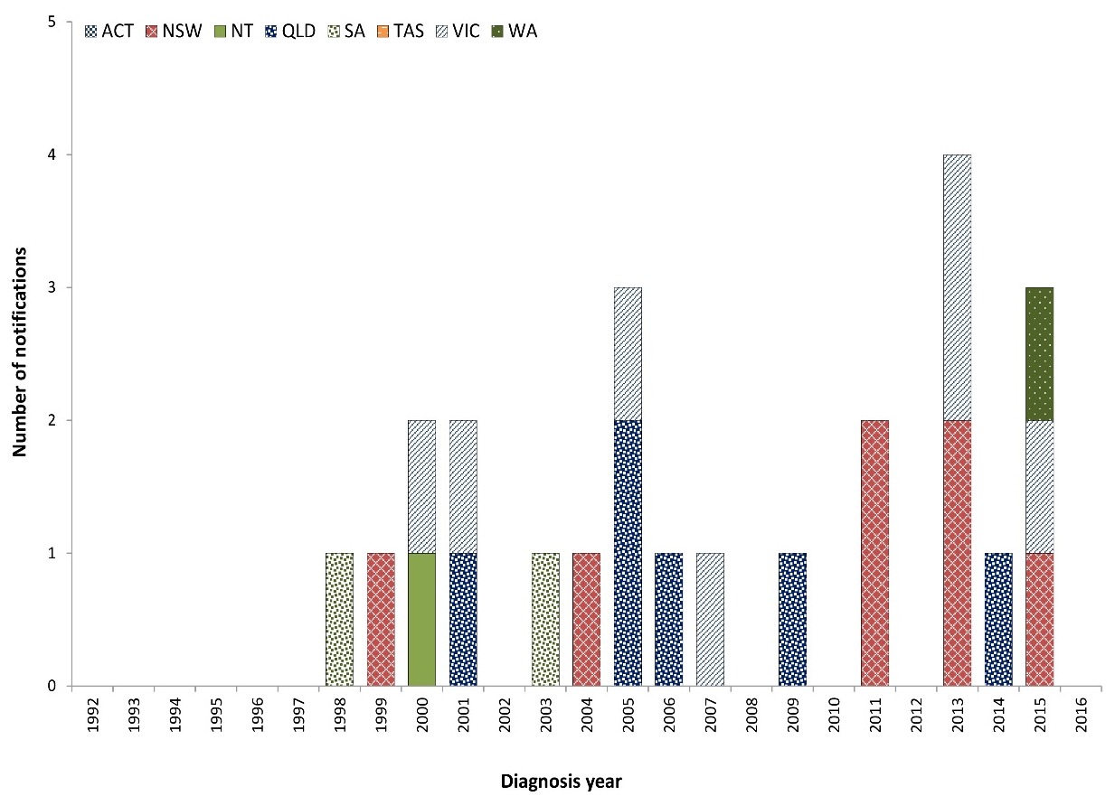

Epidemiology of botulism in Australia, 2016
No botulism cases were reported in 2016.

Campylobacteriosis
Campylobacteriosis is a gastrointestinal disease caused by the Campylobacter bacterium. It is a common cause of bacterial gastroenteritis globally, with infection rates in Australia among the highest in the industrialised world.¹³ In Australia, it is commonly associated with the consumption of undercooked poultry.¹⁴ Campylobacteriosis may also be acquired through consumption of cross-contaminated foods; by animal-to-person transmission; and through consumption of unpasteurised milk or contaminated water.
Surveillance data include confirmed cases only. A confirmed case requires laboratory definitive evidence of infection. Due to the volume of notifications, individual case follow-up is not undertaken routinely in all jurisdictions. Public health follow-up is usually limited to outbreaks and clusters of notified cases. During the reporting period, campylobacteriosis was not a notifiable condition in New South Wales; however, outbreaks of campylobacteriosis were investigated.

Overall trend
- The incidence of campylobacteriosis in Australia has increased steadily, since notification began in 1991, to 2011 (Figure 2). A decreasing trend was observed in 2012 and 2013. This may be related to work undertaken with poultry processors to identify and control contamination on-farm and processing operations in several jurisdictions.^{15,16}
- The marked increase in notifications since 2014 occurring throughout Australia is at least in part due to the increase in PCR testing as a method of laboratory diagnosis (refer to earlier section on CIDT testing).
Table 2: Summary of campylobacteriosis notifications in Australia,ª 2016
Category | Value
Number of notifications | 24,171
Rate | 146.9 cases per 100,000 population
Jurisdiction with the highest number of notifications | Victoria (n = 8,276; 34%)
Seasonality | Highest incidence in summer (28%) and spring (27%)^{b}
Foodborne outbreaks | 10
Foods implicated in outbreaks | Chicken liver pâté (n = 3); chicken wontons (n = 1); baguette with crayfish, iceberg lettuce and seafood dressing (suspected) (n = 1); and unknown (n = 5)^{c}
a Excluding New South Wales.
b In Australia, December, January and February are defined as summer, and September, October and November are defined as spring.
c Refer to Foodborne outbreaks section.

Table 3: Demographics of cases with the highest campylobacteriosis notification rates in Australia,ª 2016
Category | Group most affected | Rate per 100,000 population | Number (% of all cases)
Age group (years) | 0–4 | 218.5 | 2,287 (10%)
Sex | Males | 160.9 | 12,173 (54%)
Jurisdiction | Tasmania | 205.0 | 1,061 (4%)
a Excluding New South Wales.

Figure 2: Campylobacteriosis notifications and rate per 100,000 population in Australia by jurisdiction of residence,ª 1991–2016
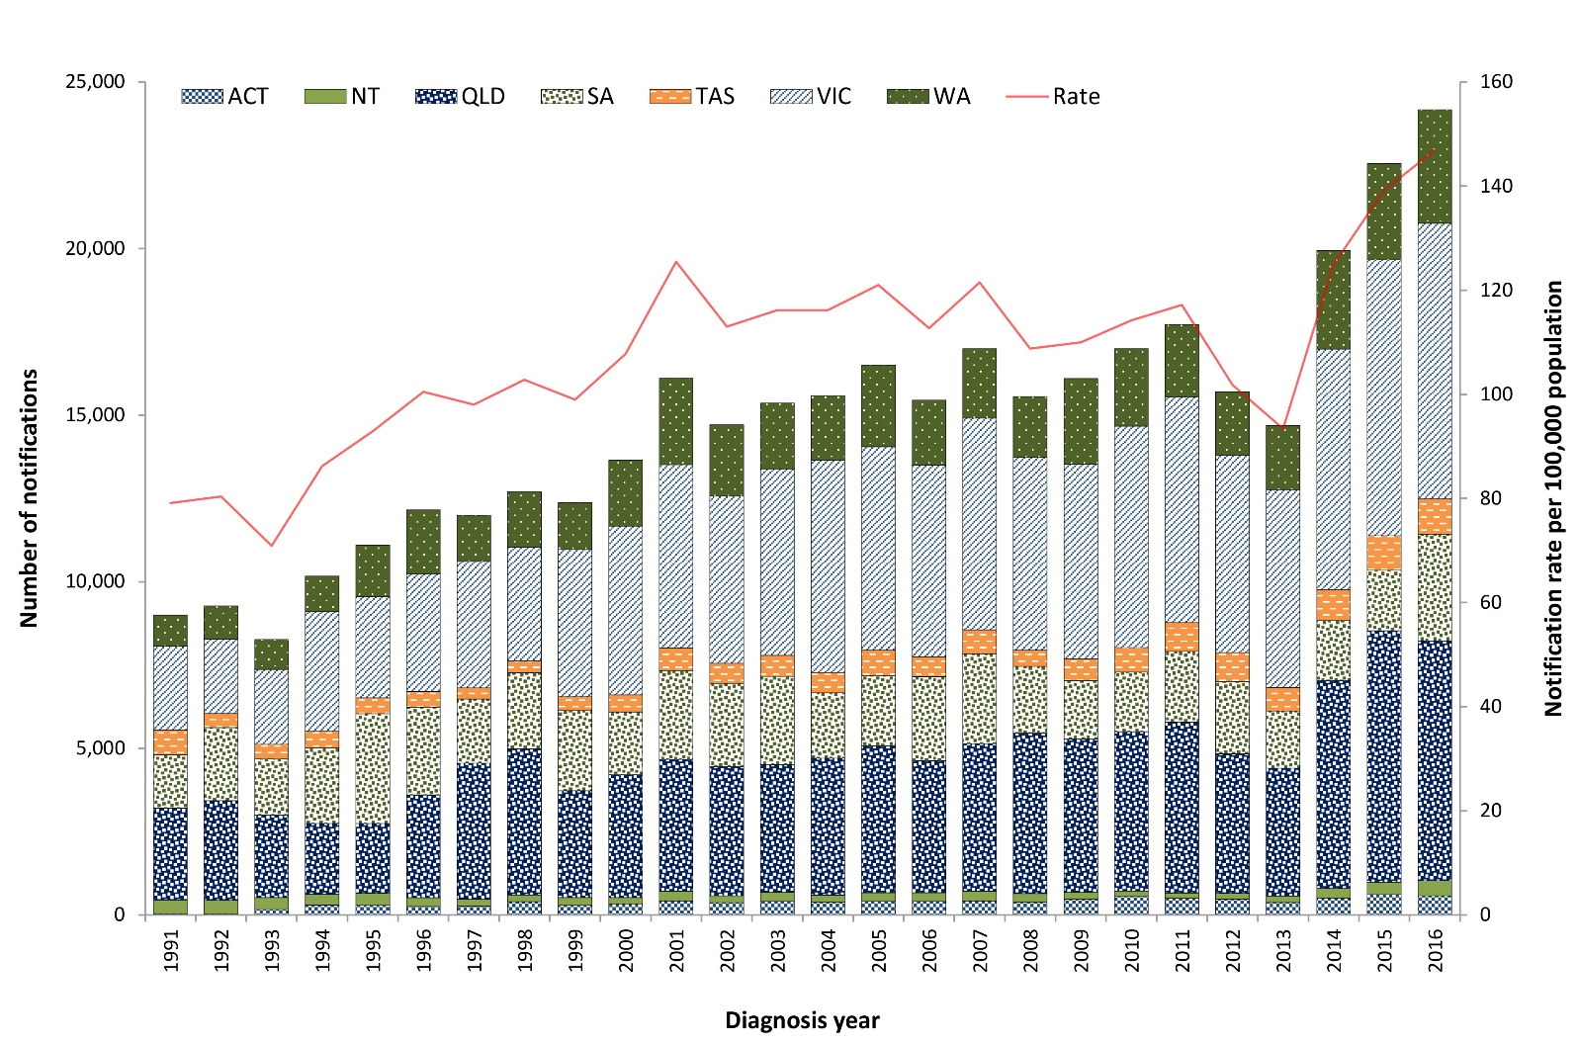
a Campylobacteriosis is not notifiable in New South Wales.

Previous outbreaks in Australia
- Foodborne outbreaks have been reported each year in Australia, commonly associated with consumption of poultry, particularly chicken and duck liver pâté. However, outbreaks account for a small proportion of the cases reported annually.

Epidemiology of campylobacteriosis in Australia, 2016
Campylobacteriosis was the most commonly-notified enteric pathogen in 2016, despite not being notifiable in New South Wales.
With the exception of the 20–24 years age group, a higher incidence was observed amongst males in every age group when compared with females (Figure 3). While consistent with previous years, the reason for this remains unclear.¹³

Figure 3: Campylobacteriosis notification rate in Australiaª by age group and sex, 2016
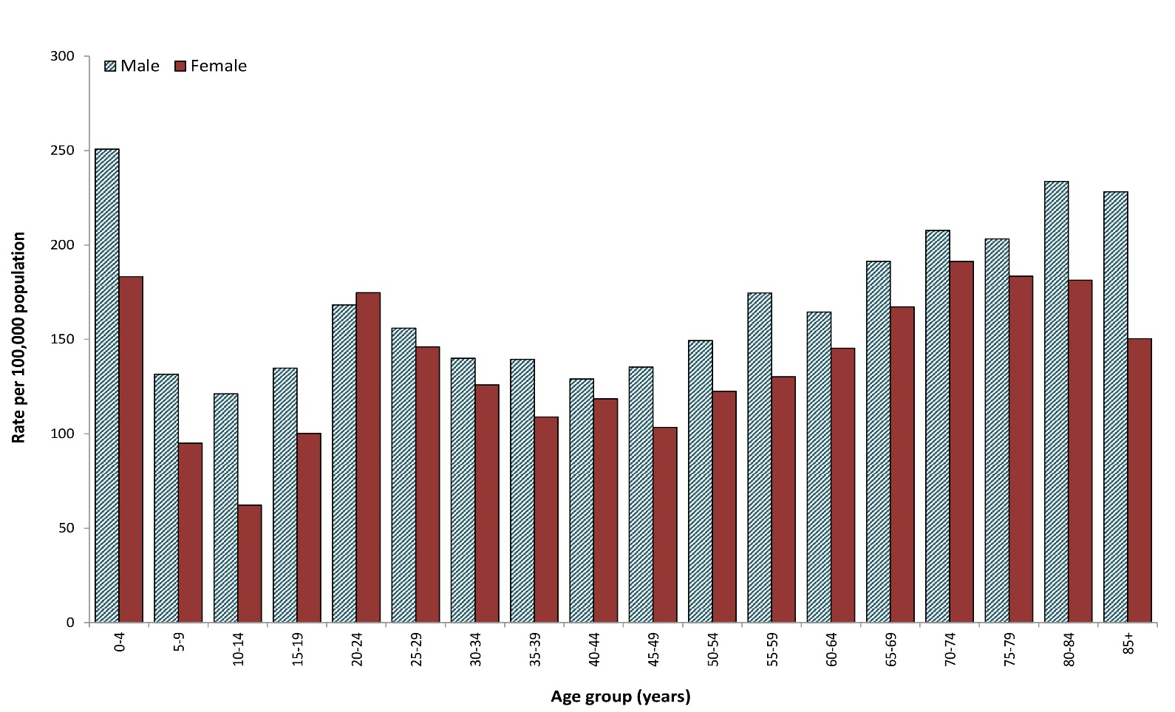
a Excluding New South Wales.

Cholera
Cholera is an infection of the digestive tract, caused by certain strains of the bacterium Vibrio cholerae that produce toxins. It is mainly seen in people who have travelled overseas including to parts of Africa, Asia, South America, the Middle East and the Pacific islands. Vibrio cholerae is found in the faeces of infected people, and is usually acquired by drinking contaminated water, eating food washed with contaminated water or prepared with contaminated hands, or eating fish or shellfish harvested from contaminated water. Person-to-person spread of cholera is less common. Symptoms typically start between two hours and five days after ingesting the bacteria. Symptoms can include characteristic ‘rice water’ faeces (profuse, watery diarrhoea), nausea and vomiting and signs of dehydration, such as weakness, lethargy and muscle cramps. Infection without symptoms or with only mild symptoms may occur, particularly in children.
Surveillance data include confirmed cases only. A confirmed case requires laboratory definitive evidence of isolation of toxigenic Vibrio cholerae O1 or O139. All notified cases are followed up by jurisdictional public health staff.

Overall trend
- All cases of cholera reported since 1991 (the commencement of the NNDSS) were acquired outside Australia, with the exception of:
  - one laboratory-acquired case in 1996;¹⁷
  - three cases in 2006 linked to imported whitebait;¹⁸
  - one laboratory-acquired case in 2013.¹⁹

Epidemiology of cholera in Australia, 2016
One case of cholera was reported in 2016 (Figure 4). The case had travelled to the Philippines.
Figure 4: Cholera notifications in Australia by jurisdiction of residence, 1991–2016
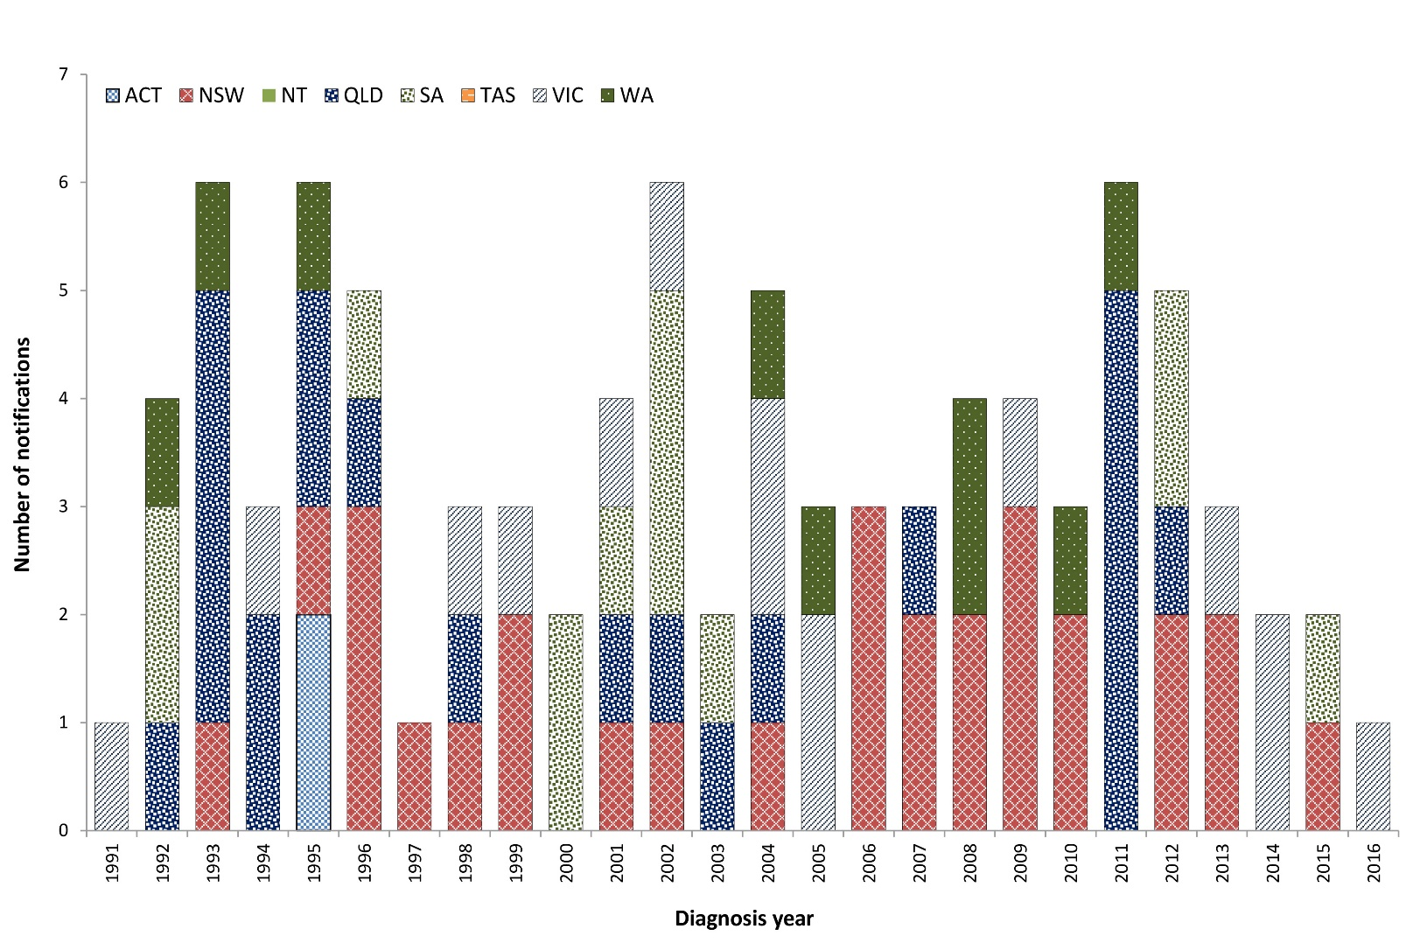

Enteric fever
Typhoid and paratyphoid fever are grouped together as enteric fever as both diseases cause a similar illness, though paratyphoid fever is less common and often less severe. Typhoid fever is caused by the bacterium Salmonella Typhi, while paratyphoid fever is caused by Salmonella Paratyphi not including S. Paratyphi B biovar Java. These infections are different to the gastroenteritis infection caused by Salmonella enterica. Enteric fever is rarely acquired in Australia with almost all notified infections acquired in resource-poor countries with poor sanitation, hand hygiene and food handling standards, and untreated drinking water. People who travel to countries where enteric fever is endemic, to visit friends or family, have been recognised as a risk group for infection in Australia.²⁰ Consumption of ready-to-eat foods, especially raw fruits and vegetables, and shellfish, as well as drinking potentially contaminated water in countries where typhoid and paratyphoid are endemic puts travellers at the greatest risk of infection.
Surveillance data include confirmed cases only. A confirmed case requires laboratory definitive evidence of typhoid or paratyphoid infection., All notified cases are followed up by jurisdictional public health staff.

Overall trend
The overall incidence of enteric fever in Australia has increased since notifications began in 1991 (Figure 5).
Figure 5: Typhoid fever and paratyphoid fever notifications and enteric fever notification rate per 100,000 population in Australia, 1991–2016
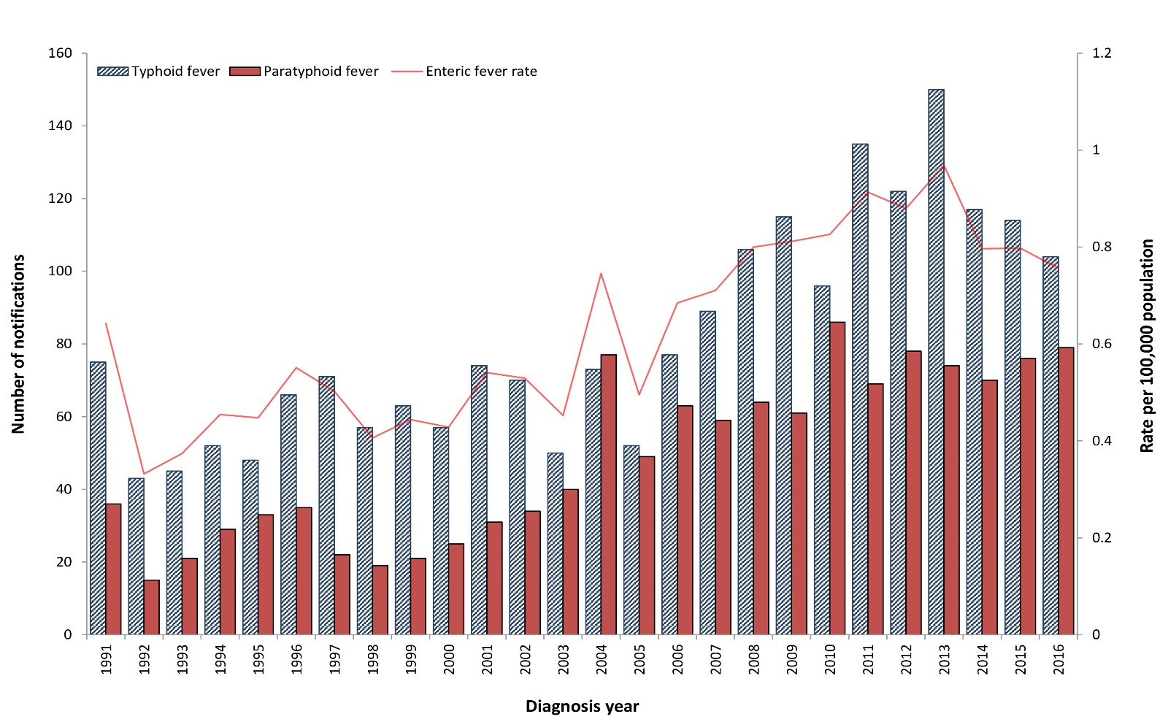

Figure 6: Typhoid fever notifications and rate per 100,000 population in Australia by jurisdiction of residence, 1991–2016
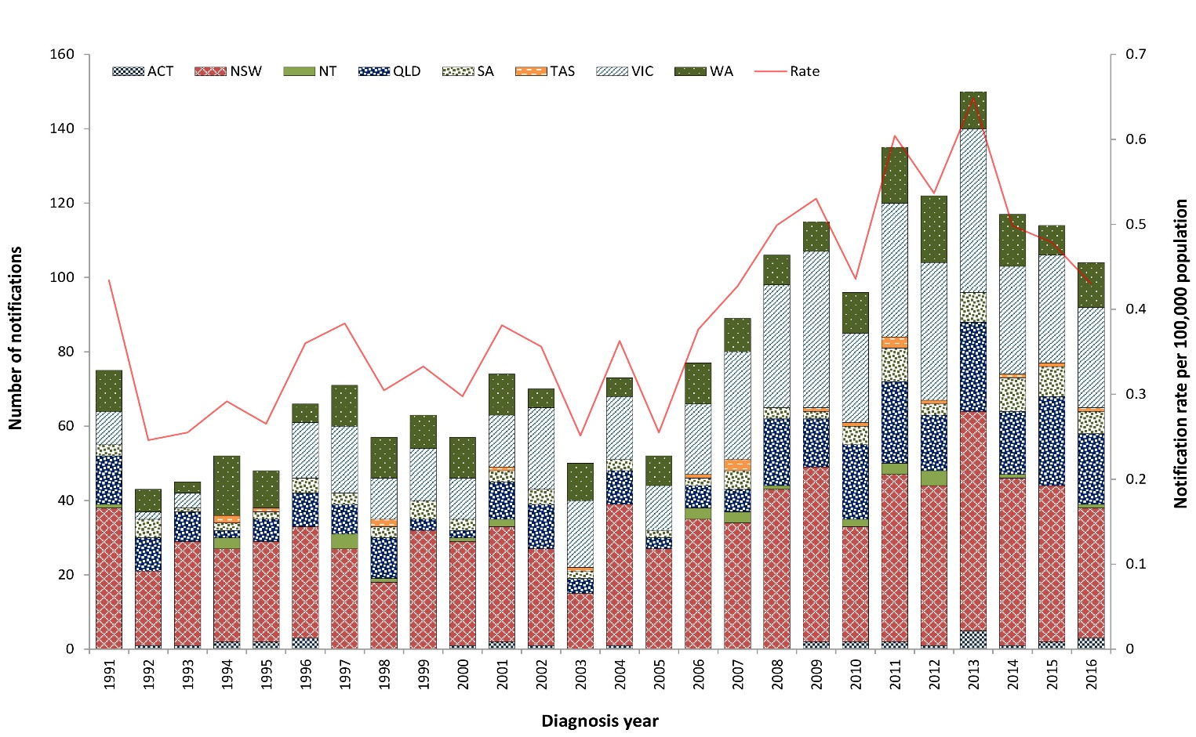
Figure 7: Paratyphoid fever notifications and rate per 100,000 population in Australia by jurisdiction of residence, 1991–2016
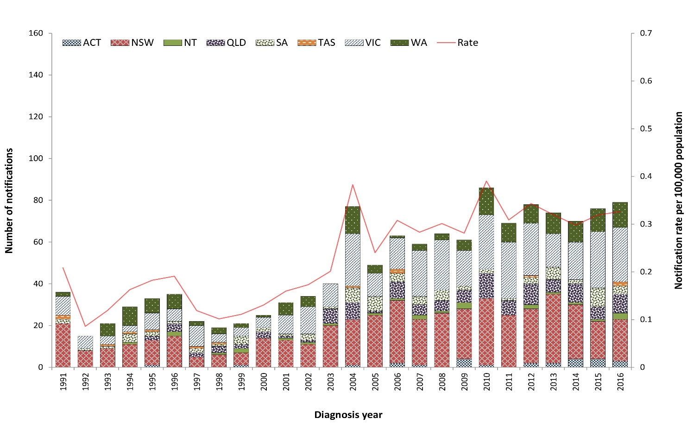
Table 4: Summary of enteric fever notifications in Australia, 2016
Category | Typhoid fever | Paratyphoid fever
Number of notifications | 104 | 79
Rate | 0.4 cases per 100,000 population | 0.3 cases per 100,000 population
Jurisdiction with highest number of notifications | New South Wales  (n = 35; 34%) | Victoria  (n = 26; 33%)
Hospitalisations (% of all cases) | 49 (47%) | 29 (37%)
Cases in Aboriginal and/or Torres Strait Islandersª | 1 | 0
Foodborne outbreaks | 0 | 0
a Indigenous status was not known for five typhoid and six paratyphoid cases.
The incidence of paratyphoid fever has remained steady in recent years, while the typhoid fever notification rate has declined (18% decrease in 2016 compared to the historical five-year mean).
Given infections are almost always acquired outside Australia, notification rates are influenced by the incidence of disease in endemic countries and the number of people who travel to these destinations.
With the exception of 2004, the annual count and rate of typhoid infections has exceeded that of paratyphoid (Figure 5).

Previous outbreaks in Australia
The last major locally-acquired typhoid outbreak occurred in Victoria in 1977 (n = 37 cases associated with a food handler who was a chronic carrier).²¹
No enteric fever foodborne outbreaks have been recorded in Australia since OzFoodNet was established in 2000.
Outbreaks resulting from transmission within households have been reported in Australia, and secondary transmission from a chronic carrier within a household setting is not uncommon. However, the exact mode or transmission from the chronic carrier is rarely able to be determined.

Epidemiology of enteric fever in Australia, 2016
- Notification rates were slightly higher in males compared with females for both typhoid (0.5 cases compared to 0.4 cases per 100,000 population) and paratyphoid (0.4 cases compared to 0.3 cases per 100,000 population).
- The median age at onset was approximately equivalent for paratyphoid cases when compared to typhoid cases (28 years compared to 27 years).
- The majority of typhoid cases (n = 80; 77%) were aged less than 35 years at the time of diagnosis, with a higher number of notifications in males aged 20 to 34 years (n = 26) when compared to females (n = 18).
- The majority of paratyphoid cases (n = 57; 72%) were aged between 20 and 45 years.
- Consistent with previous years, the largest numbers of typed typhoid cases were phage type E1 (n = 23; 22%), E9 (n = 7; 7%), and D2 (n = 6; 6%). Phage typing was unknown or unable to be performed for 63 cases (61%).
- Consistent with previous years, the majority of paratyphoid cases were Paratyphoid A (n = 64; 81%) with the remaining cases Paratyphoid B (n = 15; 19%).

Country of acquisition
- As seen in previous years, almost all enteric fever cases in 2016 were acquired outside of Australia, with 95% (n = 99) of typhoid and 93% (n = 69) of paratyphoid cases with available information reporting overseas travel during their incubation period.
- India was the most commonly-reported country of acquisition for both typhoid and paratyphoid fever cases (Table 5).
- Of the five typhoid cases acquired in Australia in 2016, three were residents of New South Wales (including a household contact of an overseas traveller, a household contact of another case, and a suspected chronic carrier) and a single case each was from Victoria (household contact of a chronic carrier) and South Australia (source unknown).
- The five paratyphoid cases acquired in Australia in 2016 were residents of New South Wales (n = 2), Queensland (n = 2) and Victoria (n = 1). The source of infection for each of these cases was unable to be determined.
Table 5: Top countries of acquisition for overseas-acquired enteric fever cases in Australia, 2016
Disease | Country of acquisition | Number of notifications, 2016 | Proportion of overseas-acquired cases, 2016ª (%) | Mean 2011–2015
Typhoid fever | India | 52 | 50 | 70
 | Bangladesh | 11 | 11 | 10
 | Pakistan | 11 | 11 | 7
 | Papua New Guinea | 6 | 6 | 3
 | Samoa | 5 | 5 | 5
Paratyphoid fever | India | 34 | 46 | 27
 | Indonesia | 14 | 19 | 6
 | Bangladesh | 5 | 7 | 5
a Excluding typhoid (n = 1) and paratyphoid (n = 5) cases acquired overseas but with an unknown country of acquisition.

Hepatitis A
Hepatitis A is an infection of the liver caused by the hepatitis A virus (HAV) that is almost always transmitted by the faecal-oral route.
During the 1990s in Australia, groups most at risk of HAV infection were overseas travellers, childcare centre attendees, Aboriginal and/or Torres Strait Islander communities, men who have sex with men (MSM) and people who use or inject illicit drugs. Since the introduction of vaccination programs and vaccine recommendations for at-risk groups, the majority of HAV infections diagnosed in Australia are acquired while travelling overseas.²² Foodborne transmission occurs rarely, although in 2009 and 2015 there were two significant multi-jurisdictional foodborne outbreaks associated with the consumption of imported food (see the Previous outbreaks in Australia section below).
Surveillance data include confirmed and probable cases. A confirmed case requires laboratory definitive evidence of hepatitis A infection and a probable case requires clinical and epidemiological evidence of infection. All notified cases are followed up by jurisdictional public health staff.

Overall trend
- The incidence of HAV has markedly declined in Australia since the first hepatitis A vaccine was registered for use in Australia in the mid-1990s (Figure 8).
- The decline in incidence amongst Aboriginal and/or Torres Strait Islander people has been attributed to the introduction of HAV vaccination. Vaccination programs and vaccination recommendations for Aboriginal and/or Torres Strait Islander children were introduced in northern Queensland in 1999 by the Queensland Government. This was expanded in 2005 by the Australian Government to include all Aboriginal and/or Torres Strait Islander children less than two years of age in Queensland, the Northern Territory, Western Australia and South Australia.
- On 1 January 2013, the HAV case definition was amended to include a requirement for confirmed cases to have clinical evidence if laboratory evidence was only suggestive of HAV infection (HAV IgM positive) and there was no epidemiological evidence. This has enabled jurisdictions to reject cases that are likely to have a false positive.

Figure 8: HAV notifications and rate per 100,000 population in Australia by jurisdiction of residence, 1991–2016
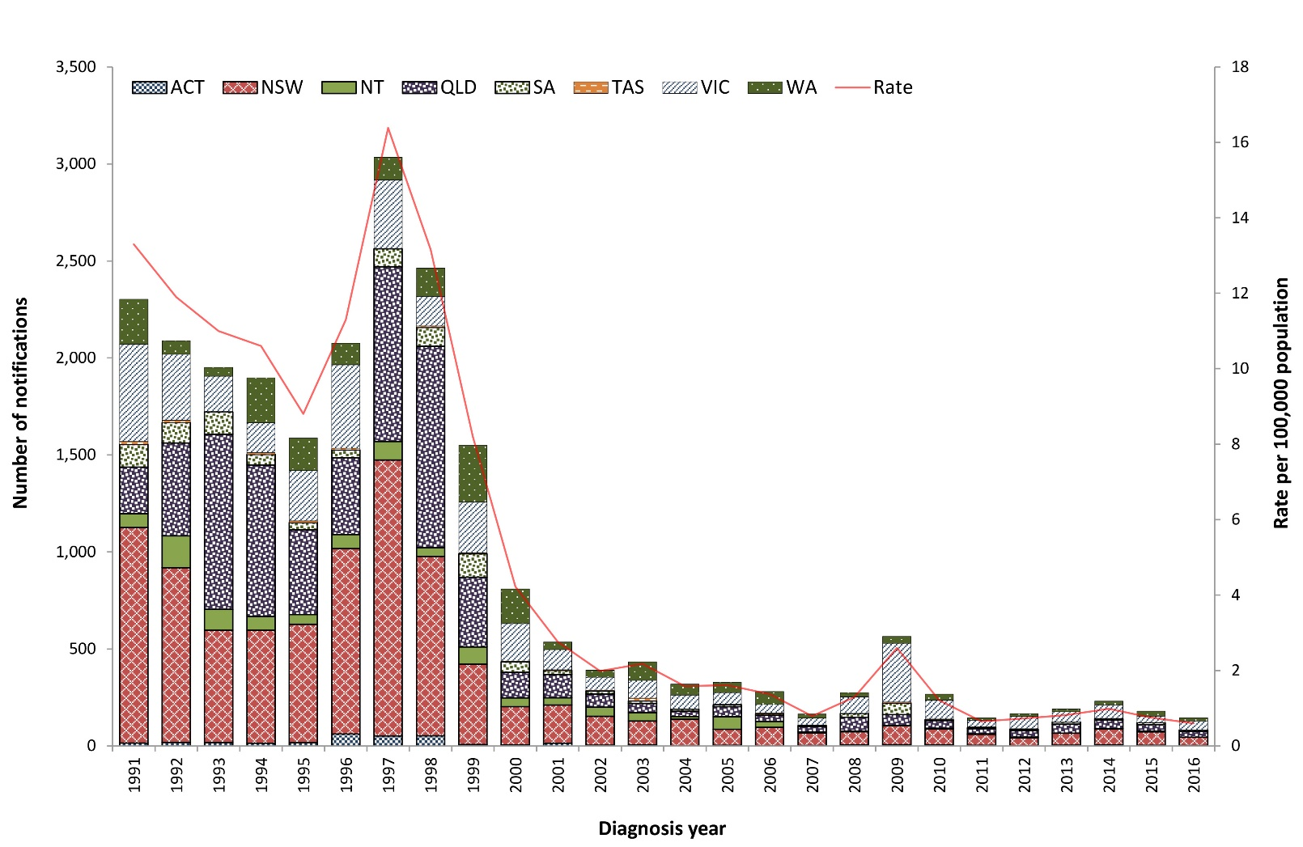
Table 6: Summary of HAV notifications in Australia, 2016
Category | Value
Number of notifications | 145
Rate | 0.6 cases per 100,000 population
Jurisdiction with the highest number of notifications | Victoria (n = 46; 32%)
Seasonality | Highest incidence in summerª for cases acquired in Australia (41%) and overseas (40%)
Hospitalisations (% of all cases) | 38 (26%)
Cases in Aboriginal and/or Torres Strait Islanders^{b} | 0
Foodborne outbreaks | 0
a In Australia, December, January and February are defined as summer.
b Indigenous status was not known for nine cases (6%).

Previous outbreaks in Australia
Significant foodborne outbreaks previously reported in Australia have been associated with consumption of:
- oysters (n = 547 cases) predominantly in New South Wales in 1997;^{23,24}
- imported semi-dried tomatoes (n = 291 cases) in multiple jurisdictions in 2009;^{25,26}
- imported frozen berries (n = 35 cases) in multiple jurisdictions in 2015.¹⁰
In addition to foodborne outbreaks, non-foodborne HAV outbreaks have also been reported in Australia amongst MSM, people who use or inject illicit drugs, people experiencing homelessness, childcare centre attendees and family groups, often where the index case has acquired their infection overseas.

Epidemiology of HAV in Australia, 2016

Country of acquisition
- As seen in previous years, the majority of HAV cases in 2016 (n = 117; 81% of cases with known country of acquisition) acquired their infection while travelling overseas (Figure 9).
Figure 9: HAV notifications in Australia by place of acquisition, 2011–2016
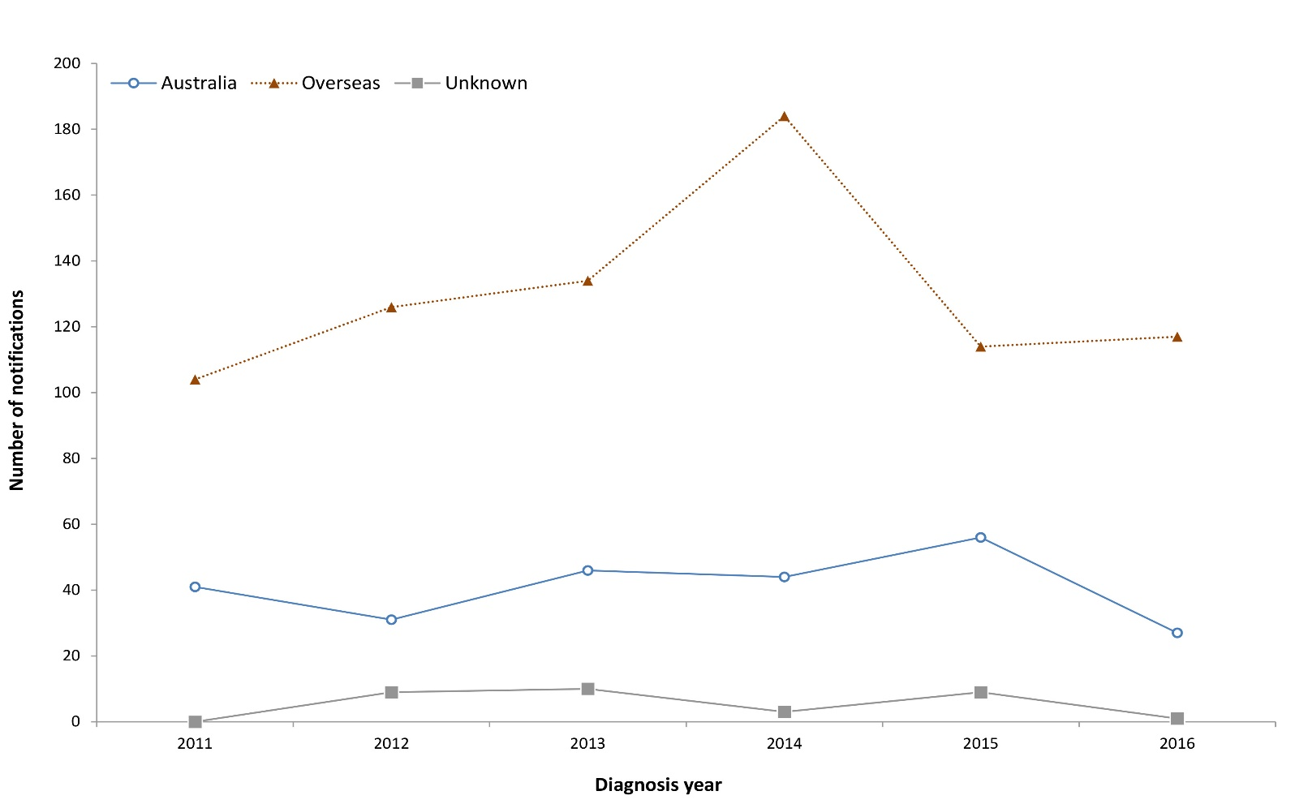

HAV cases acquired overseas (n = 117)
- The majority (85%) of overseas-acquired HAV cases were aged less than 45 years, with the highest rates reported amongst males aged 20 to 24 years of age (n = 13; 1.5 cases per 100,000 population).
- HAV infection was most commonly acquired in India and Pakistan (Table 7).

Table 7: Top ten countries of acquisition for overseas-acquired HAV cases in Australia, 2016
Country of acquisition | Number of notifications, 2016 | Proportion of overseas-acquired cases, 2016 | Mean  2011–2015
India | 19 | 17% | 23
Pakistan | 13 | 12% | 11
Iraq | 8 | 7% | 3
Vanuatu | 7 | 6% | 5
Lebanon | 6 | 5% | 7
Philippines | 6 | 5% | 12
Fiji | 5 | 4% | 12
Cambodia | 4 | 4% | 12
Thailand | 4 | 4% | 1
United States of America | 3 | 3% | 2
a Excluding cases known to be overseas acquired without an identified country of acquisition (n = 5).

HAV cases acquired in Australia (n = 27)
- Cases acquired in Australia were most common in males aged 25–29 years (n = 5).
- Cases were reported in residents of Queensland (n = 9), Victoria (n = 7), Western Australia (n = 7) and New South Wales (n = 4).
- Six cases were likely acquired through contact with an infectious household member (the index case’s infection in each instance was overseas acquired). Four cases were part of an outbreak associated with frozen berry consumption reported in late 2015. The source was not definitively identified for the remaining 17 cases.
- No cases were reported amongst Aboriginal and/or Torres Strait Islander people.

Hepatitis E
Hepatitis E is an infection of the liver caused by the hepatitis E virus (HEV) that is almost always transmitted by the faecal-oral route. Infections are rarely notified in Australia and are usually associated with overseas travel. HEV infections acquired in Australia are occasionally notified and some of these infections have been associated with the consumption of undercooked pork products, particularly pork livers.²⁷ HEV has been found in pig herds in Australia.²⁸
Surveillance data include confirmed cases only. A confirmed case requires either laboratory definitive evidence or laboratory suggestive and clinical evidence of HEV infection. Testing practices for HEV vary across jurisdictions. All notified cases are followed up by jurisdictional public health staff.

Overall trend
- While HEV infection is rare in Australia, notification rates have trended upwards since national notification began in 2001, peaking in 2014 owing to a local outbreak (Figure 10). Increased testing and changes in testing practices may have increased notifications.
Figure 10: HEV notifications and rate per 100,000 population in Australia by jurisdiction of residence, 2001–2016
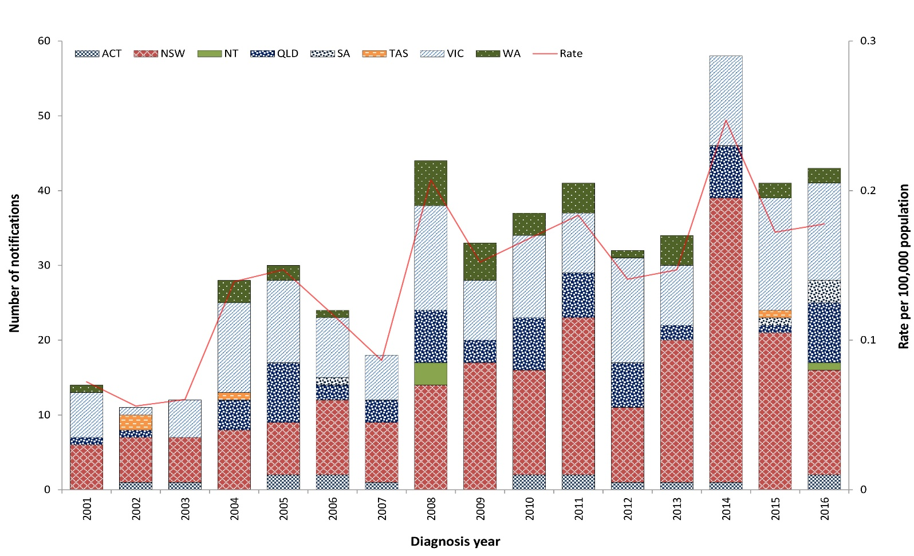

Table 8: Summary of HEV notifications in Australia, 2016
Category | Value
Number of notifications | 43
Rate | 0.2 cases per 100,000 population
Jurisdiction with the highest number of notifications | New South Wales (n = 14; 33%)
Seasonality | Highest incidence in summerª (n = 20; 47%)
Hospitalisations (% of all cases) | 19 (44%)
Cases in Aboriginal and/or Torres Strait Islanders (% of cases) | 1 (2%)
Foodborne outbreaks | 0
a In Australia, December, January and February are defined as summer.

Previous outbreaks in Australia
- A foodborne outbreak in NSW, following the consumption of pork liver pâté in 2014 (n = 17 cases), is the only known outbreak of HEV to have occurred in Australia.²⁷

Epidemiology of HEV in Australia, 2016

Country of acquisition
- From 2004 (when travel history has been collected nationally) until 2013, almost all HEV infections were acquired overseas, most commonly in India. While overseas travel continues to account for the majority of cases since 2013, an increasing number of Australian-acquired infections has been reported (Figure 11).

Figure 11: HEV notifications in Australia by place of acquisition, 2004–2016
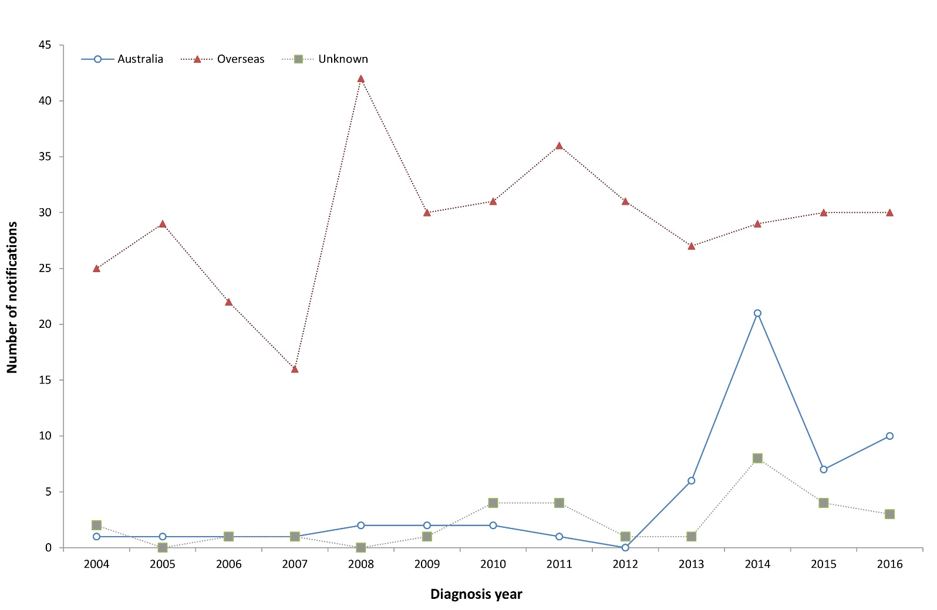

HEV cases acquired overseas (n = 30)
- HEV infection was most commonly acquired in India (Table 9).
- The majority of cases acquired overseas were male (n = 25; 78%), with a median age of 31 years (range 13–79 years).

HEV cases acquired in Australia (n = 10)
- Cases were residents of Victoria (n = 6), New South Wales (n = 2), Queensland (n = 1) and South Australia (n = 1).
- While the source of infection was not identified for these cases, eight of the nine cases with food consumption data available reportedly consumed pork products during their respective incubation periods.
- The majority of cases acquired in Australia were male (n = 7; 70%), and the median age was 43 years (range 18–67 years).

Table 9: Top three countries of acquisition for overseas-acquired HEV cases in Australia, 2016 (n = 30)
Country of acquisition | Number of notifications, 2016 | Proportion of overseas-acquired cases, 2016 | Mean 2011–2015
India | 13 | 43% | 16
Pakistan | 5 | 17% | 2
Bangladesh | 3 | 10% | 1

Listeriosis
Listeriosis is a rare but serious illness caused by the Listeria monocytogenes bacterium. Infection occurs following the consumption of contaminated food, or in the case of a fetus or newborn, vertically from their pregnant mother. A wide variety of foods may be contaminated with L. monocytogenes, but cases of listeriosis are predominantly associated with commercially manufactured ready-to-eat foods that have a long recommended refrigerated shelf-life and fresh foods that are consumed fresh or without further cooking, for example cold meats (from delicatessen or pre-packaged), cold cooked chicken, pâté, pre-packaged salads, fresh fruits such as rockmelon, chilled cooked seafood, smoked fish and soft cheeses. The elderly, pregnant women and people who are immunocompromised (either by medical condition or medications) are at an increased risk of infection.²⁹
Surveillance data include confirmed cases only. A confirmed case requires laboratory definitive evidence of invasive listeriosis infection or requires clinical and epidemiological evidence of infection. All notified cases are followed up by jurisdictional public health staff.

Overall trend
- With the exception of increases due to outbreaks in 2009 and 2012–2013, the rate of listeriosis in Australia has remained steady since national notification began in 1994 (Figure 12).

Figure 12: Listeriosis notifications and rate per 100,000 population in Australia by jurisdiction of residence, 1994–2016
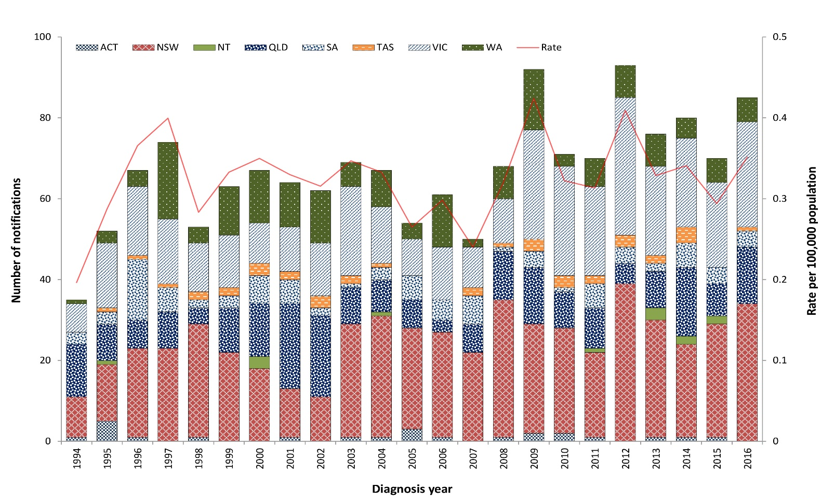
Table 10: Summary of listeriosis notifications in Australia, 2016
Category | Value
Number of notifications | 85 including 68 non-perinatal cases and 17 perinatal cases
Rate | 0.4 cases per 100,000 population
Hospitalisation (% of all cases) | 85 (100%)
Cases in Aboriginal and/or Torres Strait Islanders (% of all cases) | 2 (2%)ª
Jurisdiction with the highest number of notifications | New South Wales (n = 34; 40%)
Foodborne outbreaks | 1 (n = 8 cases)
Food implicated in outbreak | Deli meats (refer to the Foodborne Outbreak section for more details)
a Both non-perinatal cases.

Previous outbreaks in Australia
Cases are usually sporadic, although foodborne outbreaks have been reported in Australia. Food sources of significant outbreaks identified in Australia since 2000 include:
- ready-to-eat meats (silverside, corned beef) (n = 5 cases) in South Australia in 2005;
- cooked chopped chicken (n = 3 cases) in Western Australia in 2009;
- chicken wraps (n = 36 cases) in multiple jurisdictions in 2009;
- melons (n = 9 cases) in multiple jurisdictions in 2010;
- cold meat (n = 6 cases) in Victoria in 2010;
- smoked salmon (suspected) (n = 3 cases) in multiple jurisdictions in 2012;
- soft cheese (brie/camembert) (n = 34 cases) in multiple jurisdictions in 2012–2013;³⁰
- profiteroles (n = 3 cases) in New South Wales in 2013;
- pre-prepared frozen meals (n = 3 cases) in Western Australia in 2013.

Epidemiology of listeriosis in Australia, 2016

Multi-locus sequence typing (MLST)
MLST is determined in silico from whole genome sequencing data. A total of 21 different MLST types were reported in 2016. The multi-jurisdictional outbreak associated with deli meats was MLST 9. For non-outbreak cases, the most common type identified was MLST 3 (Table 11).
Table 11: Listeriosis cases in Australia by MLST type, 2016ª
MLST | No. cases | Proportion
3 | 15 | 19%
9^{b} | 15 | 19%
1 | 12 | 15%
2 | 6 | 8%
204 | 6 | 8%
155 | 5 | 6%
8 | 3 | 4%
14 | 3 | 4%
91 | 2 | 3%
121 | 2 | 3%
5 | 1 | 1%
7 | 1 | 1%
59 | 1 | 1%
87 | 1 | 1%
120 | 1 | 1%
307 | 1 | 1%
308 | 1 | 1%
427 | 1 | 1%
459 | 1 | 1%
710 | 1 | 1%
997 | 1 | 1%
Total | 80 | 100%
a Excluding cases with isolates not viable for typing (n = 2), and maternal fetal infection counted once only (n = 3). Data taken from NELSS.
b MLST 9 includes seven cases that were part of a single outbreak.

Perinatal cases (n = 17)
- Of the 17 perinatal cases notified, ten cases were pregnant women and seven were neonates (infants less than four weeks of age). Of these 17 cases, seven mother/neonate pairs were notified (representing 14 notifications) and three notifications were in a mother only.
- The outcome of the ten pregnancies was miscarriage (n = 1), neonatal death (n = 3), and neonatal survival (n = 6). None of the pregnant women died.
- Illnesses reported in the mother (available for nine cases) included bacteraemia/sepsis (n = 4), non-specific ‘flu-like’ symptoms (n = 3) and febrile gastroenteritis (n = 1), with the remaining case reporting fever, muscle and body aches and back pain.

Non-perinatal cases (n = 68)
- 53% of cases were male (n = 36), representing a slightly higher rate of infection when compared with females (0.3 cases compared to 0.26 cases per 100,000 population).
- The majority of cases (n = 47; 69%) were aged over 65 years, with 38% (n = 26) aged over 80 years.
- Septicaemia was the most common clinical presentation (Table 12).
- Sixty-four cases (94%) had at least one illness/condition known to increase their risk of listeriosis infection, with cancer and heart disease most commonly reported (Table 13).
- Of the four cases with no known comorbidities, all were aged over 50 years. The cases did not report taking medications including corticosteroids, cyclosporine or other immunosuppressive drugs, antacids or gastric acid medications in the four weeks prior to illness.
- Five cases died, all of whom had septicaemia. Two deaths were attributed specifically to listeriosis.
Table 12: Non-perinatal listeriosis cases by clinical presentation in Australia, 2016ª
Nature of the illness | No. cases | Proportion of all cases (%) | Deaths
Septicaemia | 51 | 75 | 5
Meningitis and septicaemia | 4 | 6 | 0
Meningitis | 3 | 4 | 0
Other^{b} | 3 | 4 | 0
Unknown | 7 | 10 | 0
Total | 68 | 100 | 5
a Data taken from NELSS.
b ‘Other’ includes probable septicaemia, hip pain and swollen thigh.

Table 13: Immunocompromising conditions for non-perinatal listeriosis cases in Australia, 2016 (n = 68)
Condition | No. cases | Proportion of all cases (%)
Cancer | 27 | 40%
Heart disease | 26 | 38%
Diabetes | 19 | 28%
Rheumatological condition | 17 | 25%
Blood disorder | 14 | 21%
Liver disease | 10 | 15%
Renal / kidney disease requiring dialysis | 8 | 12%
Other renal disease | 8 | 12%
Chronic lung disease (excluding asthma) | 5 | 7%
Organ transplant | 3 | 4%
No immunocompromising conditions | 4 | 6%

Salmonellosis
Salmonellosis is an infection caused by the Salmonella bacterium. It is second to campylobacteriosis as the most commonly-notified enteric pathogen in Australia. Salmonella infections acquired in Australia are usually associated with consumption of contaminated food, or less commonly, after contact with infected animals or an infected person. Food sources associated with Salmonella infection in Australia include raw and undercooked foods of animal origin, particularly eggs and poultry, and fresh produce.³¹ Infection can also occur following exposure to Salmonella in the environment. Many Salmonella infections are also notified in people returning from overseas.
Surveillance data include confirmed cases only. A confirmed case requires laboratory definitive evidence of infection. Note that paratyphoid and typhoid fever infections are reported separately (refer to the Enteric Fever section). Surveillance data are monitored by jurisdictional public health staff to identify potential outbreaks. Triggers for further investigation vary within and between jurisdictions, depending on background infection rates, availability and timeliness of sub-typing information, and resource capacity.

Overall trend
- Salmonellosis notification rates have increased steadily since national notification began in 1991 (Figure 13).
- A marked increase was observed across most jurisdictions from 2014 onwards. This is due, at least in part, to the increase in PCR testing as a method of laboratory diagnosis (refer to earlier section on CIDT testing).

Figure 13: Salmonellosis notifications and rate per 100,000 population in Australia by jurisdiction of residence, 1991–2016
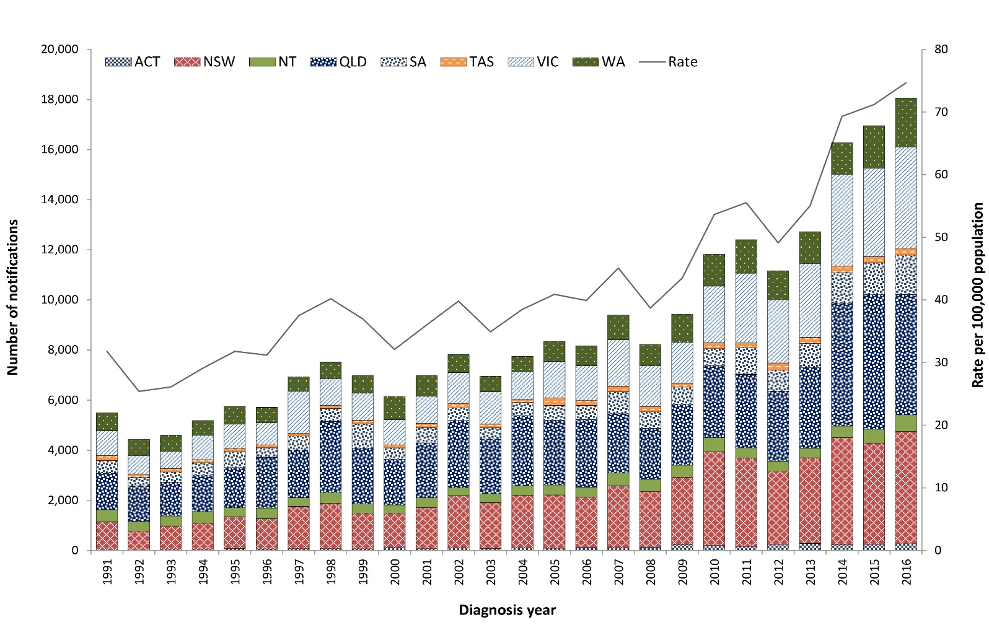
Table 14: Summary of salmonellosis notifications in Australia, 2016
Category | Value
Number of notifications | 18,060
Rate | 74.7 cases per 100,000 population
Jurisdiction with the highest number of notifications | Queensland (n = 4,806; 27%)
Seasonality | Highest incidence in summer (33%) and autumn (30%)ª
Foodborne outbreaks | 73
Foods implicated in outbreaks | Most common food source was eggs (n = 35 outbreaks) with a single significant outbreak each caused by rockmelons, mung bean sprouts and bagged salad products (refer to the Foodborne outbreaks section)
a In Australia, December, January and February are defined as summer; March, April and May are defined as autumn.

Table 15: Groups with the highest salmonellosis notification rate in Australia, 2016
Category | Group most affected | Rate per 100,000 population | Number (% of all cases)
Age group (years) | 0–4 | 260.9 | 4,105 (23%)
Sex | Females | 77.8 | 9,479 (53%)
Jurisdiction | Northern Territory | 267.8 | 658 (4%)

Previous outbreaks in Australia
Salmonellosis is the enteric pathogen most commonly identified in foodborne outbreaks in Australia. These outbreaks have been most frequently associated with the consumption of raw or minimally-cooked egg products.^{32,33} (Refer to the Foodborne outbreak section.)
S. Typhimurium is the most commonly-identified serotype in Salmonella outbreaks reported in Australia. The foods implicated in the largest of these outbreaks include:
- Vietnamese bánh mì rolls (n = 213 cases) in Victoria in 2003;
- dips served at a Turkish restaurant (n = 442 cases) in Victoria in 2005;
- pork or chicken and salad rolls made with raw-egg mayonnaise (n = 319 cases) in New South Wales in 2007;
- chicken (n = 391 cases) in multiple jurisdictions in 2012;³⁰
- potato salad containing raw eggs (n = 350 cases) in Queensland in 2013;
- raw-egg mayonnaise (n = 242 cases) in Victoria in 2014.
Other notable foodborne Salmonella outbreaks reported in Australia include:
- S. Saintpaul associated with rockmelon (n = 38 cases) in multiple jurisdictions in 2006;³⁴
- S. Litchfield associated with papaya (n = 26 cases) in multiple jurisdictions in 2006.³⁵
Notable non-foodborne outbreaks reported in Australia include:
- S. Paratyphi B biovar Java associated with tropical fish aquariums in 2003–2004;³⁶
- S. Paratyphi B biovar Java associated with playground sand in New South Wales in 2007–2009;³⁷
- S. Litchfield associated with a Northern Territory car rally in 2009.³⁸
Despite the number of salmonellosis outbreaks reported, they account for only a small proportion of salmonellosis cases notified annually.

Epidemiology of salmonellosis in Australia, 2016
Consistent with previous years, notifications were significantly higher in children aged less than five years when compared with all other age groups. For all age groups over 15 years, higher rates were reported in females than in males (Figure 14).

Figure 14: Salmonellosis notification rate per 100,000 population in Australia by age group and sex, 2016
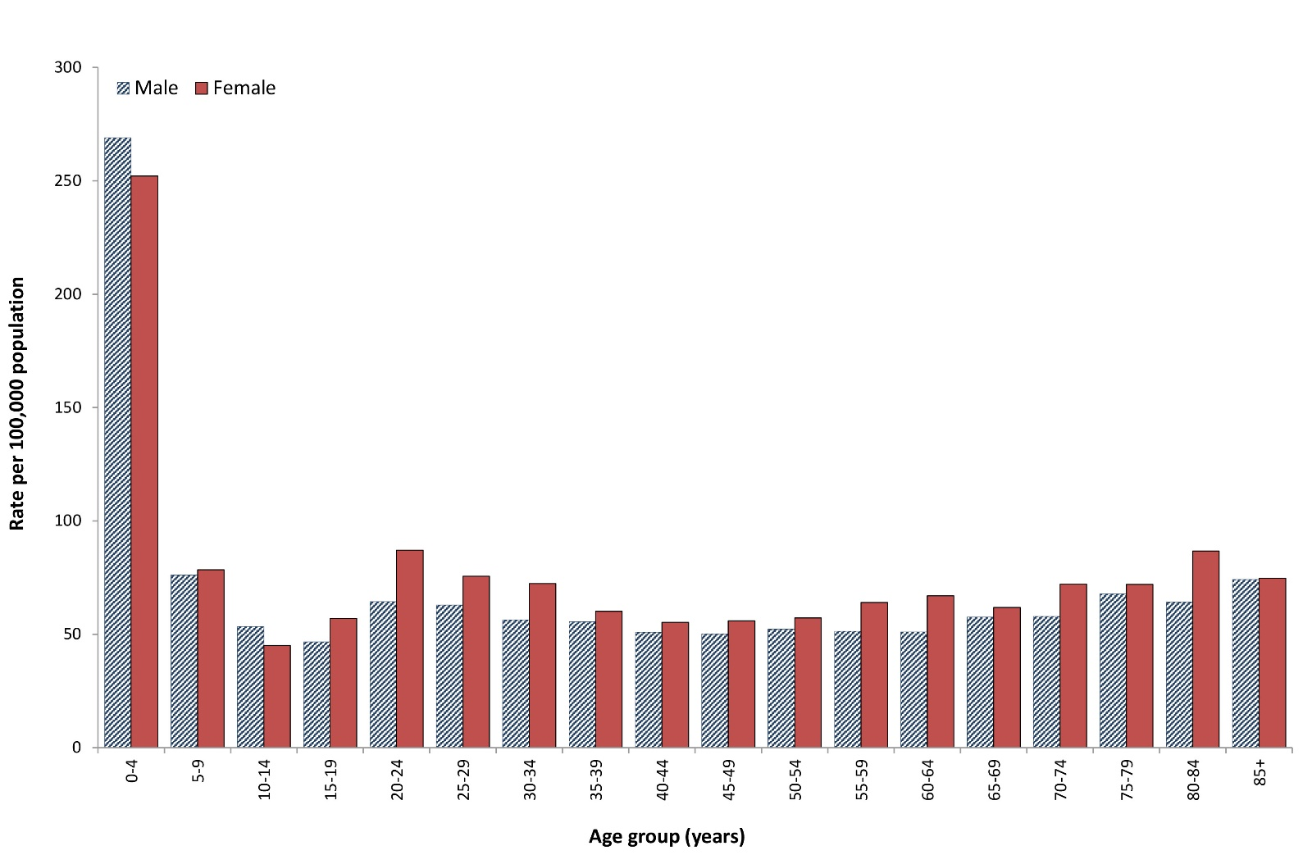

Serotyping
Serotyping information was available for 89% (n = 15,991) of salmonellosis notifications in 2016, with a total of 231 different serotypes identified. S. Typhimurium was the most common serotype identified, with a slightly lower number of cases in 2016 (n = 6,041) than the historical five-year mean (n = 6,346). The five most commonly-identified serotypes are shown in Table 16, and when combined account for 58% of all cases with serotyping performed.
Table 16: Top five Salmonella serotypes notified in Australia, 2016
Salmonella serotype | No. 2016 | % of all serotypes | Mean 2011–2015
S. Typhimurium | 6,041 | 38% | 6,346
S. Saintpaul | 1,072 | 7% | 467
S. Enteritidis | 1,018 | 6% | 827
S. Virchow | 780 | 5% | 629
S. Paratyphi B var Java | 422 | 3% | 290

While there were fewer case counts, a notable increase in S. Kentucky cases was observed in 2016 compared to the historical five-year mean (n = 172 cases compared to n = 35). Where known, the majority of cases were acquired during travel overseas in Indonesia and other parts of Asia.

Salmonella Enteritidis
S. Enteritidis is a globally important Salmonella serotype that can infect the internal contents of eggs, but is not endemic in Australian egg layer flocks.³⁹ For this reason, a travel history is sought from all notified cases, and cases who have not travelled outside Australia are further investigated to identify the likely source of infection.
A total of 1,019 S. Enteritidis cases were notified in 2016. This was higher than the historical five-year mean of 827 cases and was due to increases in both locally- and overseas-acquired cases.
Of the 1,019 S. Enteritidis cases notified in 2016, 78% (n = 793) were acquired overseas, 14% (n = 143) were acquired in Australia, and the place of acquisition was unknown for the remaining cases (n = 83; 8%).

S. Enteritidis acquired in Australia (n = 143)
S. Enteritidis infections acquired in Australia were most commonly reported in Queensland, followed by New South Wales and Western Australia (Table 17). While whole genome sequencing on New South Wales cases without overseas travel identified potential clustering, this was not supported by epidemiological evidence. Outside of New South Wales, phage typing (PT) was conducted on 90% (n = 83) of Australian-acquired cases. Consistent with previous years, S. Enteritidis phage type 26 was the most commonly-identified phage type (n = 24) with almost all cases occurring in Queensland residents (no common exposures identified). In Western Australia, a S. Enteritidis phage type 25 Var 1 outbreak affecting 30 people occurred on a cruise ship (refer to Appendix B for more details). An additional 14 phage types were identified amongst the remaining cases with no other clusters identified.
Table 17: Salmonella Enteritidis cases by place of acquisition and jurisdiction of residence in Australia, 2016
Jurisdiction | Cases acquired in Australia |  | Overseas-acquired cases |  | Unknown | Total
 | No. | Mean 2011–2015 | No. | Mean 2011–2015 | No. | No.
Qld | 53 | Not available | 90 | Not available | 61 | 204
NSW | 43 | 13 | 189 | 124 | 14 | 246
WA | 29 | 19 | 209 | 217 | 0 | 238
Vic | 7 | 11 | 200 | 169 | 5 | 212
SA | 5 | 2 | 70 | 60 | 1 | 76
Tas | 2 | 2 | 9 | 8 | 1 | 12
NT | 3 | 0 | 15 | 11 | 1 | 19
ACT | 1 | Not available | 11 | Not available | 0 | 12
Total | 143 | 61 | 793 | 657 | 83 | 1,019

S. Enteritidis acquired overseas (n = 793)
Consistent with previous years, the majority of overseas-acquired S. Enteritidis cases reported travel to South East Asia during their incubation period, with 47% of cases with a known country of acquisition reporting travel to Indonesia (n = 419).

Shigellosis
Shigellosis is a diarrhoeal disease caused by the Shigella bacterium. In Australia, the most common mode of transmission is person-to-person spread during close contact with an infectious case. This includes transmission in poor hygiene conditions, transmission between young children, and transmission during certain types of sexual activity (such as oral-anal sex). Person-to-person transmission is common due to the low infectious dose. Outbreaks can occur in conditions of crowding and poor sanitation and hygiene. Occasionally, infections may be foodborne, caused by infectious food handlers contaminating ready-to-eat food during preparation and handling. The majority of notifications in Australia however, are in people who have acquired their infection during overseas travel. Populations at the highest risk of acquiring shigellosis in Australia include Aboriginal and/or Torres Strait Islander communities and MSM.^{40,41}
Surveillance data include confirmed cases only. A confirmed case requires laboratory definitive evidence of Shigella. The ipaH gene is the target of all current nucleic acid tests for Shigella. However, the ipaH gene is common to Shigella species and enteroinvasive Escherichia coli (EIEC). Since 2014, when PCR testing was introduced, jurisdictions have classified PCR-positive cases differently. Victoria, the Northern Territory and Tasmania include cases found to be positive on PCR alone as confirmed cases in the surveillance data, whereas only cases confirmed by culture are included in the Australian Capital Territory, New South Wales, Queensland, South Australia and Western Australia.

Overall trend
- Except for peaks in the number of notifications in 2005 and 2008 (observed in multiple jurisdictions), the notification rate has remained steady between 2001 (when national notification began) and 2013 (Figure 15).
- A marked increase was observed across most jurisdictions from 2014 onwards. This is due, at least in part, to the increase in PCR testing as a method of laboratory diagnosis (refer to the earlier section on CIDT testing).
- Since the introduction and increasing use of PCR testing, there has been variation in the classification and subsequent notification of cases across jurisdictions to the NNDSS. Some jurisdictions have included PCR-positive cases in the absence of confirmation by culture in the surveillance data, influencing the number of notifications by jurisdiction observed in Figure 15.
- A local outbreak amongst MSM contributed to the increase observed in New South Wales in 2014.

Figure 15: Shigellosis notifications and rate per 100,000 population in Australia by jurisdiction of residence, 2001–2016
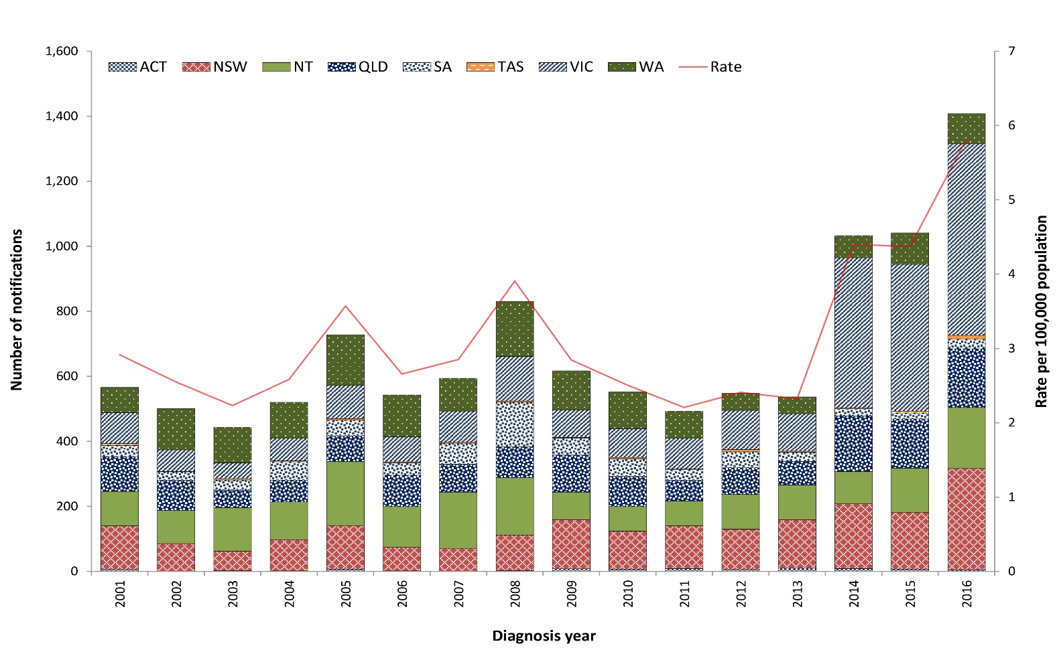
Table 18: Summary of shigellosis notifications in Australia, 2016
Number of notifications | 1,408
Rate | 5.8 cases per 100,000 population
Jurisdiction with the highest number of notifications | Victoriaª (n = 589; 42%)
Foodborne outbreaks | 2
Implicated foods and settings | Contamination of cherry strudel by restaurant food handler; and contamination of multiple foods consumed at catered function.
a Victoria includes PCR-positive cases as confirmed cases.

Previous outbreaks in Australia
In addition to non-foodborne outbreaks among MSM and Aboriginal and/or Torres Strait Islander communities, five foodborne outbreaks have been reported in Australia since 2000. The most significant foodborne outbreak was associated with the consumption of imported baby corn, with 55 cases reported in Australia in 2007.⁴²

Epidemiology of shigellosis in Australia, 2016

Aboriginal and/or Torres Strait Islander people (n = 200)
- Indigenous status was available for 92% of cases (n = 1,293), with 15% of cases identifying as Aboriginal and/or Torres Strait Islander (n = 200). A higher burden of disease continues to be observed in Aboriginal and/or Torres Strait Islander people, with rates of infection of 31 cases per 100,000 Aboriginal and/or Torres Strait Islander people, compared to five cases per 100,000 non-Indigenous people.
- The majority of cases among Aboriginal and/or Torres Strait Islander people occurred in the Northern Territory (n = 140; 70%), followed by Queensland (n = 22; 11%) and Western Australia (n = 21; 11%).
- Almost half of the infections among Aboriginal and/or Torres Strait Islander people (n = 91; 46%) were in children aged less than five years. This was a notably higher proportion than the 13% (n = 178) of overall shigellosis notifications in 2016 occurring in children aged less than five years.
- Higher rates were observed in Aboriginal and/or Torres Strait Islander females aged over 20 years (26 cases per 100,000 population) than in Aboriginal and/or Torres Strait Islander males (17 cases per 100,000 population).

Country of acquisition
- Information on the country of acquisition was available for 60% (n = 847) of cases, of which approximately two-thirds (n = 533; 63%) were acquired due to overseas travel.
- Similar numbers of males and females acquired their infection overseas, while notably more males than females acquired their infection in Australia. This may be associated with male-to-male sexual transmission (Figure 16). In New South Wales, an outbreak occurred amongst MSM.
- Consistent with previous years, overseas-acquired cases were most commonly acquired in Indonesia (n = 128; 24%) and India (n = 95; 18%).
Figure 16: Shigellosis notifications in Australia by place of acquisition and sex, 2016

Shiga toxin-producing Escherichia coli infection and haemolytic uraemic syndrome
Shiga toxigenic E. coli (STEC) infection is a diarrhoeal illness caused by the strains of the Escherichia coli (E. coli) bacterium that produce shiga toxins. The principal reservoirs of STEC in Australia are the lower intestinal tract of ruminants, particularly cattle and sheep. Infections in humans can occur after consuming contaminated food including undercooked meat, particularly minced beef/burgers, unwashed salad and vegetables, or unpasteurised milk or milk products; drinking or swimming in contaminated water; close contact with an infectious case; or direct contact with infectious animals on farms or at petting zoos.⁴³
Haemolytic uraemic syndrome (HUS) is a severe and potentially fatal condition characterised by kidney failure, bleeding and anaemia that is more common in young children and the elderly. While STEC is the most common infectious agent that causes HUS, it can also be caused by other infectious agents including Shigella and Streptococcus pneumoniae. HUS can also result from non-infectious causes. Cases resulting from a STEC infection usually report a history of a diarrhoeal illness, often bloody, up to three weeks (usually within seven days) prior to the onset of HUS. Attempts are made for collection and microbiological examination of stool samples from all HUS cases. However, due to the timing since onset of diarrhoea, STEC may no longer be detectable in the stool at the time of subsequent stool testing.
Surveillance data of STEC and HUS consist of confirmed cases only. A confirmed case of STEC requires laboratory definitive evidence; a confirmed case of HUS requires clinical evidence only. Outside of Victoria, where STEC is isolated in the context of HUS, it is notified as both STEC and HUS. In Victoria, it is notified only as HUS.
Notification rates are significantly influenced by local testing practices (see below). Prior to 1 July 2016, the case definition required ‘identification of the gene associated with the production of shiga toxin or vero toxin in E. coli by nucleic acid testing on isolate or raw bloody diarrhoea’. From 1 July 2016, ‘raw bloody diarrhoea’ was replaced with ‘faeces’, and ‘vero toxin’ removed.

Overall trend
- Notification rates of STEC have trended upwards between 2001 (when national notification began) and 2015. The peak observed in 2013 was related to a zoonotic outbreak in Queensland (see below) (Figure 17).
- The consistently higher incidence observed in South Australia since 2001 reflects the routine testing of all bloody stool samples in addition to clinician requests.
- In June 2016, the only laboratory in South Australia conducting STEC testing began testing all faeces for STEC, instead of only bloody stool samples, resulting in a sharp increase in notifications.
- Changes to the case definition for confirmed STEC cases in 2016 and the increasing uptake of CIDT have contributed to the increase in STEC cases nationally.
- HUS is rare in Australia. In comparison with STEC, notification rates have remained stable since notification began in 1999.
- While the number of STEC notifications in 2016 more than doubled the 2015 annual count, the count of HUS notifications in 2016 was comparable with 2015. In South Australia, the jurisdiction with the highest number of notifications in 2016 (n = 176), only a single HUS case was reported, in a person who did not have a STEC infection.
Figure 17: STEC notifications and rate per 100,000 population in Australia by jurisdiction of residence, 2001–2016ª
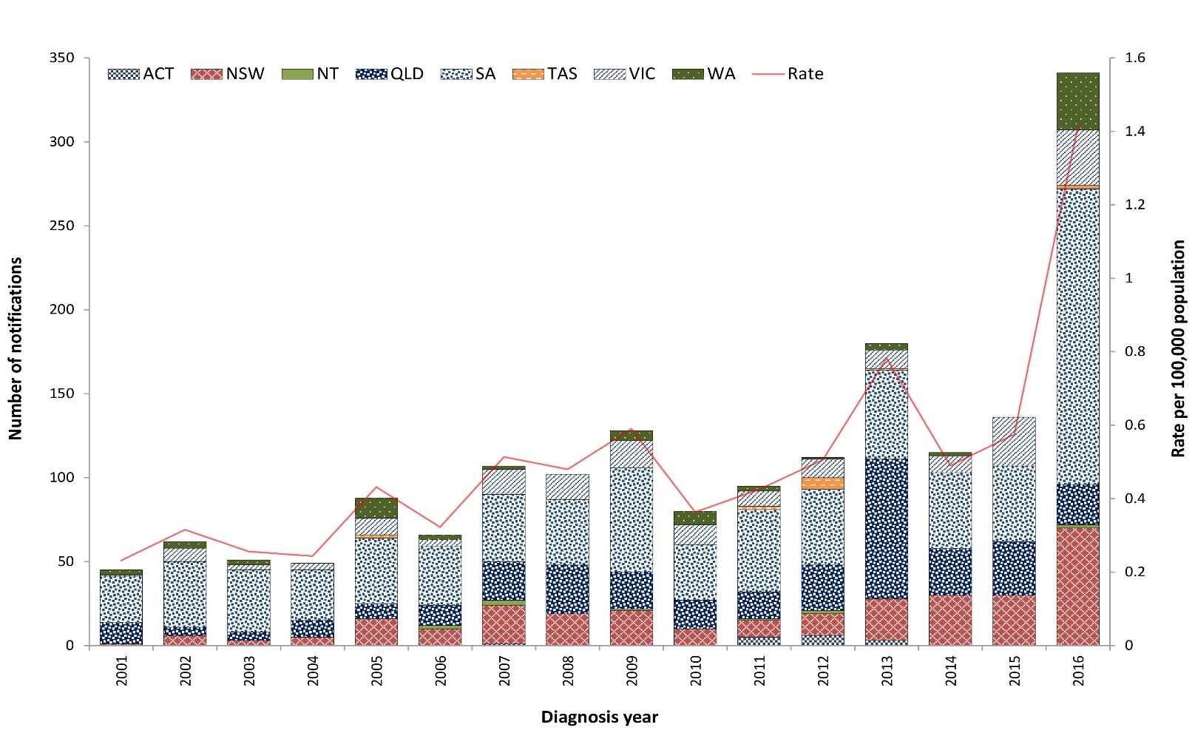
a Data include HUS cases where a STEC organism was isolated.
Table 19: Summary of STEC and HUS notifications in Australia, 2016
Category | STEC | HUS
Number of notifications | 343 | 16
Rate | 1.4 cases per 100,000 population | 0.1 cases per 100,000 population
Jurisdiction with highest number of notifications | South Australia (n = 176; 51%) | Queensland and New South Wales (n = 4; 25%)
Seasonality | Highest incidence in springª  (n = 120; 35%) | Highest incidence in summera (n = 7; 44%)
Foodborne outbreaks | Zero | Zero
a In Australia, September, October and November are defined as spring, and December, January and February are defined as summer.

Previous outbreaks in Australia
Most STEC cases are sporadic in Australia, though outbreaks have been reported. Risk factors identified in a national case-control study in Australia during 2003–2007 included consuming hamburgers; eating at restaurants; occupational exposure to animals or raw red meat by case or household member; antibiotic use in the four weeks before illness; consumption of sliced chicken meat or corned beef from a delicatessen; bush camping in Australia; and eating at catered events.⁴³

Foodborne outbreaks
Significant foodborne outbreaks have been reported internationally, and have been most commonly associated with ground beef or sprouts. Sprouts from a farm in Germany were the implicated source of an international outbreak in 2011 that included over 3,000 STEC and 800 HUS cases.⁴⁴ In Australia, however, foodborne outbreaks are rare, the most notable being a large outbreak of E. coli O111 infection in 1995 associated with the consumption of contaminated mettwurst.⁴⁵ Since 2000 (when OzFoodNet commenced), the implicated foods in confirmed and probable STEC outbreaks reported in Australia include:
- potato salad consumed at a camp in rural South Australia in 2009 (n = 31; no HUS cases)
- kangaroo meat consumed in a remote Northern Territory community in 2012 (n = 5; no HUS cases).

Non-foodborne outbreaks
Outbreaks due to contaminated tank water and zoonotic transmission at petting zoos have been reported in Australia. The largest STEC outbreak in Australia occurred following contact with animals at a petting zoo in Queensland in 2013 (n = 57 STEC cases; no HUS cases).

Epidemiology of STEC and HUS in Australia, 2016
- STEC notifications peaked in children aged 0–4 years (n = 42; 12%), followed by those aged 20–24 years (n = 30; 9%) (Figure 18).
- Consistent with previous years, HUS was most commonly reported in children aged 0–4 years (n = 9; 56%).
- STEC was identified in 63% (n = 10) of the HUS cases reported in 2016. The remaining six cases were due to other pathogens such as Streptococcus pneumoniae (n = 1) or were of unknown aetiology (n = 5).

Aboriginal and/or Torres Strait Islander people
- Sixteen STEC cases (of which five were aged 0–4 years) were in Aboriginal and/or Torres Strait Islander people, compared with the historical five-year mean of two cases. Cases were reported in South Australia (n = 7), New South Wales (n = 4), Western Australia (n = 3) and Queensland (n = 2).

Figure 18: STEC cases in Australia by age group and sex, 2016
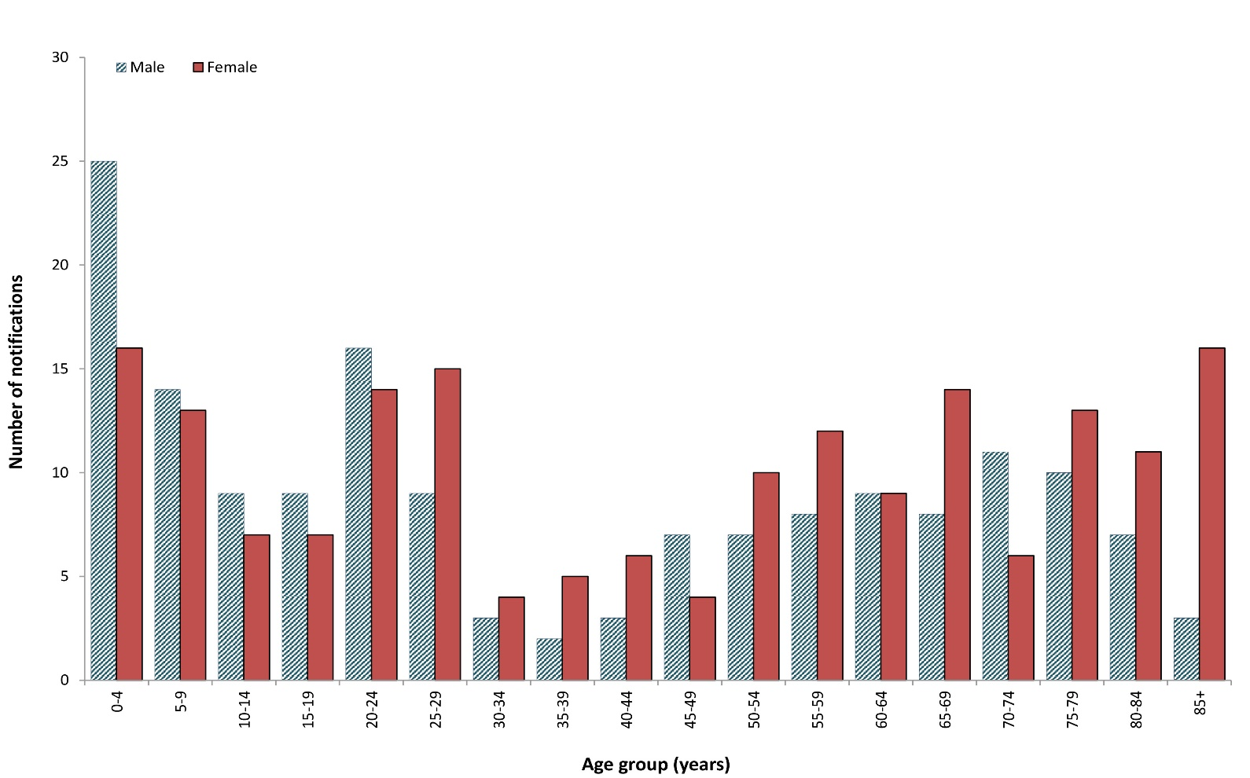

Outbreaks of gastrointestinal disease including foodborne disease outbreaks
In 2016, a total of 188 outbreaks of gastrointestinal illness caused by foodborne, animal-to-person, environmental or waterborne disease were reported by OzFoodNet sites, affecting 3,721 individuals. The majority (94%) of outbreaks were a result of foodborne and probable foodborne transmission of infection (Table 20). A small number of environmental and animal-to-person transmission outbreaks were also reported.
Table 20: Gastrointestinal disease outbreaks and ill people by transmission modeª in Australia, 2016
Transmission mode | Outbreaks |  |  | Ill people
 | No. 2016 | Proportion | Mean 2011–2015 | No. 2016 | Proportion | Mean 2011–2015
Foodborne and probable foodborne | 177 | 94% | 150 | 3,639 | 98% | 2,316
Animal-to-person and probable animal-to-person | 2 | 1% | 1 | 19 | 1% | 18
Environmental and probable environmental | 9 | 5% | 11 | 63 | 2% | 78
Waterborne and probable waterborne | 0 | 0% | 2 | 0 | 0% | 40
Total | 188 | 100% | 164 | 3,721 | 100% | 2,460
a Refer to Appendix A for transmission mode of definitions.

Foodborne and probable foodborne outbreaks
OzFoodNet sites reported 177 outbreaks for which the consumption of food was the probable or confirmed mode of transmission (hereon referred to collectively as foodborne outbreaks) (Table 20). Foodborne outbreaks affected a total of 3,639 people. This was a 57% increase on the mean number of ill people from the previous five years (n = 2,316). Admission to hospital was required for at least 348 people, and four deaths were reported during the outbreaks.
New South Wales reported the highest numbers of both outbreaks and ill people in 2016 (Table 21). Consistent with previous years, outbreaks were most commonly reported in the warmer months of January to March (Quarter 1) (Figure 19). Seventy-four outbreaks occurred in the first quarter of 2016 affecting 1,685 people. These were the highest numbers of both outbreaks and ill people reported in a single quarter in the period 2011–2016 (Figure 19 and Figure 20). Two large multi-jurisdictional Salmonella outbreaks accounted for almost half of the total number of affected people in the first quarter (see the Multi-jurisdictional foodborne outbreak investigations section).
A summary of the foodborne outbreaks is provided in the following section. Refer to Appendix B for details on individual outbreaks.

Table 21: Foodborne outbreaks and ill people in Australia by jurisdiction, 2016
Jurisdiction | Outbreaks |  | Ill people
 | No. | Proportion | Total No. | Mean ill per outbreak | Hospitalised | Fatalities
Multi-jurisdictional | 4 | 2% | 882 | 221 | 121 | 1
ACT | 11 | 6% | 128 | 12 | 7 | 1
NSW | 62 | 35% | 1,380 | 22 | 60 | 2
NT | 4 | 2% | 61 | 15 | 13 | 0
Qld | 27 | 15% | 198 | 7 | 17 | 0
SA | 12 | 7% | 277 | 23 | 48 | 0
Tas | 6 | 3% | 103 | 17 | 6 | 0
Vic | 30 | 17% | 425 | 14 | 47 | 0
WA | 21 | 12% | 185 | 9 | 29 | 0
Total | 177 | 100% | 3,639 | 21 | 348 | 4
Figure 19: Foodborne outbreaks in Australia by year and quarter,ª 2011–2016
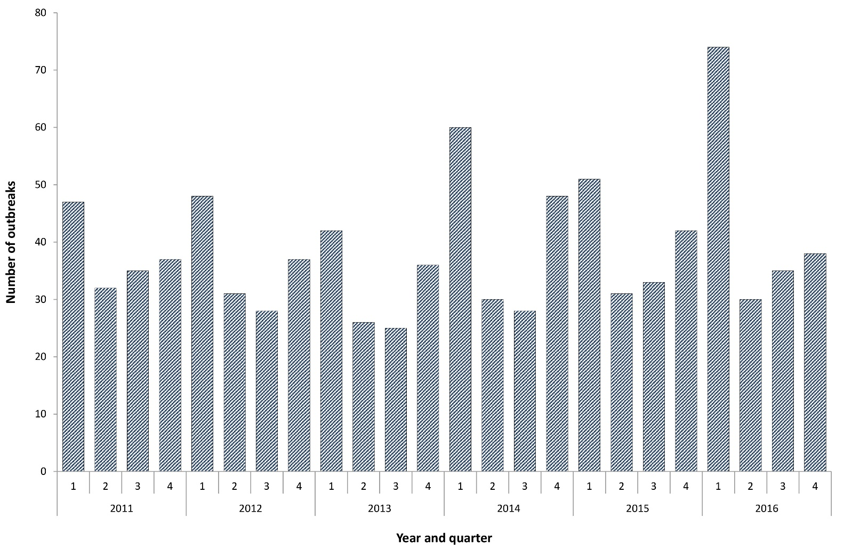
a Year and quarter of the outbreak is based on the month of onset of the first case or month of notification of the first case or the month the investigation into the outbreak commenced.

Figure 20: Number of ill people in foodborne outbreaks in Australia by year and quarter,ª 2011–2016
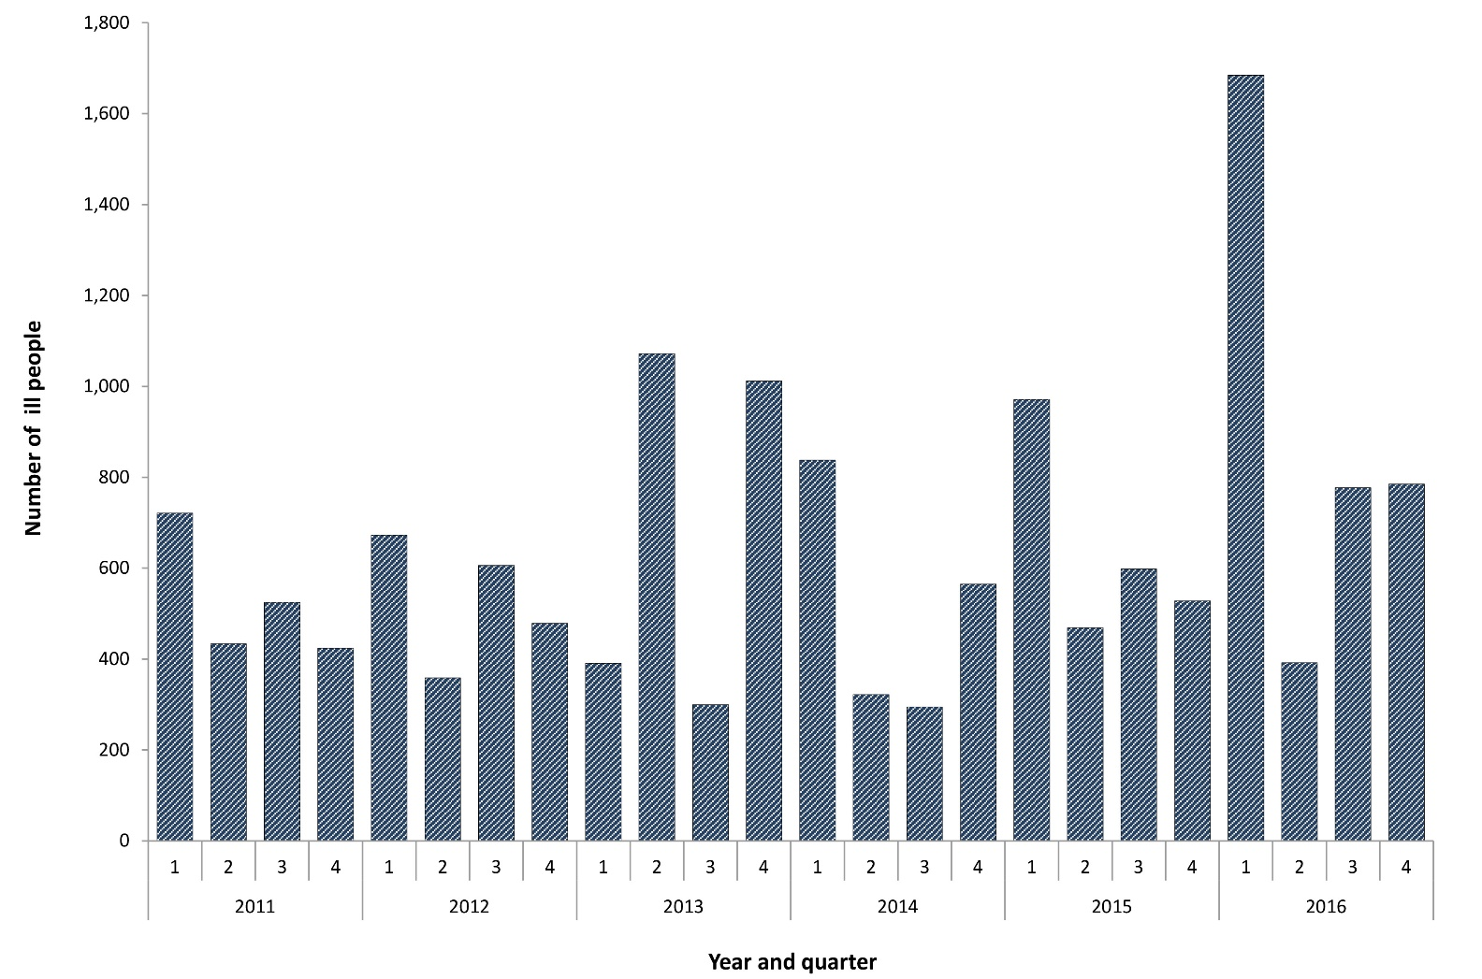
a Year and quarter of the outbreak is based on the month of onset of the first case or month of notification of the first case or the month the investigation into the outbreak commenced.

Aetiologies
Salmonella was the most frequently-identified aetiological agent in foodborne outbreaks in 2016, responsible for 41% (n = 73) of all outbreaks and illness in 56% (n = 2,054) of people known to experience foodborne disease (Table 22). Salmonella was the aetiological agent in the three largest foodborne outbreaks in 2016: S. Anatum associated with bagged salads (n = 311), S. Saintpaul associated with mung bean sprouts (n = 419) and a S. Typhimurium outbreak associated with a bakery (n = 202). S. Typhimurium was the most commonly-identified serotype, accounting for 88% (64/73) of Salmonella outbreaks reported in 2016, of which 46 different MLVA profiles were identified.

Table 22: Foodborne outbreaks and ill people in Australia by aetiology, 2016
Aetiological agent | Outbreaks |  | Ill people |  | Hospitalisations
 | No. | % of all outbreaks | No. | % of all ill | No. | % of all hospitalised
Salmonella | 73 | 41% | 2,054 | 56% | 298 | 86%
Norovirus | 15 | 8% | 511 | 14% | 5 | 1%
Ciguatoxin | 14 | 8% | 56 | 2% | 5 | 1%
Campylobacter | 10 | 6% | 100 | 3% | 5 | 1%
Clostridium perfringens | 6 | 3% | 87 | 2% | 0 | 0%
Scombrotoxin | 4 | 2% | 9 | <1% | 3 | 1%
Bacillus cereus toxin | 1 | 1% | 20 | 1% | 0 | 0%
Shigella | 2 | 1% | 10 | <1% | 0 | 0%
Vibrio parahaemolyticus | 2 | 1% | 20 | 1% | 4 | 1%
Listeria monocytogenes | 1 | 1% | 8 | <1% | 8 | 2%
Staphylococcus aureus toxin | 1 | 1% | 24 | 1% | 13 | 4%
Unknown | 48 | 27% | 740 | 20% | 7 | 2%
Total | 177 | 100% | 3,639 | 100% | 348 | 100%

Food commodity
A food vehicle was identified in 62% (n = 109) of foodborne outbreaks in 2016. Outbreaks were categorised as attributable to one of 19 food commodities if a single contaminated ingredient was identified or all of the identified ingredients belonged to a single food category.⁴⁶ A single food commodity was identified for 43% (n = 76) of foodborne outbreaks in 2016. The most commonly-identified commodity was eggs (n = 35; 20%), followed by fish (n = 18; 11%) (Table 23 and Table 24).

Table 23: Foodborne outbreaks and ill people by food commodity in Australia, 2016ª
Food commodity | No. of outbreaks | Proportion (%) of all outbreaks^{b} | No. of ill people | Proportion (%) of all ill^{b}
Eggs | 35 | 20% | 510 | 14%
Fish | 18 | 10% | 65 | 2%
Poultry | 7 | 4% | 148 | 4%
Molluscs | 7 | 4% | 58 | 2%
Pork | 2 | 1% | 21 | 1%
Dairy | 1 | 1% | 44 | 1%
Beef | 1 | 1% | 2 | <1%
Fruits-nuts | 1 | 1% | 144 | 4%
Grains-beans | 1 | 1% | 20 | 1%
Lamb | 1 | 1% | 24 | 1%
Leafy vegetables | 1 | 1% | 311 | 9%
Sprouts | 1 | 1% | 419 | 12%
>1 category implicated | 33 | 19% | 715 | 20%
Not attributed | 68 | 38% | 1,158 | 32%
Total | 177 | 100% | 3,639 | 100%
a The remaining commodities of oils-sugars, fungi, root vegetables, vine-stalk or kangaroo were not implicated in an outbreak in 2016.
b Percentages do not add to 100 due to rounding.
Table 24: Foodborne outbreaks in Australia by aetiology and food commodity, 2016
Aetiology | Beef | Dairy | Eggs | Fish | Fruits | Grain | Lamb | Leafy plants | Molluscs | Pork | Poultry | Sprouts | > 1 food category implicated | Not attributed
Bacillus cereus | 0 | 0 | 0 | 0 | 0 | 1 | 0 | 0 | 0 | 0 | 0 | 0 | 0 | 0
Campylobacter | 0 | 0 | 0 | 0 | 0 | 0 | 0 | 0 | 0 | 0 | 4 | 0 | 1 | 5
Ciguatoxin | 0 | 0 | 0 | 14 | 0 | 0 | 0 | 0 | 0 | 0 | 0 | 0 | 0 | 0
Clostridium perfringens | 1 | 0 | 0 | 0 | 0 | 0 | 0 | 0 | 0 | 1 | 0 | 0 | 2 | 2
Listeria monocytogenes | 0 | 0 | 0 | 0 | 0 | 0 | 0 | 0 | 0 | 0 | 0 | 0 | 1 | 0
Norovirus | 0 | 0 | 0 | 0 | 0 | 0 | 0 | 0 | 2 | 0 | 0 | 0 | 6 | 7
Salmonella | 0 | 1 | 35 | 0 | 1 | 0 | 0 | 1 | 0 | 0 | 2 | 1 | 12 | 20
Scombrotoxin | 0 | 0 | 0 | 4 | 0 | 0 | 0 | 0 | 0 | 0 | 0 | 0 | 0 | 0
Shigella | 0 | 0 | 0 | 0 | 0 | 0 | 0 | 0 | 0 | 0 | 0 | 0 | 2 | 0
Staphylococcus aureus toxin | 0 | 0 | 0 | 0 | 0 | 0 | 0 | 0 | 0 | 0 | 0 | 0 | 1 | 0
Vibrio parahaemolyticus | 0 | 0 | 0 | 0 | 0 | 0 | 0 | 0 | 2 | 0 | 0 | 0 | 0 | 0
Unknown | 0 | 0 | 0 | 0 | 0 | 0 | 1 | 0 | 3 | 1 | 1 | 0 | 8 | 34
Total | 1 | 1 | 35 | 18 | 1 | 1 | 1 | 1 | 7 | 2 | 7 | 1 | 33 | 68

Eggs
Outbreaks of salmonellosis associated with the consumption of raw or minimally-cooked egg products are an important cause of foodborne outbreaks in Australia.^{10,27} Eggs were identified as the probable or confirmed source for 35 foodborne outbreaks reported in 2016 (20%). With the exception of Tasmania and the Northern Territory, egg-related outbreaks occurred throughout the country. These outbreaks affected 510 people, of whom 89 were admitted to hospital. This was 30% higher than the historical five-year mean of 27 egg-related outbreaks. S. Typhimurium was the causative pathogen for all 35-egg associated-outbreaks, with 29 different MLVA profiles identified. Eggs accounted for almost all of the S. Typhimurium outbreaks reported in 2016 for which a single food commodity was identified (35/40; 88%). Egg-related outbreaks were reported across six jurisdictions, peaking in January (n = 6) and February (n = 6), with the highest number occurring in Western Australia (n = 14; 40%) followed by South Australia (n = 7; 20%) (Figure 21). Egg-related outbreaks most commonly resulted from consuming food prepared at a restaurant (19/35; 54%), followed by private residence (7/35; 20%). Thirteen (37%) of the outbreaks associated with the consumption of eggs or egg-based dishes were associated with the consumption of desserts, including tiramisu, chocolate mousse and fried ice cream. Ten outbreaks (29%) were associated with the consumption of egg-based sauces and dressings such as mayonnaise, aioli and hollandaise sauce. Other implicated egg-containing vehicles included breakfast egg dishes and milkshakes (Table 25, Appendix B). The single biggest egg-related outbreak in 2016 occurred in South Australia, in which 143 people became ill following the consumption of scrambled eggs at a hotel restaurant.
Figure 21: Egg outbreaks by month and jurisdiction in Australia, 2016
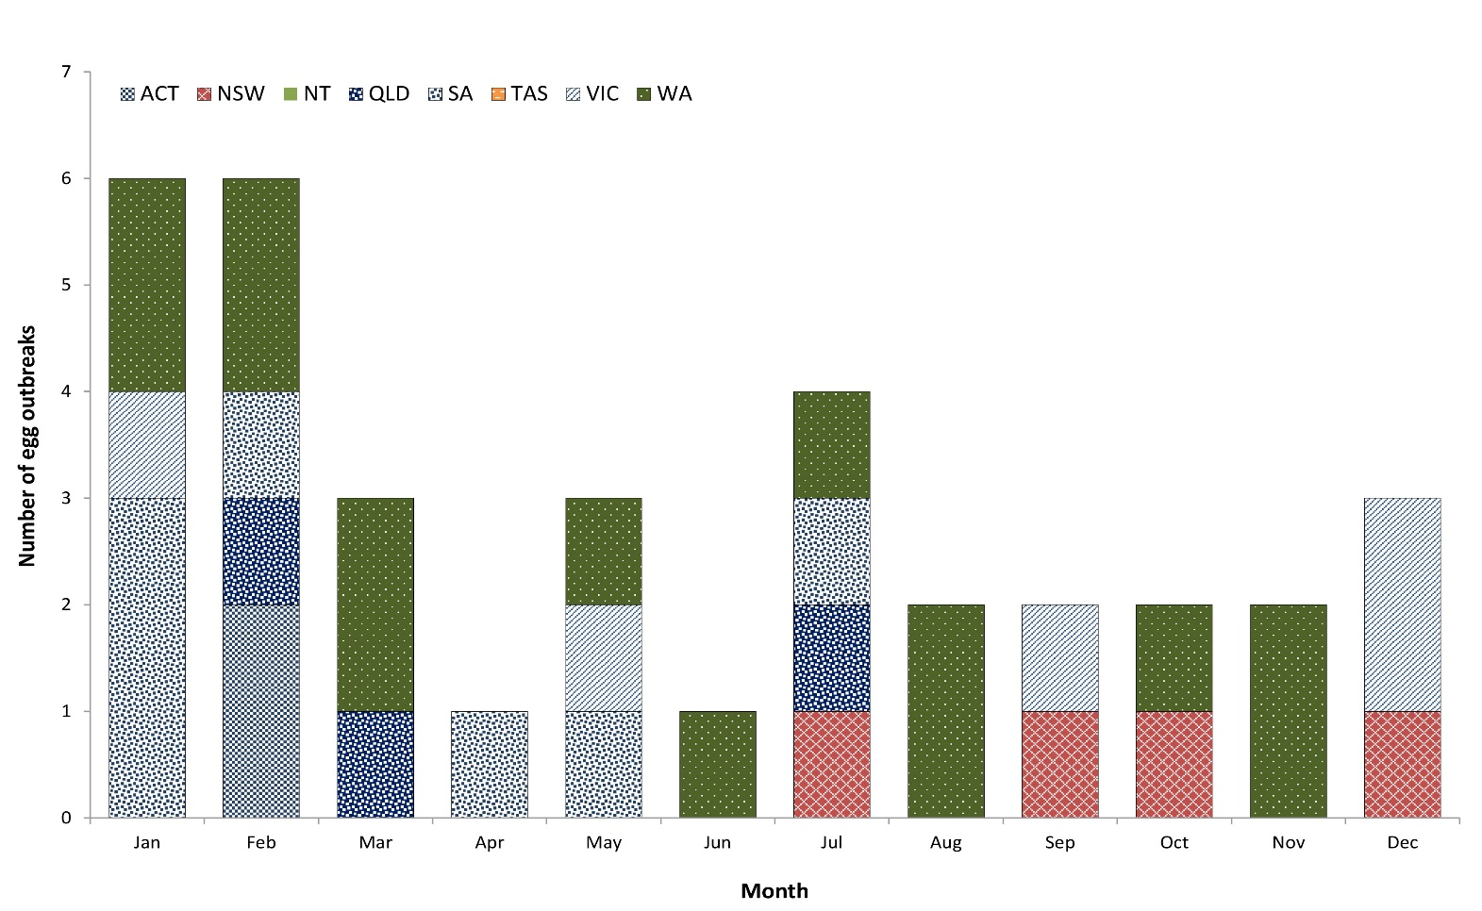

Table 25: Implicated food vehicle in egg-associated outbreaks in Australia, 2016
Implicated meal type | No. outbreaks | No. ill | No. hospitalised
Egg-based desserts | 13 | 119 | 27
Egg-based sauces | 10 | 178 | 28
Egg dishes | 7 | 177 | 31
Otherª | 5 | 36 | 3
Total | 35 | 510 | 89
a ‘Other’ includes raw egg milkshakes and outbreaks with multiple egg items.

Seafood
Seafood, comprising the three commodities of fish, molluscs and crustaceans, was implicated as the source in 25 foodborne outbreaks reported in 2016. Aetiological agents identified included ciguatoxin (n = 14), scombrotoxin (n = 4), norovirus (n = 2) and V. parahaemolyticus (n = 2).
Ciguatera fish poisoning outbreaks occurred throughout the year, primarily in Queensland (n = 12), with the remaining two outbreaks in northern New South Wales. Nine outbreaks were due to the consumption of fish caught by recreational fisherman and five associated with fish purchased from retail premises.
The consumption of raw oysters harvested in New South Wales was the confirmed source of norovirus infection for 70 people in New South Wales and the likely source of infection for three separate norovirus outbreaks affecting a total of 27 people in the Australian Capital Territory.
Two V. parahaemolyticus outbreaks were reported in 2016, affecting at least 20 people across multiple jurisdictions. Tasmanian oysters were the source of one outbreak affecting 11 people (refer to Multi-jurisdictional foodborne outbreak investigations section) and South Australian oysters were implicated in a second outbreak affecting nine people. V. parahaemolyticus outbreaks are rarely identified in Australia, with only two previous outbreaks recorded since OzFoodNet began in 2000 (unidentified source in New South Wales in 2002 and Tasmania in 2005).

Settings
Restaurants were the most commonly-reported food preparation setting, accounting for 46% (n = 82) of all foodborne outbreaks and 37% (n = 1,338) of the total number of ill people reported during outbreaks in 2016 (Table 26).

Table 26: Foodborne outbreaks in Australia by setting prepared, 2016
Setting prepared | No. of outbreaks | % of all outbreaks | No. of ill people | % of all ill people | No. of hospitalisations | % of all hospitalisations
Restaurant | 82 | 46% | 1,338 | 37% | 73 | 21%
Primary production | 25 | 14% | 990 | 27% | 122 | 35%
Private residence | 15 | 8% | 139 | 4% | 17 | 5%
Commercial caterer | 14 | 8% | 346 | 10% | 8 | 2%
Take-away | 12 | 7% | 327 | 9% | 38 | 11%
Aged care | 7 | 4% | 73 | 2% | 6 | 2%
Bakery | 6 | 3% | 137 | 4% | 33 | 9%
Fair/festival/mobile service | 3 | 2% | 35 | 1% | 7 | 2%
Camp | 2 | 1% | 123 | 3% | 2 | 1%
Correctional facility | 2 | 1% | 6 | < 1% | 1 | < 1%
Monastery | 1 | 1% | 5 | < 1% | 3 | 1%
Community | 1 | 1% | 6 | < 1% | 2 | 1%
Church | 1 | 1% | 12 | < 1% | 2 | 1%
Commercial manufacturer | 2 | 1% | 32 | 1% | 21 | 6%
Grocery store/ delicatessen | 2 | 1% | 29 | 1% | 3 | 1%
Cruise | 1 | 1% | 30 | 1% | 10 | 3%
Private caterer | 1 | 1% | 11 | < 1% | 0 | 0%
Total | 177 | 100% | 3,639 | 100% | 348 | 100%

Level of evidence for foodborne outbreaks
There was statistical evidence of an association between the consumption of the implicated food and illness for 26 foodborne outbreaks in 2016, ascertained from ten point-source cohort studies and 16 case-control studies. Of these, five outbreaks also had microbiological evidence of the aetiological agent in the epidemiologically implicated food. In addition to compelling descriptive evidence, microbiological evidence also supported the implicated food in 19 outbreaks. Compelling descriptive evidence alone supported foodborne transmission for the remaining 132 outbreaks in 2016 (Table 27).

Table 27: Evidence to support foodborne transmission for outbreaks in Australia, 2016
Aetiological agent | Statistical | Statistical and microbiological | Compelling descriptive | Microbiological and compelling descriptive | Total
Salmonella | 9 | 4 | 50 | 10 | 73
Norovirus | 4 | 0 | 10 | 1 | 15
Ciguatoxin | 0 | 0 | 11 | 3 | 14
Campylobacter | 1 | 1 | 8 | 0 | 10
Clostridium perfringens | 2 | 0 | 4 | 0 | 6
Scombrotoxin | 0 | 0 | 3 | 1 | 4
Bacillus cereus toxin | 0 | 0 | 1 | 0 | 1
Shigella | 0 | 0 | 2 | 0 | 2
Vibrio parahaemolyticus | 0 | 0 | 2 | 0 | 2
Listeria monocytogenes | 0 | 0 | 0 | 1 | 1
Staphylococcus aureus toxin | 0 | 0 | 0 | 1 | 1
Unknown | 5 | 0 | 42 | 1 | 48
Total | 21 | 5 | 132 | 19 | 177

Multi-jurisdictional foodborne outbreak investigations in 2016
OzFoodNet undertook four multi-jurisdictional outbreak investigations (MJOI) in 2016.

Salmonella Anatum
In January, routine surveillance detected an increase in S. Anatum cases in Victoria and later in South Australia. In February, the outbreak source was identified as bagged salad, following mandatory notification to the Victorian Department of Health and Human Services of the detection of Salmonella (later identified as S. Anatum) in the product. Consequently, multiple types of bagged salads were recalled. OzFoodNet initiated a MJOI on 8 February 2016. Whole genome sequencing (WGS) was used to identify outbreak cases and to compare the human and food isolates. Of the 311 confirmed outbreak cases identified nationally, the majority 247 (79%) were Victorian residents, with illness onset dates ranging from 15 December 2015 to 6 April 2016. The remaining 64 cases were from New South Wales (n = 24), South Australia (n = 28), Queensland (n = 10) and the Australian Capital Territory (n = 2). In order to provide additional supportive evidence that bagged salads were the source of the outbreak, a case-control study was conducted in Victoria. Controls were randomly selected from cases of cryptosporidiosis or campylobacteriosis that were notified in Victoria during the outbreak period. Sixty-four outbreak cases of S. Anatum and 88 controls were enrolled in the study. The multivariable analysis demonstrated an association with being a case of S. Anatum and consumption of bagged salad products or mixes (adjusted Odds Ratio (aOR) 3.19; 95% Confidence Interval (CI) 1.45–7.05; p = 0.004) and lettuce eaten outside the home (aOR 3.25; 95% CI 1.44–7.35; p = 0.005).

Salmonella Saintpaul
OzFoodNet commenced a MJOI on 11 February 2016 in response to increases in S. Saintpaul notifications in New South Wales, South Australia, the Australian Capital Territory and later in the Northern Territory. A total of 419 probable and confirmed cases of S. Saintpaul were reported, with acute gastroenteritis onsets from 1 December 2015 to 10 June 2016. South Australia reported 264 cases, New South Wales 92 cases, the Northern Territory 57 cases and the Australian Capital Territory six cases associated with this outbreak. WGS was used during and after the outbreak, whereby confirmed cases had the outbreak strain. However, with so many cases, it was not possible at the time to sequence them all, so a probable case definition was also utilised. The hypothesis that a fresh produce item was the source of the outbreak was tested in a case-control study including 72 cases and 144 controls. Controls were randomly selected from cases of salmonellosis or campylobacteriosis notified during the outbreak period and were matched by local government area of residence. The multivariate analysis found an association with being a case of S. Saintpaul and consumption of mung bean sprouts (aOR 19.9; 95% CI 6.1–65.2; p < 0.0001) and red onions (aOR 3.3; 95% CI 1.3–8.1; p = 0.01). Whilst the case-control study was being conducted, an environmental investigation in South Australia identified one mung bean sprout supplier via traceback and S. Saintpaul was isolated from environmental samples collected from the production facility and retail mung bean sprout samples. Mung bean sprouts from the affected producer were recalled.

Listeria monocytogenes
A cluster of listeriosis was detected when epidemiological, environmental and laboratory investigations linked multiple infections in New South Wales residents to one another, to supermarket delicatessen products, and to cases interstate. WGS subsequently confirmed that the cases were likely to be related, prompting the initiation of a MJOI on 16 March 2016. A total of eight cases (three each from New South Wales and Victoria, and one each from South Australia and Queensland) were linked to the outbreak by molecular typing (binary type 83, MLVA 04-20-19-04-03-11-10-04-00) and/or WGS. Of seven cases interviewed, all had consumed cold meats, cheeses and/or salads from various deli counters within the four weeks prior to onset. Food samples and environmental swabs collected during traceback investigations isolated L. monocytogenes with the same genetic profile from three supermarket delicatessens, as well as from a ham production facility in New South Wales that distributed products to various supermarkets implicated by cases. The investigation concluded that the likely source of the outbreak was deli products originating from a common ham supplier, with subsequent cross-contamination of other deli products at the point of retail. The NSW Food Authority worked with the affected supermarkets and the ham supplier to implement control measures to prevent further cases and to minimise risks of recurrence.

Salmonella Hvittingfoss
A MJOI commenced on 18 July 2016 in response to an increase in S. Hvittingfoss notifications in New South Wales, South Australia and Western Australia. A total of 144 cases were notified across six jurisdictions during the outbreak (67 in New South Wales, 32 in South Australia, 24 in Victoria, ten in Queensland, eight in Western Australia and three in the Australian Capital Territory). Approximately half the cases were aged less than five years and 22% were over 65 years. Data on the frequency of consumption of a range of fresh fruit and vegetables were collected from interviews of cases from four states and territories and compared with data from the Victorian Food Frequency Survey suggesting that rockmelon was consumed by cases at a higher than expected rate. A case-control study was conducted to test the hypothesis that rockmelon was the outbreak vehicle, including 27 cases of S. Hvittingfoss and 48 controls from New South Wales and South Australia. Controls were randomly selected cases of S. Typhimurium or campylobacteriosis notified in the same jurisdiction as the case during the outbreak period frequency matched by age. Analysis of study data found rockmelons were significantly associated with illness (aOR 6.4; 95% CI 1.8–22.4). Two separate strains of S. Hvittingfoss were identified on WGS of 110 case isolates. Food-traceback activities were conducted in multiple states and territories concurrently. South Australian authorities detected S. Hvittingfoss and other serovars on retail samples of rockmelon from the implicated grower. Based on the epidemiological and laboratory evidence, rockmelons were confirmed as the source of the outbreak and a food recall was conducted.

Animal-to-person and probable animal-to-person outbreaks
Animals were the source of two gastrointestinal outbreaks reported in 2016 (Table 20). Animal-to-person outbreaks are rarely identified in Australia, with a total of six reported in the previous five years, including three that were associated with petting zoos; two with pets at aged care facilities; and a single outbreak on a farm.
The two outbreaks investigated in 2016 were a S. Typhimurium outbreak affecting 16 children at a childcare centre with pet chickens in Victoria; and a S. Bovismorbificans outbreak affecting three children at a childcare centre with pet chickens in New South Wales.

Waterborne and probable waterborne outbreaks
Waterborne outbreaks (including confirmed and probable outbreaks) are rare in Australia, with a total of 11 reported in the previous five years. No such outbreaks were identified in 2016 (Table 20).

Environmental and probable environmental outbreaks
Nine environmental outbreaks (including confirmed and probable outbreaks) were reported in 2016 affecting 63 people (Table 20). There were eight cryptosporidium outbreaks following exposure at a swimming pool and a single S. Chester outbreak associated with a mud run in Victoria. This was lower than the five-year historical mean of 12 environmental outbreaks affecting 78 people and the five-year historical high of 39 outbreaks affecting 247 people in 2013 (all of which occurred in Victoria). With the exception of a single suspected viral outbreak associated with a Victorian water play park in 2012, all environmental outbreaks reported from 2012 to 2015 have been cryptosporidium outbreaks associated with swimming pools. Note that, while swimming pools and other swimming facilities associated with more than one case of cryptosporidiosis in New South Wales are reviewed for compliance with state requirements, such data are not included in this report as they are not reported as outbreaks. As a result of this and other differences in reporting across jurisdictions, data on environmental and probable environmental outbreaks should be interpreted with caution.

Acknowledgements
We thank the many epidemiologists, Masters of Applied Epidemiology scholars, project officers, interviewers and research assistants at each of the OzFoodNet sites who contributed to this report. We acknowledge the work of various public health professionals and laboratory staff around Australia who interviewed patients, tested specimens, typed isolates and investigated outbreaks. We would particularly like to thank jurisdictional laboratories, the Australian Salmonella Reference Centre at SA Pathology, the Institute of Clinical Pathology and Medical Research, Queensland Health Forensic and Scientific Services, the Microbiological Diagnostic Unit Public Health Laboratory, the National Enteric Pathogen Surveillance Scheme and PathWest for their help with foodborne disease surveillance.

Author details
OzFoodNet contributors to this report include (in alphabetical order): Robert Bell (Qld), Anthony Draper (NT), Emily Fearnley (SA), Neil Franklin (NSW), Keira Glasgow (NSW), Joy Gregory (Vic), Michelle Harlock (Tas), Kirsty Hope (NSW), Stacey Kane (Central), Megge Miller (SA), Nevada Pingault (WA), Tim Sloan-Gardner (ACT), Russell Stafford (Qld), Kate Ward (Central) and Rose Wright (Central).

Correspondence
OzFoodNet Co-ordinating Epidemiologist, Office of Health Protection, Australian Government Department of Health, GPO Box 9848, MDP 14, CANBERRA ACT 2601. Email: ozfoodnet@health.gov.au

References
- Kirk M, Glass K, Ford L, Brown K, Hall G. Foodborne illness in Australia: Annual incidence circa 2010. Canberra: Australian National University, National Centre for Epidemiology and Population Health; 2014. Available from: https://www1.health.gov.au/internet/main/publishing.nsf/Content/E829FA59A59677C0CA257D6A007D2C97/$File/Foodborne-Illness-Australia-circa-2010.pdf.
- Kirk M, Ford L, Glass K, Hall G. Foodborne illness, Australia, circa 2000 and circa 2010. Emerg Infect Dis. 2014;20(11):1857–64.
- Australian Government Department of Health and Ageing. The annual cost of foodborne illness in Australia. Canberra: Australian Government Department of Health and Ageing; 2006.
- Australian Bureau of Statistics. 3101.0 - Australian Demographic Statistics. [Internet.] Canberra: Australian Bureau of Statistics. Available from: https://www.abs.gov.au/statistics/people/population/national-state-and-territory-population.
- Atkinson R, Maguire H, Gerner-Smidt P. A challenge and an opportunity to improve patient management and public health surveillance for food-borne infections through culture-independent diagnostics. J Clin Microbiol. 2013;51(8):2479–82.
- Cronquist AB, Mody RK, Atkinson R, Besser J, D’Angelo MT, Hurd S et al. Impacts of culture-independent diagnostic practices on public health surveillance for bacterial enteric pathogens. Clin Infect Dis. 2012;54(Suppl 5):S432–9.
- Qin X, Klein EJ, Galanakis E, Thomas AA, Stapp JR, Rich S et al. Real-time PCR assay for detection and differentiation of Shiga toxin-producing Escherichia coli from clinical samples. J Clin Microbiol. 2015;53(7):2148–53.
- Langley G, Besser J, Iwamoto M, Lessa FC, Cronquist A, Skoff TH et al. Effect of culture-independent diagnostic tests on future Emerging Infections Program surveillance. Emerg Infect Dis. 2015;21(9):1582–8.
- May FJ, Stafford RJ, Carroll H, Robson JM, Vohra R, Nimmo GR et al. The effects of culture independent diagnostic testing on the diagnosis and reporting of enteric bacterial pathogens in Queensland, 2010 to 2014. Commun Dis Intell Q Rep. 2017;41(3):E223–30.
- OzFoodNet Working Group. Monitoring the incidence and causes of diseases potentially transmitted by food in Australia: annual report of the OzFoodNet Network, 2013–2015. Commun Dis Intell (2018). 2020;45. doi: https://doi.org./10.33321/cdi.2021.45.21.
- Hall G, Raupach J, Yohannes K. An estimate of the under-reporting of foodborne notifiable diseases: Salmonella, Campylobacter, Shiga-toxin producing Escherichia coli (STEC). Canberra: National Centre for Epidemiology and Population Health, Australian National University; 2006.
- Hall G, Yohannes K, Raupach J, Becker N, Kirk M. Estimating community incidence of Salmonella, Campylobacter, and Shiga toxin-producing Escherichia coli infections, Australia. Emerg Infect Dis. 2008;14(10):1601–9.
- 13 Moffatt CRM, Glass K, Stafford R, D’Este C, Kirk MD. The campylobacteriosis conundrum – examining the incidence of infection with Campylobacter sp. in Australia, 1998–2013. Epidemiol Infect. 2017;145(4):839–47. doi: https://doi.org/10.1017/S0950268816002909.
- Stafford RJ, Schluter P, Kirk M, Wilson A, Unicomb L , Ashbolt R et al. A multi-centre prospective case-control study of campylobacter infection in persons aged 5 years and older in Australia. Epidemiol Infect. 2007;135(6):978–88. doi: https://doi.org/10.1017/S0950268806007576.
- Food Regulation. Australia’s Foodborne Illness Reduction Strategy 2018-2021+: A strategy to reduce foodborne illness in Australia, particularly related to Campylobacter and Salmonella. Canberra: Australian Government Department of Health, Food Regulation; 29 June 2018. https://foodregulation.gov.au/internet/fr/publishing.nsf/Content/51D7B1FFFCAD05C5CA2582B900051DDD/$File/FORUM-AUS-FBI-RS-2018.pdf.
- Queensland Government Department of Agriculture and Fisheries (DAF). Department of Agriculture and Fisheries Annual Report 2017–2018. Brisbane: Queensland Government, DAF: 2018. Available from: https://www.parliament.qld.gov.au/documents/tableOffice/TabledPapers/2018/5618T1506.pdf.
- Curran M, Harvey B, Crerar S, Oliver G, D’Souza R, Myint H et al. Annual report of the National Notifiable Diseases Surveillance System, 1996. Commun Dis Intell. 1997;21(20):281–307.
- Forssman B, Mannes T, Musto J, Gottlieb T, Robertson G, Natoli JD et al. Vibrio cholerae O1 El Tor cluster in Sydney linked to imported whitebait. Med J Aust. 2007;187(6):345–7.
- NNDSS Annual Report Writing Group. Australia’s notifiable disease status, 2013: Annual report of the National Notifiable Diseases Surveillance System. Commun Dis Intell Q Rep. 2015;39(3):E387–478.
- Heywood AE, Zwar N, Forssman BL, Seale H, Stephens N, Musto J et al. The contribution of travellers visiting friends and relatives to notified infectious diseases in Australia: state-based enhanced surveillance. Epidemiol Infect. 2016;144(16):3554–63.
- Forsyth JR, Bennett NM, Hogben S, Hutchinson EM, Rouch G, Tan A et al. The year of the Salmonella seekers—1977. Aust N Z J Public Health. 2003;27(4):385–9.
- Thompson C, Dey A, Fearnley E, Polkinghorne B, Beard F. Impact of the national targeted Hepatitis A immunisation program in Australia: 2000–2014. Vaccine. 2017;35(1):170–6.
- Conaty S, Bird P, Bell G, Kraa E, Grohmann G, McAnulty JM. Hepatitis A in New South Wales, Australia from consumption of oysters: the first reported outbreak. Epidemiol Infect. 2000;124(1):121–30.
- Department of Health and Human Services (DHHS). Surveillance of notifiable infectious diseases in Victoria 1997. Melbourne: Victorian Government, DHHS; 1 June 2011. Available from: https://www2.health.vic.gov.au/public-health/infectious-diseases/infectious-diseases-surveillance/search-infectious-diseases-data/Surveillance%20of%20notifiable%20infectious%20diseases%20in%20Victoria%201997.
- Donnan EJ, Fielding JE, Gregory JE, Lalor K, Rowe S, Goldsmith P et al. A multistate outbreak of hepatitis A associated with semidried tomatoes in Australia, 2009. Clin Infect Dis. 2012;54(6):775–81.
- OzFoodNet Working Group. Monitoring the incidence and causes of diseases potentially transmitted by food in Australia: annual report of the OzFoodNet network, 2009. Commun Dis Intell Q Rep. 2010;34(4):396–426.
- Yapa, CM, Furlong C, Rosewell A, Ward KA, Adamson S, Shadbolt C et al. First reported outbreak of locally acquired hepatitis E virus infection in Australia. Med J Aust. 2016;204(7):274.
- Chandler JD, Riddell MA, Li F, Love RJ, Anderson DA. Serological evidence for swine hepatitis E virus infection in Australian pig herds. Vet Microbiol. 1999;68(1–2):95–105.
- Dalton CB, Merritt TD, Unicomb LE, Kirk MD, Stafford RJ, Lalor K, OzFoodNet Working Group. A national case-control study of risk factors for listeriosis in Australia. Epidemiol Infect. 2011;139(3):437–45.
- OzFoodNet Working Group. Monitoring the incidence and causes of diseases potentially transmitted by food in Australia: annual report of the OzFoodNet Network, 2012. Commun Dis Intell (2018). 2018;42. pii: S2209-6051(18)00014-3.
- Ford L, Moffatt CRM, Fearnley E, Miller M, Gregory J, Sloan-Gardner TS et al. The epidemiology of Salmonella enterica outbreaks in Australia, 2001-2016. Front Sustain Food Syst. 2018;2(86). doi: https://doi.org/10.3389/fsufs.2018.00086.
- Moffatt CRM, Musto J, Pingault N, Combs B, Miller M, Stafford R et al. Recovery of Salmonella enterica from Australian layer and processing environments following outbreaks linked to eggs. Foodborne Pathog Dis. 2017;14(8):478–82.
- Moffatt CRM, Musto J, Pingault N, Miller M, Stafford R, Gregory J et al. Salmonella Typhimurium and outbreaks of egg-associated disease in Australia, 2001 to 2011. Foodborne Pathog Dis. 2016;13(7):379–85.
- Munnoch SA, Ward K, Sheridan S, Fitzsimmons GJ, Shadbolt CT, Piispanen JP et al. A multi-state outbreak of Salmonella Saintpaul in Australia associated with cantaloupe consumption. Epidemiol Infect. 2009;137(3):367–74.
- Gibbs R, Pingault N, Mazzucchelli T, O’Reilly L, MacKenzie B, Green J et al. An outbreak of Salmonella enterica serotype Litchfield infection in Australia linked to consumption of contaminated papaya. J Food Prot. 2009;72(5):1094–8.
- Musto J, Kirk M, Lightfoot D, Combs BG, Mwanri L. Multi-drug resistant Salmonella Java infections acquired from tropical fish aquariums, Australia, 2003–04. Commun Dis Intell Q Rep. 2006;30(2):222–7.
- Staff M, Musto J, Hogg G, Janssen M, Rose K. Salmonellosis outbreak traced to playground sand, Australia, 2007–2009. Emerg Infect Dis. 2012;18(7):1159–62.
- Wallace P, Kirk MD, Munnoch SA, Gunn J, Stafford RJ, Kelly PM. An outbreak of Salmonella Litchfield on a car rally, Northern Territory, 2009. Commun Dis Intell Q Rep. 2010;34(2):124–6.
- Gantois I, Ducatelle R, Pasmans F, Haesebrouck F, Gast R, Humphrey TJ et al. Mechanisms of egg contamination by Salmonella Enteritidis. FEMS Microbiol Rev. 2009;33(4):718–38. doi: https://doi.org/10.1111/j.1574-6976.2008.00161.x.
- Guglielmino CJD, Kakkanat A, Forde BM, Rubenach S, Merone L, Stafford R et al. Outbreak of multi-drug-resistant (MDR) Shigella flexneri in northern Australia due to an endemic regional clone acquiring an IncFII plasmid. Eur J Clin Microbiol Infect Dis. 2021;402(2):279–86. doi: https://doi.org/10.1007/s10096-020-04029-w.
- Rowe S, Radwan S, Lalor K, Valcanis M, Gregory J. An outbreak of shigellosis among men who have sex with men, Victoria, 2008. Vic Infect Dis Bull. 2010;13(4):119–24.
- Lewis HC, Ethelberg S, Olsen KEP, Nielsen EM, Lisby M, Madsen SB et al. Outbreaks of Shigella sonnei infections in Denmark and Australia linked to consumption of imported raw baby corn. Epidemiol Infect. 2009;137(3):326–34.
- McPherson M, Lalor K, Combs B, Raupach J, Stafford R, Kirk MD. Serogroup-specific risk factors for Shiga toxin-producing Escherichia coli infection in Australia. Clin Infect Dis. 2009;49(2):249–56.
- Buchholz U, Bernard H, Werber D, Böhmer MM, Remschmidt C, Wilking H et al. German outbreak of Escherichia coli O104:H4 associated with sprouts. N Engl J Med. 2011;365(19):1763–70.
- Paton AW, Ratcliff RM, Doyle RM, Seymour-Murray J, Davos D, Lanser JA et al. Molecular microbiological investigation of an outbreak of hemolytic-uremic syndrome caused by dry fermented sausage contaminated with Shiga-like toxin-producing Escherichia coli. J Clin Microbiol. 1996;34(7):1622–7.
- Painter JA, Ayers T, Woodruff R, Blanton E, Perez N, Hoekstra RM et al. Recipes for foodborne outbreaks: a scheme for categorizing and grouping implicated foods. Foodborne Pathog Dis. 2009;6(10):1259–64.

Appendix
Appendix A: Revised OzFoodNet definitions for modes of outbreak transmission implemented in 2016
Mode | Definition
Foodborne | An incident where two or more persons experience a similar illness after consuming a common food or meal and analytical epidemiological evidence and/or microbiological evidence (including food and/or environmental) implicates the meal or food as the source of illness; or the aetiology of the outbreak can only result through foodborne transmission (for example Listeria monocytogenes, ciguatera fish poisoning).
Probable foodborne | An incident where two or more persons experience a similar illness after consuming a common food or meal and compelling descriptive epidemiological evidence implicates the meal or food as the suspected source of illness. This includes outbreaks where the mode of transmission is suspected to be from an ill food handler to food to person.
Waterborne | An incident where two or more persons experience a similar illness after the consumption of water from a common source and analytical epidemiological evidence and/or microbiological evidence implicates the drinking water supply as the source of illness. This does not include outbreaks associated with accidental consumption of water during recreational water exposures (environmental transmission).
Probable waterborne | An incident where two or more persons experience a similar illness after consumption of water from a common source and compelling descriptive epidemiological evidence implicates the drinking water supply as the source of illness. This does not include outbreaks associated with accidental consumption of water during recreational water exposures (environmental transmission).
Animal-to-person | An incident where two or more persons experience a similar illness after exposure to animals and analytical epidemiological evidence and/or microbiological evidence implicates the animal as the source of illness.
Probable animal-to-person | An incident where two or more persons experience a similar illness after exposure to animals and compelling descriptive epidemiological evidence implicates the animals as the suspected source of illness.
Environmental | An incident where two or more persons experience a similar illness following exposure to a contaminated environment and epidemiological evidence and/or microbiological evidence implicates a specific environmental source as the cause of illness. This includes recreational exposure to water.
Probable environmental | An incident where two or more persons experience a similar illness following exposure to a contaminated environment and compelling descriptive epidemiological evidence identifies a specific environmental source as the suspected cause of illness but the exact source of contamination is unknown. This includes recreational exposure to water.

Appendix B: Foodborne and probable foodborne outbreak summary for OzFoodNet sites, Australia, 2016
Jurisdiction | Monthª | Setting prepared | Agent responsible^{b} | No. ill | No. hospitalised | No. fatalities | Evidence^{c} | Epidemiological study | Responsible vehicle | Commodity | Contamination factor
MJOI | Feb | Primary production | S. Anatum | 311 | 24 | 0 | AM | Case control study | Bagged salad product | Leafy plants | Ingestion of contaminated raw products
MJOI | Feb | Primary production | S. Saintpaul | 419 | 76 | 0 | AM | Case control study | Mung bean sprouts | Sprouts | Ingestion of contaminated raw products
MJOI | Mar | Commercial manufacturer | Listeria monocytogenes, Binary type 83, MLVA 04-20-19-04-03-11-10-04-00 | 8 | 8 | 0 | DM | Case series | Deli items | > 1 food category implicated | Ingestion of contaminated raw products, cross contamination from raw ingredients
MJOI | Jul | Primary production | S. Hvittingfoss | 144 | 13 | 1 | AM | Case control study | Rockmelon | Fruits | Ingestion of contaminated raw products
ACT | Jan | Restaurant | Unknown (suspected toxin) | 4 | 0 | 0 | D | No formal study | Garlic sauce | > 1 food category implicated | Other source of contamination
ACT | Jan | Primary production | Unknown | 7 | 0 | 0 | D | Case series | Oysters | Molluscs | Ingestion of contaminated raw products
ACT | Feb | Restaurant | S. Typhimurium, MLVA 03-26-13-08-523 | 5 | 2 | 0 | D | Case series | Egg and lettuce sandwiches | Eggs | Unknown
ACT | Feb | Restaurant | S. Typhimurium, MLVA 03-26-13-08-523 | 5 | 0 | 0 | D | Case series | Eggs Benedict | Eggs | Unknown
ACT | Mar | Restaurant | Unknown (suspected Clostridium perfringens) | 24 | 0 | 0 | D | Case series | Lamb bun | Lamb | Unknown
ACT | Mar | Primary production | Unknown | 16 | 0 | 0 | A | Point source cohort | Oysters | Molluscs | Ingestion of contaminated raw products
ACT | Mar | Primary production | Unknown (suspected viral) | 4 | 0 | 0 | D | Case series | Oysters | Molluscs | Ingestion of contaminated raw products
ACT | Mar | Private residence | S. Typhimurium, MLVA 03-24-13-10-523 | 4 | 3 | 0 | D | Case series | Unknown | Not attributed | Unknown
ACT | May | Restaurant | S. Typhimurium, MLVA 03-12-18-14-523 | 26 | 1 | 1 | A | Point source cohort | Salmon and avocado dip sandwiches | > 1 food category implicated | Unknown
ACT | May | Restaurant | S. Typhimurium, MLVA 03-10-14-11-496 | 15 | 1 | 0 | D | Point source cohort | Unknown | Not attributed | Unknown
ACT | Nov | Grocery store/ delicatessen | Unknown | 18 | 0 | 0 | A | Point source cohort | Salami | Pork | Unknown
NSW | Jan | Take-away | S. Typhimurium, MLVA 03-26-13-08-523 | 202 | 32 | 0 | DM | Case series | Bakery items | > 1 food category implicated | Cross contamination from raw ingredients, inadequate cleaning of equipment
NSW | Jan | Grocery store/ delicatessen | S. Typhimurium, MLVA 04-18-12-00-490 | 11 | 3 | 0 | D | Case series | Contaminated deli items | > 1 food category implicated | Food handler contamination
NSW | Jan | Bakery | S. Typhimurium, MLVA 03-26-19-08-523 | 33 | 1 | 0 | DM | No formal study | Cream and custard profiterole cake | > 1 food category implicated | Cross contamination from raw ingredients
NSW | Jan | Take-away | S. Bareilly | 28 | Unknown | 0 | DM | Case series | Korean sushi | > 1 food category implicated | Cross contamination from raw ingredients
NSW | Jan | Primary production | Norovirus | 4 | 0 | 0 | D | No formal study | Oysters | Molluscs | Unknown
NSW | Jan | Primary production | Norovirus | 7 | 0 | 0 | DM | No formal study | Oysters | Molluscs | Unknown
NSW | Jan | Private residence | Scombrotoxin | 3 | 1 | 0 | D | No formal study | Tilapia fish | Fish | Toxic substance or part of tissue
NSW | Jan | Restaurant | Scombrotoxin | 2 | 2 | 0 | D | No formal study | Tuna sashimi | Fish | Toxic substance or part of tissue
NSW | Jan | Aged care facility | S. Typhimurium, MLVA 03-26-13-08-523 | 2 | 1 | 1 | D | No formal study | Unknown | Not attributed | Unknown
NSW | Jan | Restaurant | S. Typhimurium, MLVA 05-17-15-10-490 | 16 | 0 | 0 | D | Case series | Unknown | Not attributed | Other source of contamination
NSW | Jan | Restaurant | Unknown | 3 | 0 | 0 | D | No formal study | Unknown | Not attributed | Unknown
NSW | Jan | Restaurant | Unknown | 3 | 0 | 0 | D | No formal study | Unknown | Not attributed | Unknown
NSW | Jan | Restaurant | Unknown | 4 | 0 | 0 | D | No formal study | Unknown | Not attributed | Unknown
NSW | Jan | Restaurant | Unknown | 17 | 0 | 0 | D | Case series | Unknown | Not attributed | Unknown
NSW | Jan | Restaurant | Unknown | 22 | 1 | 0 | D | Point source cohort | Unknown | Not attributed | Unknown
NSW | Jan | Restaurant | Unknown | 8 | 0 | 0 | D | No formal study | Unknown | Not attributed | Unknown
NSW | Jan | Restaurant | Unknown (suspected viral) | 4 | 0 | 0 | D | No formal study | Unknown | Not attributed | Unknown
NSW | Feb | Commercial caterer | Shigella sonnei | 7 | 0 | 0 | D | Case series | Multiple foods | > 1 food category implicated | Food handler contamination
NSW | Feb | Aged care facility | S. Infantis | 4 | 2 | 0 | D | No formal study | Unknown | Not attributed | Unknown
NSW | Feb | Restaurant | S. Typhimurium, MLVA 03-09-08-12-523 | 3 | 1 | 0 | D | Case series | Unknown | Not attributed | Unknown
NSW | Feb | Aged care facility | S. Typhimurium, MLVA 03-12-12-11-523 | 13 | 2 | 0 | D | No formal study | Unknown | Not attributed | Unknown
NSW | Feb | Restaurant | Unknown | 22 | 0 | 0 | D | Case series | Unknown | Not attributed | Unknown
NSW | Feb | Take-away | Unknown (suspected viral) | 10 | 0 | 0 | D | No formal study | Unknown | Not attributed | Unknown
NSW | Mar | Take-away | Norovirus | 13 | 0 | 0 | D | No formal study | Rice paper rolls | > 1 food category implicated | Unknown
NSW | Mar | Primary production | Ciguatoxin | 3 | 0 | 0 | DM | Case series | Spanish mackerel | Fish | Toxic substance or part of tissue
NSW | Mar | Restaurant | Campylobacter | 5 | 1 | 0 | D | No formal study | Unknown | Not attributed | Unknown
NSW | Mar | Restaurant | Unknown | 3 | 0 | 0 | D | No formal study | Unknown | Not attributed | Unknown
NSW | Apr | Primary production | Ciguatoxin | 5 | 2 | 0 | DM | No formal study | Spanish mackerel | Fish | Toxic substance or part of tissue
NSW | Apr | Restaurant | Unknown | 2 | 0 | 0 | D | No formal study | Unknown | Not attributed | Unknown
NSW | Apr | Restaurant | Unknown | 7 | 0 | 0 | D | No formal study | Unknown | Not attributed | Unknown
NSW | Apr | Take-away | Unknown | 5 | 0 | 0 | D | Case series | Unknown | Not attributed | Unknown
NSW | May | Restaurant | Unknown | 5 | 0 | 0 | D | No formal study | Unknown | Not attributed | Unknown
NSW | May | Take-away | Unknown | 13 | 0 | 0 | D | No formal study | Unknown | Not attributed | Unknown
NSW | Jun | Restaurant | Shigella spp. | 3 | 0 | 0 | D | No formal study | Cherry strudel | > 1 food category implicated | Food handler contamination
NSW | Jun | Restaurant | Norovirus | 26 | 0 | 0 | D | No formal study | Unknown | Not attributed | Food handler contamination
NSW | Jun | Restaurant | Unknown | 23 | 0 | 0 | D | No formal study | Unknown | Not attributed | Person to food to person
NSW | Jul | Restaurant | S. Typhimurium, MLVA 03-11-15-10-523 | 5 | 1 | 0 | D | Case series | Raw egg products | Eggs | Unknown
NSW | Jul | Camp | Unknown | 116 | 0 | 0 | D | No formal study | Unknown | Not attributed | Person to food to person, other source of contamination
NSW | Jul | Restaurant | Unknown | 3 | 0 | 0 | D | No formal study | Unknown | Not attributed | Unknown
NSW | Aug | Restaurant | Norovirus | 80 | 1 | 0 | D | Case series | Unknown | Not attributed | Unknown
NSW | Aug | Commercial caterer | Unknown | 19 | 0 | 0 | D | No formal study | Unknown | Not attributed | Food handler contamination
NSW | Aug | Restaurant | Unknown | 7 | 0 | 0 | D | No formal study | Unknown | Not attributed | Unknown
NSW | Sep | Commercial caterer | Unknown | 3 | 0 | 0 | D | No formal study | Chicken/salmon/egg wraps | > 1 food category implicated | Food handler contamination
NSW | Sep | Restaurant | Unknown (suspected viral) | 19 | 0 | 0 | D | Case series | Multiple foods from buffet | > 1 food category implicated | Unknown
NSW | Sep | Restaurant | S. Typhimurium, MLVA 03-09-07-12-523 | 8 | 0 | 0 | D | Case series | Multiple foods, likely initial contamination from eggs | Eggs | Inadequate cleaning of equipment, ingestion of contaminated raw products
NSW | Sep | Restaurant | S. Typhimurium, MLVA 03-12-11-15-523 | 6 | 0 | 0 | D | Case series | Unknown | Not attributed | Ingestion of contaminated raw products
NSW | Sep | Aged care facility | S. Typhimurium, MLVA 03-14-09-13-523 | 13 | 0 | 1 | D | Case series | Unknown | Not attributed | Unknown
NSW | Sep | Restaurant | Unknown | 30 | 0 | 0 | D | Case series | Unknown | Not attributed | Unknown
NSW | Sep | Restaurant | Unknown (suspected viral) | 12 | 1 | 0 | D | No formal study | Unknown | Not attributed | Unknown
NSW | Oct | Restaurant | S. Typhimurium, MLVA 03-10-08-11-496 | 4 | 0 | 0 | D | Case series | Eggs | Eggs | Ingestion of contaminated raw products
NSW | Oct | Commercial caterer | Norovirus | 52 | 0 | 0 | D | No formal study | Unknown | Not attributed | Unknown
NSW | Oct | Restaurant | Unknown (suspected viral) | 9 | 0 | 0 | D | No formal study | Unknown | Not attributed | Unknown
NSW | Oct | Restaurant | Unknown (suspected viral) | 8 | 0 | 0 | D | No formal study | Unknown | Not attributed | Unknown
NSW | Oct | Restaurant | Unknown (suspected viral) | 62 | 0 | 0 | D | Point source cohort | Unknown | Not attributed | Unknown
NSW | Nov | Restaurant | Campylobacter | 3 | 0 | 0 | D | No formal study | Chicken liver pâté | Poultry | Ingestion of contaminated raw products
NSW | Nov | Commercial caterer | S. Typhimurium, MLVA 03-25-18-12-523 | 79 | 5 | 0 | A | Case series | Duck pancakes | Poultry | Cross contamination from raw ingredients
NSW | Nov | Restaurant | Norovirus | 171 | 0 | 0 | D | No formal study | Unknown | Not attributed | Food handler contamination
NSW | Nov | Restaurant | Unknown (suspected viral) | 70 | 0 | 0 | D | No formal study | Unknown | Not attributed | Unknown
NSW | Dec | Restaurant | S. Typhimurium, MLVA 03-18-09-11-523 | 6 | 0 | 0 | D | No formal study | Sauce containing raw eggs | Eggs | Ingestion of contaminated raw products
NSW | Dec | Restaurant | Unknown (suspected toxin) | 4 | 0 | 0 | D | No formal study | Unknown | Not attributed | Unknown
NSW | Dec | Restaurant | Unknown (suspected viral) | 6 | 0 | 0 | D | No formal study | Unknown | Not attributed | Food handler contamination
NSW | Dec | Restaurant | Unknown (suspected viral) | 44 | 3 | 0 | D | No formal study | Unknown | Not attributed | Unknown
NT | Feb | Restaurant | Unknown (suspected viral) | 30 | 0 | 0 | A | Point source cohort | Chicken or egg sandwiches | > 1 food category implicated | Unknown
NT | Apr | Take-away | Salmonella species | 2 | 0 | 0 | D | Case series | Unknown | Not attributed | Unknown
NT | Aug | Commercial manufacturer | Staphylococcus aureus toxin | 24 | 13 | 0 | DM | Case series | Fresh noodles | > 1 food category implicated | Food handler contamination
NT | Aug | Restaurant | Unknown (suspected viral) | 5 | 0 | 0 | D | Case series | Unknown | Not attributed | Person to food to person
Qld | Jan | Primary production | Ciguatoxin | 5 | Unknown | 0 | D | Case series | Spanish mackerel | Fish | Toxic substance or part of tissue
Qld | Feb | Fair/festival/mobile service | S. Typhimurium, MLVA 03-26-13-08-524 | 12 | 2 | 0 | D | Case series | Crêpes | Eggs | Ingestion of contaminated raw products
Qld | Mar | Private residence | Norovirus | 46 | 1 | 0 | A | Case control study | Cake | > 1 food category implicated | Food handler contamination
Qld | Mar | Restaurant | Unknown | 13 | 0 | 0 | D | Case series | Japanese bento boxes | > 1 food category implicated | Unknown
Qld | Mar | Take-away | Clostridium perfringens | 3 | 0 | 0 | D | Case series | Pork rolls with gravy | Pork | Other source of contamination
Qld | Mar | Fair/festival/mobile service | S. Typhimurium, MLVA 03-26-13-08-524 | 10 | 4 | 0 | D | Case series | Unknown | Not attributed | Unknown
Qld | Mar | Bakery | S. Typhimurium, MLVA 03-17-09-11-524 | 7 | 2 | 0 | D | Case series | Vietnamese rolls with raw egg butter | Eggs | Inadequate cleaning of equipment, cross contamination from raw ingredients
Qld | Apr | Aged care facility | Campylobacter | 12 | 0 | 0 | D | No formal study | Unknown | Not attributed | Unknown
Qld | May | Restaurant | Unknown | 6 | 0 | 0 | D | Case series | Unknown | Not attributed | Inadequate cleaning of equipment, cross contamination from raw ingredients
Qld | Jun | Commercial caterer | Clostridium perfringens | 2 | 0 | 0 | D | Case series | Beef calderata | Beef | Other source of contamination
Qld | Jun | Primary production | Ciguatoxin | 4 | 0 | 0 | D | Case series | Coral trout | Fish | Toxic substance or part of tissue
Qld | Jun | Restaurant | Clostridium perfringens | 3 | 0 | 0 | D | Case series | Unknown | Not attributed | Unknown
Qld | Jul | Restaurant | S. Typhimurium, MLVA 03-15-12-11-524 | 11 | 3 | 0 | DM | Case series | Fried ice cream | Eggs | Ingestion of contaminated raw products
Qld | Jul | Restaurant | S. Typhimurium, MLVA 03-12-12-09-524 | 13 | 1 | 0 | D | Case series | Multiple foods, suspected cross contamination | > 1 food category implicated | Cross contamination from raw ingredients
Qld | Jul | Primary production | Ciguatoxin | 2 | 0 | 0 | D | Case series | Red throat emperor | Fish | Toxic substance or part of tissue
Qld | Jul | Primary production | Ciguatoxin | 2 | 0 | 0 | D | Case series | Red throat emperor | Fish | Toxic substance or part of tissue
Qld | Jul | Primary production | Ciguatoxin | 4 | 0 | 0 | D | Case series | Yellow tailed kingfish | Fish | Toxic substance or part of tissue
Qld | Sep | Primary production | Ciguatoxin | 3 | 3 | 0 | D | Case series | Coral trout | Fish | Toxic substance or part of tissue
Qld | Sep | Primary production | Ciguatoxin | 5 | 0 | 0 | D | Case series | Flowery cod | Fish | Toxic substance or part of tissue
Qld | Oct | Primary production | Ciguatoxin | 5 | 0 | 0 | DM | Case series | Coral trout | Fish | Toxic substance or part of tissue
Qld | Oct | Primary production | Ciguatoxin | 3 | 0 | 0 | D | Case series | Mackerel | Fish | Toxic substance or part of tissue
Qld | Oct | Private residence | Unknown | 3 | 0 | 0 | D | No formal study | Unknown | Not attributed | Unknown
Qld | Nov | Primary production | Ciguatoxin | 7 | 0 | 0 | D | Case series | Spanish mackerel | Fish | Toxic substance or part of tissue
Qld | Nov | Primary production | Ciguatoxin | 4 | 0 | 0 | D | Case series | Spanish mackerel | Fish | Toxic substance or part of tissue
Qld | Nov | Primary production | Ciguatoxin | 4 | 0 | 0 | D | Case series | Spanish mackerel | Fish | Toxic substance or part of tissue
Qld | Nov | Restaurant | Unknown | 4 | 0 | 0 | D | Case series | Unknown | Not attributed | Unknown
Qld | Dec | Private residence | Norovirus | 5 | 1 | 0 | D | Case series | Sweets including rum balls and white Christmas | > 1 food category implicated | Food handler contamination
SA | Jan | Restaurant | S. Typhimurium, MLVA 03-15-07-12-550 | 3 | 1 | 0 | D | Case series | Egg-based dishes | Eggs | Ingestion of contaminated raw products
SA | Jan | Restaurant | S. Typhimurium, MLVA 03-10-09-10-523 | 15 | 1 | 0 | D | Case series | Eggs | Eggs | Cross contamination from raw ingredients, inadequate cleaning of equipment
SA | Jan | Restaurant | S. Typhimurium, MLVA 03-14-10-10-523 | 31 | 8 | 0 | D | Case series | Ice cream containing raw eggs | Eggs | Ingestion of contaminated raw products
SA | Feb | Take-away | i. subsp 1 ser 4, 12:i:- | 3 | 0 | 0 | D | Case series | Vietnamese rolls | > 1 food category implicated | Cross contamination from raw ingredients
SA | Feb | Take-away | S. Typhimurium, MLVA 03-25-12-11-523 | 10 | 1 | 0 | D | Case series | Vietnamese rolls with raw egg butter | Eggs | Ingestion of contaminated raw products
SA | Mar | Restaurant | S. Typhimurium, MLVA 03-24-13-10-523 | 3 | 2 | 0 | D | Case series | Unknown | Not attributed | Unknown
SA | Apr | Correctional facility | S. Typhimurium, MLVA 03-09-09-14-523 | 4 | 0 | 0 | D | Case series | Milkshake containing raw eggs | Eggs | Ingestion of contaminated raw products
SA | May | Take-away | S. Typhimurium, MLVA 03-12-09-11-523 | 32 | 4 | 0 | D | Case series | Vietnamese rolls with raw egg butter | Eggs | Ingestion of contaminated raw products
SA | Jul | Restaurant | S. Typhimurium, MLVA 03-24-11-10-523 | 143 | 27 | 0 | A | Case control study | Scrambled eggs | Eggs | Cross contamination from raw ingredients, inadequate cleaning of equipment
SA | Oct | Bakery | S. Typhimurium, MLVA 03-14-10-10-523 | 8 | 2 | 0 | D | Case series | Sandwiches/wraps containing salad and meat or egg | > 1 food category implicated | Cross contamination from raw ingredients
SA | Dec | Commercial caterer | Campylobacter | 11 | 1 | 0 | D | Case series | Chicken liver parfait | Poultry | Unknown
SA | Dec | Restaurant | S. Typhimurium, MLVA 03-23-05-10-523 and MLVA 03-24-25-10-523 | 14 | 1 | 0 | DM | Case series | Multiple foods, including hummus and aioli | > 1 food category implicated | Ingestion of contaminated raw products, cross contamination from raw ingredients
Tas | Jan | Primary production | Vibrio parahaemolyticus | 11 | 4 | 0 | D | Case series | Oysters | Molluscs | Ingestion of contaminated raw products
Tas | Apr | Restaurant | Unknown (suspected viral) | 13 | 0 | 0 | A | Case control study | Side salad | > 1 food category implicated | Food handler contamination
Tas | May | Commercial caterer | Campylobacter jejuni | 31 | 1 | 0 | AM | Point source cohort | Chicken wontons | Poultry | Ingestion of contaminated raw products
Tas | Jul | Restaurant | Campylobacter | 12 | 0 | 0 | A | Point source cohort | Crayfish, iceberg lettuce and seafood dressing roll (suspected) | > 1 food category implicated | Cross contamination from raw ingredients
Tas | Oct | Restaurant | Unknown (suspected toxin) | 5 | 0 | 0 | D | Case series | Mexican foods | > 1 food category implicated | Inadequate cleaning of equipment
Tas | Nov | Commercial caterer | Norovirus | 31 | 1 | 0 | D | Case control and cohort | Unknown | Not attributed | Food handler contamination
Vic | Jan | Bakery | S. Typhimurium, MLVA 03-12-09-13-523 | 44 | 9 | 0 | DM | Case series | Custard | Dairy | Cross contamination from raw ingredients
Vic | Jan | Private residence | S. Typhimurium, MLVA 03-24-13-10-523 | 3 | 1 | 0 | D | Case series | Tiramisu containing raw eggs | Eggs | Ingestion of contaminated raw products
Vic | Jan | Restaurant | Norovirus | 10 | Unknown | 0 | D | Case series | Unknown | Not attributed | Unknown
Vic | Jan | Camp | S. Typhimurium, MLVA 03-14-10-08-523 | 7 | 2 | 0 | D | Case series | Unknown | Not attributed | Unknown
Vic | Feb | Restaurant | S. Typhimurium, MLVA 03-22-13-11-523 | 3 | 0 | 0 | D | Case series | Barramundi spring rolls | > 1 food category implicated | Unknown
Vic | Feb | Restaurant | Norovirus | 22 | 0 | 0 | A | Case control study | Caramelised onion and/or smoked ricotta scones and chicken sui mai dumplings | > 1 food category implicated | Unknown
Vic | Feb | Private caterer | S. Typhimurium, MLVA 03-25-17-12-523 | 11 | 0 | 0 | A | Case control study | Grilled chicken | Poultry | Ingestion of contaminated raw products
Vic | Feb | Restaurant | S. Typhimurium, MLVA 03-22-13-11-523 | 18 | 2 | 0 | D | Case series | Mixed spit roasted meats | > 1 food category implicated | Cross contamination from raw ingredients
Vic | Feb | Community | S. Typhimurium, MLVA 03-22-13-11-523 | 6 | 2 | 0 | D | Case series | Unknown | Not attributed | Unknown
Vic | Mar | Restaurant | Campylobacter jejuni | 3 | 0 | 0 | D | Case series | Unknown | Not attributed | Unknown
Vic | Mar | Monastery | S. Typhimurium, MLVA 03-22-13-11-523 | 5 | 3 | 0 | D | Case series | Unknown | Not attributed | Unknown
Vic | Apr | Commercial caterer | Norovirus | 5 | 0 | 0 | A | Case control study | Rocket salad | > 1 food category implicated | Unknown
Vic | May | Restaurant | Unknown | 8 | 1 | 0 | A | Case control study | Ham sandwiches and/or jelly slice | > 1 food category implicated | Person to food to person
Vic | May | Restaurant | Campylobacter | 5 | 0 | 0 | D | Case series | Unknown | Not attributed | Unknown
Vic | May | Bakery | S. Typhimurium, MLVA 03-26-13-08-523 | 34 | 15 | 0 | D | Case series | Vietnamese rolls with raw egg butter | Eggs | Ingestion of contaminated raw products
Vic | Jun | Commercial caterer | Clostridium perfringens | 55 | 0 | 0 | A | Case control study | Cashew and green pea curry and/or chicken curry | > 1 food category implicated | Other source of contamination
Vic | Jun | Private residence | S. Typhimurium, MLVA 03-09-09-14-523 | 14 | 2 | 0 | D | Point source cohort | Unknown | Not attributed | Unknown
Vic | Jul | Restaurant | Scombrotoxin | 2 | 0 | 0 | D | Case series | Mackerel | Fish | Toxic substance or part of tissue
Vic | Jul | Take-away | Unknown | 6 | 1 | 0 | D | Case series | Roast chicken | Poultry | Unknown
Vic | Jul | Aged care facility | Campylobacter | 11 | 1 | 0 | D | Case series | Unknown | Not attributed | Unknown
Vic | Aug | Commercial caterer | Bacillus cereus | 20 | 0 | 0 | DM | Case series | Fried rice | Grain | Toxic substance or part of tissue
Vic | Aug | Correctional facility | S. Typhimurium, MLVA 03-09-07-12-523 | 2 | 1 | 0 | D | Case series | Unknown | Not attributed | Unknown
Vic | Sep | Restaurant | S. Typhimurium, MLVA 03-09-09-13-523 | 14 | 2 | 0 | A | Case control study | Tacos containing raw egg chipotle cream | Eggs | Ingestion of contaminated raw products
Vic | Oct | Primary production | Scombrotoxin | 2 | 0 | 0 | DM | Case series | Butterfish | Fish | Toxic substance or part of tissue
Vic | Oct | Restaurant | Unknown | 11 | 0 | 0 | D | Case series | Unknown | Not attributed | Unknown
Vic | Nov | Restaurant | Norovirus | 14 | 1 | 0 | D | Point source cohort | Unknown | Not attributed | Food handler contamination
Vic | Nov | Private residence | S. subsp1 4,5,12,i-, MLVA 04-15-11-00-490 | 11 | 1 | 0 | D | Case series | Unknown | Not attributed | Unknown
Vic | Dec | Private residence | S. Typhimurium, MLVA 03-09-09-12-523 | 5 | 3 | 0 | D | No formal study | Chocolate mousse containing raw eggs | Eggs | Ingestion of contaminated raw products
Vic | Dec | Commercial caterer | Norovirus | 25 | 0 | 0 | A | Case control study | Multiple foods, including chicken and mango croutons, chicken and mayonnaise sandwiches, and Thai beef croutons | > 1 food category implicated | Unknown
Vic | Dec | Restaurant | S. Typhimurium, MLVA 03-09-09-14/15-523 | 49 | Unknown | 0 | A | Point source cohort | Sauce containing raw eggs | Eggs | Ingestion of contaminated raw products
WA | Jan | Private residence | S. Typhimurium, MLVA 03-26-20-11-523 | 5 | 0 | 0 | D | Case series | Tiramisu containing raw eggs | Eggs | Ingestion of contaminated raw products
WA | Jan | Private residence | S. Typhimurium, MLVA 03-12-12-11-523 | 6 | 1 | 0 | D | No formal study | Unknown | Not attributed | Unknown
WA | Jan | Restaurant | S. Typhimurium, MLVA 03-26-16-11-523 | 5 | 1 | 0 | D | Case series | Unknown | Not attributed | Unknown
WA | Jan | Church | S. Typhimurium, MLVA 03-25-16-11-523 | 12 | 2 | 0 | D | Case series | Vietnamese pork rolls containing raw egg mayonnaise | Eggs | Ingestion of contaminated raw products
WA | Feb | Bakery | S. Typhimurium, MLVA 03-25-19-11-523 | 11 | 4 | 0 | DM | Case series | Chocolate mousse cake containing raw eggs | Eggs | Ingestion of contaminated raw products
WA | Feb | Private residence | S. Typhimurium, MLVA 03-25-18-11-523 | 8 | 0 | 0 | A | Point source cohort | Tiramisu containing raw eggs | Eggs | Ingestion of contaminated raw products
WA | Mar | Cruise ship | S. Enteritidis | 30 | 10 | 0 | A | Case control study | Banana smoothie, berry smoothie and fish | > 1 food category implicated | Ingestion of contaminated raw products, cross contamination from raw ingredients
WA | Mar | Primary production | Vibrio parahaemolyticus | 9 | 0 | 0 | D | Case series | Oysters | Molluscs | Ingestion of contaminated raw products
WA | Mar | Restaurant | S. Typhimurium, MLVA 03-25-19-11-523 | 2 | 1 | 0 | D | Case series | Scrambled eggs/eggs Benedict | Eggs | Unknown
WA | Mar | Restaurant | S. Typhimurium, MLVA 05-15-13-11-490 | 4 | 1 | 0 | D | Case series | Tiramisu containing raw eggs | Eggs | Ingestion of contaminated raw products
WA | May | Private residence | S. Typhimurium, MLVA 03-10-15-11-496 | 5 | 0 | 0 | D | Case series | Chocolate fondant containing undercooked eggs | Eggs | Ingestion of contaminated raw products
WA | May | Aged care facility | Clostridium perfringens | 18 | 0 | 0 | D | Case series | Unknown | Not attributed | Unknown
WA | Jun | Private residence | S. Typhimurium, MLVA 03-26-16-12-523 | 9 | 2 | 0 | DM | Case control study | Chocolate mousse cake containing raw eggs | Eggs | Ingestion of contaminated raw products
WA | Jul | Private residence | S. Typhimurium, MLVA 03-25-16-11-523 | 12 | 1 | 0 | DM | Case control study | Tiramisu containing raw eggs | Eggs | Ingestion of contaminated raw products
WA | Aug | Restaurant | S. Typhimurium, MLVA 03-24-13-14-523 | 11 | 1 | 0 | A | Case control study | Aioli containing raw eggs | Eggs | Ingestion of contaminated raw products
WA | Aug | Restaurant | Campylobacter | 7 | 1 | 0 | D | Case series | Chicken liver pâté | Poultry | Ingestion of contaminated raw products
WA | Aug | Restaurant | S. Typhimurium, MLVA 03-13-11-10-523 | 3 | 1 | 0 | D | Case series | Sauce containing raw eggs | Eggs | Ingestion of contaminated raw products
WA | Oct | Commercial caterer | Clostridium perfringens | 6 | 0 | 0 | A | Case control study | Curry | > 1 food category implicated | Unknown
WA | Oct | Restaurant | S. Typhimurium, MLVA 03-17-09-12-523 | 3 | 2 | 0 | DM | Case series | Fried ice cream | Eggs | Ingestion of contaminated raw products
WA | Nov | Restaurant | S. Typhimurium, MLVA 03-17-09-12-523 | 6 | 0 | 0 | AM | Case control study | Combination Chinese omelette | Eggs | Ingestion of contaminated raw products
WA | Nov | Fair/festival/mobile service | S. Typhimurium, MLVA 03-25-16-11-523 | 13 | 1 | 0 | D | Case series | Couscous dish with eggs | Eggs | Ingestion of contaminated raw products
a Month of outbreak is the month of onset of the first case or month of notification of the first case or the month the investigation into the outbreak commenced.
b MLVA: Multi-locus variable number tandem repeat analysis.
c A: analytical epidemiological association between illness and one or more foods. D: descriptive evidence implicating the suspected vehicle or suggesting foodborne transmission. M: microbiological confirmation of aetiological agent in the suspected vehicle and cases.

Communicable Diseases Intelligence
ISSN: 2209-6051 Online

Communicable Diseases Intelligence (CDI) is a peer-reviewed scientific journal published by the Office of Health Protection and Response, Department of Health. The journal aims to disseminate information on the epidemiology, surveillance, prevention and control of communicable diseases of relevance to Australia.

Editor: Jennie Hood
Deputy Editor: Simon Petrie
Design and Production: Kasra Yousefi
Editorial Advisory Board: David Durrheim, Mark Ferson, John Kaldor, Martyn Kirk and Linda Selvey

Website: http://www.health.gov.au/cdi

Contacts
CDI is produced by the Office of Health Protection and Response, Australian Government Department of Health, GPO Box 9848, (MDP 6) CANBERRA ACT 2601

Email: cdi.editor@health.gov.au

Submit an Article
You are invited to submit your next communicable disease related article to the Communicable Diseases Intelligence (CDI) for consideration. More information regarding CDI can be found at: http://health.gov.au/cdi.
Further enquiries should be directed to: cdi.editor@health.gov.au.

This journal is indexed by Index Medicus and Medline.

Creative Commons Licence - Attribution-NonCommercial-NoDerivatives CC BY-NC-ND
© 2021 Commonwealth of Australia as represented by the Department of Health
This publication is licensed under a Creative Commons Attribution-NonCommercial-NoDerivatives 4.0 International Licence from https://creativecommons.org/licenses/by-nc-nd/4.0/legalcode (Licence). You must read and understand the Licence before using any material from this publication.

Restrictions
The Licence does not cover, and there is no permission given for, use of any of the following material found in this publication (if any):
- the Commonwealth Coat of Arms (by way of information, the terms under which the Coat of Arms may be used can be found at www.itsanhonour.gov.au);
- any logos (including the Department of Health’s logo) and trademarks;
- any photographs and images;
- any signatures; and
- any material belonging to third parties.

Disclaimer
Opinions expressed in Communicable Diseases Intelligence are those of the authors and not necessarily those of the Australian Government Department of Health or the Communicable Diseases Network Australia. Data may be subject to revision.

Enquiries
Enquiries regarding any other use of this publication should be addressed to the Communication Branch, Department of Health, GPO Box 9848, Canberra ACT 2601, or via e-mail to: copyright@health.gov.au

Communicable Diseases Network Australia
Communicable Diseases Intelligence contributes to the work of the Communicable Diseases Network Australia.
http://www.health.gov.au/cdna

For further information see https://www1.health.gov.au/internet/main/Publishing.nsf/Content/cda-surveil-nndssnndssintro.htm.
https://www1.health.gov.au/internet/main/publishing.nsf/Content/cdna-song-listeriosis.htm.
https://www1.health.gov.au/internet/main/Publishing.nsf/Content/cda-surveil-nndss-nndssintro.htm.
https://www1.health.gov.au/internet/main/publishing.nsf/ Content/cda-surveil-nndss-casedefs-cd_botsm.htm.
Botulism became notifiable in all jurisdictions of Australia in 2001.
https://www1.health.gov.au/internet/main/publishing.nsf/ Content/cda-surveil-nndss-casedefs-cd_campy.htm.
https://www1.health.gov.au/internet/main/publishing.nsf/Content/cda-surveil-nndss-casedefs-cd_cholra.htm.
https://www1.health.gov.au/internet/main/publishing.nsf/Content/cda-surveil-nndss-casedefs-cd_typhi.htm.
https://www1.health.gov.au/internet/main/publishing.nsf/Content/cda-surveil-nndss-casedefs-cd_paratyhoid.htm.
https://www1.health.gov.au/internet/main/publishing.nsf/Content/cdna-song-typhoid-paratyphoid.htm.
https://www1.health.gov.au/internet/main/publishing.nsf/Content/cda-surveil-nndss-casedefs-cd_hepa.htm.
https://www1.health.gov.au/internet/main/publishing.nsf/Content/cdna-song-hepa.htm.
https://www1.health.gov.au/internet/main/publishing.nsf/Content/cda-surveil-nndss-casedefs-cd_hepe.htm.
https://www1.health.gov.au/internet/main/publishing.nsf/Content/cda-surveil-nndss-casedefs-cd_listera.htm.
https://www1.health.gov.au/internet/main/publishing.nsf/Content/cdna-song-listeriosis.htm.
Miscarriage is defined as fetal death at less than 20 weeks gestation.
Neonatal death is defined as fetal death at greater than or equal to 20 weeks gestation.
https://www1.health.gov.au/internet/main/publishing.nsf/content/cda-surveil-nndss-casedefs-cd_salmon.htm.
https://www1.health.gov.au/internet/main/publishing.nsf/Content/cda-surveil-nndss-casedefs-cd_shigel.htm.
https://www.health.nsw.gov.au/Infectious/foodborne/ Publications/NSW-ofn-annual-report-2016.pdf.
https://www1.health.gov.au/internet/main/publishing.nsf/Content/cda-surveil-nndss-casedefs-cd_stec.htm.
https://www1.health.gov.au/internet/main/publishing.nsf/Content/cda-surveil-nndss-casedefs-cd_hus.htm.

