Decreased incidence of enterovirus and norovirus infections during the COVID-19 pandemic, Victoria, Australia, 2020
Leesa D Bruggink, Arnau Garcia-Clapes, Thomas Tran, Julian D Druce, Bruce R Thorley

Abstract
Significant reductions in the incidence of enteroviruses and noroviruses, both transmitted primarily by the faecal-oral route, were noted in 2020 compared to the previous decade, in Victoria, Australia. The enterovirus specimen positivity rate was reduced by 84.2% in 2020, while the norovirus outbreak positivity rate declined by 49.0%. The most likely explanation for these reductions is the concurrence of social restrictions, physical distancing, personal hygiene awareness and international and domestic border closures in response to the COVID-19 pandemic.
The first diagnosed case of coronavirus disease 2019 (COVID-19) in Victoria, Australia, occurred on 25 January 2020.¹ Victoria has now experienced two waves of COVID-19, the disease caused by the SARS-CoV-2 virus; as of 1 October 2020, there have been 20,183 cases diagnosed in Victoria.²
During the COVID-19 pandemic, there have been reports of reduced amounts of inter-seasonal (summer) influenza in the United States of America (USA), as well as very low seasonal (winter) activity in southern hemisphere countries, including Australia.³ This report retrospectively examines referral data for enteroviruses and noroviruses to demonstrate that some non-respiratory viruses have also declined in incidence in Victoria, Australia, during the pandemic.
Human enteroviruses are non-enveloped, single-stranded, positive-sense RNA viruses in the family Picornaviridae.⁴ There are more than 100 types of human enterovirus classified within four species, A–D, which have been implicated in a wide variety of diseases ranging from febrile illness to meningitis, encephalitis, myocarditis and paralysis. Some well-known human enteroviruses include enterovirus-A71, enterovirus-D68 and poliovirus. Many different enterovirus types are detected each year in Australia and globally, with most infections involving children.^{5–7} Human enteroviruses are transmitted person-to-person mainly through the faecal-oral route, but respiratory transmission may also occur.⁸
Noroviruses are non-enveloped, single-stranded, positive-sense RNA viruses in the family Caliciviridae.⁹ They are considered the most common cause of non-bacterial acute gastroenteritis, and are currently divided into 10 genogroups, of which six are known to infect humans.¹⁰ Noroviruses are detected all year round, with a peak commonly occurring in spring/summer in Australia and New Zealand.^{11,12} Noroviruses are predominantly transmitted person-to-person through the faecal-oral route.⁹
Many specimen types, including respiratory, cerebrospinal fluid (CSF), faecal, blood, plasma and skin or vesicular swabs, are routinely referred to the Victorian Infectious Diseases Reference Laboratory (VIDRL) for testing for enteroviruses, while faecal specimens from gastroenteritis outbreaks (as defined by the Victorian Department of Health and Human Services) are referred for testing for the presence of noroviruses. Screening of specimens for enterovirus and norovirus RNA is performed using real-time reverse-transcription polymerase chain reaction (RT-PCR) methods. The real-time RT-PCR for enterovirus RNA detection is a previously-described in-house assay.⁵ The norovirus real-time RT-PCR is a commercial assay (RIDAGENE Norovirus I & II, R-Biopharm, PG1415) previously evaluated in the laboratory.¹³ All specimens included in this study were referred from Victoria, Australia. Data are collected as part of routine clinical microbiology testing and for public health surveillance purposes, and are not identifiable to individual patients.
From January 2010 to September 2020 inclusive, VIDRL received 21,123 specimens for enterovirus RT-PCR testing, of which 2,547 (12.1%) had enterovirus RNA detected. CSF (55%) and faeces (12%) were the most common specimen types received for testing, with respiratory specimens, blood and swabs each accounting for less than 10% of the total. When the trends in January to September specimen referrals and percentage of tests positive for enterovirus RNA were examined in the decade 2010–2019 and compared to those from 2020, a noticeable decline in the positivity rate was observed (Figure 1). In 2010–2019, the average number of specimens referred for enterovirus testing from January to September each year was 1,430.6, with a 2.8% reduction to 1390 specimens in 2020. However, the enterovirus specimen positivity rate was significantly reduced, from an average of 12.3% of tests in January to September 2010–2019, to an average of 1.9% of tests in the same period of 2020; an 84.2% reduction (paired two-tailed t-test: p < 0.05). The average monthly referral of specimens for enterovirus testing in January to September did not differ appreciably in 2020 from 2010–2019; however, the specimen positivity rate for enterovirus RNA was noticeably lower in January to March 2020 compared to the monthly average for the previous decade, and reduced further still from April to September (Table 1, Figure 2).
Figure 1: Number of enterovirus RNA tests and the positivity rate for total tests for January to September each year from 2010 to 2020
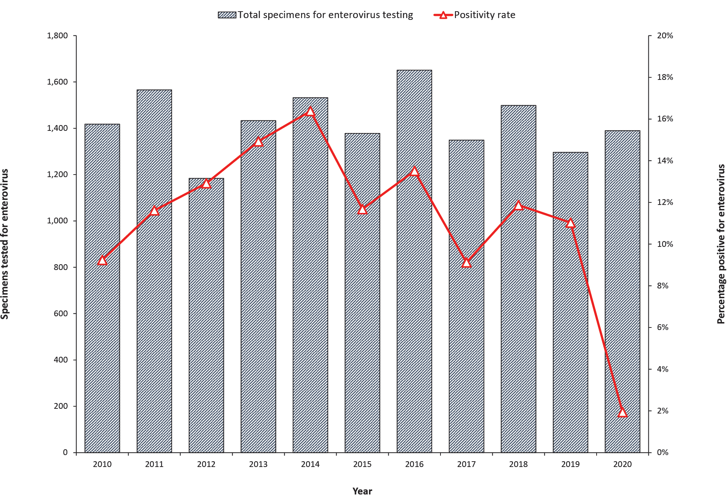

Figure 2: Average number of enterovirus RNA tests by month and the positivity rate for 2010 to 2019,ª compared to tests performed in 2020
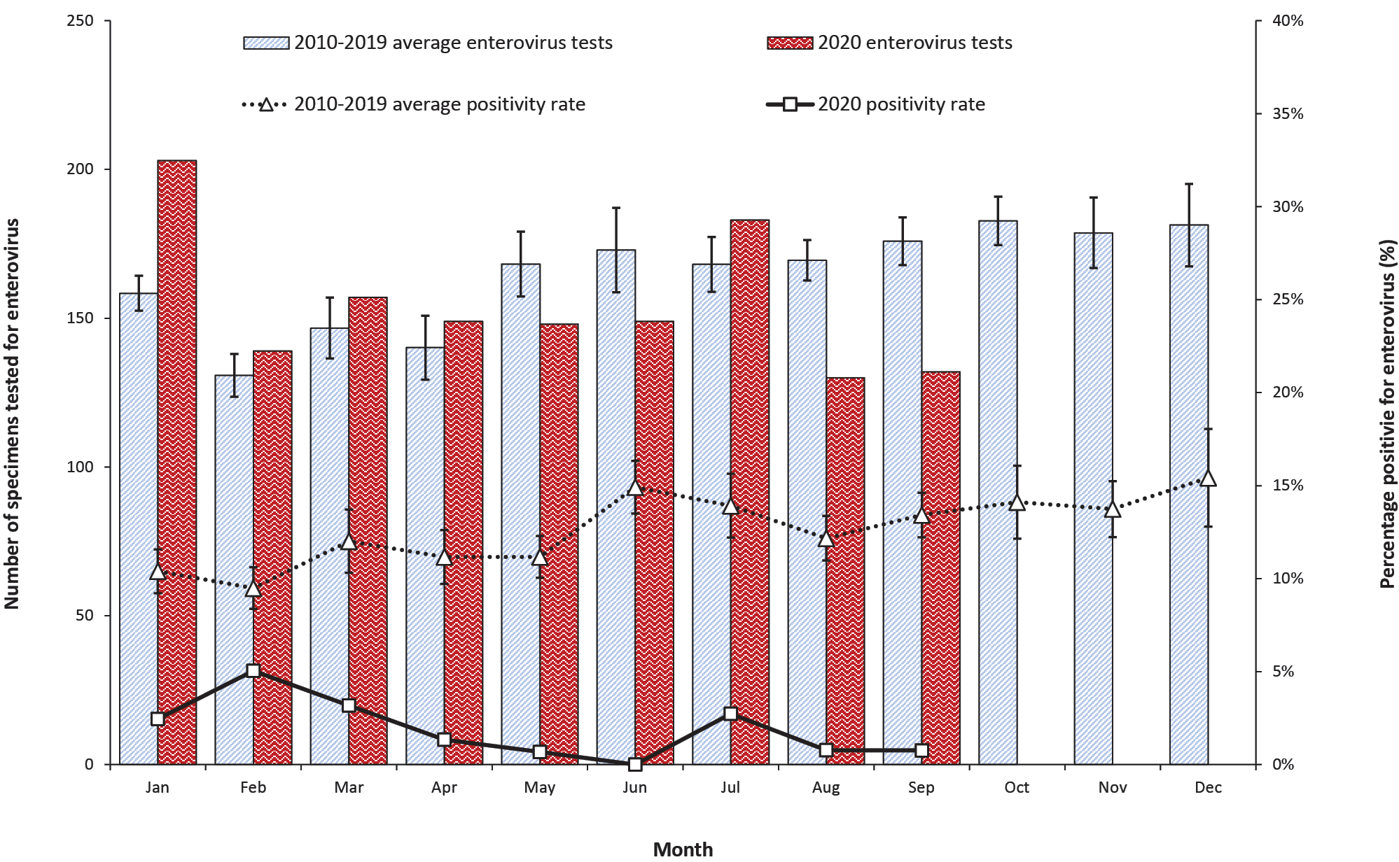
a Error bars represent the standard error of the mean.

Table 1: Average number of specimens tested for enterovirus RNA and the enterovirus positivity rate for January to September 2010–2019, compared to the same period of 2020
 | 2010–2019 |  |  |  | 2020
 | Average number of outbreaks with specimens tested | Average number of outbreaks with norovirus detected | Range of outbreaks with norovirus detections | Average norovirus positivity rate | Number of outbreaks with specimens tested | Number of outbreaks with norovirus detected | Norovirus positivity rate
January | 15.0 | 9.2 | 1–35 | 61.3% | 13 | 8 | 61.5%
February | 11.9 | 5.9 | 3–9 | 49.6% | 13 | 5 | 38.5%
March | 18.3 | 8.4 | 4–15 | 45.9% | 2 | 1 | 50.0%
April | 16.2 | 9.3 | 2–24 | 57.4% | 6 | 1 | 16.7%
May | 20.8 | 12.2 | 1–33 | 58.7% | 5 | 0 | 0.0%
June | 23.3 | 15.7 | 1–40 | 67.4% | 2 | 0 | 0.0%
July | 28.8 | 20.0 | 7–46 | 69.4% | 5 | 1 | 20.0%
August | 26.2 | 17.4 | 6–36 | 66.4% | 2 | 0 | 0.0%
September | 22.8 | 14.7 | 7–28 | 64.5% | 3 | 0 | 0.0%
Total | 183.3 | 112.8 | 64–197 | 61.5% | 51 | 16 | 31.4%

From January 2010 to September 2020 inclusive, VIDRL received faecal specimens from 2,582 gastroenteritis outbreaks for norovirus RT-PCR testing, of which 1,585 outbreaks (61.4%) had norovirus RNA detected in at least one specimen. When the trends in referrals of faecal specimens from gastroenteritis outbreaks and the percentage of outbreaks positive for norovirus were examined for the decade 2010–2019, compared to 2020, a distinct difference was observed (Figure 3). In 2010–2019, the average number of norovirus outbreaks referred each year from January to September was 183.3, but in 2020 it declined to 51, a reduction of 72.2% (Table 2, Figure 4). Additionally, the norovirus positivity rate reduced from an average of 61.5% of outbreaks in January to September in 2010 to 2019, to an average of 31.4% in 2020 (Table 2, Figure 4), a 49.0% reduction (paired two-tailed t-test: p < 0.05).

Table 2: Average number of gastroenteritis outbreaks with specimens tested for norovirus RNA and the norovirus positivity rate for January to September 2010–2019, compared to the same period of 2020
 | 2010–2019 |  |  |  | 2020
 | Average number of specimens tested | Average number of specimens with enterovirus detected | Range of specimen number with enterovirus detections | Average enterovirus positivity rate | Number of specimens tested | Number of specimens with enterovirus detected | Enterovirus positivity rate
January | 158.4 | 16.2 | 8–22 | 10.4% | 203 | 5 | 2.5%
February | 130.8 | 12.8 | 4–26 | 9.5% | 139 | 7 | 5.0%
March | 146.7 | 18.5 | 4–49 | 12.0% | 157 | 5 | 3.2%
April | 140.1 | 16.5 | 5–35 | 11.2% | 149 | 2 | 1.3%
May | 168.2 | 18.7 | 10–32 | 11.2% | 148 | 1 | 0.7%
June | 172.9 | 25.3 | 16–44 | 14.9% | 149 | 0 | 0.0%
July | 168.1 | 24.2 | 9–54 | 13.9% | 183 | 5 | 2.7%
August | 169.5 | 20.4 | 10–31 | 12.2% | 130 | 1 | 0.8%
September | 175.9 | 23.3 | 14–31 | 13.4% | 132 | 1 | 0.8%
Total | 1,430.6 | 175.9 | 123–251 | 12.3% | 1,390 | 27 | 1.9%

Figure 3: Number of gastroenteritis outbreaks with specimens tested and the norovirus RNA positivity rate for January to September each year from 2010 to 2020
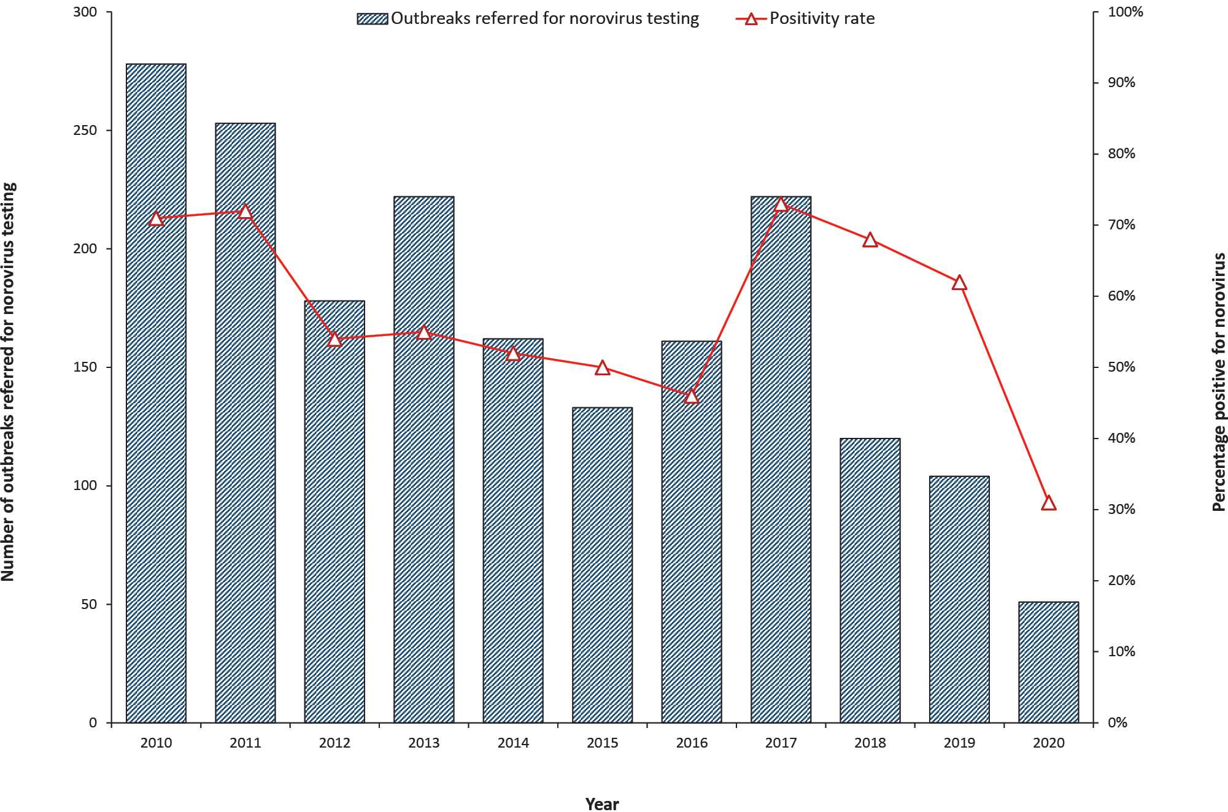

Figure 4: Average number of gastroenteritis outbreaks tested by month for 2010 to 2019,ª compared to the number of outbreaks tested in 2020
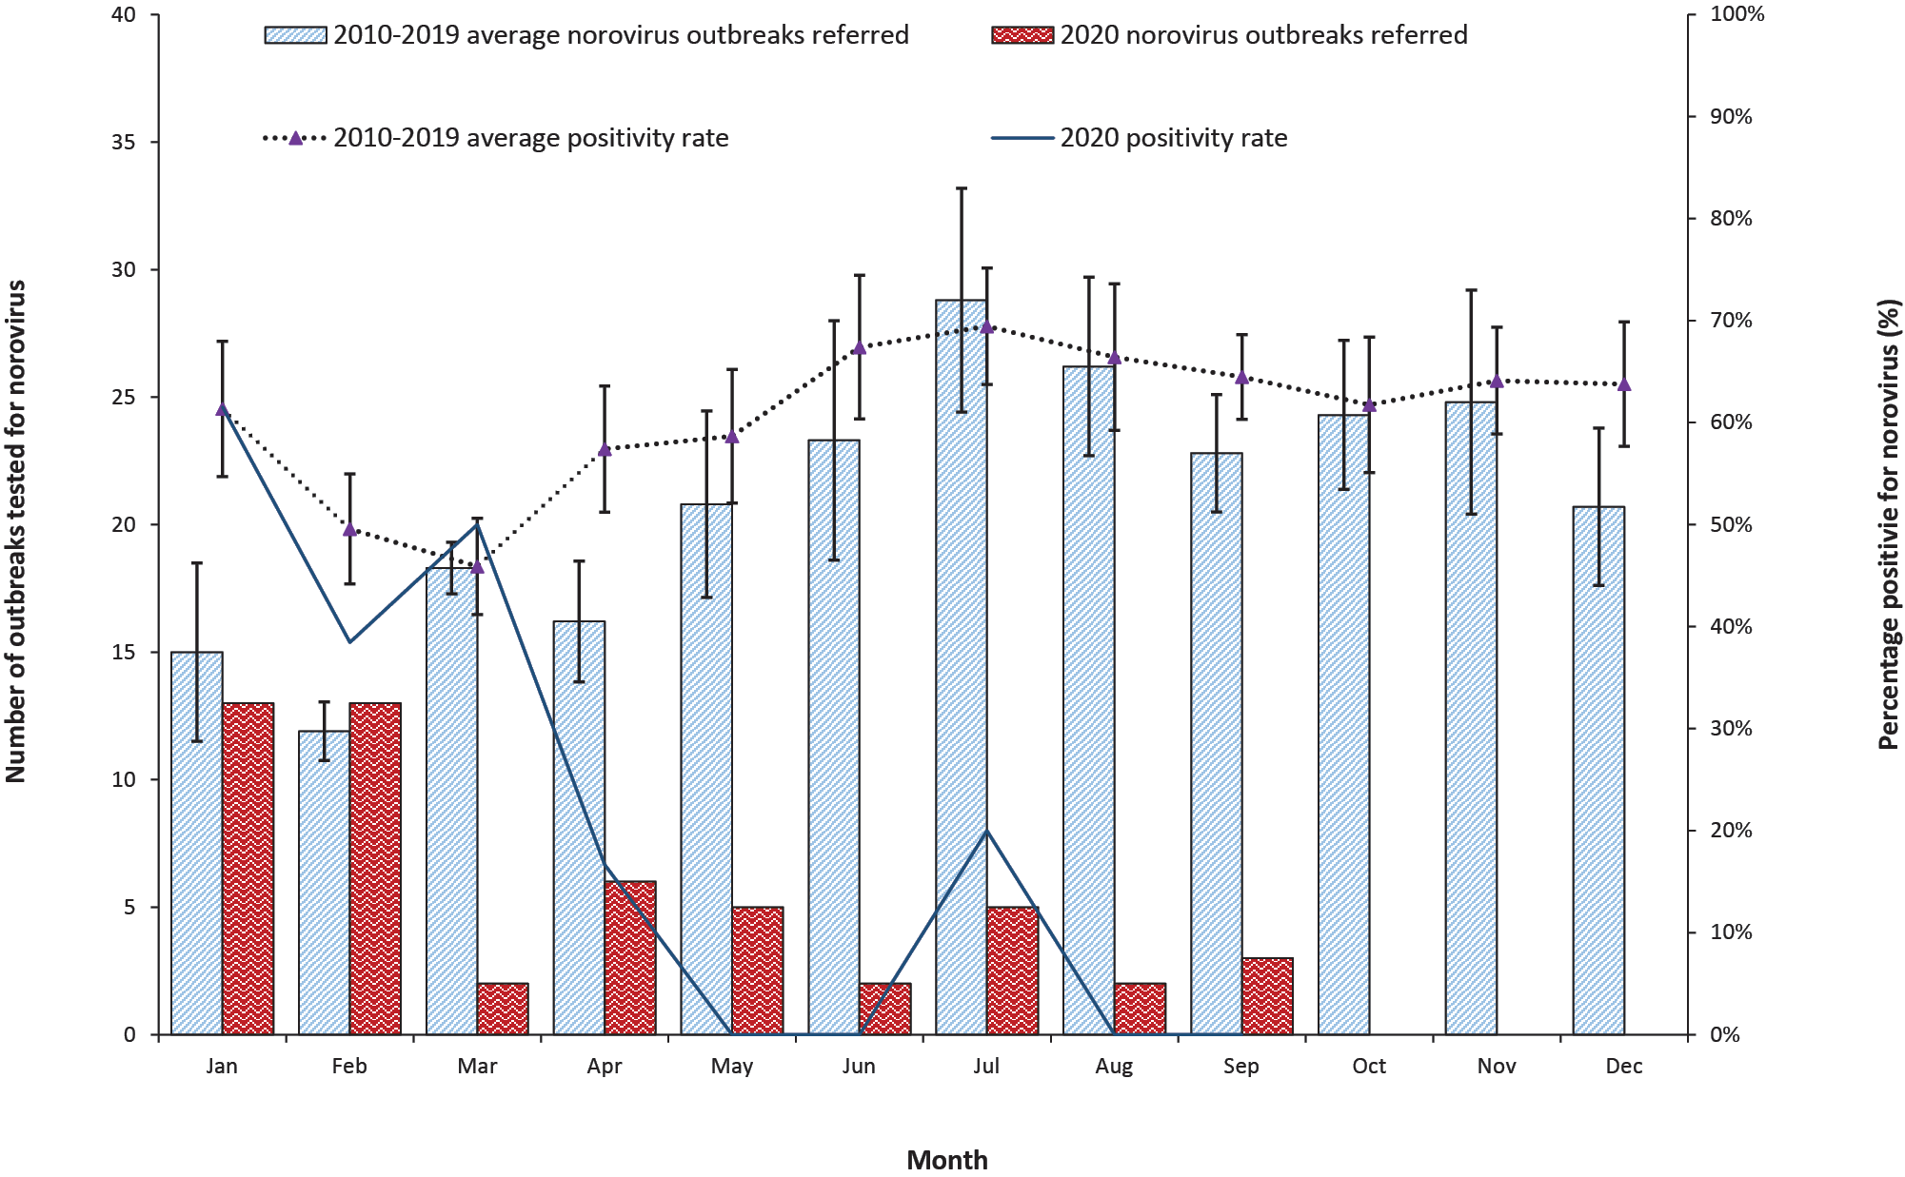
Victoria, and in particular the capital city Melbourne, was under high-level restrictions from 31 March to 31 May 2020, and from 9 July to 30 September 2020, with lower-level restrictions from 1 June to 8 July.¹⁴ High-level restrictions included: all non-essential retail closed; gyms and beauty services closed; restaurants and cafes takeaway only; work from home unless an essential worker; online schooling at home; strict limits on home visits and socialising in public; restrictions on travel between rural and metropolitan areas; and border closures between states. Compulsory mask-wearing in public, nighttime curfew and stay at home orders within a 5 km limit were also a feature of the second round of high-level restrictions imposed from 9 July 2020. Lower-level restrictions included: some non-essential retail open with COVID-safe plans; restaurants and cafes serving a limited number of patrons; work from home if you can; and onsite schooling. Australia’s international borders have been closed since 20 March 2020, except for returning Australian citizens/residents.¹⁵ Communications throughout Australia concerning physical distancing (1.5 m) and hand hygiene have been consistent since the beginning of the pandemic.
While the number of specimens referred for enterovirus testing remained comparable to previous years for January to September 2020, the enterovirus positivity rate was at record low levels from April onwards, coinciding with the imposition of COVID-19 restrictions in Victoria. The overall reduction of 84.2% in the enterovirus positivity rate for 2020 compared to the previous decade was significant. The number of specimens with enterovirus RNA detected from January to March 2020 was low, but still within the range (or close to that) reported across 2010–2019, and continued a trend first noted in November 2019.
Norovirus outbreak referrals for 2020 were down from March compared to 2010–2019, but the norovirus positivity rate reduced sharply from April onwards, with only one norovirus outbreak identified from May to September, coinciding with the initial high-level restrictions. The only previous occurrence of any calendar month with zero norovirus positive outbreaks in the last 20 years was in June 2003. An overall reduction of 49.0% in the positivity rate for norovirus outbreaks in 2020 compared to the previous decade was significant.
This study is limited in the sense that it only examines data from one Australian state, and only one testing site. However, VIDRL is the main testing laboratory for the Victorian Department of Health and Human Services and therefore receives a significant volume of testing referrals for Victorian patients. Further, the ability to compare referrals in 2020 to a decade of previous data reduces this limitation when examining the data for trends.
Enteroviruses and noroviruses, both primarily faecal-oral viruses, have shown a significant reduction in incidence in Victoria, Australia, in 2020 compared to the previous decade. The most likely explanation is the concurrence of social restrictions, physical distancing, personal hygiene awareness and international and domestic border closures resulting from the COVID-19 pandemic in 2020. It remains to be seen whether infectious diseases, other than COVID-19, increase in incidence when restrictions are eased.

Author details
Dr Leesa D Bruggink, Senior Medical Scientist¹
Mr Arnau Garcia-Clapes, Administrative Officer¹
Mr Thomas Tran, Senior Medical Scientist²
Dr Julian D Druce, Laboratory Head²
Dr Bruce R Thorley, Laboratory Head¹
- Enteric Virus Laboratory, Victorian Infectious Diseases Reference Laboratory (VIDRL), Royal Melbourne Hospital, at the Peter Doherty Institute for Infection and Immunity
- Viral Identification Laboratory, Victorian Infectious Diseases Reference Laboratory (VIDRL), Royal Melbourne Hospital, at the Peter Doherty Institute for Infection and Immunity

Corresponding author
Dr Leesa D Bruggink
Victorian Infectious Diseases Reference Laboratory, Royal Melbourne Hospital, at the Peter Doherty Institute for Infection and Immunity, 792 Elizabeth St, Melbourne, Victoria, Australia
Email: leesa.bruggink@vidrl.org.au
Phone: +61 03 93429607

References
- Department of Health and Human Services (DHHS). Media releases. [Internet.] Melbourne: Victoria State Government, DHHS; 2020. [Accessed on 29 October 2020.] Available from: https://www2.health.vic.gov.au/about/media-centre/mediareleases.
- DHHS. Coronavirus update for Victoria – 01 October 2020. [Internet.] Melbourne: Victoria State Government, DHHS; 1 October 2020. [Accessed on 29 October 2020.] Available from: https://www.dhhs.vic.gov.au/coronavirus-update-victoria-01-october-2020.
- Olsen SJ, Azziz-Baumgartnet E, Budd AP, Brammer L, Sullivan S, Pineda RF et al. Decreased influenza activity during the COVID-19 pandemic – United States, Australia, Chile, and South Africa, 2020. MMWR Morb Mortal Wkly Rep. 2020;69(37):1305–9.
- Pallansch MA, Oberste MS, Whitton JL. Enteroviruses: polioviruses, coxsackieviruses, echoviruses, and newer enteroviruses. In Knipe DM, Howley PM, eds. Fields Virology. Volume 1. (Sixth edition.) Philadelphia: Wolters Kluwer Health/Lippincott Williams & Wilkins; 2013, 490–530.
- Papadakis G, Chibo D, Druce J, Catton M, Birch C. Detection and genotyping of enteroviruses in cerebrospinal fluid in patients in Victoria, Australia, 2007–2013. J Med Virol. 2014;86(9):1609–13.
- Roberts JA, Hobday LK, Ibrahim A, Thorley B. Australian National Enterovirus Reference Laboratory annual report, 2018. Commun Dis Intell (2018). 2020;44. doi: https://doi.org/10.33321/cdi.2020.44.26.
- Suresh S, Rawlinson WD, Andrews PI, Stelzer-Braid S. Global epidemiology of nonpolio enteroviruses causing severe neurological complications: A systematic review and meta-analysis. Rev Med Virol. 2020;30(1):e2082. doi: https://doi.org/10.1002/rmv.2082.
- Oberste MS, Pallansch MA. Establishing evidence for enterovirus infection in chronic disease. Ann N Y Acad Sci. 2003;1005:23–31.
- Green KY. Caliciviridae: the noroviruses. In Knipe DM, Howley PM, eds. Fields Virology. Volume 1. (Sixth edition.) Philadelphia: Wolters Kluwer Health/Lippincott Williams & Wilkins; 2013, 582–608.
- Chhabra P, de Graaf M, Parra GI, Chan MCW, Green K, Martella V et al. Updated classification of norovirus genogroups and genotypes. J Gen Virol. 2019;100(10):1393–406.
- Bruggink L, Witlox K, Huang B, Warrilow D, Marshall J. GII.4 norovirus recombinant causes gastroenteritis epidemic in eastern Australia, winter 2017. J Med Virol. 2018;90(6):1168–71.
- Lun JH, Hewitt J, Yan GJH, Tuipulotu DE, Rawlinson WD, White PA. Recombinant GII.P16/GII.4 Sydney 2012 was the dominant norovirus identified in Australia and New Zealand in 2017. Viruses. 2018;10(10):548. doi: https://dx.doi.10.3390/v10100548.
- Dunbar NL, Bruggink LD, Marshall JA. Evaluation of the RIDAGENE real-time PCR assay for the detection of GI and GII norovirus. Diagn Microbiol Infect Dis. 2014;79:317–21.
- DHHS. Media hub – coronavirus (COVID-19). [Internet.] Melbourne: Victoria State Government, DHHS; 2020. [Accessed on 29 October 2020.] Available from: https://www.dhhs.vic.gov.au/media-hub-coronavirus-disease-covid-19.
- Prime Minister of Australia. Border restrictions. Media release 19 Mar 2020. [Internet.] Canberra: Australian Government Department of Prime Minister and Cabinet; 19 March 2020. [Accessed on 13 November 2020.] Available from: https://www.pm.gov.au/media/border-restrictions.

Communicable Diseases Intelligence
ISSN: 2209-6051 Online

Communicable Diseases Intelligence (CDI) is a peer-reviewed scientific journal published by the Office of Health Protection, Department of Health. The journal aims to disseminate information on the epidemiology, surveillance, prevention and control of communicable diseases of relevance to Australia.

Editor: Tanja Farmer
Deputy Editor: Simon Petrie
Design and Production: Kasra Yousefi
Editorial Advisory Board: David Durrheim, Mark Ferson, John Kaldor, Martyn Kirk and Linda Selvey

Website: http://www.health.gov.au/cdi

Contacts
Communicable Diseases Intelligence is produced by:
Health Protection Policy Branch, Office of Health Protection, Australian Government Department of Health
GPO Box 9848, (MDP 6) CANBERRA ACT 2601

Email: cdi.editor@health.gov.au

Submit an Article
You are invited to submit your next communicable disease related article to the Communicable Diseases Intelligence (CDI) for consideration. More information regarding CDI can be found at: http://health.gov.au/cdi.
Further enquiries should be directed to: cdi.editor@health.gov.au.

This journal is indexed by Index Medicus and Medline.

Creative Commons Licence - Attribution-NonCommercial-NoDerivatives CC BY-NC-ND
© 2021 Commonwealth of Australia as represented by the Department of Health
This publication is licensed under a Creative Commons Attribution-NonCommercial-NoDerivatives 4.0 International Licence from https://creativecommons.org/licenses/by-nc-nd/4.0/legalcode (Licence). You must read and understand the Licence before using any material from this publication.

Restrictions
The Licence does not cover, and there is no permission given for, use of any of the following material found in this publication (if any):
- the Commonwealth Coat of Arms (by way of information, the terms under which the Coat of Arms may be used can be found at www.itsanhonour.gov.au);
- any logos (including the Department of Health’s logo) and trademarks;
- any photographs and images;
- any signatures; and
- any material belonging to third parties.

Disclaimer
Opinions expressed in Communicable Diseases Intelligence are those of the authors and not necessarily those of the Australian Government Department of Health or the Communicable Diseases Network Australia. Data may be subject to revision.

Enquiries
Enquiries regarding any other use of this publication should be addressed to the Communication Branch, Department of Health, GPO Box 9848, Canberra ACT 2601, or via e-mail to: copyright@health.gov.au

Communicable Diseases Network Australia
Communicable Diseases Intelligence contributes to the work of the Communicable Diseases Network Australia.
http://www.health.gov.au/cdna

