Australian Meningococcal Surveillance Programme Annual Report, 2020
Monica M Lahra, CR Robert George, Masoud Shoushtari and Tiffany R Hogan for the National Neisseria Network

Abstract
Invasive meningococcal disease (IMD) is a notifiable disease in Australia, and both probable and laboratory-confirmed cases of IMD are reported to the National Notifiable Diseases Surveillance System (NNDSS). In 2020, there were 90 notifications of IMD, the lowest number documented since records began in the NNDSS in 1991. Of these, 97% (87/90) were laboratory-confirmed cases, with 70% (61/87) confirmed by bacterial culture and 30% (26/87) by nucleic acid amplification testing. The serogroup was determined for 85/87 laboratory-confirmed cases of IMD: serogroup B (MenB) accounted for 64% of infections (54/85); MenW for 19% (16/85); MenY for 16% (14/85); and MenC 1.2% (1/85). Fine typing was available on 60/85 (71%) of cases with serogroup determined; of the typed MenW, all were PorA antigen type P1.5,2 and sequence type 11, the hypervirulent strain reported in recent outbreaks in Australia and overseas.
The primary peaks of IMD notifications in Australia in 2020 were observed in infants less than 1 year (16/87, 18%) and in adults aged 45–64 years (14/87, 16%). MenB infections predominated in those aged less than 5 years and 15–19 years; MenW and MenY infections predominated in those aged 45 years or more.
All 61 IMD isolates were tested for antimicrobial susceptibility: none were penicillin resistant; however, 56/61 (92%) had decreased susceptibility to penicillin. All isolates were susceptible to ceftriaxone, ciprofloxacin and rifampicin.
Keywords: antibiotic resistance; disease surveillance; meningococcal disease; Neisseria meningitidis

Introduction
Australia’s National Neisseria Network (NNN) was established in 1979 as a collaborative network of reference laboratories in each state and territory that contribute to the laboratory surveillance of the pathogenic Neisseria: N. meningitidis and N. gonorrhoeae. The NNN has coordinated laboratory data from cases of invasive meningococcal disease (IMD) for the Australian Meningococcal Surveillance Programme (AMSP) since 1994, and is supported by the Australian Government Department of Health and the jurisdictions.¹ The NNN laboratories supply phenotypic and genotypic data to supplement the notification data from the National Notifiable Diseases Surveillance System (NNDSS), which includes cases of probable and laboratory-confirmed IMD.
As recorded by the NNDSS, notifications of IMD in Australia peaked in 2002 at 3.5 cases per 100,000 persons,² with the majority of disease at that time caused by MenB and MenC. In 2003 the introduction of the conjugate serogroup C meningococcal vaccine to the National Immunisation Program (NIP) was followed by significant and sustained reduction of both the number of serogroup C IMD, and the overall notifications to a nadir of 0.6 cases per 100,000 in 2013.^{3,4} After 2013, the IMD notification rate increased to 1.5 cases per 100,000 in 2017,² when MenACWY immunisation programmes were implemented across jurisdictions in targeted age groups. This was followed by a change in the NIP in 2018 substituting monovalent MenC vaccine with the quadrivalent MenACWY vaccine. IMD notifications declined to 1.1 per 100,000 in 2018, and 0.8 per 100,000 in 2019. In 2020, there were 0.3 cases per 100,000 recorded, representing a reduction in disease rate beyond expected vaccine impact and likely attributable to the impact of public health measures implemented in the coronavirus disease 2019 (COVID-19) pandemic. IMD is a rare disease in Australia, but one of public health concern, and continued monitoring of phenotypic and genotypic features of IMD strains is critical to plan and inform clinical management of cases, case clusters and outbreaks of IMD locally and nationally, and for informing and monitoring public health interventions.

Methods

Case confirmation of invasive meningococcal disease
Case confirmation is based on isolation of N. meningitidis, or a positive nucleic acid amplification test (NAAT) from a normally sterile site, defined as laboratory-definitive evidence of IMD according to national case definitions.⁵ Information regarding the site of infection, age and sex of the patients is collated by the NNN for the AMSP.
Invasive N. meningitidis infections are categorised on the basis of the site from which N. meningitidis was isolated, or from which meningococcal DNA was detected (blood, joint fluid, and vitreous fluid). When N. meningitidis is detected from both blood and cerebrospinal fluid (CSF) from the same patient, the case is classified as one of meningitis.

Phenotyping and genotyping of Neisseria meningitidis
Phenotyping is limited to the determination of the serogroup by detection of soluble polysaccharide antigens. Genotyping of both isolates and DNA extracts is performed by sequencing products derived from amplification of the porA gene. Multi-locus sequence typing and clonal complex assignment is also reported by the jurisdictions.

Antibiotic susceptibility testing
Meningococcal isolates were tested to determine their minimum inhibitory concentration (MIC) values for antibiotics used for treatment (ceftriaxone, penicillin), and clearance of carriage (ciprofloxacin and rifampicin). This program has historically reported penicillin testing categories as: susceptible (MIC ≤ 0.03 mg/L); less susceptible (MIC 0.06–0.5 mg/L); and resistant (MIC ≥ 1 mg/L).⁶ Additionally, to monitor across antimicrobial susceptibility testing methods, a distribution of penicillin MIC values is now reported.

Results
In 2020, there were 90 IMD cases notified to the NNDSS, of which 87 were laboratory-confirmed.² Laboratory data were available to the AMSP for all 87 laboratory-confirmed cases of IMD in Australia in 2020, as shown in Figure 1. In 2020, the peak incidence for IMD occurred in summer and early autumn (1 January to 31 March) (Table 1).

Figure 1: Number of invasive meningococcal disease cases reported to the National Notifiable Diseases Surveillance System compared with laboratory-confirmed data from the Australian Meningococcal Surveillance Programme, Australia, 1991-2020
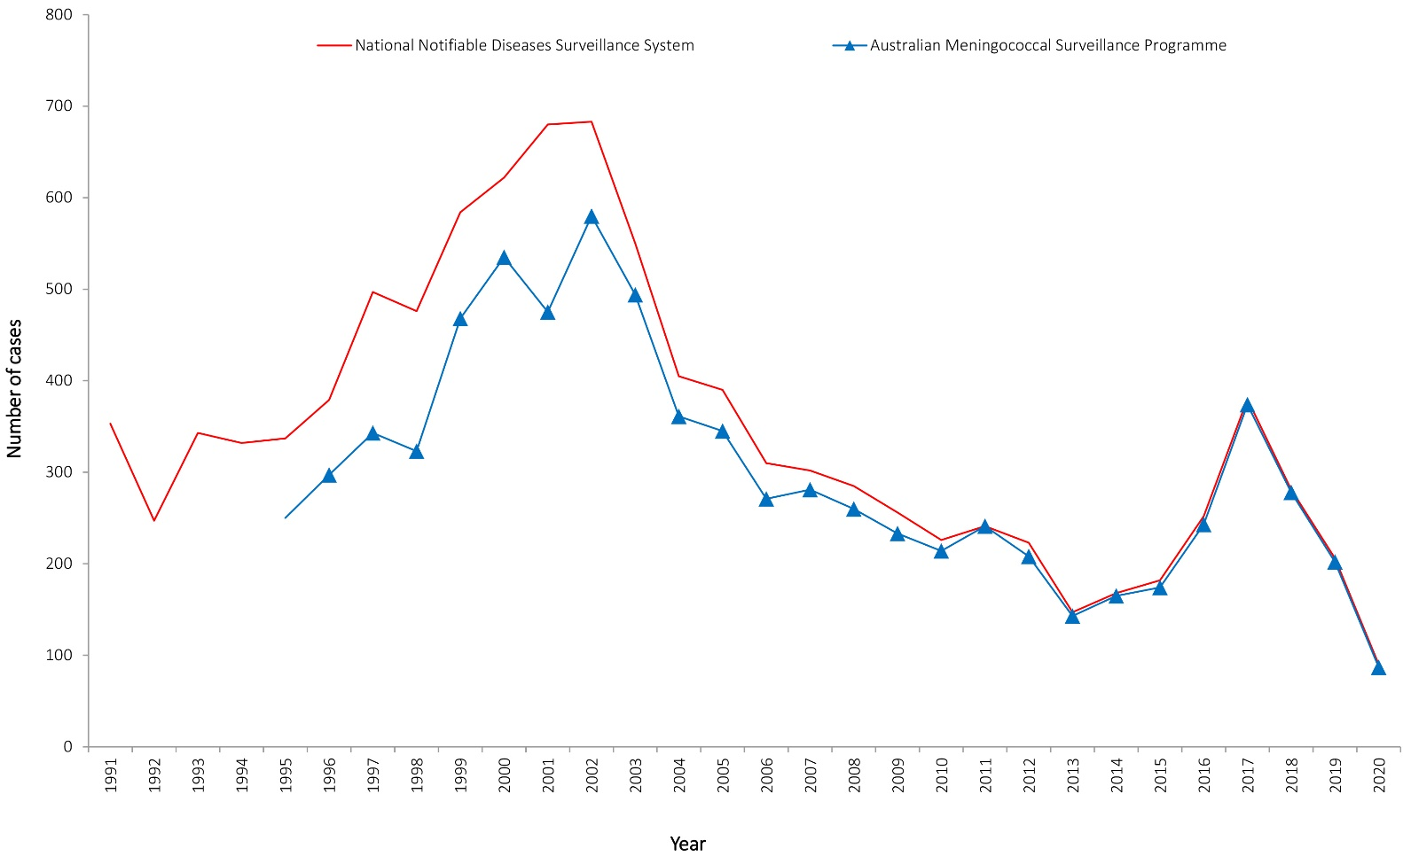
Table 1: Laboratory-confirmed cases of invasive meningococcal disease, Australia, 2020
IMD  serogroup  2020 | 1 January – 31 March | 1 April – 30 June | 1 July – 30 September | 1 October– 31 December | 2020 total
B | 15 | 11 | 14 | 14 | 54
C | 0 | 0 | 0 | 1 | 1
Y | 7 | 0 | 3 | 4 | 14
W | 7 | 5 | 4 | 0 | 16
NDª | 2 | 0 | 0 | 0 | 2
Total | 31 | 16 | 21 | 19 | 87
a ND: unknown / not determined.
In 2020 there was a decrease in notifications of IMD across jurisdictions compared with 2019. Whilst Queensland reported the highest number of cases (27 cases), this was a decrease from 58 cases in 2019; New South Wales had the second-highest number of cases (21), a decrease from 70 cases in 2019. The number of cases from each jurisdiction for 2020 is shown in Table 2.
Table 2: Number of laboratory-confirmed cases of invasive meningococcal disease, Australia, 2020, by state or territory and serogroup
State/territory | Serogroups
 | B | C | Y | W | NDª | Total
Australian Capital Territory | 0 | 0 | 0 | 1 | 0 | 1
New South Wales | 17 | 0 | 2 | 2 | 0 | 21
Northern Territory | 1 | 0 | 0 | 0 | 0 | 1
Queensland | 17 | 0 | 6 | 4 | 0 | 27
South Australia | 3 | 0 | 2 | 0 | 0 | 5
Tasmania | 3 | 0 | 0 | 0 | 0 | 3
Victoria | 11 | 0 | 1 | 4 | 2 | 18
Western Australia | 2 | 1 | 3 | 5 | 0 | 11
Australia | 54 | 1 | 14 | 16 | 2 | 87
% | 62.1 | 1.1 | 16.1 | 18.4 | 2.3
a ND: unknown / not determined.

Age distribution
The peak incidence of IMD in 2020 depicted a bimodal pattern in infants less than one year old (18%; 16/87) and in adults aged 45 to 64 years, comprising 16% (14/87) of IMD cases in 2020 (Table 3). In 2020, 29% of IMD (25/87) occurred in children less than 5 years of age. Between 2003 and 2014, the proportion of IMD occurring in children aged less than 5 years ranged from 28% to 36% of cases. Since 2015, in Australia the proportion of IMD in children less than 5 years of age has ranged from 21% to 27%.
Table 3: Laboratory-confirmed cases of invasive meningococcal disease, Australia, 2020, by age and serogroup, and the proportion of IMD attributable to MenB
Serogroup | Age group (years) |  |  |  |  |  |  |  |  | Total
 | < 1 | 1–4 | 5–9 | 10–14 | 15–19 | 20–24 | 25–44 | 45–64 | 65+
B | 15 | 9 | 4 | 1 | 8 | 5 | 5 | 6 | 1 | 54
C | 0 | 0 | 0 | 0 | 0 | 0 | 1 | 0 | 0 | 1
Y | 1 | 0 | 0 | 1 | 1 | 1 | 1 | 2 | 7 | 14
W | 0 | 0 | 1 | 1 | 0 | 1 | 3 | 6 | 4 | 16
ND | 0 | 0 | 0 | 0 | 1 | 1 | 0 | 0 | 0 | 2
Total | 16 | 9 | 5 | 3 | 10 | 8 | 10 | 14 | 12 | 87
%B within age group | 94 | 100 | 80 | 33 | 80 | 63 | 50 | 43 | 8 | 62

Samples from laboratory-confirmed cases
In 2020, diagnosis was confirmed by a positive bacterial culture in 70% of cases of IMD (61/87); and for 30% (26/87), IMD was confirmed by NAAT testing alone (Table 4). There were 23 diagnoses of meningitis and 63 diagnoses of septicaemia (Table 4). Additionally, there was one further IMD diagnosis confirmed from a joint fluid aspirate (Table 4).
Table 4: Number of laboratory-confirmed cases of invasive meningococcal disease, Australia, 2020, by specimen type and method of confirmation
Specimen | Bacterial culture | Nucleic Acid Amplification Test | Total
Blood | 55 | 8 | 63
CSF +/- Blood | 6 | 17 | 23
Otherª | 0 | 1 | 1
Total | 61 | 26 | 87
a Other specimen: joint aspirate (1).

Notifications and proportion of MenB, MenC, MenW and MenY IMD
Serogrouping was determined for 85/87 laboratory-confirmed cases of IMD (Tables 2 and 3), with MenB accounting for 62% of all IMD in Australia in 2020. With respect to serogroup infections by age group, as shown in Table 3, MenB IMD was the predominant serogroup in children aged 4 years and younger (24/25; 96%) and in older teenagers and adolescents (15–19 years; 8/10; 80%). MenB accounted for the majority of disease across most age groups however with only one notification in 65 years and older (1/12; 8%). By contrast MenW (13/16; 81%) and MenY (10/14; 71%) disease predominated in cases 25 years and older.
New South Wales and Queensland each reported the equal-largest number of MenB IMD notifications (17/54), each accounting for 31% of MenB IMD in 2020. New South Wales was the state with the highest proportion of MenB, with this serotype accounting for 81% of its cases (17/21) (Table 2). In the years 2006–2012, the proportion of IMD cases caused by MenB was 84%–88% nationwide; in 2013–2014 it was lower (75–80%); in 2015 it was 64%, falling to 36% in 2016–2017. There was an increase in attributable proportion in 2018 to 44%, in 2019 to 50%, and the proportion has again increased to 62% of IMD cases reported (Figure 2).

Figure 2: Proportion of serogroups of laboratory-confirmed invasive meningococcal disease, Australia, 2000–2020 by year
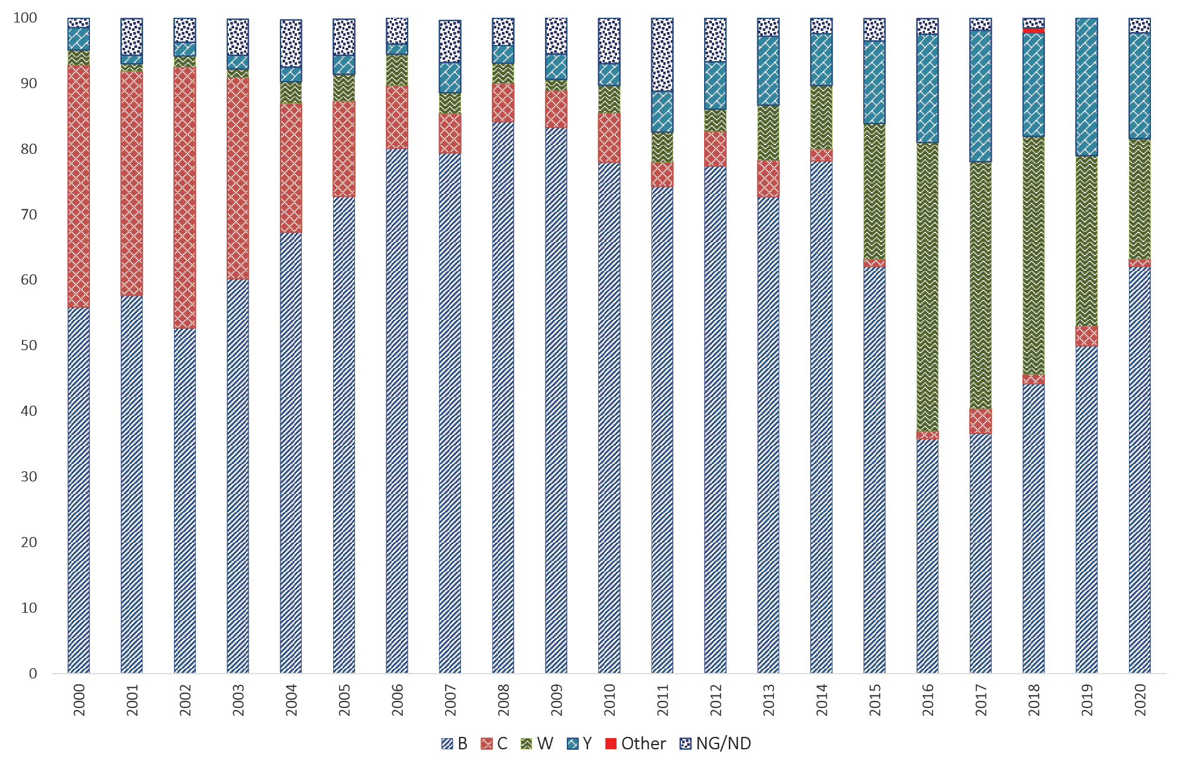
There was one notification nationally of MenC IMD in 2020, from Western Australia, lower than the six cases of MenC IMD reported in Australia in 2019 (Table 3, Figure 3).⁷

Figure 3: Number of serogroups B, C, Y and W cases of laboratory-confirmed invasive meningococcal disease, Australia, 2020, by age
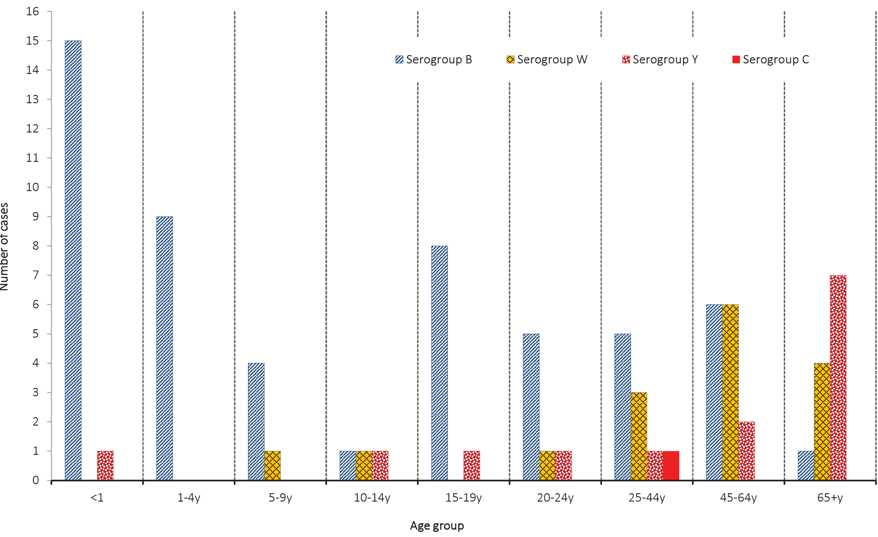
The rise in IMD notifications in Australia since 2014 was due to an increasing number of infections of both MenW and MenY, as shown in Figure 1 and Figure 2. Prior to 2015, the proportion of cases of IMD caused by MenW was low, ranging from 1.1 to 4.8% in 1997–2012, then increasing to 8.4–9.7% in 2013–2014. In 2015 it was 21%; in 2016 it was 44%; in 2017–2018 it was 36–38%; it continued to decline to 26% in 2019, as shown in Figure 2. In 2020 there were 16/87 MenW infections accounting for 18% of IMD overall. IMD caused by MenW was sporadic in children and adolescents, but was the predominant cause of IMD in the older age groups in 2020. Of all IMD infections in 2020 in those aged 45 years and older, 10/26 (38%) were MenW.
A similar pattern and trend was seen in the number and proportion of IMD caused by MenY in 2020 (n = 14; 16% of total IMD). Prior to 2015, the proportion of cases of IMD caused by MenY ranged from 1.3 to 4.6% in the period 1997–2010; then 6.2–10.5% in 2011–2014. In 2015 the proportion rose to 12.6%, increasing to 16.5% in 2016 and again to 20% in 2017. The proportion was lower in 2018 (15.8%) and in 2019 increased to 21% (Figure 2). Nine of the 14 MenY IMD (64%) reported in 2020 were in those aged 45 years and older.
Of the 14 cases of IMD caused by MenY in 2020, Queensland reported the largest number (6/14 notifications in 2020). MenY was reported in all jurisdictions excepting the Australian Capital Territory, the Northern Territory, and Tasmania (Table 2). MenY IMD was reported in all age groups in 2020, excepting those aged 1 to 9 years (Table 3, Figure 3).

Genotyping
In 2020, genotyping was possible for 69% of IMD laboratory confirmed cases (60/87); results are shown in Figure 4, Figure 5, and Table 5. There were 33/60 MenB typed; the predominant porA types in 2020 were P1.7,16-26 (7 cases; 21%) and P1.22,14 (6 cases; 18%). The porA type P1.7-2,4, the predominant type in previous years, only accounted for 4/33 (12%) of MenB cases able to be typed in 2020 (Figure 4). There was one MenC IMD in 2020 from Western Australia, of the porA type P1.5,2 (Table 5). For serogroup W IMD with typing information available (13/16 cases, 81%), all were of the single genotype P1.5,2 (Figures 5 and Table 5). The porA type P1.5,2 has been the predominant genotype in recent years, from the clonal complex 11, the same strain type as the hypervirulent serogroup W strain also reported in the United Kingdom and South America since 2009 (Table 6).^{8,9} For MenY IMD, of the 13 cases with typing information available, the predominant genotype was P1.5-1,10-1 (8/13 able to be typed; 62%), as has been reported since 2014, when the increase in serogroup Y IMD was first noted in Australia (Figure 5).
Figure 4: Number of porA genotypes for MenB in laboratory-confirmed cases of invasive meningococcal disease Australia, 2020
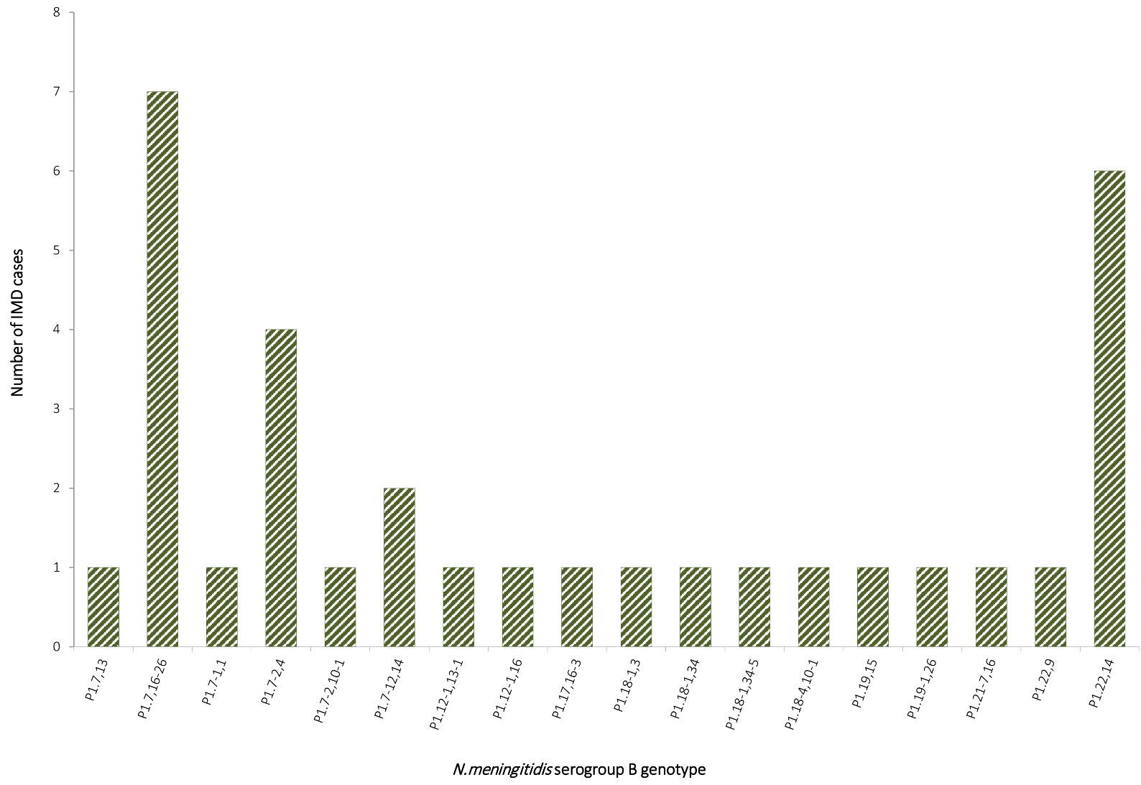

Figure 5: Number of porA genotypes for MenW and MenY IMD in laboratory-confirmed cases of invasive meningococcal disease, Australia, 2020
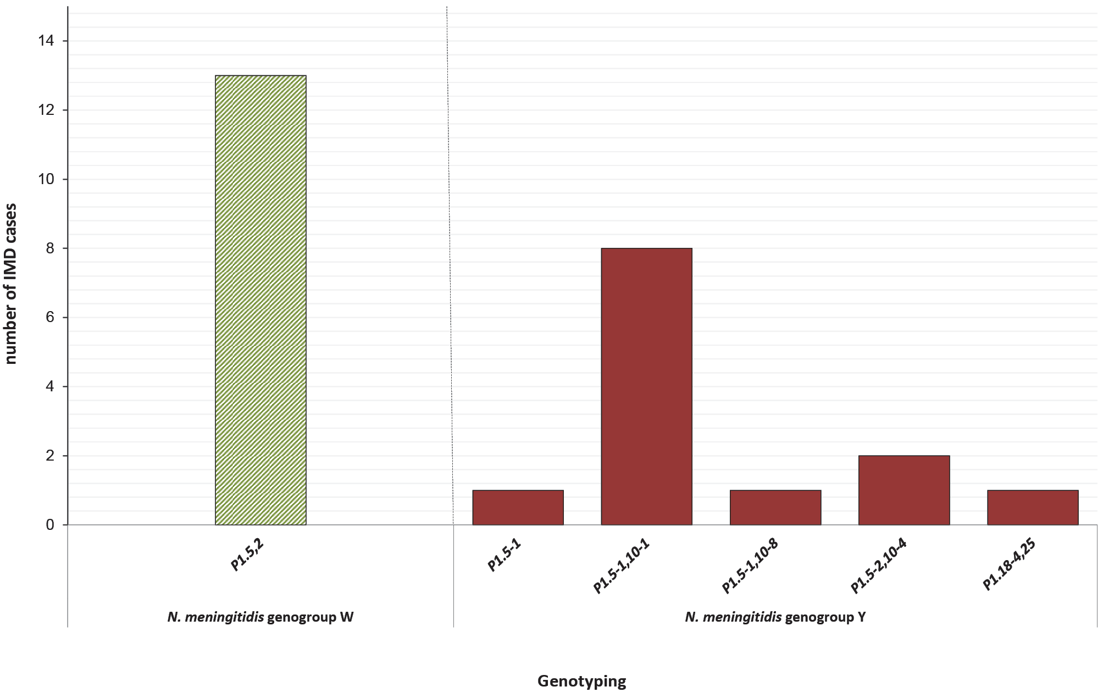

Table 5: Distribution of porA genotype laboratory-confirmed cases of invasive meningococcal disease, Australia, 2020, by state or territory
2020 AMSP |  | Number per serogroup per state / territory
GENOGROUP | GENOTYPE PorA | NSW | QLD | VIC | SA | WA | ACT | TAS | NT
W | P1.5,2 | 0 | 4 | 4 | 0 | 5 | 0 | 0 | 0
C | P1.5,2 | 0 | 0 | 0 | 0 | 1 | 0 | 0 | 0
Y | P1.5-1 | 0 | 0 | 0 | 1 | 0 | 0 | 0 | 0
Y | P1.5-1,10-1 | 2 | 3 | 1 | 1 | 1 | 0 | 0 | 0
Y | P1.5-1,10-8 | 0 | 1 | 0 | 0 | 0 | 0 | 0 | 0
Y | P1.5-2,10-4 | 0 | 1 | 0 | 0 | 1 | 0 | 0 | 0
B | P1.7,13 | 0 | 1 | 0 | 0 | 0 | 0 | 0 | 0
B | P1.7,16-26 | 0 | 3 | 3 | 0 | 1 | 0 | 0 | 0
B | P1.7-1,1 | 0 | 0 | 1 | 0 | 0 | 0 | 0 | 0
B | P1.7-2,4 | 1 | 1 | 1 | 1 | 0 | 0 | 0 | 0
B | P1.7-2,10-1 | 0 | 1 | 0 | 0 | 0 | 0 | 0 | 0
B | P1.7-12,14 | 0 | 2 | 0 | 0 | 0 | 0 | 0 | 0
B | P1.12-1,13-1 | 0 | 0 | 1 | 0 | 0 | 0 | 0 | 0
B | P1.12-1,16 | 0 | 1 | 0 | 0 | 0 | 0 | 0 | 0
B | P1.17,16-3 | 0 | 1 | 0 | 0 | 0 | 0 | 0 | 0
B | P1.18-1,3 | 0 | 0 | 1 | 0 | 0 | 0 | 0 | 0
B | P1.18-1,34 | 0 | 1 | 0 | 0 | 0 | 0 | 0 | 0
B | P1.18-1,34-5 | 0 | 0 | 1 | 0 | 0 | 0 | 0 | 0
B | P1.18-4,10-1 | 0 | 1 | 0 | 0 | 0 | 0 | 0 | 0
Y | P1.18-4,25 | 0 | 0 | 0 | 0 | 1 | 0 | 0 | 0
B | P1.19,15 | 0 | 1 | 0 | 0 | 0 | 0 | 0 | 0
B | P1.19-1,26 | 0 | 1 | 0 | 0 | 0 | 0 | 0 | 0
B | P1.21-7,16 | 0 | 0 | 0 | 0 | 0 | 0 | 1 | 0
B | P1.22,9 | 0 | 0 | 1 | 0 | 0 | 0 | 0 | 0
B | P1.22,14 | 0 | 3 | 1 | 0 | 0 | 0 | 2 | 0

Table 6: Laboratory-confirmed cases of MenW invasive meningococcal disease, Australia, 2020, by sequence type (ST)
Sequence type | MenW genotype
 | P1.5,2 | P1.5,2-67 | P1.5-1,2-2 | P1.5-1,10-4 | Total
ST 11 | 13 | 0 | 0 | 0 | 13
ST 1287 | 0 | 0 | 0 | 0 | 0
ST 13135 | 0 | 0 | 0 | 0 | 0
Not determined | 0 | 0 | 0 | 0 | 0
Total | 13 | 0 | 0 | 0 | 13

Antibiotic susceptibility testing
Isolates of N. meningitidis are tested against both treatment (ceftriaxone and penicillin) and clearance antibiotics (rifampicin and ciprofloxacin). In 2020, seventy percent of laboratory-confirmed IMD (61/87) had N. meningitidis cultured, permitting antimicrobial susceptibility testing (AST) to be performed by the NNN laboratories. Ceftriaxone susceptibility testing was performed on all 61 isolates and all were susceptible in 2020. With regards to penicillin, the distribution of penicillin MIC values is shown in Table 7. Eight percent of IMD isolates (5/61) were fully susceptible to penicillin (MIC ≤ 0.03 mg/L); and 92% (56/61) less susceptible to penicillin (MIC 0.064–0.5 mg/L). Of the isolates tested, 8/61 (13%) had a penicillin MIC of 0.5 mg/L, which is close to the MIC breakpoint for resistance; 7/8 (88%) of these were MenW. In recent years, MenW has demonstrated higher penicillin MIC values and higher proportions of resistance. In 2020, none of the 61 IMD isolates tested were resistant to penicillin (MIC ≥ 1 mg/L). The proportion of penicillin resistance in all IMD isolates has gradually declined since 2016 at 5.8%, to 5.1% in 2017, then to 1.4% in 2018 and 0.6% in 2019 as shown in Figure 6. Regarding the clearance antibiotics for IMD, all 61 isolates were susceptible to ciprofloxacin and rifampicin.
Table 7: Penicillin MIC distribution of laboratory-confirmed invasive meningococcal disease isolates, Australia, 2020
Penicillin MIC distribution
MIC mg/L | ≤0.032 | 0.064 | 0.125 | 0.25 | 0.5 | 1 | 2 | ≥4 | Total
Number of isolates | 5 | 16 | 11 | 21 | 8 | 0 | 0 | 0 | 61
% | 8 | 26 | 18 | 34 | 13 | 0 | 0 | 0 | 100

Figure 6: Proportion of penicillin-susceptible, less susceptible and resistant invasive meningococcal disease isolates, Australia, by year
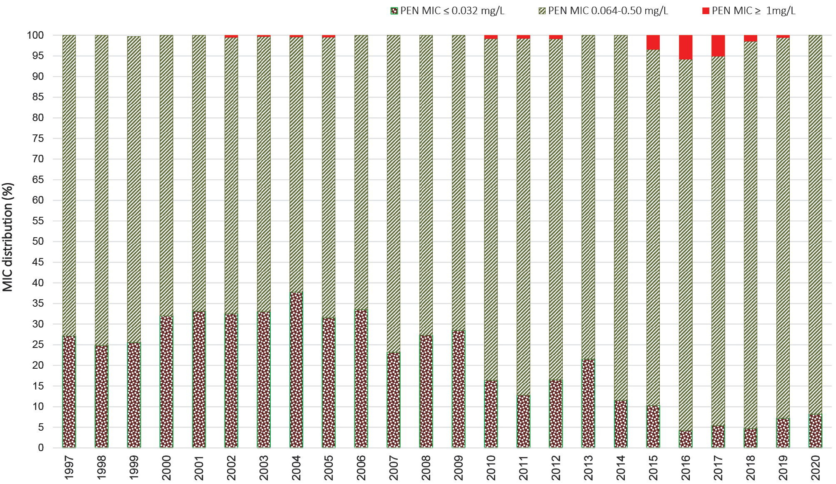

Discussion
In 2020, 97% of IMD notifications in Australia (87/90) were laboratory confirmed,³ a similar proportion to previous years. Notably in 2020, there was an overall decrease in notifications of IMD by 57% when compared with 2019, coincident with widespread public health initiatives designed to reduce COVID-19 transmission. These included social and personal distancing, hand hygiene and cough etiquette, use of masks, restrictions to travel and access to aged care and hospitals. Notifications of influenza were also reduced, of relevance as antecedent infection is a risk factor for IMD.
In Australia in 2016–2017, increased notifications of MenW and MenY IMD prompted time-limited, jurisdictional MenACWY vaccination programs for target age groups.^{4,10} In July 2018, the NIP replaced MenC vaccine at 12 months of age with a quadrivalent ACWY vaccine. There followed a decrease in both notifications and proportion of MenW and MenY disease, accompanied by a gradual increase in the proportion of disease caused by MenB (from 44 to 50% in 2018–2019 to 62% in 2020). Prior to the introduction of the MenC vaccine in 2003 in Australia, the proportion of MenB IMD was 84–88% in the years 2006–2012 then declining. Notifications of IMD subsequently increased with the emergence of MenW and MenY disease since 2014 in Australia.⁴
With regards to serogroup infections by age group: MenB accounted for majority of disease in all age groups (range 50–100%) excepting the age groups of 10–14 years and 45 years and older, where in the latter age group MenW and MenY were in the majority. A recombinant multi-component meningococcal B vaccine has been available in Australia since 2014,¹¹ although this vaccine is not currently on the NIP. MenW caused 18% (16/87) of IMD in Australia, a decrease from 26% in 2019, and of these MenW IMD cases, 13/16 (81%) ccurred in those aged 25 years and older. In 2020, MenY accounted for 16% of IMD nationally (14/87), and was reported sporadically across age groups; however, 9/14 MenY IMD cases (64%) were reported in those aged 45 years and older. The primary peak of IMD notifications was observed in infants less than 5 years (25/87; 29%), with this peak due primarily to MenB (96%).
With regards to prevailing IMD serogroups and genotypes, the number of IMD cases caused by MenB in 2020 was less than in 2019, although the proportion was higher (54/87, 62%, in 2020, compared with 101/202, 50%, in 2019). New South Wales and Queensland reported the largest equal numbers of MenB notifications, however, South Australia continues to report the highest proportion of MenB, with the exception of Tasmania where all three IMD notifications in 2020 were MenB. The predominant MenB genotype in Australia is P1.7,16-26 (7/33), followed by genotype P1.22,14 (6/33), marking a change from recent years; the previous dominant MenB genotype, P1.7-2,4, now accounts for 4/33 of MenB IMD.
The predominant circulating strain of MenW continues to be genotype P1.5,2 sequence type (ST) 11. This same MenW strain previously emerged in the United Kingdom (UK) and South America in 2009,^{8,9} and spread to account for 25% of IMD in the UK in 2014–2015 and 59% of all cases in Chile in 2012. MenW ST11 is hypervirulent and associated with atypical clinical presentations, more severe disease, and a higher case fatality rate.⁹ The initial increase in MenW overseas and in Australia was seen in older adults, but was subsequently reported in all age groups, particularly in adolescents and infants.¹² The predominant MenY genotype since 2014 continues to be P1.5-1,10-1; whereas previously MenY genotype distribution had been more heterogeneous.¹³
Antimicrobial susceptibility testing of IMD isolates in 2020 demonstrated no penicillin resistance in clinical isolates. The incidence of penicillin resistance in N. meningitidis in Australia was less than 1% annually of IMD isolates tested in 1996–2014, rising to 3.4% in 2015; 5.8% in 2016; and 5.1% in 2017; and decreasing to 0.6% in 2019. The majority of penicillin-resistant meningococcal isolates are MenW.
However, the proportion of IMD isolates less susceptible to penicillin has been increasing from 62–75% in 1996–2006; 67–79% in 2007–2009; 78–88% in 2010–2015; 90–94% in 2016–2019; and 92% in 2020. All IMD isolates tested in 2020 were susceptible to ceftriaxone, ciprofloxacin and rifampicin.
There has been an ongoing decrease in IMD notifications from 1.5 cases per 100,000 in 2017; to 1.1 per 100,000 in 2018; 0.8 cases per 100,000 in 2019; and 0.3 cases per 100,000 in 2020. The year 2020 has also seen a decrease in the proportion of isolates attributable to MenW and MenY. This was coincident both with widespread public health initiatives designed to reduce COVID-19 transmission and following changes in the NIP. The NNN is continuing to lead further investigations with the Australian Government Department of Health and is closely monitoring the phenotypic and genotypic features of N. meningitidis causing IMD in Australia. Additional investigations by the NNN, including whole genome sequencing of IMD isolates, are in progress to enhance IMD surveillance in Australia. The AMSP data are used for informing treatment guidelines and disease prevention strategies; and to monitor the effect of interventions.

Acknowledgements
Meningococcal isolates were received in the reference centres from many laboratories throughout Australia. The considerable time and effort involved in forwarding these isolates is recognised and these efforts are greatly appreciated. These data could not have been provided without this assistance and the help of clinical colleagues and public health personnel. The Australian Government Department of Health provided funding for the National Neisseria Network.
Members of the AMSP in 2020, to whom isolates and samples should be referred, and enquiries directed, are listed below.

Australian Capital Territory
P Collignon, S Bradbury Microbiology Department, The Canberra Hospital, Gilmore Crescent, Garran ACT 2605 Telephone: +61 2 6244 2510 Email: peter.collignon@act.gov.au

New South Wales
MM Lahra, EA Limnios, TR Hogan, RL Kundu, J El Nasser, S Ray, M Shoushtari Microbiology Department, New South Wales Health Pathology, The Prince of Wales Hospital, Barker Street, Randwick NSW 2031 Telephone: +61 2 9382 9084 Facsimile: +61 2 9382 9310 Email: monica.lahra@health.nsw.gov.au
M Maley, R Porritt Department of Microbiology and Infectious Diseases, New South Wales Health Pathology, Liverpool Hospital, Locked Mail Bag 7090, Liverpool BC NSW 1871 Telephone: +61 8738 5124 Facsimile: +61 2 8738 5129 Email: Joanne.Mercer@sswahs.nsw.gov.au or Robert.Porritt@sswahs.nsw.gov.au

Northern Territory
R Baird, K Freeman Microbiology Department, Territory Pathology, Royal Darwin Hospital, Rocklands Drive. Tiwi NT 0810 Telephone: +61 8 8922 8167 Facsimile: +61 8 8922 7788 Email: rob.baird@nt.gov.au

Queensland
S Schlebusch, H Smith, V Hicks, A. Jennison Public Health Microbiology, Queensland Health Forensic and Scientific Services, 39 Kessels Road, Coopers Plains Qld 4108 Telephone: +61 7 3096 2825 Facsimile: +61 7 3096 2973+61 7 3274 9175 Email: Amy.Jennison@health.qld.gov.au

South Australia
I Bastian, A Lawrence, J Holds SA Pathology, Royal Adelaide Hospital Site, Microbiology and Infectious Diseases,Royal Adelaide Hospital, North Terrace, Adelaide, SA 5000 Telephone: +61 8 8222 3335 Facsimile: +61 8 2223543 Email: andrew.lawrence@health.sa.gov.au

Tasmania
L Cooley, B McEwan Department of Microbiology and Infectious Diseases, Royal Hobart Hospital, 48 Liverpool Street, Hobart Tasmania 7000 Telephone: +61 3 6222 8656 Email: belinda.mcewan@dhhs.tas.gov.au

Victoria
B Howden, K Stevens Microbiological Diagnostic Unit Public Health Laboratory, Department of Microbiology and Immunology, The Peter Doherty Institute, The University of Melbourne, Parkville Victoria 3052 Telephone: +61 3 8344 5713 Facsimile: +61 3 8344 7833 Email: kerries@unimelb.edu.au

Western Australia
D Speers, J Bew Department of Microbiology, QEII Medical Centre, PP Block Level 5, PathWest Laboratory Medicine WA, Hospital Avenue, Nedlands, WA 6009 Telephone: +61 8 6383 4501 Facsimile: +61 8 9382 8046 Email: jane.bew@health.wa.gov.au

Author details
Monica M Lahra^{1, 2}
CR Robert George³
Masoud Shoushtari¹
Tiffany R Hogan¹
- World Health Organisation Collaborating Centre for STI and AMR, Sydney and Neisseria Reference Laboratory, Department of Microbiology, New South Wales Health Pathology, The Prince of Wales Hospital, Randwick, 2031, NSW Australia.
- School of Medical Sciences, Faculty of Medicine, The University of New South Wales, NSW, 2052 Australia
- New South Wales Health Pathology, John Hunter Hospital, Newcastle, 2300, NSW Australia

Corresponding author
Professor Monica Lahra,
Director, Microbiology Department, Neisseria Reference Laboratory and WHO Collaborating Centre for STI and AMR, New South Wales Health Pathology, Level 4, Campus Centre, The Prince of Wales Hospital, RANDWICK NSW, 2031.
Email: monica.lahra@health.nsw.gov.au

References
- National Neisseria Network. Meningococcal Isolate Surveillance Australia 1994. Commun Dis Intell. 1995;19(12):286–9.
- Australian Government Department of Health. National Notifiable Disease Surveillance System. [Webpage.] Canberra: Australian Government Department of Health; 2020. Available from: http://www9.health.gov.au/cda/source/cda-index.cfm.
- National Notifiable Diseases Surveillance System (NNDSS). Number of notifications of Meningococcal disease (invasive), received from State and Territory health authorities in the period of 1991 to 2012 and year-to-date notifications for 2014. [Webpage.] Canberra: Australian Government Department of Health, NNDSS; 2021. Available from: http://www9.health.gov.au/cda/source/rpt_4_sel.cfm.
- Australian Government Department of Health. Invasive meningococcal disease. [Internet.] Canberra: Australian Government Department of Health; 20 March 2020. Available from: https://www1.health.gov.au/internet/main/publishing.nsf/Content/ohp-meningococcal-W.htm.
- Australian Government Department of Health. Invasive meningococcal disease: CDNA national guidelines for public health units. [Internet.] Canberra: Australian Government Department of Health; 4 July 2017. Available from: http://www.health.gov.au/internet/main/publishing.nsf/content/cdna-song-imd.htm.
- Tapsall JW, Shultz T, Limnios E, Munro R, Mercer J, Porritt R et al. Surveillance of antibiotic resistance in invasive isolates of Neisseria meningitidis in Australia 1994–1999. Pathology. 2001;33(3):359–61.
- Lahra MM, Hogan TR. Australian Meningococcal Surveillance Programme annual report, 2019. Commun Dis Intell (2018). 2020;44. doi: https://doi.org/10.33321/cdi.2020.44.62.
- Abad R, López EL, Debbag R, Vázquez JA. Serogroup W meningococcal disease: global spread and current affect on the Southern Cone in Latin America. Epidemiol Infect. 2014;142(12):2461–70.
- Ladhani SN, Beebeejaun K, Lucidarme J, Campbell H, Gray S, Kaczmarski E et al. Increase in endemic Neisseria meningitidis capsular group W sequence type 11 complex associated with severe invasive disease in England and Wales. Clin Infect Dis. 2015;60(4):578–85.
- Chiu C, Dey A, Wang H, Menzies R, Deeks S, Mahajan D et al. Vaccine preventable diseases in Australia, 2005 to 2007. Commun Dis Intell Q Rep. 2010;34(Supp):S1–167.
- Australian Government Department of Health. Immunise Australia Program. Meningococcal Disease. [Internet.] Canberra: Australian Government Department of Health; 20 April 2015. Available from: https://www.health.gov.au/internet/immunise/publishing.nsf/Content/immunise-meningococcal.
- Araya P, Fernández J, Del Canto F, Seoane M, Ibarz-Pavón AB, Barra G et al. Neisseria meningitidis ST-11 clonal complex, Chile 2012. Emerg Infect Dis. 2015;21(2):339–41.
- Bröker M, Jacobsson S, Kuusi M, Pace D, Simões MJ, Skoczynska A et al. Meningococcal serogroup Y emergence in Europe: update 2011. Hum Vaccin Immunother. 2012;8(12):1907–11.

Communicable Diseases Intelligence
ISSN: 2209-6051 Online

Communicable Diseases Intelligence (CDI) is a peer-reviewed scientific journal published by the Office of Health Protection and Response, Department of Health. The journal aims to disseminate information on the epidemiology, surveillance, prevention and control of communicable diseases of relevance to Australia.

Editor: Jennie Hood
Deputy Editor: Simon Petrie
Design and Production: Kasra Yousefi
Editorial Advisory Board: David Durrheim, Mark Ferson, John Kaldor, Martyn Kirk and Linda Selvey

Website: http://www.health.gov.au/cdi

Contacts
CDI is produced by Environmental Health and Health Protection Policy Branch, Office of Health Protection and Response, Australian Government Department of Health, GPO Box 9848, (MDP 6) CANBERRA ACT 2601

Email: cdi.editor@health.gov.au

Submit an Article
You are invited to submit your next communicable disease related article to the Communicable Diseases Intelligence (CDI) for consideration. More information regarding CDI can be found at: http://health.gov.au/cdi.
Further enquiries should be directed to: cdi.editor@health.gov.au.

This journal is indexed by Index Medicus and Medline.

Creative Commons Licence - Attribution-NonCommercial-NoDerivatives CC BY-NC-ND
© 2021 Commonwealth of Australia as represented by the Department of Health
This publication is licensed under a Creative Commons Attribution-NonCommercial-NoDerivatives 4.0 International Licence from https://creativecommons.org/licenses/by-nc-nd/4.0/legalcode (Licence). You must read and understand the Licence before using any material from this publication.

Restrictions
The Licence does not cover, and there is no permission given for, use of any of the following material found in this publication (if any):
- the Commonwealth Coat of Arms (by way of information, the terms under which the Coat of Arms may be used can be found at www.itsanhonour.gov.au);
- any logos (including the Department of Health’s logo) and trademarks;
- any photographs and images;
- any signatures; and
- any material belonging to third parties.

Disclaimer
Opinions expressed in Communicable Diseases Intelligence are those of the authors and not necessarily those of the Australian Government Department of Health or the Communicable Diseases Network Australia. Data may be subject to revision.

Enquiries
Enquiries regarding any other use of this publication should be addressed to the Communication Branch, Department of Health, GPO Box 9848, Canberra ACT 2601, or via e-mail to: copyright@health.gov.au

Communicable Diseases Network Australia
Communicable Diseases Intelligence contributes to the work of the Communicable Diseases Network Australia.
http://www.health.gov.au/cdna

