Salmonellosis in Australia in 2020: possible impacts of COVID-19 related public health measures
Barbara P F Davis, Janaki Amin, Neil Franklin, Paul J Beggs

Abstract

Background
More than seventy per cent of salmonellosis in Australia is thought to be due to contaminated food. Rates of salmonellosis vary across the Australian states and territories, with the highest rates in the Northern Territory. In 2020, to control coronavirus disease 2019 (COVID-19), Australia implemented public health measures including border closures, physical distancing and hygiene advice. This study analyses salmonellosis notification rates in 2020 and considers possible impacts of COVID-19 measures.

Methods
Monthly and annual salmonellosis notifications per 100,000 population, for each of Australia’s eight states and territories for the years 2015 to 2020, were extracted from Australia’s publicly accessible National Notifiable Diseases Surveillance System. For each jurisdiction, the salmonellosis rate each month in 2020 was compared with the previous 5-year median rate for that calendar month. The possible impacts of COVID-19 public health measures on salmonellosis notifications in the respective states and territories were examined.

Results
The annual Australian salmonellosis notification rate was 27% lower in 2020 than the previous 5-year median. The reduction in salmonellosis rate varied throughout Australia. States and territories with more stringent, more frequent or longer COVID-19 public health measures had generally greater salmonellosis rate reductions. However, Tasmania had a 50% deeper reduction in salmonellosis rate than did the Northern Territory, despite similar restriction levels.

Conclusions
Salmonellosis notifications decreased in Australia during the global COVID-19 pandemic. The reduction in notifications corresponded with the implementation of public health measures. Persistence of high rates in the Northern Territory could indicate the overarching importance of demographic and environmental factors.
Keywords: salmonellosis, rates, notifications, COVID-19, Australia, public health measures

Introduction
Salmonellosis in humans is a predominantly foodborne disease with seasonal variation in rates of infection.¹ Non-typhoidal Salmonella species consist of over 2500 serovars and are widely distributed in nature in soil, water, and animal hosts.² More than 70% of salmonellosis in Australia is thought to be from contaminated food.³ Public health efforts to reduce foodborne salmonellosis focus on minimising contamination “during all stages of the food cycle from the farm to consumer”.⁴ Across Australia there are marked differences in salmonellosis notification rates between jurisdictions, with annual median rates in the Northern Territory (215.3 per 100,000 population per year in 2015–2019) three times the national annual median of 66.6 per 100,000 population per year in 2015–2019 (Appendix A, Figure A.1a).
In 2020, Australia experienced a series of public health challenges, including widespread bushfires and extensive smoke coverage across much of eastern Australia, and the coronavirus disease 2019 (COVID-19) pandemic. A preliminary analysis by Bright et al. found that notifications to June 2020 for most notifiable infectious diseases, including salmonellosis, had declined in Australia, most likely due to public health measures implemented to control COVID-19 including border closures, physical distancing and hygiene advice.⁵ Decreases in foodborne diseases in 2020 have also been reported in other countries including the United Kingdom and the United States of America.^{6,7}
In this study we have examined salmonellosis rates in Australia and each of its eight states and territories in 2020 and have compared these rates to historical data. We have also explored the possible impacts of COVID-19 public health measures, including the impact of public health measures in high- and low-salmonellosis rate states/territories.

Methods

Data

Salmonellosis notifications
Salmonellosis is a notifiable disease in Australia.⁸ Monthly salmonellosis notification numbers and rates (per 100,000 population) for each state and territory, and for Australia as a whole, were extracted on 22 February 2021 from the National Notifiable Diseases Surveillance System (NNDSS) website database for the years 2015 to 2020.⁹ Annual salmonellosis notification rates for Australia were extracted on 8 March 2021 from the NNDSS for the years 2015 to 2020.⁹

Australian and state/territory public health measures
Australia-wide and jurisdictional COVID-19 public health measures were obtained from the Prime Minister’s media statements; from a Parliament Australia website report, COVID-19: a chronology of state and territory announcements (up until June 2020); and from state and territory government media announcements to the end of December 2020.^{10–21} In interpreting the impact of COVID-19 public health measures on salmonellosis notifications, public health measure “commencement” indicates the start of major public health measures such as closure of non-essential businesses. Public health measure “ending” or “easing” indicates the timing for re-opening of businesses and for permission granted to have greater numbers of people at gatherings. Border public health measures are not described in this study.

Analysis
Descriptive data analysis was conducted on the numbers and rates of salmonellosis notifications nationally and by state/territory. Each jurisdiction’s median, minimum, and maximum number of salmonellosis notifications per 100,000 was calculated for each calendar month for the years 2015 to 2019. The 2015–2019 median for each month was used as a better measure of the typical monthly value, because the mean would be more subject to skewing due to occasional salmonellosis outbreaks. For each state/territory, the percentage change in monthly salmonellosis rates from the five-year median to 2020 was calculated by subtracting the five-year median from the 2020 rate and then dividing by the five-year median and converting to a percentage. The annual percentage change for Australia in 2020 was calculated using the same method. The timing of commencement and easing of public health measures in 2020 was included in graphs of the salmonellosis five-year median and 2020 monthly rates for all states and territories.

Results
The five-year median number of annual salmonellosis notifications for 2015 to 2019 in Australia was 16,375 (range: 14,146–18,009 notifications per year). In 2020, there were 12,033 salmonellosis notifications in Australia, a 27% reduction on the five-year median and 15% lower than the 2015–2019 five-year minimum.
Figure 1 shows that for each year from 2015 to 2019, Australia’s highest monthly salmonellosis notification rate decreased from 9.7 per 100,000 in 2015 to 6.3 per 100,000 in 2019. In 2020, the peak monthly rate was 10.1 per 100,000 in February, the highest for any time in the period 2015 to 2020. For the remaining months in 2020, the rate was consistently below the 5-year medians and minima (Figure 2) and the minimum monthly rate of 1.8 per 100,000 was the lowest for the period 2015–2020.
Figure 1: Australian monthly salmonellosis notifications per 100,000,ª 2015 to 2020
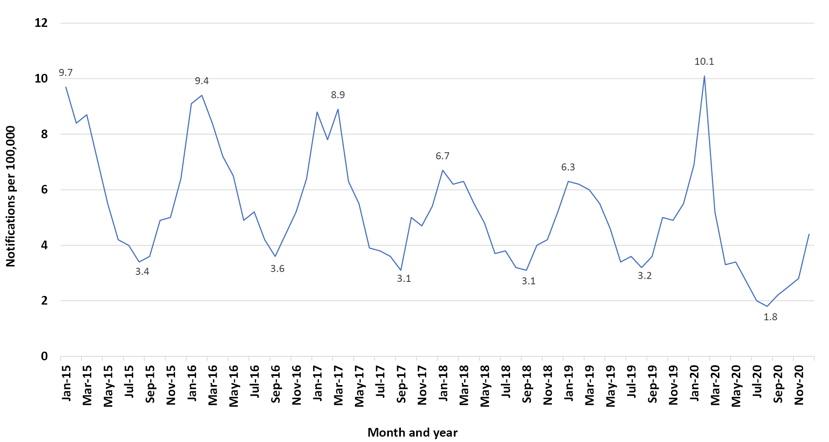
a The rates shown on the graph indicate the maximum and minimum for each year.
The Northern Territory had the highest overall monthly salmonellosis rates for 2015–2019, peaking in April 2016 at 42.7 cases per 100,000 (Figure 3). The lowest monthly rate for all the years 2015 to 2020, of 0.7 notifications per 100,000, was recorded for the Australian Capital Territory in July and October 2020. This lowest rate is just 1.6% of the highest Northern Territory rate. The range bars showed wide variation in rates between jurisdictions. The largest range was almost 30 cases per 100,000 per month for February from 2015 to 2019 in the Australian Capital Territory.
Figure 3 shows that in February 2020 there was an increase in salmonellosis rates compared with the five-year median in six of the eight states and territories of Australia (Northern Territory, Queensland, Western Australia, New South Wales, Victoria and Tasmania). From March to December 2020, the monthly rates for all jurisdictions were consistently below the five-year median except in June and September for Western Australia and in December for Tasmania (Figure 3; Appendix A, Tables A.1 to A.3). The rates in South Australia, Victoria and New South Wales in 2020 showed prolonged low plateaus. Victoria had the greatest drop and longest plateau coinciding with its two COVID-19 lockdown periods (Appendix A, Box A.1), with rates from March to December 2020 being on average 59.0% lower than the median for these months from the 2015–2019 period. The Australian Capital Territory and South Australia also showed large average decreases in rates in March to December 2020 compared to these months in the 2015-2019 period (52.8% and 51.3% respectively).
Figure 2: Australian monthly salmonellosis notifications per 100,000 for 2020 and monthly medians for 2015 to 2019 with maxima and minima as range bars
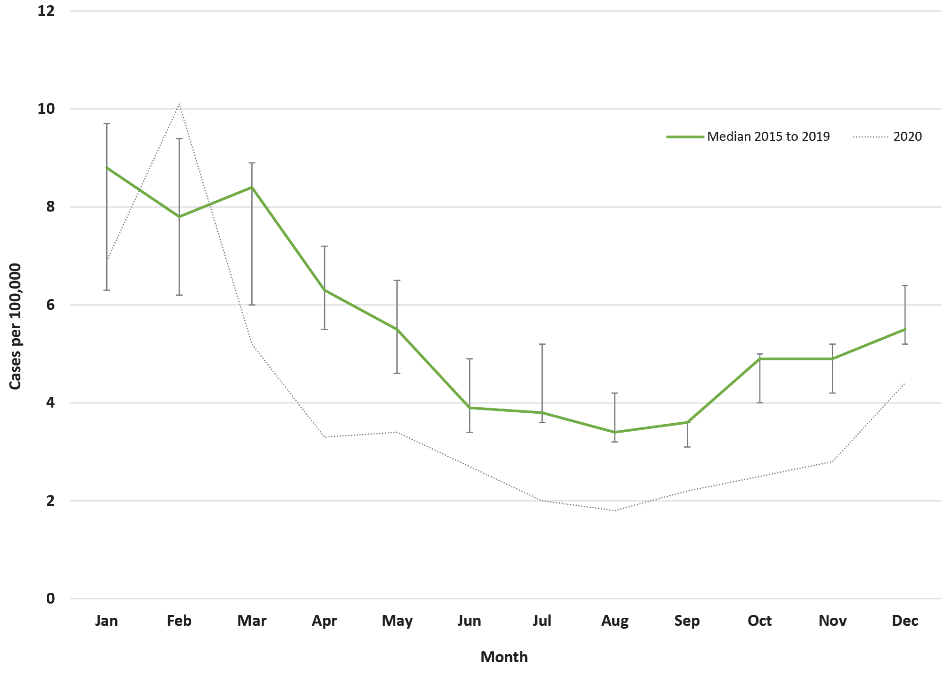
Appendix A, Tables A.1 to A.3 show both absolute and percent changes in 2020 from the 2015 to 2019 median salmonellosis rates. The smallest average monthly decreases occurred in Western Australia (12.0%), Queensland (13.2%), and the Northern Territory (21.8%). The Australian Capital Territory had the greatest percent monthly reductions of 83.3% and 75.0%. Victoria had the third greatest percent monthly reduction of 72.2%. Several jurisdictions had minimum monthly rates of around 1 per 100,000 population per month.
Figure 3 shows salmonellosis notification rates in relation to commencement and easing of restrictions. For all jurisdictions, rates decreased below the five-year median at the time of public health measure commencement in March. However, at the time of public health measure easing in June (Table A.4), the notification rates did not decrease as steeply as the seasonal five-year decrease. In the case of Victoria, when public health measures recommenced in July, the rate decreased, in contrast to the five-year median which increased.

Figure 3: Australian state and territory monthly salmonellosis notifications per 100,000 for 2020 and monthly medians for 2015 to 2019 with maxima and minima as range bars, and showing also COVID-19 public health measures (restrictions)
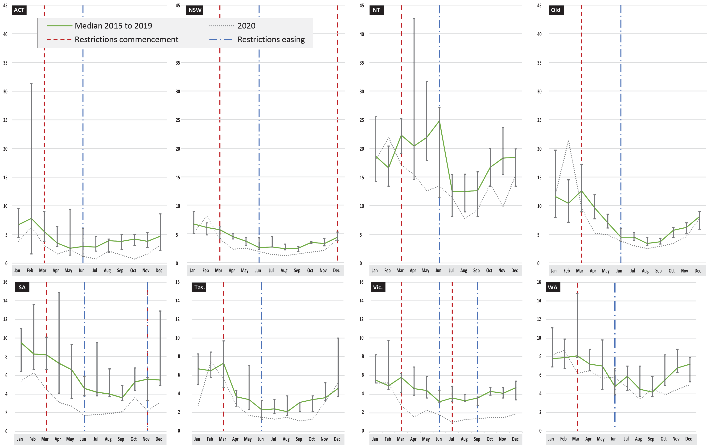

Discussion
This study showed that salmonellosis notifications decreased in Australia in 2020 during the global COVID-19 pandemic, coinciding with the implementation, across Australia, of public health measures on human movement and interaction. Monthly salmonellosis notification rates for the states and territories were consistently below their preceding five-year medians. Monthly salmonellosis rates fell in 2020 by varying amounts throughout Australia and appeared to be influenced by the level of public health measures.
A reduction in total numbers of salmonellosis cases was observed from 2015 to 2019. A decrease in Salmonella Typhimurium in New South Wales since 2014 has been attributed in part to the New South Wales Food Authority Foodborne Illness Reduction Strategy.²² In addition, there has been a national focus on reducing salmonellosis cases through Australia’s Foodborne Illness Reduction Strategy.²³ The peak in notifications of salmonellosis in Australia in February 2020 was due to a single large multi-jurisdictional outbreak.⁵
Our study identified that, in 2020, the largest percentage decreases in salmonellosis monthly rates were in Victoria, which had the longest most severe public health measures, and the Australian Capital Territory. A reduced number of restaurant meals and social gatherings where food was produced for large numbers of people likely contributed to a reduction in salmonellosis risk.⁵ Indeed, restaurants were the meal preparation location associated with by far the largest proportion (54.1%) of the 869 foodborne outbreaks in New South Wales between 2000 and 2017,⁴ as is the case nationally.²⁴ As Bright et al. commented in their preliminary analysis of the first half of 2020: “While declines in notifications of salmonellosis reflected seasonal trends, physical distancing measures that saw the closure of dine-in services at food businesses also likely contributed to a reduction in case numbers.”⁵ Similarly, travel public health measures may have reduced the importation of Salmonella.²⁵
Other factors contributing to the fall in salmonellosis notifications throughout Australia in 2020 may be the Australian population’s increased attention to hand and surface hygiene.²⁶ In addition to reducing cross-contamination of food-borne sources, hand hygiene could also reduce transmission of other environmental sources of Salmonella.²⁷ It is possible that food production safety on farms and processing and transport improved during the year of 2020 as part of general hygiene measures such as those introduced following COVID-19 outbreaks in abattoirs. But it is unlikely that changes in the overall methods of food production would have occurred.
Smaller decreases for monthly percentage changes in salmonellosis were observed in Western Australia, Queensland, and the Northern Territory than in Victoria, New South Wales, South Australia, the Australian Capital Territory and Tasmania. The geographic variation in annual percent change is shown in Appendix Figure A.1b. The smaller decreases for Western Australia, Queensland and the Northern Territory could reflect milder public health measures for Western Australia, Queensland and the Northern Territory. Victoria by comparison had a longer lockdown and South Australia and New South Wales also had additional public health measures.
However, Tasmania—which had similar public health measures to Western Australia, and strict border closure—experienced almost three times the rate reduction seen in Western Australia and almost 50% more than the reduction recorded in the Northern Territory. This difference between states could indicate the importance of environmental and demographic differences. For example, the Northern Territory’s tropical climate and higher proportion of young people and Indigenous (Aboriginal and Torres Strait Islander) people are all factors that have been associated with higher salmonellosis rates and which may have varied the impact of COVID-19 public health measures on salmonellosis rates.^{28,29} It could also suggest the importance of a non-foodborne origin of Salmonella in Western Australia, Queensland and the Northern Territory, for which the social distancing changes could have had less impact.^{30,31} However, Tasmania also has specific environmental Salmonella serotypes (e.g., Salmonella Mississippi), which account for a large portion of its salmonellosis notifications.²⁷
Notifications are likely to under-represent salmonellosis, as not all people with infection are symptomatic; even when symptomatic, not all seek medical treatment or get tested. The latter consideration may have been exacerbated during 2020, due to fears about presenting to clinics being a COVID-19 infection risk. However, a large survey of health service use from January to June 2020 by the Australian Bureau of Statistics found no significant decrease in general practitioner service usage.³² Medicare Benefits Scheme data show service type changed, with a large drop in face to face attendance between March and June 2020 and a large increase in teleconference health care.³³ In addition, Bright et al. considered the possibility that COVID-19 pathology requirements may have shifted laboratory testing priorities.⁵ A 37.4% decline occurred in testing numbers for the Medical Benefits Schedule subsidised test of culture for faeces for faecal pathogens between January and June 2020.⁵ While changes in laboratory testing priorities likely contributed to the decline in notified salmonellosis cases, they are unlikely to have fully accounted for the observed decrease. Additionally, a reason why this might not be an underestimation is that salmonellosis tends to peak in younger age groups,³⁴ and caregivers would be expected to continue to access health services for children.

Limitations
A limitation is that this study used publicly available monthly salmonellosis notification data. There is scope for more detailed investigations with finer resolution temporal (e.g., daily) and spatial (e.g., Health District) data to link the onset of the salmonellosis infections more accurately with the timing of public health measures.

Conclusions
Two phenomena in Australian salmonellosis notifications were observed in 2020. The first was the highest monthly rate since 1991 in February which was associated with a food-related multijurisdictional outbreak. The second was the occurrence of large reductions in jurisdictional rates of salmonellosis across March to December. The second phenomenon, of markedly reduced notifications during COVID-19 public health measures, supports the importance of behavioural factors in the prevention of Salmonella infection. Wide-scale application of significant public health measures during COVID-19 appears to have had an impact in reducing infectious diseases including salmonellosis. It is recommended that public health advice continues to promote hand hygiene as this simple intervention has demonstrated to reduce Salmonella transmission. Persistence of high salmonellosis rates in northern states compared to southern states, however, suggests the importance of environmental factors and demographic factors in these areas.

Disclosure statement
The authors report no conflict of interest.

Author details
Barbara PF Davis¹
Janaki Amin²
Neil Franklin^{3,4}
Paul J Beggs⁵
- Department of Earth and Environmental Sciences, Faculty of Science and Engineering, Macquarie University, Sydney, New South Wales, Australia. ORCID: 0000-0001-6144-0083.
- Department of Health Systems and Populations, Faculty of Medicine, Health and Human Sciences, Macquarie University, Sydney, New South Wales, Australia. ORCID:0000-0003-2161-9366.
- National Centre for Epidemiology and Population Health, Research School of Population Health, The Australian National University, Canberra, Australian Capital Territory, Australia.
- OzFoodNet, New South Wales Ministry of Health, Sydney, New South Wales, Australia. ORCID: 0000-0002-1529-9979.
- Department of Earth and Environmental Sciences, Faculty of Science and Engineering, Macquarie University, Sydney, New South Wales, Australia. ORCID: 0000-0001-9949-1783.

Corresponding author
Barbara PF Davis
Department of Earth and Environmental Sciences, Faculty of Science and Engineering, Macquarie University, Sydney, New South Wales, Australia.
Email: barbara.davis1@hdr.mq.edu.au

References
- D’Souza RM, Becker NG, Hall G, Moodie KBA. Does ambient temperature affect foodborne disease? Epidemiology. 2004;15(1):86–92. doi: https://doi.org/10.1097/01.ede.0000101021.03453.3e.
- Hellberg RS, Chu E. Effects of climate change on the persistence and dispersal of foodborne bacterial pathogens in the outdoor environment: a review. Crit Rev Microbiol. 2016;42(4):548–72. doi: https://doi.org/10.3109/1040841X.2014.972335.
- Vally H, Glass K, Ford L, Hall G, Kirk MD, Shadbolt C et al. Proportion of illness acquired by foodborne transmission for nine enteric pathogens in Australia: an expert elicitation. Foodborne Pathog Dis. 2014;11(9):727–33. doi: https://doi.org/10.1089/fpd.2014.1746.
- Franklin N, Hope K, Glasgow K, Glass K. Describing the epidemiology of foodborne outbreaks in New South Wales from 2000 to 2017. Foodborne Pathog Dis. 2020;17(11):701–11. doi: https://doi.org/10.1089/fpd.2020.2806.
- Bright A, Glynn-Robinson A-J, Kane S, Wright R, Saul N. The effect of COVID-19 public health measures on nationally notifiable diseases in Australia: preliminary analysis. Commun Dis Intell (2018). 2020;44. doi: https://doi.org/10.33321/cdi.2020.44.85.
- Betts R. How did COVID-19 cause food poisoning cases to plummet? [Internet.] Gloucestershire: Campden BRI; 29 January 2021. Available from: https://www.campdenbri.co.uk/blogs/covid-19-food-poisoning.php.
- Barkley D. The impact of COVID-19 on foodborne disease. [Internet.] Columbus: Ohio State University, CFI (Center for Foodborne Illness Research and Prevention); 26 March 2021. Available from: https://foodsafety.osu.edu/blog/march-26-2021-1046am/impact-covid-19-foodborne-disease.
- Australian Government Department of Health. Salmonellosis case definition. [Webpage.] Canberra: Australian Government Department of Health; 1 January 2016. Available from: https://www1.health.gov.au/internet/main/publishing.nsf/Content/cda-surveil-nndss-casedefs-cd_salmon.htm.
- Australian Government Department of Health. Introduction to the National Notifiable Diseases Surveillance System. [Internet.] Canberra: Australian Government Department of Health; 9 June 2015. Available from: http://www1.health.gov.au/internet/main/publishing.nsf/Content/cda-surveil-nndss-nndssintro.htm.
- Parliament of Australia. COVID-19: a chronology of state and territory government announcements (up until 30 June 2020). [Webpage.] Canberra: Parliament of Australia; 22 October 2020. Available from: https://www.aph.gov.au/About_Parliament/Parliamentary_Departments/Parliamentary_Library/pubs/rp/rp2021/Chronologies/COVID-19StateTerritoryGovernmentAnnouncements.
- Premier of Victoria. News and updates from Dan Andrews and his team. Melbourne: Victorian Government, Office of the Premier; 2020–2021. Available from: https://www.premier.vic.gov.au/.
- Tasmanian Government. Coronavirus disease (COVID-19). Important community updates. [Webpage.] Hobart: Tasmanian Government; 2020–2021. Available from: https://coronavirus.tas.gov.au/facts/important-community-updates.
- Australian Capital Territory Government. Open Government. Rachel Stephen-Smith MLA media releases. [Webpage.] Canberra: Australian Capital Territory Government; 2020–2021. Available from: https://www.cmtedd.act.gov.au/open_government/inform/act_government_media_releases/rachel-stephen-smith-mla-media-releases.
- Government of South Australia. Steven Marshall Premier of South Australia. Media releases. [Webpage.] Adelaide: Government of South Australia, Office of the Premier; 2020–2021. Available from: https://www.premier.sa.gov.au/news/media-releases.
- Government of Western Australia. Media Statements for portfolio: Premier. [Webpage.] Perth: Government of Western Australia, Office of the Premier; 2020–2021. Available from: https://www.mediastatements.wa.gov.au/Pages/Portfolios/Premier.aspx?QualitemContentRollupPage=1.
- Government of New South Wales Department of Health (NSW Health). 2020 media releases from NSW Health. [Webpage.] Sydney: NSW Health; 2020–2021. Available from: https://www.health.nsw.gov.au/news/Pages/2020-nsw-health.aspx.
- Queensland Health. Department of Health media releases. [Webpage.] Brisbane: Queensland Government, Queensland Health; 2020–2021. Available from: https://www.health.qld.gov.au/news-events/doh-media-releases.
- Northern Territory Government. Coronavirus (COVID-19). Updates. [Webpage.] Darwin: Northern Territory Government; 2020–2021. Available from: https://coronavirus.nt.gov.au/updates.
- Prime Minister of Australia. Update on Coronavirus Measures. [Media statement.] Canberra: Australian Government Department of the Prime Minister and Cabinet; 22 March 2020. Available from: https://www.pm.gov.au/media/update-coronavirus-measures-220320.
- Prime Minister of Australia. Update on Coronavirus Measures. [Media statement.] Canberra: Australian Government Department of the Prime Minister and Cabinet; 20 March 2020. Available from: https://www.pm.gov.au/media/update-coronavirus-measures-0.
- Prime Minister of Australia. National Cabinet Statement. [Media statement.] Canberra: Australian Government Department of the Prime Minister and Cabinet; 29 March 2020. Available from: https://www.pm.gov.au/media/national-cabinet-statement.
- NSW Health, Communicable Diseases Branch. OzFoodNet (Enhancing foodborne disease surveillance across Australia). NSW Annual Report 2018. Sydney: NSW Health; April 2019. Available from: https://www.health.nsw.gov.au/Infectious/foodborne/Publications/nsw-ofn-annual-report-2018.pdf.
- Australian Government Department of Health. Australia’s Foodborne Illness Reduction Strategy 2018-2021+: A strategy to reduce foodborne illness in Australia, particularly related to Campylobacter and Salmonella. Canberra: Australian Government Department of Health, Food Regulation Secretariat; 29 June 2018. Available from: https://foodregulation.gov.au/internet/fr/publishing.nsf/Content/51D7B1FFFCAD05C5CA2582B900051DDD/$File/FORUM-AUS-FBI-RS-2018.pdf.
- Astridge KH, McPherson M, Kirk MD, Knope K, Gregory J, Kardamanidis K et al. Foodborne disease outbreaks in Australia 2001–2009. Food Aust. 2011;63(12):44–50.
- Iveson JB, Bradshaw SD, Smith DW. The movement of humans and the spread of Salmonella into existing and pristine ecosystems. Microbiol Aust. 2017;38(4):201–3. doi: https://doi.org/10.1071/MA17070.
- MacIntyre CR, Nguyen P-Y, Chughtai AA, Trent M, Gerber B, Steinhofel K et al. Mask use, risk-mitigation behaviours and pandemic fatigue during the COVID-19 pandemic in five cities in Australia, the UK and USA: a cross-sectional survey. Int J Infect Dis. 2021;106:199–207. doi: https://doi.org/10.1016/j.ijid.2021.03.056.
- Ashbolt R, Kirk MD. Salmonella Mississippi infections in Tasmania: the role of native Australian animals and untreated drinking water. Epidemiol Infect. 2006;134(6):1257–65. doi: https://doi.org/10.1017/S0950268806006224.
- Gibney KB, Cheng AC, Hall R, Leder K. An overview of the epidemiology of notifiable infectious diseases in Australia, 1991–2011. Epidemiol Infect. 2016;144(15):3263–77. doi: https://doi.org/10.1017/S0950268816001072.
- Hamilton NJ, Draper ADK, Baird R, Wilson A, Ford T, Francis JR. Invasive salmonellosis in paediatric patients in the Northern Territory, Australia, 2005–2015. J Paediatr Child Health. 2021;57(9):1397–401. doi: https://doi.org/10.1111/jpc.15473.
- Williams S, Patel M, Markey P, Muller R, Benedict S, Ross I et al. Salmonella in the tropical household environment—everyday, everywhere. J Infect. 2015;71(6):642–8. doi: https://doi.org/10.1016/j.jinf.2015.09.011.
- Fearnley EJ, Lal A, Bates J, Stafford R, Kirk MD, Glass K. Salmonella source attribution in a subtropical state of Australia: capturing environmental reservoirs of infection. Epidemiol Infect. 2018;146(15):1903–8. doi: https://doi.org/10.1017/S0950268818002224.
- Australian Bureau of Statistics. Patient Experiences in Australia. Summary of Findings. (Reference period 2020–21 finanical year.) [Internet.] Canberra: Australian Bureau of Statistics; 17 November 2020. Available from: https://www.abs.gov.au/statistics/health/health-services/patient-experiences-australia-summary-findings/latest-release.
- Australian Institute of Health and Welfare (AIHW). Impacts of COVID-19 on Medicare Benefits Scheme and Pharmaceutical Benefits Scheme service use. [Internet.] Canberra: Australian Government, AIHW; 17 December 2020. Available from: https://www.aihw.gov.au/reports/health-care-quality-performance/covid-impacts-on-mbs-and-pbs/contents/impact-on-mbs-service-use.
- Ford L, Glass K, Veitch M, Wardell R, Polkinghorne B, Dobbins T et al. Increasing incidence of Salmonella in Australia, 2000-2013. PLoS One. 2016;11(10):e0163989. doi: https://doi.org/10.1371/journal.pone.0163989.
- Mannix L. The world’s longest COVID-19 lockdowns: how Victoria compares. [Newspaper article.] Melbourne: The Age; 7 September 2020. Available from: https://www.theage.com.au/national/victoria/the-world-s-longest-covid-19-lockdowns-how-victoria-compares-20200907-p55t7q.html.

Appendix A
Box A.1. Federal and state/territory government COVID-19 public health measures and advice
On 20 March 2020, the Federal government closed international borders to non- Australians.²⁰ On 22 March 2020, National Cabinet advised closure of non-essential businesses and reduced size of gatherings at home and for events such as weddings.¹⁹ On 29 March 2020, the National Cabinet’s guidance was to stay at home unless for shopping, medical or exercise or work and limited indoor gatherings to two people.²¹
State/territory governments supported National Cabinet advice and implemented public health measures of their own such as lockdowns of specific areas, mask wearing on public transport and in enclosed spaces and interstate border public health measures. State/territory governments relaxed these public health measures when COVID-19 case numbers fell. The timing for these interventions varied across Australia. In all states/territories except Victoria, public health measures were reduced incrementally from June 2020. In Melbourne, Victoria, a second lockdown was put in place from 8 July 2020 until September 2020.³⁵ By September, Melbourne had experienced four cumulative months of tight public health measures in total. General public health advice issued by state/territory government health departments included 1. handwashing, 2. mask wearing, and 3. physical distancing.

Table A.1: Monthly rate (cases per 100,000) in 2020 compared to the 2015 to 2019 median, for the Australian Capital Territory, New South Wales, and the Northern Territory
 | Australian Capital Territory |  |  |  | New South Wales |  |  |  | Northern Territory
Month | 2015–2019 | 2020 | Absolute change | % change | 2015–2019 | 2020 | Absolute change | % change | 2015–2019 | 2020 | Absolute change | % change
Jan | 6.7 | 3.8 | -2.9 | -43.3 | 6.7 | 5.2 | -1.5 | -22.4 | 18.6 | 17.9 | -0.7 | -3.8
Feb | 7.8 | 6.3 | -1.5 | -19.2 | 6.1 | 8.1 | 2.0 | 32.8 | 16.6 | 21.9 | 5.3 | 31.9
Mar | 5.5 | 3.1 | -2.4 | -43.6 | 5.7 | 4.1 | -1.6 | -28.1 | 22.3 | 17.1 | -5.2 | -23.3
Apr | 3.5 | 1.6 | -1.9 | -54.3 | 4.5 | 2.3 | -2.2 | -48.9 | 20.4 | 15.4 | -5.0 | -24.5
May | 2.6 | 2.3 | -0.3 | -11.5 | 3.7 | 2.5 | -1.2 | -32.4 | 21.9 | 12.6 | -9.3 | -42.5
Jun | 2.9 | 1.2 | -1.7 | -58.6 | 2.6 | 1.9 | -0.7 | -26.9 | 24.8 | 13.4 | -11.4 | -46.0
Jul | 2.8 | 0.7 | -2.1 | -75.0 | 2.7 | 1.4 | -1.3 | -48.2 | 12.5 | 11.4 | -1.1 | -8.8
Aug | 3.9 | 2.1 | -1.8 | -46.2 | 2.4 | 1.2 | -1.2 | -50.0 | 12.5 | 7.7 | -4.8 | -38.4
Sep | 3.8 | 1.4 | -2.4 | -63.2 | 2.5 | 1.5 | -1.0 | -40.0 | 12.6 | 9.3 | -3.3 | -26.2
Oct | 4.2 | 0.7 | -3.5 | -83.3 | 3.5 | 1.8 | -1.7 | -48.6 | 16.7 | 13.8 | -2.9 | -17.4
Nov | 3.8 | 1.6 | -2.2 | -57.9 | 3.3 | 2.1 | -1.2 | -36.4 | 18.3 | 9.8 | -8.5 | -46.5
Dec | 4.7 | 3.1 | -1.6 | -34.0 | 4.4 | 4.1 | -0.3 | -6.8 | 18.4 | 15.4 | -3.0 | -16.3
Average (Jan–Dec) | 4.4 | 2.3 | -2.0 | -49.2 | 4.0 | 3.0 | -1.0 | -29.7 | 18.0 | 13.8 | -4.2 | -21.8
Average (Mar–Dec) | 3.8 | 1.8 | -2.0 | -52.8 | 3.5 | 2.3 | -1.2 | -36.6 | 18.0 | 12.6 | -5.5 | -29.0

Table A.2: Monthly rate (cases per 100,000) in 2020 compared to the 2015 to 2019 median, for Queensland, South Australia, and Tasmania
 | Queensland |  |  |  | South Australia |  |  |  | Tasmania
Month | 2015–2019 | 2020 | Absolute change | % change | 2015–2019 | 2020 | Absolute change | % change | 2015–2019 | 2020 | Absolute change | % change
Jan | 11.6 | 11.9 | 0.3 | 2.6 | 9.5 | 5.4 | -4.1 | -43.2 | 6.7 | 2.8 | -3.9 | -58.2
Feb | 10.4 | 21.4 | 11.0 | 105.8 | 8.3 | 6.3 | -2.0 | -24.1 | 6.5 | 7.5 | 1.0 | 15.4
Mar | 12.6 | 9.6 | -3.0 | -23.8 | 8.2 | 4.5 | -3.7 | -45.1 | 7.3 | 5.6 | -1.7 | -23.3
Apr | 9.6 | 5.2 | -4.4 | -45.8 | 7.3 | 3.1 | -4.2 | -57.5 | 3.7 | 2.8 | -0.9 | -24.3
May | 7.0 | 4.9 | -2.1 | -30.0 | 6.6 | 2.7 | -3.9 | -59.1 | 3.4 | 1.7 | -1.7 | -50.0
Jun | 4.5 | 3.8 | -0.7 | -15.6 | 4.6 | 1.7 | -2.9 | -63.0 | 2.3 | 1.5 | -0.8 | -34.8
Jul | 4.5 | 3.0 | -1.5 | -33.3 | 4.2 | 1.8 | -2.4 | -57.1 | 2.4 | 1.3 | -1.1 | -45.8
Aug | 3.4 | 2.5 | -0.9 | -26.5 | 4.0 | 1.9 | -2.1 | -52.5 | 2.1 | 1.5 | -0.6 | -28.6
Sep | 3.7 | 2.9 | -0.8 | -21.6 | 3.6 | 2.1 | -1.5 | -41.7 | 3.1 | 1.1 | -2.0 | -64.5
Oct | 5.7 | 3.4 | -2.3 | -40.4 | 5.3 | 3.6 | -1.7 | -32.1 | 3.4 | 1.3 | -2.1 | -61.8
Nov | 6.2 | 4.6 | -1.6 | -25.8 | 5.6 | 2.2 | -3.4 | -60.7 | 3.6 | 3.2 | -0.4 | -11.1
Dec | 8.1 | 7.8 | -0.3 | -3.7 | 5.5 | 3.1 | -2.4 | -43.6 | 4.6 | 5.2 | 0.6 | 13.0
Average (Jan–Dec) | 7.3 | 6.8 | -0.5 | -13.2 | 6.1 | 3.2 | -2.9 | -48.3 | 4.1 | 3.0 | -1.1 | -31.2
Average (Mar–Dec) | 6.5 | 4.8 | -1.8 | -26.6 | 5.5 | 2.7 | -2.8 | -51.3 | 3.6 | 2.5 | -1.1 | -33.1

Table A.3: Monthly rate (cases per 100,000) in 2020 compared to the 2015 to 2019 median, for Victoria, Western Australia, and Australia
 | Victoria |  |  |  | Western Australia |  |  |  | Australia
Month | 2015–2019 | 2020 | Absolute change | % change | 2015–2019 | 2020 | Absolute change | % change | 2015–2019 | 2020 | Absolute change | % change
Jan | 5.5 | 5.2 | -0.3 | -5.5 | 7.8 | 8.2 | 0.4 | 5.1 | 8.8 | 6.9 | -1.9 | -21.6
Feb | 4.9 | 5.2 | 0.3 | 6.1 | 7.9 | 8.7 | 0.8 | 10.1 | 7.8 | 10.1 | 2.3 | 29.5
Mar | 5.8 | 2.8 | -3.0 | -51.7 | 8.1 | 6.2 | -1.9 | -23.5 | 8.4 | 5.2 | -3.2 | -38.1
Apr | 4.6 | 1.6 | -3.0 | -65.2 | 7.2 | 6.5 | -0.7 | -9.7 | 6.3 | 3.3 | -3.0 | -47.6
May | 4.4 | 2.3 | -2.1 | -47.7 | 7.0 | 5.7 | -1.3 | -18.6 | 5.5 | 3.4 | -2.1 | -38.2
Jun | 3.2 | 1.8 | -1.4 | -43.8 | 4.8 | 5.8 | 1.0 | 20.8 | 3.9 | 2.7 | -1.2 | -30.8
Jul | 3.6 | 1.0 | -2.6 | -72.2 | 5.9 | 4.7 | -1.2 | -20.3 | 3.8 | 2.0 | -1.8 | -47.4
Aug | 3.3 | 1.3 | -2.0 | -60.6 | 4.5 | 3.4 | -1.1 | -24.4 | 3.4 | 1.8 | -1.6 | -47.1
Sep | 3.6 | 1.4 | -2.2 | -61.1 | 4.2 | 4.6 | 0.4 | 9.5 | 3.6 | 2.2 | -1.4 | -38.9
Oct | 4.3 | 1.5 | -2.8 | -65.1 | 5.5 | 3.9 | -1.6 | -29.1 | 4.9 | 2.5 | -2.4 | -49.0
Nov | 4.1 | 1.5 | -2.6 | -63.4 | 6.8 | 4.5 | -2.3 | -33.8 | 4.9 | 2.8 | -2.1 | -42.9
Dec | 4.7 | 1.9 | -2.8 | -59.6 | 7.2 | 5.0 | -2.2 | -30.6 | 5.5 | 4.4 | -1.1 | -20.0
Average (Jan–Dec) | 4.3 | 2.3 | -2.0 | -49.2 | 6.4 | 5.6 | -0.8 | -12.0 | 5.6 | 3.9 | -1.6 | -32.7
Average (Mar–Dec) | 4.2 | 1.7 | -2.5 | -59.0 | 6.1 | 5.0 | -1.1 | -16.0 | 5.0 | 3.0 | -2.0 | -40.0

Table A.4: Australian federal and state/territory advice/public health measures related to control of COVID-19 in 2020.
State/territory | Stay at home / Closure of nonessential businesses | Mask wearing
Australian Capital Territory | March to June
New South Wales | March to June, December
Northern Territory | March to June
Queensland | March to June
South Australia | March to June, November
Tasmania | March to June
Victoria | March to June, July to September | From July
Western Australia | March to June

Appendix Figure A.1: (a) Australian state and territory median annual salmonellosis notifications per 100,000 for 2015 to 2019; (b) percentage decrease in 2020
Figure A.1a
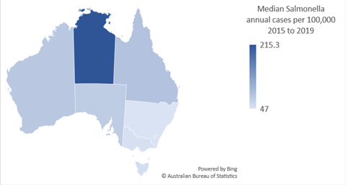
Figure A.1b
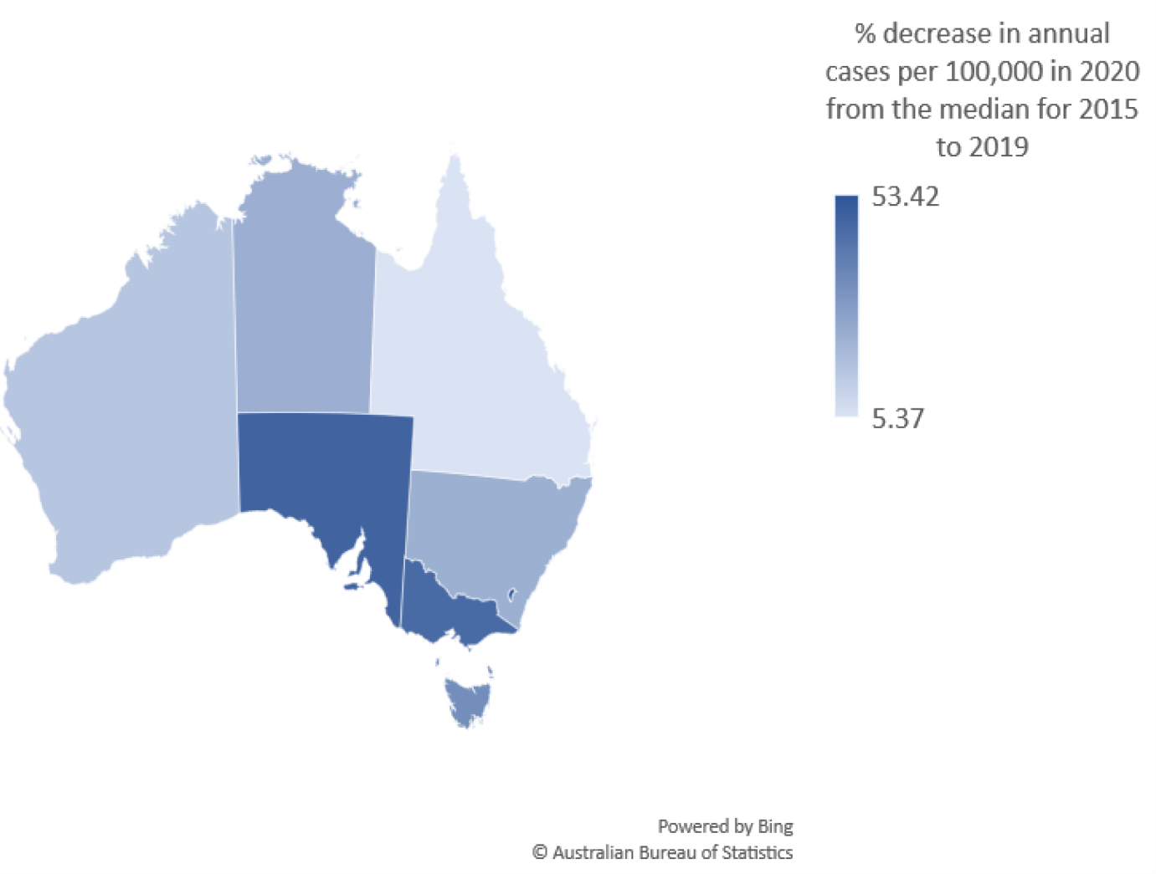

Communicable Diseases Intelligence
ISSN: 2209-6051 Online

Communicable Diseases Intelligence (CDI) is a peer-reviewed scientific journal published by the Office of Health Protection and Response, Department of Health. The journal aims to disseminate information on the epidemiology, surveillance, prevention and control of communicable diseases of relevance to Australia.

Editor: Jennie Hood
Deputy Editor: Simon Petrie
Design and Production: Kasra Yousefi
Editorial Advisory Board: David Durrheim, Mark Ferson, John Kaldor, Martyn Kirk and Linda Selvey

Website: http://www.health.gov.au/cdi

Contacts
CDI is produced by the Office of Health Protection and Response, Australian Government Department of Health, GPO Box 9848, (MDP 6) CANBERRA ACT 2601

Email: cdi.editor@health.gov.au

Submit an Article
You are invited to submit your next communicable disease related article to the Communicable Diseases Intelligence (CDI) for consideration. More information regarding CDI can be found at: http://health.gov.au/cdi.
Further enquiries should be directed to: cdi.editor@health.gov.au.

This journal is indexed by Index Medicus and Medline.

Creative Commons Licence - Attribution-NonCommercial-NoDerivatives CC BY-NC-ND
© 2022 Commonwealth of Australia as represented by the Department of Health
This publication is licensed under a Creative Commons Attribution-NonCommercial-NoDerivatives 4.0 International Licence from https://creativecommons.org/licenses/by-nc-nd/4.0/legalcode (Licence). You must read and understand the Licence before using any material from this publication.

Restrictions
The Licence does not cover, and there is no permission given for, use of any of the following material found in this publication (if any):
- the Commonwealth Coat of Arms (by way of information, the terms under which the Coat of Arms may be used can be found at www.itsanhonour.gov.au);
- any logos (including the Department of Health’s logo) and trademarks;
- any photographs and images;
- any signatures; and
- any material belonging to third parties.

Disclaimer
Opinions expressed in Communicable Diseases Intelligence are those of the authors and not necessarily those of the Australian Government Department of Health or the Communicable Diseases Network Australia. Data may be subject to revision.

Enquiries
Enquiries regarding any other use of this publication should be addressed to the Communication Branch, Department of Health, GPO Box 9848, Canberra ACT 2601, or via e-mail to: copyright@health.gov.au

Communicable Diseases Network Australia
Communicable Diseases Intelligence contributes to the work of the Communicable Diseases Network Australia.
http://www.health.gov.au/cdna

