Influenza epidemiology in patients admitted to sentinel Australian hospitals in 2019: the Influenza Complications Alert Network (FluCAN)
Allen C Cheng, Dominic E Dwyer, Mark Holmes, Louis B Irving, Graham Simpson, Sanjaya Senanayake, Tony Korman, N Deborah Friedman, Louise Cooley, Peter Wark, Anna Holwell, Simon Bowler, John W Upham, Daniel M Fatovich, Grant W Waterer, Kristine Macartney, Christopher C Blyth, Nigel Crawford, Jim Buttery, Helen S Marshall, Julia E Clark, Joshua Francis, Tom Kotsimbos, Paul M Kelly

Abstract
Influenza is a common cause of acute respiratory infection, and is a major cause of morbidity and mortality. This report summarises the epidemiology of hospitalisations with laboratory-confirmed influenza during the 2019 influenza season.
The Influenza Complications Alert Network (FluCAN) is a sentinel hospital-based surveillance program that operates at sites in all jurisdictions in Australia. Cases were defined as patients hospitalised at any of the 17 sentinel hospitals with influenza confirmed by nucleic acid detection. Data were also collected on a frequency matched control group of influenza-negative patients admitted with acute respiratory infection.
During the period 1 April to 31 October 2019 (the 2019 influenza season), there were 4,154 patients admitted with confirmed influenza to one of 17 FluCAN sentinel hospitals. Of these, 44% were elderly (≥ 65 years), 21% were children (< 16 years), 7.7% were Aboriginal and Torres Strait Islander peoples, 1.7% were pregnant and 73% had chronic comorbidities. Most admissions were due to influenza A infection (85%). Estimated vaccine coverage was 75% in the elderly, 49% in non-elderly adults with medical comorbidities, and 27% in young children (< 5 years). The estimated vaccine effectiveness in the target adult population was 42% (95% confidence interval [95% CI]: 36%, 49%).
There were a larger number of hospital admissions detected with confirmed influenza in this national observational surveillance system in 2019 than in 2018.
Keywords: Influenza; public health surveillance; influenza vaccines; vaccination coverage; vaccine effectiveness

Introduction
Influenza is an acute respiratory viral infection caused by influenza viruses. Global studies suggest that along with respiratory syncytial virus (RSV), influenza A and B are the most common viruses identified in surveillance systems,¹ and it has been estimated that influenza caused 9.5 million hospitalisations and 145,000 deaths in 2017.² In Australia, an analysis of administrative hospital data found that influenza is diagnosed in up to 10,000 admissions annually, with the highest incidence in children and the elderly.³ In this report, we describe the epidemiology of hospitalisation with laboratory-confirmed influenza in the 2019 season in Australia.

Methods
The Influenza Complications Alert Network (FluCAN) is a national hospital-based sentinel surveillance system.^{4–6} Since 2011, the participating sites have been:
- Canberra Hospital (Australian Capital Territory, ACT)
- Calvary Hospital (ACT)
- Westmead Hospital (New South Wales, NSW)
- John Hunter Hospital (NSW)
- Children’s Hospital at Westmead (NSW)
- Alice Springs Hospital (Northern Territory, NT)
- Mater Hospital (Queensland, Qld)
- Princess Alexandra Hospital (Qld)
- Cairns Base Hospital (Qld)
- Royal Adelaide Hospital (South Australia, SA)
- Royal Hobart Hospital (Tasmania, Tas.)
- The Alfred Hospital (Victoria, Vic.)
- Royal Melbourne Hospital (Vic.)
- Monash Medical Centre (Vic.)
- University Hospital Geelong (Vic.)
- Royal Perth Hospital (Western Australia, WA)
- Perth Children’s Hospital (previously Princess Margaret Hospital, WA).
In 2018, additional specialist paediatric hospitals—(Queensland Children’s Hospital (previously Lady Cilento Children’s Hospital, Qld), Women’s and Children’s Hospital (SA), the paediatric ward of the Royal Darwin Hospital (NT) and Royal Children’s Hospital (Vic.)—also contributed data, but data from these sites were only included to estimate vaccine effectiveness to facilitate comparisons with previous years (Figure 1). Ethical approval has been obtained at all participating sites and at Monash University. Hospital bed capacity statistics were obtained from each participating hospital, and national bed capacity was obtained from the last published Australian Institute of Health and Welfare (AIHW) report.⁷
Figure 1: Participants included in surveillance and vaccine effectiveness cohorts
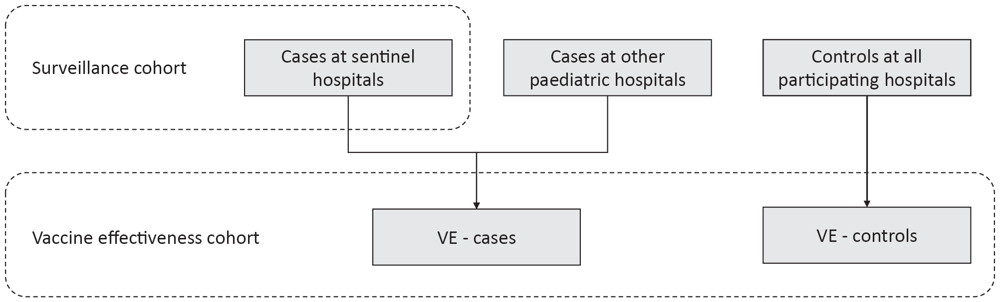
An influenza case was defined as a patient admitted to hospital with influenza confirmed by nucleic acid testing (NAT). Surveillance is conducted from early April to the end of October (with follow-up continuing to the end of November) each year. Data on a frequency-matched group of test-negative controls were also collected. Admission or transfer to an intensive care unit (ICU) included patients managed in a high dependency unit (HDU). The onset date was defined as the date of admission except for patients where the date of the test was more than seven days after admission, where the onset date was the date of the test. The presence of risk factors and comorbidities was ascertained from the patient’s medical record. Restricted functional capacity was defined as those who were not fully active and not able to carry out all activities without restriction prior to the acute illness.⁸
We examined factors associated with ICU admission using multivariable regression. Factors independently associated with ICU admission were determined using a logistic regression model with no variable selection process, as all included factors were plausibly related to ICU admission.
The presentation delay was defined as the time from onset of illness to admission to hospital. The treatment delay was defined as the time from onset of illness to prescription of oseltamivir (in patients that received treatment). Patients were categorised into those that (a) did not receive oseltamivir; (b) received oseltamivir within two days of symptom onset; and (c) received oseltamivir more than two days after symptom onset. We modelled factors associated with length of hospital stay, including antiviral use, using a negative binomial regression, where the exponential of the regression coefficient represents the relative increase in hospital length of stay.
Vaccine coverage was estimated from the proportion of vaccinated individuals in test negative controls in each age group, stratified by the presence of chronic comorbidities. Vaccine effectiveness ϵ was estimated from θ, the odds ratio of vaccination in cases versus controls, using the formula ϵ = 1 − θ with the odds ratio calculated from a conditional logistic regression, stratified by site and month and adjusted for age group, the presence of chronic comorbidities, pregnancy and Aboriginal or Torres Strait Islander ethnicity.

Results
During the period 1 April to 31 October 2019, there were 4,154 patients admitted with laboratory-confirmed influenza to the 17 FluCAN sentinel hospitals. The peak weekly number of admissions was in mid-August (week 27) (Figure 2). The majority of cases were due to influenza A (n = 3,537, 85.1%). The proportion due to influenza B varied across jurisdictions, ranging from 3.3% in Tasmania and 4.3% in SA to 24.3% in NSW and 24.4% in WA.
Of the 4,154 patients admitted with confirmed influenza, 1,850 (44.5%) were elderly (> 65 years of age); 883 (21.3%) were children (< 16 years of age); 319 (7.7%) were Aboriginal and Torres Strait Islander peoples; and 3,023 (72.8%) had chronic comorbidities (Table 1, Table 2). There were 69 pregnant women, representing 15.0% of the 461 female patients aged 16–49, or 1.7% of the total. Of the 3,458 patients (83.2%) for whom influenza vaccination status was ascertained, 1,658/3,458 (47.9%) had been vaccinated.

Figure 2: Date of admission in patients hospitalised with confirmed influenza, 2019ª
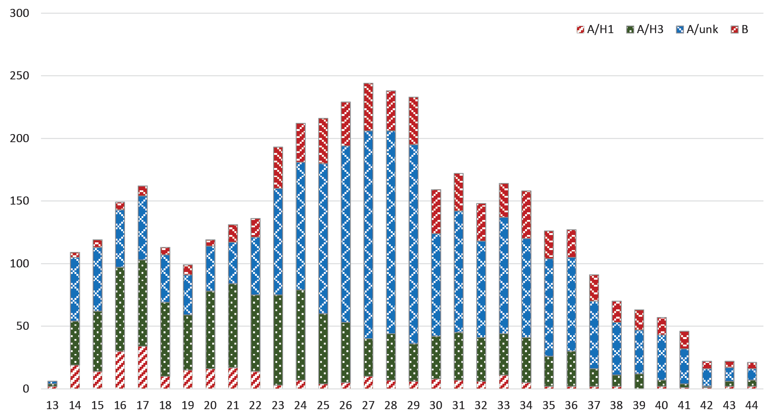
a By week beginning on listed date; representing date of admission (or date of influenza diagnosis if acquired after more than seven days in hospital).

Incidence of hospital admissions with influenza
Overall, the peak incidence of admissions with confirmed influenza was 4.5 per 100 hospital beds (Figure 3; in epidemiological week 27), but varied from a high of 23.3 weekly admissions per 100 hospital beds at the Alice Springs Hospital to a low of 0.4 per 100 hospital beds at Princess Alexandra Hospital (Figure 4).

Presentation and management
Of all cases, 3,960 patients had a known date of onset of illness documented. Of these, 200 cases (5.1%) were diagnosed more than seven days after admission and therefore were likely to be hospital-acquired. For the remaining 3,760 patients with community-onset laboratory-confirmed influenza where the duration of symptoms was known, the median duration of symptoms prior to admission was three days (interquartile range (IQR): 1, 5 days). In 2,721 patients that received antivirals, the delay from onset of illness to admission was more than two days in 56.7% (n = 1,544), and was similar in children (54.4%), non-elderly adults (59.0%) and the elderly (62.4%).
Radiological evidence of pneumonia was present in 641 patients (15.4%). The proportion of patients with pneumonia was lower in children (9.6%) than in non-elderly adults (15.3%) and elderly adults (18.3%). A higher proportion of patients with pneumonia were admitted to ICU (20.1%) than those without pneumonia (5.5%).
Of all cases, 323 (7.8%) patients were admitted to ICU, comprising 259 patients (6.2%) initially admitted to ICU and a further 64 (1.5%) subsequently transferred to ICU after initial admission to a general ward. Non-elderly adults, those admitted with A/H1N1 infection and those with chronic comorbidities were more likely to be admitted to ICU; residents of nursing homes were less likely to be admitted to ICU (Table 3).

Table 1: Demographic characteristics of hospitalized patients with confirmed influenza
 | Influenza type/subtype |  |  |  | Total
 | A/H1N1 | A/H3N2 | A/unknown | B
Number | 266 | 1,140 | 2,131 | 617 | 4,154
Age group
< 16 years | 53 (19.9%) | 187 (16.4%) | 299 (14.0%) | 344 (55.8%) | 883 (21.3%)
16–49 years | 85 (32.0%) | 168 (14.7%) | 438 (20.6%) | 137 (22.2%) | 828 (19.9%)
50–64 years | 58 (21.8%) | 155 (13.6%) | 323 (15.2%) | 57 (9.2%) | 593 (14.3%)
65–79 years | 51 (19.2%) | 298 (26.1%) | 519 (24.4%) | 52 (8.4%) | 920 (22.1%)
80+ years | 19 (7.1%) | 332 (29.1%) | 552 (25.9%) | 27 (4.4%) | 930 (22.4%)
Male | 148 (55.6%) | 566 (49.6%) | 1,034 (48.5%) | 307 (49.8%) | 2,055 (49.5%)
Pregnant | 4 (1.5%) | 15 (1.3%) | 39 (1.8%) | 11 (1.8%) | 69 (1.7%)
Aboriginal and Torres Strait Islander persons | 40 (15.0%) | 110 (9.6%) | 120 (5.6%) | 49 (7.9%) | 319 (7.7%)
Jurisdiction
ACT | 33 (12.4%) | 29 (2.5%) | 481 (22.6%) | 67 (10.9%) | 610 (14.7%)
NSW | 67 (25.2%) | 244 (21.4%) | 406 (19.1%) | 230 (37.3%) | 947 (22.8%)
NT | 38 (14.3%) | 96 (8.4%) | 8 (0.4%) | 13 (2.1%) | 155 (3.7%)
Qld | 8 (3.0%) | 36 (3.2%) | 198 (9.3%) | 61 (9.9%) | 303 (7.3%)
SA | 33 (12.4%) | 253 (22.2%) | 67 (3.1%) | 16 (2.6%) | 369 (8.9%)
Tas. | 15 (5.6%) | 209 (18.3%) | 13 (0.6%) | 8 (1.3%) | 245 (5.9%)
Vic. | 45 (16.9%) | 81 (7.1%) | 823 (38.6%) | 108 (17.5%) | 1,057 (25.4%)
WA | 27 (10.2%) | 192 (16.8%) | 135 (6.3%) | 114 (18.5%) | 468 (11.3%)

Use of antivirals
Of the 3,621 patients where the date of onset was reported, 1,173 (32.4%) did not receive oseltamivir; 961 (26.5%) received oseltamivir within 2 days of symptom onset; and 1,447 (40.0%) received oseltamivir more than 2 days after the onset of illness. Oseltamivir use was lower in children (18.4% within 2 days; a further 21.9% more than 2 days) than in non-elderly adults (29.5%; 42.3%) and the elderly (29.5%; 49.1%) (table 4).

Outcome
The mean length of hospital stay for all patients was 4.9 days. Admission to ICU was associated with a mean hospital length of stay of 9.5 days compared to those not admitted to ICU (4.5 days). Of the 3,956 patients where hospital mortality status was documented, 111 patients died (2.8%); of these, 34 deaths (31%) occurred in patients admitted to ICU, and 77 deaths (69%) in those not admitted to ICU.
Length of hospital stay was shorter in patients who did not receive oseltamivir (median 2 days; IQR: 1, 4 days) than in those who received oseltamivir within two days (median 3 days; IQR: 2, 6 days) or in those who received oseltamivir after two days (median 3 days; IQR: 2, 6 days; Kruskal–Wallis test p < 0.001). The crude association between oseltamivir use and longer length of hospital stay was largely accounted for by age, the severity of illness and the presence of comorbidities in a multivariate model (Table 5).

Table 2: Risk factors, severity and outcomes in hospitalized adult patients with confirmed influenza
 | Not admitted to ICU | Admitted to ICU | Total
 | n (%) | n (%)
Number of patients | 3,831 (92.2%) | 323 (7.8%) | 4,154
Pregnant | 64 (92.8%) | 5 (7.2%) | 69
Chronic comorbidities | 2,762 (91.4%) | 261 (8.6%) | 3,023
Chronic respiratory illness | 1,150 (90.3%) | 123 (9.7%) | 1,273
Diabetes | 746 (90.5%) | 78 (9.5%) | 824
Chronic liver disease | 163 (88.1%) | 22 (11.9%) | 185
Immunosuppressed | 572 (91.8%) | 51 (8.2%) | 623
Malignancy | 337 (92.3%) | 28 (7.7%) | 365
Chronic cardiac disease | 1,119 (90.2%) | 121 (9.8%) | 1,240
Obesity | 341 (86.5%) | 53 (13.5%) | 394
Chronic neurological illness | 728 (91.7%) | 66 (8.3%) | 794
Chronic renal disease | 498 (91.4%) | 47 (8.6%) | 545
Nursing home resident | 275 (97.9%) | 6 (2.1%) | 281
Received influenza vaccine | 1,544 (93.1%) | 114 (6.9%) | 1,658
Influenza subtype
A/H1 | 225 (84.6%) | 41 (15.4%) | 266
A/H3 | 1,057 (92.7%) | 83 (7.3%) | 1,140
A/unknown | 1,964 (92.2%) | 167 (7.8%) | 2,131
B | 585 (94.8%) | 32 (5.2%) | 617
In-hospital mortalityª | 77/3,664  (CFR: 2.1%) | 34/292  (CFR: 11.6%) | 111/3,956  (CFR: 2.8%)
a CFR: case fatality ratio.

Table 3: Factors associated with admission to intensive care in patients hospitalised with confirmed influenza
Variable | Crude ORª | p value | Adjusted OR^{a,b} | p value
Age
< 16 years | 0.48 (0.34, 0.67) | < 0.01 | 0.51 (0.34, 0.75) | < 0.01
16–64 years | 1 |  | 1
65+ years | 0.62 (0.48, 0.79) | < 0.01 | 0.59 (0.45, 0.78) | < 0.01
Medical comorbidities | 1.63 (1.22, 2.17) | < 0.01 | 1.67 (1.23, 2.28) | < 0.01
Aboriginal or Torres Strait Islander peoples | 1.15 (0.77, 1.73) | 0.49 | 0.89 (0.58, 1.36) | 0.58
Pregnancy | 0.93 (0.37, 2.32) | 0.87 | 0.58 (0.23, 1.46) | 0.25
Restricted functional status | 1.11 (0.88, 1.40) | 0.38 | 0.81 (0.62, 1.05) | 0.12
Influenza type/subtype
A/H1 | 3.33 (2.05, 5.42) | < 0.01 | 2.67 (1.61, 4.41) | < 0.01
A/H3 | 1.44 (0.94, 2.19) | 0.09 | 1.30 (0.84, 2.03) | 0.24
A/unk | 1.55 (1.05, 2.29) | 0.03 | 1.41 (0.93, 2.12) | 0.10
B | 1 |  | 1
a OR: odds ratio.
b All variables included in multivariate model.
Figure 3: Incidence of confirmed influenza (per 100 influenza tests and per 1000 admissions) by epidemiological week, 2019
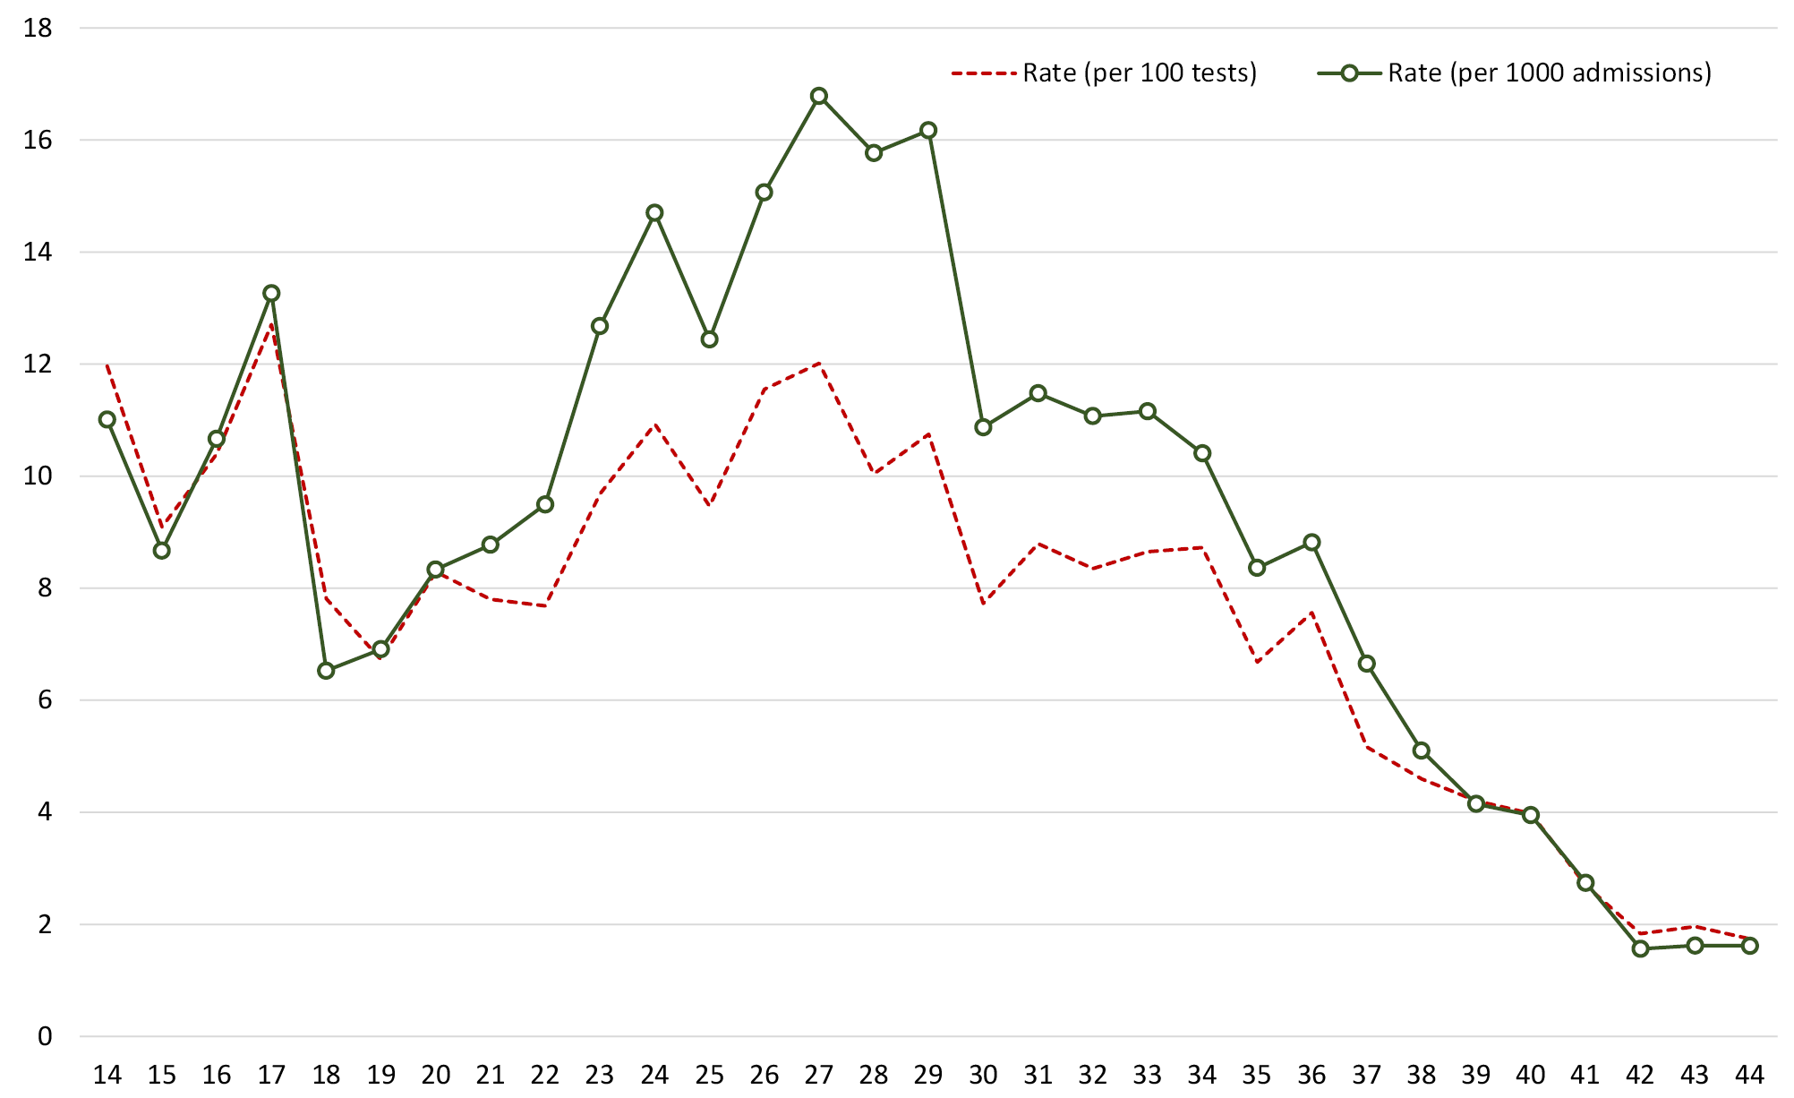

Table 4: Oseltamivir treatment, by age group in patients with confirmed influenza
Factor | Age < 16 years | Age 16–64 years | Age 65+ years | p value
Number of patients | 855 | 1,171 | 1,595
Oseltamivir not received | 511 (59.8%) | 325 (28.2%) | 337 (21.4%) | < 0.001^{b}
Oseltamivir received | 344 (40.2%) | 826 (71.8%) | 1,238 (78.6%)
- received < 48h of onset | 157 (18.4%) | 339 (29.5%) | 465 (29.5%)
- received ≥ 48h of onset | 187 (21.9%) | 487 (42.3%) | 773 (49.1%)
Delay between onset and admission, in days, median (IQR) | 3 (1, 5) | 3 (1, 5) | 3 (2, 4) | 0.55
Delay between onset and treatment,ª in days, median (IQR) | 3 (2, 5) | 3 (2, 5) | 3 (2, 5) | 0.100
Length of stay, in days, median (IQR) | 1 (1, 2) | 2 (1, 4) | 4 (2, 7)
a Of patients who received oseltamivir.
b This p value refers to a chi squared test for the categories oseltamivir not received / oseltamivir received within 48 hr of onset / oseltamivir received more than 48 hr after onset, with a null hypothesis that proportions within each category are equal across all age groups.
Table 5: Factors associated with length of stay in patients with confirmed influenza
Variable | Crude rate ratioª | p value | Adjusted rate ratioª | p value
Oseltamivir treatment
No oseltamivir | 1 (referent) |  | 1 (referent)
received < 48h of onset | 1.35 (1.03, 1.76) | 0.03 | 1.12 (0.91, 1.38) | 0.273
received ≥ 48h of onset | 1.42 (1.06, 1.90) | 0.018 | 1.10 (0.89, 1.36) | 0.354
Age group
< 16 years | 0.54 (0.39, 0.75) | < 0.001 | 0.64 (0.49, 0.84) | 0.039
16–64 years | 1 (referent) |  | 1 (referent)
65+ years | 1.30 (1.09, 1.57) | 0.004 | 1.27 (1.07, 1.52) | 0.008
Comorbidities | 1.90 (1.53, 2.35) | < 0.001 | 1.51 (1.29, 1.77) | < 0.001
ICU admission | 2.12 (1.78, 2.53) | < 0.001 | 2.09 (1.84, 2.36) | < 0.001
a Represents relative difference in length of stay; rate ratio (RR) > 1 indicates longer stay associated with factor.

Vaccine coverage and effectiveness
A cohort to estimate vaccine effectiveness included 4,154 cases at the 17 surveillance hospitals together with 1,180 cases at additional paediatric hospitals (Figure 1). Vaccination status was ascertained in 4,617 of 5,334 cases (86.6%) and 3,083 of 3,678 test-negative control patients (83.8%).
Estimated vaccine coverage was 75.3% (683/907) in the elderly (≥ 65 years) and 46.9% (285/608) in non-elderly adults with medical comorbidities. Of the elderly patients without influenza who had received influenza vaccine and the vaccine type was known, 92.1% (500/543) were vaccinated with adjuvanted trivalent influenza vaccine (TIV), 2.7% (15/543) were vaccinated with high-dose TIV, and 5.2% (28/543) were vaccinated with quadrivalent influenza vaccine (QIV). Of the 1,799 participants aged > 65 years (both cases and controls) where vaccination status was ascertained, 1,123 (62.4%) were recorded in the Australian Immunisation Register. In children within the 6 months – 4 years age group, estimated vaccine coverage was 27.1% (247/910), and in children aged 5–15 years the estimated coverage was 20.1% (167/831).
In adults who were elderly and/or had chronic medical conditions, the adjusted odds ratio of vaccination was 0.57 (95% CI: 0.51, 0.65). The estimated vaccine effectiveness in the target adult population was therefore 42% (95% CI: 36%, 49%). In the elderly (> 65 years), estimated vaccine effectiveness was lower (VE 29%, 95% CI: 11%, 43%). The estimated vaccine effectiveness (versus no vaccine) of adjuvanted TIV was 32% (95% CI: 12, 48%); the number of cases > 65 years who received high-dose TIV or standard QIV was too small for meaningful analysis.
Figure 4: Peak incidence of confirmed influenza (per 100 hospital beds per week) by hospitalª
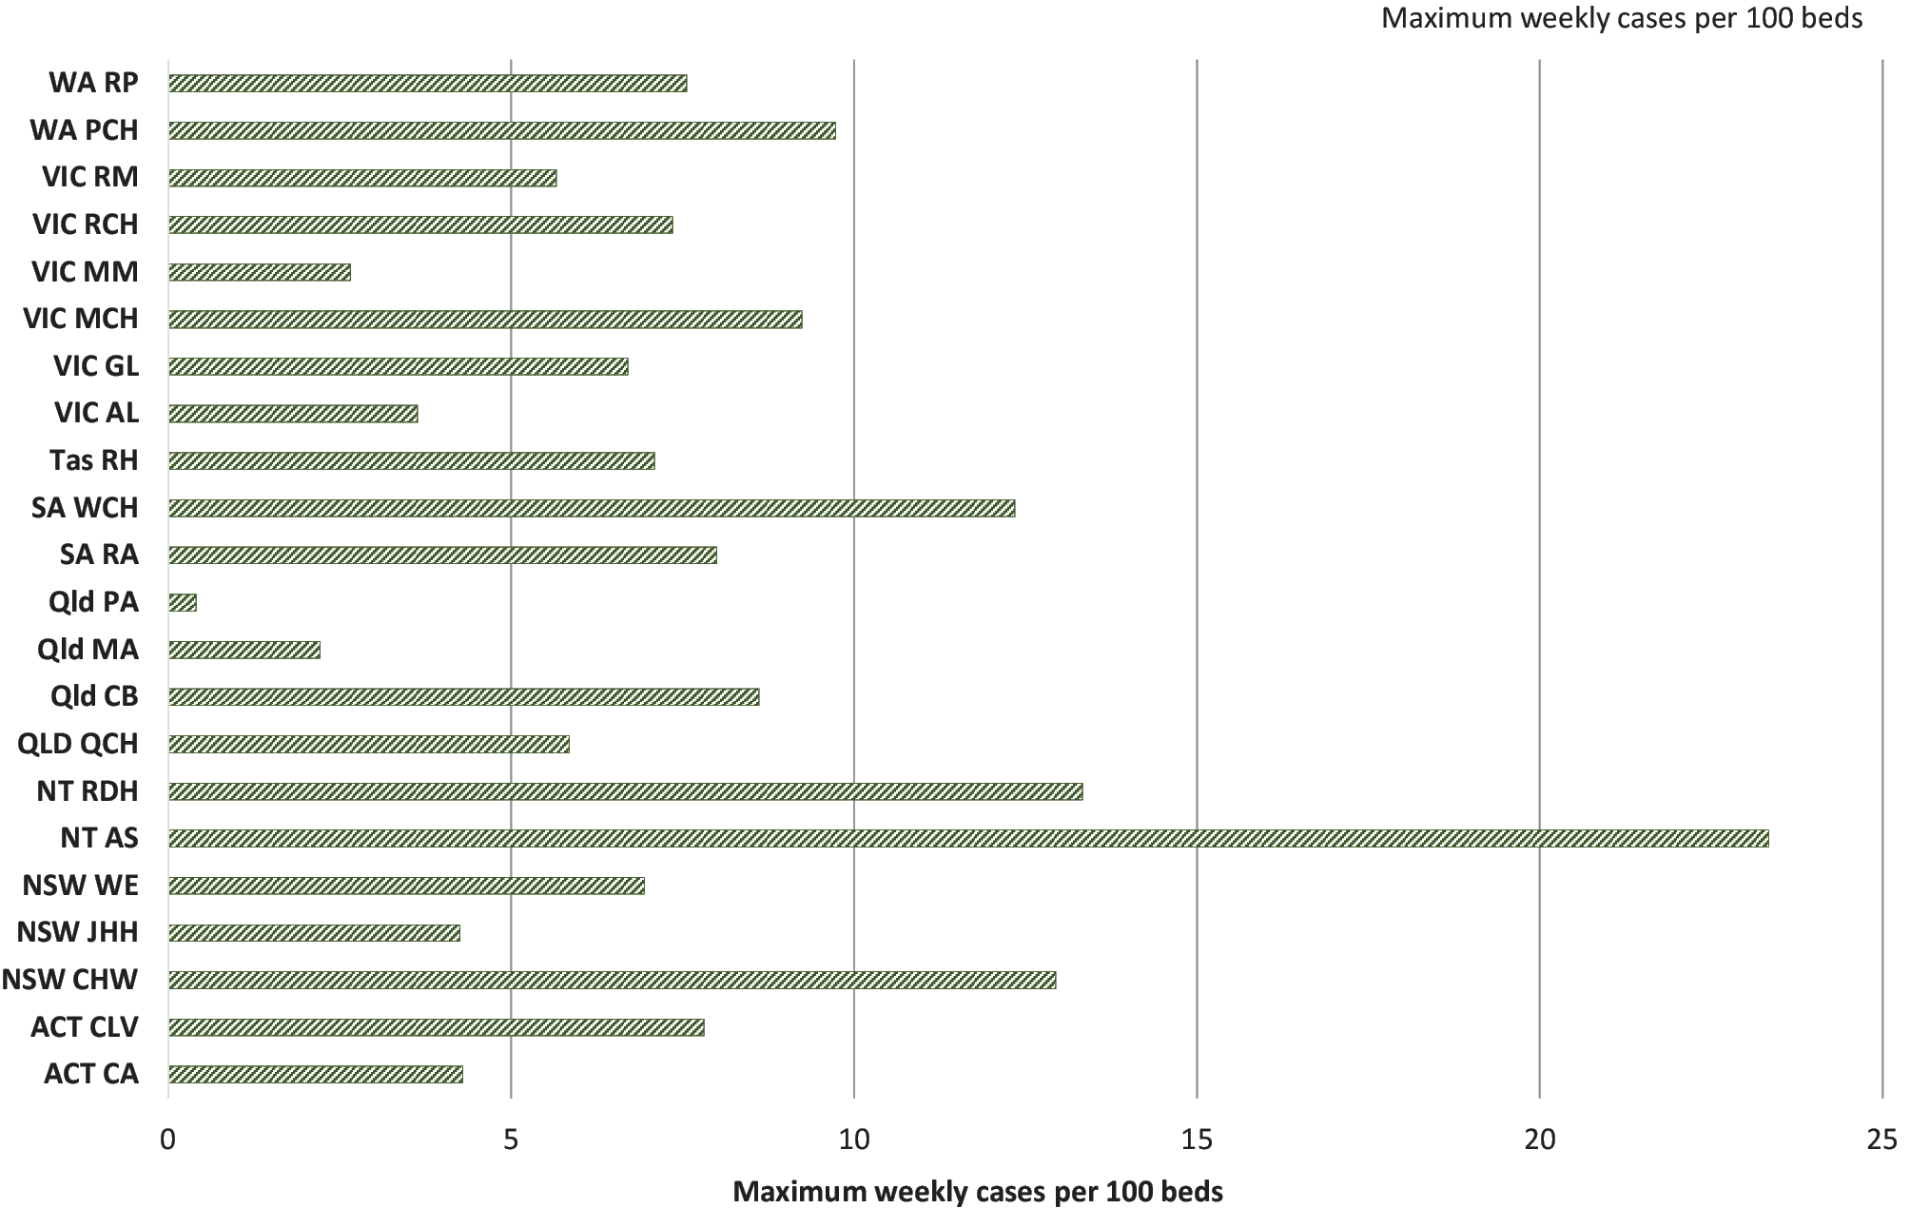
a CA: Canberra Hospital; CLV: Calvary Hospital; CHW: Children’s Hospital at Westmead; JHH: John Hunter Hospital; WE: Westmead Hospital; AS: Alice Springs Hospital; RDH: Royal Darwin Hospital; QCH: Queen’s Children Hospital; CB: Cairns Base Hospital; MA: Mater Hospital; PA: Princess Alexandra Hospital; RA: Royal Adelaide; WCH: Women’s and Children’s Hospital; RH: Royal Hobart Hospital; AL: The Alfred Hospital; GL: University Hospital Geelong; MCH: Monash Children’s Hospital; MM: Monash Medical Centre; RCH: Royal Children’s Hospital; RM: Royal Melbourne; PCH: Perth Children’s Hospital; RP: Royal Perth Hospital.

Discussion
This report has documented a high number of cases in the FluCAN sentinel sites during 2019, comparable with the total number of cases reported in 2017. Based on the number of FluCAN hospital beds relative to the national bed capacity, this is estimated to represent more than 30,000 admissions across the country. Confirmed cases are likely to be an underestimate of the true burden of severe influenza in the participating sites for several reasons; the early start to the 2019 season meant that many cases may have presented prior to the commencement of surveillance in April. Additionally, not all cases of influenza are diagnosed, particularly those with delayed presentations of influenza-related complications (such as secondary bacterial pneumonia) and non-respiratory complications (such as encephalopathy or acute myocardial infarction).
There were significant differences in the timing and duration of the influenza season across different jurisdictions, with the Northern Territory, Queensland and South Australia having early activity; Western Australia having a short spike in cases; and the Australian Capital Territory, New South Wales, Tasmania and Victoria having a prolonged duration of elevated influenza activity. A previous study has compared FluCAN’s interim case counts with those of other surveillance systems and has noted that intensity varies between southern hemisphere countries.⁹ The 2019 season was dominated by the A/H3N2 subtype, with smaller proportions due to A/H1N1 and influenza B infection.
There has been speculation about the impact of increased use of point of care testing on notified influenza cases that became increasingly available in 2018.¹⁰ The hospitals that participate in FluCAN have had mostly-unchanged access to nucleic acid testing over many years, and testing in hospital inpatients is generally encouraged due to clinical and infection control implications. The data reported here therefore suggest that the increased reported case numbers in 2019, compared to 2018, represent a real increase in the incidence rate of severe influenza, with hospital activity comparable to 2017. However, the possibility cannot be excluded that increased awareness amongst clinicians may have led to increased testing.
The peak rate of influenza hospitalisations relative to hospital bed capacity provides a measure of impact. The peak rate of admissions overall was 4.5 per 100 beds/week in week 27, lower than in 2017 where peak admissions were 5.9 per 100 beds/week in week 35. Notably the two Northern Territory hospitals (Alice Springs Hospital and the paediatric ward of the Royal Darwin Hospital) had the highest peak rate of influenza admissions. Based on a mean length of hospital stay of 4.9 days, this suggests that 3.2% of hospital beds were occupied with patients with confirmed influenza during that week.
In 2019, there was a change to the funding arrangements for enhanced influenza vaccines for older Australians. In contrast to 2018, when both the adjuvanted (Fluad, Seqirus) and high dose (Fluzone HD, Sanofi) vaccines were available,¹¹ in 2019, only the adjuvanted vaccine was available under the National Immunisation Program, while the high-dose vaccine was only available on the private market. As expected, the majority of those over 65 years of age received the adjuvanted influenza vaccine.
Jurisdictional paediatric influenza vaccine programs for children aged 6 months – 4 years were initiated in 2018 and continued in 2019. These will be funded under the National Immunisation Program in 2020. The impact of this program is yet to be formally evaluated, but is likely to be positive given good vaccine effectiveness and improving vaccine coverage. Although complications are rare, at a population level, influenza causes hospitalisations, severe complications and mortality in this patient group.^{3,12}
Estimates of influenza vaccine coverage obtained from the present report are higher than estimates made from the Australian Immunisation Register (AIR). Based on AIR data, estimated coverage in children aged 6 months – 4 years was 5.6% in 2017 and at 26.2% in 2018.¹³ In adults, estimated coverage in people aged 18–49 years was 8.9%; in those aged 50–64 years, coverage was 17.2%; and in those aged ≥ 65 years it was 46.3%.¹⁴ In contrast, surveys and surveillance systems have consistently found higher coverage.^{5,6,15} Although estimated coverage in older Australians > 65 years has been similar, there was a change in the vaccine formulation received, consistent with the change in funding status for the high-dose vaccine. However, it is difficult to reconcile the present report’s estimates of relatively stable vaccine coverage with distribution data which suggested an increase in doses supplied by around 13% since 2018.¹⁶ The capture of the AIR in vaccinated cases and controls > 65 years increased from 48% in 2018 to 62% in 2019.
Estimates of vaccine effectiveness are likely to vary due to differences in circulating strains, target populations, methodology and, potentially, the vaccine types used. The most recently-reported estimates from the northern hemisphere were from the 2018/2019 season dominated by A/H1N1, where vaccine effectiveness has been higher than against A/H3N2. These include primary-care based estimates in the United States of America (47%; 95% CI: 34–57%),¹⁷ Europe (32–43% in different systems),¹⁸ and Canada (72%; 95% CI: 60–81% against A/H1N1),¹⁹ and a Danish hospital-based system (38%; 95% CI: 24–49%).¹⁸ A recent study has reported heterogeneous interim estimates in southern hemisphere systems.⁹ The present report’s estimates of vaccine effectiveness in the target population are relatively high when compared to previous seasons where A/H3N2 has dominated.
Data suggest that influenza vaccination of elderly adults averts 10–15% of confirmed influenza in primary care in US and European studies.^{20–22} A previous FluCAN report has estimated that influenza vaccination averted 50% of hospital admissions with confirmed influenza in the elderly, 41% in non-elderly adults with comorbidities and 25% in children,²³ although these proportions would be expected to vary with vaccine effectiveness and coverage. A recent study has found that the influenza vaccine protects against fatal hospital admission with confirmed influenza by 31%.²⁴
The ALIC4E trial, a clinical trial of oseltamivir in elderly patients in primary care conducted independently of pharmaceutical sponsorship, was recently reported.²⁵ The trial confirmed previous findings that oseltamivir is associated with an improvement of around 24 hours in the time to recovery. However, it found that benefits were greater in the elderly; in those with chronic comorbidities; and in those with an increased severity of symptoms. Interestingly, the trial also suggested that patients with delayed presentations of more than 48–72 hours also appeared to benefit.
Although the ALIC4E trial was based in primary care, its finding is of relevance to hospitalized patients who tend to be older, to have chronic comorbidities, to have severe illness and to present later in the course of illness. Unfortunately, despite enrolling 3,266 patients, the ALIC4E trial was underpowered to detect differences in complications of influenza relevant for public health policy, such as hospitalisation and death. National guidelines continue to recommend use of oseltamivir based on observational studies.²⁶ The present report’s finding that patients that received oseltamivir had a longer length of stay is largely accounted for by confounding, as this association was not found on adjusted analyses.
There are several limitations to this surveillance system. Not all cases of influenza in hospitals are diagnosed due to the lack of use of diagnostics, poor quality sample collection or delayed presentations. Surveillance data from other systems documented intense interseasonal activity with notifications in March 2019 comparable to peak activity in 2018,²⁷ prior to FluCAN surveillance commencing in April. There are a number of potential confounders when considering the association between influenza hospitalisation and influenza vaccination, including confounding by indication, the healthy user effect, and confounding by frailty. Additionally, there are some concerns that other biases may be inherent to the test negative study design commonly used to assess vaccine effectiveness, although more recent data suggests that these may not result in significant bias.^{28,29}
In summary, the 2019 FluCAN surveillance system detected a larger number of hospital admissions with laboratory-confirmed influenza in a national observational study than has been seen in recent seasons. Vaccination coverage appeared similar to previous seasons in adults, but increased in children. With the change in funding status, the adjuvanted vaccine was used most commonly in the elderly. Vaccine effectiveness in the target population and the elderly was moderate overall, but was particularly high in children.

Acknowledgements
We thank Janette Taylor Li (Lucy) Ying, Renuka Liyanage(Westmead Hospital), Cazz Finucane, Camille Gibson (Perth Children’s Hospital; Telethon Institute), Janine Roney, Jill Garlick, Virginia Cable, Nicola Dunford (The Alfred Hospital), Stevie Lingman, Melissa Finney, Megan Martin (Mater Hospital), Michelle Thompson, Fiona Sultana Casey McLeod, Adam Kadmon, Stewart Duncum, Gerri Shandler, Sarah Mclean (Royal Melbourne Hospital), Jocelynne McRae, Laura Rost, Nicole Dinsmore Gemma Saravanos, Kathy Meredith (Children’s Hospital at Westmead), Wendy Beckingham, Sandra Root, Michelle Gordon, Teena Russell, Kris Farrelly, Staphanie Hatte (Canberra and Calvary Hospitals), Stella Green, Sue Richmond, Michelle Gosley (Cairns Base Hospital), Jane Nelson, Anngie Everitt (Alice Springs Hospital; Menzies School of Health Research), Tina Collins, Krystal Rudland (Princess Alexandra Hospital), Susan Wagg (Royal Hobart Hospital), Tiffany Perkins, Anne Welsh (University Hospital Geelong, Barwon Health), Doug Dorahy, Isabella Mackay (John Hunter Hospital), Jenny McGrath, Louise Milazzo, Sarah Richards, Cathy Short, Cate Green, Mary McAlister, Eve Boxhall, Ashleigh Richardson, Catriona Doran, Nicole Gurrey, Sophie Whitehead, Jiayas Lin, Rebecca Glover, Segun Kandel, Monima Pamang, Kate Shelton (Royal Adelaide Hospital), Jonathon Burcham, Sophie Damianopoulos, Helen Hammersley Fiona Seroney (Royal Perth Hospital). We also thank Rebecca Doyle, Sara Cook, Sonia Dougherty (Queensland Children’s Hospital), Chris Heath, Mary Walker (Women & Childrens Hospital Adelaide), Laura Francis (Royal Darwin Hospital) Gowri Selvaraj, Karen Bellamy (Monash Children’s Hospital) and Alissa McMinn, Donna Lee, Isabella Overmars, Lois Tham (Royal Children’s Hospital). We acknowledge the support of the Australian Government Department of Health for funding this system.

Author details
Prof Allen C Cheng, Alfred Health; Monash University
Prof Dominic E Dwyer, University of Sydney, Westmead Hospital,
Prof Mark Holmes, University of Adelaide, Royal Adelaide Hospital,
A/Prof Louis Irving, Royal Melbourne Hospital, University of Melbourne,
Dr Graham Simpson, Cairns Base Hospital,
A/Prof Sanjaya Senenayake, Australian National University, The Canberra Hospital,
A/Prof Tony Korman, Monash Medical Centre; Monash University,
A/Prof N. Deborah Friedman, University Hospital Geelong,
Dr Louise Cooley, Royal Hobart Hospital
Prof Peter Wark, University of Newcastle, John Hunter Hospital
Dr Anna Holwell, Alice Springs Hospital,
Dr Simon Bowler, Mater Hospitals
Prof John Upham, Princess Alexandra Hospital, University of Queensland
Prof Daniel M. Fatovich, University of Western Australia, Royal Perth Hospital
Prof Grant Waterer, University of Western Australia, Royal Perth Hospital
A/Prof Christopher C Blyth, Perth Children’s Hospital, University of Western Australia, Telethon Kids Institute
Dr Nigel Crawford, Royal Children’s Hospital, Melbourne; Murdoch Children’s Research Institute
Prof Jim Buttery, Monash Children’s Hospital, Monash University
Prof Helen S. Marshall, Women’s and Children’s Hospital, University of Adelaide
A/Prof Julia E. Clark, Queensland Children’s Hospital
Dr Joshua Francis, Royal Darwin Hospital
Prof Kristine Macartney, Children’s Hospital at Westmead,
A/Prof Tom Kotsimbos, Alfred Health; Monash University
Adjunct Prof Paul Kelly, Australian Department of Health; Australian National University Medical School

Corresponding author
Prof Allen Cheng, Department of Epidemiology and Preventive Medicine, Monash University, Commercial Road, Melbourne VIC 3004.
Email: allen.cheng@monash.edu

References
- Lam TT, Tang JW, Lai FY, Zaraket H, Dbaibo G, Bialasiewicz S et al. Comparative global epidemiology of influenza, respiratory syncytial and parainfluenza viruses, 2010-2015. J Infect. 2019;79(4):373–82.
- GBD 2017 Influenza Collaborators. Mortality, morbidity, and hospitalisations due to influenza lower respiratory tract infections, 2017: an analysis for the Global Burden of Disease Study 2017. Lancet Respir Med. 2019;7(1):69–89.
- Li-Kim-Moy J, Yin JK, Patel C, Beard FH, Chiu C, Macartney KK et al. Australian vaccine preventable disease epidemiological review series: influenza 2006 to 2015. Commun Dis Intell Q Rep. 2016;40(4):E482–95.
- Kelly PM, Kotsimbos T, Reynolds A, Wood-Baker R, Hancox B, Brown SGA et al. FluCAN 2009: initial results from sentinel surveillance for adult influenza and pneumonia in eight Australian hospitals. Med J Aust. 2011;194(4):169–74.
- Cheng AC, Holmes M, Dwyer DE, Senanayake S, Cooley L, Irving LB et al. Influenza epidemiology in patients admitted to sentinel Australian hospitals in 2018: the Influenza Complications Alert Network (FluCAN). Commun Dis Intell (2018). 2019;43. doi: https://doi.org/10.33321/cdi.2019.43.48.
- Cheng AC, Holmes M, Dwyer DE, Senanayake S, Cooley L, Irving LB et al. Influenza epidemiology in patients admitted to sentinel Australian hospitals in 2017: the Influenza Complications Alert Network (FluCAN). Commun Dis Intell (2018). 2019;43. doi: https://doi.org/10.33321/cdi.2019.43.39.
- Australian Institute of Health and Welfare (AIHW). Hospital resources 2016–17: Australian hospital statistics. Canberra: Australian Government, AIHW; 27 June 2018. Available from: https://www.aihw.gov.au/reports/hospitals/ahs-2016-17-hospital-resources/contents/table-of-contents.
- Oken MM, Creech RH, Tormey DC, Horton J, Davis TE, McFadden ET et al. Toxicity and response criteria of the Eastern Cooperative Oncology Group. Am J Clin Oncol. 1982;5(6):649–55.
- Sullivan SG, Arriola CS, Bocacao J, Burgos P, Bustos P, Carville KS et al. Heterogeneity in influenza seasonality and vaccine effectiveness in Australia, Chile, New Zealand and South Africa: early estimates of the 2019 influenza season. Euro Surveill. 2019;24(45). doi: https://doi.org/10.2807/1560-7917.ES.2019.24.45.1900645.
- Sheppeard V, Gilmour R, Tobin S. Record number of influenza tests in 2019, not a “mutant flu crisis”. Med J Aust. 2019;211(7). doi: https://doi.org/10.5694/mja2.50321.
- Sheridan SL, Patel C, Macartney K, Cheng AC. New enhanced influenza vaccines for older Australians: what promise do they hold? Med J Aust. 2018;209(3):110–2.
- Britton PN, Blyth CC, Macartney K, Dale RC, Li-Kim-Moy J, Khandaker G et al. The spectrum and burden of influenza-associated neurological disease in children: combined encephalitis and influenza sentinel site surveillance from Australia, 2013–2015. Clin Infect Dis. 2017;65(4):653–60.
- National Centre for Immunisation Research and Surveillance (NCIRS). Annual Immunisation Coverage Report 2018. Sydney: NCIRS; November 2019. Available from: https://www.ncirs.org.au/sites/default/files/2019-11/NCIRS%20Annual%20Immunisation%20Coverage%20Report%202018.pdf.
- NCIRS. Exploratory analysis of the ﬁrst 2 years of adult vaccination data recorded on AIR. Sydney: NCIRS; 6 December 2019. Available from: https://www.ncirs.org.au/new-ncirs-report-exploratory-analysis-first-2-years-adult-vaccination-data-recorded-air.
- Dyda A, Karki S, Hayen A, MacIntyre CR, Menzies R, Banks E et al. Influenza and pneumococcal vaccination in Australian adults: a systematic review of coverage and factors associated with uptake. BMC Infect Dis. 2016;16(1). doi: https://doi.org/10.1186/s12879-016-1820-8.
- Hunt G. Record numbers of Australians getting vaccinated against the flu. [Internet.] Canberra: Greg Hunt, Federal Member for Flinders / Minister for Health and Aged Care; 29 May 2019. Available from: https://www.greghunt.com.au/record-numbers-of-australians-getting-vaccinated-against-the-flu/.
- Doyle JD, Chung JR, Kim SS, Gaglani M, Raiyani C, Zimmerman RK et al. Interim estimates of 2018–19 seasonal influenza vaccine effectiveness — United States, February 2019. MMWR Morb Mortal Wkly Rep. 2019;68(6):135–9.
- Kissling E, Rose A, Emborg HD, Gherasim A, Pebody R, Pozo F et al. Interim 2018/19 influenza vaccine effectiveness: six European studies, October 2018 to January 2019. Euro Surveill. 2019;24(8). doi: https://doi.org/10.2807/1560-7917.ES.2019.24.1900121.
- Skowronski DM, Leir S, Sabaiduc S, Murti M, Dickinson JA, Olsha R et al. Interim estimates of 2018/19 vaccine effectiveness against influenza A(H1N1)pdm09, Canada, January 2019. Euro Surveill. 2019;24(4). doi: https://doi.org/10.2807/1560-7917.ES.2019.24.4.1900055.
- Kostova D, Reed C, Finelli L, Cheng PY, Gargiullo PM, Shay DK et al. Influenza illness and hospitalizations averted by influenza vaccination in the United States, 2005–2011. PLoS One. 2013;8(6). doi: https://doi.org/10.1371/journal.pone.0066312.
- Jackson ML, Phillips CH, Benoit J, Jackson LA, Gaglani M, Murthy K et al. Burden of medically attended influenza infection and cases averted by vaccination – United States, 2013/14 through 2015/16 influenza seasons. Vaccine. 2018;36(4):467–72.
- Machado A, Mazagatos C, Dijkstra F, Kislaya I, Gherasim A, McDonald SA et al. Impact of influenza vaccination programmes among the elderly population on primary care, Portugal, Spain and the Netherlands: 2015/16 to 2017/18 influenza seasons. Euro Surveill. 2019;24(45). doi: https://doi.org/10.2807/1560-7917.ES.2019.24.45.1900268.
- Cheng AC, Holmes M, Dwyer DE, Irving LB, Korman TM, Senenayake S et al. Influenza epidemiology in patients admitted to sentinel Australian hospitals in 2015: the Influenza Complications Alert Network. Commun Dis Intell Q Rep. 2016;40(4):E521–6.
- Nation ML, Moss R, Spittal MJ, Kotsimbos T, Kelly PM, Cheng AC. Influenza vaccine effectiveness against influenza-related mortality in Australian hospitalized patients: a propensity score analysis. Clin Infect Dis. 2020;72(1):99–107.
- Butler CC, van der Velden AW, Bongard E, Saville BR, Holmes J, Coenen S et al. Oseltamivir plus usual care versus usual care for influenza-like illness in primary care: an open-label, pragmatic, randomised controlled trial. Lancet. 2020;395(10217):42–52.
- Muthuri SG, Venkatesan S, Myles PR, Leonardi-Bee J, Al Khuwaitir TSA, Al Mamun A et al. Effectiveness of neuraminidase inhibitors in reducing mortality in patients admitted to hospital with influenza A H1N1pdm09 virus infection: a meta-analysis of individual participant data. Lancet Respir Med. 2014;2(5):395–404.
- Barr IG, Deng YM, Grau ML, Han AX, Gilmour R, Irwin M et al. Intense interseasonal influenza outbreaks, Australia, 2018/19. Euro Surveill. 2019;24(33). doi: https://doi.org/10.2807/1560-7917.ES.2019.24.33.1900421.
- Ainslie KEC, Shi M, Haber M, Orenstein WA. On the bias of estimates of influenza vaccine effectiveness from test-negative studies. Vaccine. 2017;35(52):7297–301.
- Lewnard JA, Tedijanto C, Cowling BJ, Lipsitch M. Measurement of vaccine direct effects under the test-negative design. Am J Epidemiol. 2018;187(12):2686–97.

Communicable Diseases Intelligence
ISSN: 2209-6051 Online

Communicable Diseases Intelligence (CDI) is a peer-reviewed scientific journal published by the Office of Health Protection and Response, Department of Health. The journal aims to disseminate information on the epidemiology, surveillance, prevention and control of communicable diseases of relevance to Australia.

Editor: Jennie Hood and Noel Lally
Deputy Editor: Simon Petrie
Design and Production: Kasra Yousefi
Editorial Advisory Board: David Durrheim, Mark Ferson, John Kaldor, Martyn Kirk and Linda Selvey

Website: http://www.health.gov.au/cdi

Contacts
CDI is produced by the Office of Health Protection and Response, Australian Government Department of Health, GPO Box 9848, (MDP 6) CANBERRA ACT 2601

Email: cdi.editor@health.gov.au

Submit an Article
You are invited to submit your next communicable disease related article to the Communicable Diseases Intelligence (CDI) for consideration. More information regarding CDI can be found at: http://health.gov.au/cdi.
Further enquiries should be directed to: cdi.editor@health.gov.au.

This journal is indexed by Index Medicus and Medline.

Creative Commons Licence - Attribution-NonCommercial-NoDerivatives CC BY-NC-ND
© 2022 Commonwealth of Australia as represented by the Department of Health
This publication is licensed under a Creative Commons Attribution-NonCommercial-NoDerivatives 4.0 International Licence from https://creativecommons.org/licenses/by-nc-nd/4.0/legalcode (Licence). You must read and understand the Licence before using any material from this publication.

Restrictions
The Licence does not cover, and there is no permission given for, use of any of the following material found in this publication (if any):
- the Commonwealth Coat of Arms (by way of information, the terms under which the Coat of Arms may be used can be found at www.itsanhonour.gov.au);
- any logos (including the Department of Health’s logo) and trademarks;
- any photographs and images;
- any signatures; and
- any material belonging to third parties.

Disclaimer
Opinions expressed in Communicable Diseases Intelligence are those of the authors and not necessarily those of the Australian Government Department of Health or the Communicable Diseases Network Australia. Data may be subject to revision.

Enquiries
Enquiries regarding any other use of this publication should be addressed to the Communication Branch, Department of Health, GPO Box 9848, Canberra ACT 2601, or via e-mail to: copyright@health.gov.au

Communicable Diseases Network Australia
Communicable Diseases Intelligence contributes to the work of the Communicable Diseases Network Australia.
http://www.health.gov.au/cdna

