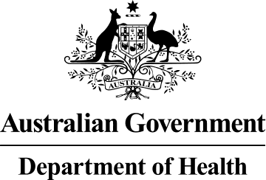

Introduction of the PBS Approved Suppliers Portal on 9 October 2019
- information for medical practitioners September 2019
The PBS Approved Suppliers Portal has been developed to allow applicants to lodge applications for approval to supply pharmaceutical benefits and update their details online.
With the introduction of the PBS Approved Suppliers Portal on 9 October 2019, a number of changes to the process for lodging applications and other forms will come into effect.
Comprehensive user guides to assist with the process will be available from the PBS Approved Suppliers Portal and the Department of Health website.

Preparing for access to the PBS Approved Suppliers Portal
To register for access to the PBS Approved Suppliers Portal you will need to obtain and
install an AUSkey. You should allow up to ten business days for this process. Instructions on how to obtain an AUSkey are available from the Australian Business Register website.
Please note, if you have already obtained and installed an AUSkey, you do not need to obtain a new one.

Lodging applications and related forms
The PDF forms listed below will continue to be available from the Department of Health website and, in line with current processes, they can be downloaded and completed as required.
  - Application for a medical practitioner to supply pharmaceutical benefits
  - Notification of bank account details for an approved medical practitioner
From 9 October 2019, you should lodge completed PDF forms via the PBS Approved Suppliers Portal. To do this, you will need to have a digital copy of the completed form (and any supporting documentation) saved to your computer. When you have signed in to the PBS Approved Suppliers Portal, you will be able to lodge your application or other form by attaching the file(s) at the ‘Upload Documents’ tab.

Contact Us
If you have any questions about the PBS Approved Suppliers Portal, please email details of your enquiry to pbsapprovedsuppliers@health.gov.au.

GPO Box 9848 Canberra ACT 2601 - www.health.gov.au

